Supplementary Materials
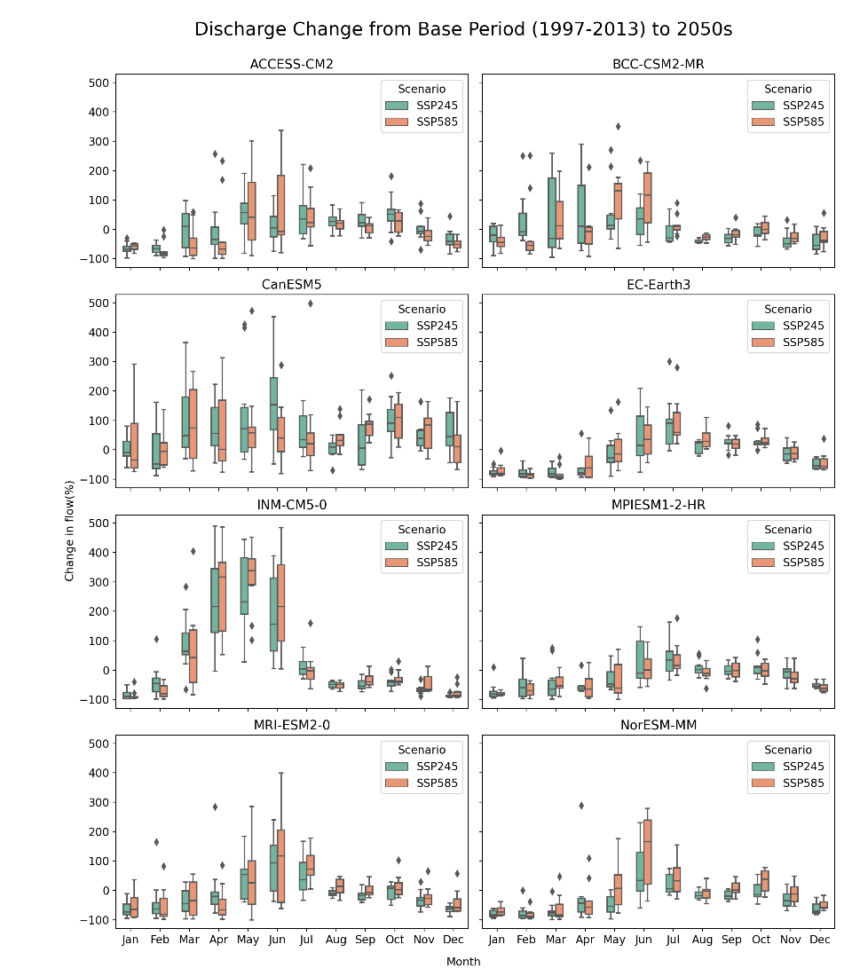
Supp. Figure 1. Predicted change in the future mean monthly discharge of Teesta River at Dalia station under SSP245 and SSP585 of 8 Models of 2050.

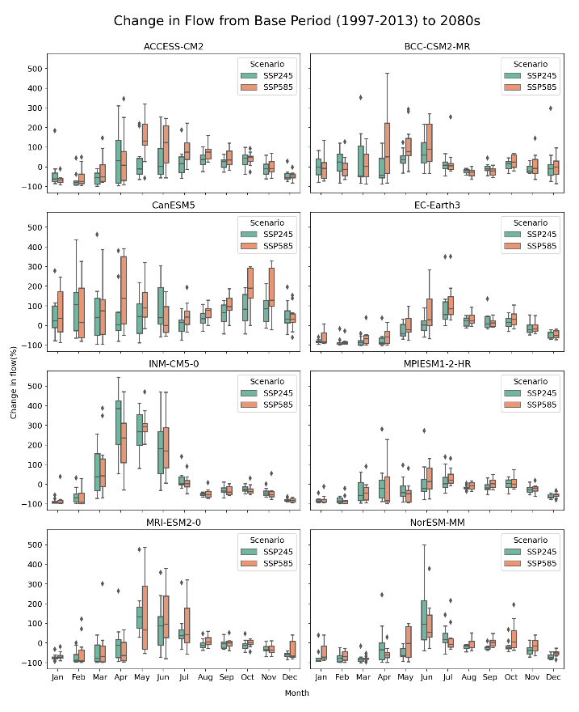
Supp. Figure 2. Predicted change in the future mean monthly discharge of Teesta River at Dalia station under the SSP245 and SSP585 scenarios of eight GCM models for the 2080s.
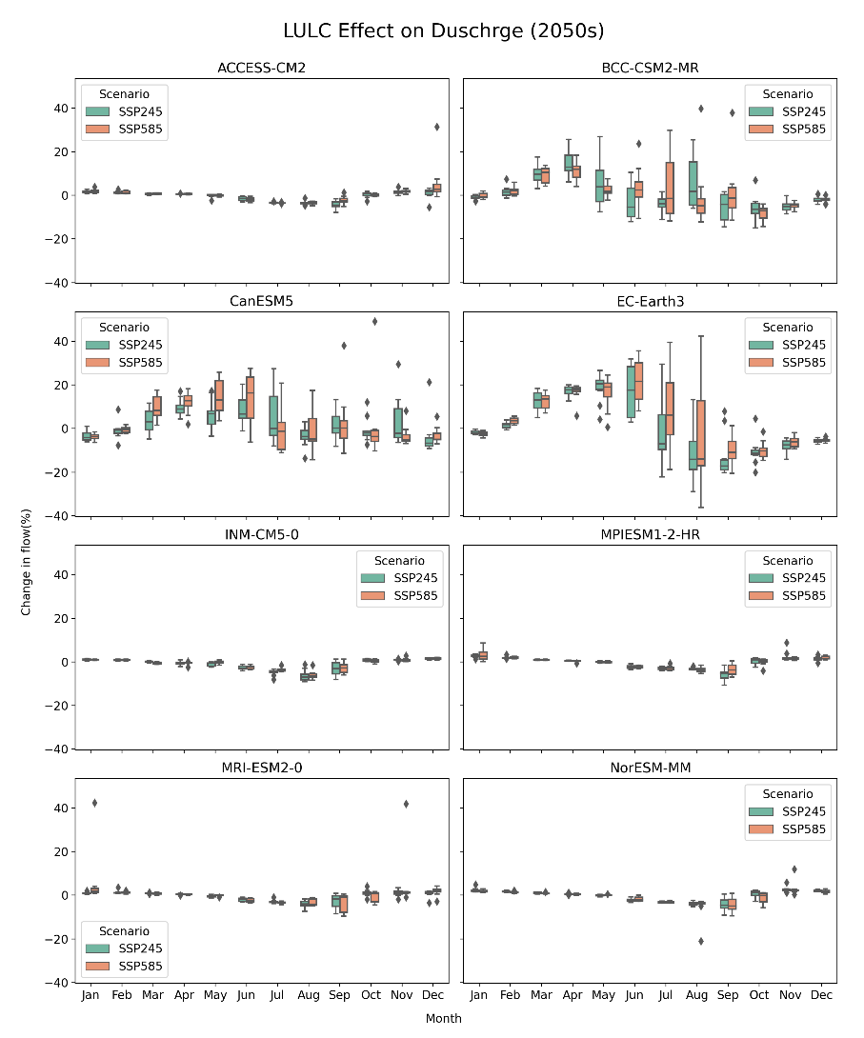
Supp. Figure 3. Predicted change in the future mean monthly discharge of Teesta River at Dalia station due to LULC change under SSP245 and SSP585 of 8 Models of 2050.
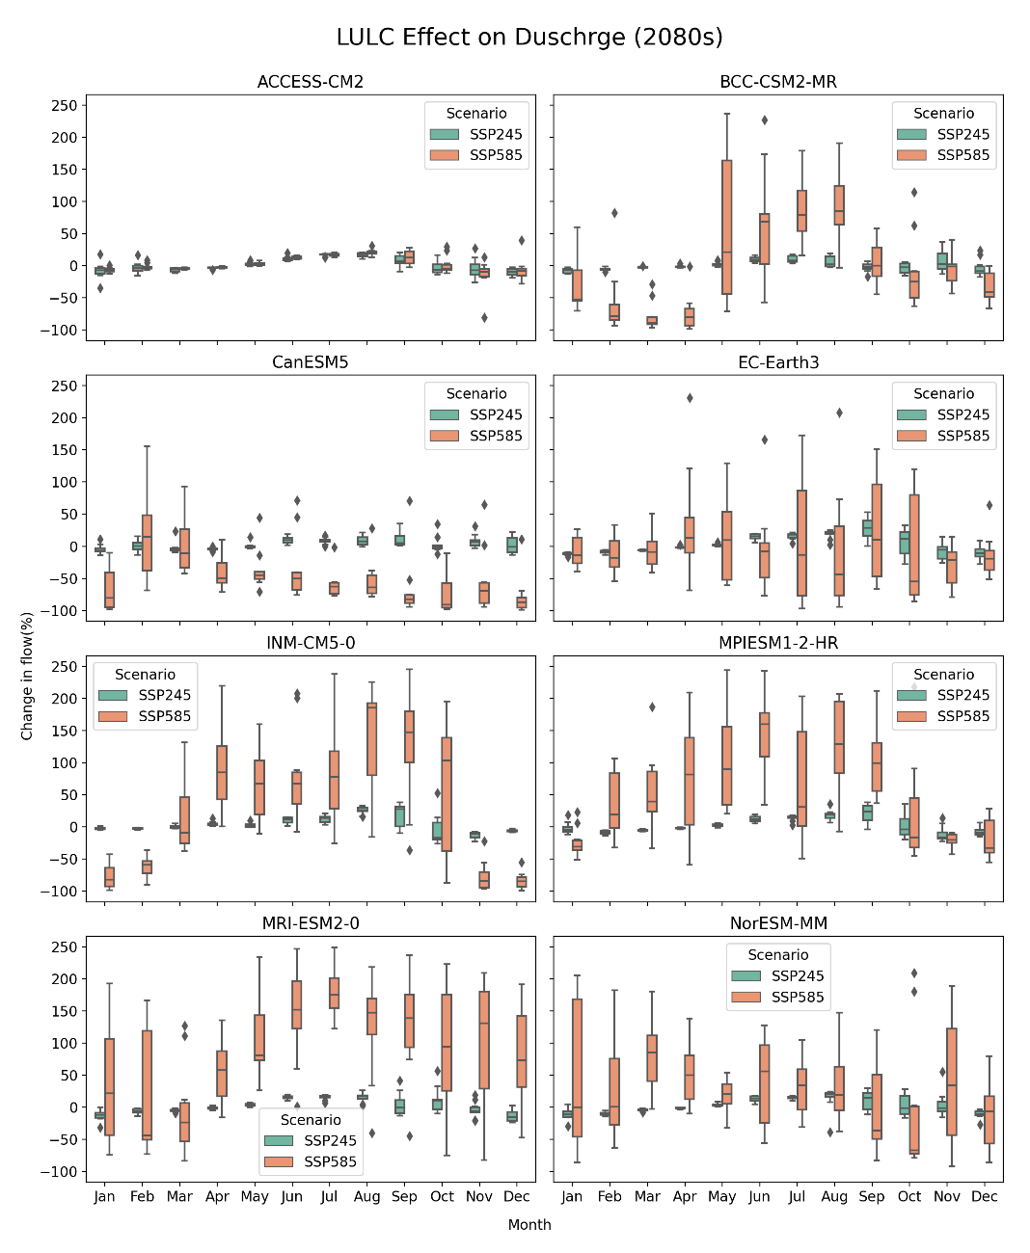
Supp. Figure 4. Predicted change in the future mean monthly discharge of Teesta River at Dalia station due to LULC change under SSP245 and SSP585 scenarios using eight models for the year 2080.

