Supporting information
Theoretical Simulation of TADF Character of 9'-Bicarbazole Modified 2,4,6-Triphenyl-1,3,5-triazine

Shuyuan Zhao^{a,#}, Zhengwen Lin^{b,#}, Fang Wang^{b}, Zhenjun Si^{a,b} *, Zhe Chen^{a,}*
ª School of Materials Science and Technology, Jilin Institute of Chemical Technology, Jilin City, P. R. China
^{b} School of Materials Science and Technology, Changchun University of Science and Technology, Changchun City, P. R. China
# Authors contributed to this article equally.

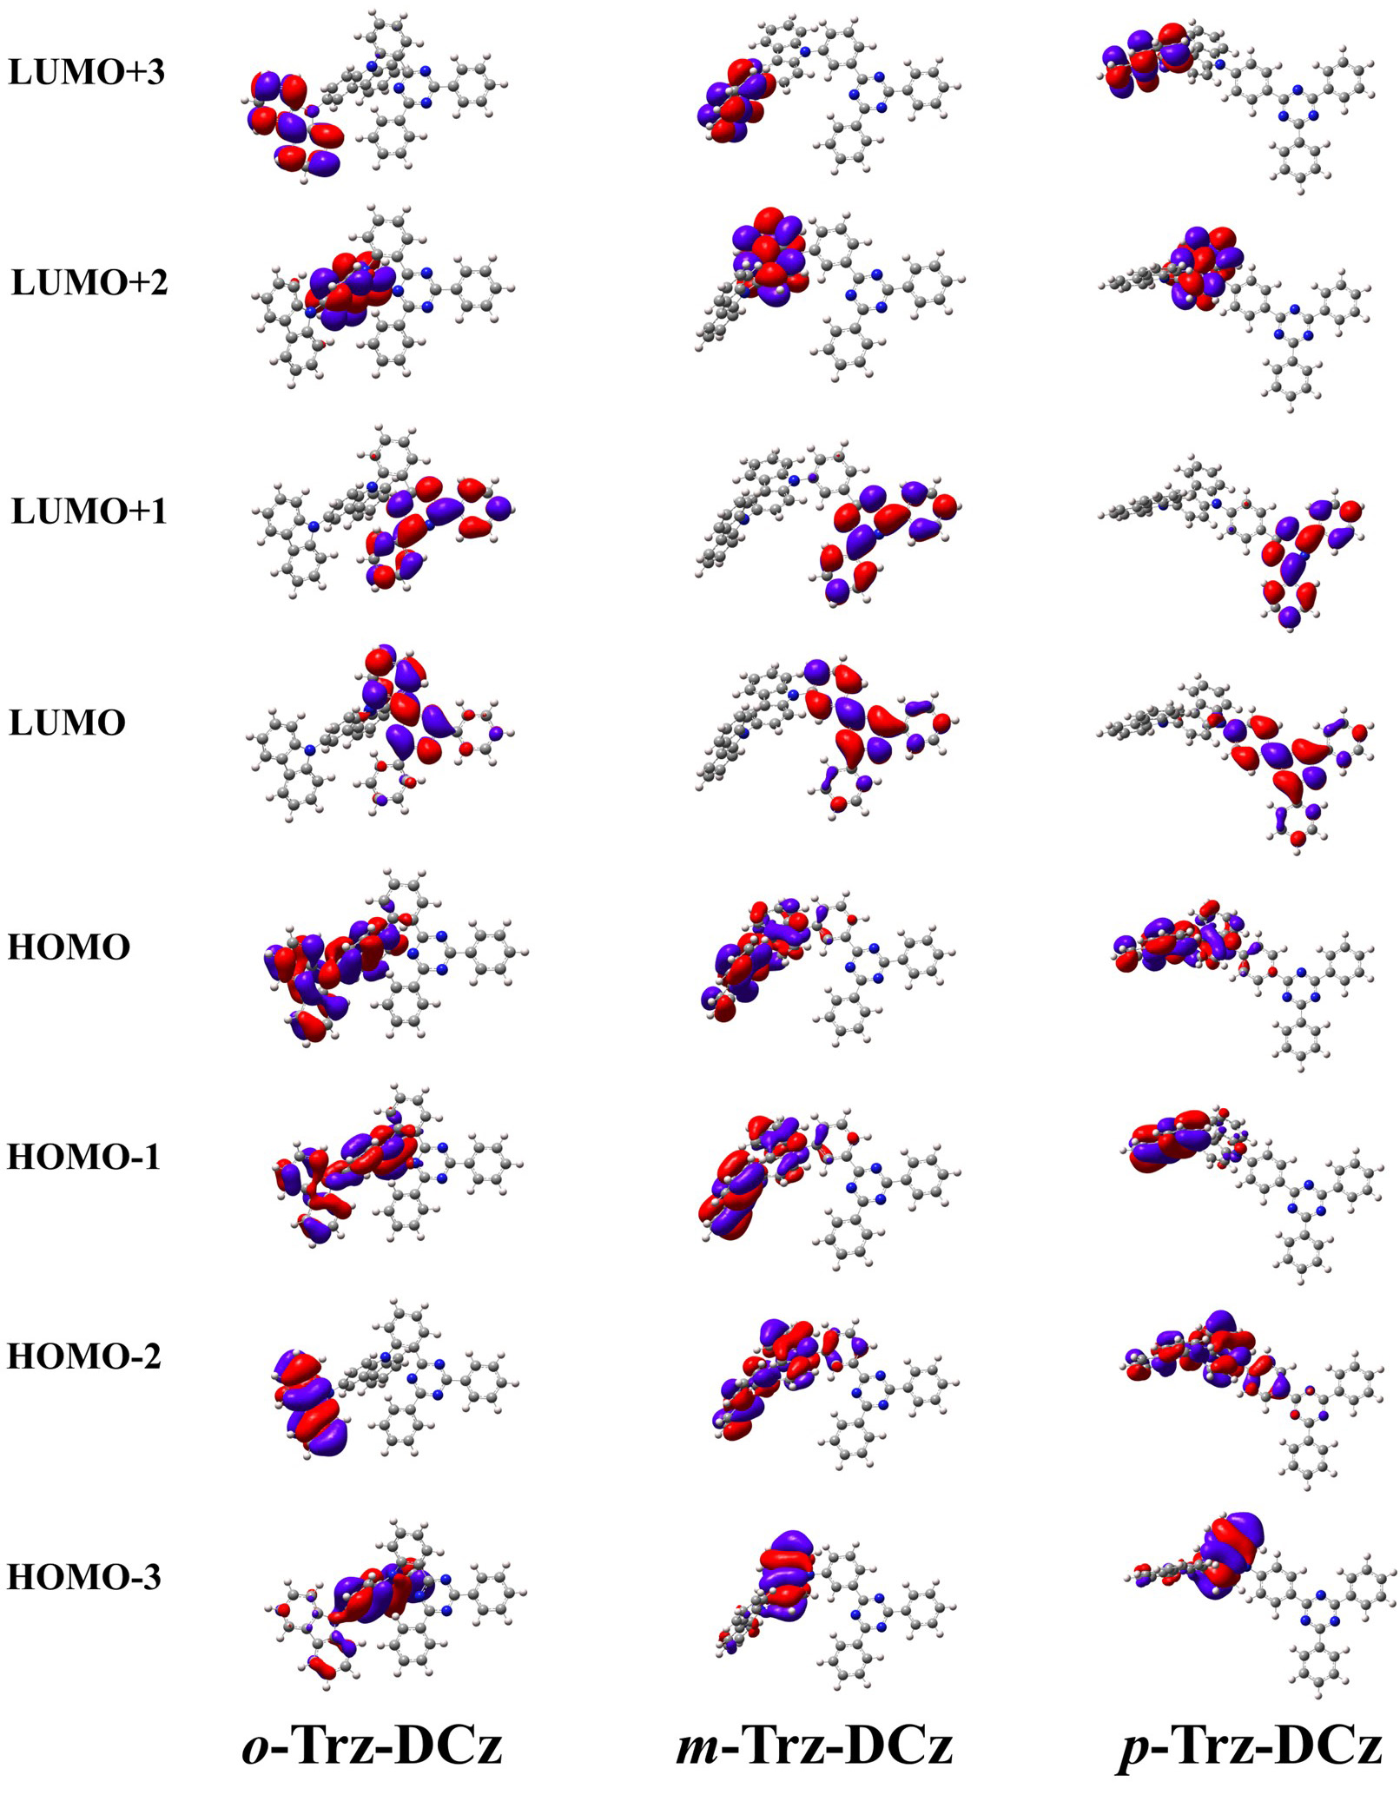
Fig. S1 Distribution of HOMO-3 ~ LUMO+3 orbitals of o-Trz-DCz, m-Trz-DCz, p-Trz-DCz in toluene solvents.

Table. S1 Energies of S₁ and T₁ states of p-Trz-DCz calculated by different functionals
 | B3LYP | PBE0 | BMK | M06-2X | CAM-BLYP | Exp.
HF% | 20 | 25 | 42 | 54 | 19/65
S₁/T₁ (eV) | 2.89/2.72 | 3.10/2.77 | 3.66/3.14 | 3.91/3.35 | 4.00/2.90 | 3.09/2.86^{[18]}
ΔE_{ST} (eV) | 0.17 | 0.33 | 0.52 | 0.56 | 1.10 | 0.23^{[17]}(0.32)^{[18]}

Table. S2 Values of θ₁, θ₂, θ₃ and θ₄ of o-Trz-DCz, m-Trz-DCz and p-Trz-DCz in S₀, S₁ and T₁ states calculated by G09
Molecule | State | θ₁ | θ₂ | θ₃ | θ₄
o-Trz-DCz | S₀ | 66.93 | 40.55 | 1.94 | 0.92
o-Trz-DCz | S₁ | 75.54 | 15.84 | 18.86 | 2.80
o-Trz-DCz | T₁ | 62.76 | 15.87 | 14.64 | 3.13
m-Trz-DCz | S₀ | 53.33 | 5.60 | 1.53 | 1.21
m-Trz-DCz | S₁ | 63.56 | 0.03 | 1.37 | 0.03
m-Trz-DCz | T₁ | 44.01 | 0.50 | 0.14 | 0.32
p-Trz-DCz | S₀ | 52.25 | 1.39 | 0.33 | 0.92
p-Trz-DCz | S₁ | 89.22 | 0.02 | 0.08 | 0.61
p-Trz-DCz | T₁ | 44.94 | 0.37 | 0.16 | 0.33

Table. S3 Values of B₁, B₂, B₃ and B₄ of o-Trz-DCz, m-Trz-DCz and p-Trz-DCz in S₀, S₁ and T₁ states calculated by G09
Molecule | State | B₁ | B₂ | B₃ | B₄
o-Trz-DCz | S₀ | 1.41 | 1.48 | 1.47 | 1.48
o-Trz-DCz | S₁ | 1.43 | 1.43 | 1.49 | 1.48
o-Trz-DCz | T₁ | 1.42 | 1.43 | 1.49 | 1.48
m-Trz-DCz | S₀ | 1.41 | 1.48 | 1.48 | 1.48
m-Trz-DCz | S₁ | 1.44 | 1.43 | 1.49 | 1.49
m-Trz-DCz | T₁ | 1.39 | 1.42 | 1.48 | 1.48
p-Trz-DCz | S₀ | 1.41 | 1.48 | 1.48 | 1.48
p-Trz-DCz | S₁ | 1.43 | 1.43 | 1.49 | 1.49
p-Trz-DCz | T₁ | 1.40 | 1.42 | 1.48 | 1.48

Table. S4 Contribution of B, A and θ to the λ during the S₀ → S₁ process and the SOC constants (cm⁻¹) between S₁ and T₁ of o-Trz-DCz, m-Trz-DCz and p-Trz-DCz.
Molecule | λ (meV) |  |  |  |  | <S₁|Ĥ_{SO}|T₁>
Molecule | B | A | θ | Total |  | S₁ | T₁
o-Trz-DCz | 214.40 | 60.56 | 119.50 | 394.46 |  | 0.1345 | 0.2520
m-Trz-DCz | 212.62 | 65.58 | 54.45 | 332.65 |  | 0.1819 | 0.4869
p-Trz-DCz | 209.18 | 34.76 | 261.91 | 505.85 |  | 0.0173 | 0.2934

* Corresponding authors: Zhenjun Si (sizhenjun@jlict.edu.cn), Zhe Chen (chenzhe0809@foxmail.com)

