Supplementary Online Content

Yuanfang Ren, Yanjun Li, Tyler J. Loftus et al. Physiologic signatures within six hours of hospitalization identify acute illness phenotypes via deep temporal interpolation and clustering network.

This supplementary material has been provided by the authors to give readers additional information about their work.

eMethods 3
eFigure 1. Cohort selection and exclusion criteria 9
eFigure 2. Spearman correlation heat map for the training cohort (N=41,502) 10
eFigure 3. Deep interpolation network for clustering of vital signs algorithm 11
eFigure 4. Gap statistic and elbow approaches showing the optimal number of clusters 12
eFigure 5. Alluvial plot showing distribution of phenotypes across worst SOFA scores of patients within first 24 hours of admission in training cohort 13
eFigure 6. Chord diagrams showing the distribution of patients with higher SOFA scores (i.e., 2+) within first 24 hours of admission of six organ systems by phenotypes in training cohort 14
eFigure 7. Survival curves and Cox proportional hazards modeling by phenotypes in training cohort 15
eFigure 8. Survival curves and Cox proportional hazards modeling by sepsis patients in training cohort 16
eFigure 9. Survival curves and Cox proportional hazards modeling by AKI patients in training cohort 17
eFigure 10. Survival curves and Cox proportional hazards modeling by surgical patients in training cohort 18
eFigure 11. Distribution of vital signs during the first six hours of hospital admission in the testing cohort 19
eFigure 12. t-SNE plot of phenotype assignments in the testing cohort 20
eFigure 13. Alluvial plot showing distribution of phenotypes across worst SOFA scores of patients within first 24 hours of admission in testing cohort 21
eFigure 14. Chord diagrams showing the distribution of patients with higher SOFA scores (i.e., 2+) within first 24 hours of admission of six organ systems by phenotypes in testing cohort 22
eFigure 15. Survival curves and Cox proportional hazards modeling by phenotypes in testing cohort 23
eFigure 16. Chord diagrams showing the distribution of nine most common admission diagnosis groups by phenotype in training cohort 24
eFigure 17. Chord diagrams showing the distribution of nine most common admission diagnosis groups by phenotype in training cohort 25
eFigure 18. Reconstruction error of physiologic signatures measured within six hours of hospital admission in training cohort using deep interpolation network 26
eFigure 19. Reconstruction error of physiologic signatures measured within six hours of hospital admission in testing cohort using deep interpolation network 27
eTable 1. Processing of vital sign time series 28
eTable 2. Used LOINCS, range of values, direction of abnormal values for lab variables 29
eTable 3. Clinic characteristics and biomarkers of the cohorts 33
eTable 4. Illness severity, clinical outcomes, and resource use of the cohorts 37
eTable 5. Statistic output from the deep interpolation network modeling in the training cohort. 39
eTable 6. Phenotype clinical characteristics and biomarkers in the training cohort 40
eTable 7. Phenotype illness severity, clinical outcomes, and resource use in the training cohort 44
eTable 8. Phenotype clinical characteristics and biomarkers in the testing cohort 46
eTable 9. Phenotype illness severity, clinical outcomes, and resource use in the testing cohort 50

eMethods

- Data source and participants and study design

Data source and participants

This project was approved by the University of Florida institutional review board under a waiver of informed consent and with authorization under the Health Insurance Portability and Accountability Act. Transparent Reporting of a multivariable prediction model for Individual Prognosis Or Diagnosis (TRIPOD) recommendations were followed under the Type 2b analysis category (nonrandom split-sample development and validation). Using the University of Florida Health (UFH) Integrated Data Repository as Honest Broker, we created a longitudinal dataset from electronic health records of all adults (age ≥18 years) admitted to the 1000-bed academic hospital at UFH between June 1, 2014 and April 1, 2016. The dataset includes structured and unstructured clinical data, demographic information, vital signs, laboratory values, medications, diagnoses, and procedures. Patients completely missing at least two of the six vital sign measurements used for clustering (systolic and diastolic blood pressure, heart rate, respiratory rate, temperature, and peripheral capillary oxygen saturation) in the first six hours of admission were excluded from the analysis (eFigure 1). The final cohort consisted of 75,762 hospital admissions for 43,598 patients.

Study design

We non-randomly split the dataset by admission dates into three cohorts: training (admissions between June 1, 2014 and May 31, 2015, n = 41,502, 55% of all admissions), validation (admissions between June 1, 2015 and October 31, 2015, n = 17,415, 22% of all admissions), and testing (admissions between November 1, 2015 and April 1, 2016, n = 16,845, 23% of all admissions). To determine acute illness phenotypes using early physiologic signatures, we derived the clinical phenotypes using unsupervised clustering methods that were applied to the repeated measurements of six vital signs available within the first six hours of hospital presentation in the training cohort. We selected hyper-parameters of clustering model using validation cohort. We assessed phenotype reproducibility by predicting phenotypes in the testing cohort and assessing phenotype frequency distributions and clinical outcomes.

- Approach to preprocess electronics health records (EHR) data

EHR vital data elements in our cohort studies were irregularly sampled time series. Prior to clustering algorithms, we excluded outliers based on the expert-defined ranges (eTable 1). For the time series missing entirely, which is due to having no measurements during the hospitalization in the plausible range for a variable, we assigned the starting point (time t=0) value of the time series to the mean value of corresponding variables in the training cohort, as listed in eTable 1. We standardized values using Min-Max scaler (eTable 1). We directly input these irregular sampled time series to our clustering algorithm without any time interval imputation.

- Deep Interpolation Network

In this section, we describe our proposed Deep Temporal Interpolation and Clustering Network (dTIC) for clustering the patients based on their vital sign data during the early stages of hospital admission. Using the raw sparse and irregularly sampled time series vital sign as the input, dTIC can automatically extract a unified and abstract representation of the entire time-series data of an encounter and cluster the patients via an end-to-end unsupervised manner. The overall network architecture consists of four main compounds: Interpolation model, Seq2Seq model, Re-interpolation model and Clustering model.

dTIC learns the feature representations and cluster assignments via a two-pass manner. In the first pass, dTIC learns the feature representations, determines the optimal number of clusters and thereby generates the initial cluster assignments. In the second pass, dTIC simultaneously learns feature representations and cluster assignments to refine the results.

Figure 1a provides the schematic representation of the dTIC architecture for feature learning process in the first learning pass. We first interpolate the raw time-series vital sign data to a regularly sampled meta-representation with pre-defined reference time points via an interpolation model.¹ Then we feed the interpolated time-series data into a Seq2Seq model with Gated Recurrent Unit (GRU)² layers for feature embedding and extracting a unified context vector lying in the low-dimensional feature space by the encoder. The context vector contains the global time-series information and is further used by other downstream tasks (e.g., clustering, classification). The decoder in the Seq2Seq model learns from the context vector and outputs the time-series data with the same length of the Seq2Seq model’s input. Then, we deploy a radial basis function network-based model³ to re-interpolate the fixed-length output to the raw irregular time points for reconstructing the raw vital signs data at corresponding time points. In order to enhance the feature representation, we also make an auxiliary prediction task via a linear neural network in which stacked real and synthetic time series data are input into the interpolation network and the classifier predicts if the learned context vector is from real data. The full feature extraction model is end-to-end trained by minimizing the reconstruction loss measured with mean square error (real data only) and classification loss measured with binary cross-entropy. The extracted feature representation (context vector) will be used to determine the optimal number of clusters and obtain the initial cluster assignment.

Figure 1b provides the overall schematic representation of the dTIC architecture for feature representation learning and cluster assignment process. In addition to the feature extraction model, a clustering network is added in the second learning pass. The clustering network computes a soft assignment between the embedded points and the cluster centroids and matches the soft assignment to the target distribution in order to simultaneously improve clustering assignment and feature representation.⁴ The full dTIC model is end-to-end trained by minimizing the reconstruction loss measured with mean square error (real data only), classification loss measured with binary cross-entropy, and clustering loss measured with Kullback-Leibler (KL) divergence between an embedded distribution and a target data distribution. We describe the components of the dTIC in detail in the following subsections.

Interpolation Model

It is common that the time series vital sign data in electronic health records to be both sparse and irregularly sampled, which means large and irregular intervals widely exist between the data observation time points. Such sparsity and irregularity pose a significant challenge for machine / deep learning techniques to analyze the crucial vital sign data for improving the human health outcome. To deal with this problem, we adopt the network proposed by Shukla and Marlin¹ first to interpolate the raw time-series data to a regularly sampled meta-representation with pre-defined reference time points.

In our study, we utilize six vital signs multivariate time series data, e.g., two kinds of blood pressure (systolic and diastolic), heart rate, temperature, Spo2, and respiratory rate. Take one variable out of six as an example. For one patient, the raw time-series data is denoted as $e=\{{(t}_{i}, x_{i})|i=1,..., I\}$, where $I$ represents the total number of observations, $t_{i}$ is the time point, and $x_{i}$ is the corresponding observed value. The time intervals between adjacent observation time points vary a lot. The interpolation model can map irregular $e$ value to the regular time series data which is defined at the $T$ reference time points $r = \left[r_{1};…; r_{T}\right]$ with evenly spaced interval.

The interpolation model consists of two layers, where the first layer separately performs the interpolation for each variable, and the second layer aggregates the information across all the studied variables. The model generates three different channel groups at each reference time point, which respectively represents smooth trends $χ$, short time-scale transients $τ$, and local observation frequencies $λ$. The interpolation model enables the single observation data point to be considered by all the reference time points and allows for the information to be shared across multiple variables. For more detailed interpolation mathematic denotation, the reader is referred to ¹.

Seq2Seq Model

With the interpolated time-series data as the input, we develop a Seq2Seq model to learn its low-dimensional representation, which can embed the contextual information over the full timeline. Seq2Seq model is a method of the encoder-decoder framework that maps an input of sequence to an output of sequence, and it is broadly used in machine translation, text summarization, conversational modeling, and some other tasks. With a single layer GRU network² as the encoder, the input sequence is encoded to a fixed-length contextual vector $h_{T}$, which is the hidden state of the last time step. The hidden state of GRU updating mechanism, illustrated in the following equation, ensures that every internal hidden node state will be calculated by the previous state ${ h}_{i-1}$ and current time step input $(χ_{i} τ_{i}, λ_{i})$.
$$h_{i}={GRU}_{Enc}\left((χ_{i} τ_{i}, λ_{i}), { h}_{i-1}\right)$$
A single-layer GRU network is also used for a decoder. At each time step, the decoder updates its current hidden state $s_{t}$ with the concatenated features incorporating the previous decoded output $o_{t-1}$ and global context vector $h_{T}$ as the input:
$$s_{t}={GRU}_{Dec}([o_{t-1}; h_{T}], s_{t-1})$$
Re-Interpolation Model

To unsupervised learn the useful representation, a common strategy is to build an autoencoder learning framework by reconstructing the input itself from the extracted bottleneck representation. Therefore, on top of the Seq2Seq model, we develop a re-interpolation network to map the output with the evenly spaced intervals to the raw irregular time points. Similar to the interpolation model, the transformation is also based on a radial basis function network. Our re-interpolation model allows the embedded values at every reference time point to make a continuous contribution to reconstructed values at all the raw time points, but the contribution weight is exponentially decayed in terms of the distance between the referenced time point $r_{i}$ and target time point $t_{j}$:
$$w(r_{i}, t_{j}, θ)=exp(-θ{(r_{i}-t_{j})}^{2})$$
where $θ$ is learnable network parameters.

After the re-interpolation, we can easily calculate the mean square error at every input time point and minimizing this reconstruction loss is served as the learning objective of the DIN model. It is worth noting that the interpolation, Seq2Seq, and re-interpolation models in the DIN are jointly optimized. Compared with the work,² it effectively improves the model learning capacity and allows the clustering representation to contain more global information across the full timeline. After the model training, we also visualize the reconstruction performance of the test cohort to verify our model learning capacity.

Clustering Model

Taking the low-dimensional feature generated in the first pass, we determine the optimal number of clusters using the combination of phenotype size, Davies-Bouldin index (DBI),⁵ silhouette score,⁶ elbow method,⁷ and gap statistic method.⁸ Once the number of cluster is determined, any standard clustering algorithm can be used to derive initial cluster centroids. In our case, we apply the centroid-based classical k-means clustering.

We improve the feature representations and cluster assignments by a clustering network.⁴ The clustering network alternates between 1) computing a soft assignment between the embedded points i and the cluster centroids by measuring the similarity between them; 2) minimizing the KL divergence between the soft assignment and the auxiliary distribution. For more detailed description of clustering model, the reader is referred to Xie et al.⁴

Classifier

To enhance the feature representation learning, we make two auxiliary prediction tasks: 1) predicting the maximum or minimum vital sign value within the next hour; and 2) predicting if the learned representation is from real time series data after feeding both real and synthetic time series data into the model. We predict minimum systolic and diastolic blood pressure, and peripheral capillary oxygen saturation; maximum heart rate, respiratory rate and temperature within the next hour. We feed both real and synthetic time series data into the model. We generate the synthetic time series data by randomly replacing values at 50% time points. It worth noting that synthetic time series data is only used for classification and is not counted in the optimization of reconstruction loss and clustering loss. We use a linear neural network to do the prediction task.

- Data visualization

  - Chord plots
Chord diagram is widely used to represent connection and relationship between several entities. We generated two sets of chord diagrams to visualize the patients’ distribution regarding different studied variables.
One set of chord diagrams were created to visualize the distribution of phenotypes across worst SOFA scores of six organ systems within first 24 hours of admission. These six organ systems include:
    - Cardiovascular
    - Respiratory
    - Coagulation
    - Liver
    - Neurologic
    - Renal
For each organ system, percent of patients with organ dysfunction, that is with SOFA score of 2 or more were calculated. For each phenotype, the larger percent of patients with higher score of that organ system, the border the ribbon. Phenotypes are shown in separate colors.
The other set of chord diagrams were created to visualize the distribution of nine most common admission diagnosis groups by phenotypes. These most common admission diagnosis groups vary from cohorts, including:
    - Nonspecific chest pain
    - Abdominal pain
    - Complication of device; implant or graft
    - Other and unspecific lower respiratory disease
    - Septicemia (except in labor)
    - Acute cerebrovascular disease
    - Cardiac dysrhythmias.
    - Congestive heart failure; nonhypertensive
    - Malaise and fatigue
    - Osteoarthritis
    - Other complications of pregnancy
For each phenotype, the larger percentage of patients with that admission diagnosis group, the border the ribbon. Phenotypes are shown in separate colors. Diagrams were generated with Circlize R package.⁹

  - Alluvial plots
Alluvial plots were generated to visualize distribution of phenotypes across worst Sequential Organ Failure Assessment Score (SOFA) scores of patients within first 24 hours of admission. Phenotypes were grouped in the left column and the total SOFA scores were categorized into 3 levels (0-1, 2-4 and 5+) listed in the right column. Ribbons connect the phenotypes and SOFA categories, which indicates a percentage of patients in a phenotype fall into a particular SOFA category and vice versa. The larger percentage of patients, the boarder the ribbon. Phenotypes are shown in separate colors. Plots were generated with Alluvial R package.¹⁰

  - t-SNE plots
t-Distributed Stochastic Neighbor Embedding (t-SNE) is a nonlinear dimensionality reduction technique well-suited for embedding high-dimensional data for visualization in a low-dimensional space. In our work, the t-SNE plots depicted the 2 dimensional feature space of the patients’ vital signs after reducing their original dimension from 36 to 2 by t-SNE algorithm. Each dot represents a patient, and patients in different phenotypes are colored differently. Plots were generated by scikit-learn t-SNE Python package.¹¹

  - Line plots
Line plots were generated to visualize the time-series vital sign data as it is well-suited for analyzing trends of different variables along time. We created a line plot for each vital sign studied in our work. To better observe the trends of different vital signs, for each encounter, we resampled the raw time series data to 5-minute frequency by averaging multiple measurements every 5 minutes. Then line plots of phenotypes for each vital sign were created by plotting the mean value and 95% confidence interval around the mean. The six vital signs include:
    - Systolic blood pressure
    - Diastolic blood pressure
    - Heart rate
    - Temperature
    - Blood oxygen saturation
    - Respiratory rate
Phenotypes are shown in separate colors. Plots were created by Seaborn lineplot Python package.¹²

- Predicting cluster members in new datasets

In the testing cohort, we used a prospective approach to assign phenotype membership to subject based upon clinical characteristics of typical cluster members in the training cohort.

To accomplish this, we first preprocessed the data using the procedure above (B). We then predicted phenotype assignments by calculating the Euclidean distance from each testing cohort admission to the centroid of each phenotype from training cohort. Consider the ith subject with p features. We represent it as $X_{i}=[x_{i1}, x_{i2}, ⋯, x_{ip}]$. We denote the mean of the kth phenotype with $μ_{k}=[μ_{k1}, μ_{k2},⋯,μ_{kp}]$ and represent it as the center of the phenotype. Thus, we calculate the Euclidean distance of the ith admission to the center of the kth phenotype, $d_{i, k}$ as:
$$d_{i, k}= \sqrt{\sum_{j=1}^{p}{{(x_{ij-}μ_{kj})}^{2}}}$$
We calculate distances of all admissions to all phenotype centroids and assigned each admission to its nearest phenotype.

- Definition of clinical characteristics

Chronic disease burden was characterized by Charlson-Deyo comorbidity index scores.¹³ Chronic kidney disease was determined from medical histories obtained prospectively at the time of enrollment and from a validated combination of International Classification of Diseases codes from electronic health records¹⁴. Severity of illness was characterized by SOFA and Modified Early Warning Score (MEWS) based on worst values within first 24 hours of hospital admission.¹⁵ Missing SOFA and MEWS scores were imputed with 0.

Measurements for clinical biomarkers that fell outside of expert-defined ranges were considered outliers and were removed from the data. All measurements within 24 hours of hospital admission were used to detect highest or lowest value. Ranges of outliers and directionality of worst values are listed in eTable 2. Only results among patients with measurements were reported. We presented continuous variables as mean (SD) and median values with interquartile ranges and as frequencies and percentages for categorical variables.

For blood pressure, invasive measurements were used, and in absence of invasive measurements at a specific date and timestamp, noninvasive measurements were used. Duration of blood pressure below certain cutoff was determined in minutes after forward-propagating previous values. We identified number of pressors and need for inotrope in the first 24 hours of admission based on medications file where dopamine, droxidopa, midodrine, ephpedrine, epinephrine, norepinephrine, phenylephrine, and vasopressin were considered for vasopressors and dobutamine and milrinone for inotrope. Troponin measurements includes Troponin T and Troponin I. In order to determine FiO2 value at each date and time stamp, formulas were used to imputed FiO2 from oxygen delivery device and corresponding oxygen flow rate.¹⁵ If no oxygen flow rate is given, default FiO2 was imputed based on respiratory device. If oxygen flow rate is outside specified range, minimum and maximum flow rate were used for imputing FiO2. If formula result is greater than maximum per-device FiO2, the maximum FiO2 was imputed. In absence of PaO2 to calculate PaO2/FiO2 ratio, SpO2/FiO2 to PaO2/FiO2 conversion was used.^{15,16}

To determine reference creatinine, we used previously validated modification of the NHS England alert algorithm.¹⁷ For patients with available preadmission measurements, reference value was defined as either the lowest in the last 7 days or a median of values from the preceding 8 to 365 days depending on availability of previous results. For patients with no available preadmission measurements and no history of chronic kidney disease (CKD), we used the lowest of admission creatinine and estimated baseline creatinine using the Modification of Diet in Renal Disease Study equation assuming that baseline estimated glomerular filtration rate (eGFR) is 75 ml/min per 1.73 m2. For patients with known history of CKD and no available preadmission measurements we used lowest creatinine value on admission day. After first seven days of hospitalization, minimum serum creatinine measurements in preceding 7 days was used as the reference creatinine. Reference creatinine was used to estimate preadmission reference glomerular filtration rate using Chronic Kidney Disease Epidemiology Collaboration equation.¹⁸ Chronic kidney disease was determined from medical histories obtained prospectively at the time of enrollment and from a validated combination of International Classification of Diseases codes from electronic health records.¹⁸ Chronic kidney disease stages were determined based on reference eGFR according to guidelines.^{19,20}

Diagnosis codes

We determined category of admission diagnosis codes, which are assigned either as International Classification of Diseases, 9th Revision, Clinical Modification (ICD-9-CM) or International Classification of Diseases, 10th Revision, Clinical Modification (ICD-10-CM) code. We used general equivalence mappings to assist with the conversion ICD-10-CM codes to ICD-9-CM codes.²¹ The Clinical Classification Software (CCS)¹⁹ consists of two related classification systems, single-level and multi-level, which are designed to meet different needs. We used multi-level CCS which expands the single-level CCS into a hierarchical system and enables evaluating larger aggregations of conditions and procedures or exploring them in greater detail. The multi-level system has four levels for diagnoses and three levels for procedures, which provide the opportunity to examine general groupings or to assess very specific conditions and procedures. We showed distribution of most common Level 1 and Level 2 codes for each cluster as well as distribution of all admission diagnosis codes that are present in at least 1% proportion of patients.

- Definition of clinical outcomes

We determined complications occurring anytime during hospitalization, including infectious and mechanical wound complications (wound complications), acute kidney injury (AKI), mechanical ventilation (MV) and intensive care unit (ICU) admission for greater than 48 hours, cardiovascular (CV) complications, neurological complications and/or delirium, sepsis, and venous thromboembolism (VTE). We used the exact dates and times to calculate the duration of MV, ICU, and hospital stay. In order to determine the duration of invasive mechanical ventilation, we developed an algorithm to identify the start and stop times for ventilation based on flowsheet data. Patient was determined to be on mechanical ventilation at a time point if the respiratory device is recorded as ventilator or endotracheal tube (ETT) or there is a recorded measurement value for tidal volume, end-tidal carbon dioxide (etCO2), positive end-expiratory pressure (PEEP), mechanical respiratory rate, or ventilator mode. We identified need for pressors or inotropes (dobutamine, dopamine, droxidopa, midodrine, milrinone, ephpedrine, epinephrine, norepinephrine, phenylephrine, or vasopressin) during hospitalization based on detailed medication records data as binary variable. Acute kidney injury (AKI) was determined using available clinical information according to Kidney Disease: Improving Global Outcomes criteria (0.3 mg/dl increase in serum creatinine within 48 hours or 50% increase from baseline within seven days or decrease in urine output to less than 0.5 ml/kg/hr for six hours).¹⁹ Community-acquired AKI was defined as development of AKI within 24 hours of hospital admission. Delirium was defined as at least one positive Confusion Assessment Method (CAM) score or having ICD-9 or ICD-10 codes for delirium. The International Classification of Diseases, Ninth and Tenth Revision, Clinical Modification (ICD-9-CM, ICD-10-CM) were used to the remaining complications.²²⁻²⁶ Date of death was determined using hospital records and the Social Security Death Index database was used to confirm death dates and obtain death dates for subjects who were not in hospital records. Thirty-day and three-year mortality were defined if the death date is thirty days or three year from hospital admission.

eFigure 1. Cohort selection and exclusion criteria

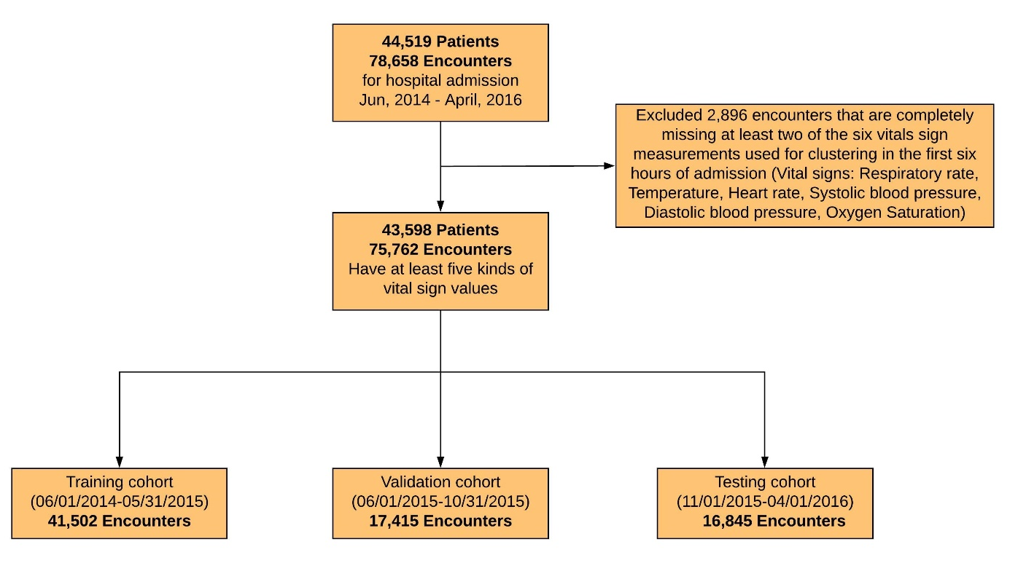

eFigure 2. Spearman correlation heat map for the training cohort (N=41,502)
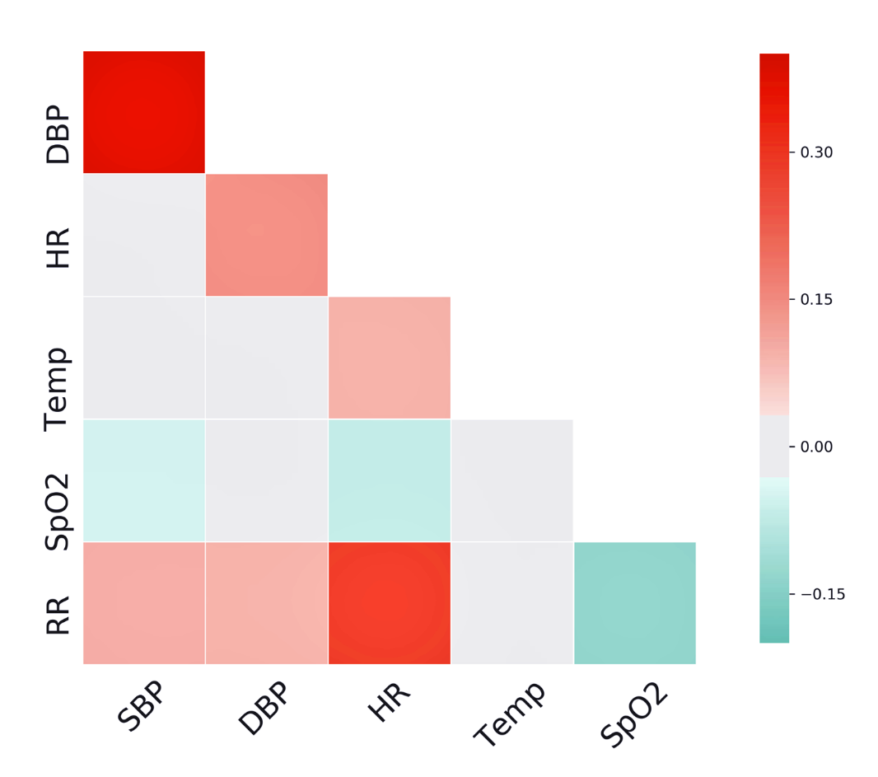
Spearman correlation heat map shows the pairwise spearman rank order correlation coefficient among the 6 vital signs studied in our paper. The darker red color, the higher correlation in positive direction.

Abbreviations: RR: respiratory rate; SpO2: peripheral capillary oxygen saturation; Temp: temperature; HR: heart rate; SBP: systolic blood pressure; DBP: diastolic blood pressure.

eFigure 3. Deep temporal interpolation and clustering network algorithm



eFigure 4. Gap statistic and elbow approaches showing the optimal number of clusters
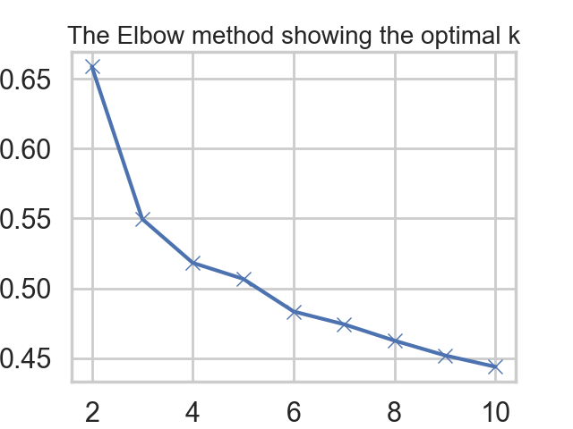
(A).

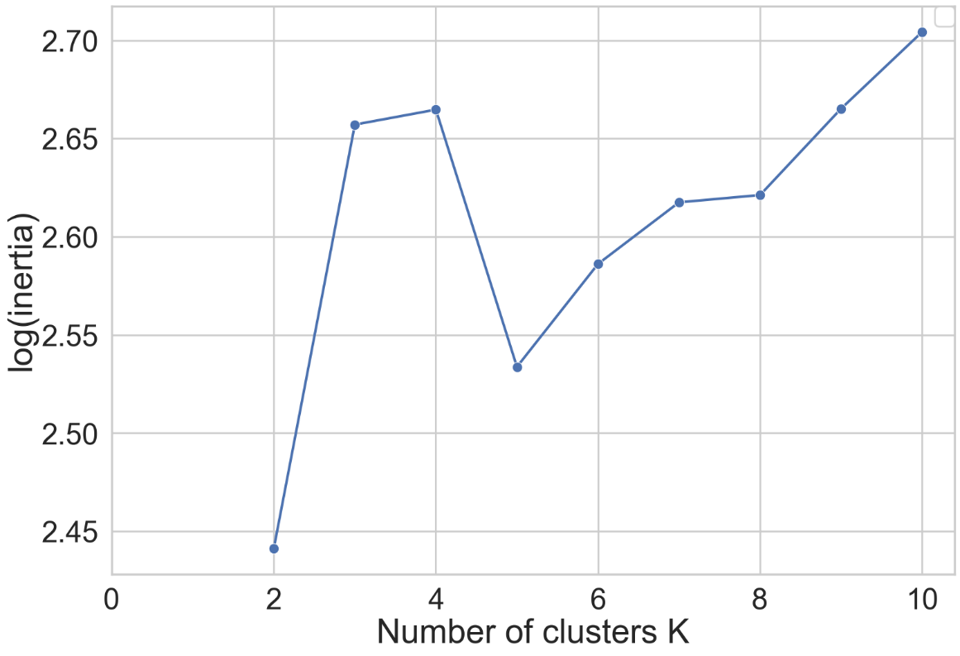
(B).

(A) Elbow approach shows the optimal number of clusters. The value of k at the “elbow”, the point after which the distortion starts decreasing in a linear fashion, suggests the optimal number of clusters. (B) Gap statistic approach shows the optimal number of clusters. Higher gap statistic value suggests the optimal number of clusters.

eFigure 5. Alluvial plot showing distribution of phenotypes across worst SOFA scores of patients within first 24 hours of admission in the training cohort
(A) Phenotype A (B) Phenotype B
(C) Phenotype C (D) Phenotype D

For each phenotype, the larger percentage of patients with that score, the broader the ribbon.

eFigure 6. Chord diagrams showing the distribution of patients with higher SOFA scores (i.e., 2+) within first 24 hours of admission of six organ systems by phenotypes in the training cohort
(i) All phenotypes
(ii) Phenotype A
(iii) Phenotype B
(iv) Phenotype C
(v) Phenotype D

For each phenotype, the larger percentage of patients with higher score of that organ system, the border the ribbon.

eFigure 7. Survival curves and Cox proportional hazards modeling by phenotypes in the training cohort
(A)
(C)
(D)
(B)

(A) Phenotype survival curves adjusted using demographic information and comorbidities. (B) Adjusted Cox proportional hazards models using demographic information and comorbidities. (C) Phenotype survival curves adjusted using demographic information, comorbidities, and SOFA scores. (D) Adjusted Cox proportional hazards model using demographic information, comorbidities, and SOFA scores. Abbreviation: CCI: Charlson comorbidity index; SOFA: sequential organ failure assessment.

eFigure 8. Survival curves and Cox proportional hazards modeling by sepsis patients in the training cohort
(A)
(C)

(D)
(B)

(A) Phenotype survival curves adjusted using demographic information and comorbidities. (B) Adjusted Cox proportional hazards models using demographic information and comorbidities. (C) Phenotype survival curves adjusted using demographic information, comorbidities, and SOFA scores. (D) Adjusted Cox proportional hazards model using demographic information, comorbidities, and SOFA scores. Abbreviation: CCI: Charlson comorbidity index; SOFA: sequential organ failure assessment.

eFigure 9. Survival curves and Cox proportional hazards modeling by AKI patients in training cohort
(A)
(C)
(D)
(B)

(A) Phenotype survival curves adjusted using demographic information and comorbidities. (B) Adjusted Cox proportional hazards models using demographic information and comorbidities. (C) Phenotype survival curves adjusted using demographic information, comorbidities, and SOFA scores. (D) Adjusted Cox proportional hazards model using demographic information, comorbidities, and SOFA scores. Abbreviation: CCI: Charlson comorbidity index; SOFA: sequential organ failure assessment.

eFigure 10. Survival curves and Cox proportional hazards modeling by surgical patients in training cohort
(A)
(C)
(D)
(B)

(A) Phenotype survival curves adjusted using demographic information and comorbidities. (B) Adjusted Cox proportional hazards models using demographic information and comorbidities. (C) Phenotype survival curves adjusted using demographic information, comorbidities, and SOFA scores. (D) Adjusted Cox proportional hazards model using demographic information, comorbidities, and SOFA scores. Abbreviation: CCI: Charlson comorbidity index; SOFA: sequential organ failure assessment.

eFigure 11. Distribution of vital signs during the first six hours of hospital admission in the testing cohort

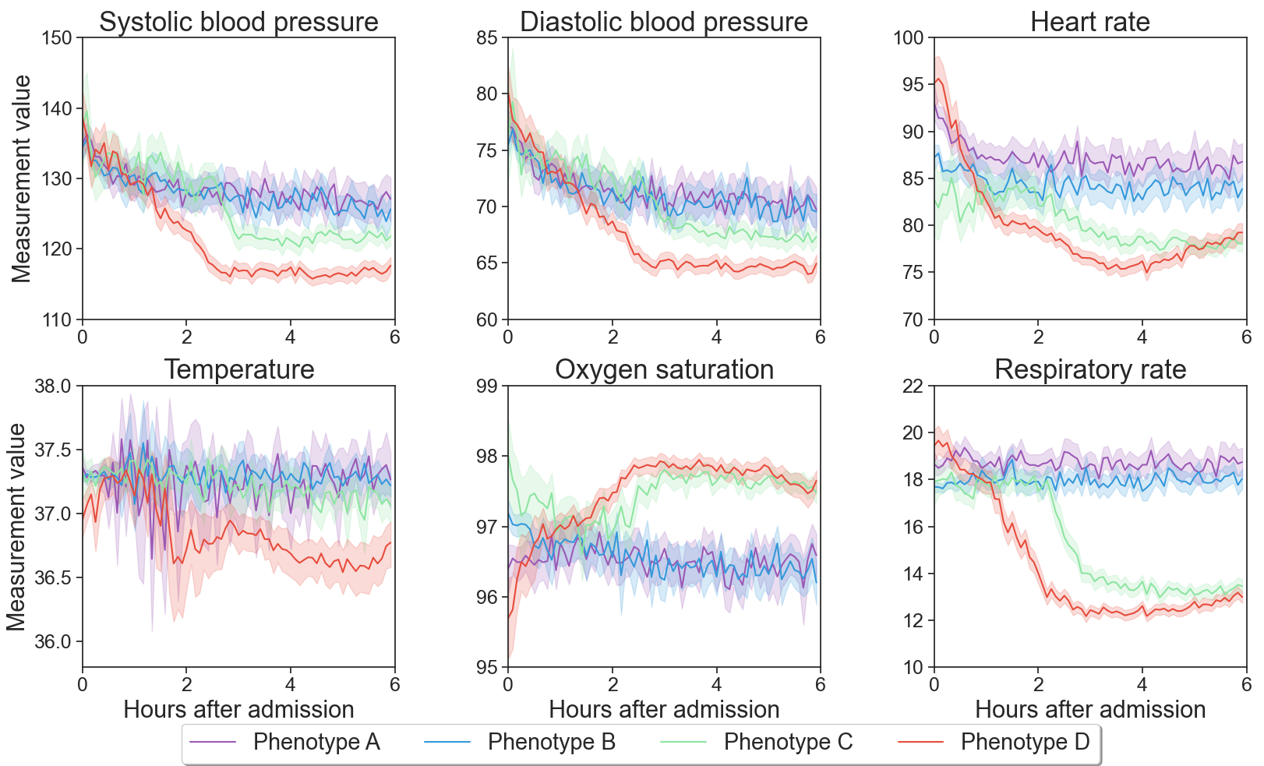

eFigure 12. t-SNE plot of phenotype assignments in the testing cohort
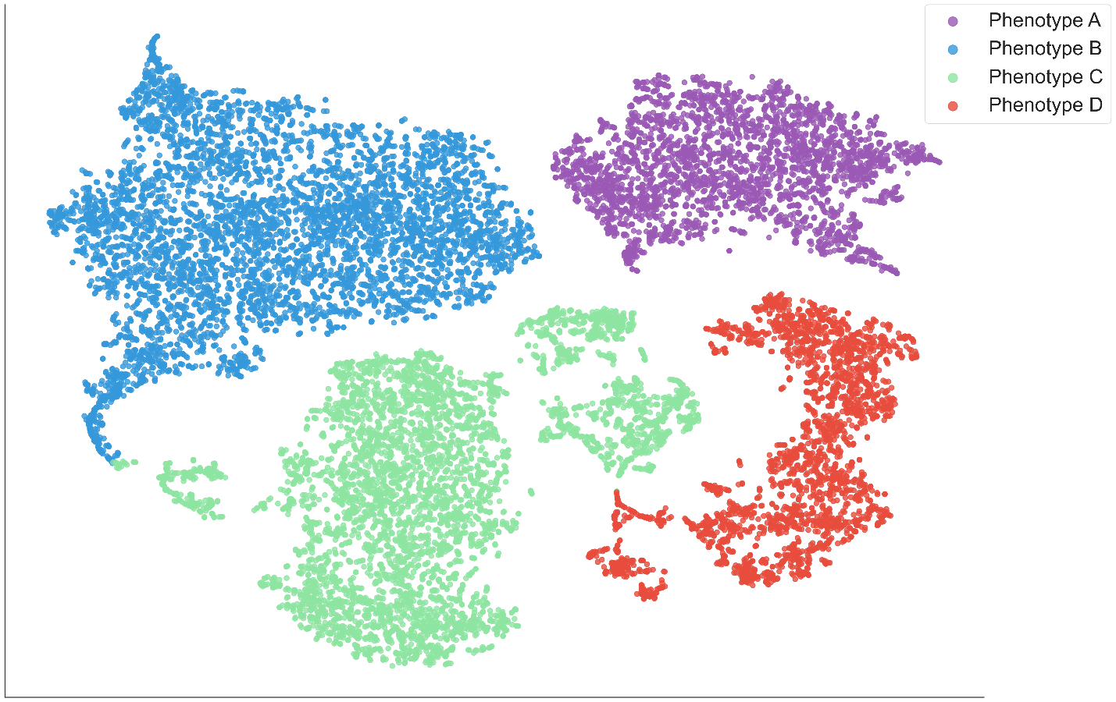
Starting from the original 128 dimensional vital sign representations, we run the t-SNE to reduce to 2 dimensions. Each dot represents a patient. Phenotypes are show in separate colors.

eFigure 13. Alluvial plot showing distribution of phenotypes across worst SOFA scores of patients within first 24 hours of admission in the testing cohort
(A) Phenotype A (B) Phenotype B
(C) Phenotype C (D) Phenotype D

For each phenotype, the larger percentage of patients with that score, the broader the ribbon.

eFigure 14. Chord diagrams showing the distribution of patients with higher SOFA scores (i.e., 2+) within first 24 hours of admission of six organ systems by phenotypes in the testing cohort
(i) All phenotypes

(iii) Phenotype B
(ii) Phenotype A

(v) Phenotype D
(iv) Phenotype C

For each phenotype, the larger percentage of patients with higher score of that organ system, the border the ribbon.

eFigure 15. Survival curves and Cox proportional hazards modeling by phenotypes in the testing cohort
(A)
(C)
(D)
(B)

(A) Phenotype survival curves adjusted using demographic information and comorbidities. (B) Adjusted Cox proportional hazards models using demographic information and comorbidities. (C) Phenotype survival curves adjusted using demographic information, comorbidities, and SOFA scores. (D) Adjusted Cox proportional hazards model using demographic information, comorbidities, and SOFA scores. Abbreviation: CCI: Charlson comorbidity index; SOFA: sequential organ failure assessment.

eFigure 16. Chord diagrams showing the distribution of nine most common admission diagnosis groups by phenotype in the training cohort
(i) All phenotypes
(ii) Phenotype A
(iii) Phenotype B
(iv) Phenotype C
(v) Phenotype D

Diagnosis groups are shown in order of frequencies of all patients. For each phenotype, the larger percentage of patients with that diagnosis, the border the ribbon. Detailed diagnosis groups from left to right are: Nonspecific chest pain, Abdominal pain, Other and unspecific lower respiratory disease, Complication of device; implant or graft, Septicemia (except in labor), Acute cerebrovascular disease, Cardiac dysrhythmias, Congestive heart failure; nonhypertensive, and Osteoarthritis.

eFigure 17. Chord diagrams showing the distribution of nine most common admission diagnosis groups by phenotype in the training cohort
(i) All phenotypes
(ii) Phenotype A
(iii) Phenotype B

(v) Phenotype D
(iv) Phenotype C

Diagnosis groups are shown in order of frequencies of all patients. For each phenotype, the larger percentage of patients with that diagnosis, the border the ribbon. Detailed diagnosis groups from left to right are: Nonspecific chest pain, Other and unspecific lower respiratory disease, Septicemia (except in labor), Abdominal pain, Complication of device; implant or graft, Acute cerebrovascular disease, Cardiac dysrhythmias, Osteoarthritis, and Other complications of pregnancy.

eFigure 18. Reconstruction error of physiologic signatures measured within six hours of hospital admission in training cohort using deep temporal interpolation and clustering network
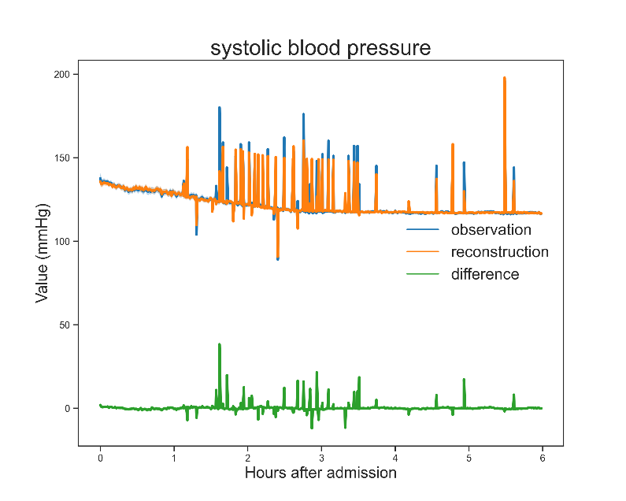
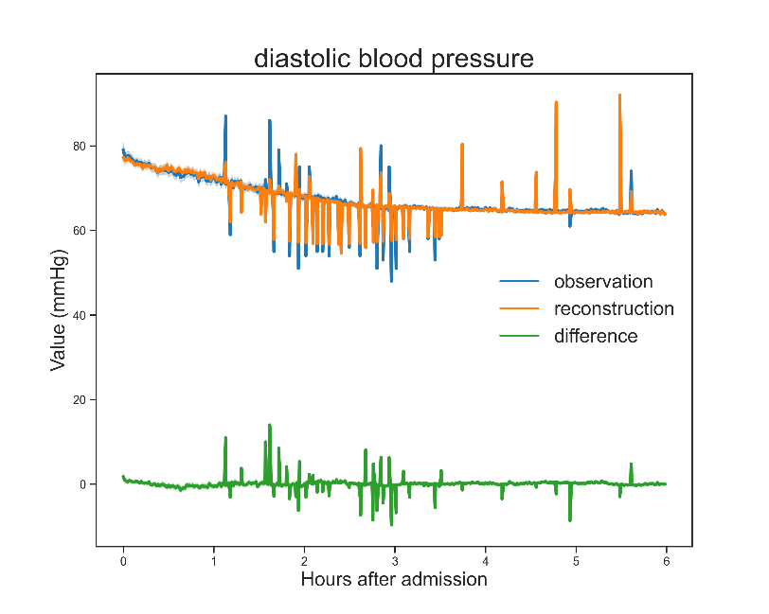
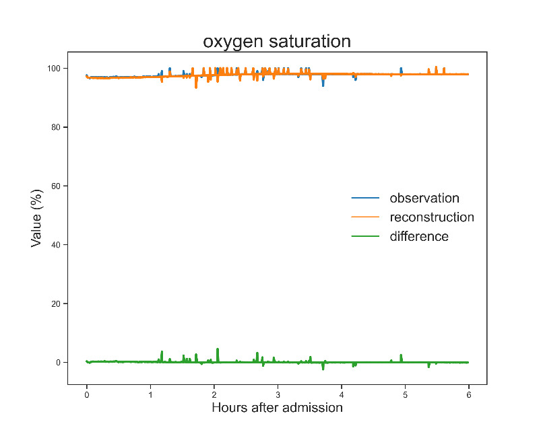
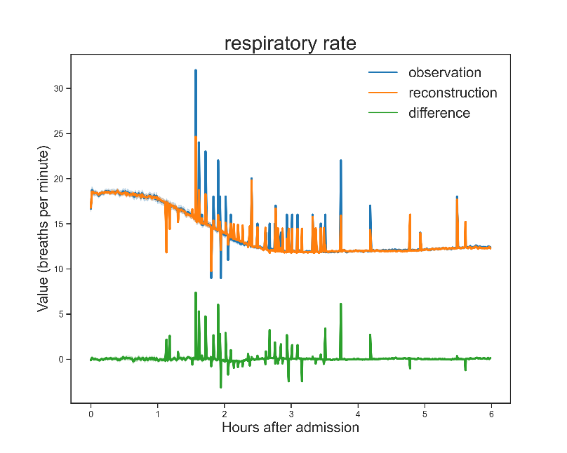
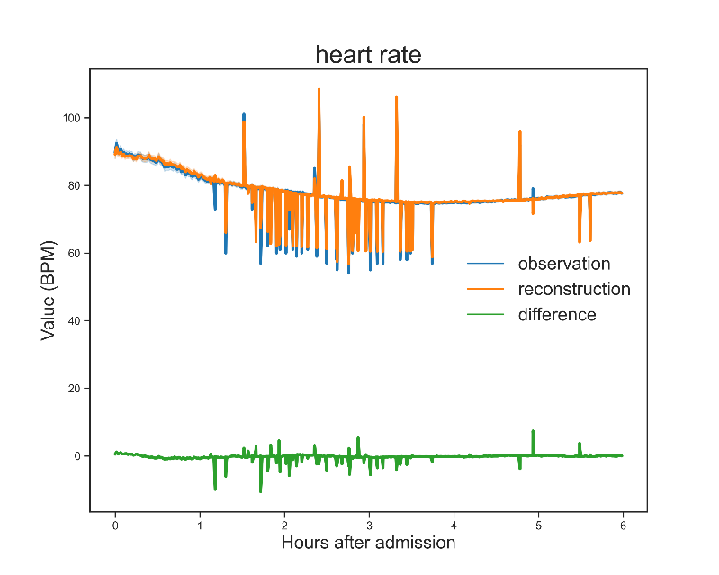
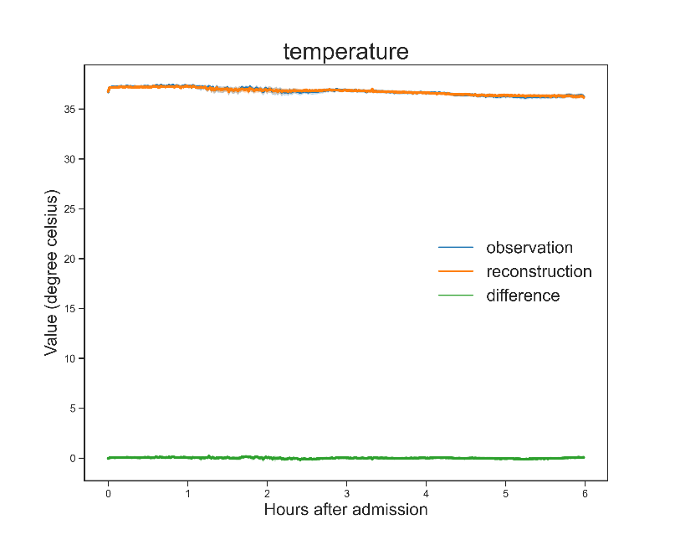

eFigure 19. Reconstruction error of physiologic signatures measured within six hours of hospital admission in testing cohort using deep temporal interpolation and clustering network
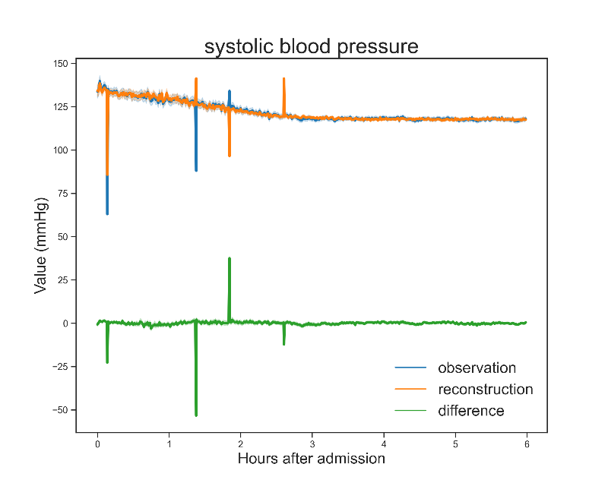
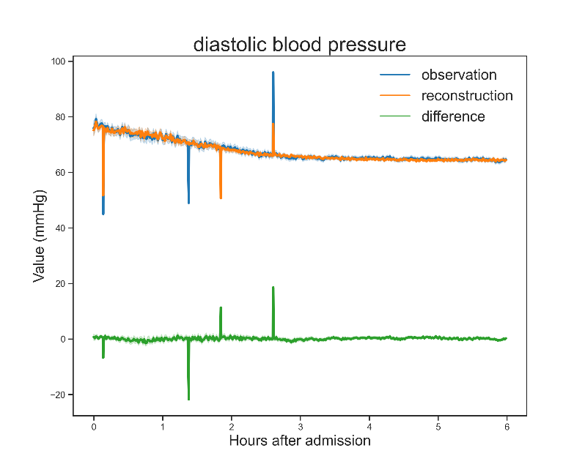
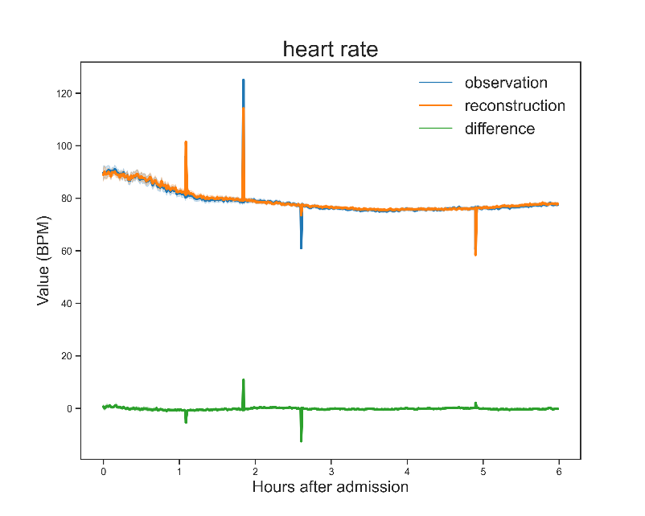
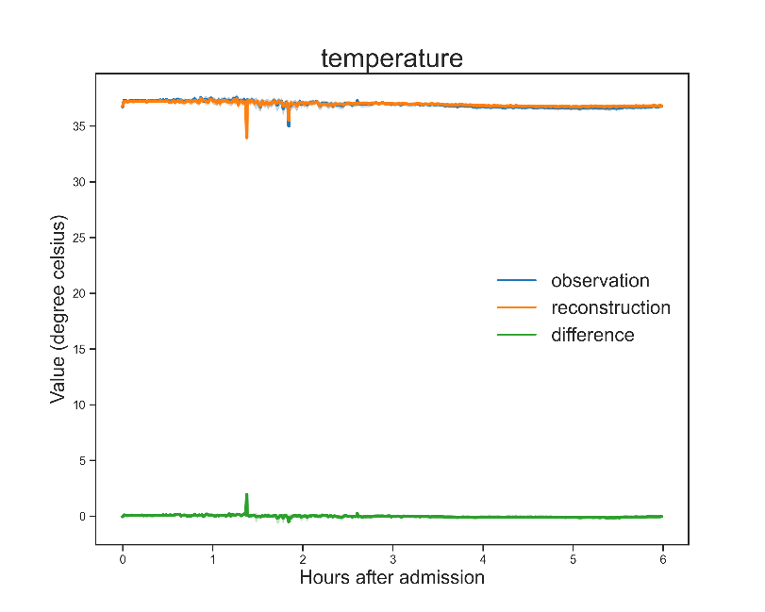
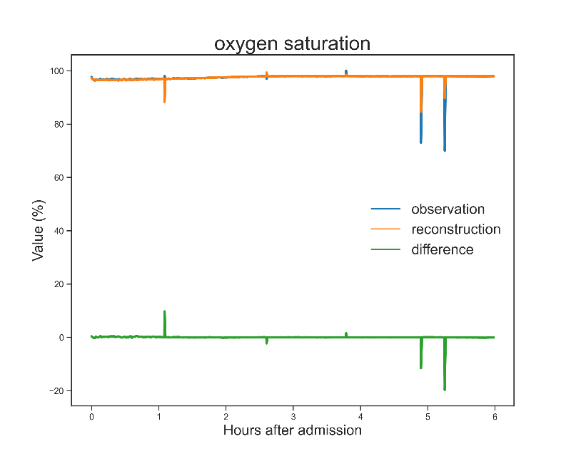
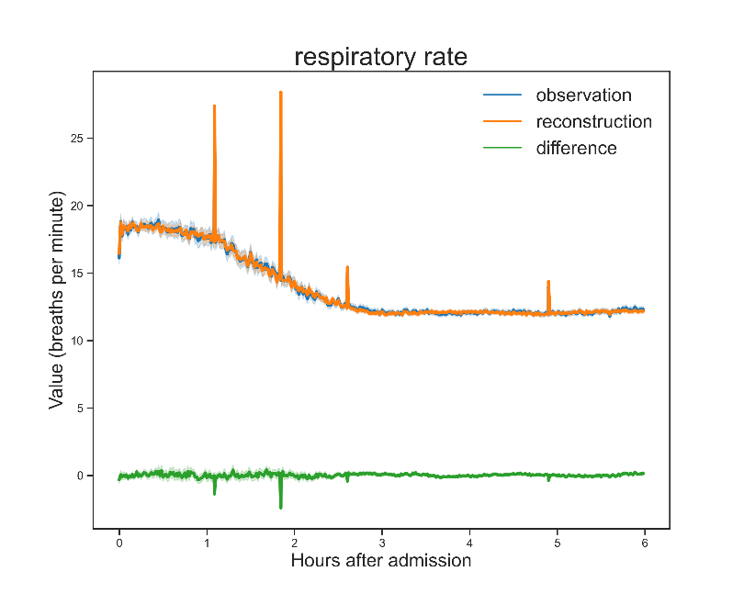

eTable 1. Processing of vital sign time series

Variables | Unit | Non-outlier range [min, max]ª | Frequency (per hour) | Missing any measurement (N = 75,762), n (%) | Values used to impute variable completely missing^{b} | Normal distribution
Systolic blood pressure | mmHg | (20, 300) | 2 | 0 (0) | 119.1 | Yes
Diastolic blood pressure | mmHg | (5, 225) | 2 | 0 (0) | 66.1 | Yes
Heart rate | beats per minute | (0, 300] | 2 | 9 (0) | 76.8 | Yes
Temperature | degree Celsius | (24, 45) | 1 | 10,713 (14) | 36.7 | No
Peripheral capillary oxygen saturation | % | (1, 100] | 2 | 3,744 (5) | 97.8 | No
Respiratory rate | breaths per minute | (0, 60] | 2 | 470 (1) | 12.7 | Yes

ª Derived from expert-defined ranges. Open brackets “)” indicate value is not included and closed brackets “]” indicate value is included in the interval.

^{b} For time series data missing entirely, including instances in which a variable was missing entirely from an admission, mean values of corresponding variables measured values in the training cohort were imputed.

eTable 2. Used LOINCS, range of values, direction of abnormal values for lab variables

Lab variables | LOINCS | LOINC Description | Plausible Rangeª | Direction of abnormal value | Missingness in all cohort (N = 75,762), n (%) | Missingness in training cohort (N = 41,502), n (%) | Missingness in validation cohort (N = 17,415), n (%) | Missingness in testing cohort (N = 16,845), n (%) | Normal distribution
Basic metabolic Panel (BMP) | 89044-2/24321-2 | Basic metabolic and albumin panel - Serum or Plasma/Basic metabolic 2000 panel - Serum or Plasma
Glucose | 2339-0, 2340-8,  2345-7, 41651-1*,  41652-9*, 41653-7*,  74774-1*, | Glucose in serum or plasma/blood | 25 - 1400 | Maximum, Minimum | 9,090 (12) | 4,783 (12) | 2,129 (12) | 2,178 (13) | No
Creatinine | 2160-0, 38483-4 | Creatinine in blood | 0 - 30 | Maximum | 10,045 (13) | 5,276 (13) | 2,353 (14) | 2,416 (14) | No
Bilirubin | 1975-2 | Bilirubin total in serum or plasma | 0 - 50 | Maximum | 38,086 (50) | 20,319 (49) | 8,853 (51) | 8,914 (53) | No
Albumin | 1751-7, 2862-1,  61151-7 | Albumin in serum or plasma | 0.6 - 6.0 | Minimum | 37,735 (50) | 20,134 (49) | 8,779 (50) | 8,822 (52) | Yes
Anion Gap | 33037-3, 10366-1 | Anion gap in Serum or Plasma | 1 - 40 | Maximum | 14,876 (20) | 9,531 (23) | 2,645 (15) | 2,700 (16) | Yes
CBC Panel | 57021-8 | CBC W Auto Differential panel - Blood
White Blood Cell Count | 26464-8, 6690-2 | Leukocytes [#/volume] in Blood | 0.1 - 240 | Maximum,  Minimum | 7,118 (9) | 3,676 (9) | 1,665 (10) | 1,777 (11) | No
Hemoglobin | 718-7,  14775-1*, 30313-1*,  30352-9*, | Hemoglobin [Mass/volume] in Blood | 3 - 23 | Minimum | 6,108 (8) | 3,112 (7) | 1,443 (8) | 1,553 (9) | Yes
Platelets | 26515-7,  777-3, 49497-1* | Platelets [#/volume] in Blood | 2 - 1900 | Minimum | 7,143 (9) | 3,684 (9) | 1,671 (10) | 1,788 (11) | Yes
Bands % | 26508-2,  ,35332-6,  764-1* | Band form neutrophils/100 leukocytes in blood | 0.9 - 90 | Maximum | 72,187 (95) | 39,455 (95) | 16,625 (95) | 16,107 (96) | Yes
Lymphocytes % | 736-9, 737-7 | Lymphocytes/100 leukocytes in blood | 0 - 100 | Maximum,  Minimum | 22,653 (30) | 12,079 (29) | 5,275 (30) | 5,299 (31) | Yes
Gas Panel
Gas Panel-Arterial blood | 24336-0
PH | 2744-1 | pH of arterial blood | 5 - 8 | Maximum,  Minimum | 64,519 (85) | 35,387 (85) | 14,894 (86) | 14,238 (85) | No
PO2 | 2703-7 | Oxygen [Partial pressure] in arterial blood | 0 - 800 | Minimum | 64,519 (85) | 35,386 (85) | 14,894 (86) | 14,239 (85) | No
Base deficit | 1922-4 | Base deficit in Arterial blood | 0 - 30 | Maximum | 69,565 (92) | 38,135 (92) | 15,986 (92) | 15,444 (92) | No
RDW | 788-0, 21000-5 | Erythrocyte distribution width [Ratio] | 2 - 40 | Maximum,  Minimum | 7,113 (9) | 3,672 (9) | 1,664 (10) | 1,777 (11) | Yes
Others
C-Reactive Protein (all sensitivity levels) | 30522-7, 1988-5 | C reactive protein in serum or plasma | 0 - 280 | Maximum | 65,389 (86) | 35,640 (86) | 15,159 (87) | 14,590 (87) | Yes
Lactate | 2518-9, 2524-7,  32693-4, 14118-4,  30242-2 | Lactate in blood | 0.3 - 28 | Maximum | 47,936 (63) | 26,055 (63) | 11,178 (64) | 10,703 (64) | No
ESR | 4537-7, 30341-2,  18184-2, 43402-7,  4538-5, 4539-3,  82477-1 | Erythrocyte sedimentation rate | 1 - 140 | Maximum | 69,214 (91) | 37,599 (91) | 16,033 (92) | 15,582 (93) | Yes
INR | 34714-6, 6301-6 | International normalized ratio | 0.8 - 18 | Maximum | 40,755 (54) | 21,145 (51) | 9,835 (56) | 9,775 (58) | No
Troponin (TnT, TnI) | 6598-7, 48425-3, 6597-9, 67151-1,10839-9, 42757-5,  49563-0 | Troponin T.cardiac in blood and Troponin I.cardiac in blood | 0 - 49 | Maximum | 49,379 (65) | 26,886 (65) | 11,553 (66) | 10,940 (65) | No

ª Values out of the range values were removed.
Abbreviations: BUN: blood urea nitrogen; CO2: carbon dioxide; AST: aspartate transaminase; ALT: alanine transaminase; PO2: partial pressure of oxygen; RDW: red cell distribution width; ESR: erythrocyte sedimentation rate; INR: international normalized ratio.
*Included LOINCs that have same description from other panels.

eTable 3. Clinic characteristics and biomarkers of the cohorts

Variables | Overall cohort | Training cohort | Validation Cohort | Testing Cohort
Number of encounters (%) | 75,762 | 41,502 (55) | 17,415 (23) | 16,845 (22)
Preadmission clinical characteristics
Age, mean (SD) | 54 (19) | 54 (19) | 54 (19)ª | 55 (19)^{a,b}
Female sex, n (%) | 41,449 (55) | 22,745 (55) | 9,499 (55) | 9,205 (55)
Race, n (%)
White | 53,101 (70) | 29,076 (70) | 12,171 (70) | 11,854 (70)
African American | 17,432 (23) | 9,634 (23) | 3,953 (23) | 3,845 (23)
Primary insurance, n (%)
Private | 17,641 (23) | 9,591 (23) | 4,115 (24) | 3,935 (23)
Medicare | 33,969 (45) | 18,499 (45) | 7,625 (44) | 7,845 (47)^{a,b}
Medicaid | 16,742 (22) | 9,231 (22) | 3,919 (23) | 3,592 (21)^{a,b}
Uninsured | 7,410 (10) | 4,181 (10) | 1,756 (10) | 1,473 (9)^{a,b}
Residency area characteristics
Total proportion of African American (%), mean (SD) | 18.8 (17.5) | 18.7 (17.5) | 18.9 (17.5) | 18.7 (17.4)
Proportion below poverty (%), mean (SD) | 22.6 (10.1) | 22.7 (10.1) | 22.7 (10.3) | 22.5 (10.2)ª
Distance from hospital (mile), median (IQR) | 18 (3, 34) | 18 (3, 34) | 18 (3, 34) | 18 (3, 34)
Comorbidities
Hypertension, n (%) | 38,985 (51) | 21,639 (52) | 8,878 (51)ª | 8,468 (50)ª
Cardiovascular disease, n (%)^{c} | 21,743 (29) | 12,058 (29) | 4,983 (29) | 4,702 (28)ª
Diabetes mellitus, n (%) | 18,127 (24) | 10,111 (24) | 4,071 (23)ª | 3,945 (23)ª
Chronic kidney disease, n (%) | 12,357 (16) | 6,518 (16) | 2,947 (17)ª | 2,892 (17)ª
Admission characteristics of patients
Emergent admission, n (%) | 55,008 (73) | 30,177 (73) | 12,542 (72) | 12,289 (73)
Transfer from another hospital, n (%) | 13,569 (18) | 7,115 (17) | 3,595 (21)ª | 2,859 (17)^{b}
Primary admission diagnostic groups
Diseases of the circulatory system, n (%) | 13,670 (18) | 7,719 (19) | 2,968 (17)ª | 2,983 (18)ª
Respiratory and infectious diseases, n (%) | 6,016 (8) | 3,306 (8) | 1,185 (7)ª | 1,525 (9)^{a,b}
Complications of pregnancy and childbirth, n (%) | 5,760 (8) | 3,148 (8) | 1,366 (8) | 1,246 (7)
Diseases of the digestive/genitourinary systems, n (%) | 9,532 (13) | 5,184 (12) | 2,201 (13) | 2,147 (13)
Diseases of the musculoskeletal/connective tissue and skin, n (%) | 6,591 (9) | 3,651 (9) | 1,522 (9) | 1,418 (8)
Neoplasms, n (%) | 4,953 (7) | 2,743 (7) | 1,136 (7) | 1,074 (6)
Clinical biomarkers and interventions within 24 hours of admission
Surgery on admission day, n (%) | 15,996 (21) | 8,644 (21) | 3,801 (22)ª | 3,551 (21)
ICU/IMC admission within first 24 hours, n (%) | 17,163 (23) | 9,426 (23) | 3,899 (22) | 3,838 (23)
Cardiovascular system
Hypotension (MAP < 60 mmHg) at any time, n (%) | 26,400 (35) | 14,470 (35) | 6,014 (35) | 5,916 (35)
Duration, median (IQR), minutes | 57 (15, 165) | 57 (15, 168) | 53 (14, 157) | 60 (15, 167)^{b}
Vasopressors used, n (%) | 13,991 (18) | 7,531 (18) | 3,294 (19) | 3,166 (19)
Out of operating room | 2,596 (3) | 1,403 (3) | 625 (4) | 568 (3)
Hypertension (SBP > 160 mmHg) at any time, n (%) | 2,7267 (36) | 14,838 (36) | 6,222 (36) | 6,207 (37)ª
Duration, median (IQR), minutes | 120 (26, 358) | 120 (27, 356) | 120 (25, 373) | 120 (26, 352)
Troponin, tested, n (%) | 26,383 (35) | 14,616 (35) | 5,862 (34)ª | 5,905 (35)^{b}
Abnormal result among tested, n (%) | 5,842 (22) | 3,398 (23) | 1,239 (21)ª | 1,205 (20)ª
Respiratory system
Highest administered FiO2, median (IQR) | 0.21 (0.21, 0.40) | 0.21 (0.21, 0.40) | 0.21 (0.21, 0.40) | 0.21 (0.21, 0.40)
Room air only, n (%) | 43,887 (58) | 23,963 (58) | 10,242 (59)ª | 9,682 (57)^{b}
0.22 - 0.40, n (%) | 26,997 (36) | 14,790 (36) | 6,125 (35) | 6,082 (36)
> 0.4, n (%) | 4,878 (6) | 2,749 (7) | 1,048 (6)ª | 1,081 (6)
PaO2/FiO2, tested with arterial blood gas, n (%) | 11,235 (15) | 6,113 (15) | 2,519 (14) | 2,603 (15)^{b}
<200 among tested, n (%) | 4,137 (37) | 2,265 (37) | 908 (36) | 964 (37)
Mechanical ventilation, n (%) | 3,924 (5) | 2,123 (5) | 883 (5) | 918 (5)
Kidney and acid-base status
Preadmission estimated glomerular filtration rate^{d} (mL/min per 1.73 m2), median (IQR) | 95 (77, 111) | 95 (78, 111) | 95 (76, 111) | 94 (76, 110)ª
Highest / reference creatinine^{d}, mean (SD) | 1.24 (0.75) | 1.24 (0.66) | 1.24 (0.74)ª | 1.23 (0.95)ª
Renal replacement therapy, n (%) | 1,166 (1.5) | 641 (1.5) | 257 (1.5) | 268 (1.6)
Highest anion gap, median (IQR), mmol/L | 14 (12, 17) | 14 (12, 17) | 14 (13, 17)ª | 14 (12, 17)^{a,b}
Arterial blood gas tested, n (%) | 11,242 (15) | 6,115 (15) | 2,521 (14) | 2,606 (15)^{b}
pH < 7.3 among tested, n (%) | 2,580 (23) | 1,437 (23) | 557 (22) | 586 (22)
Highest base deficit, mean (SD), mmol/L | 4.8 (4.7) | 4.8 (4.7) | 4.9 (4.6) | 4.6 (4.8)^{a,b}
Lactate, tested, n (%) | 27,826 (37) | 15,447 (37) | 6,237 (36)ª | 6,142 (36)
2 - 4 mmol/L among tested, n (%) | 6,717 (24) | 3,739 (24) | 1,498 (24) | 1,480 (24)
> 4 mmol/L among tested, n (%) | 2,532 (9) | 1,374 (9) | 578 (9) | 580 (9)
Inflammation
Highest white blood cell count, median (IQR), x10^9/L | 9 (7, 13) | 9 (7, 13) | 9 (7, 13)ª | 9 (7, 12)ª
Highest premature neutrophils (bands)), median (IQR), % | 10 (4, 20) | 10 (4, 20) | 9 (3, 19) | 9 (4, 18)
Lowest lymphocytes, median (IQR), % | 16 (9, 24) | 16 (9, 24) | 16 (9, 24) | 16 (9, 24)
C-reactive protein, tested, n (%) | 10373 (14) | 5862 (14) | 2256 (13)ª | 2255 (13)
Highest C-reactive protein, median (IQR), mg/L | 18 (5, 81) | 18 (5, 77) | 17 (4, 80) | 28 (5, 93)^{a,b}
Erythrocyte sedimentation rate, tested, n (%) | 6548 (9) | 3903 (9) | 1382 (8)ª | 1263 (7)ª
Highest erythrocyte sedimentation rate, median (IQR), mm/h | 40 (19, 74) | 40 (19, 73) | 42 (19, 77) | 41 (20, 73)
Highest temperature, mean (SD), Celsius | 37.7 (0.6) | 37.7 (0.6) | 37.7 (0.6) | 37.7 (0.6)^{a,b}
38 - 39, n (%) | 15,774 (21) | 8,633 (21) | 3,563 (20) | 3,578 (21)
> 39, n (%) | 2,779 (4) | 1,548 (4) | 604 (3) | 627 (4)
Lowest temperature, mean (SD), Celsius | 36.7 (0.9) | 36.7 (1.0) | 36.7 (0.9)ª | 36.8 (0.9)^{a,b}
Hematologic
Lowest hemoglobin, mean (SD), g/dL | 11.4 (2.3) | 11.5 (2.3) | 11.4 (2.3)ª | 11.2 (2.3)^{a,b}
Highest RDW, mean (SD), % | 15.4 (2.1) | 15.5 (2.1) | 15.2 (2.1)ª | 15.3 (2.1)^{a,b}
Lowest platelets, median (IQR), x10^9/L | 208 (160, 266) | 210 (161, 269) | 204 (157, 260)ª | 207 (160, 266)^{a,b}
Platelets < 200, n (%) | 31,078 (41) | 16,707 (40) | 7,489 (43)ª | 6,882 (41)ª
< 100 | 4,779 (15) | 2,643 (16) | 1,128 (15) | 1,008 (15)
100 - 200 | 26,299 (85) | 14,064 (84) | 6,361 (85) | 5,874 (85)
International normalized ratio, tested, n (%) | 35,007 (46) | 20,357 (49) | 7,580 (44)ª | 7,070 (42)^{a,b}
>= 2 | 3,291 (9) | 1,836 (9) | 757 (10)ª | 698 (10)
Neurologic
Glasgow Coma Scale score, n (%)
Moderate (9 - 12) | 3,125 (4) | 1,708 (4) | 687 (4) | 730 (4)
Severe (<= 8) | 2,662 (4) | 1,482 (4) | 587 (3) | 593 (4)
Liver and metabolic
Bilirubin, tested, n (%) | 37,676 (50) | 21,183 (51) | 8,562 (49)ª | 7931 (47)^{a,b}
>= 2 mg/dL, n (%) | 2,530 (7) | 1,427 (7) | 607 (7) | 496 (6)
Highest glucose, median (IQR), mg/dL | 127 (104, 170) | 126 (104, 170) | 126 (104, 169) | 128 (104, 172)^{a,b}
Albumin, tested, n (%) | 38,027 (50) | 21,368 (51) | 8,636 (50)ª | 8,023 (48)^{a,b}
< 2.5 | 2,159 (6) | 1,243 (6) | 471 (5) | 445 (6)
2.5 - 3.5 | 12,118 (32) | 6,904 (32) | 2,665 (31)ª | 2,549 (32)

Abbreviation: ICU: intensive care unit; IMC: intermediate care unit; MAP: mean arterial pressure; SBP: systolic blood pressure; RDW: red cell distribution width; SD: standard deviation; IQR: interquartile range.
All p values were adjusted for multiple comparisons using the Bonferroni method.
ª p < 0.05 compared to training cohort.
^{b} p < 0.05 compared to validation cohort.
^{c} Cardiovascular disease was considered if there was a history of congestive heart failure, coronary artery disease, or peripheral vascular disease.
^{d} Reference glomerular filtration rate and reference creatinine were derived without use of race correction (see eMethods for details).

eTable 4. Illness severity, clinical outcomes, and resource use of the cohorts

Variables | Overall cohort | Training cohort | Validation Cohort | Testing Cohort
Number of encounters (%) | 75,762 | 41,502 (55) | 17,415 (23) | 16,845 (22)
Acuity scores within 24h of admission
SOFA score > 6, n (%) | 6,463 (9) | 3,506 (8) | 1,503 (9) | 1,454 (9)
Patients in ICU/IMC, SOFA score <= 6, n (%) | 12,477 (16) | 6,882 (17) | 2,795 (16) | 2,800 (17)
Patients in ICU/IMC, SOFA score > 6, n (%) | 4,686 (6) | 2,544 (6) | 1,104 (6) | 1,038 (6)
Patients in ward, SOFA score <= 6, n (%) | 56,822 (75) | 31,114 (75) | 13,117 (75) | 12,591 (75)
Patients in ward, SOFA score > 6, n (%) | 1,777 (2) | 962 (2) | 399 (2) | 416 (2)
MEWS score > 4, n (%) | 5,033 (7) | 2,828 (7) | 1,115 (6) | 1,090 (6)
Patients in ICU/IMC, MEWS score <= 4, n (%) | 13,316 (18) | 7,235 (17) | 3,041 (17) | 3,040 (18)
Patients in ICU/IMC, MEWS score > 4, n (%) | 3,847 (5.1) | 2,191 (5.3) | 858 (4.9) | 798 (4.7)ª
Patients in ward, MEWS score <= 4, n (%) | 57,413 (76) | 31,439 (76) | 13,259 (76) | 12,715 (75)
Patients in ward, MEWS score > 4, n (%) | 1,186 (2) | 637 (2) | 257 (1) | 292 (2)
Resource use during hospitalization
Hospital days, median (IQR) | 4 (2, 7) | 4 (2, 7) | 4 (2, 7) | 4 (2, 7)
Surgery at any time, n (%) | 21,436 (28) | 11,634 (28) | 5,084 (29)ª | 4,718 (28)^{b}
Admitted to ICU/IMC^{c}, n (%) | 20,380 (27) | 11,121 (27) | 4,643 (27) | 4,616 (27)
Days in ICU/IMC^{d}, median (IQR) | 4 (2, 7) | 4 (2, 7) | 4 (2, 7) | 4 (2, 7)^{a,b}
Days in ICU/IMC greater than 48 hrs, n (%) | 15,201 (75) | 8,332 (75) | 3,468 (75) | 3,401 (74)
Mechanical ventilation, n (%) | 5,970 (8) | 3,218 (8) | 1,403 (8) | 1,349 (8)
Mechanical ventilation hours, median (IQR)^{e} | 32 (12, 108) | 35 (14, 113) | 31 (11, 105)ª | 28 (10, 92)ª
Mechanical ventilation greater than 2 calendar days, n (%) | 2,993 (50) | 1,661 (52) | 699 (50) | 633 (47)ª
Renal replacement therapy, n (%) | 2,316 (3) | 1,262 (3) | 524 (3) | 530 (3)
Complications
Acute kidney injury overall, n (%) | 12,547 (17) | 6,905 (17) | 2,901 (17) | 2,741 (16)
Community-acquired AKI, n (%) | 7,007 (56) | 3,839 (56) | 1,603 (55) | 1,565 (57)
Hospital-acquired AKI, n (%) | 5,540 (44) | 3,066 (44) | 1,298 (45) | 1,176 (43)
Worst AKI staging, n (%)
Stage 1 | 8,036 (64) | 4,360 (63) | 1,878 (65) | 1,798 (66)
Stage 2 | 2,407 (19) | 1,362 (20) | 533 (18) | 512 (19)
Stage 3 | 1,496 (12) | 848 (12) | 348 (12) | 300 (11)
Stage 3 with RRT | 608 (5) | 335 (5) | 142 (5) | 131 (5)
Venous thromboembolism, n (%) | 2,902 (4) | 1,257 (3) | 708 (4)ª | 937 (6)^{a,b}
Sepsis, n (%) | 7,322 (10) | 3,750 (9) | 1,659 (10) | 1,913 (11)^{a,b}
Hospital disposition, n (%)
Hospital mortality | 2,134 (2.8) | 1,141 (2.7) | 480 (2.8) | 513 (3.0)
Another hospital, LTAC, SNF, Hospice | 8,423 (11.1) | 4,475 (10.8) | 2,002 (11.5)ª | 1,946 (11.6)ª
Home or short-term rehabilitation | 65,205 (86.1) | 35,886 (86.5) | 14,933 (85.7) | 14,386 (85.4)ª
30-day mortality, n (%) | 2,984 (4) | 1,633 (4) | 646 (4) | 705 (4)
Three-year mortality, n (%) | 14,634 (19) | 8,013 (19) | 3,297 (19) | 3,324 (20)

Abbreviation: SOFA: sequential organ failure assessment; MEWS: modified early warning score; ICU: intensive care unit; IMC: intermediate care unit; SD: standard deviation; IQR: interquartile range.
All p-values were adjusted for multiple comparisons using the Bonferroni method.
ª p < 0.05 compared to training cohort.
^{b} p < 0.05 compared to validation cohort.
^{c} At any time during hospitalization.
^{d} Values were calculated among patients admitted to ICU/IMC.
^{e} Values were calculated among patients requiring MV.

eTable 5. Statistic output from the deep interpolation network modeling in the training cohort.

 | Statics |  | Class size (N = 41,502), n (%)
Class number | Sihouetteª | Davies-Bouldin Index^{b} | 1 | 2 | 3 | 4 | 5 | 6 | 7 | 8 | 9 | 10
2 | 0.60 | 0.77 | 34,750 (84) | 6,752 (16) | . | . | . | . | . | . | . | .
3 | 0.33 | 1.04 | 6,110 (15) | 17,450 (42) | 17,942 (43) | . | . | . | . | . | . | .
4 | 0.30 | 1.27 | 14,356 (35) | 4,238 (10) | 5,078 (12) | 17,830 (43) | . | . | . | . | . | .
5 | 0.30 | 1.24 | 5,016 (12) | 17,401 (42) | 4,844 (12) | 13,886 (33) | 355 (0.9) | . | . | . | . | .
6 | 0.24 | 1.42 | 14,307 (34) | 3,985 (10) | 2,631 (6) | 8,261 (20) | 11,965 (29) | 353  (0.9) | . | . | . | .
7 | 0.23 | 1.42 | 8,496 (20) | 3,030 (7) | 11,834 (29) | 1,956 (5) | 14,019 (34) | 354 (0.9) | 1,813 (4) | . | . | .
8 | 0.24 | 1.453 | 11,824 (28) | 1,229 (3) | 13,990 (34) | 2,841 (7) | 8,477 (20) | 345 (0.8) | 1,068 (3) | 1,728 (4) | . | .
9 | 0.19 | 1.60 | 10,106 (24) | 1,227 (3) | 10,218 (25) | 9,701 (23) | 344 (0.8) | 2,769 (7) | 1,038 (3) | 1,589 (4) | 4,510 (11) | .
10 | 0.18 | 1.63 | 2,746 (7) | 6,096 (15) | 10,041 (24) | 1,582 (4) | 1,221 (3) | 5,690 (14) | 9,298 (22) | 344 (0.8) | 999 (2) | 3,485 (8)

ª Higher Silhouette score indicates better clustering.
^{b} Lower Davies-Bouldin Index score indicates better clustering.

eTable 6. Phenotype clinical characteristics and biomarkers in the training cohort

Variables | Total | Acute Illness Phenotypes
Variables | Total | Phenotype A | Phenotype B | Phenotype C | Phenotype D
Number of encounters (%) | 41,502 | 7,647 (18) | 13,710 (33) | 12,901 (31) | 7,244 (17)
Preadmission clinical characteristics
Age, mean (SD), years | 54 (19) | 57 (19)^{a,c} | 53 (19)^{a,b} | 51 (19) | 57 (17)ª
Female sex, n (%) | 22,745 (55) | 3,963 (52)^{a,c} | 7,595 (55)^{a,b} | 7,391 (57) | 3,796 (52)ª
Race, n (%)
White | 29,076 (70) | 5,203 (68)^{a,b} | 9,421 (69)^{b} | 9,021 (70) | 5,431 (75)ª
African American | 9,634 (23) | 2,036 (27)^{a,b,c} | 3,411 (25)^{a,b} | 2,930 (23) | 1,257 (17)ª
Primary insurance, n (%)
Private | 9,591 (23) | 1,323 (17)^{a,b,c} | 2,917 (21)^{a,b} | 3,314 (26) | 2,037 (28)ª
Medicare | 18,499 (45) | 3,839 (50)^{a,b,c} | 6,120 (45)^{a,b} | 5,158 (40) | 3,382 (47)ª
Medicaid | 9,231 (22) | 1,641 (21)^{a,b,c} | 3,213 (23)^{b} | 3,104 (24) | 1,273 (18)ª
Uninsured | 4,181 (10) | 844 (11)^{b} | 1,460 (11)^{b} | 1,325 (10) | 552 (8)ª
Residing neighborhood characteristics
Proportion of African Americans (%), mean (SD) | 18.7 (17.5) | 19.6 (17.8)^{a,b} | 19.3 (17.8)^{a,b} | 18.6 (17.5) | 17.2 (16.1)ª
Proportion below poverty (%), mean (SD) | 22.7 (10.1) | 23.8 (10.1)^{a,b,c} | 23.1 (10.1)^{a,b} | 22.5 (10.0) | 21.2 (9.8)ª
Distance from hospital (mile), median (IQR) | 18 (3, 34) | 14 (3, 27)^{a,b,c} | 14 (3, 32)^{a,b} | 18 (3, 36) | 23 (9, 40)ª
Comorbidities
Hypertension, n (%) | 21,639 (52) | 4,129 (54)^{a,b} | 7,205 (53)^{b} | 6,704 (52) | 3,601 (50)ª
Cardiovascular disease, n (%)^{b} | 12,058 (29) | 2,413 (32)^{a,b,c} | 3,991 (29)^{b} | 3,682 (29) | 1,972 (27)
Diabetes mellitus, n (%) | 10,111 (24) | 1,972 (26)^{a,b} | 3,370 (25) | 3,100 (24) | 1,669 (23)
Chronic kidney disease, n (%) | 6,518 (16) | 1,450 (19)^{a,b} | 2,467 (18)^{a,b} | 1,802 (14) | 799 (11)ª
Admission characteristics of patients
Emergent admission, n (%) | 30,177 (73) | 7,257 (95)^{a,b,c} | 11,764 (86)^{a,b} | 8,064 (63) | 3,092 (43)ª
Transfer from another hospital, n (%) | 7,115 (17) | 1,986 (26)^{a,b,c} | 3,014 (22)^{a,b} | 1,087 (8) | 1,028 (14)ª
Primary admission diagnostic groups
Diseases of the circulatory system | 7,719 (19) | 1,934 (25)^{a,b,c} | 2,425 (18)^{a,b} | 1,834 (14) | 1,526 (21)ª
Respiratory and infectious diseases | 3,306 (8) | 961 (13)^{a,b,c} | 1,161 (8)^{a,b} | 705 (5) | 479 (7)ª
Complications of pregnancy and childbirth | 3,148 (8) | 391 (5)^{a,c} | 1,147 (8)^{a,b} | 1,248 (10) | 362 (5)ª
Diseases of the digestive/genitourinary systems | 5,184 (12) | 789 (10)^{a,c} | 1686 (12)ª | 1,876 (15) | 833 (11)ª
Diseases of the musculoskeletal/connective tissue and skin | 3,651 (9) | 317 (4)^{a,b,c} | 1042 (8)^{a,b} | 1,222 (9) | 1,070 (15)ª
Neoplasms | 2,743 (7) | 93 (1)^{a,b,c} | 665 (5)^{a,b} | 1,138 (9) | 847 (12)ª
Clinical biomarkers and interventions within 24 hours of admission
Surgical procedure on admission day, n (%) | 8,644 (21) | 272 (4)^{a,b,c} | 813 (6)^{a,b} | 3,466 (27) | 4,093 (57)ª
ICU/IMC admission within first 24 hours, n (%) | 9,426 (23) | 2,372 (31)^{a,b,c} | 1,979 (14)^{b} | 1,921 (15) | 3,154 (44)ª
Cardiovascular system
Hypotension (MAP < 60 mmHg) at any time, n (%) | 14,470 (35) | 2,234 (29)^{a,b,c} | 2,903 (21)^{a,b} | 4,445 (34) | 4,888 (67)ª
Duration, median (IQR), minutes | 57 (15, 168) | 86 (30, 224)^{a,b} | 92 (30, 233)^{a,b} | 33 (10, 120) | 37 (10, 129)
Vasopressors used, n (%) | 7,531 (18) | 421 (6)^{a,b,c} | 641 (5)^{a,b} | 2633 (20) | 3836 (53)ª
Out of operating room | 1,403 (3) | 242 (3)^{a,b,c} | 146 (1)^{a,b} | 229 (2) | 786 (11)ª
Hypertension (SBP > 160 mmHg) at any time, n (%) | 14,838 (36) | 2,923 (38)^{a,b,c} | 3,684 (27)^{a,b} | 4,272 (33) | 3,959 (55)ª
Duration, median (IQR), minutes | 120 (27, 356) | 174 (52, 445)^{a,b,c} | 214 (73, 477)^{a,b} | 114 (19, 336) | 44 (9, 165)ª
Troponin, tested, n (%) | 14,616 (35) | 4,502 (59)^{a,b,c} | 4,862 (35)^{a,b} | 3,055 (24) | 2,197 (30)ª
Abnormal result among tested, n (%) | 3,398 (23) | 1,109 (25)^{a,b,c} | 884 (18)^{b} | 585 (19) | 820 (37)ª
Respiratory system
Highest administered FiO2, median (IQR), % | 0.21 (0.21, 0.40) | 0.21 (0.21, 0.29)^{a,b,c} | 0.21 (0.21, 0.28)^{a,b} | 0.21 (0.21, 0.40) | 0.40 (0.29, 0.40)ª
Room air only, n (%) | 23,963 (58) | 4,615 (60)^{b,c} | 10,130 (74)^{a,b} | 7,874 (61) | 1,344 (19)ª
0.22 – 0.40, n (%) | 14,790 (36) | 2,496 (33)^{a,b,c} | 3,252 (24)^{a,b} | 4,484 (35) | 4,558 (63)ª
> 0.40, n (%) | 2,749 (7) | 536 (7)^{a,b,c} | 328 (2)^{a,b} | 543 (4) | 1,342 (19)ª
P_{a}O2/FiO₂, tested with arterial blood gas, n (%) | 6,113 (15) | 1,352 (18)^{a,b,c} | 1,033 (8)^{a,b} | 1,273 (10) | 2,455 (34)ª
<200 among tested, n (%) | 2,265 (37) | 496 (37)^{b,c} | 301 (29)^{b} | 430 (34) | 1,038 (42)ª
Mechanical ventilation, n (%) | 2,123 (5) | 434 (6)^{a,b,c} | 191 (1)^{a,b} | 314 (2) | 1,184 (16)ª
Kidney and acid-base status
Preadmission estimated glomerular filtration rate^{c} (mL/min per 1.73 m²), median (IQR) | 95 (78, 111) | 93 (74, 109)^{a,c} | 96 (77, 111)^{a,b} | 97 (80, 113) | 93 (79, 106)ª
Highest /reference creatinine^{c} ratio, mean (SD) | 1.24 (0.66) | 1.30 (0.70)^{a,b,c} | 1.22 (0.59)^{a,b} | 1.20 (0.67) | 1.28 (0.74)ª
Renal replacement therapy, n (%) | 641 (2) | 160 (2)^{a,c} | 168 (1)^{b} | 175 (1) | 138 (2)ª
Highest anion gap, median (IQR), mmol/L | 14 (12, 17) | 15 (12, 18)^{a,c} | 14 (12, 16)^{b} | 14 (11, 16) | 15 (12, 18)ª
Arterial blood gas tested, n (%) | 6,115 (15) | 1,353 (18)^{a,b,c} | 1,033 (8)^{a,b} | 1,274 (10) | 2,455 (34)ª
pH < 7.3 among tested, n (%) | 1437 (23) | 298 (22)^{b,c} | 160 (15)^{b} | 242 (19) | 737 (30)ª
Highest base deficit among tested, mean (SD), mmol/L | 4.8 (4.7) | 5.4 (5.0)^{a,c} | 4.5 (4.6) | 4.4 (4.3) | 4.8 (4.6)
Lactate, tested, n (%) | 15,447 (37) | 3,935 (51)^{a,b,c} | 4,308 (31)^{a,b} | 3,706 (29) | 3,498 (48)ª
2 – 4 mmol/L among tested, n (%) | 3,739 (24) | 978 (25)^{c} | 956 (22)^{b} | 870 (23) | 935 (27)ª
> 4 mmol/L among tested, n (%) | 1,374 (9) | 331 (8)^{a,b,c} | 207 (5)^{b} | 216 (6) | 620 (18)ª
Inflammation
Highest white blood cell count, median (IQR), x10⁹/L | 9 (7, 13) | 9 (7, 13)^{b,c} | 9 (6, 12)^{a,b} | 9 (7, 12) | 11 (8, 15)ª
Highest premature neutrophils (bands), median (IQR), % | 10 (4, 20) | 12 (4, 22)^{a,b,c} | 7 (3, 15)^{b} | 9 (3, 18) | 15 (7, 26)ª
Lowest lymphocytes, median (IQR), % | 16 (9, 24) | 15 (8, 24)^{a,b,c} | 16 (10, 25)^{b} | 17 (10, 26) | 10 (6, 18)ª
C-reactive protein, tested, n (%) | 5,862 (14) | 1,246 (16)^{a,b} | 2,396 (17)^{a,b} | 1,759 (14) | 461 (6)ª
Highest C-reactive protein, median (IQR), mg/L | 18 (5, 77) | 20 (5, 89)^{a,b} | 18 (5, 73)^{a,b} | 15 (4, 70) | 39 (7, 112)ª
Erythrocyte sedimentation rate, tested, n (%) | 3,903 (9) | 775 (10)^{b,c} | 1,591 (12)^{a,b} | 1,253 (10) | 284 (4)ª
Highest erythrocyte sedimentation rate, median (IQR), mm/h | 40 (19, 73) | 42 (18, 72) | 41 (20, 75)^{b} | 39 (19, 71) | 32 (15, 66)
Highest temperature, mean (SD), Celsius | 37.7 (0.6) | 37.7 (0.6)^{b,c} | 37.6 (0.6)^{a,b} | 37.7 (0.6) | 37.9 (0.6)ª
38 - 39, n (%) | 8,633 (21) | 1,519 (20)^{b,c} | 2,238 (16)^{a,b} | 2,486 (19) | 2,390 (33)ª
> 39, n (%) | 1,548 (4) | 354 (5)^{a,c} | 453 (3)^{b} | 368 (3) | 373 (5)ª
Lowest temperature, mean (SD), Celsius | 36.7 (1.0) | 36.7 (0.8)^{b,c} | 36.8 (0.7)^{a,b} | 36.7 (0.7) | 36.3 (1.7)ª
Hematologic
Lowest hemoglobin, mean (SD), g/dL | 11.5 (2.3) | 11.6 (2.4)^{b} | 11.7 (2.3)^{b} | 11.6 (2.2) | 10.9 (2.3)ª
Highest RDW, mean (SD), % | 15.5 (2.1) | 15.6 (2.1)^{a,b} | 15.6 (2.3)^{a,b} | 15.4 (2.1) | 15.3 (1.9)
Lowest platelets, median (IQR), x10⁹/L | 210 (161, 269) | 209 (160, 271)^{a,b,c} | 216 (165, 277)^{b} | 214 (165, 270) | 195 (150, 247)ª
Platelets < 200, n (%), x10⁹/L | 16,707 (40) | 3,289 (43)^{a,b,c} | 5,347 (39)^{a,b} | 4,769 (37) | 3,302 (46)ª
< 100 | 2,643 (16) | 526 (7) | 910 (7)ª | 715 (6) | 492 (7)
100 - 200 | 14,064 (84) | 2,763 (84) | 4,437 (83)ª | 4,054 (85) | 2,810 (85)
International normalized ratio, tested, n (%) | 20,357 (49) | 4,830 (63)^{a,b,c} | 6,942 (51)^{a,b} | 5,201 (40) | 3,384 (47)ª
>= 2 | 1,836 (9) | 432 (9) | 666 (10) | 433 (8) | 305 (9)
Neurologic
Glasgow Coma Scale score, n (%)
Moderate neurologic dysfunction (9 - 12) | 1,708 (4) | 385 (5)^{a,b,c} | 340 (2)^{b} | 284 (2) | 699 (10)ª
Severe neurologic dysfunction (<= 8) | 1,482 (4) | 359 (5)^{a,b,c} | 144 (1)^{a,b} | 207 (2) | 772 (11)ª
Liver and metabolic
Bilirubin tested, n (%), mg/dL | 21,183 (51) | 4,759 (62)^{a,b,c} | 8,018 (58)^{a,b} | 5,894 (46) | 2,512 (35)ª
≥ 2 | 1,427 (7) | 271 (6)^{b} | 542 (7)^{b} | 395 (7) | 219 (9)ª
Highest glucose, median (IQR), mg/dL | 126 (104, 170) | 127 (105, 175)^{a,b,c} | 120 (101, 161)^{b} | 123 (101, 164) | 144 (116, 187)ª
Albumin, tested, n (%) | 21,368 (51) | 4,780 (63)^{a,b,c} | 8,070 (59)^{a,b} | 5,951 (46) | 2,567 (35)ª
< 2.5 | 1,243 (6) | 304 (6)^{a,b,c} | 419 (5)^{b} | 260 (4) | 260 (10)ª
2.5 - 3.5 | 6,904 (32) | 1,678 (35)^{a,b,c} | 2,515 (31)^{a,b} | 1,719 (29) | 992 (39)ª

Abbreviation: ICU: intensive care unit; IMC: intermediate care unit; MAP: mean arterial pressure; SBP: systolic blood pressure; RDW: red cell distribution width; SD: standard deviation; IQR: interquartile range.
All p-values were adjusted for multiple comparisons using the Bonferroni method.
ª p < 0.05 compared to Phenotype C .
^{b} p < 0.05 compared to Phenotype D.
^{c} p < 0.05 compared to Phenotype B.
^{d} Cardiovascular disease was considered if there was a history of congestive heart failure, coronary artery disease, or peripheral vascular disease.
^{e} Reference glomerular filtration rate and reference creatinine were derived without use of race correction (see eMethods for details).

eTable 7. Phenotype illness severity, clinical outcomes, and resource use in the training cohort

Variables | Total | Acute Illness Phenotypes
Variables | Total | Phenotype A | Phenotype B | Phenotype C | Phenotype D
Number of encounters (%) | 41,502 | 7,647 (18) | 13,710 (33) | 12,901 (31) | 7,244 (17)
Acuity scores within 24h of admission
SOFA score > 6, n (%) | 3,506 (8) | 656 (9)^{a,b,c} | 508 (4)^{a,b} | 768 (6) | 1,574 (22)ª
Patients in ICU/IMC, SOFA score ≤ 6, n (%) | 6,882 (17) | 1,822 (24)^{a,c} | 1,690 (12)^{b} | 1,514 (12) | 1,856 (26)ª
Patients in ICU/IMC, SOFA score > 6, n (%) | 2,544 (6) | 550 (7)^{a,b,c} | 289 (2)^{a,b} | 407 (3) | 1,298 (18)ª
Patients on ward, SOFA score ≤ 6, n (%) | 31,114 (75) | 5,169 (68)^{a,b,c} | 11,512 (84)^{a,b} | 10,619 (82) | 3,814 (53)ª
Patients on ward, SOFA score > 6, n (%) | 962 (2) | 106 (1)^{a,b} | 219 (2)^{a,b} | 361 (3) | 276 (4)ª
MEWS score ≥ 5, n (%) | 2,828 (7) | 873 (11)^{a,b,c} | 575 (4)^{a,b} | 387 (3) | 993 (14)ª
Patients in ICU/IMC, MEWS score ≤ 4, n (%) | 7,235 (17) | 1,703 (22)^{a,b,c} | 1,618 (12)^{b} | 1,643 (13) | 2,271 (31)ª
Patients in ICU/IMC, MEWS score > 4, n (%) | 2,191 (5) | 669 (9)^{a,b,c} | 361 (3)^{b} | 278 (2) | 883 (12)ª
Patients on ward, MEWS score ≤ 4, n (%) | 31,439 (76) | 5,071 (66)^{a,b,c} | 11,517 (84)^{b} | 10,871 (84) | 3,980 (55)ª
Patients on ward, MEWS score > 4, n (%) | 637 (2) | 204 (3)^{a,b,c} | 214 (2)ª | 109 (1) | 110 (2)ª
Resource use during hospitalization
Hospital days, median (IQR) | 4 (2, 7) | 4 (2, 7)^{a,b,c} | 4 (2, 7)^{a,b} | 3 (2, 6) | 4 (3, 7)ª
Surgery at any time, n (%) | 11,634 (28) | 860 (11)^{a,b,c} | 2,006 (15)^{a,b} | 4,452 (35) | 4,316 (60)ª
Admitted to ICU/IMC^{b}, n (%) | 11,121 (27) | 2,700 (35)^{a,b,c} | 2,673 (19)^{b} | 2,446 (19) | 3,302 (46)ª
Days in ICU/IMC^{c}, median (IQR) | 4 (2, 7) | 4 (3, 7)ª | 4 (3, 7)ª | 4 (2, 6) | 4 (3, 8)ª
ICU/IMC stay greater than 48 hrs, n (%) | 8,332 (75) | 2,068 (77)ª | 2,008 (75)ª | 1,751 (72) | 2,505 (76)ª
Mechanical ventilation, n (%) | 3,218 (8) | 695 (9)^{a,b,c} | 554 (4)^{a,b} | 628 (5) | 1341 (19)ª
Mechanical ventilation hours, median (IQR)^{d} | 35 (14, 113) | 44 (17, 127)^{a,b} | 35 (13, 116) | 25 (11, 101) | 33 (14, 113)
Mechanical ventilation greater than 2 calendar days, n (%) | 1,661 (52) | 403 (58)^{a,b} | 284 (51) | 302 (48) | 672 (50)
Renal replacement therapy, n (%) | 1,262 (3) | 314 (4)^{a,b,c} | 396 (3) | 322 (2) | 230 (3)ª
Complications
Acute kidney injury, n (%) | 6905 (17) | 1,598 (21)^{a,b,c} | 2,279 (17)^{a,b} | 1,680 (13) | 1,348 (19)ª
Community-acquired AKI, n (%) | 3839 (56) | 924 (58)^{c} | 1,200 (53)^{b} | 897 (53) | 818 (61)ª
Hospital-acquired AKI, n (%) | 3066 (44) | 674 (42)^{c} | 1,079 (47)^{b} | 783 (47) | 530 (39)ª
Worst AKI staging, n (%)
Stage 1 | 4360 (63) | 961 (60)^{a,c} | 1,479 (65)^{b} | 1,112 (66) | 808 (60)ª
Stage 2 | 1362 (20) | 346 (22)ª | 425 (19) | 300 (18) | 291 (22)
Stage 3 | 848 (12) | 206 (13) | 270 (12) | 202 (12) | 170 (13)
Stage 3 with RRT | 335 (5) | 85 (5) | 105 (5) | 66 (4) | 79 (6)
Venous thromboembolism, n (%) | 1257 (3) | 261 (3)^{a,b} | 481 (4)^{a,b} | 334 (3) | 181 (2)
Sepsis, n (%) | 3750 (9) | 1,049 (14)^{a,b,c} | 1,102 (8)^{a,b} | 754 (6) | 845 (12)ª
Hospital disposition, n (%)
Hospital mortality | 1141 (3) | 294 (4)^{a,b,c} | 278 (2)^{a,b} | 184 (1) | 385 (5)ª
Another hospital, LTAC, SNF, Hospice | 4475 (11) | 1,140 (15)^{a,b,c} | 1,591 (12)ª | 932 (7) | 812 (11)ª
Home or short-term rehabilitation | 35886 (86) | 6,213 (81)^{a,b,c} | 11,841 (86)^{a,b} | 11,785 (91) | 6,047 (83)ª
30-day mortality, n (%) | 1633 (3.9) | 439 (6)^{a,c} | 458 (3)^{a,b} | 278 (2) | 458 (6)ª
Three-year mortality, n (%) | 8013 (19) | 1,892 (25)^{a,b,c} | 2,861 (21)^{a,b} | 1,975 (15) | 1,285 (18)ª

Abbreviation: SOFA: sequential organ failure assessment; MEWS: modified early warning score; ICU: intensive care unit; IMC: intermediate care unit; IQR: interquartile range.
ª The p-values represent difference < 0.05 compared to Phenotype C and were adjusted for multiple comparisons using the Bonferroni method. Supplemental Tables list p values for all within-group comparisons.
^{b} At any time during hospitalization.
^{c} Values were calculated among patients admitted to ICU/IMC.
^{d} Values were calculated among patients requiring MV.

eTable 8. Phenotype clinical characteristics and biomarkers in the testing cohort

Variables | Total | Acute Illness Phenotypes
Variables | Total | Phenotype A | Phenotype B | Phenotype C | Phenotype D
Number of encounters (%) | 16,845 | 3,036 (18) | 5,880 (35) | 5,201 (31) | 2,728 (16)
Preadmission clinical characteristics
Age, mean (SD), years | 55 (19) | 57 (19)^{a,b,c} | 54 (19)^{a,b} | 52 (19) | 58 (17)ª
Female sex, n (%) | 9,205 (55) | 1,592 (52)^{a,c} | 3,287 (56)^{b} | 2,932 (56) | 1,394 (51)ª
Race, n (%)
White | 11,854 (70) | 2,096 (69)^{b} | 4,063 (69)^{b} | 3,646 (70) | 2,049 (75)ª
African American | 3,845 (23) | 780 (26)^{a,b} | 1,415 (24)^{b} | 1,181 (23) | 469 (17)ª
Primary insurance, n (%)
Private | 3,935 (23) | 557 (18)^{a,b,c} | 1281 (22)^{a,b} | 1339 (26) | 758 (28)
Medicare | 7,845 (47) | 1,574 (52)^{a,c} | 2,717 (46)^{a,b} | 2,196 (42) | 1,358 (50)ª
Medicaid | 3,592 (21) | 623 (21)^{b} | 1,330 (23)^{b} | 1,172 (23) | 467 (17)ª
Uninsured | 1,473 (9) | 282 (9)^{b} | 552 (9)^{b} | 494 (9) | 145 (5)ª
Residing neighborhood characteristics
Proportion of African Americans (%), mean (SD) | 18.7 (17.4) | 19.7 (17.9)^{a,b} | 19.3 (17.6)^{a,b} | 18.8 (17.8) | 16.4 (15.7)ª
Proportion below poverty (%), mean (SD) | 22.5 (10.2) | 23.5 (10.3)^{a,b,c} | 22.7 (10.2)^{b} | 22.5 (10.2) | 20.7 (9.9)ª
Distance from hospital (mile), median (IQR) | 18 (3, 34) | 14 (3, 27)^{a,b,c} | 14 (3, 32)^{a,b} | 18 (3, 34) | 24 (9, 40)ª
Comorbidities
Hypertension, n (%) | 8,468 (50) | 1,510 (50) | 2,966 (50) | 2,625 (50) | 1,367 (50)
Cardiovascular disease, n (%)^{b} | 4,702 (28) | 850 (28) | 1,671 (28) | 1,415 (27) | 766 (28)
Diabetes mellitus, n (%) | 3,945 (23) | 761 (25) | 1,334 (23) | 1,203 (23) | 647 (24)
Chronic kidney disease, n (%) | 2,892 (17) | 638 (21)^{b} | 1,169 (20)^{a,b} | 787 (15) | 298 (11)ª
Admission characteristics of patients
Emergent admission, n (%) | 12,289 (73) | 2,888 (95)^{a,b,c} | 5,048 (86)^{a,b} | 3,353 (64) | 1,000 (37)ª
Transfer from another hospital, n (%) | 2,859 (17) | 743 (24)^{a,b,c} | 1287 (22)^{a,b} | 464 (9) | 365 (13)ª
Primary admission diagnostic groups
Diseases of the circulatory system | 2,983 (18) | 688 (23)^{a,c} | 989 (17)^{a,b} | 734 (14) | 572 (21)ª
Respiratory and infectious diseases | 1,525 (9) | 436 (14)^{a,b,c} | 576 (10)^{a,b} | 351 (7) | 162 (6)
Complications of pregnancy and childbirth | 1,246 (7) | 151 (5)^{a,c} | 471 (8)^{a,b} | 497 (10) | 127 (5)ª
Diseases of the digestive/genitourinary systems | 2,147 (13) | 316 (10)^{a,c} | 759 (13)ª | 772 (15) | 300 (11)ª
Diseases of the musculoskeletal/connective tissue and skin | 1,418 (8) | 91 (3)^{a,b,c} | 393 (7)^{a,b} | 480 (9) | 454 (17)ª
Neoplasms | 1,074 (6) | 54 (2)^{a,b,c} | 306 (5)^{a,b} | 344 (7) | 370 (14)ª
Clinical biomarkers and interventions within 24 hours of admission
Surgical procedure on admission day, n (%) | 3,551 (21) | 109 (4)^{a,b,c} | 329 (6)^{a,b} | 1398 (27) | 1,715 (63)ª
ICU/IMC admission within first 24 hours, n (%) | 3,838 (23) | 977 (32)^{a,b,c} | 891 (15)^{b} | 827 (16) | 1,143 (42)ª
Cardiovascular system
Hypotension (MAP < 60 mmHg) at any time, n (%) | 5,916 (35) | 940 (31)^{a,b,c} | 1,307 (22)^{a,b} | 1,768 (34) | 1,901 (70)ª
Duration, median (IQR), minutes | 60 (15, 167) | 90 (35, 240)^{a,b} | 83 (30, 222)^{a,b} | 36 (11, 129) | 33 (10, 120)
Vasopressors used, n (%) | 3,166 (19) | 185 (6)^{a,b} | 286 (5)^{a,b} | 1,088 (21) | 1,607 (59)ª
Out of operating room | 568 (3) | 106 (3)^{a,b,c} | 61 (1)^{a,b} | 107 (2) | 294 (11)ª
Hypertension (SBP > 160 mmHg) at any time, n (%) | 6,207 (37) | 1,144 (38)^{b,c} | 1,643 (28)^{a,b} | 1,820 (35) | 1,600 (59)ª
Duration, median (IQR), minutes | 120 (26, 352) | 161 (45, 440)^{a,b,c} | 207 (65, 486)^{a,b} | 111 (18, 345) | 45 (9, 164)ª
Troponin, tested, n (%) | 5,905 (35) | 1,753 (58)^{a,b,c} | 2,174 (37)^{a,b} | 1,258 (24) | 720 (26)
Abnormal result among tested, n (%) | 1,205 (20) | 398 (23)^{b,c} | 357 (16)^{b} | 240 (19) | 210 (29)ª
Respiratory system
Highest administered FiO2, median (IQR), % | 0.21 (0.21, 0.40) | 0.21 (0.21, 0.33)^{b,c} | 0.21 (0.21, 0.28)^{a,b} | 0.21 (0.21, 0.40) | 0.40 (0.40, 0.40)ª
Room air only, n (%) | 9,682 (57) | 1,772 (58)^{a,b,c} | 4,269 (73)^{a,b} | 3,205 (62) | 436 (16)ª
0.22 – 0.40, n (%) | 6,082 (36) | 1,029 (34)^{b,c} | 1,446 (25)^{a,b} | 1,763 (34) | 1,844 (68)ª
> 0.40, n (%) | 1,081 (6) | 235 (8)^{a,b,c} | 165 (3)^{a,b} | 233 (4) | 448 (16)ª
P_{a}O2/FiO₂, tested with arterial blood gas, n (%) | 2,603 (15) | 621 (20)^{a,b,c} | 526 (9)^{b} | 537 (10) | 919 (34)ª
<200 among tested, n (%) | 964 (37) | 239 (38) | 172 (33)^{b} | 181 (34) | 372 (40)
Mechanical ventilation, n (%) | 918 (5) | 207 (7)^{a,b,c} | 101 (2)^{a,b} | 154 (3) | 456 (17)ª
Kidney and acid-base status
Preadmission estimated glomerular filtration rate^{c} (mL/min per 1.73 m²), median (IQR) | 94 (76, 110) | 92 (72, 107)^{a,c} | 94 (76, 112)^{b} | 96 (79, 112) | 92 (78, 106)ª
Highest /reference creatinine^{c} ratio, mean (SD) | 1.23 (0.95) | 1.27 (0.70)^{a,b,c} | 1.22 (0.63)ª | 1.22 (1.44) | 1.23 (0.63)
Renal replacement therapy, n (%) | 268 (2) | 64 (2)^{c} | 75 (1) | 87 (2) | 42 (2)
Highest anion gap, median (IQR), mmol/L | 14 (12, 17) | 15 (13, 18)^{a,b,c} | 14 (12, 16)^{a,b} | 14 (12, 17) | 15 (12, 18)ª
Arterial blood gas tested, n (%) | 2,606 (15) | 622 (20)^{a,b,c} | 526 (9)^{b} | 538 (10) | 920 (34)ª
pH < 7.3 among tested, n (%) | 586 (22) | 98 (16)^{a,b} | 86 (16)^{a,b} | 125 (23) | 277 (30)ª
Highest base deficit among tested, mean (SD), mmol/L | 4.6 (4.8) | 4.3 (4.5) | 4.8 (5.5) | 4.4 (4.3) | 4.9 (4.9)
Lactate, tested, n (%) | 6,142 (36) | 1,559 (51)^{a,b,c} | 1,826 (31)^{a,b} | 1,486 (29) | 1,271 (47)ª
2 – 4 mmol/L among tested, n (%) | 1,480 (24) | 425 (27)^{a,c} | 415 (23) | 308 (21) | 332 (26)ª
> 4 mmol/L among tested, n (%) | 580 (9) | 154 (10)^{b,c} | 93 (5)^{a,b} | 113 (8) | 220 (17)ª
Inflammation
Highest white blood cell count, median (IQR), x10⁹/L | 9 (7, 12) | 9 (7, 13)^{a,b,c} | 9 (6, 12)^{a,b} | 9 (7, 12) | 11 (8, 14)ª
Highest premature neutrophils (bands), median (IQR), % | 9 (4, 18) | 9 (5, 17)^{b,c} | 7 (2, 15)^{b} | 9 (4, 20) | 15 (7, 26)ª
Lowest lymphocytes, median (IQR), % | 16 (9, 24) | 14 (8, 23)^{a,b,c} | 16 (9, 25)^{a,b} | 17 (10, 26) | 10 (6, 18)ª
C-reactive protein, tested, n (%) | 2,255 (13) | 514 (17)^{a,b} | 914 (16)^{a,b} | 650 (12) | 177 (6)ª
Highest C-reactive protein, median (IQR), mg/L | 28 (5, 93) | 34 (7, 99)^{b} | 20 (5, 86)^{b} | 17 (4, 77) | 66 (12, 160)ª
Erythrocyte sedimentation rate, tested, n (%) | 1,263 (7) | 255 (8)^{b,c} | 549 (9)^{a,b} | 398 (8) | 61 (2)ª
Highest erythrocyte sedimentation rate, median (IQR), mm/h | 41 (20, 73) | 39 (19, 67) | 42 (22, 74) | 39 (19, 75) | 36 (21, 57)
Highest temperature, mean (SD), Celsius | 37.7 (0.6) | 37.8 (0.7)^{b,c} | 37.7 (0.6)^{a,b} | 37.7 (0.5) | 37.9 (0.6)ª
38 - 39, n (%) | 3,578 (21) | 609 (20)^{b,c} | 1,010 (17)^{a,b} | 1,051 (20) | 908 (33)ª
> 39, n (%) | 627 (4) | 164 (5)^{a,c} | 207 (4)ª | 127 (2) | 129 (5)ª
Lowest temperature, mean (SD), Celsius | 36.8 (0.9) | 36.8 (0.9)^{b} | 36.8 (0.6)^{b} | 36.8 (0.7) | 36.4 (1.5)ª
Hematologic
Lowest hemoglobin, mean (SD), g/dL | 11.2 (2.3) | 11.4 (2.4)^{b} | 11.3 (2.3)^{b} | 11.4 (2.2) | 10.7 (2.2)ª
Highest RDW, mean (SD), % | 15.3 (2.1) | 15.4 (2.1)^{a,b} | 15.4 (2.2)^{a,b} | 15.2 (1.9) | 15.1 (1.8)
Lowest platelets, median (IQR), x10⁹/L | 207 (160, 266) | 208 (159, 265)^{b,c} | 213 (164, 279)ª | 208 (164, 266) | 192 (149, 242)ª
Platelets < 200, n (%), x10⁹/L | 6,882 (41) | 1,324 (44)^{a,b,c} | 2,329 (40)^{a,b} | 1,992 (38) | 1,237 (45)ª
< 100 | 1,008 (15) | 204 (15)ª | 406 (17)^{a,b} | 238 (12) | 160 (13)
100 - 200 | 5,874 (85) | 1,120 (85)ª | 1,923 (83)^{a,b} | 1,754 (88) | 1,077 (87)
International normalized ratio, tested, n (%) | 7,070 (42) | 1,579 (52)^{a,b,c} | 2,575 (44)ª | 1,778 (34) | 1,138 (42)ª
>= 2 | 698 (10) | 163 (10) | 276 (11) | 158 (9) | 101 (9)
Neurologic
Glasgow Coma Scale score, n (%)
Moderate neurologic dysfunction (9 - 12) | 730 (4) | 172 (6)^{a,b,c} | 131 (2)^{b} | 148 (3) | 279 (10)ª
Severe neurologic dysfunction (<= 8) | 593 (4) | 161 (5)^{a,b,c} | 69 (1)^{b} | 77 (1) | 286 (10)ª
Liver and metabolic
Bilirubin tested, n (%), mg/dL | 7,931 (47) | 1,830 (60)^{a,b,c} | 3,186 (54)^{a,b} | 2,104 (40) | 811 (30)ª
≥ 2 | 496 (6) | 113 (6) | 196 (6) | 119 (6) | 68 (8)
Highest glucose, median (IQR), mg/dL | 128 (104, 172) | 131 (107, 181)^{a,b,c} | 122 (102, 164)^{b} | 123 (101, 165) | 143 (117, 185)ª
Albumin, tested, n (%) | 8,023 (48) | 1,838 (61)^{a,b,c} | 3,209 (55)^{a,b} | 2,138 (41) | 838 (31)ª
< 2.5 | 445 (6) | 117 (6)^{a,b} | 160 (5)^{b} | 85 (4) | 83 (10)ª
2.5 - 3.5 | 2,549 (32) | 639 (35)^{a,c} | 979 (31)^{b} | 599 (28) | 332 (40)ª

Abbreviation: ICU: intensive care unit; IMC: intermediate care unit; MAP: mean arterial pressure; SBP: systolic blood pressure; RDW: red cell distribution width; SD: standard deviation; IQR: interquartile range.
All p-values were adjusted for multiple comparisons using the Bonferroni method.
ª p < 0.05 compared to Phenotype C .
^{b} p < 0.05 compared to Phenotype D.
^{c} p < 0.05 compared to Phenotype B.
^{d} Cardiovascular disease was considered if there was a history of congestive heart failure, coronary artery disease, or peripheral vascular disease.
^{e} Reference glomerular filtration rate and reference creatinine were derived without use of race correction (see eMethods for details).

eTable 9. Phenotype illness severity, clinical outcomes, and resource use in the testing cohort

Variables | Total | Acute Illness Phenotypes
Variables | Total | Phenotype A | Phenotype B | Phenotype C | Phenotype D
Number of encounters (%) | 16,845 | 3,036 (18) | 5,880 (35) | 5,201 (31) | 2,728 (16)
Acuity scores within 24h of admission
SOFA score > 6, n (%) | 1,454 (9) | 286 (9)^{a,b,c} | 244 (4)^{a,b} | 336 (6) | 588 (22)ª
Patients in ICU/IMC, SOFA score ≤ 6, n (%) | 2,800 (17) | 741 (24)^{a,c} | 742 (13)^{b} | 631 (12) | 686 (25)ª
Patients in ICU/IMC, SOFA score > 6, n (%) | 1,038 (6) | 236 (8)^{a,b,c} | 149 (3)^{a,b} | 196 (4) | 457 (17)ª
Patients on ward, SOFA score ≤ 6, n (%) | 12,591 (75) | 2,009 (66)^{a,b,c} | 4,894 (83)^{b} | 4,234 (81) | 1,454 (53)ª
Patients on ward, SOFA score > 6, n (%) | 416 (2) | 50 (2)^{a,b} | 95 (2)^{a,b} | 140 (3) | 131 (5)ª
MEWS score ≥ 5, n (%) | 1,090 (6) | 358 (12)^{a,c} | 271 (5)^{a,b} | 175 (3) | 286 (10)ª
Patients in ICU/IMC, MEWS score ≤ 4, n (%) | 3,040 (18) | 722 (24)^{a,b,c} | 728 (12)^{b} | 702 (13) | 888 (33)ª
Patients in ICU/IMC, MEWS score > 4, n (%) | 798 (5) | 255 (8)^{a,c} | 163 (3)^{b} | 125 (2) | 255 (9)ª
Patients on ward, MEWS score ≤ 4, n (%) | 12,715 (75) | 1,956 (64)^{a,b,c} | 4,881 (83)^{b} | 4,324 (83) | 1,554 (57)ª
Patients on ward, MEWS score > 4, n (%) | 292 (2) | 103 (3)^{a,b,c} | 108 (2)ª | 50 (1) | 31 (1)
Resource use during hospitalization
Hospital days, median (IQR) | 4 (2, 7) | 4 (2, 7)^{a,c} | 4 (2, 7)^{a,b} | 3 (2, 6) | 4 (3, 7)ª
Surgery at any time, n (%) | 4,718 (28) | 338 (11)^{a,b,c} | 856 (15)^{a,b} | 1,728 (33) | 1,796 (66)ª
Admitted to ICU/IMC^{b}, n (%) | 4,616 (27) | 1,130 (37)^{a,b,c} | 1,233 (21)^{b} | 1,055 (20) | 1,198 (44)ª
Days in ICU/IMC^{c}, median (IQR) | 4 (2, 7) | 4 (2, 7) | 4 (2, 7)^{b} | 4 (2, 6) | 4 (3, 7)ª
ICU/IMC stay greater than 48 hrs, n (%) | 3,401 (74) | 821 (73) | 906 (73) | 756 (72) | 918 (77)ª
Mechanical ventilation, n (%) | 1,349 (8) | 307 (10)^{a,b,c} | 258 (4)^{b} | 268 (5) | 516 (19)ª
Mechanical ventilation hours, median (IQR)^{d} | 28 (10, 92) | 31 (14, 90) | 29 (9, 92) | 20 (7, 69) | 29 (12, 98)
Mechanical ventilation greater than 2 calendar days, n (%) | 633 (47) | 151 (49) | 128 (50) | 114 (43) | 240 (47)
Renal replacement therapy, n (%) | 530 (3) | 127 (4)^{c} | 160 (3) | 161 (3) | 82 (3)
Complications
Acute kidney injury, n (%) | 2,741 (16) | 636 (21)^{a,b,c} | 970 (16)ª | 670 (13) | 465 (17)ª
Community-acquired AKI, n (%) | 1,565 (57) | 366 (58) | 521 (54)^{b} | 395 (59) | 283 (61)
Hospital-acquired AKI, n (%) | 1,176 (43) | 270 (42) | 449 (46)^{b} | 275 (41) | 182 (39)
Worst AKI staging, n (%)
Stage 1 | 1,798 (66) | 401 (63) | 654 (67) | 455 (68) | 288 (62)
Stage 2 | 512 (19) | 127 (20) | 169 (17) | 131 (20) | 85 (18)
Stage 3 | 300 (11) | 78 (12) | 109 (11) | 57 (9) | 56 (12)
Stage 3 with RRT | 131 (5) | 30 (5) | 38 (4)^{b} | 27 (4) | 36 (8)
Venous thromboembolism, n (%) | 937 (6) | 203 (7)^{a,b} | 364 (6)^{a,b} | 256 (5) | 114 (4)
Sepsis, n (%) | 1,913 (11) | 550 (18)^{a,b,c} | 661 (11)ª | 400 (8) | 302 (11)ª
Hospital disposition, n (%)
Hospital mortality | 513 (3) | 130 (4)^{a,c} | 149 (3)^{a,b} | 75 (1) | 159 (6)ª
Another hospital, LTAC, SNF, Hospice | 1,946 (12) | 464 (15)^{a,b,c} | 730 (12)ª | 435 (8) | 317 (12)ª
Home or short-term rehabilitation | 14,386 (85) | 2,442 (80)^{a,c} | 5,001 (85)^{a,b} | 4,691 (90) | 2,252 (83)ª
30-day mortality, n (%) | 705 (4) | 181 (6)^{a,c} | 221 (4)^{a,b} | 123 (2) | 180 (7)ª
Three-year mortality, n (%) | 3,324 (20) | 781 (26)^{a,b,c} | 1,228 (21)^{a,b} | 815 (16) | 500 (18)ª

Abbreviation: SOFA: sequential organ failure assessment; MEWS: modified early warning score; ICU: intensive care unit; IMC: intermediate care unit; IQR: interquartile range.
ª The p-values represent difference < 0.05 compared to Phenotype C and were adjusted for multiple comparisons using Bonferroni method. Supplemental Tables list p values for all within-group comparisons.
^{b} At any time during hospitalization.
^{c} Values were calculated among patients admitted to ICU/IMC.
^{d} Values were calculated among patients requiring MV.

References

1 Satya Narayan Shukla, B. M. M. in International Conference on Learning Representations. (2019).
2 Kyunghyun Cho, B. v. M., Caglar Gulcehre, Dzmitry Bahdanau, Fethi Bougares, Holger Schwenk, Yoshua Bengio. in Conference on Empirical Methods in Natural Language Processing (EMNLP) 1724–1734 (2014).
3 Orr, M. J. (Technical Report, center for cognitive science, University of Edinburgh …, 1996).
4 Xie, J., Girshick, R. & Farhadi, A. in International conference on machine learning. 478-487 (PMLR).
5 Davies, D. L. & Bouldin, D. W. A cluster separation measure. IEEE transactions on pattern analysis and machine intelligence, 224-227 (1979).
6 Rousseeuw, P. J. Silhouettes: a graphical aid to the interpretation and validation of cluster analysis. Journal of computational and applied mathematics 20, 53-65 (1987).
7 Thorndike, R. L. in Psychometrika. (Citeseer).
8 Tibshirani, R., Walther, G. & Hastie, T. Estimating the number of clusters in a data set via the gap statistic. Journal of the Royal Statistical Society: Series B (Statistical Methodology) 63, 411-423 (2001).
9 Gu, Z., Gu, L., Eils, R., Schlesner, M. & Brors, B. circlize Implements and enhances circular visualization in R. Bioinformatics 30, 2811-2812, doi:10.1093/bioinformatics/btu393 (2014).
10 Alluvial: R Package for Creating Alluvial Diagrams. Version: 0.1-2. Bojanowski M and Edwards R, <https://github.com/mbojan/alluvial>
11 scikit-learn t-SNE Python package, <https://scikit-learn.org/stable/modules/generated/sklearn.manifold.TSNE.html>
12 Seaborn lineplot Python package, <https://seaborn.pydata.org/generated/seaborn.lineplot.html>
13 Deyo, R. A., Cherkin, D. C. & Ciol, M. A. Adapting a clinical comorbidity index for use with ICD-9-CM administrative databases. J Clin Epidemiol 45, 613-619, doi:10.1016/0895-4356(92)90133-8 (1992).
14 Wald, R. et al. Acute renal failure after endovascular vs open repair of abdominal aortic aneurysm. J Vasc Surg 43, 460-466; discussion 466, doi:10.1016/j.jvs.2005.11.053 (2006).
15 Shickel, B. et al. DeepSOFA: A Continuous Acuity Score for Critically Ill Patients using Clinically Interpretable Deep Learning. Sci Rep 9, 1879, doi:10.1038/s41598-019-38491-0 (2019).
16 Rice, T. W. et al. Comparison of the SpO2/FIO2 ratio and the PaO2/FIO2 ratio in patients with acute lung injury or ARDS. Chest 132, 410-417, doi:10.1378/chest.07-0617 (2007).
17 Selby, N. M., Hill, R. & Fluck, R. J. Standardizing the Early Identification of Acute Kidney Injury: The NHS England National Patient Safety Alert. Nephron 131, 113-117, doi:10.1159/000439146 (2015).
18 Levey, A. S. et al. A new equation to estimate glomerular filtration rate. Ann Intern Med 150, 604-612, doi:10.7326/0003-4819-150-9-200905050-00006 (2009).
19 Kidney Disease: Improving Global Outcomes (KDIGO) CKD Work Group. KDIGO 2012 clinical practice guideline for the evaluation and management of chronic kidney disease. Kidney Int, Suppl. 3, 1-150 (2013).
20 Stevens, P. & Levin, A. Kidney Disease: Improving Global Outcomes Chronic Kidney Disease Guideline Development Work Group M. Evaluation and management of chronic kidney disease: synopsis of the kidney disease: improving global outcomes 2012 clinical practice guideline. Ann Intern Med 158, 825-830 (2013).
21 General equivalence mappings to assist with the conversion ICD-10-CM codes to ICD-9-CM codes, <https://www.cms.gov/Medicare/Coding/ICD10/downloads/ICD-10_GEM_fact_sheet.pdf>
22 LaPar, D. J. et al. Primary payer status affects mortality for major surgical operations. Ann Surg 252, 544-550; discussion 550-541, doi:10.1097/SLA.0b013e3181e8fd75 (2010).
23 Guller, U. et al. Laparoscopic versus open appendectomy: outcomes comparison based on a large administrative database. Ann Surg 239, 43-52, doi:10.1097/01.sla.0000103071.35986.c1 (2004).
24 Dombrovskiy, V. Y., Martin, A. A., Sunderram, J. & Paz, H. L. Rapid increase in hospitalization and mortality rates for severe sepsis in the United States: a trend analysis from 1993 to 2003. Crit Care Med 35, 1244-1250, doi:10.1097/01.Ccm.0000261890.41311.E9 (2007).
25 Thottakkara, P. et al. Application of Machine Learning Techniques to High-Dimensional Clinical Data to Forecast Postoperative Complications. PLoS One 11, e0155705, doi:10.1371/journal.pone.0155705 (2016).
26 Hobson, C. et al. Cost and Mortality Associated With Postoperative Acute Kidney Injury. Ann Surg 261, 1207-1214, doi:10.1097/SLA.0000000000000732 (2015).

