Functionalizing of Polydimethylsiloxane with Cell Shape Imprinting and Nano Layer Hydroxyapatite-Coating to Accelerate Osteoblast Proliferation and Differentiation
Morteza Mehrjooª, Akbar Karkhanehª, Masoumeh Haghbin Nazarpak^{b*}, Mostafa Alishahi^{c} and Shahin Bonakdar^{d}
ª Biomedical Engineering Department, Amirkabir University of Technology (Polytechnic Tehran), Tehran 158754413, Iran
^{b} New Technologies Research Center (NTRC), Amirkabir University of Technology (Polytechnic Tehran), Tehran 158754413, Iran
^{c} Department of Materials and Polymer Engineering, Faculty of Engineering, Hakim Sabzevari University, 96179-76487, Sabzevar, Iran
^{d} National Cell Bank Department, Pasteur Institute of Iran, Tehran, Iran

- Supplementary Data
Flowcytometry investigation aimed to Characterize the Human Osteoblast
It widely recognizes and identifies cell types, including ADSCs, using clusters of differentiation (CD) markers. The ADSCs in this study were examined using flow cytometry for specific surface markers. In the first passage, ADSCs were collected by trypsinization and washed with PBS, then incubated in a 1% bovine serum albumin non-specific blocking solution for 30 minutes. A fluorescently conjugated mouse anti-human antibody was applied to the ADSCs after centrifugation and removal of the blocking solution, and the surface markers CD34, CD45, CD105 (BD Biosciences, USA), and CD90 (BioLegend, USA) were measured using a flow cytometer (BD FACS Calibur, San Jose, CA, USA) and FlowJo software. Aside from CD34 and CD45, all remaining markers are MSC-specific surface markers and are not expected to be expressed by hematopoietic stem cells. As shown in Figure 1, CD markers characterized ADSCs flow cytometrically. Studies with flow cytometry show that the ADSC-specific markers (CD105 and CD90) were expressed efficiently in the ADSC passages, but the hematopoietic markers (CD45 and CD34) were weakly expressed.
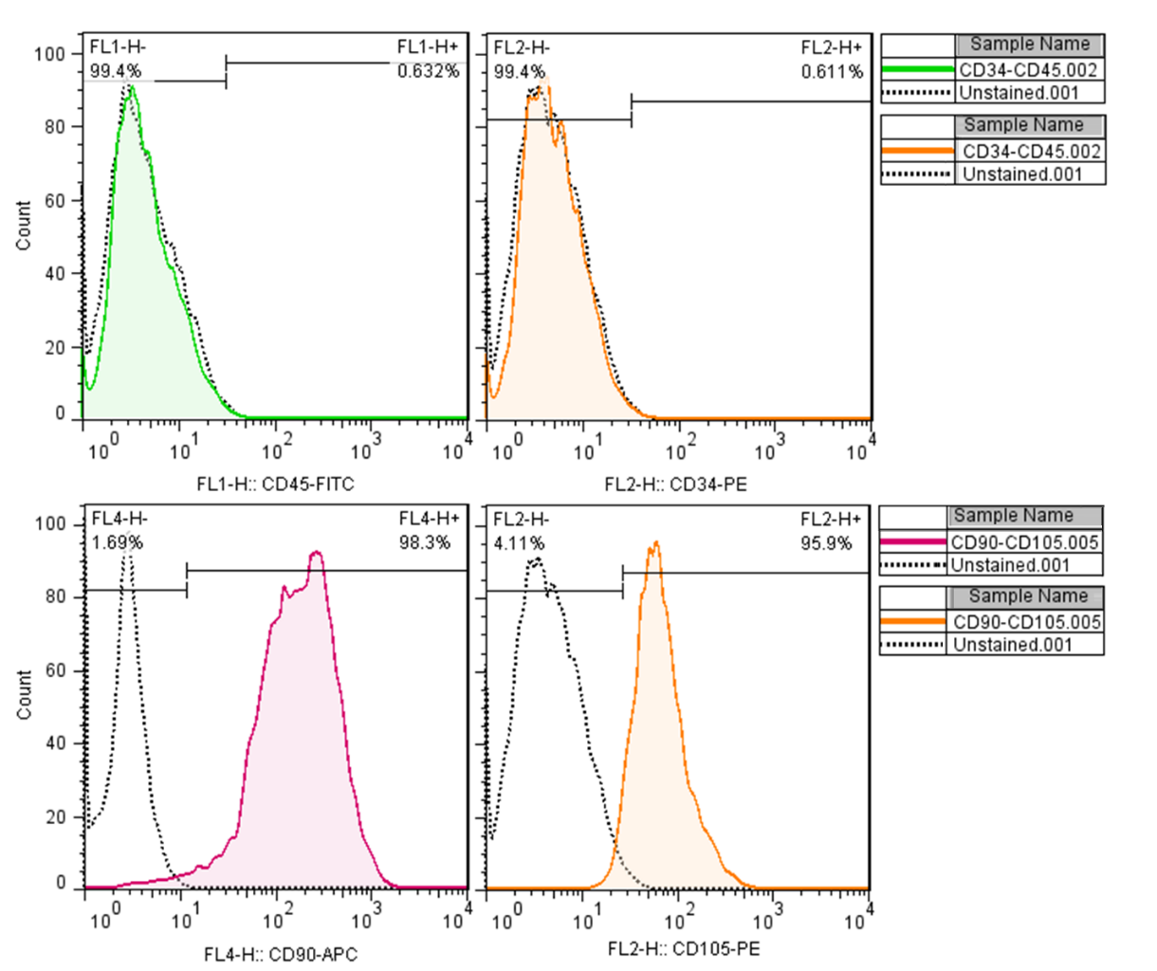
Figure 1- Newly obtained adipose-derived stem cells (ADSCs) were analyzed by flow cytometry by using negative and positive CD markers (CD34, CD45, CD90, and CD105).
In this study, before coating the nano-hydroxyapatite (NHA), the substrates (constructed with various curing agent/PDMS ratios (1:10, 1:20, and 1:30), were characterized. The Results are as follows;
Alizarin Red and Crystal Violet staining
According to Figures 2 and 4, among plain substrates, the highest calcium deposition and cell proliferation can be seen in the cells’ microenvironment differentiated on a substrate with the curing agent/PDMS ratio of 1:10. Following this, the curing agent/PDMS ratio of 1:20 had the second highest calcium deposition and cell proliferation. This quantity in patterned substrates belonged to the curing agent/PDMS ratio of 1:20, which was more than 1:10 and 1:30 (Figures 3 and 4).
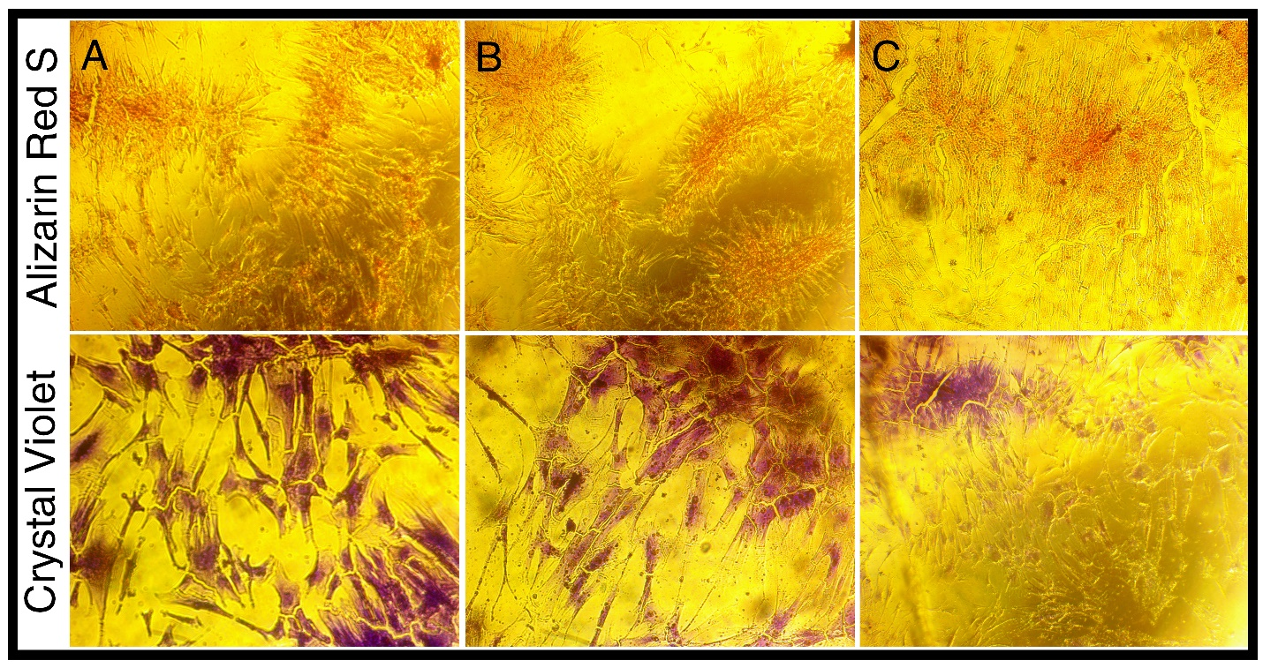
Figure 2- Alizarin Red and Crystal violet staining of plain substrates with ratios of curing agent/PDMS, 1:10(A), 1: 20 (B), 1:30 (C)
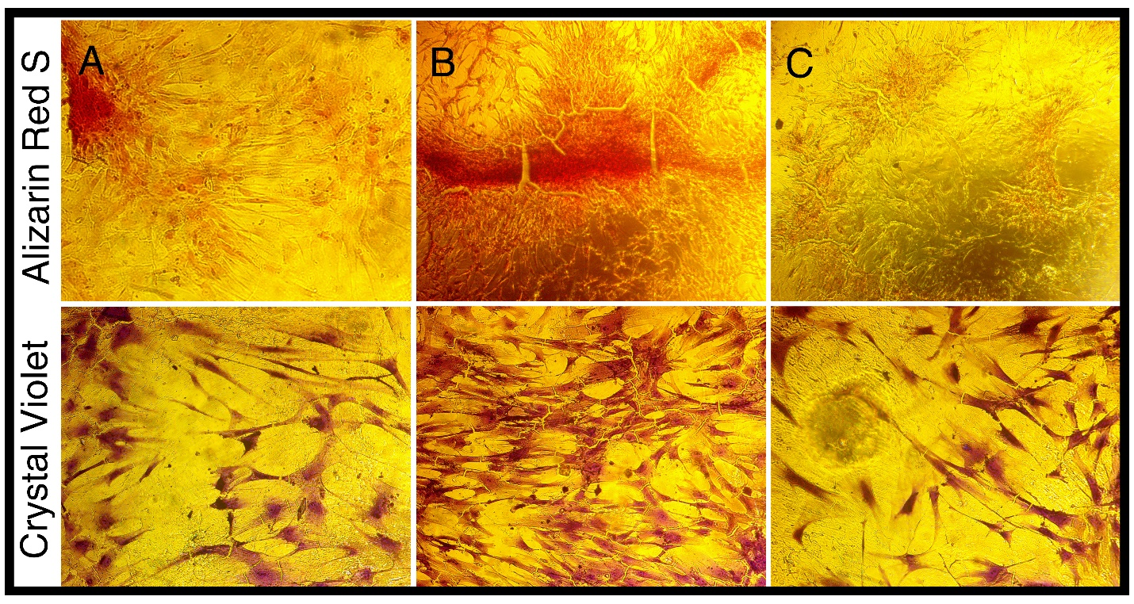
Figure 3-Alizarin Red and Crystal violet staining of patterned substrates with ratios of curing agent/PDMS 1:10(A), 1: 20 (B), 1:30 (C)

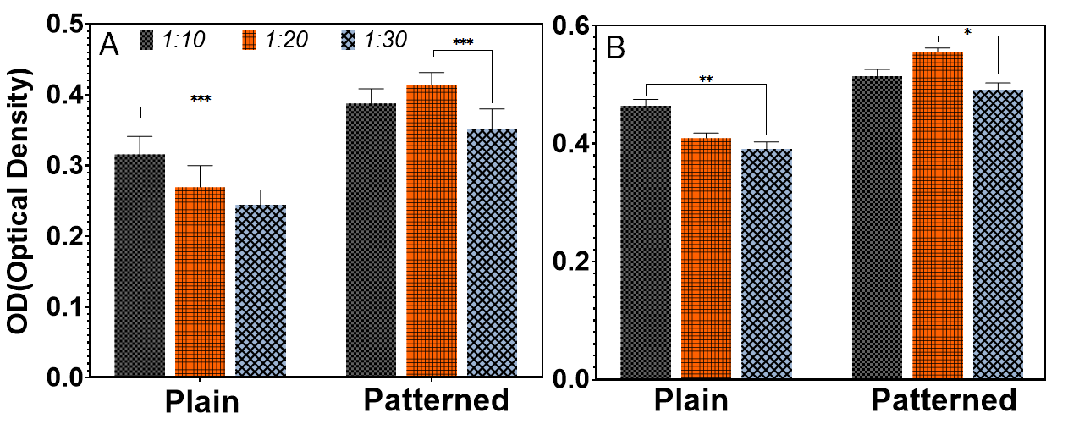
Figure 4- Optical density of Alizarin red staining (A)- Crystal Violet staining (B)- *p-value of <0.05, **p-value of <0.01, and *** p-value of <0.001 between two groups.
Cell viability
After culturing Osteoblasts on substrates with different curing agent/PDMS ratios, no toxic effect was observed.
Figure 5- Biocompatibility of substrates with various curing agent/PDMS ratios. There was no significant difference between groups

Real-time PCR
The molecular investigations illustrated better maturing, and differentiation of adipose stem cells (ADSCs) cultured on substrates with the curing agent/PDMS ratio of 1:20. Looking in detail, RUNX2, OSC, COL1, and COL2 were expressed by differentiated osteoblasts significantly.
Figure 6-Real-time PCR of RUNX2, OSC, COL1, and COL2- *p-value of <0.05, **p-value of <0.01, and *** p-value of <0.001 between two groups.

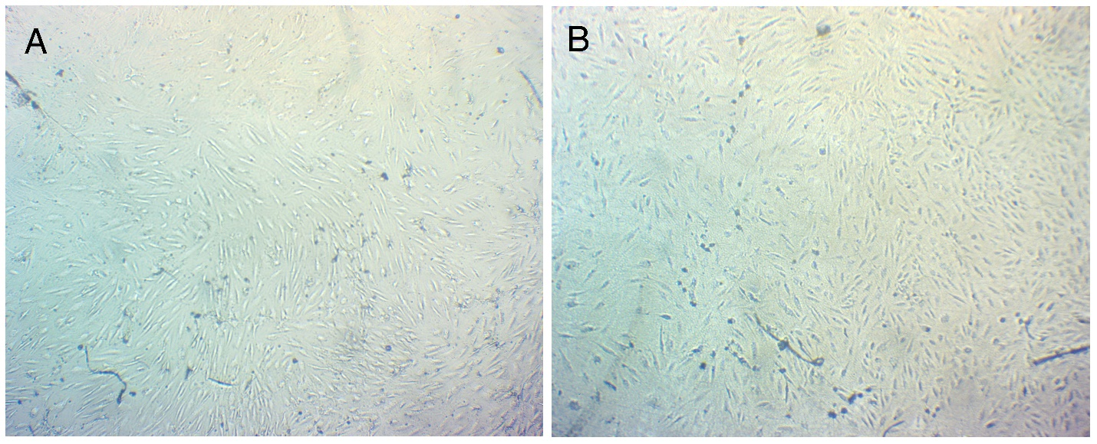
Figure 7- Cell patterns on Substrate NHA-coated 50 nm (A)- Plain Substrate (B)
Figure 8- SEM of Cell attachement on substrates.

Corresponding authors a.karkhaneh@aut.ac.ir haghbin@aut.ac.ir

