Supplementary Information

Ιn vitro RNA delivery in breast cancer cells using polysaccharide functionalized SPIONs

Olga Tsave¹, Maria Psarrou^{2,3}, Georgia Kastrinaki^{1,4}, Eleni Papachristou⁵, Rigini Papi⁵, Vassilios Zaspalis^{1,4}, Lori Nalbandian^{4†}, Charalampos Sarafidis⁶, Andreas Ouranidis¹ Theodora Choli-Papadopoulou⁵, Maria Vamvakaki^{2,3}, Christos Chatzidoukas¹*
¹ Department of Chemical Engineering, Aristotle University of Thessaloniki (AUTH), Thessaloniki, 54124, Greece.
² Department of Materials Science and Technology, University of Crete, Vasilika Vouton, 70013, Heraklion, Crete, Greece.
³Institute of Electronic Structure and Laser, Foundation of Research and Technology-Hellas, Vasilika Vouton, 70013, Heraklion, Crete, Greece.
⁴ Chemical Process & Energy Resources Institute (CPERI), Centre for Research & Technology Hellas (CERTH), Thessaloniki, Thermi, Greece.
⁵ Department of Chemistry, Aristotle University of Thessaloniki, GR-54124 Thessaloniki, Greece.
⁶ Department of Physics, Aristotle University of Thessaloniki, 54124 Thessaloniki, Greece.

∗ Corresponding author. (Assist. Professor. C. Chatzidoukas)
Tel.: +30 2310 99 6167
E-mail address: chatzido@auth.gr

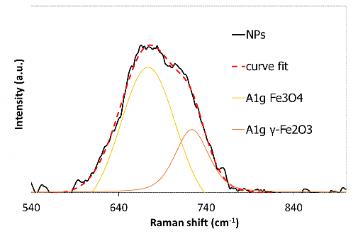 | 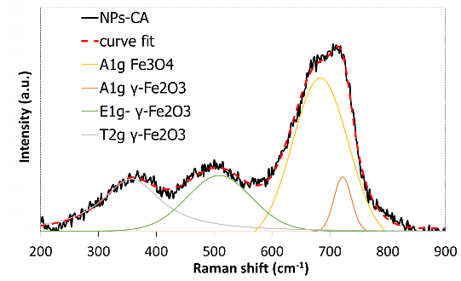
(a) | (b)
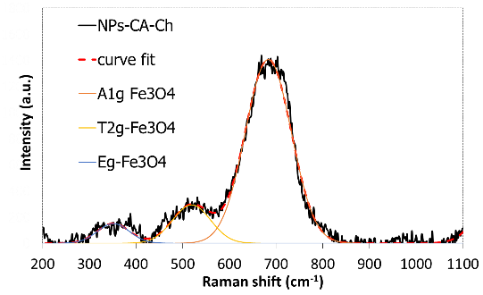 | 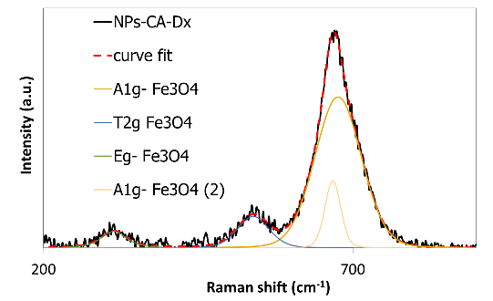
(c) | (d)
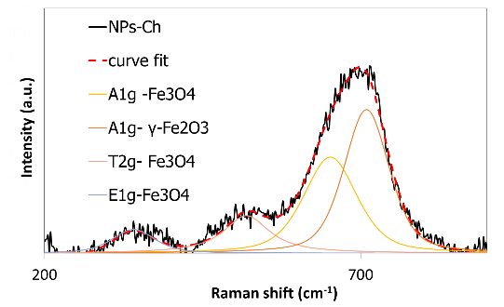 | 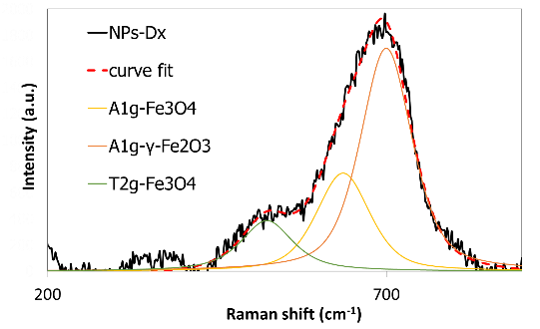
(e) | (f)
Fig. S1: Raman spectra with the deconvolution curves attributed to magnetite and maghemite for (a) NPs, (b) NPs-CA, (c) NPs-CA-Ch, (d) NPs-CA-Dex, (e) NPs-Ch and (f) NPs-Dx.

Fig. S2: ¹H NMR spectrum of Q-chitosan in D₂O.

The appearance of the characteristic chemical shift at 3.15 ppm in the ¹H NMR spectrum of Q-chitosan, assigned to the protons of the newly incorporated trimethyl ammonium groups (Fig. S2), verified the successful quaternization of the polymer.

Fig. S3: (a) FTIR spectra of chitosan (black solid line) and Q-chitosan (red dashed line) and (b) TGA curves of chitosan (black solid line) and Q-chitosan (red dashed line).

The ATR-FTIR spectra of chitosan (black solid line) before quaternization, showed the vibration band at 1588 cm⁻¹, attributed to the amino groups and the shoulder at 1652 cm⁻¹, attributed to the amide bonds of the chitin units of chitosan []. After quaternization (Q-chitosan, red dashed line), a strong vibration band at 1476 cm⁻¹, which corresponds to the C-H bonds of the newly incorporated trimethyl ammonium groups, appeared, confirming the successful quaternization of the biopolymer. Moreover, a peak at 1650 cm⁻¹, which corresponds to the primary amine groups of chitosan, which were not modified, was evident.

Fig. S4: ¹H NMR spectra of dextran and Ox-dextran in d₆-DMSO.

The appearance of a new peak at 9.3 ppm in the ¹H NMR spectrum of Ox-dextran denoted the successful modification of the polymer.

Fig. S5: (a) FTIR spectra of dextran (black solid line) and Ox-dextran (red dashed line) and (b) TGA curves of dextran (black solid line) and Ox-dextran (red dashed line).

The ATR-FTIR spectrum of Ox-dextran showed the bands at 1019 and 1634 cm⁻¹, which are attributed to the vibrations of the C-O bonds and a characteristic vibration band of the carbonyl bond of the aldehyde group at 1738 cm⁻¹, verifying the successful oxidation of the polymer.

Fig. S6: TEM images of the (a) NPs-CA-Ch and (b) NPs-CA-Dx.

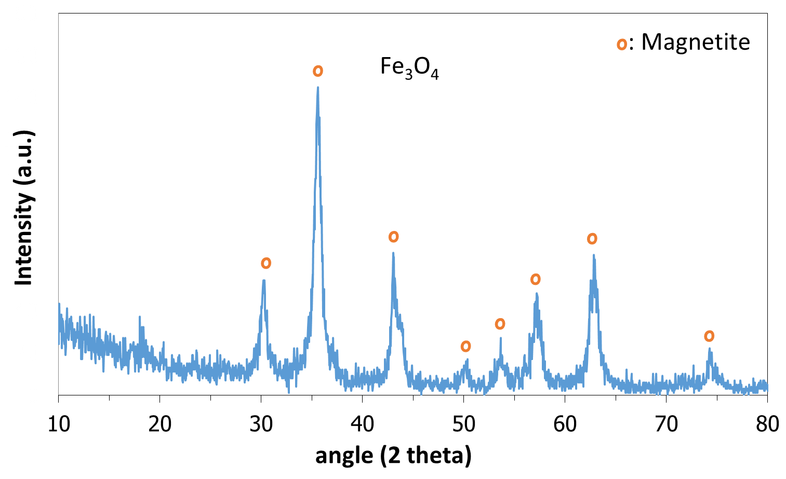
Fig. S7: XRD diagram of the bare Fe₃O₄ SPIONs.

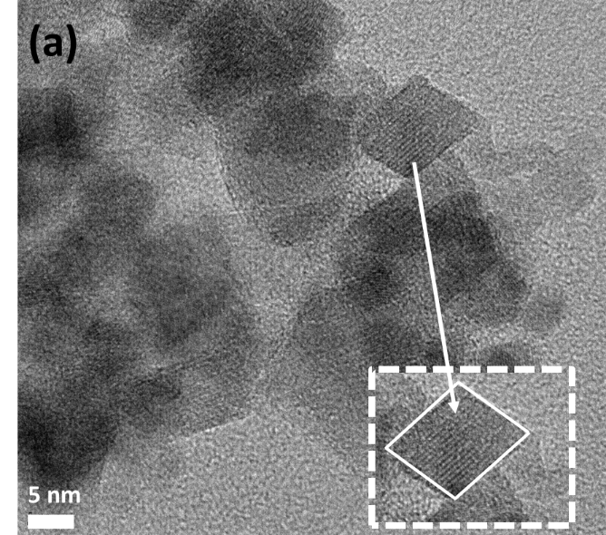 | 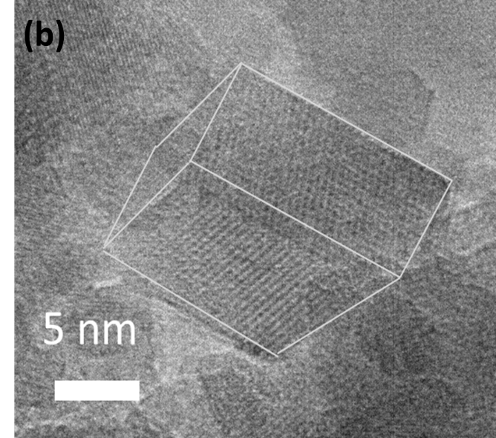
Fig. S8: (a) TEM image depicting agglomerates of NPs; the dashed line image shows a primary (single) particle defining with white outline the particle perimeter, (b) a high resolution TEM image of a primary particle defining with while outline the crystal planes of a cubic monocrystalline NP; superparamagnetic nanoparticles are monocrystalline

Fig. S8(a) illustrates the agglomerates of nanoparticles as observed in the TEM image. In Fig. S8(b), a primary cubic nanoparticle is depicted, revealing its monocrystalline nature through the orientation of planes in the three-dimensional structure. This observation aligns with the anticipated expectation, as superparamagnetic nanoparticles are known to be monocrystalline.

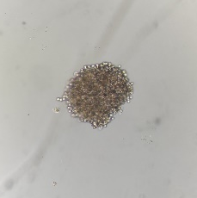
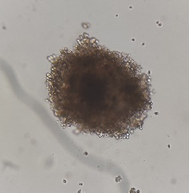
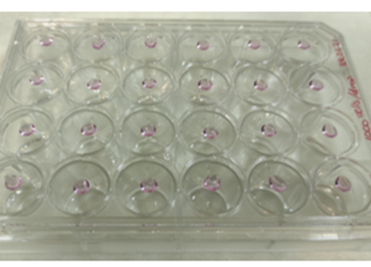
(b)
(a)

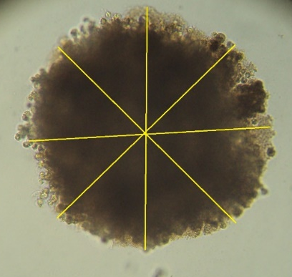
(d)
(c)

Fig. S9: (a), (b) Cell spheroid formation on days 3 and 12. (c) The hanging drop method. (d) Schematic representation of the diameter of each aggregate obtained as an average of 5 measurements.

Fig. S10: Representative micrographs of cell adhesion of T47D cells following their treatment with SPIONs (photographs obtained using a LEICA inverted microscope, with a 10x phase contrast. Images were captured at several time points).

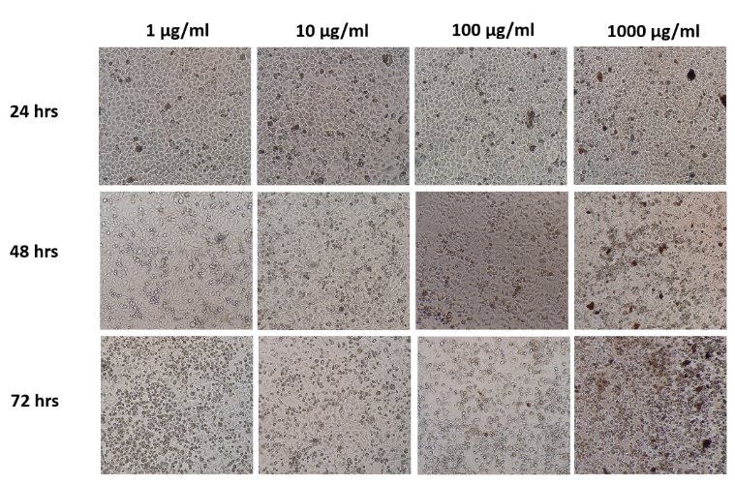
NPs

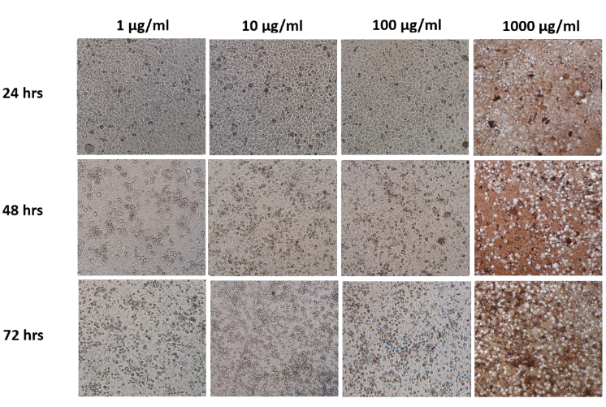
NPs-CA

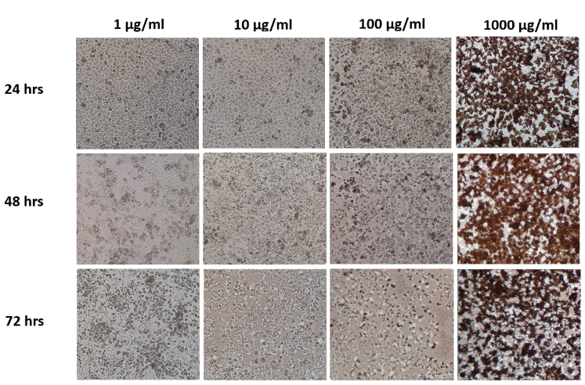
NPs-Ch

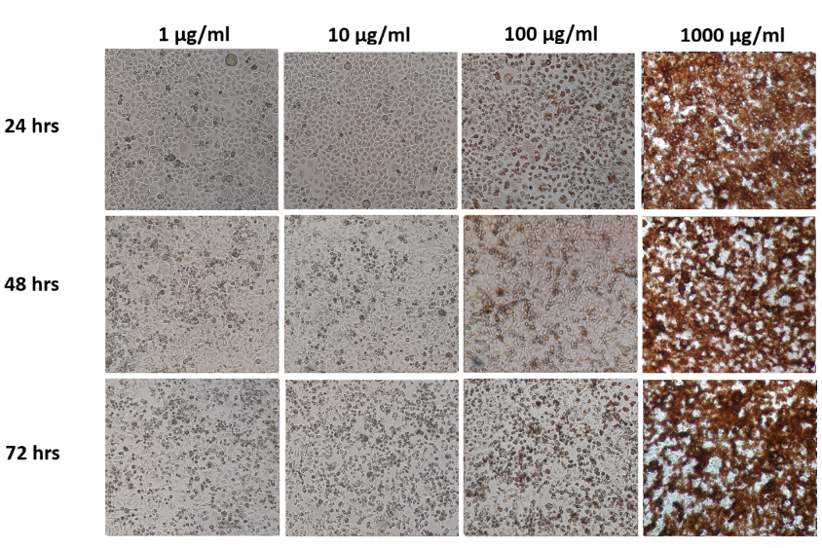
NPs-CA-Ch

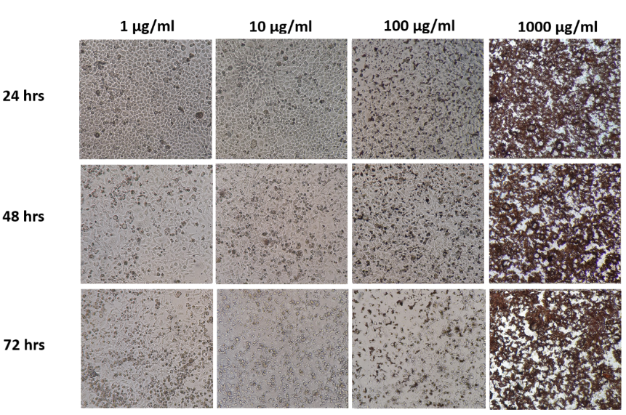
NPs-Dx

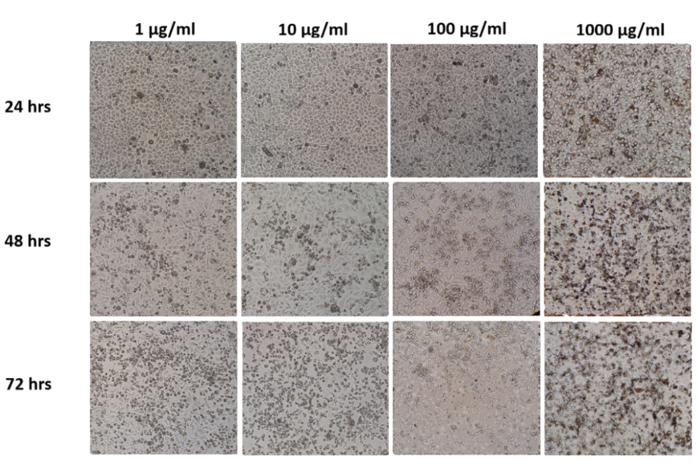
NPs-CA-Dx

Fig. S11: Representative micrographs of cell morphology of T47D cells following treatment with the SPIONs (photographs obtained using a LEICA inverted microscope, with a 10x phase contrast. Images were captured at several time points).
(a)
(b)
(c)
(d)
Fig. S12: Percentage change of cell survival of the T47D cells (2D monolayers), following treatment with various concentrations (1-1000 μM) of a) NPs, b) NPs-CA, c) NPs-Dx, and NPs-Ch for 24 h in the presence or absence of a magnetic field.

Wan, Y.; Creber, K.A.M.; Peppley, B.; Bui, V.T. Ionic conductivity of chitosan membranes. Polymer (Guildf). 2003, 44, 1057–1065, doi:10.1016/S0032-3861(02)00881-9.

