Supplementary Table 1:
Supplementary Table 1 Total number of photos (human, domestic animal, wild animal and blank) captured by camera traps in Kali Tiger Reserve.
Total Captures | Blank photos | Humans | Wild Animals | Domestic Animals
2,31,167 | 1,79,736 | 43,726 | 4,116 | 2,416

Supplementary Figure 1:
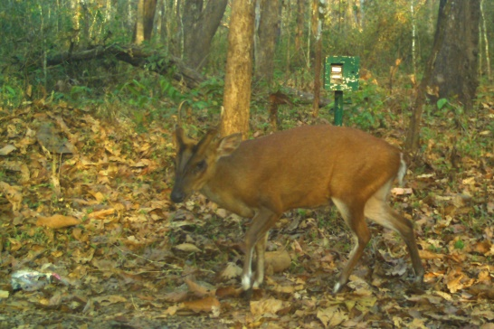
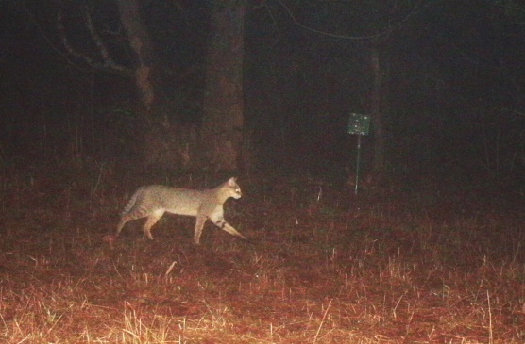
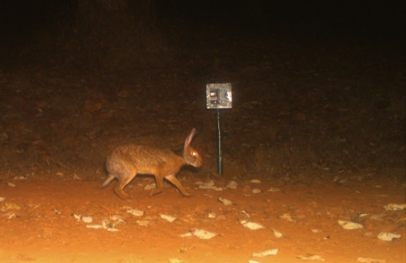
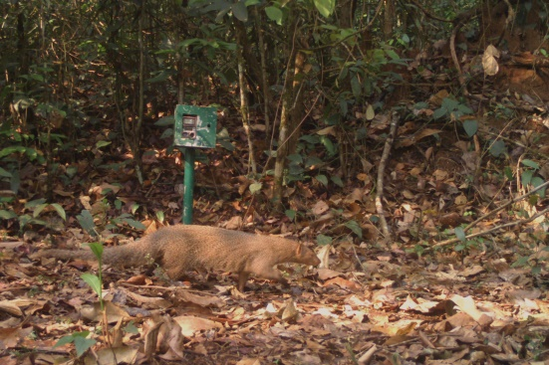
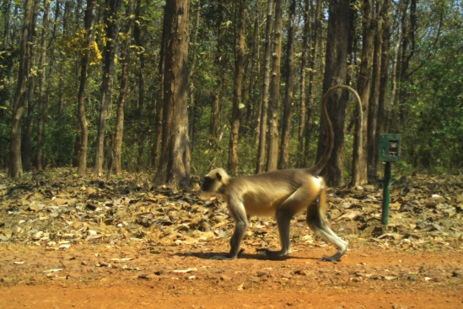
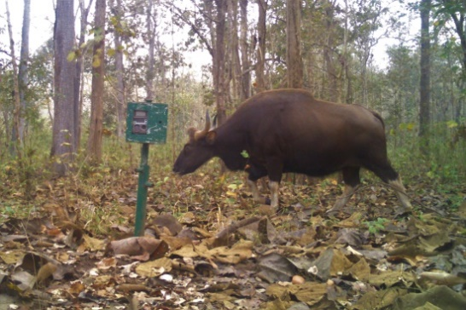
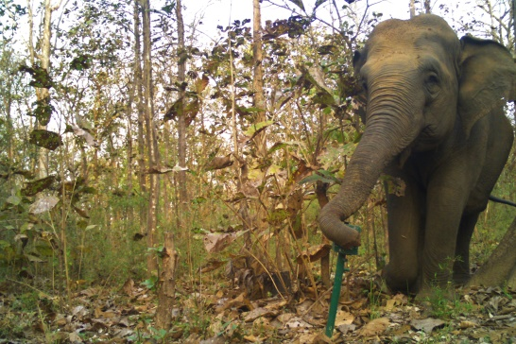
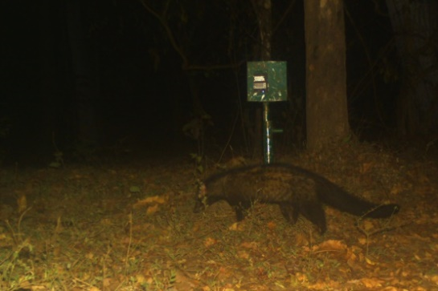
(a)
(h)
(g)
(f)
(e)
(d)
(c)
(b)

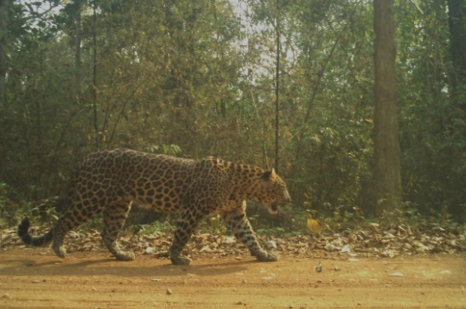
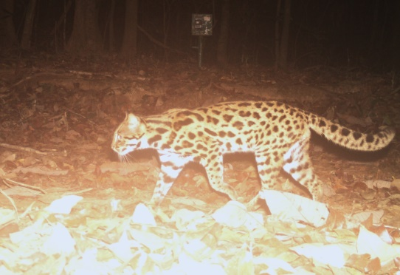
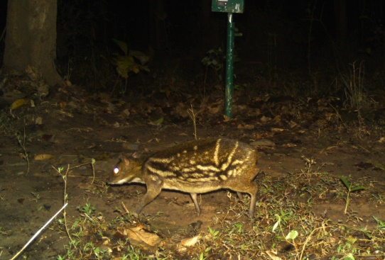
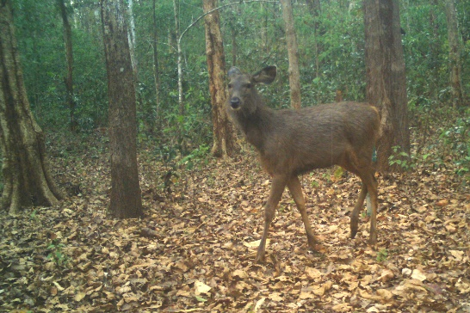
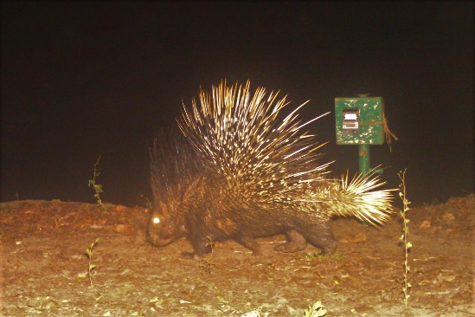
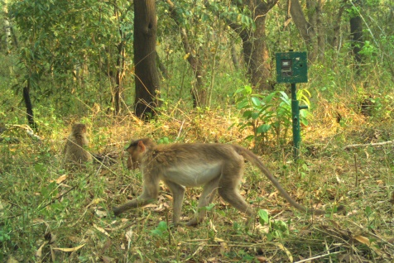
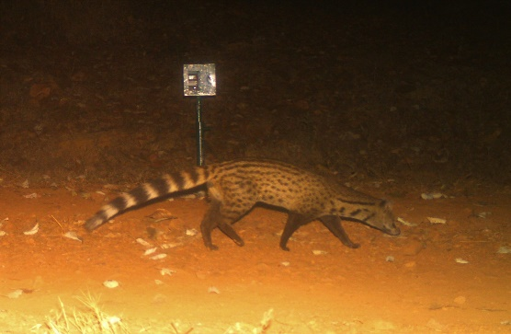
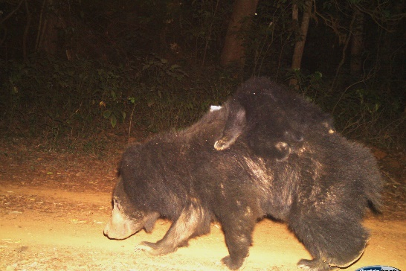
(i)
(j)
(k)
(l)
(m)
(n)
(o)
(p)

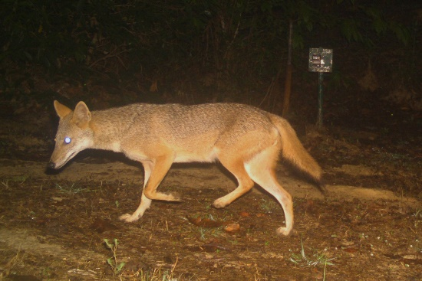
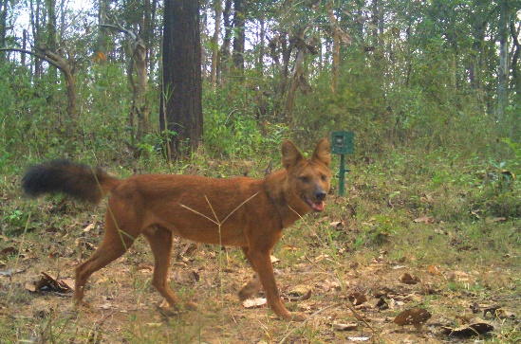
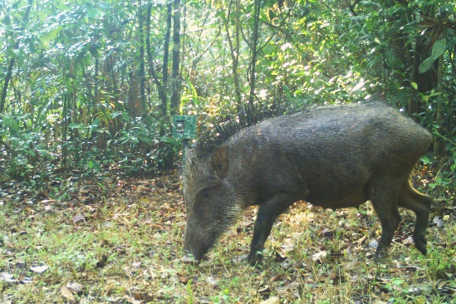
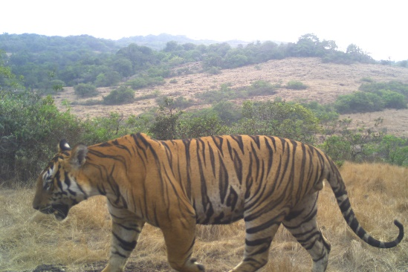
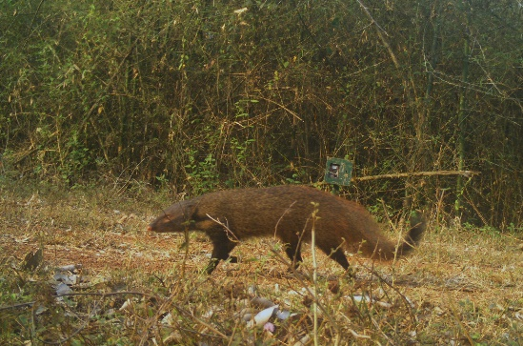
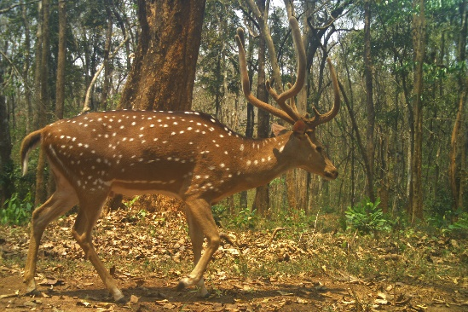
(v)
(u)
(t)
(s)
(r)
(q)

Supplementary Figure 3: Images showing the camera trap capture of (a) barking deer, (b) common palm civet, (c) Asian elephant, (d) gaur, (e) gray langurs (f) Indian Grey Mongoose (g) hare, (h) jungle cat, (i) leopard, (j) leopard cat, (k) mouse deer, (l) porcupine, (m) rhesus monkey, (n) sambar deer, (o) small Indian civet, (p) sloth bear, (q) spotted deer, (r) stripe necked mongoose, (s) tiger, (t) wild boar, (u) wild dog and (v) jackal.

Supplementary Figure 2:

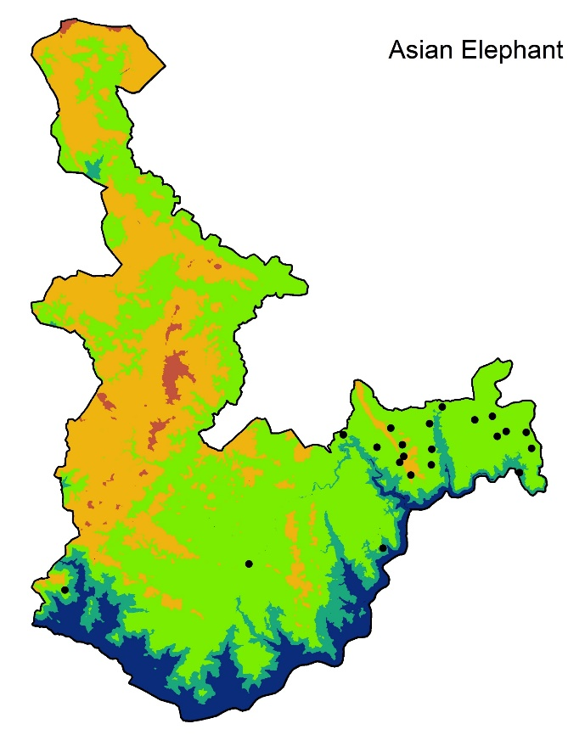
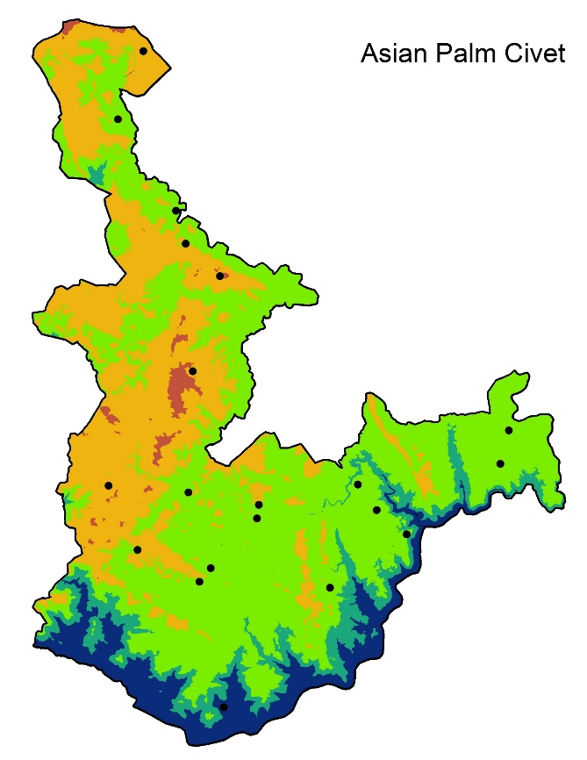
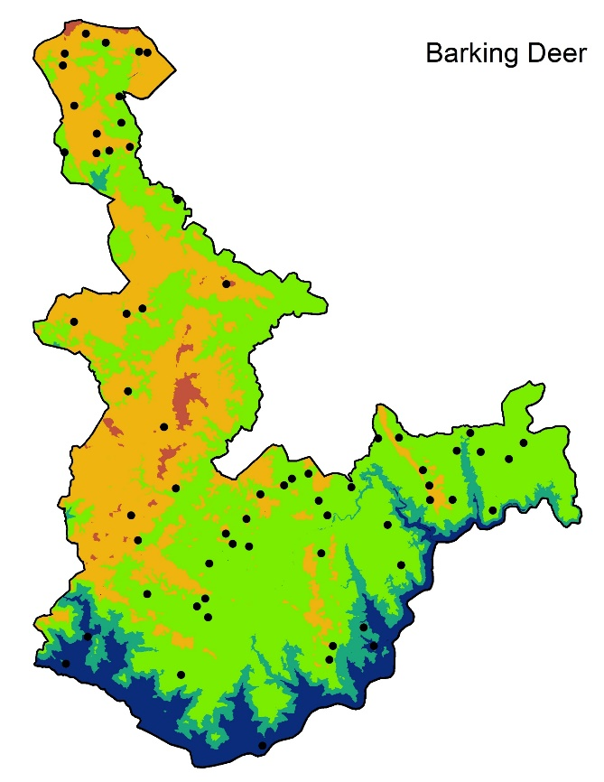
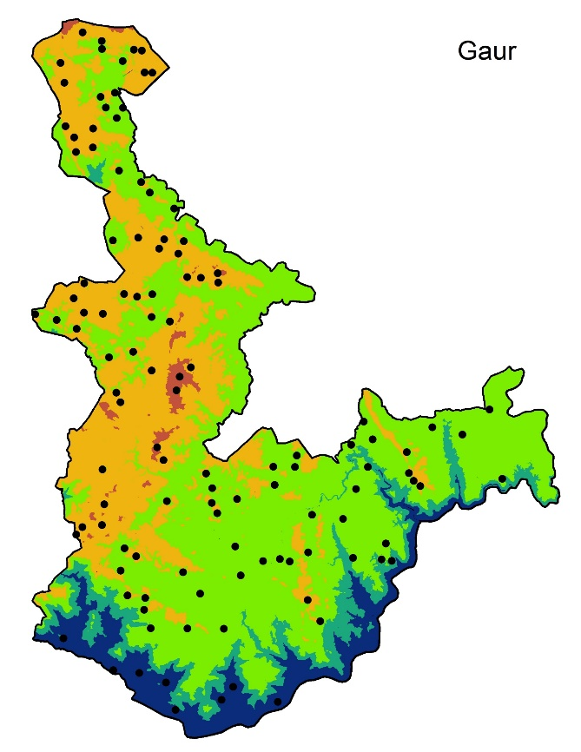
(a)
(b)
(c)
(d)
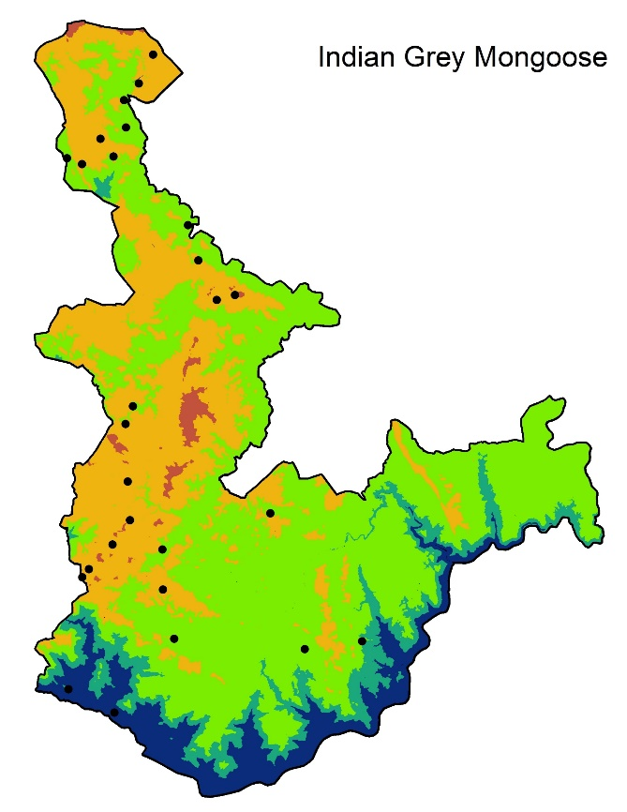
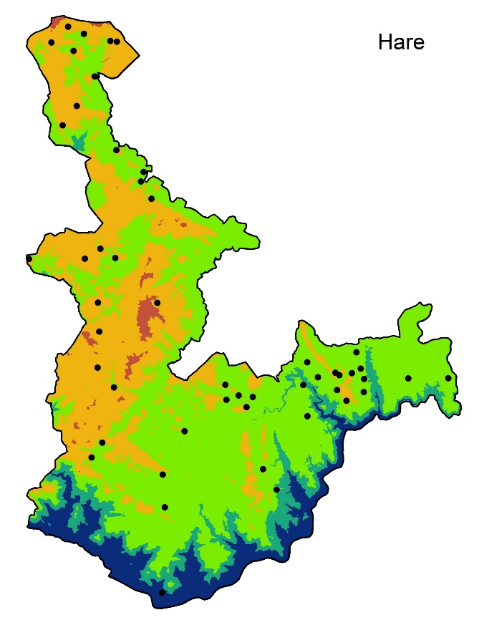
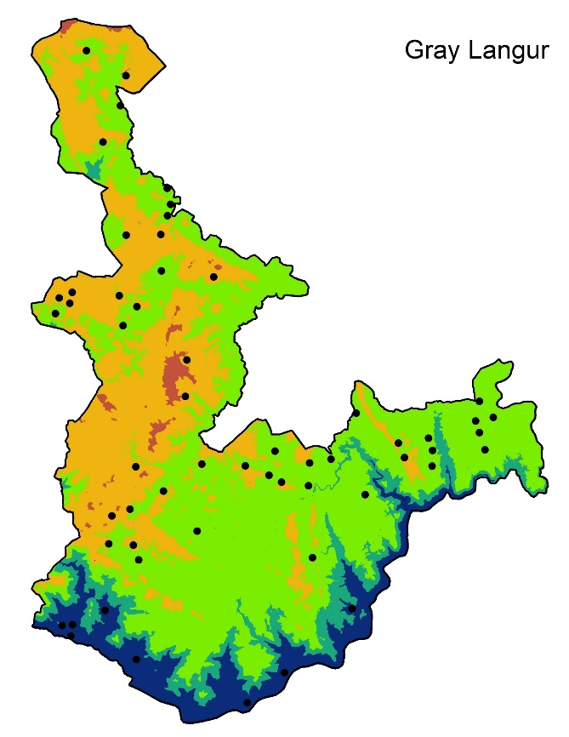
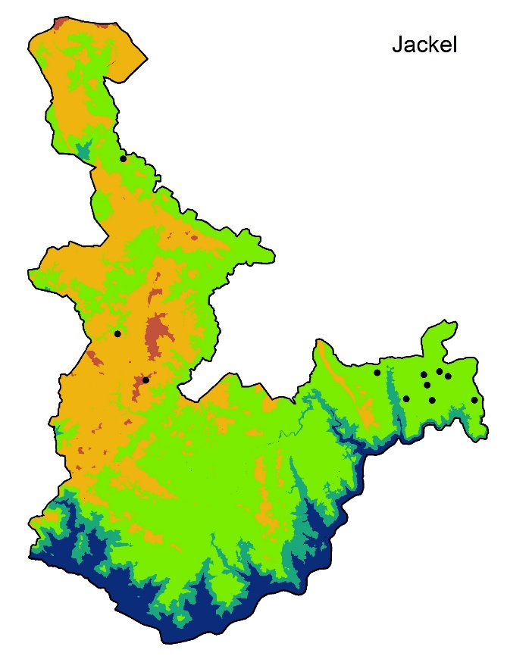
(e)
(f)
(g)
(h)
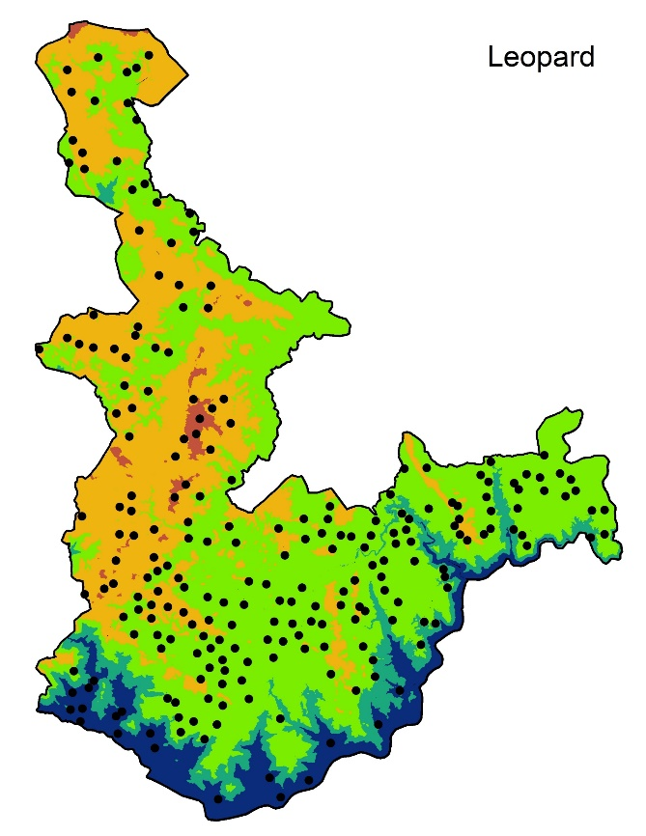
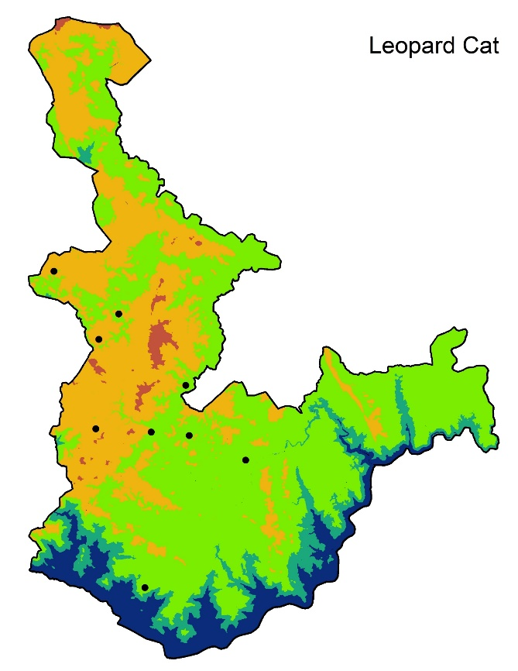
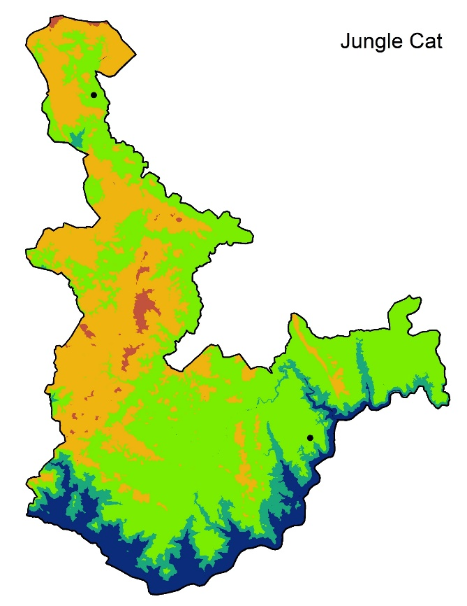
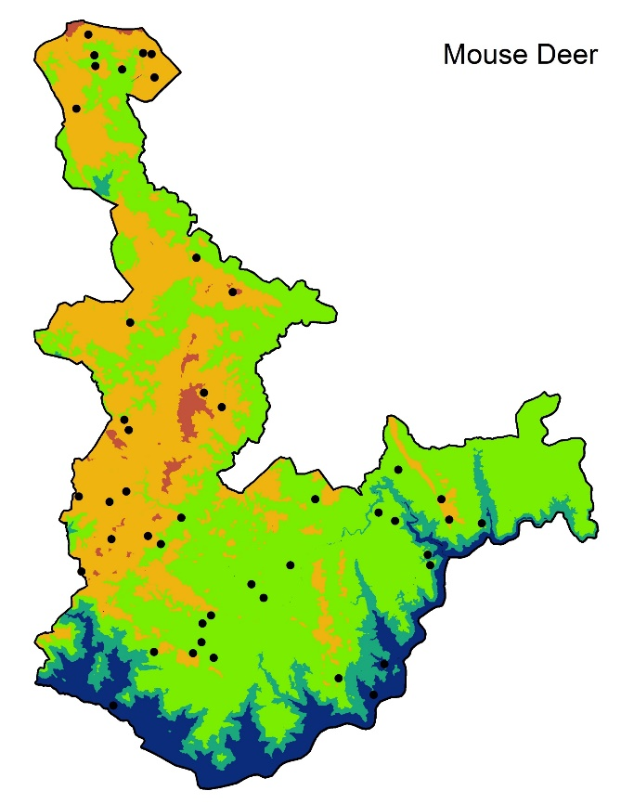
(i)
(j)
(k)
(l)
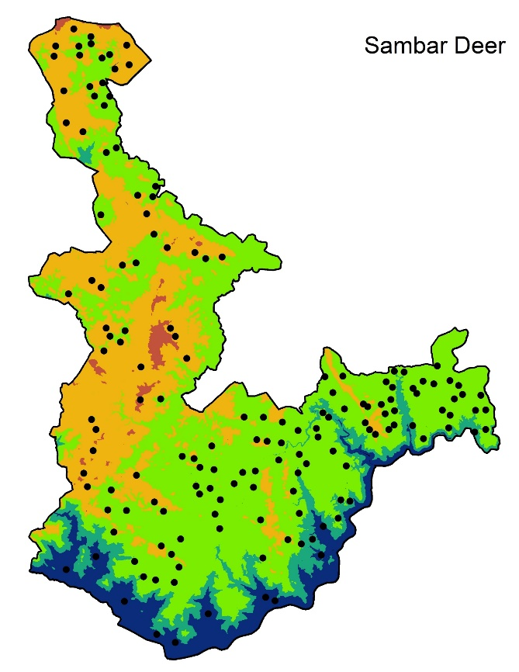
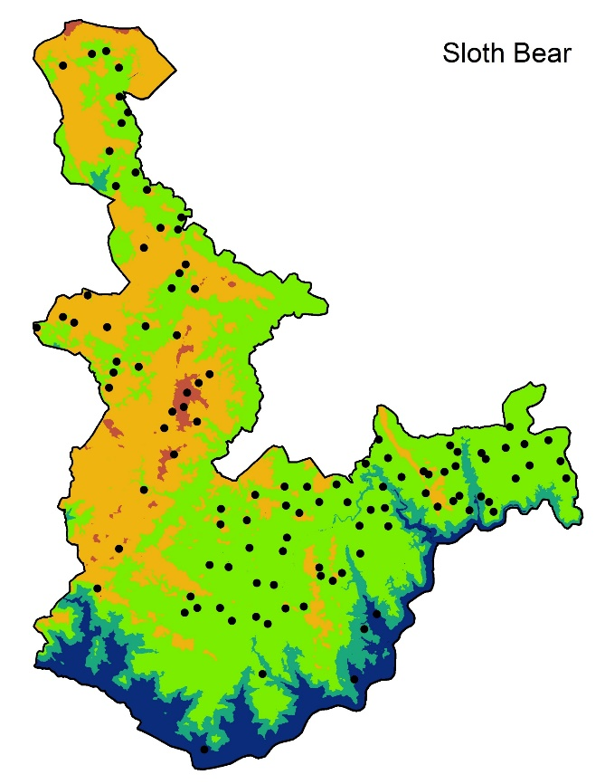
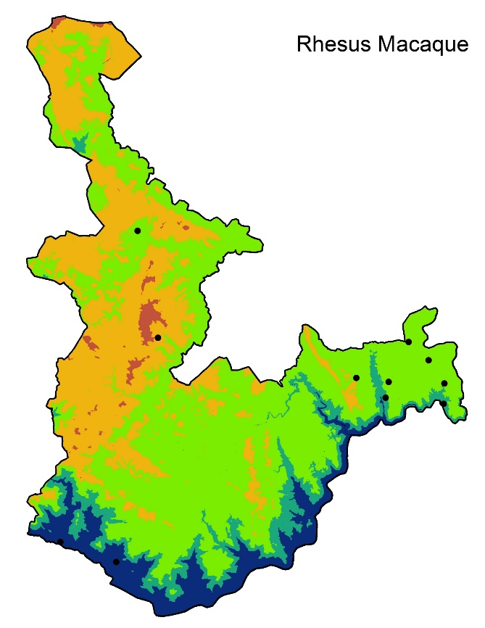
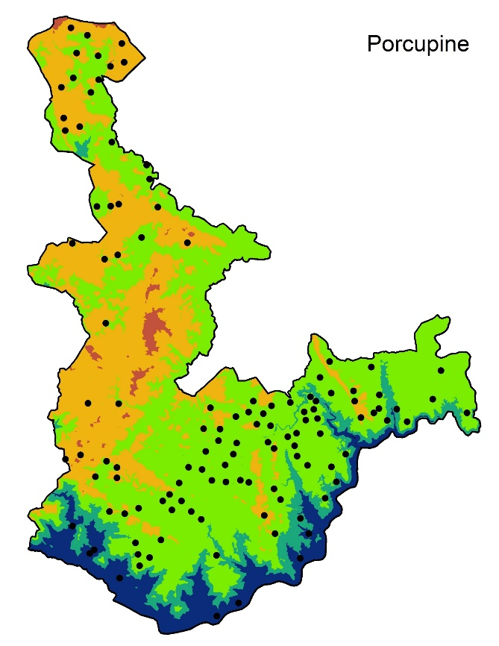
(m)
(n)
(o)
(p)
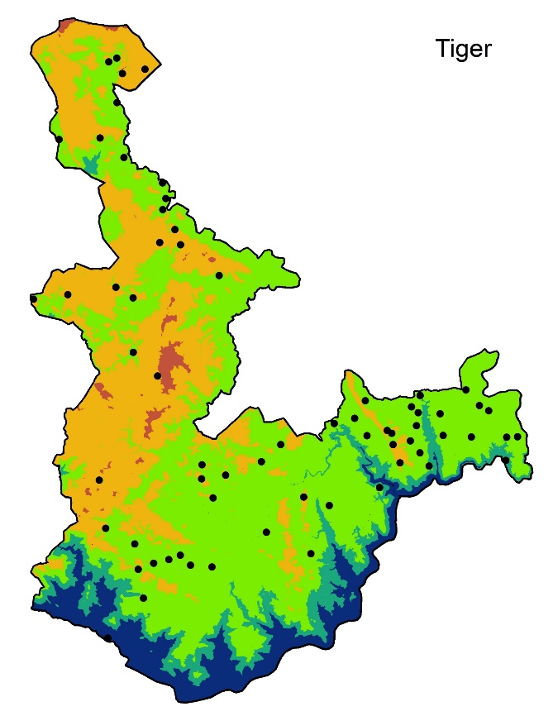
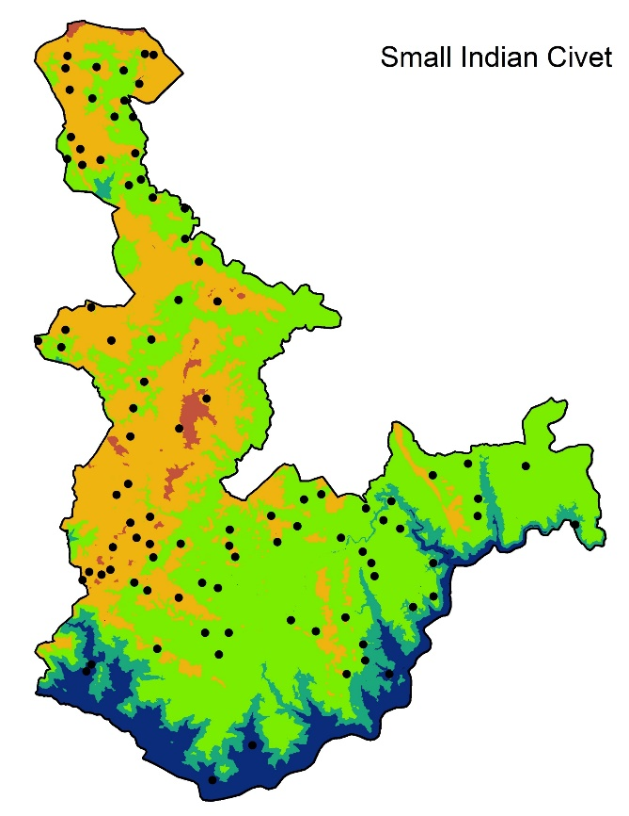
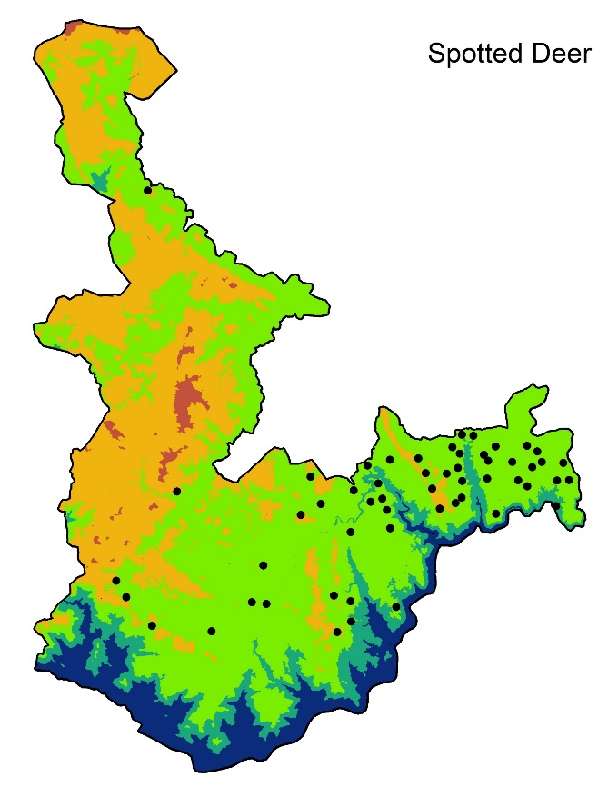
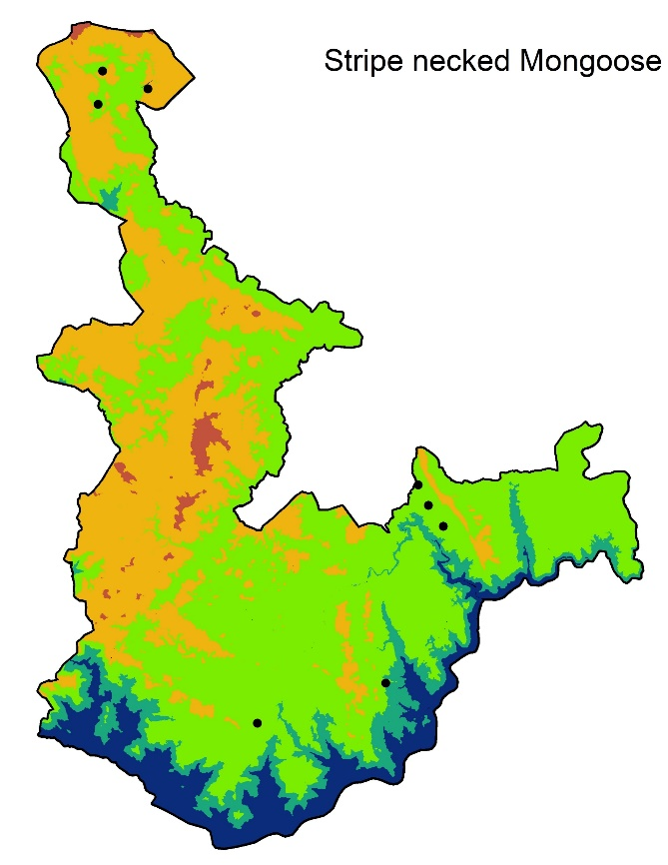
(q)
(r)
(s)
(t)
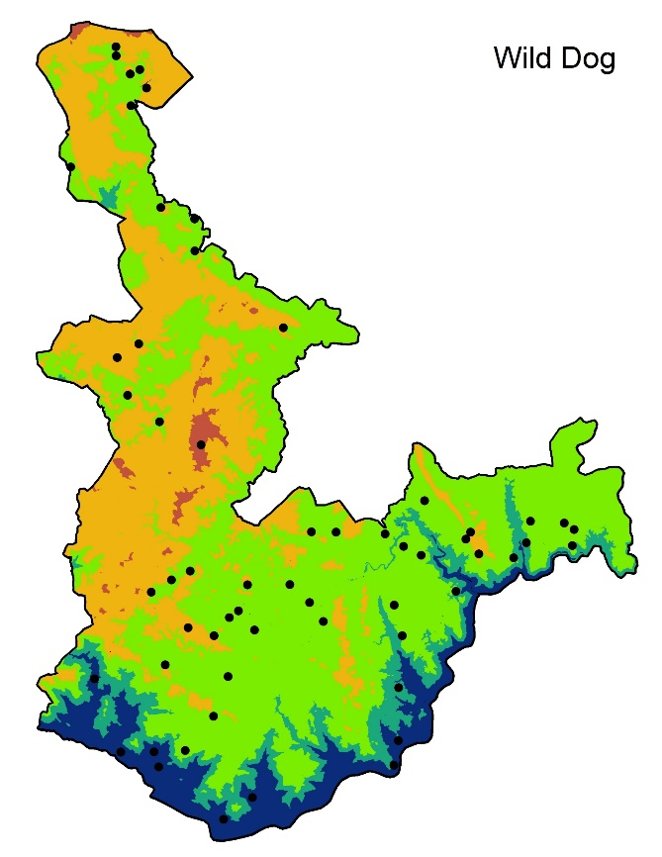
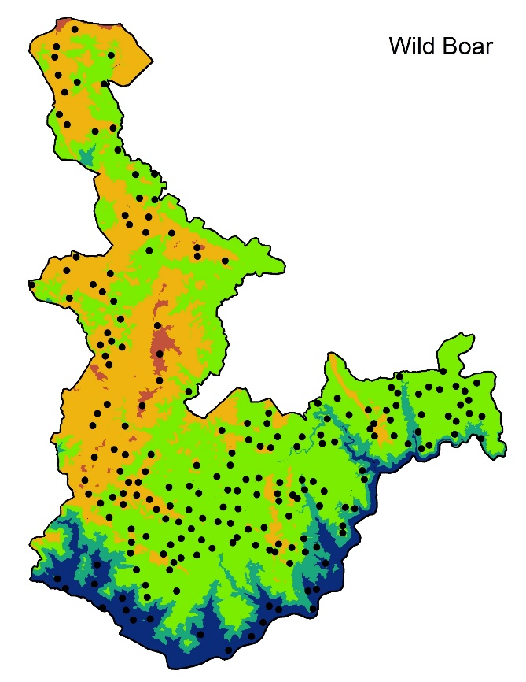
(u)
(v)

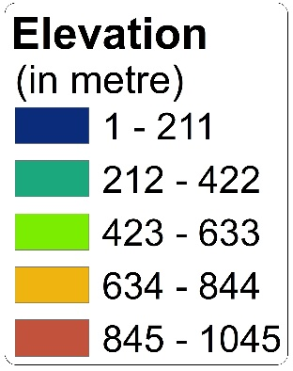

Supplementary Figure 2: Map showing the camera trap locations where the species were detected (a) Asian elephant, (b) barking deer, (c) Gaur, (d) Asian palm civet, (e) Indian grey mongoose, (f) hare, (g) grey langur, (h) jackal, (i) jungle cat, (j) leopard, (k) leopard cat, (l) mouse deer, (m) sambar deer, (n) sloth beer, (o) rhesus monkey, (p) porcupine, (q) strip necked mongoose, (r) spotted deer, (s) small India civet, (t) Tiger, (u) wild dog and (v) wild boar.

Supplementary Figure 3:
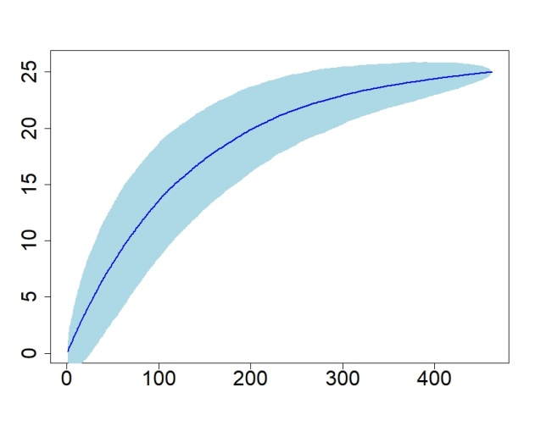
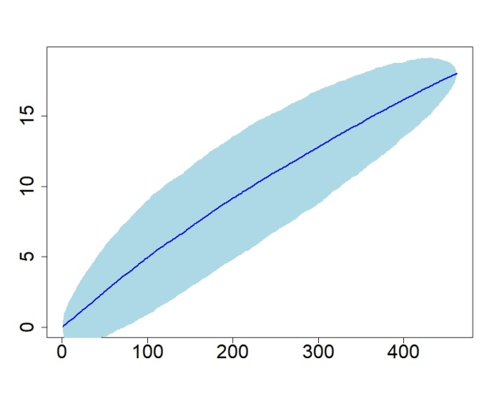
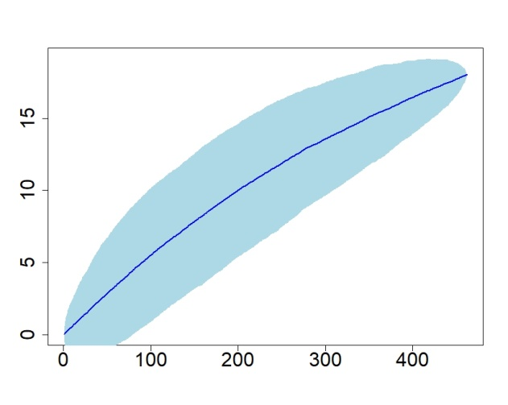
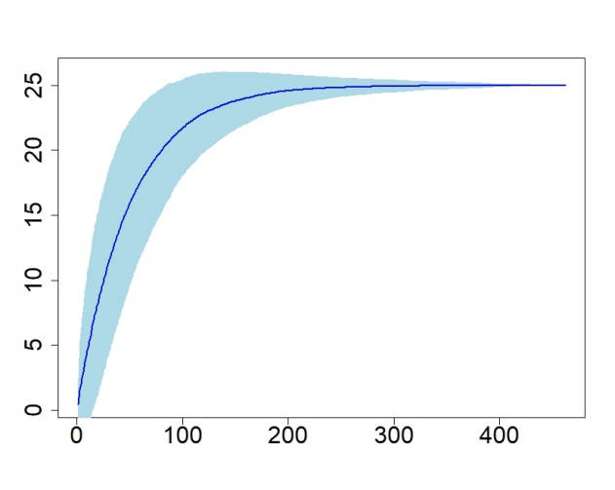
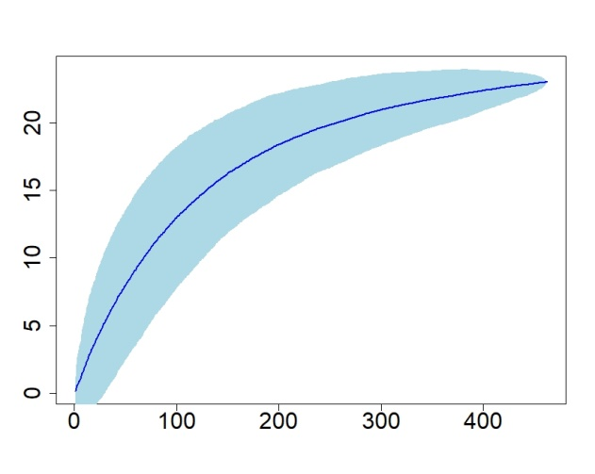
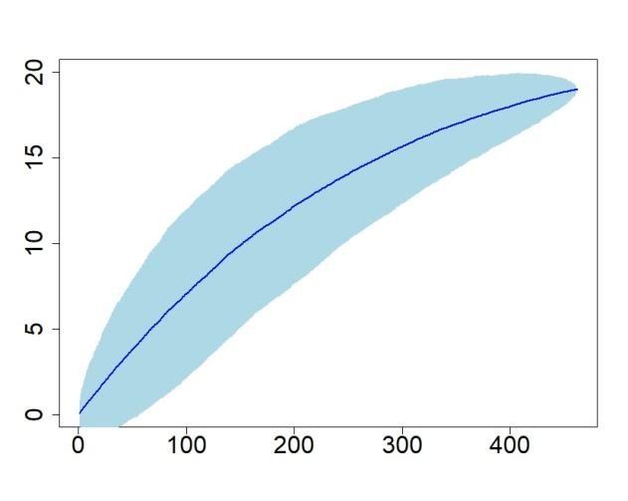
(a)
(b)
(c)
(d)
(e)
(f)
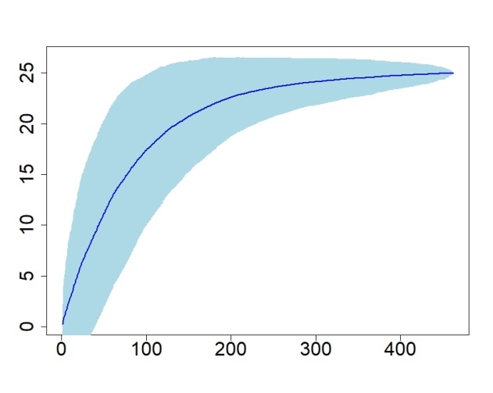
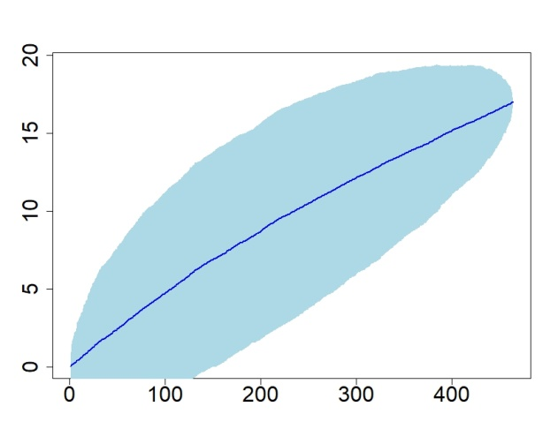
(g)
(h)

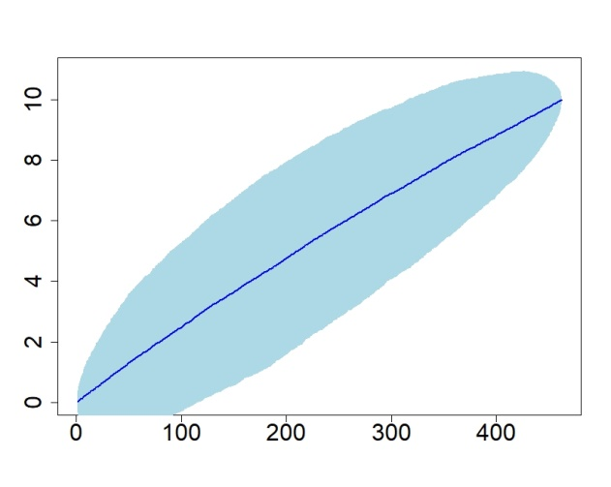
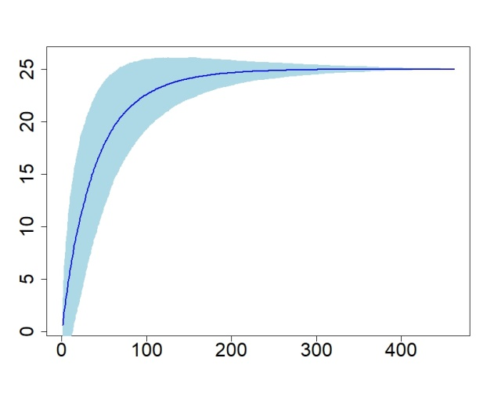
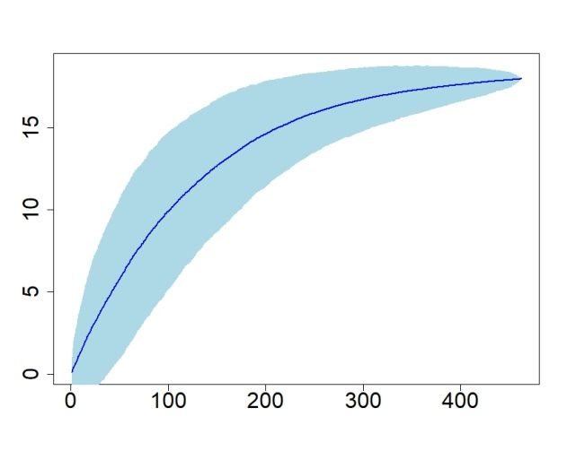
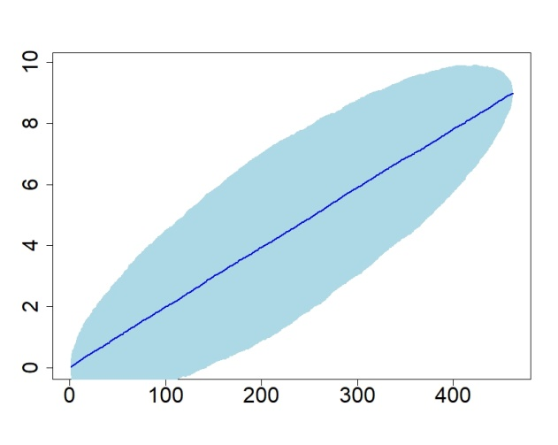
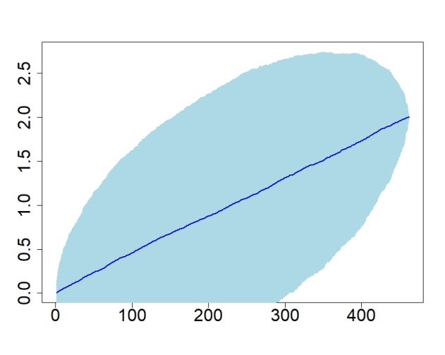
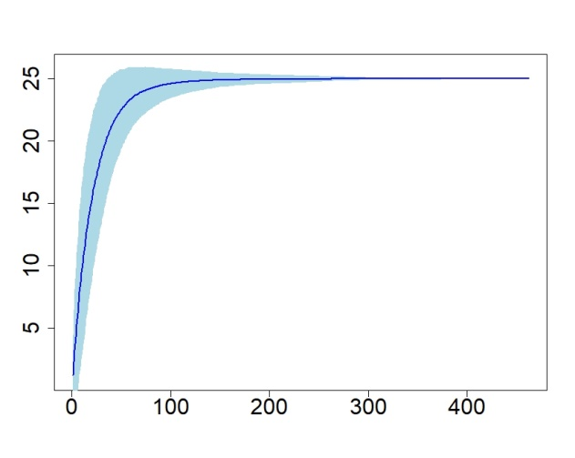
(m)
(l)
(l)
(k)
(j)
(i)

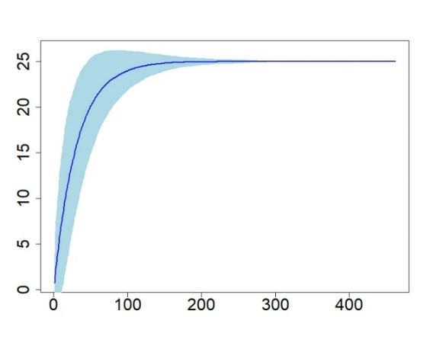
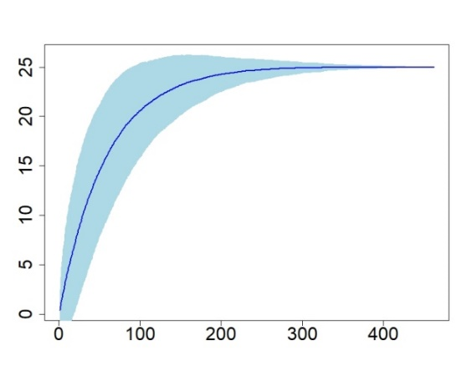
(n)
(o)

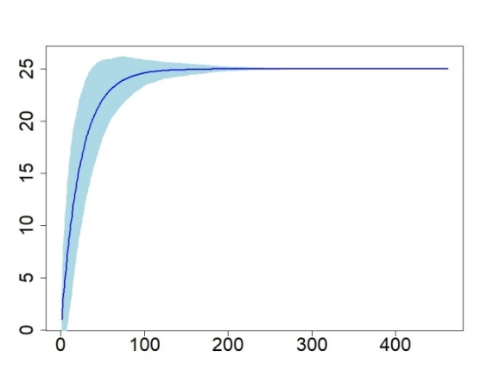
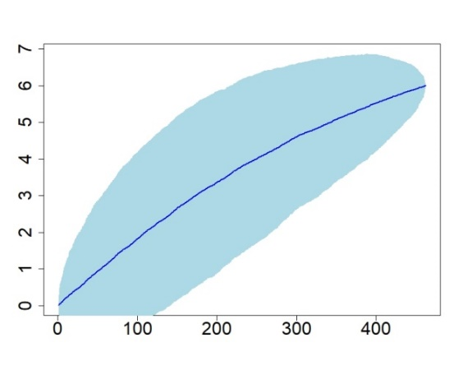
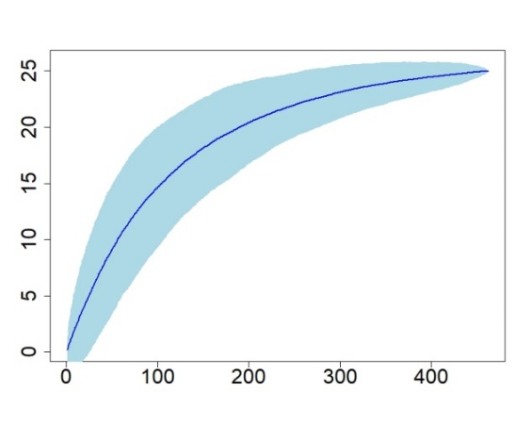
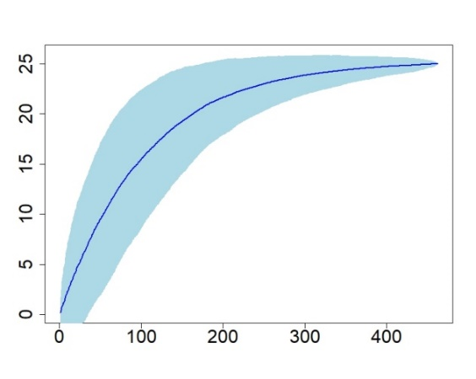
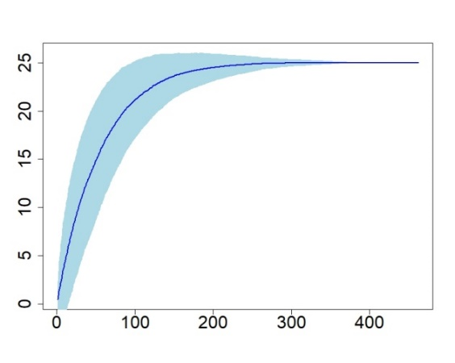
(u)
(t)
(r)
(p)
(q)

(s)

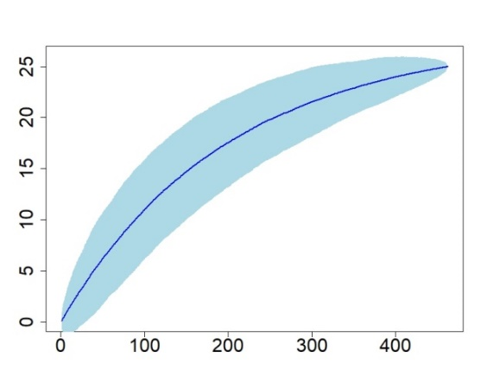

Supplementary Figure 1: Rarefaction curve (blue line) illustrating the cumulative number of captured (a) barking deer, (b) common palm civet, (c) Asian elephant, (d) gaur, (e) gray langurs (f) Indian Grey Mongoose (g) hare, (h) jackal, (i) jungle cat, (j) leopard, (k) leopard cat, (l) mouse deer, (m) porcupine, (n) rhesus monkey, (o) sambar deer, (p) small Indian civet, (q) sloth bear, (r) spotted deer, (s) stripe necked mongoose, (t) tiger, (u) wild boar and (v) wild dog. The light blue shadow represents the 95% confidence interval.

