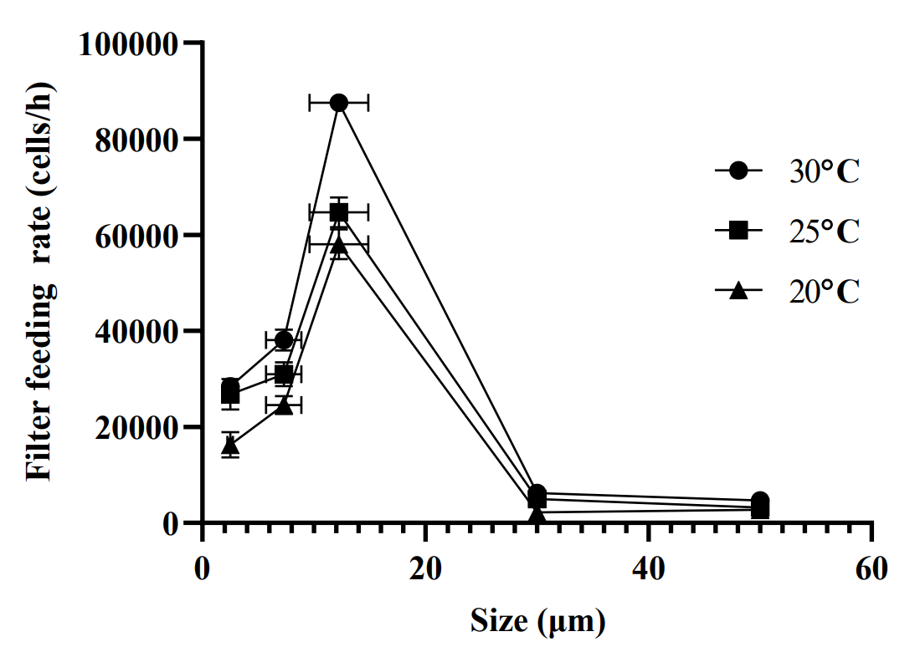
Fig. S1 day 25 FFR of particle
Fig. S2 day3 and day5 selection of particle

