Supplementary information
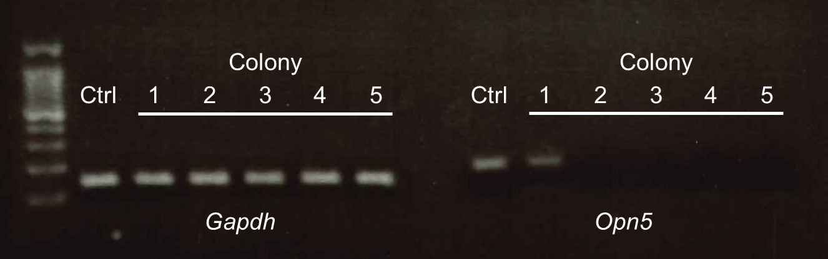
Supplementary Fig. S1. PCR result of expanded Opn5 KO 661w cells for the assessment of transfection. Colonies 2 to 5 exhibited no Opn5 expression. Cells from colonies 2-5 were selected for further experiments.

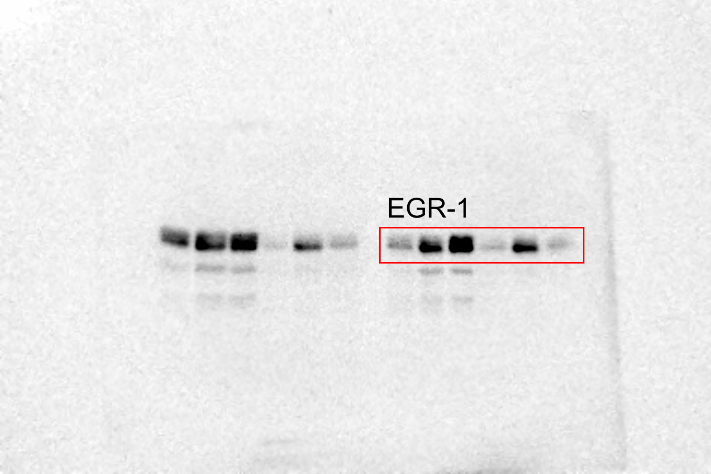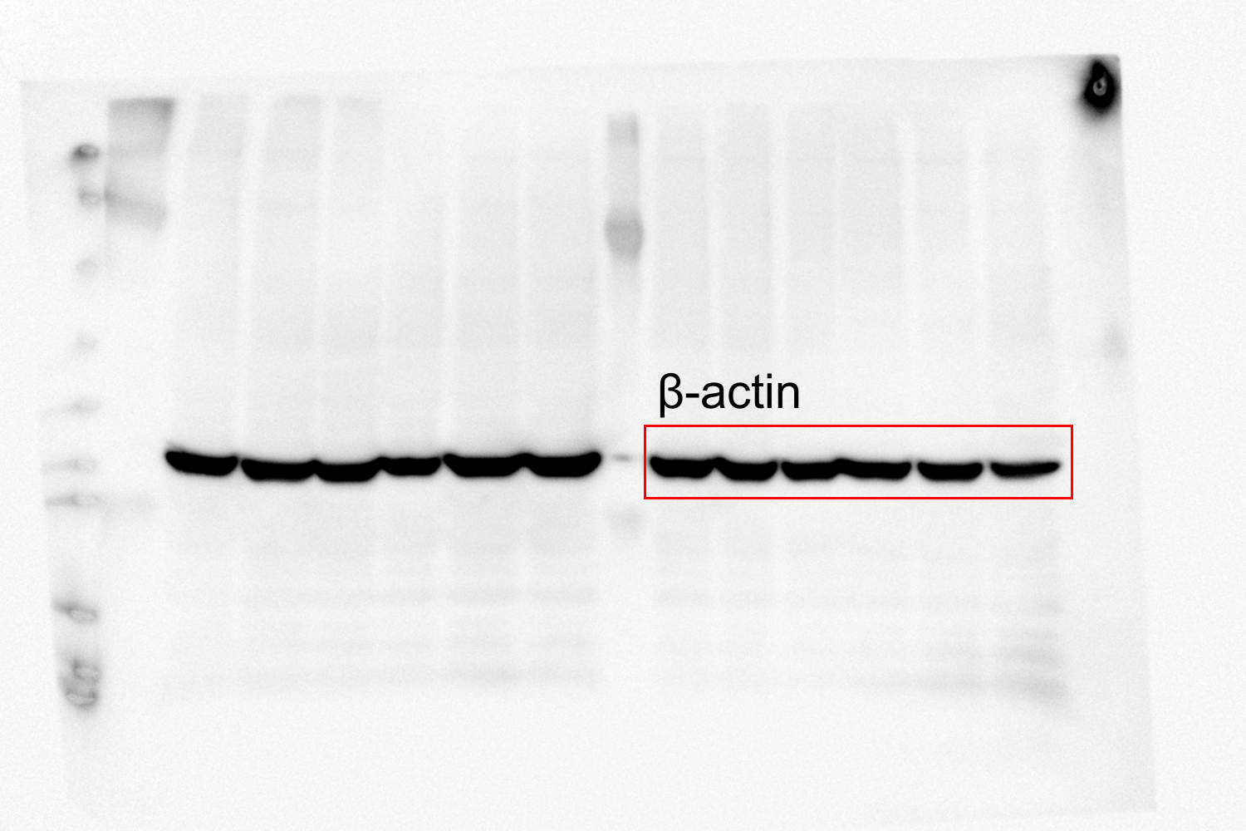
Supplementary Fig. S2. The original western blot images of Figure 1C. Red line boxes indicate the cropped membrane images.

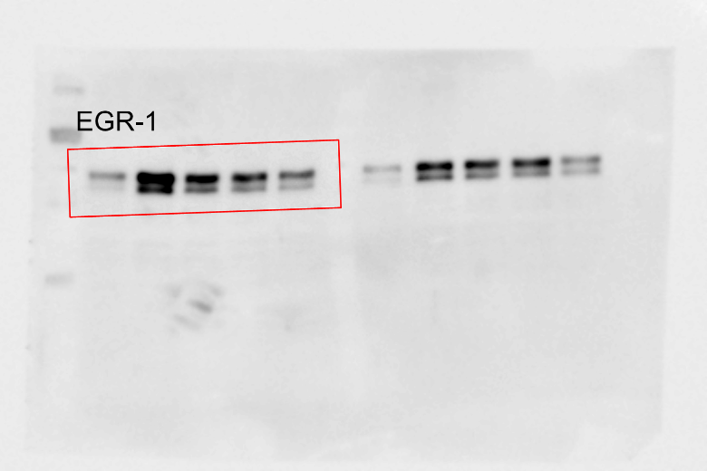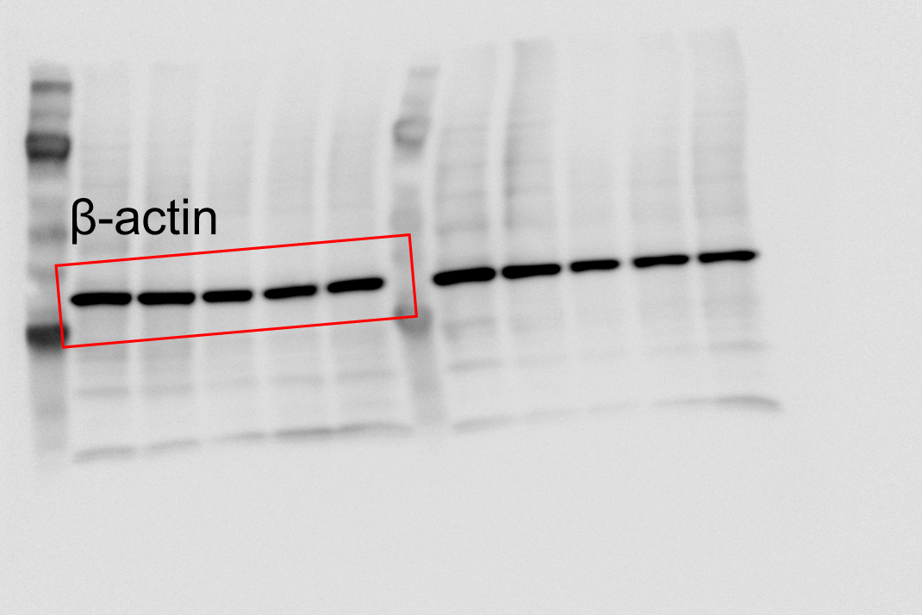
Supplementary Fig. S3. The original western blot images of Figure 3C. Red line boxes indicate the cropped membrane images.

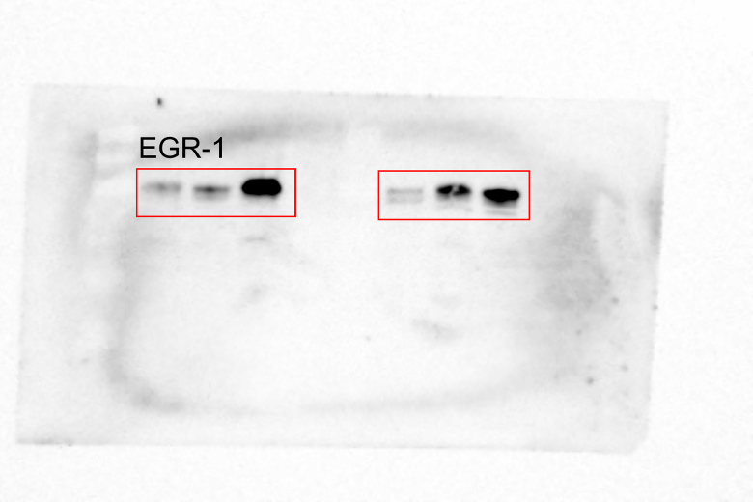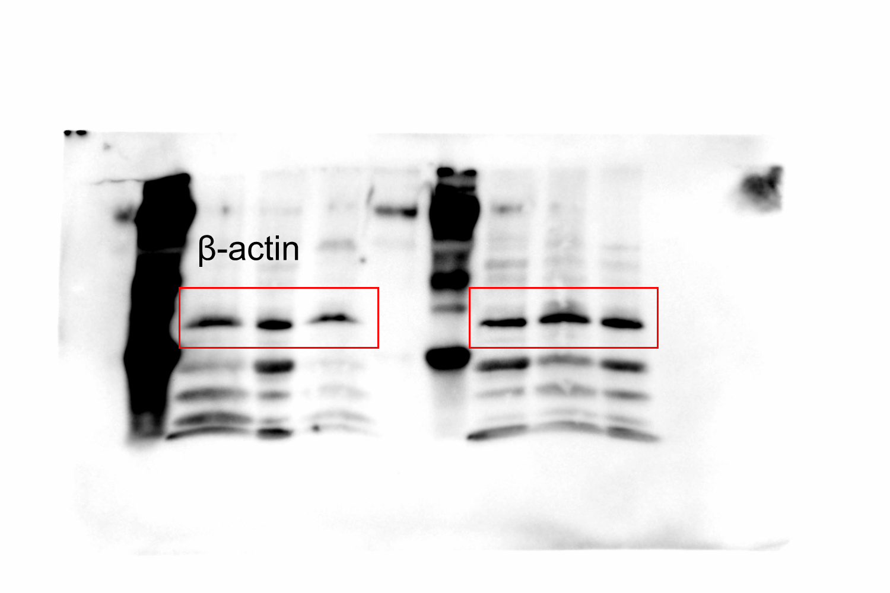
Supplementary Fig. S4. The original western blot images of Figure 4C. Red line boxes indicate the cropped membrane images.

