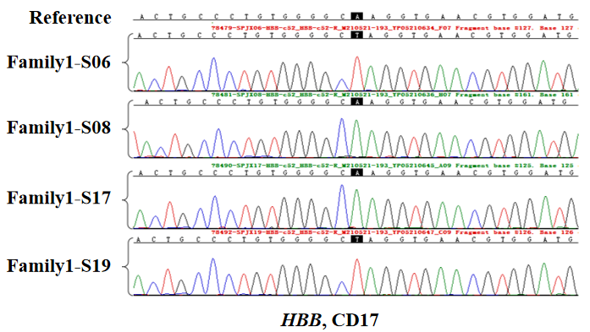
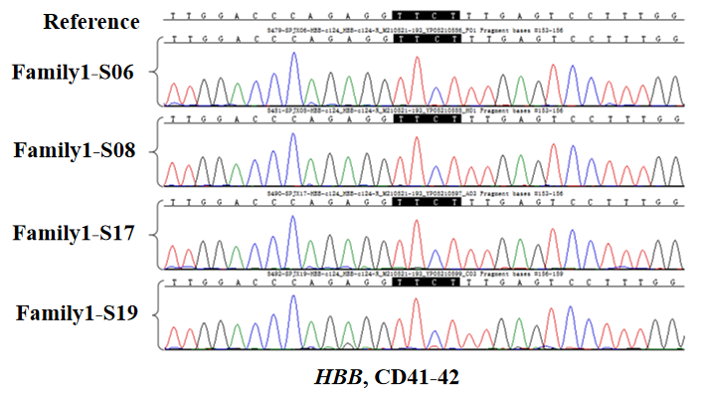
Figure S1. The Sanger sequencing results of single sperm from Ⅱ-5 of family 1. Sperm Family1-S06 and Family1-S19 carried the codon 17 variant, while Sperm Family1-S08 and Family1-S17 did not. All the four sperms did not carry the codon 41-42 variant.
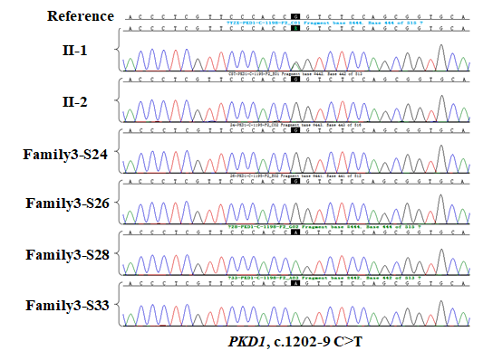
Figure S5. The Sanger sequencing results of the couple and single sperm from Ⅱ-1 of family 3. The male (Ⅱ-1) and his sperm Family3-S28 and Family3-S33 carried the missense variant in the PKD1 gene, while the female(Ⅱ-2), sperm Family3-S24 and Family3-S26 did not.

