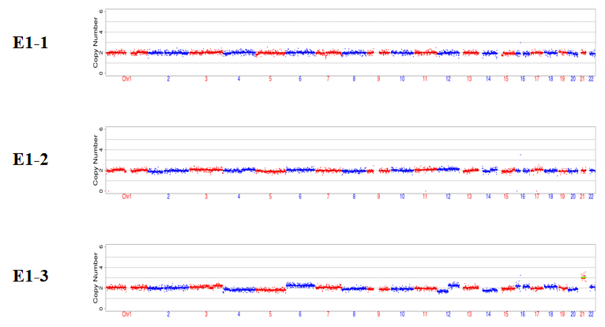
Figure S2. The CNVs of E1-1, E1-2, and E1-3. Embryo E1-1 and E1-2 were euploid, while E1-3 was 21-trisome. The green horizontal line indicated an abnormal copy number.
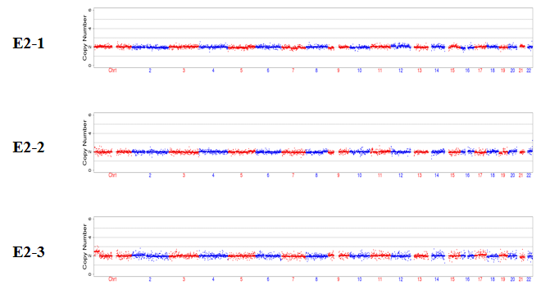
Figure S4. The CNVs of E2-1, E2-2, and E2-3. All the three embryos were euploid.
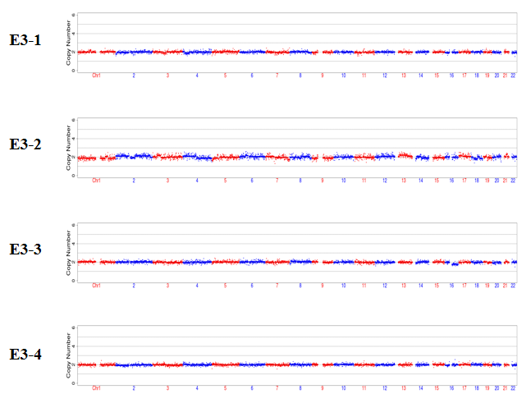
Figure S6. The CNVs of E3-1, E3-2, E3-3, and E3-4. All the four embryos were euploid.

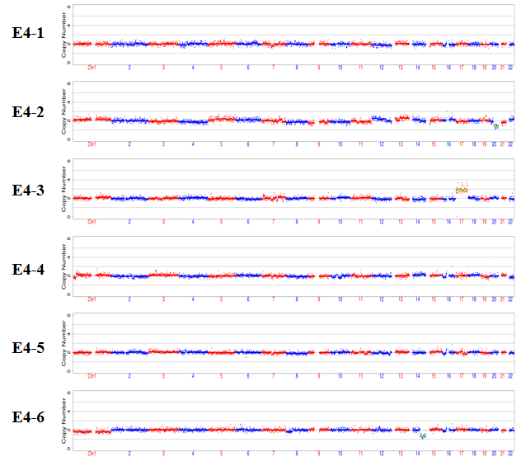
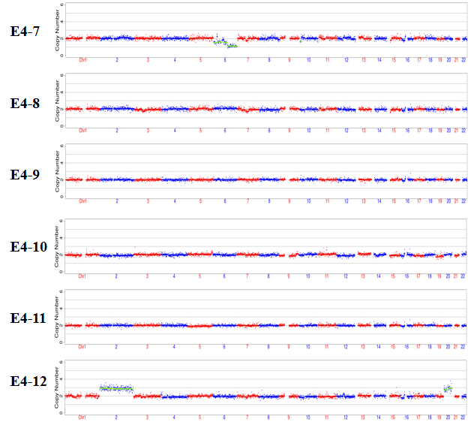
Figure S7. The CNVs of E4-1, E4-2, E4-3, E4-4, E4-5, E4-6, E4-7, E4-8, E4-9, E4-10, E4-11, and E4-12. Monosomy 20q mosaicism and monosomy 14q mosaicism were detected in E4-2 and E4-6, respectively. E4-3 was 17-trisome. Monosomy 6p was detected in E 4-7. E4-12 carried trisomy 2 and trisomy 20. The rest embryos were euploid. The green horizontal lines indicated abnormal copy numbers.

