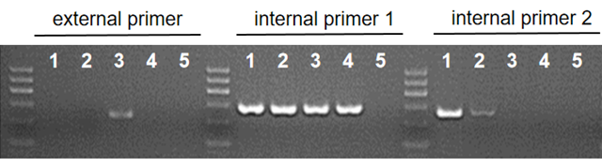
Figure S3. The GAP-PCR results of embryos for family 2. We designed one pair of external primers (HBA-absSEA230-F/R) and two pairs of internal primers (HBA-SEAR286-F/R, HBA-LAP-F/R) to verify whether the embryos carried the SEA deletion. Lane 1, gDNA of a normal people. Lane 2, E2-1. Lane 3, E2-2. Lane 4, E2-3. Lane 5, blank control. According to the results, E2-1 was unaffected, E2-2 was heterozygous and E2-3 was uncertain.

