Supplementary Text
Model comparison
We model that in 2019, 235 Mt of plastic waste were generated across 210 countries, territories, and special administrative regions (SARs) of which 92 Mt (range: 69-115 Mt) was mismanaged and leaked to the environment. These result are in-line with the estimate of Lau et al. (2020), who predict approximately 230 Mt of global plastic generation of which 100 Mt is mismanaged in 2016, and Lebreton and Andrady (2019), who calculated 181 Mt plastic waste was generated in 2015 of which 80Mt (60-99 Mt) was leaked to the environment (24, 26).

From this domestic mismanaged waste, we model that 34 Mt (21-48 Mt) entered the aquatic environment (i.e. lakes larger than 100 km², oceans, and rivers with a 50% chance, or less, of intermittence of at least 1 day per year; Fig. 1). Our estimate of plastic waste entering the aquatic environment, is within the uncertainty ranges of the estimate presented by Borrelle et al. (2020), who modeled values of approximately 30Mt for 2019 (22). Most global plastic leakage to aquatic environments occurs in Asia (25 Mt), followed by Australasia (9 Mt; 8-10 Mt), and Africa (8 Mt; 7-9 Mt), whereby, China (8 Mt), Indonesia (6 Mt), and Russia (3 Mt) represent nations with significant sources of aquatic plastic pollution. The most polluted watersheds were estimated to be the Yangtse in Asia (3 Mt), the Volga in Europe (1 Mt) and the Congo in Africa (1 Mt).

We model that 14 Mt (9-18 Mt) of plastic waste directly entered coastal environments (i.e. aquatic environments within 50 km of a coastline; Fig. 1). Although our estimate is higher than Jambeck et al.’s 2010 estimate of 4.8-12.7 Mts, our global average conversion of mismanaged waste plastic to coastal aquatic environments of 14%, calculated using spatially detailed mismanaged waste and aquatic features, is lower than Jambeck et al.’s original global assumption of 25% (25). The expected increase in total waste reaching coastal environments is a result of increased plastic waste generation per capita and population growth between 2010 and 2019 (42, 46).

Finally, we model that 1.7 Mt (1.1-2.2 Mt) of plastic waste entered oceans via rivers in 2019. Although estimates of plastic waste transported to oceans have yielded a wide range of results both at the global (0.47-2.75 Mt) and river scale, our results are generally in line with previous estimates of both scales that have included macroplastics (23, 27, 28, 58). Our results indicate that the river to ocean plastic flux is dominated by pollution within Asian rivers, though direct riverine comparisons are difficult as the ranges of previous estimates span four orders of magnitude. For instance, plastic pollution estimates in the Yangtze River range between 471-1.54*10⁶ tons and 10-1.76*10⁵ tons in the Indus River (59). Nonetheless, our estimates by river generally fall within these wide ranges (river estimates available in Supplementary Table 5). The vast majority of ocean plastic originates in the marine environments of the Malay Archipelago and Chinese coastline (910 kilotons; kt), but are also found to pollute the Bay of Bengal (77 kt), the Caribbean Sea (46 kt), Northern European Seas (27 kt) and the Gulf of Guinea (26 kt), threatening biodiverse Ecomarine regions across the planet (60, 61).

Sensitivity analysis
The ranges presented in this paper are the result of utilizing various sources of national scale plastic waste mismanagement rates, trade patterns, and aquatic environment reaches. In certain countries, national plastic waste mismanagement rates vary significantly depending on the reporting sources (e.g. Russia 18.5%-97.5% mismanagement rate) generating a significant amount of uncertainty (26, 42). Furthermore, the comparative fate of imported plastic waste compared to domestically produced plastic waste remains unclear. High-income countries typically guarantee the fate of their plastic waste exports as recyclate; however, research indicates that plastic waste imports are not more likely to be recycled than domestic waste and are frequently mixed with it (29, 50). Moreover, contaminated plastic waste that is not suitable for recycling is routinely mislabeled as recyclable to avoid trade restriction (13, 51). In certain cases, waste is imported to be recycled, despite importing parties having no infrastructure to do so, increasing the likelihood of the imports being mismanaged (19, 20).

In addition to unclear mismanagement rates of both domestic and imported waste, including trade adds an additional layer regarding international and intra-national re-exports. Although we model one generation of re-exports, untangling the plastic waste trade network remains extremely arduous. Countries are not obligated to report re-exports as such, and may export plastic waste illegally or report the waste under unrelated HS codes (20, 29, 35). For example, in 2019 authorities intercepted plastic waste illegally exported from Canada to India, via Belgium (13, 51). However, with congested ports, limited workforces, and massive volumes of goods to monitor, even suspicious trade cargo are typically not inspected (13). As a result, effectively tracking the original source, true quality, and true quantities of plastic waste exports remains an obstacle to develop global inventories of plastic waste sources (32).

Probabilistic models attempt to incorporate the influence of many parameters such as wind, terrain slope, and precipitation, river flow, and stream order however these can be difficult to properly calibrate, particularly at a global scale (23, 62). Other modelling approaches include observational extrapolation or linear regression models connected to environmental drivers, though these may be skewed by incomplete or unrepresentative samples (62–64). These different techniques have led estimates of plastic litter in the environment spanning more than four order of magnitudes across the literature (59). In the case of our probabilistic model, the relationship between mismanaged waste and the aquatic environment was a highly uncertain parameter. We modeled the spatial reach of the aquatic environment by using state-of-the-art hydrological information on the location of permanent surface water bodies, however the extent of the aquatic environment varies drastically depending on probability of intermittence used as the minimum threshold of a permanent water body (56).

To explore the influence of these uncertain factors on our model, we performed a sensitivity analysis on five key input parameters (Supplementary Fig. 1). First, we develop minimum and maximum plastic mismanagement waste rates for each country using the data reported by Kaza et al. (2018) and Lebreton and Andrady (2019), and their mean as a midpoint estimate. We find this decreases total aquatic plastic waste to a minimum of 23 Mt and a maximum of 50 Mt, highlighting the wide ranges of expected mismanaged wastes (Supplementary Table 1) for certain critical countries that generate large amounts of plastic waste annually such as China (range: 11Mt), Russia (range: 5Mt) and Indonesia (range: 1 Mt). Secondly, we modified which waste disposal pathways may be considered mismanaged for each income level. In this analysis we only consider dumped and unaccounted waste across all income levels as mismanaged waste (Extended Data Table 1). Doing so decreases mismanaged plastic waste to 28 Mt, with Indonesia (4 Mt) and China (2 Mt) accounting for the majority of this decrease. These two countries generate large amounts of plastic waste, of which more than 60% is disposed of in ‘unspecified landfills’ (Supplementary Table 6). Nevertheless, excluding these two countries, the majority of mismanaged waste in the midpoint estimate is reported as dumped or is unaccounted for, with only a fraction of mismanaged waste being considered as disposed of in various types of landfills (Supplementary Table 6. Thirdly, we adjusted the rate of waste mismanagement of imports by ± 50% (maximum of 100%) of the mismanagement rate of domestic waste. Doing so creates a range between 0.7-2.1Mt of trade plastic waste reaching the aquatic environment, most affecting Malaysia (range: 0.3 Mt), Vietnam (range: 0.3 Mt), and Thailand (range: 0.2 Mt) highlighting the importance of ensuring adequate plastic waste disposal capacity in all major importing nations. Fourthly, we explored the impact of removing our re-export modelling due to the inherent uncertainty from a lack of reported data. This slightly reduces our estimate to 1.2 Mt (from 1.5 Mt), as the majority of intermediaries were found to be high-income countries before reaching their final destination. Without the re-export algorithm these high-income countries, with low mismanagement rates become the destination of trade plastic waste, reducing the global mismanagement rate of traded plastics. With this form of the plastic waste trade, we expect Vietnam would leak 0.15 Mt less plastic waste, Thailand 0.08 Mt, and Malaysia 0.05 Mt. Finally, we altered the spatial reach of the aquatic environment, adjusting our criteria from rivers with a 50% chance or less of intermittence of at least 1 day per year to rivers with a 25% chance or less for a minimum estimate and a 75% chance or less for a maximum estimate. This parameter yields a total range of 25-43 Mt of total plastic waste entering the aquatic environment (Supplementary Fig. 1), particularly altering estimates in Asia, with China (range: 4 Mt), Thailand (range: 2Mt), India (range: 2Mt), Indonesia (range: 2Mt) accounting for the largest disparities.
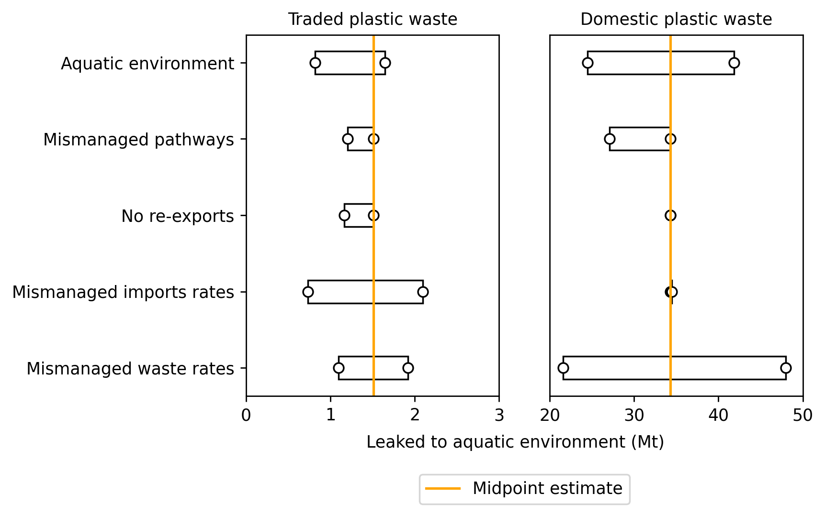
Supplementary Fig. 1 Results of sensitivity analysis. ‘Mismanaged waste rates’ indicates the ranges in domestic mismanaged waste rates provided by Kaza et al. (2018) and Lebreton and Andrady (2019). ‘Mismanaged import rates’ indicates a change of plus or minus 50% (maximum of 100%) in mismanaged rates of imports compared to domestic waste. ‘No re-exports’ removes the re-export algorithm applied to net-exporters (see methods). ‘Mismanaged pathways’ adjusts the mismanaged waste rates of Kaza et al. (2018) using only dumped or unaccounted waste (see Supplementary Table 6). ‘Aquatic environment’ adjusts the criteria of perennial rivers from 25-75% chance of intermittence for at least 1 day in year (midpoint = 50%).

Supplementary Table 6. Disposal pathways of plastic waste and their contribution to mismanagement. In red are pathways assumed to contribute to mismanagement in our midpoint estimate. These pathways are reduced to 0 in our sensitivity analysis to better understand their contribution to total plastic waste mismanagement.
 | Mismanaged waste (%)
 | HIC | UMC | LMC | LIC
Open dump | 100 | 100 | 100 | 100
Incineration | 0 | 0 | 0 | 0
Unspecified landfill | 0 | 0 | 0 | 0
Controlled landfill | 0 | 0 | 0 | 0
Sanitary landfill gas | 0 | 0 | 0 | 0
Recycling | 0 | 0 | 0 | 0
Other | 0 | 0 | 0 | 0
Unaccounted | 100 | 100 | 100 | 100
Marine Dump | 100 | 100 | 100 | 100

