Table S1: Prevalence of comorbidities and frailty index parameters in the study population (N = 1457).
Frailty index parameters
Physical
Physically inactive* | 3.0
Weak hand grip strength** (%) | 2.1
Ankle brachial index (ABI <= 0.9) (%) | 0.9
Underweight (BMI <=18.5 kg/m2) or obese (BMI >= 30 kg/m2)(%) | 17.0
Incontinence (%) | 12.4
Falling due to vertigo (%)
None | 98.2
Self-reported | 1.3
Confirmed by physician | 0.5
Interference with normal living due to pain during past 4 weeks (%)
Not at all | 60.2
A little | 37.4
A lot | 2.4
Limited in activities of daily living (ADL) due to poor health (%)
Not at all | 96.6
A little | 2.6
A lot | 0.8
Limited in moderate activities due to poor health (%)
Not at all | 84.0
A little | 13.5
A lot | 2.5
Limited while walking due to poor health (%)
Not at all | 94.9
A little | 3.8
A lot | 1.3
Limited in vigorous activities due to poor health (%)
Not at all | 73.9
A little | 22.6
A lot | 3.4
Limited while climbing stairs due to poor health (%)
Not at all | 91.5
A little | 7.0
A lot | 1.5
Cognitive factors
Speed ranked in lowest decile in DCS cohort | 5.2
Memory ranked in lowest decile in DCS cohort | 5.3
Flexibility ranked in lowest decile in DCS cohort | 4.1
Psychological
Poor self-perceived health (%) | 10.6
Feeling downhearted and blue (%)
Rarely | 84.2
Occasionally | 13.9
Continuously | 1.9
Feeling happiness (%)
Rarely | 2.9
Occasionally | 23.2
Continuously | 73.9
Feeling a lack of energy (%)
Rarely | 73.5
Occasionally | 24.6
Continuously | 1.8
Feeling worn out (%)
Rarely | 69.3
Occasionally | 29.2
Continuously | 1.4
Comorbidity related frailty parameters
Cardiovascular disease (%) | 3.9
High systolic blood pressure (>= 160 mmHg) (%) | 5.8
Diabetes (%) | 6.9
Self-reported malignancy (%) | 11.3
Joint inflammation (%) | 10.0
Osteoporosis (%) | 7.3
Cerebrovascular accident (CVA) (%) | 1.2
Migraine (%) | 12.7
Nervous system diseases (%) | 0.8
Low spirometry ratio (FEV/FVC <= 0.7) (%) | 20.7
Impaired renal function (eGFR < 60) (%) | 7.8
Trouble with eyesight (%) | 5.6
Trouble hearing (%) | 4.5
Severe lower back pain (%)
None | 84.9
Self-reported | 4.9
Confirmed by physician | 10.2
Severe digestive tract disorders (%)
None | 95.0
Self-reported | 1.4
Confirmed by physician | 3.6
Asthma (%)
No Asthma | 94.0
Asthma without attacks | 5.3
Asthma with attacks | 0.7
Other comorbidities
Arthrosis (%) | 29.6
Psoriasis (%) | 6.4
Ever high blood pressure (%) | 48.2
Hypertension (%) | 47.4
Myocardial infarction (%) | 3.3
Coronary artery bypass (%) | 2.1
Balloon dilation (%) | 2.6
Cardiac catheterization (%) | 7.0
Pacemaker (%) | 1.4
Vascular surgery (%) | 1.4
Any comorbidity (%) | 54.9
* Physically inactive is based on failing to meet the Dutch healthy exercise norm, belonging to the 25th lowest percentile of walking activity, and belonging to the 10th percentile lowest low/medium/high intensive activities in the DCS.
** Hand grip strength is adjusted for sex and BMI, with weak hand grip strength referring to a handgrip strength of <17 through >21 kg for women with a BMI ranging between <23 through >29. And a hand grip strength of <29 through >32 kg for men with a BMI ranging between <24 through >28.

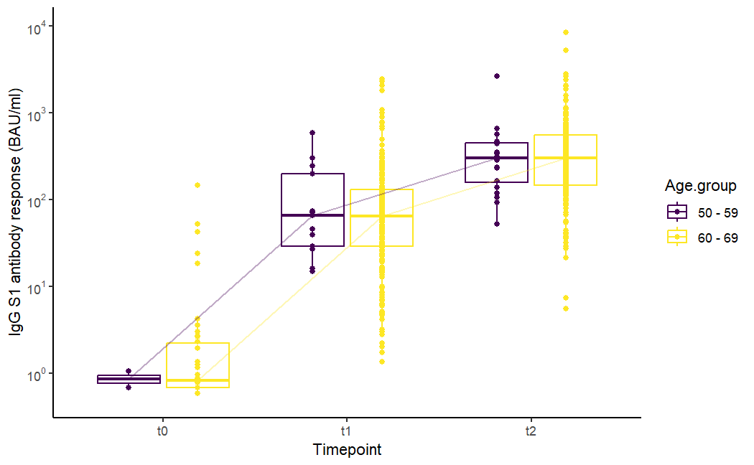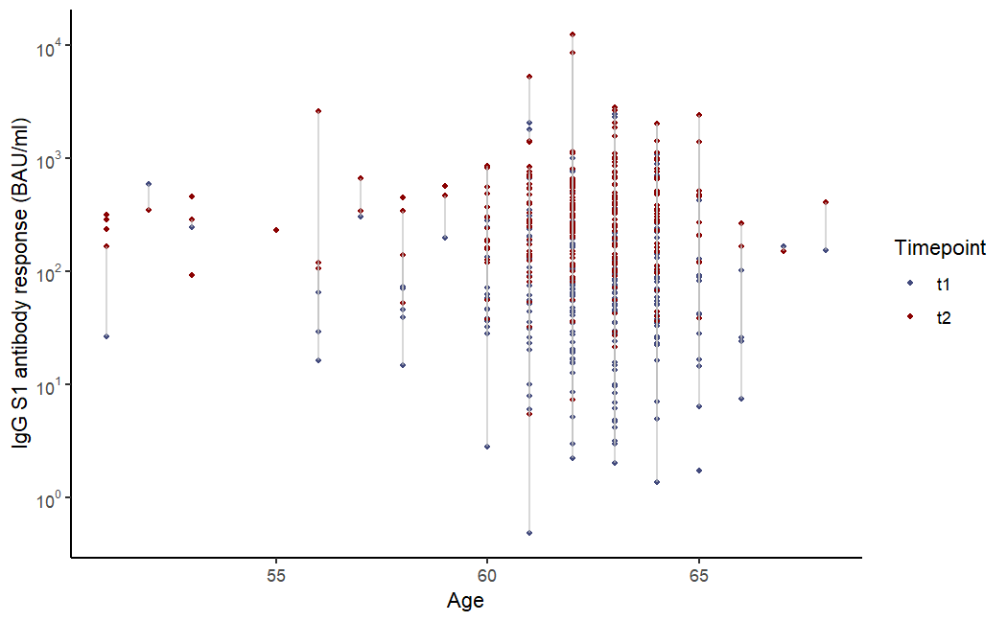
A
B
Figure S1: Distribution of the SARS-CoV-2 -S1 IgG antibody concentrations in binding antibody units per milliliter (BAU/ml) in persons aged 50-70 years of age vaccinated with AZD1222 at T0, T1, and T2 per ten year age group (A) and matched antibody concentrations per individual at T1 (blue) and T2 (red) across age in years (B).

Table S2: Linear correlation of determinants and anti-S1 IgG concentrations one month after first vaccination dose (T1), second vaccination dose (T2), and the log-fold increase (LFC) during the primary vaccination series with BNT162b2, corrected for age and sex. Statistically significant (P <= 0.05) associations are made bold.
 | T1 |  |  | T2 |  |  | LFC
 | β | Error | P | β | Error | P | β | Error | P
Socioeconomic status | -3.8E-02 | 5.6E-02 | 5.0E-01 | -2.0E-02 | 3.6E-02 | 5.8E-01 | 1.3E-02 | 4.4E-02 | 7.6E-01
Physically active (NNGB) | -4.8E-02 | 9.6E-02 | 6.2E-01 | 1.4E-02 | 6.1E-02 | 8.3E-01 | 1.3E-01 | 7.6E-02 | 8.9E-02
Waist circumference | -1.3E-02 | 4.1E-03 | 1.1E-03 | 5.4E-04 | 2.6E-03 | 8.4E-01 | 1.3E-02 | 3.2E-03 | 4.0E-05
Currently smoking | -1.9E-01 | 3.7E-01 | 6.1E-01 | -1.2E-01 | 2.4E-01 | 6.3E-01 | 1.2E-01 | 3.0E-01 | 7.0E-01
Drinking alcohol | -3.9E-02 | 1.0E-01 | 7.0E-01 | -9.7E-02 | 6.5E-02 | 1.4E-01 | -1.5E-03 | 8.1E-02 | 9.9E-01
Systolic blood pressure | 2.4E-03 | 2.9E-03 | 4.0E-01 | 1.6E-03 | 1.9E-03 | 4.0E-01 | -1.5E-03 | 2.3E-03 | 5.2E-01
Total cholesterol | 6.4E-02 | 4.5E-02 | 1.6E-01 | 1.8E-02 | 2.9E-02 | 5.4E-01 | -2.2E-02 | 3.6E-02 | 5.4E-01
HDL cholesterol | 2.9E-01 | 1.2E-01 | 1.6E-02 | 6.5E-02 | 7.8E-02 | 4.0E-01 | -2.2E-01 | 9.5E-02 | 2.0E-02
Creatinine | -4.2E-03 | 3.3E-03 | 2.1E-01 | -3.3E-03 | 2.2E-03 | 1.3E-01 | 2.0E-03 | 2.6E-03 | 4.4E-01
Glucose | -5.7E-02 | 2.9E-02 | 5.1E-02 | -2.6E-02 | 2.0E-02 | 1.9E-01 | 4.6E-02 | 2.3E-02 | 4.8E-02
GlycA | -3.7E-01 | 4.1E-01 | 3.7E-01 | 2.0E-01 | 2.6E-01 | 4.4E-01 | 3.3E-01 | 3.2E-01 | 3.0E-01
CRP | 7.5E-03 | 1.1E-02 | 4.8E-01 | 3.7E-03 | 6.9E-03 | 5.9E-01 | -4.8E-03 | 8.2E-03 | 5.6E-01
Frailty index | -2.3 | 7.2E-01 | 1.4E-03 | -8.1E-01 | 4.6E-01 | 8.1E-02 | 1.6 | 5.7E-01 | 5.1E-03
Kidney function (eGFR) | -5.5E-01 | 2.4E-01 | 2.1E-02 | 8.7E-02 | 1.5E-01 | 5.7E-01 | 5.8E-01 | 1.9E-01 | 2.4E-03
FEV1 max | -1.7E-01 | 8.5E-02 | 4.7E-02 | -7.4E-02 | 5.6E-02 | 1.9E-01 | 6.5E-02 | 6.8E-02 | 3.4E-01
FVC max | -6.5E-02 | 6.7E-02 | 3.3E-01 | -5.1E-02 | 4.3E-02 | 2.4E-01 | -5.5E-03 | 5.3E-02 | 9.2E-01
Lung function (FEV1/FVC) | -6.4E-01 | 6.6E-01 | 3.3E-01 | 3.4E-01 | 4.3E-01 | 4.3E-01 | 9.3E-01 | 5.4E-01 | 8.3E-02
Number of comorbidities | -1.2E-02 | 3.3E-02 | 7.3E-01 | 1.8E-02 | 2.2E-02 | 4.1E-01 | 1.4E-02 | 2.7E-02 | 5.9E-01
Having any comorbidity | -7.7E-02 | 9.7E-02 | 4.3E-01 | -2.2E-02 | 6.2E-02 | 7.3E-01 | 3.6E-02 | 7.7E-02 | 6.4E-01
Bypass | -1.3E-01 | 3.3E-01 | 6.9E-01 | 2.0E-01 | 2.1E-01 | 3.4E-01 | 1.4E-01 | 2.5E-01 | 5.9E-01
Balloon dilation | -7.3E-01 | 3.1E-01 | 2.0E-02 | -3.3E-01 | 1.9E-01 | 8.7E-02 | 2.8E-01 | 2.4E-01 | 2.5E-01
Cardiac catheterization | -3.6E-01 | 1.8E-01 | 4.8E-02 | -8.3E-02 | 1.1E-01 | 4.7E-01 | 2.4E-01 | 1.4E-01 | 9.8E-02
Pacemaker | -1.2E-01 | 3.6E-01 | 7.4E-01 | -3.0E-02 | 2.2E-01 | 8.9E-01 | 1.6E-01 | 2.7E-01 | 5.6E-01
Vascular surgery | -1.9E-01 | 4.0E-01 | 6.4E-01 | -3.3E-01 | 2.5E-01 | 1.8E-01 | -2.5E-01 | 3.1E-01 | 4.2E-01
Cardiovascular disease | 1.1E-01 | 2.3E-01 | 6.5E-01 | 7.2E-02 | 1.5E-01 | 6.2E-01 | -1.4E-01 | 1.8E-01 | 4.4E-01
Myocardial infarction | 5.6E-01 | 5.7E-01 | 3.2E-01 | 7.2E-01 | 3.3E-01 | 3.0E-02 | -2.9E-03 | 4.4E-01 | 9.9E-01
Stroke | 2.2E-02 | 4.7E-01 | 9.6E-01 | -9.0E-02 | 3.2E-01 | 7.7E-01 | -7.5E-02 | 3.7E-01 | 8.4E-01
Ever high blood pressure | 2.0E-02 | 1.8E-01 | 9.1E-01 | 1.5E-01 | 1.1E-01 | 1.8E-01 | 7.4E-02 | 1.4E-01 | 6.1E-01
Diabetes | -6.9E-01 | 3.4E-01 | 4.3E-02 | -2.2E-01 | 2.3E-01 | 3.3E-01 | 7.3E-01 | 2.8E-01 | 9.4E-03
Hypertension | -1.2E-02 | 9.6E-02 | 9.0E-01 | 1.3E-02 | 6.2E-02 | 8.4E-01 | 2.9E-02 | 7.6E-02 | 7.1E-01
Migraine | -3.0E-01 | 2.5E-01 | 2.4E-01 | -6.6E-02 | 1.7E-01 | 7.0E-01 | 1.9E-01 | 2.1E-01 | 3.8E-01
Gastrointestinal disease | -6.8E-01 | 4.0E-01 | 9.2E-02 | -4.8E-01 | 2.9E-01 | 1.0E-01 | 4.6E-01 | 3.6E-01 | 2.0E-01
Psoriasis | 2.0E-01 | 3.4E-01 | 5.5E-01 | 1.2E-01 | 2.3E-01 | 5.9E-01 | 5.1E-03 | 2.7E-01 | 9.8E-01
Incontinence | 1.1E-01 | 2.5E-01 | 6.7E-01 | -7.3E-02 | 1.7E-01 | 6.6E-01 | 2.5E-02 | 2.1E-01 | 9.0E-01
Hernia | 1.1E-01 | 2.7E-01 | 6.7E-01 | 1.0E-01 | 1.8E-01 | 5.8E-01 | -7.7E-02 | 2.2E-01 | 7.3E-01
Arthrosis | 1.8E-01 | 1.9E-01 | 3.6E-01 | 1.6E-01 | 1.3E-01 | 2.1E-01 | -1.0E-01 | 1.6E-01 | 5.2E-01
Joint inflammation | -9.1E-02 | 2.9E-01 | 7.5E-01 | -2.0E-01 | 1.9E-01 | 3.0E-01 | -2.8E-01 | 2.4E-01 | 2.4E-01
Osteoporosis | -1.5E-03 | 3.3E-01 | 1.0 | 3.3E-01 | 2.3E-01 | 1.4E-01 | -1.7E-01 | 2.8E-01 | 5.4E-01
Nervous system diseases | -7.7E-01 | 9.7E-01 | 4.3E-01 | 4.3E-01 | 9.1E-01 | 6.4E-01 | 8.5E-02 | 1.1 | 9.4E-01
Falling due to vertigo | -2.5E-01 | 4.4E-01 | 5.7E-01 | -4.2E-01 | 2.7E-01 | 1.2E-01 | -2.1E-01 | 3.4E-01 | 5.4E-01
High blood pressure now | -1.0E-01 | 1.8E-01 | 5.8E-01 | 2.2E-02 | 1.2E-01 | 8.5E-01 | 1.4E-01 | 1.4E-01 | 3.4E-01
Malignancy | 2.2E-02 | 1.4E-01 | 8.8E-01 | -1.7E-02 | 9.2E-02 | 8.6E-01 | 2.5E-02 | 1.1E-01 | 8.3E-01
Lower back pain | -3.9E-01 | 1.5E-01 | 1.1E-02 | -2.3E-01 | 9.7E-02 | 1.9E-02 | 1.8E-01 | 1.2E-01 | 1.4E-01
Cerebrovascular accident | -3.4E-01 | 5.2E-01 | 5.1E-01 | 2.2E-02 | 3.5E-01 | 9.5E-01 | 3.2E-01 | 4.3E-01 | 4.6E-01
Neurologic disease | -6.9E-01 | 5.6E-01 | 2.2E-01 | -2.9E-01 | 3.8E-01 | 4.5E-01 | 4.8E-01 | 4.8E-01 | 3.2E-01
Asthma | 2.6E-01 | 3.4E-01 | 4.4E-01 | 4.0E-01 | 2.2E-01 | 7.1E-02 | 2.2E-01 | 2.7E-01 | 4.3E-01
Impaired eyesight | -1.5E-01 | 1.9E-01 | 4.3E-01 | 1.0E-01 | 1.3E-01 | 4.4E-01 | 8.2E-02 | 1.6E-01 | 6.1E-01
Impaired hearing | 1.7E-02 | 2.3E-01 | 9.4E-01 | -5.6E-02 | 1.4E-01 | 7.0E-01 | 1.9E-02 | 1.9E-01 | 9.2E-01
Feeling downhearted | -2.9E-01 | 2.1E-01 | 1.7E-01 | -1.8E-01 | 1.4E-01 | 2.0E-01 | 1.6E-01 | 1.7E-01 | 3.6E-01
Feeling happiness | -4.1E-02 | 1.8E-01 | 8.2E-01 | 1.2E-01 | 1.2E-01 | 3.2E-01 | 1.6E-01 | 1.5E-01 | 2.7E-01
Feeling a lack of energy | -1.6E-01 | 1.9E-01 | 4.0E-01 | 2.6E-02 | 1.2E-01 | 8.4E-01 | 2.3E-01 | 1.5E-01 | 1.4E-01
Feeling worn out | -2.1E-01 | 1.9E-01 | 2.8E-01 | -1.1E-02 | 1.2E-01 | 9.3E-01 | 1.3E-01 | 1.5E-01 | 4.1E-01
Physically inactive | 2.0E-01 | 2.8E-01 | 4.8E-01 | -5.9E-03 | 1.8E-01 | 9.7E-01 | -3.1E-01 | 2.2E-01 | 1.6E-01
Limited in ADL | -3.0E-01 | 3.8E-01 | 4.3E-01 | 1.1E-01 | 2.8E-01 | 7.0E-01 | 4.4E-01 | 3.3E-01 | 1.9E-01
Limited in moderate activities | -5.0E-01 | 2.2E-01 | 2.2E-02 | -2.9E-01 | 1.4E-01 | 3.9E-02 | 1.9E-01 | 1.7E-01 | 2.7E-01
Limited while walking | -3.0E-02 | 3.2E-01 | 9.3E-01 | -7.0E-02 | 2.3E-01 | 7.6E-01 | 2.0E-01 | 2.8E-01 | 4.8E-01
Limited in vigorous activities | -3.6E-01 | 1.9E-01 | 6.0E-02 | -1.7E-01 | 1.2E-01 | 1.8E-01 | 2.0E-01 | 1.6E-01 | 2.0E-01
Limited while climbing stairs | -6.4E-02 | 2.7E-01 | 8.2E-01 | 1.3E-01 | 1.9E-01 | 5.0E-01 | 2.8E-01 | 2.3E-01 | 2.2E-01
Grip strength | 1.7E-01 | 3.3E-01 | 6.1E-01 | 2.6E-03 | 2.2E-01 | 9.9E-01 | -8.9E-02 | 2.6E-01 | 7.3E-01
Cognition: Speed <= 10th population percentile | -1.2E-01 | 2.7E-01 | 6.5E-01 | -7.1E-02 | 1.8E-01 | 7.0E-01 | 2.7E-01 | 2.1E-01 | 2.1E-01
Cognition: Memory <= 10th population percentile | 9.7E-02 | 2.6E-01 | 7.1E-01 | -1.8E-01 | 1.6E-01 | 2.6E-01 | -1.2E-01 | 2.0E-01 | 5.7E-01
Cognition: Flexibility <= 10th population percentile | -3.4E-01 | 3.1E-01 | 2.7E-01 | -4.7E-01 | 2.0E-01 | 1.9E-02 | 5.0E-02 | 2.5E-01 | 8.4E-01
BMI | -3.0E-02 | 1.1E-02 | 6.1E-03 | 4.2E-03 | 7.0E-03 | 5.5E-01 | 3.4E-02 | 8.6E-03 | 8.9E-05
Pain | -1.8E-01 | 1.7E-01 | 3.1E-01 | -8.9E-02 | 1.1E-01 | 4.3E-01 | 1.2E-01 | 1.4E-01 | 3.9E-01
Ankle brachial index | 9.9E-02 | 5.7E-01 | 8.6E-01 | 1.8E-01 | 3.0E-01 | 5.4E-01 | 2.4E-01 | 4.3E-01 | 5.7E-01
Poor self-perceived health | -1.3E-01 | 1.6E-01 | 4.1E-01 | -2.0E-02 | 1.0E-01 | 8.5E-01 | 1.5E-01 | 1.3E-01 | 2.4E-01

Table S3: Multivariate correlation of sociodemographic and cardiometabolic determinants with the anti-S1 antibody concentrations one month after first vaccination dose (T1), second vaccination dose (T2), and the log-fold increase (LFC) during the primary vaccination series with BNT162b2. Statistically significant (P <= 0.05) associations are made bold.
 | T1 |  |  | T2 |  |  | LFC
 | β | 95% CI | P | β | 95% CI | P | Β | 95% CI | P
Female sex | -3.8E-01 | -1.1, 3.2E-01 | 2.8E-01 | 1.1E-01 | -3.5E-01, 5.7E-01 | 6.3E-01 | 6.0E-01 | 5.0E-02, 1.2 | 3.3E-02
Age | -6.2E-02 | -1.1E-01, -1.8E-02 | 5.8E-03 | -3.1E-02 | -6.0E-02, -2.3E-03 | 3.4E-02 | 3.2E-02 | -3.4E-03, 6.6E-02 | 7.6E-02
Middle socio-economic status | -5.4E-02 | -5.5E-01, 4.4E-01 | 8.3E-01 | 8.7E-02 | -2.2E-01, 4.0E-01 | 5.8E-01 | 1.2E-01 | -2.7E-01, 5.0E-01 | 5.4E-01
High socio-economic status | -1.9E-01 | -6.8E-01, 3.0E-01 | 4.4E-01 | -7.2E-03 | -3.2E-01, 3.1E-01 | 9.6E-01 | 9.5E-02 | -2.9E-01, 4.8E-01 | 6.2E-01
Physically active (NNGB) | -2.3E-01 | -6.7E-01, 2.1E-01 | 3.0E-01 | -1.7E-02 | -2.9E-01, 2.6E-01 | 9.1E-01 | 4.4E-01 | 9.4E-02, 7.9E-01 | 1.3E-02
Waist circumference (per 10cm) | -1.8E-03 | -3.3E-01, 3.2E-01 | 9.9E-01 | 8.1E-02 | -1.2E-01, 2.8E-01 | 4.3E-01 | 8.4E-02 | -1.6E-01, 3.3E-01 | 5.1E-01
Current smoker | -1.5E-01 | -1.0, 7.3E-01 | 7.4E-01 | -3.0E-03 | -5.4E-01, 5.3E-01 | 9.9E-01 | 2.8E-01 | -3.7E-01, 9.4E-01 | 4.0E-01
Alcohol consumption | -8.0E-02 | -5.2E-01, 3.6E-01 | 7.2E-01 | -1.1E-01 | -3.9E-01, 1.6E-01 | 4.2E-01 | 8.1E-02 | -2.7E-01, 4.3E-01 | 6.5E-01
Systole (per 10 mmHg) | 3.8E-02 | -8.8E-02, 1.6E-01 | 5.5E-01 | 6.3E-02 | -1.7E-02, 1.4E-01 | 1.2E-01 | 1.6E-02 | -8.1E-02, 1.1E-01 | 7.5E-01
Cholesterol (mmol/L) | 8.7E-02 | -1.2E-01, 2.9E-01 | 4.1E-01 | 1.5E-02 | -1.1E-01, 1.4E-01 | 8.1E-01 | -1.8E-02 | -1.8E-01, 1.4E-01 | 8.2E-01
HDL (mmol/L) | 2.5E-01 | -3.8E-01, 8.8E-01 | 4.4E-01 | 1.5E-01 | -2.4E-01, 5.4E-01 | 4.4E-01 | -7.7E-02 | -5.9E-01, 4.3E-01 | 7.6E-01
Creatinine (per 10 mmol/L) | -7.3E-02 | -3.1E-01, 1.6E-01 | 5.5E-01 | -3.8E-02 | -1.9E-01, 1.1E-01 | 6.2E-01 | 9.1E-02 | -8.9E-02, 2.7E-01 | 3.2E-01
Glucose (mmol/L) | -3.0E-02 | -1.5E-01, 8.6E-02 | 6.1E-01 | -2.5E-02 | -1.0E-01, 5.3E-02 | 5.3E-01 | 5.7E-02 | -3.6E-02, 1.5E-01 | 2.3E-01
GlycA (mmol/L) | 5.2E-02 | -1.8, 1.90 | 9.6E-01 | 6.4E-01 | -5.6E-01, 1.8 | 2.9E-01 | 3.4E-01 | -1.1, 1.8 | 6.5E-01
CRP (mmol/L) | 5.2E-03 | -3.2E-02, 4.2E-02 | 7.8E-01 | -4.6E-03 | -2.7E-02, 1.8E-02 | 6.9E-01 | -1.0E-02 | -3.8E-02, 1.7E-02 | 4.6E-01
Frailty index | -1.8 | -5.7, 2.0 | 3.5E-01 | -7.4E-01 | -3.3, 1.8 | 5.6E-01 | 1.1 | -2.0, 4.3 | 4.9E-01
eGFR | -1.1 | -3.4, 1.2 | 3.6E-01 | -4.4E-02 | -1.5, 1.4 | 9.5E-01 | 1.6 | -2.2E-01, 3.4 | 8.6E-02
FEV1/FVC ratio | 1.4 | -8.5, 1.1E+01 | 7.8E-01 | 2.9 | -3.0, 8.8 | 3.4E-01 | 9.2E-01 | -6.6, 8.5 | 8.1E-01
Number of comorbidities | 8.9E-02 | -5.8E-02, 2.4E-01 | 2.3E-01 | 3.1E-02 | -6.0E-02, 1.2E-01 | 5.0E-01 | -9.0E-02 | -2.0E-01, 2.4E-02 | 1.2E-01

Table S4: Multivariate correlation of comorbidities and frailty index parameters with the anti-S1 antibody concentrations one month after first vaccination dose (T1), second vaccination dose (T2), and the log-fold increase (LFC) during the primary vaccination series with BNT162b2. Statistically significant (P <= 0.05) associations are made bold.
 | T1 |  |  | T2 |  |  | LFC
 | β | 95% CI | P | β | 95% CI | P | β | 95% CI | P
Age | -4.5E-02 | -7.5E-02, -1.5E-02 | 3.3E-03 | -3.0E-02 | -4.7E-02, -1.2E-02 | 1.3E-03 | -4.0E-03 | -3.1E-02, 2.3E-02 | 7.7E-01
Having any comorbidity | -6.6E-01 | -1.2E+00, -9.6E-02 | 2.2E-02
Arthrosis | 2.8E-01 | -1.4E-01, 7.0E-01 | 1.9E-01
Asthma | -3.3E-01 | -1.8E+00, 1.1E+00 | 6.6E-01
BMI | -2.8E-01 | -7.6E-01, 2.0E-01 | 2.6E-01 | 3.1E-01 | 2.5E-02, 6.0E-01 | 3.3E-02 | 4.0E-01 | -2.4E-02, 8.2E-01 | 6.4E-02
Cardiac catheterization | -1.9E+00 | -3.2E+00, -6.0E-01 | 4.4E-03 | -6.3E-02 | -4.3E-01, 3.0E-01 | 7.3E-01 | 7.9E-02 | -4.5E-01, 6.1E-01 | 7.7E-01
Cardiovascular disease | 1.7E+00 | 5.4E-01, 2.9E+00 | 4.6E-03
Cognition: memory <= 10th population percentile |  |  |  | -5.2E-02 | -5.0E-01, 4.0E-01 | 8.2E-01 | -2.1E-01 | -8.8E-01, 4.7E-01 | 5.5E-01
Cognition: speed <= 10th population percentile | -7.0E-01 | -1.5E+00, 7.7E-02 | 7.7E-02 | -5.9E-01 | -1.0E+00, -1.4E-01 | 1.1E-02 | 7.0E-01 | 3.7E-02, 1.4E+00 | 3.9E-02
Feeling downhearted | -3.9E-01 | -1.3E+00, 5.6E-01 | 4.1E-01
Diabetes | -5.7E-01 | -1.3E+00, 1.8E-01 | 1.3E-01 | -3.4E-01 | -8.1E-01, 1.3E-01 | 1.5E-01 | 5.5E-01 | -1.3E-01, 1.2E+00 | 1.1E-01
Gastrointestinal disease |  |  |  | -6.5E-01 | -1.2E+00, -1.0E-01 | 2.0E-02 | 3.2E-01 | -4.7E-01, 1.1E+00 | 4.3E-01
Impaired hearing | 2.0E-02 | -1.3E+00, 1.3E+00 | 9.8E-01
Joint inflammation | 3.9E-01 | -2.4E-01, 1.0E+00 | 2.3E-01
Lower-back pain | -6.0E-01 | -1.2E+00, 3.1E-02 | 6.2E-02 | -4.1E-01 | -8.1E-01, -1.5E-02 | 4.2E-02 | 2.0E-02 | -5.7E-01, 6.1E-01 | 9.5E-01
Feeling a lack of energy | 5.1E-01 | -4.2E-01, 1.4E+00 | 2.8E-01 | 2.3E-01 | -2.9E-01, 7.5E-01 | 3.9E-01 | -5.8E-02 | -8.2E-01, 7.1E-01 | 8.8E-01
Osteoporosis |  |  |  | 5.2E-01 | 5.7E-02, 9.8E-01 | 2.8E-02 | 3.6E-02 | -6.5E-01, 7.2E-01 | 9.2E-01
Physically inactive |  |  |  | -9.0E-01 | -1.8E+00, 4.0E-02 | 6.0E-02 | -2.0E-01 | -1.5E+00, 1.1E+00 | 7.6E-01
Psoriasis | 5.7E-01 | -1.2E-01, 1.3E+00 | 1.0E-01
Low spirometry ratio | -2.7E-01 | -7.3E-01, 1.9E-01 | 2.4E-01 | -2.6E-01 | -5.2E-01, 3.1E-03 | 5.3E-02 | -1.6E-01 | -5.4E-01, 2.2E-01 | 4.1E-01

