Additional file 1
Supplementary Tables and Figures
Table S1. Summary of the 51 isolates used for the MAT-genotyping in the current study.
Isolate name | Species | Continent | Country (location) | Collector/Donor | Year of isolation from soil/in vitro | Origin | Single MAT sequence amplified with primer
1A | R. proliferus | Africa | Ivory Coast | G. Droh | 2013/2013 | Cacao orchard | Yes
2A | R. proliferus | Africa | Ivory Coast | G. Droh | 2013/2013 | Cacao orchard | Yes
3A | R. proliferus | Africa | Ivory Coast | G. Droh | 2013/2013 | Cacao orchard | Yes
4A | R. proliferus | Africa | Ivory Coast | G. Droh | 2013/2013 | Cacao orchard | Yes
5A | R. proliferus | Africa | Ivory Coast | G. Droh | 2013/2013 | Cacao orchard | Yes
6A | R. proliferus | Africa | Ivory Coast | G. Droh | 2013/2013 | Cacao orchard | Yes
7A | R. proliferus | Africa | Ivory Coast | G. Droh | 2013/2013 | Cacao orchard | Yes
8A | R. proliferus | Africa | Ivory Coast | G. Droh | 2013/2013 | Cacao orchard | Yes
9A | R. proliferus | Africa | Ivory Coast | G. Droh | 2013/2013 | Cacao orchard | Yes
10A | R. proliferus | Africa | Ivory Coast | G. Droh | 2013/2013 | Cacao orchard | Yes
11A | R. proliferus | Africa | Ivory Coast | G. Droh | 2013/2013 | Cacao orchard | Yes
12A | R. proliferus | Africa | Ivory Coast | G. Droh | 2013/2013 | Cacao orchard | Yes
13A | R. proliferus | Africa | Ivory Coast | G. Droh | 2013/2013 | Cacao orchard | Yes
14A | R. proliferus | Africa | Ivory Coast | G. Droh | 2013/2013 | Cacao orchard | Yes
5B | R. irregularis | unknown | unknown | Symbiom | unknown | unknown | Yes
7B | R. irregularis | unknown | unknown | Symbiom | unknown | unknown | Yes
A1 | R. irregularis | Europe | Switzerland, Tanikon | J. Jansa | ~1999/~1999 | Field without tillage | Yes
AZ151 | R. intraradices | North America | USA, Arizona | J. Morton (INVAM) | 1998/2013 | unknown | Yes
B1 | R. irregularis | Europe | Switzerland, Tanikon | J. Jansa | ~1999/~1999 | Field without tillage | Yes
B10 | R. irregularis | Europe | Switzerland, Tanikon | J. Jansa | ~1999/~1999 | Field without tillage | Yes
B12 | R. irregularis | Europe | Switzerland, Tanikon | J. Jansa | ~1999/~1999 | Field without tillage | Yes
B4 | R. irregularis | Europe | Switzerland, Tanikon | J. Jansa | ~1999/~1999 | Field without tillage | Yes
BEG53 | R. irregularis | North America | Canada, Québec | D. Redecker (BEG) | 1982/2013 | unknown | Yes
BEG72 | R. irregularis | Europe | Spain, South Catalonia | A. Camprubi (IRTA) | unknown/ 2013 | unknown | Yes
BEG144 | R. irregularis | Europe | Russia, Gatchina | D. Redecker (BEG) | 1979/2013 | Maize field | Yes
C2 | R. irregularis | Europe | Switzerland, Tanikon | J. Jansa | ~1999/~1999 | Field with tillage | Yes
C5 | R. irregularis | Europe | Switzerland, Tanikon | J. Jansa | ~1999/~1999 | Field with tillage | Yes
CH3 | Rhizophagus sp. | Europe | Czech Republic | Symbiom | unknown | unknown | Yes
D3 | R. irregularis | Europe | Switzerland, Tanikon | J. Jansa | ~1999/~1999 | Field with tillage | Yes
D4 | R. irregularis | Europe | Switzerland, Tanikon | J. Jansa | ~1999/~1999 | Field with tillage | Yes
DAOM229457 | R. irregularis | North America | Canada, Ontario | Y.Dalpe (GINCO) | unknown | Agricultural field | Yes
DAOM234180 | R. irregularis | North America | Canada, Québec | Y.Dalpe (GINCO) | 1998/unknown | Agricultural field | Yes
DAOM224181 | R. irregularis | North America | Canada, Québec | Y.Dalpe (GINCO) | 2000/unknown | Fixed dunes | Yes
DAOM234328 | R. irregularis | Europe | Finland, Laukaa | Y.Dalpe (GINCO) | unknown | Side of the road | Yes
DAOM240158 | R. irregularis | unknown | unknown | unknown | unknown | unknown | Yes
DAOM240443 | R. irregularis | North America | Canada, Québec | Y.Dalpe (GINCO) | 2000/unknown | Fixed dunes | Yes
DAOM240448 | R. irregularis | Africa | Tunisia | Y.Dalpe (GINCO) | 2005/unknown | unknown | Yes
DAOM240721 | R. irregularis | Europe | Belgium, Louvain-la-Neuve | Y.Dalpe (GINCO) | 2004/unknown | Garden | Yes
ESQLS69 | Rhizophagus sp. (previously assigned to R. irregularis in Savary et al.(2018)) | Europe | Czech Republic | Symbiom | unknown | unknown | Yes
FL208 | R. intraradices | North America | USA, Florida | J. Morton (INVAM) | 1978/2013 | Citrus orchard | Yes
FL707 | R. irregularis | North America | USA, Florida | J. Morton (INVAM) | 2000/2013 | Sugarcane field | Yes
GLAM | R. irregularis | Europe | UK | Symbiom | unknown | unknown | Yes
India1105 | R. irregularis | North America | Canada, Québec | A. Adholeya (TERI) | unknown | unknown | Yes
KUVA | Rhizophagus sp. (previously assigned to R. irregularis in Savary et al.(2018)) | Middle East | Kuwait | Symbiom | unknown | unknown | Yes
LPA8 | Rhizophagus sp. | Europe | France, Burgundy | Symbiom | 1978/unknown | unknown | Yes
LPA9 | R. irregularis | Europe | Greece, Cap sounion | Symbiom | 1980/unknown | Wasteland | Yes
LPA54 | Rhizophagus sp. (previously assigned to R. irregularis in Savary et al.(2018)) | Europe | Denmark | unknown | unknown | unknown | Yes
SAMP7 | R. irregularis | Europe | UK | Symbiom | unknown | unknown | Yes
Tu101 | R. intraradices | Europe | Turkey | J. Morton (INVAM) | 1996/2013 | Cotton field | Yes
UK128 | R. intraradices | Europe | UK | J. Morton (INVAM) | 1993/2013 | Rothamsted Expt. Station | Yes
UK131 | R. intraradices | Europe | UK | J. Morton (INVAM) | 1995/2013 | unknown | Yes

Table S2. Degenerated primers designed for MAT-genotyping.
Name | Sequence | Length (bp) | Tm (°C) | GC content
SJF | 5'-CGTGRGCGKATTACCAAGGA-3' | 20 | 64.3 | 55%
SJR | 5'-GACATGGTTCAATAATAGAAGAAATCG-3' | 27 | 61 | 33.3%

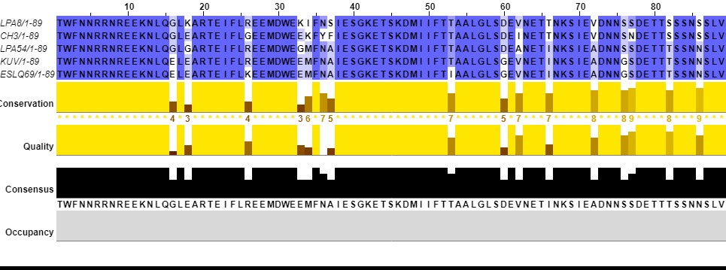
Figure S1. Amino acid sequence similarity of the MAT-locus within a Rhizophagus irregularis cluster. The amino acid sequences represent the encoded HD2 protein and positions where amino acids differ are highlighted.

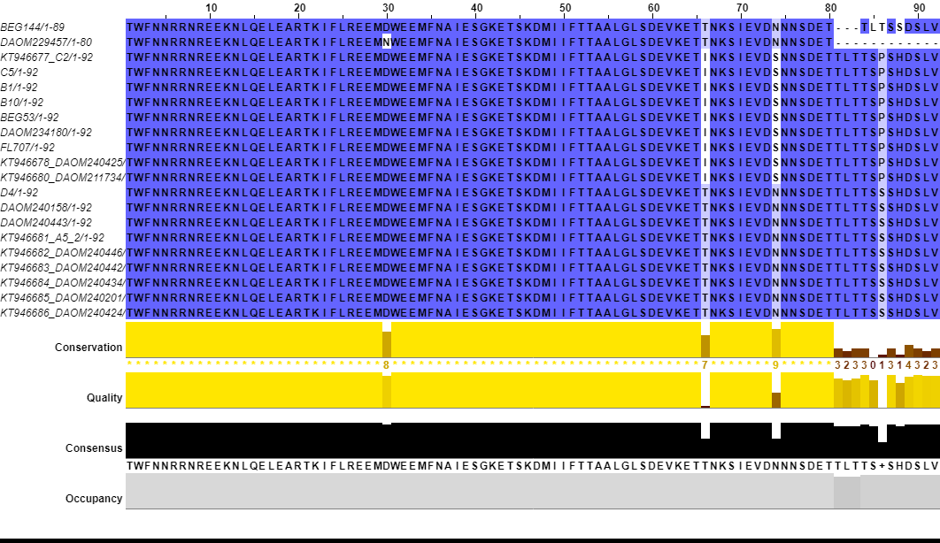
Figure S2. Sequence similarities of the alleles within MAT6. Ninety-two amino acid sequences of the HD2 protein among the isolates were compared. Two main subgroups appear with sequence divergence occurring at position 66 (Isoleucine; I) or Threonine; T), 74 (Serine; S) or Asparagine; N) and 86(Proline; P) or Serine; S).

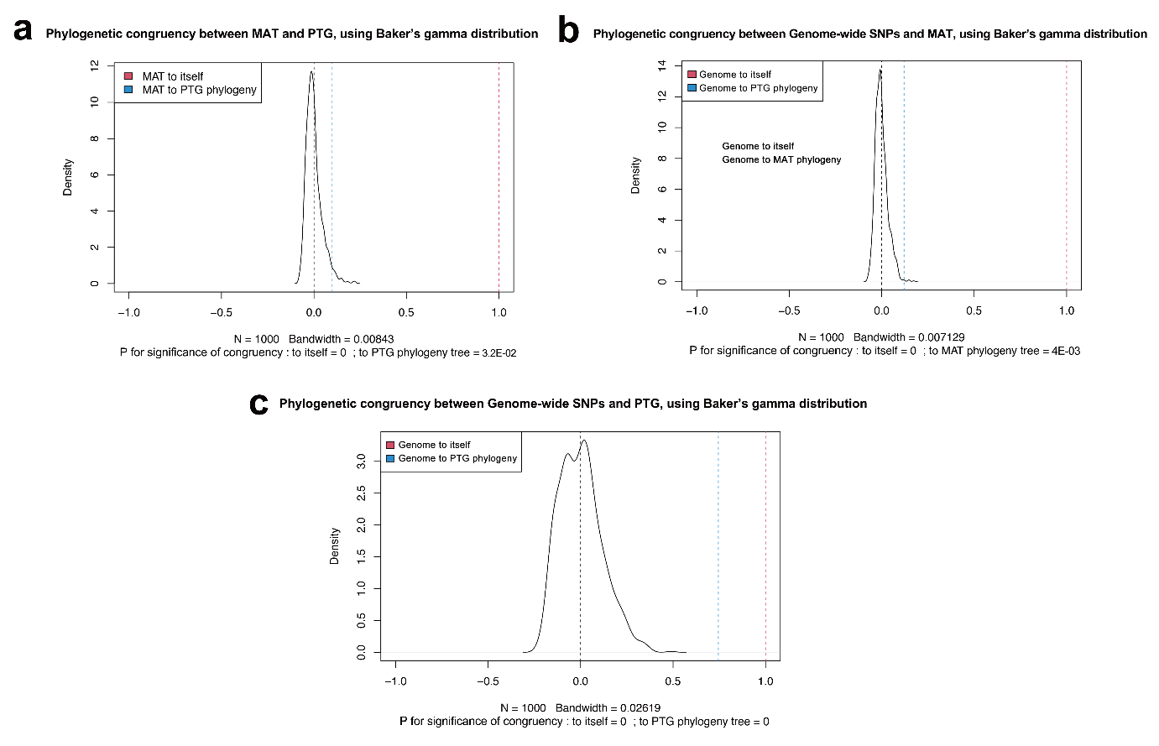
Figure S3. Baker’s Gamma correlation coefficient confirmed phylogenetic congruency among all three trees based on data from the genome-wide SNPs, the MAT-locus and the PTG. Permutation analysis of 1000 iterations confirmed the significant similarities in all pairs of trees (p < 0.05 in all comparisons and summarized as p = 0 in the plot). For each pair, Baker's Gamma correlation coefficient between reference and target trees was plotted (blue). At the same time, Baker's Gamma correlation coefficient between the reference tree and itself was plotted (red) as a reference. Among the three phylogenetic trees based on genome-wide SNPs, the MAT-loci and PTG, all pairwise comparisons were tested: a) Test of congruence between MAT-locus and PTG trees, b) test of congruence between genome-wide SNPs and MAT-locus trees, c) test of congruence between genome-wide SNPs and PTG trees.

