In-situ growth of SiC_{w} on the surface of C/C composite materials and different influencing factors on the morphology control of SiC_{w} transition layer
Chen Xie, Yun Jiang, Jingtao Chen, Jiahua Min , Jijun Zhang*, Xiaoyan Liang* and Pengfei Hu*
School of Materials Science and Engineering, Shanghai University, Shanghai 200444, China

Corresponding authors. telephone/Fax:+86-18301825160
E-mail：zhangjijun222@shu.edu.cn(J.J.Zhang), xxlyy@shu.edu.cn(X.Y.Liang), hpf-hqx@shu.edu.cn (P.F. Hu)

Table S1 Spectrum information EDS-point scan mode
Element | 1 | 2 | 3 | 4 | 5 | 6
C | 57.16 | 66.45 | 64.71 | 64.75 | 38.48 | 90.75
O | 0.35 | 0.30 | 0.37 | 0.43 | 2.15 | 4.31
Ni | 41.95 | 32.59 | 33.89 | 33.08 | 59.36 | 4.94
Total | 100 | 100 | 100 | 100 | 100 | 100

Table S2 Thermodynamic calculation of Ni salt reduction process
(1) | Ni(NO₃)₂·6H₂O→ Ni(NO₃)₂·2H₂O→ Ni(NO₃)(OH)_{1.5}O_{0.25}·H₂O(Basic Salt)→ Ni₂O₃ + NiO→ NiO(<600 ℃)
(2) | NiO + Si = Ni + SiO_{(g)} | ΔG= 134.756 KJ-172.425 J*T | T>781.53 K
(3) | NiO + SiO_{(g)} = Ni + SiO_{2(g)} | ΔG= -572.305 KJ+178.377 J*T | T<3208.40 K
(4) | NiO + C = Ni + CO_{(g)} | ΔG= 126.616 KJ-178.870 J*T | T>707.86 K
(5) | NiO + CO_{(g)} = Ni + CO_{2(g)} | ΔG= -43.112 KJ- 8.361 J*T | ΔG<0
(6) | 2C + O_{2(g)} = 2CO_{(g)} | ΔG= -221.402 KJ- 177.572 J*T | ΔG<0
(7) | 2Si + O_{2(g)} = 2SiO_{(g)} | ΔG= -197.460 KJ- 181.191 J*T | ΔG<0

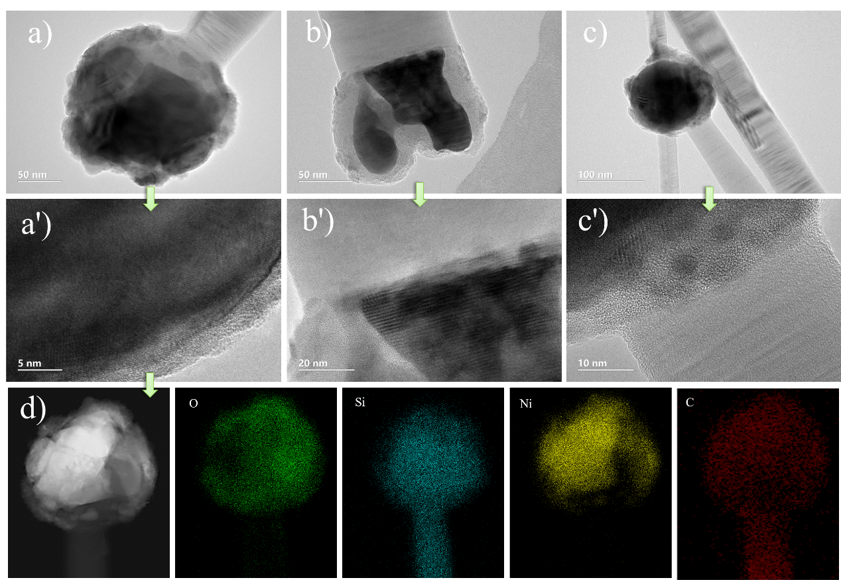
Figure S1.TEM images and EDS spectrum of the Ni-SiC_{w} interface

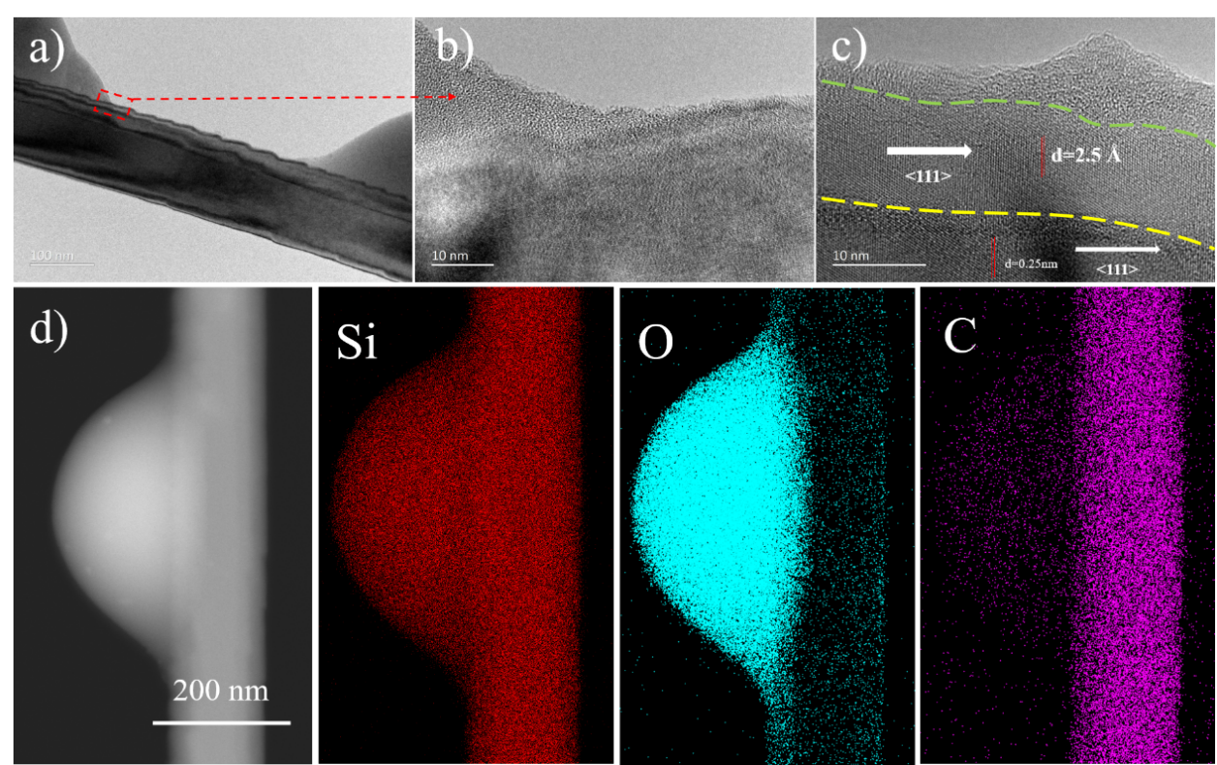
Figure S2. Morphological structure of beaded SiC_{w}: a-c) TEM and HRTEM images of bead-like SiC_{w}; d) HAADF-STEM and EDS-mapping scan patterns of bead-like SiC_{w}

