InterDILI: interpretable prediction of drug-induced liver injury through permutation feature importance and attention mechanism
Soyeon Lee¹, and Sunyong Yoo^{1,*}
¹Department of ICT Convergence System Engineering, Chonnam National University, Gwangju 61186, Republic of Korea

Supplementary Figure
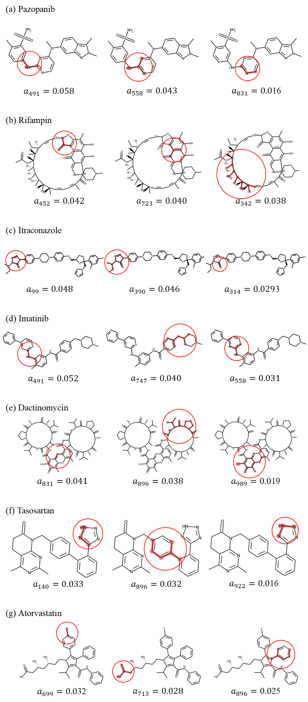
Figure S1 The three most important molecular substructures in (a) Pazopanib, (b) Rifampin, (c) Itraconazole, (d) Imatinib, (e) Dactinomycin, and (f) Tasosartan. The highlights in red were features that contributed significantly to the DILI prediction. An attention weight is presented under each molecular substructure, and they are arranged in order of highest to lowest attention weights.

Additional Table
Table S1 Hyperparameter search details and optimal values for the machine learning models.

Model | Parameters | Ranges | Optimal values
RF | Number of trees | [10, 30, 50, 70, 90] | 90
 | Max number of features | [18, 20, 22, 24] | 18
 | Max depth | [100, 130, 150, 170] | 130
LGBM | Max number of leaves | [20, 40, 60, 80, 100] | 60
 | Number of boosting iterations | [10, 30, 50, 70, 90] | 30
 | Minimal number of data | [5, 10, 15] | 10
 | Max depth | [3, 5, 10] | 10
LR | Maximum number of iterations | [1000, 3000, 5000, 7000, 10000] | 1,000
 | Strength of the regularization | [0.001, 0.01, 0.1, 1, 10, 100] | 0.01
NN with attention | Number of layers | [1, 2, 3] | 1
NN with attention | Number of nodes | [16, 32, 64, 128, 256, 512] | 512

Table S2 Performance of the RF, LGBM, LR, NN with attention, and CNN models.

Model | Accuracy | Sensitivity | Specificity | Precision | F1 score
RF | 0.90 | 0.96 | 0.87 | 0.83 | 0.89
LGBM | 0.84 | 0.91 | 0.73 | 0.74 | 0.82
LR | 0.81 | 0.77 | 0.62 | 0.76 | 0.77
NN with attention | 0.89 | 0.88 | 0.90 | 0.85 | 0.86
CNN [16] | 0.89 | - | - | - | -

Table S3 Molecular substructures corresponding to features with high importance in the RF model.

Feature | Substructure | SMILES
356 | 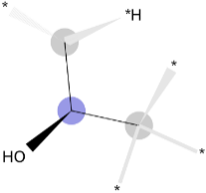 | C[C@H](C)O
849 | 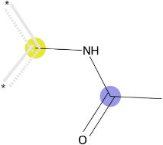 | cNC(C)=O
 | 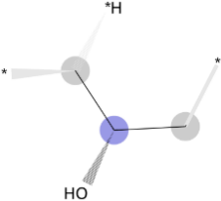 | C[C@@H](C)O
 | 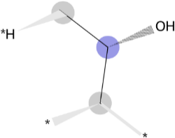 | C[C@H](C)O
314 | 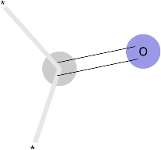 | C=O
 | 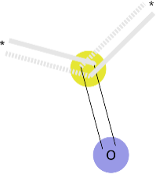 | c=O
 | 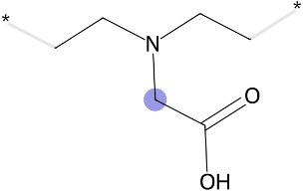 | CCN(CC)CC(=O)O
227 | 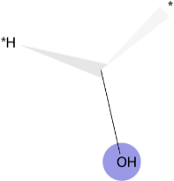 | CO
 | 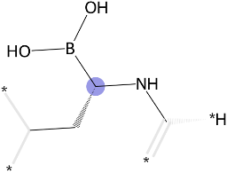 | CC[C@@H](NC)B(O)O
 | 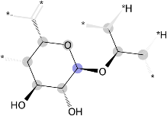 | CC(C)O[C@@H]1O[C@@H](C)C[C@H](O)[C@H]1O
 | 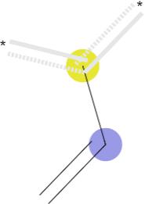 | C=Cc
935 | 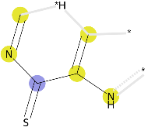 | cnc(=S)c(c)[nH]
 | 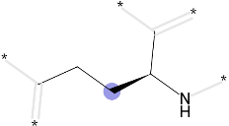 | CCC[C@@H](C)N
 | 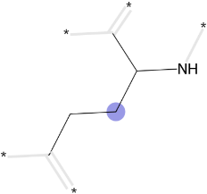 | CCCC(C)N
 | 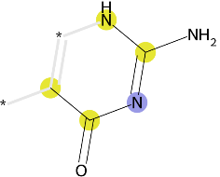 | cc(=O)nc([nH])N
 | 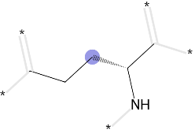 | CCC[C@H](C)N
 | 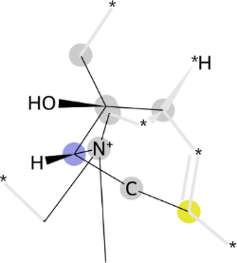 | C[C@](C)(O) [C@@H](Cc)[N+](C)(C)C
893 | 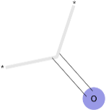 | C=O
 | 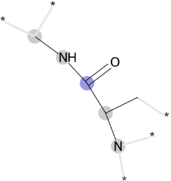 | CNC(=O)C(C)N
 | 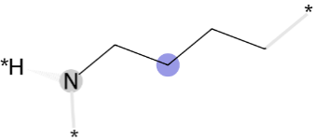 | CCCCN
 | 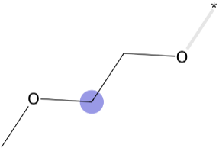 | COCCO
 | 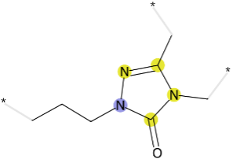 | CCCn1nc(C)n(C)c1=O
 | 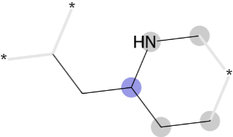 | CCC(CC)NC
 | 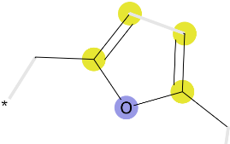 | cc(C)oc(c)C
 | 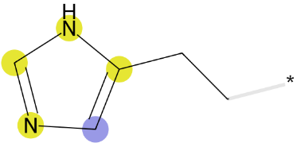 | CCc1cnc[nH]1
798 | 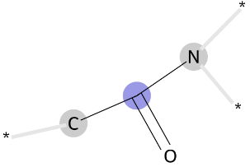 | CC(N)=O
 | 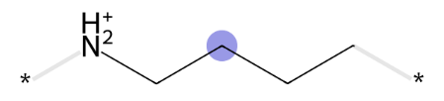 | CCCC[NH2+]
 | 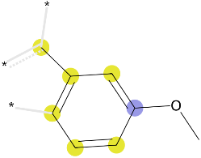 | cc1cccc(OC)c1
 | 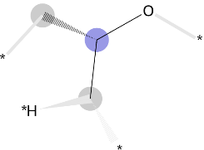 | C[C@@H](C)O
 | 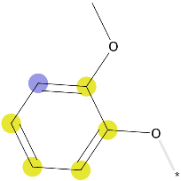 | COc1ccccc1O
 | 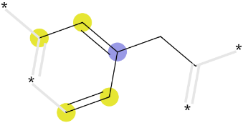 | ccc(cc)CC
 | 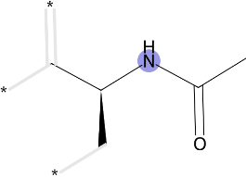 | CC(=O)NC(C)C
 | 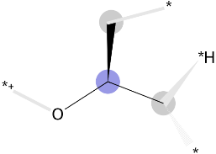 | C[C@H](C)O
 | 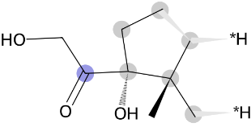 | CC[C@](O)(C(=O)CO)C(C)(C)C
 | 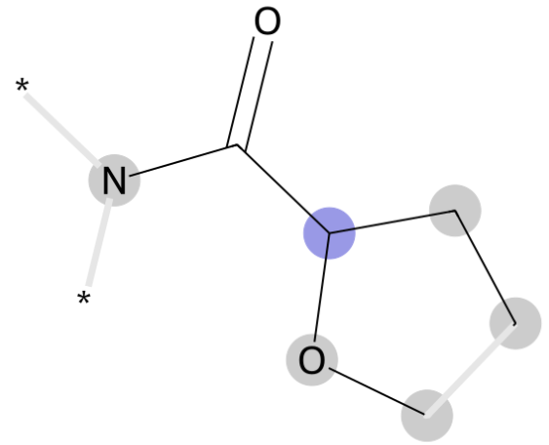 | CCC(OC)C(N)=O
 | 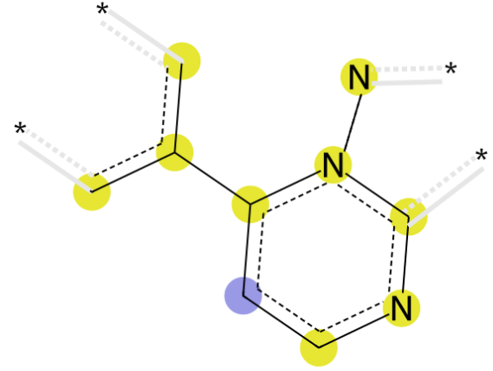 | cc(c)-c1ccncn1n
 | 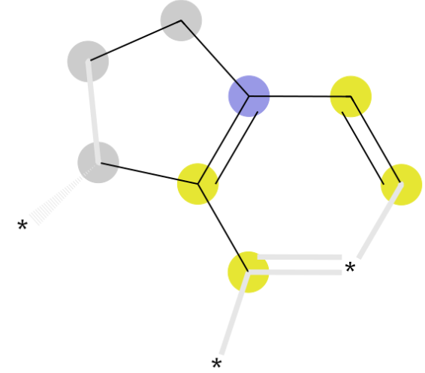 | ccc(CC)c(c)C
 | 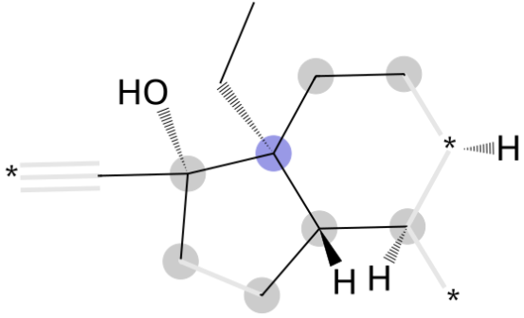 | CCC(CC)([C@H](C)C)C(C)(C)O
 | 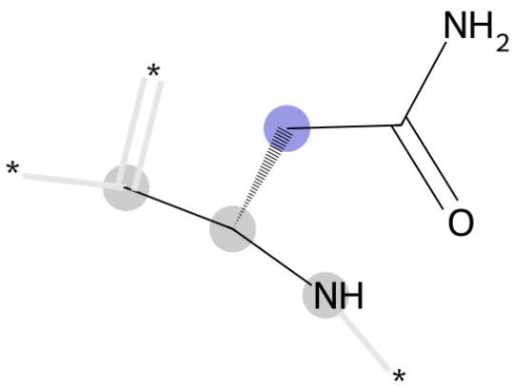 | C[C@@H](N)CC(N)=O
 | 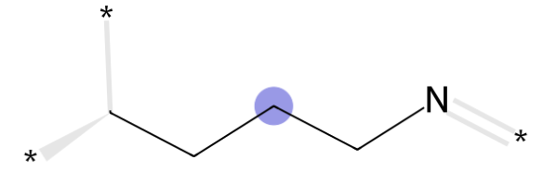 | CCCCN
 | 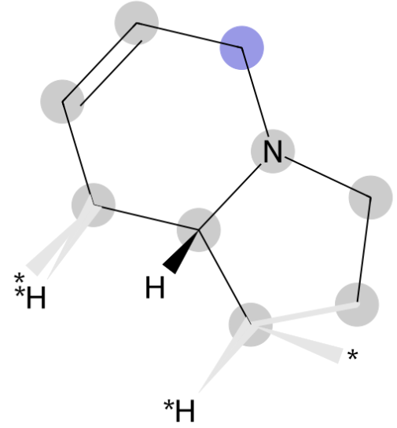 | C[C@@H]1CC=CCN1CC
 | 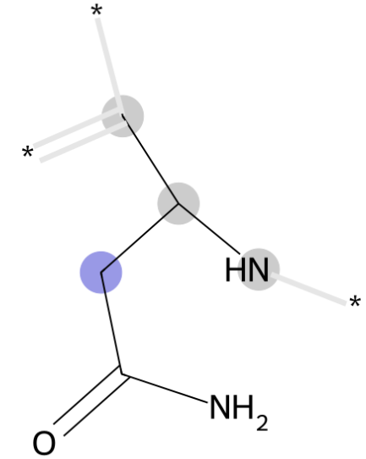 | CC(N)CC(N)=O
 | 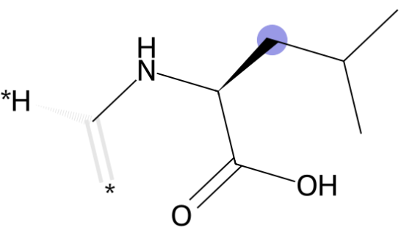 | CN[C@@H](CC(C)C)C(=O)O
 | 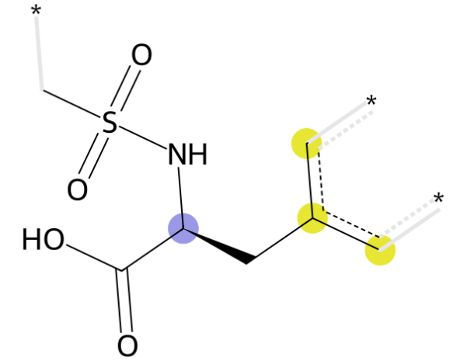 | cc(c)C[C@H](NS(C)(=O)=O)C(=O)O

Table S4 Molecular substructures corresponding to features with high importance in the LGBM model.

Feature | Substructure | SMILES
378 | 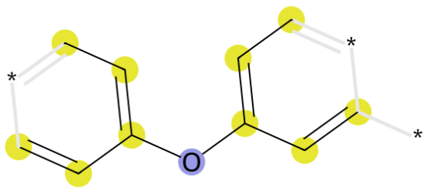 | ccc(cc)Oc(cc)cc
 | 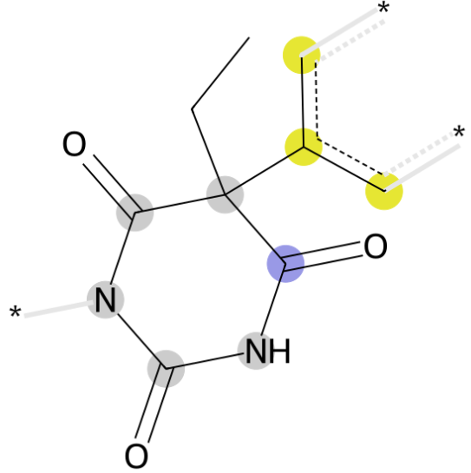 | cc(c)C1(CC)C(=O)NC(=O)NC1=O
 | 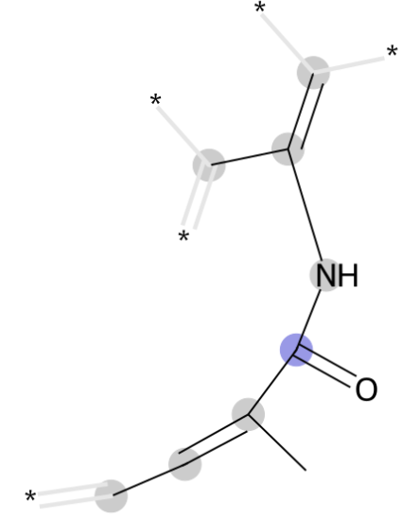 | C=C(C)NC(=O)/C(C)=C\C
 | 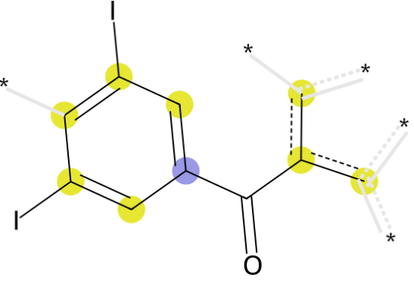 | cc(c)C(=O)c1cc(I)cc(I)c1
 | 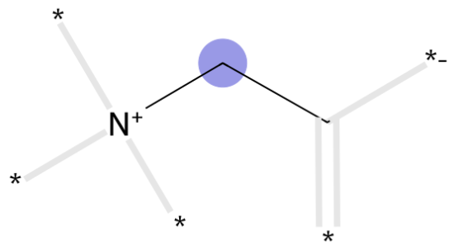 | CC[N+]
 | 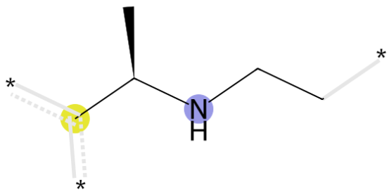 | CCNC(C)c
 | 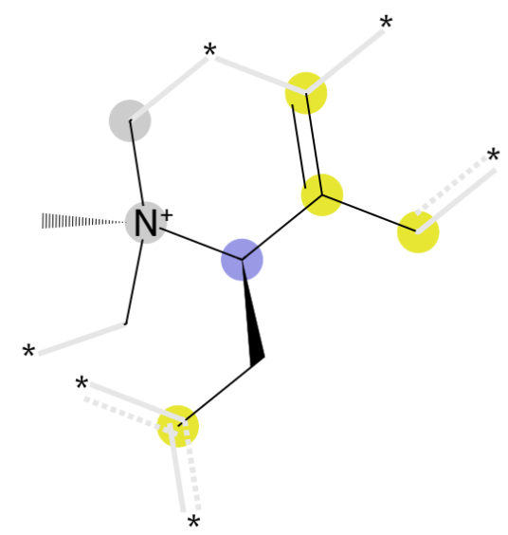 | cc(c)[C@@H](Cc)[N+](C)(C)C
 | 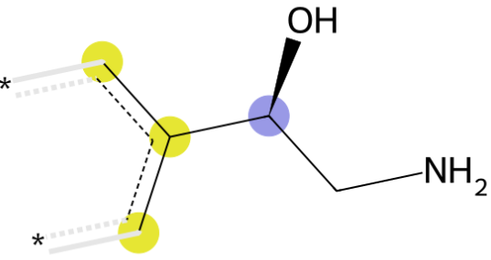 | cc(c)[C@@H](O)CN
 | 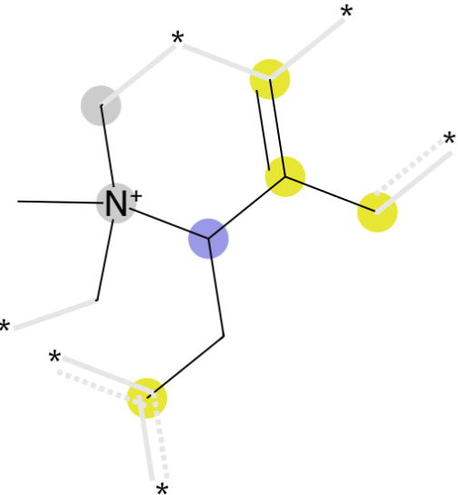 | cc(c)C(Cc)[N+](C)(C)C
806 | 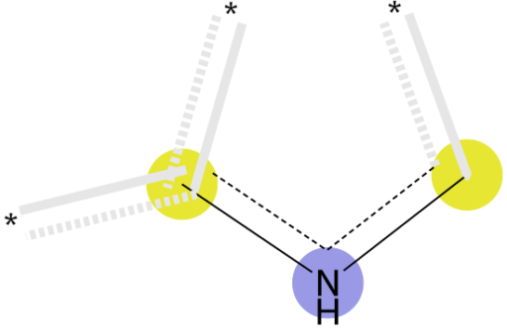 | c[nH]c
 | 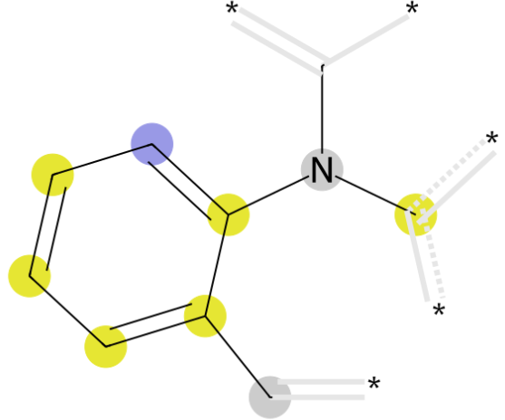 | Cc1ccccc1N(c)C
 | 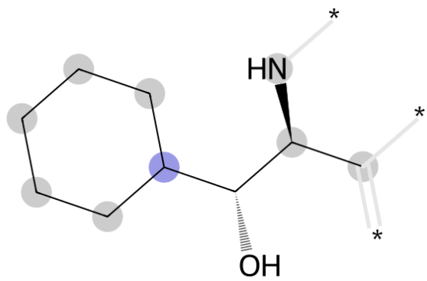 | C[C@H](N)[C@H](O)C1CCCCC1
 | 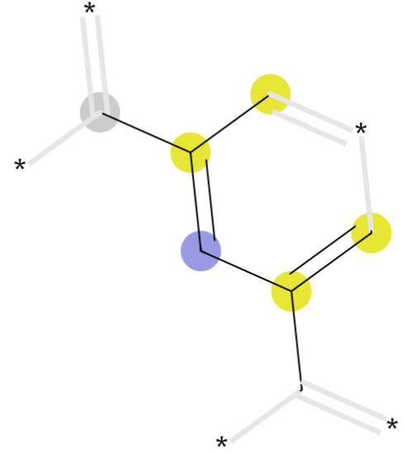 | cc(C)cc(c)C
 | 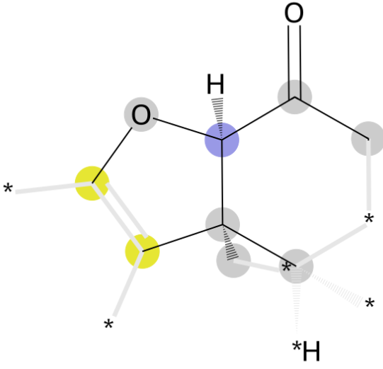 | CC(C)(c)[C@@H](Oc)C(C)=O
 | 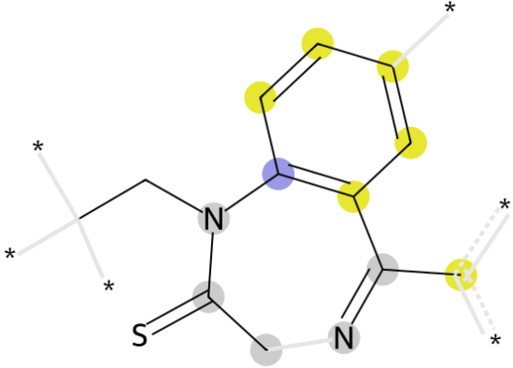 | CCN(C(C)=S)c1ccccc1C(c)=N
 | 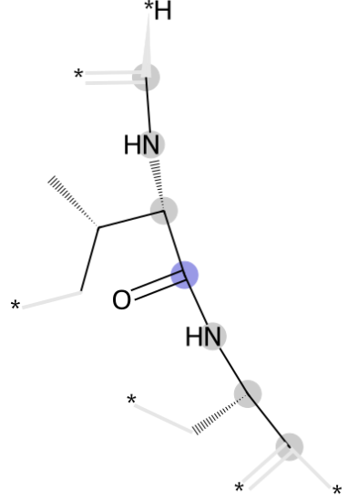 | CN[C@H](C(=O)NC(C)C)C(C)C
314 |  | C=O
 |  | c=O
 |  | CCN(CC)CC(=O)O
392 | 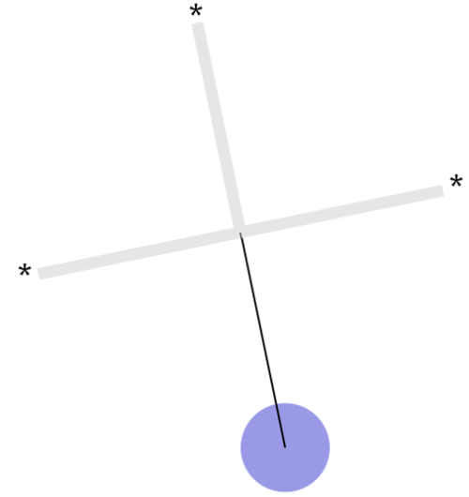 | CCS
 | 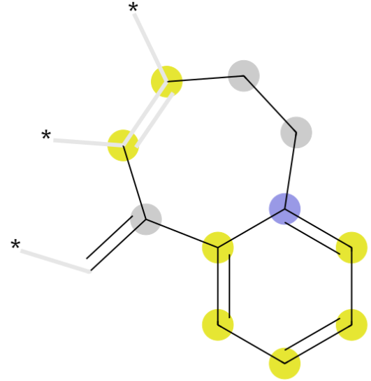 | C=C(c)c1ccccc1CCc
 | 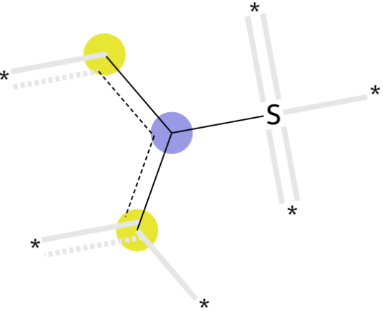 | cc(c)S
 | 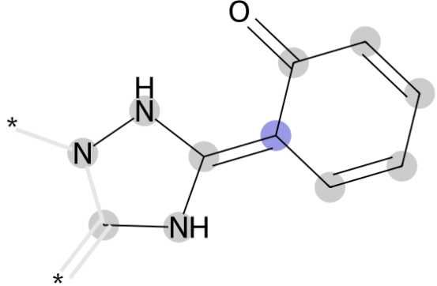 | CN/C(NN)=C1\C=CC=CC1=O
 | 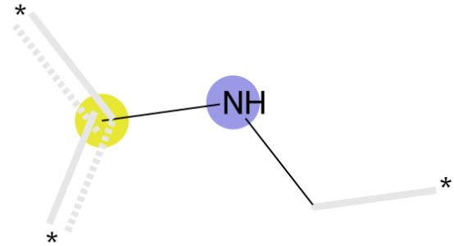 | CNc, cNC
 | 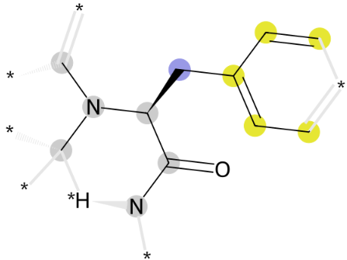 | CN(C)[C@@H](Cc(cc)cc)C(N)=O
 | 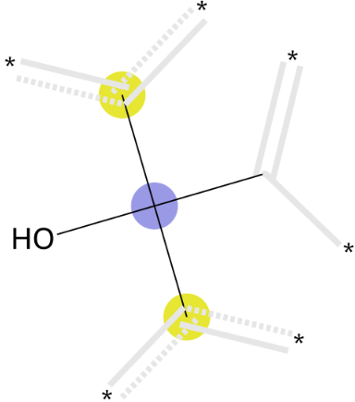 | CC(c)(c)O
 | 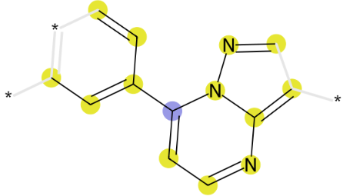 | ccc(cc)-c1ccnc(c)n1nc
 | 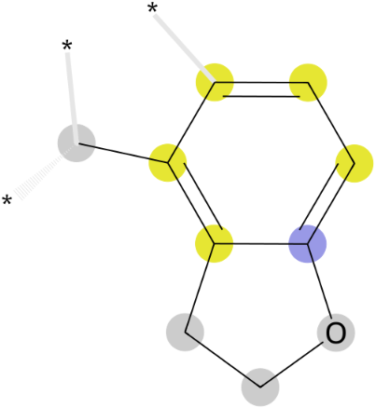 | Cc1cccc2c1CCO2
 | 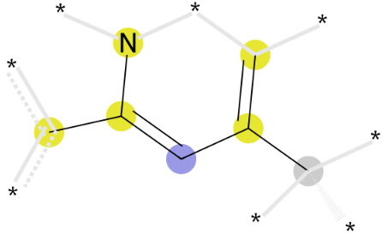 | Cc(c)cc(-c)n
 | 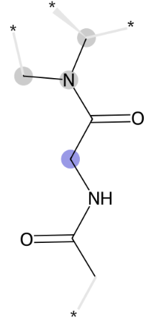 | CC(=O)NCC(=O)N(C)C
 | 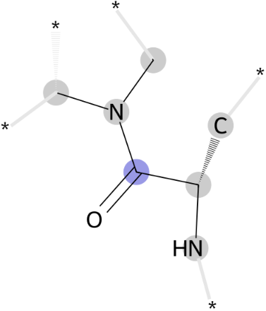 | C[C@H](N)C(=O)N(C)C
 | 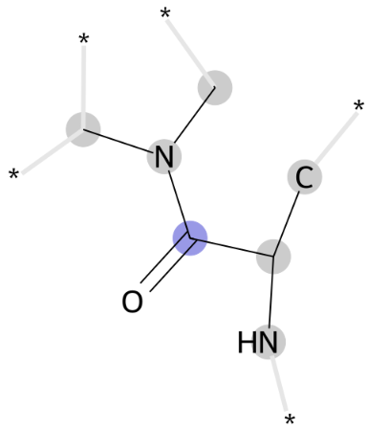 | CC(N)C(=O)N(C)C
 | 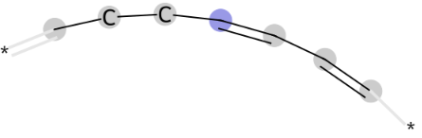 | C=C/C=C/CCC
981 | 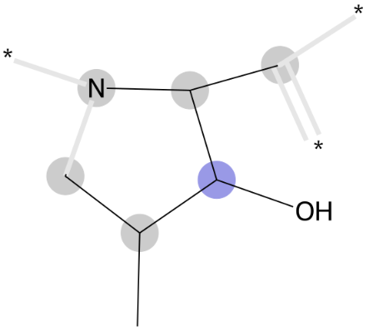 | CC(C)C(O)C(C)N
 | 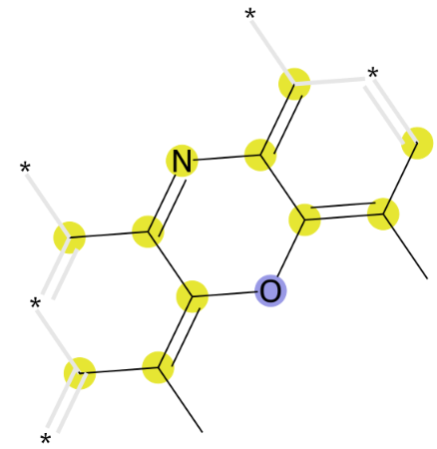 | cc1nc(c)c(c(c)C)oc-1c(c)C
 | 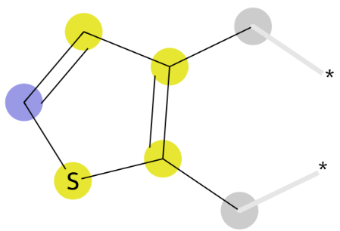 | Cc1ccsc1C
 | 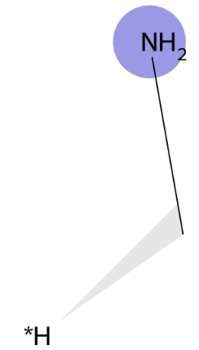 | CN
 | 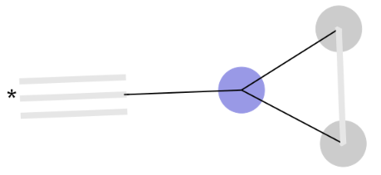 | CC(C)C
 | 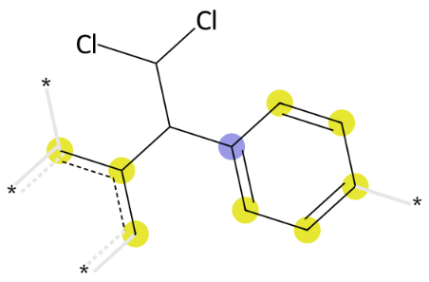 | cc(c)C(c1ccccc1)C(Cl)ClS
 | 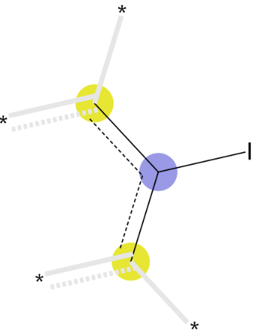 | cc(c)I
650 | 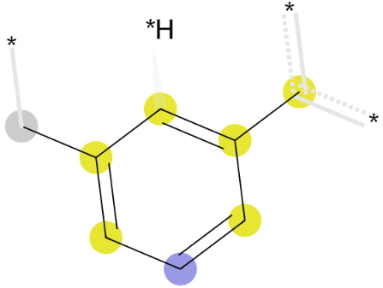 | Cc1cccc(-c)c1

Table S5 Molecular substructures corresponding to features with high importance in the LR model.

Feature | Substructure | SMILES
237 | 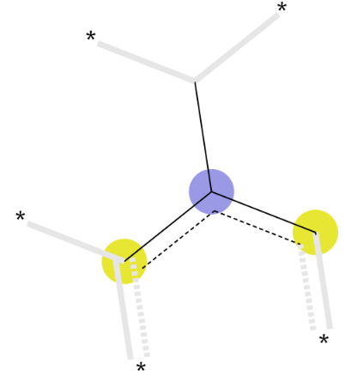 | cc(c)C
 | 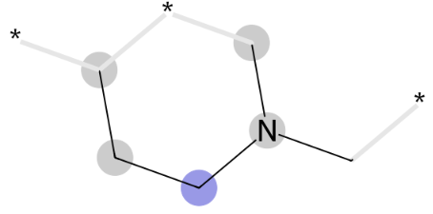 | CCCN(C)C
 | 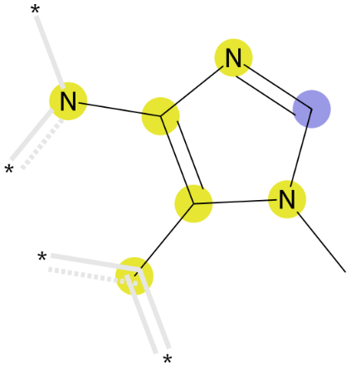 | cc1c(n)ncn1C
 | 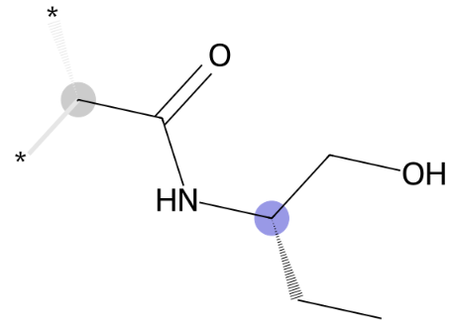 | CC[C@@H](CO)NC(C)=O
 | 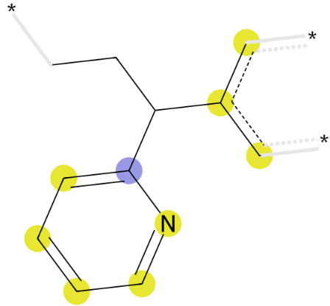 | cc(c)C(CC)c1ccccn1
 | 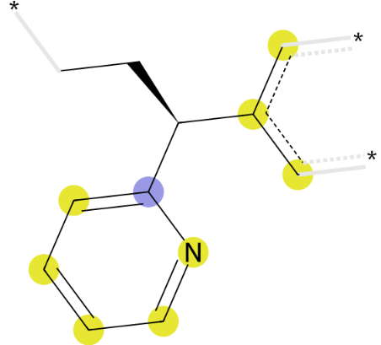 | cc(c)[C@H](CC)c1ccccn1
 | 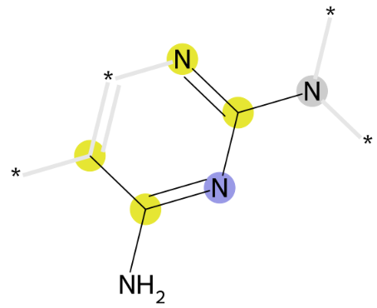 | cc(N)nc(n)NS
 | 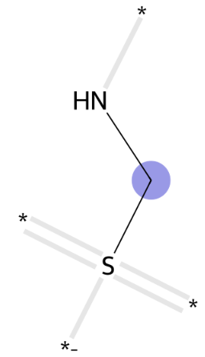 | NCS
 | 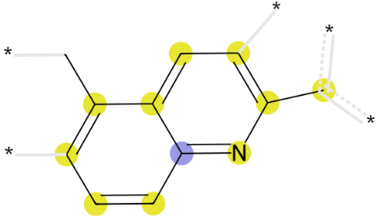 | c-c1ccc2c(C)cccc2n1
 | 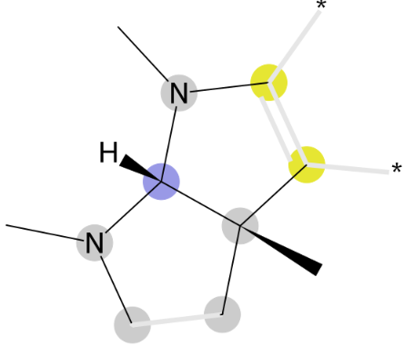 | cN(C)C(N(C)C)C(C)(C)c
 | 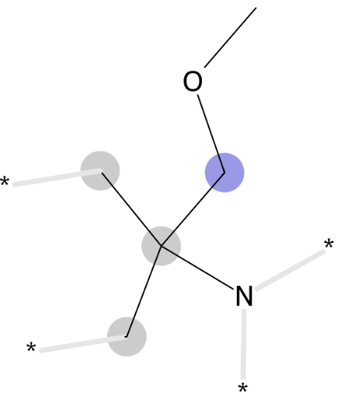 | COCC(C)(C)N
 | 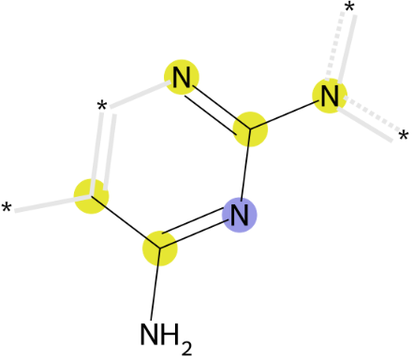 | cc(N)nc(n)-n
 | 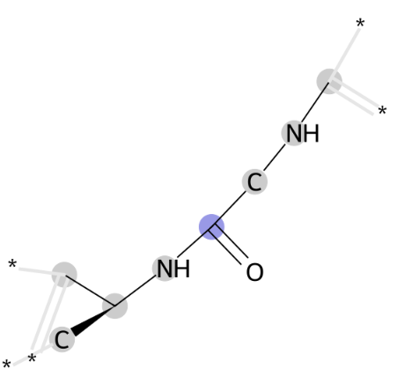 | CNCC(=O)NC(C)C
 | 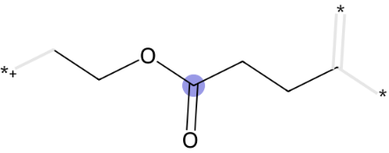 | CCCC(=O)OCC
 | 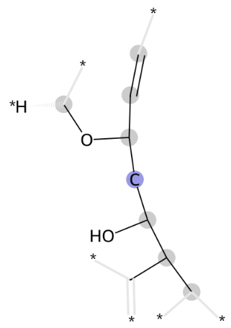 | C=CC(CC(O)C(C)C)OC
486 | 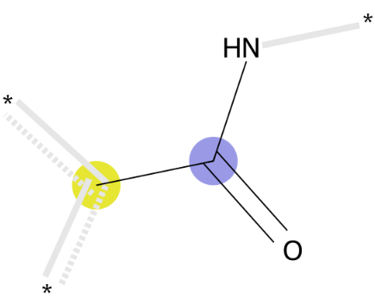 | cC(N)=O
 | 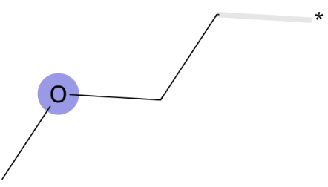 | CCOC
 | 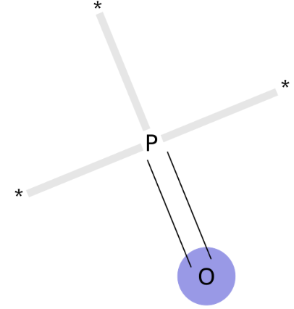 | O=P
 | 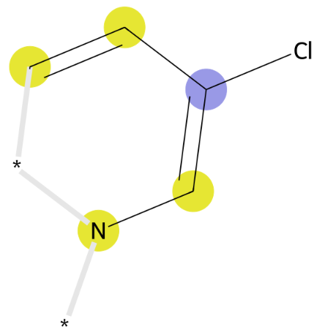 | ccc(Cl)cn
 | 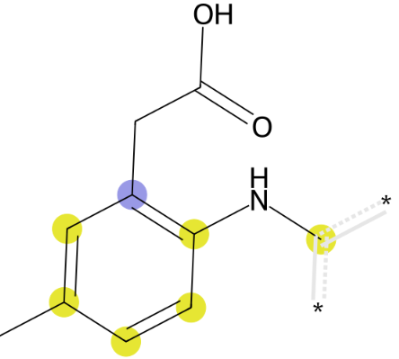 | cNc1ccc(C)cc1CC(=O)O
 | 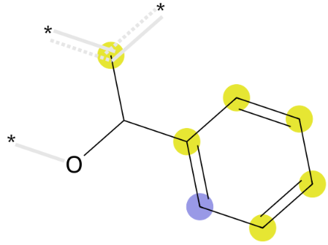 | cC(O)c1ccccc1
 | 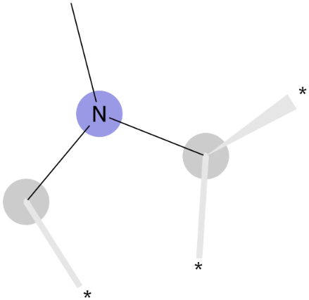 | CN(C)C
 | 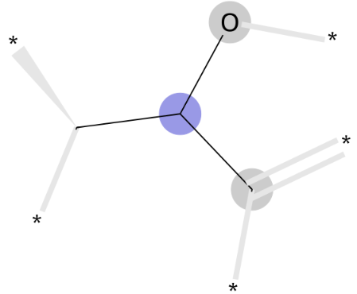 | CC(C)O
 | 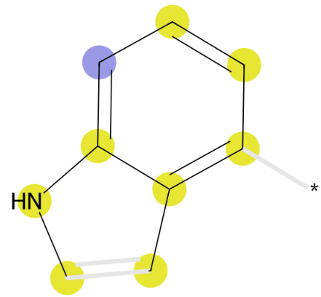 | c[nH]c1ccccc1c
 | 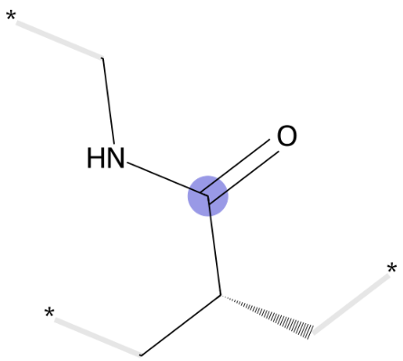 | CNC(=O)C(C)C
 | 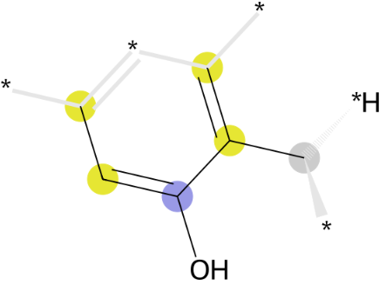 | ccc(O)c(c)C
 | 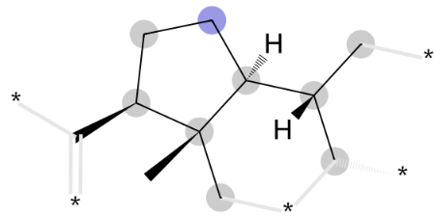 | CC(C)[C@@H]1CC[C@H](C)C1(C)C
 | 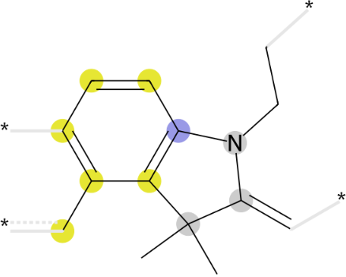 | C=C1N(CC)c2cccc(c)c2C1(C)C
 | 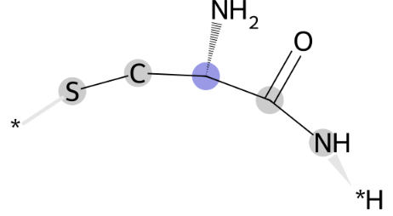 | NC(=O)[C@@H](N)CS
 | 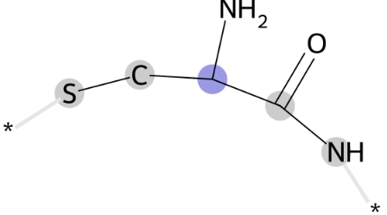 | NC(=O)C(N)CS
 | 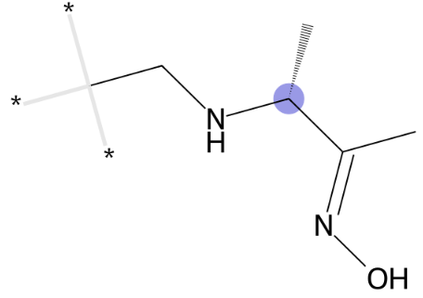 | CCN[C@H](C)/C(C)=N/O
392 |  | CCS
 |  | C=C(c)c1ccccc1CCc
 |  | cc(c)S
 |  | CN/C(NN)=C1\C=CC=CC1=O
 |  | CNc, cNC
 |  | CN(C)[C@@H](Cc(cc)cc)C(N)=O
 |  | CC(c)(c)O
 |  | ccc(cc)-c1ccnc(c)n1nc
 |  | Cc1cccc2c1CCO2
 |  | Cc(c)cc(-c)n
 |  | CC(=O)NCC(=O)N(C)C
 |  | C[C@H](N)C(=O)N(C)C
 |  | CC(N)C(=O)N(C)C
 |  | C=C/C=C/CCC

Table S6 Molecular substructures corresponding to features with high importance in the LR model.

Feature | Substructure | SMILES
464 | 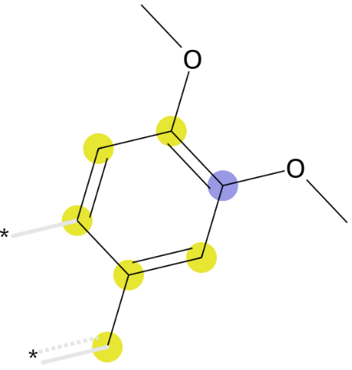 | cc1ccc(OC)c(OC)c1
 | 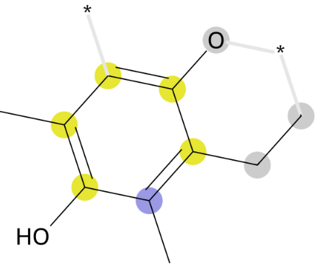 | CCc1c(O)cc(C)c(O)c1C
 | 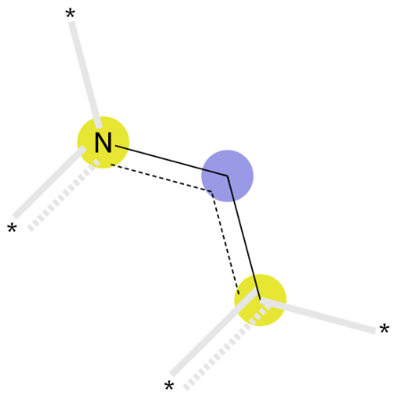 | ccn
 | 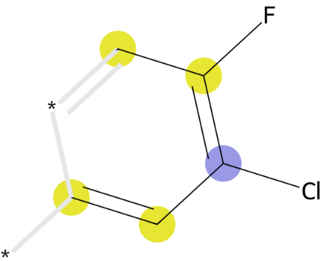 | ccc(Cl)c(c)F
 | 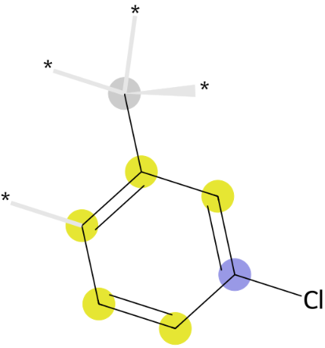 | Cc1cccc(Cl)c1
 | 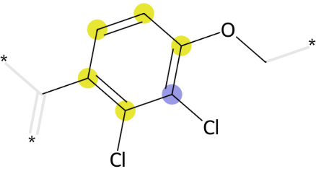 | COc1ccc(C)c(Cl)c1Cl
 | 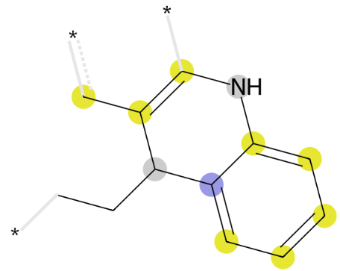 | cc1cNc2ccccc2C1CC
 | 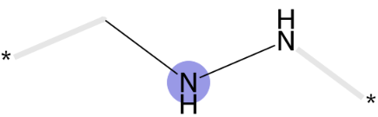 | CNN
 | 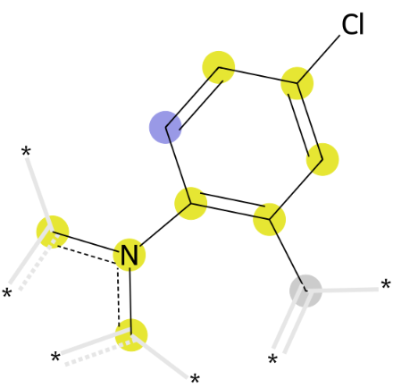 | cn(c)-c1ccc(Cl)cc1C
 | 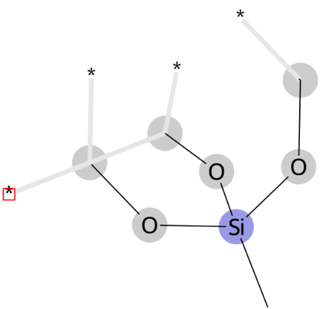 | CO[Si](C)(OC)OC
 | 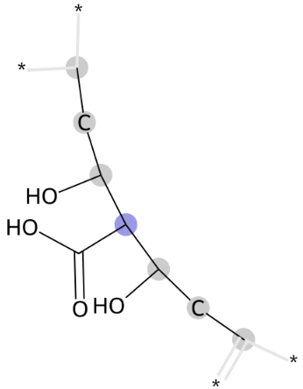 | CCC(O)C(C(=O)O)C(O)CC
612 | 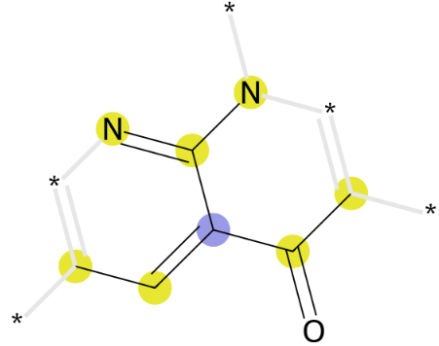 | ccc(c(c)=O)c(n)n
 | 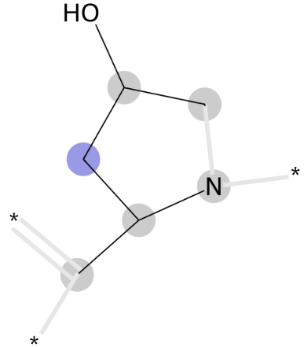 | CC(N)CC(C)O
 | 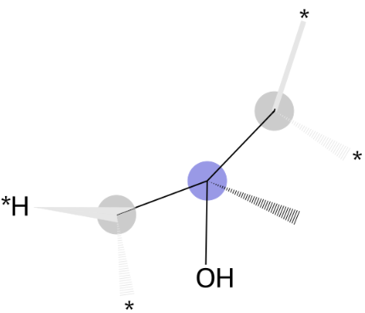 | CC(C)(C)O
 | 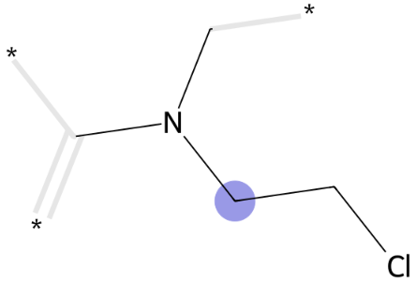 | CN(C)CCCl
 | 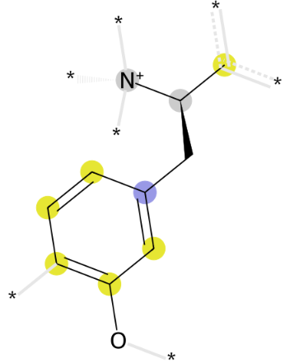 | c[C@H]([N+])Cc1cccc(O)c1
 | 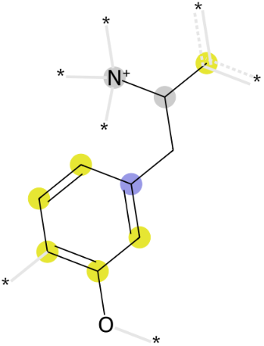 | cC([N+])Cc1cccc(O)c1
 | 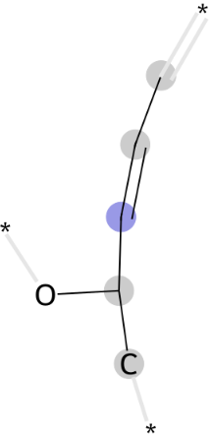 | C/C=C/C(C)O
659 | 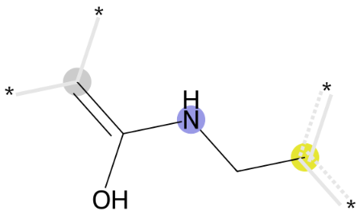 | C=C(O)NCc
 | 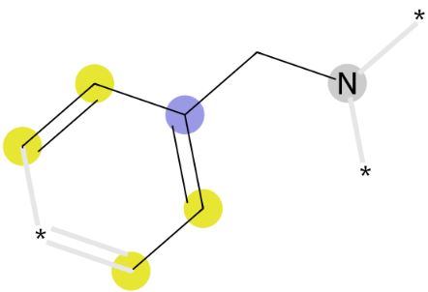 | ccc(cc)CN
 | 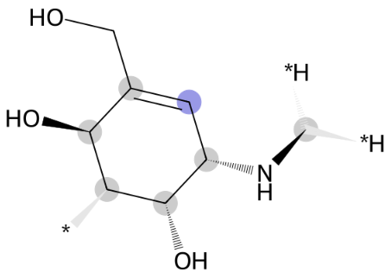 | CN[C@H]1C=C(CO)[C@H](O)C[C@H]1O
 | 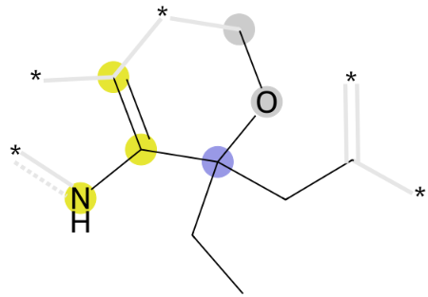 | cc([nH])C(CC)(CC)OC
 | 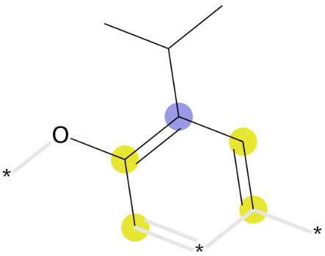 | ccc(c(c)O)C(C)C
 | 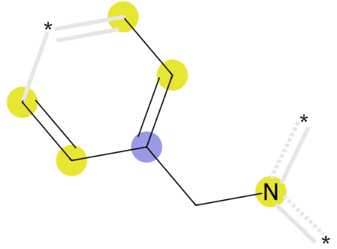 | ccc(cc)Cn
 | 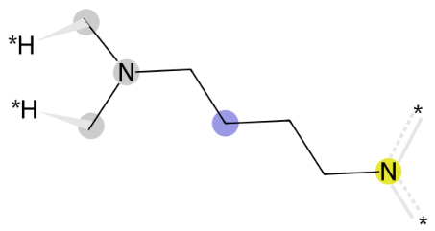 | CN(C)CCCCn
 | 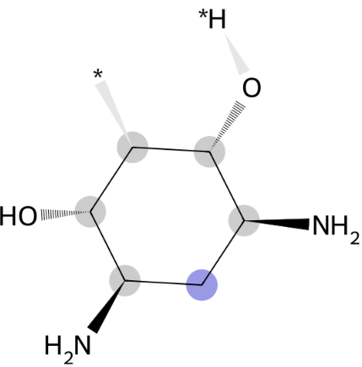 | N[C@@H]1C[C@H](N)[C@@H](O)C[C@H]1O
 | 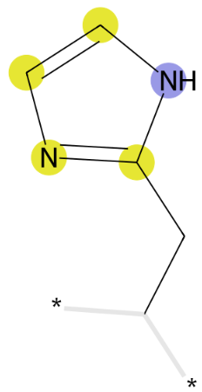 | CCc1ncc[nH]1
 | 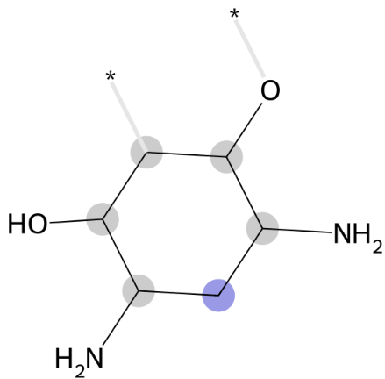 | NC1CC(N)C(O)CC1O
 | 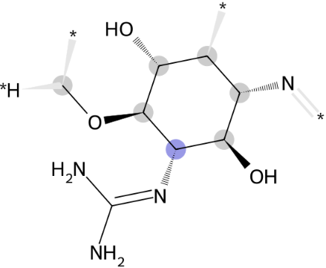 | CO[C@@H]1[C@@H](N=C(N)N)[C@H](O)[C@@H](N)C[C@H]1O
 | 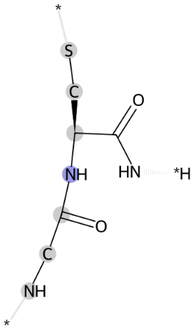 | NCC(=O)N[C@@H](CS)C(N)=O
 | 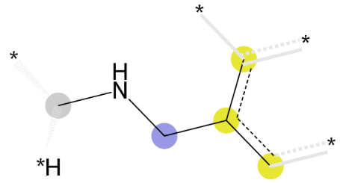 | cc(c)CNC
 | 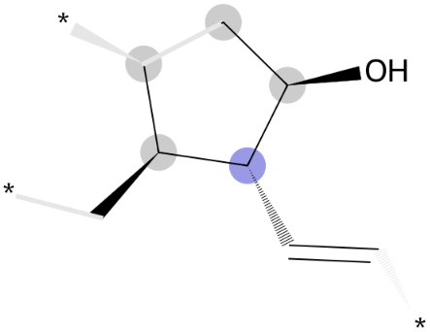 | C=C[C@H]([C@H](C)C)[C@@H](C)O
392 |  | CCS
 |  | C=C(c)c1ccccc1CCc
 |  | cc(c)S
 |  | CN/C(NN)=C1\C=CC=CC1=O
 |  | CNc, cNC
 |  | CN(C)[C@@H](Cc(cc)cc)C(N)=O
 |  | CC(c)(c)O
 |  | ccc(cc)-c1ccnc(c)n1nc
 |  | Cc1cccc2c1CCO2
 |  | Cc(c)cc(-c)n
 |  | CC(=O)NCC(=O)N(C)C
 |  | C[C@H](N)C(=O)N(C)C
 |  | CC(N)C(=O)N(C)C
 |  | C=C/C=C/CCC
138 | 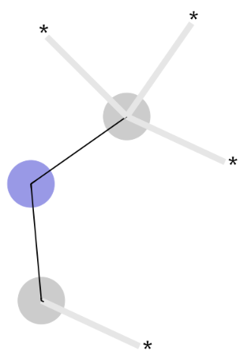 | CCC
 | 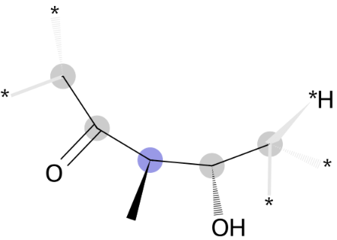 | C[C@H](O)[C@@H](C)C(C)=O
 | 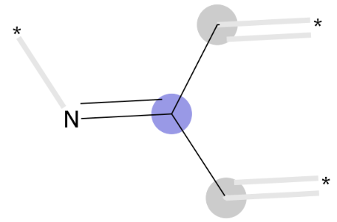 | CC(C)=N
 | 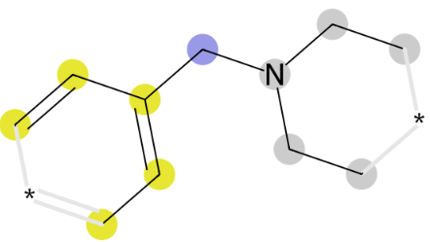 | ccc(cc)CN(CC)CC
 | 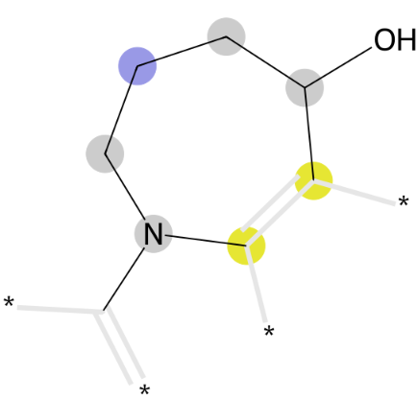 | cC(O)CCCN(C)c
 | 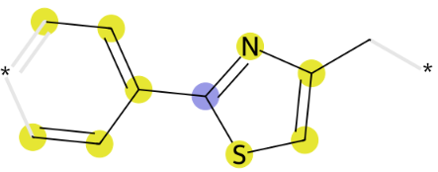 | ccc(cc)-c1nc(C)cs1
 | 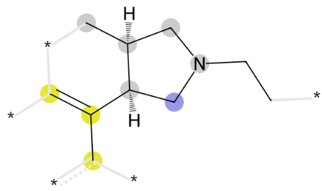 | cc(c)[C@@H]1CN(CC)C[C@@H]1C
 | 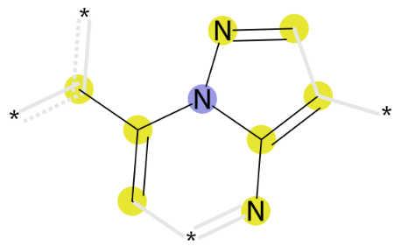 | cnn(c(c)-c)c(c)n
 | 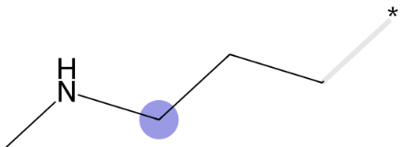 | CCCNC
807 | 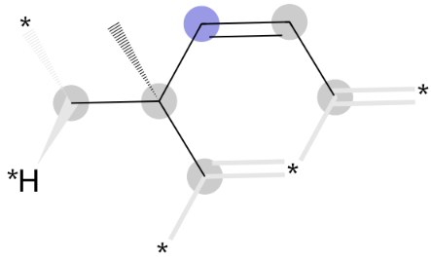 | CC=CC(C)(C)C
 | 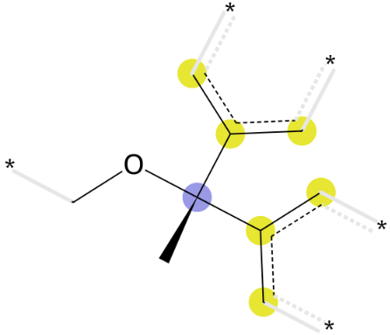 | cc(c)C(C)(OC)c(c)c
 | 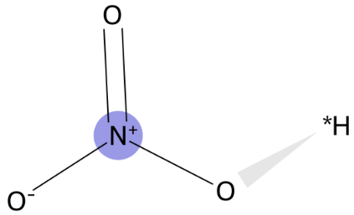 | O=[N+]([O-])O

