Table 2 Molecular substructures corresponding to features
Feature | Substructure | Description | SMILES
80 | 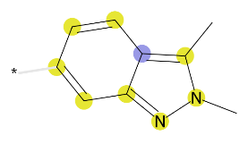 | 2,3-Dimethylindazole | Cc1c2ccccc2nn1C
 | 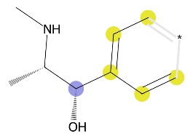 | (1S,2S)-1-cyclohexyl-2-(methylamino)propan-1-ol | ccc(cc)[C@H](O)[C@H](C)NC
 | 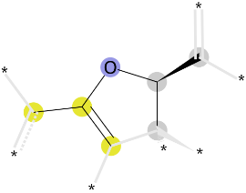 | 2-isopropoxypropane | C[C@H](C)Oc(c)c
 | 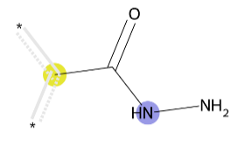 | Acetohydrazide | cC(=O)NN
 | 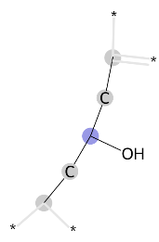 | Pentan-3-ol | CCC(O)CC
464 | 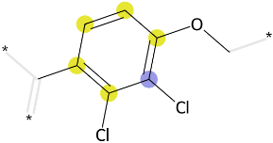 | 2,3-Dichloro-4-methylanisole | COc1ccc(C)c(Cl)c1Cl
 | 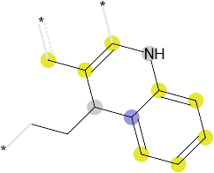 | 4-Ethyl-3-methylene-1,2,3,4-tetrahydroquinoline | cc1cNc2ccccc2C1CC
 | 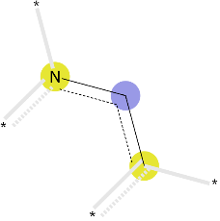 | Ethenamine | ccn
 | 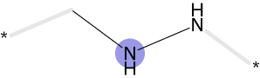 | Methylhydrazine | CNN
 | 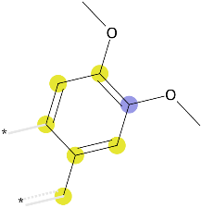 | 1,2-dimethoxy-4-methylbenzene | cc1ccc(OC)c(OC)c1
 | 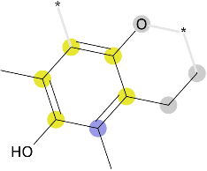 | 2-ethyl-3,5-dimethylbenzene-1,4-diol | CCc1c(O)cc(C)c(O)c1C
 | 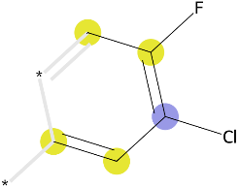 | (Z)-3-choloro-4-fluoropenta-1,3-diene | ccc(Cl)c(c)F
 | 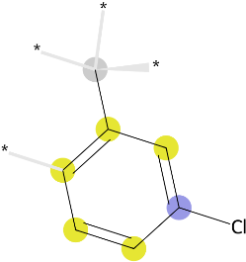 | 1-chloro-3-methylbenzene | Cc1cccc(Cl)c1
 | 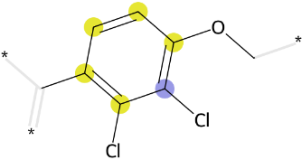 | 2,3-dichloro-1-methoxy-4-methyldbenzene | COc1ccc(C)c(Cl)c1Cl
 | 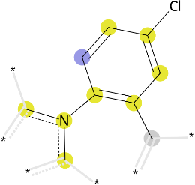 | 1-(4-chloro-2-methylphenyl)pyrrolidine | cn(c)-c1ccc(Cl)cc1C
 | 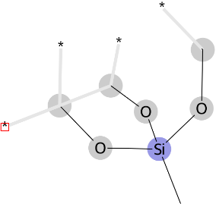 | Trimethoxy(methyl)silane | CO[Si](C)(OC)OC
 | 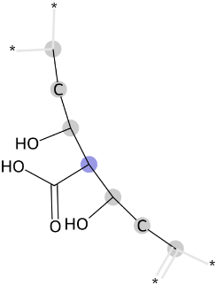 | 3-hydroxy-2-(1-hydroxypropyl)pentanoic acid | CCC(O)C(C(=O)O)C(O)CC
The dashed lines represents conjugated double bonds, asterisk indicates sites that can be replaced by different atoms. The bold font are molecular substructures known to be related to DILI. The blue colors indicate the central atom in the environment, yellow colors indicate the aromatic atoms, and gray colors indicate the aliphatic ring atoms.

