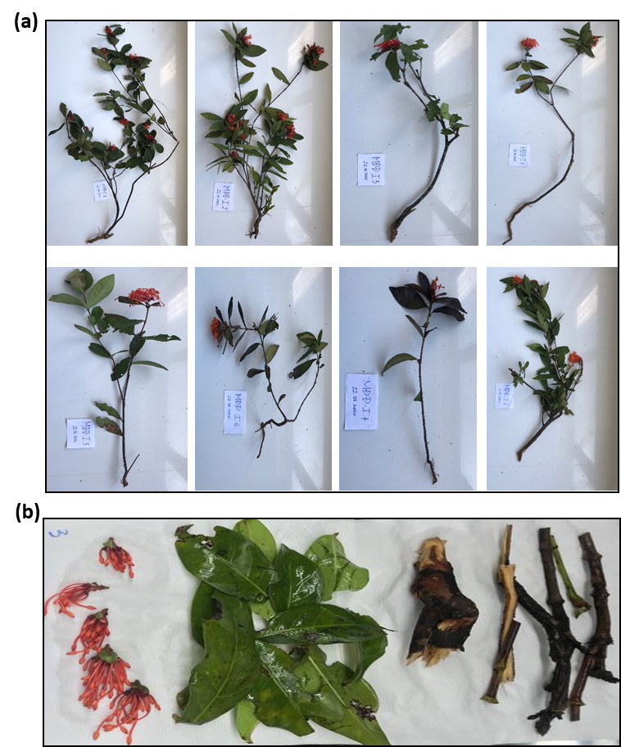
Figure S1. Ixora chinensis plants were collected in Vietnam

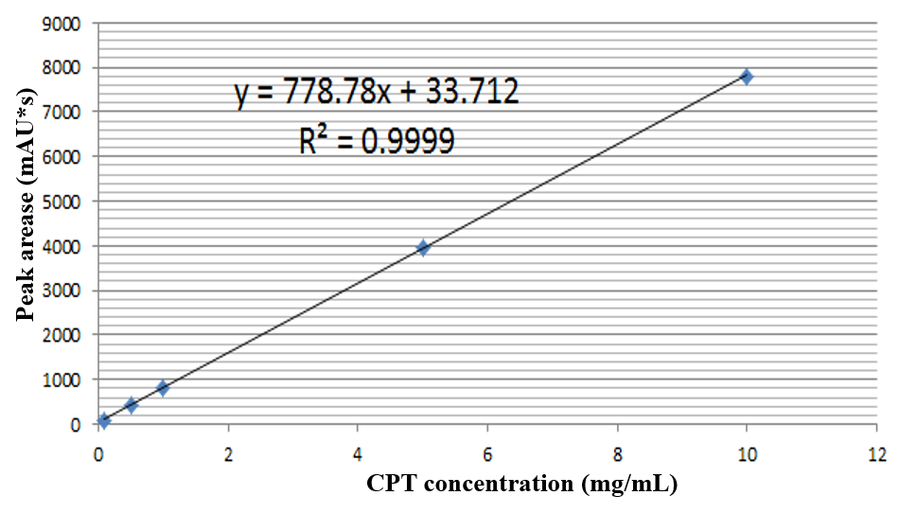
Figure S2. Calibration curve of camptothecin

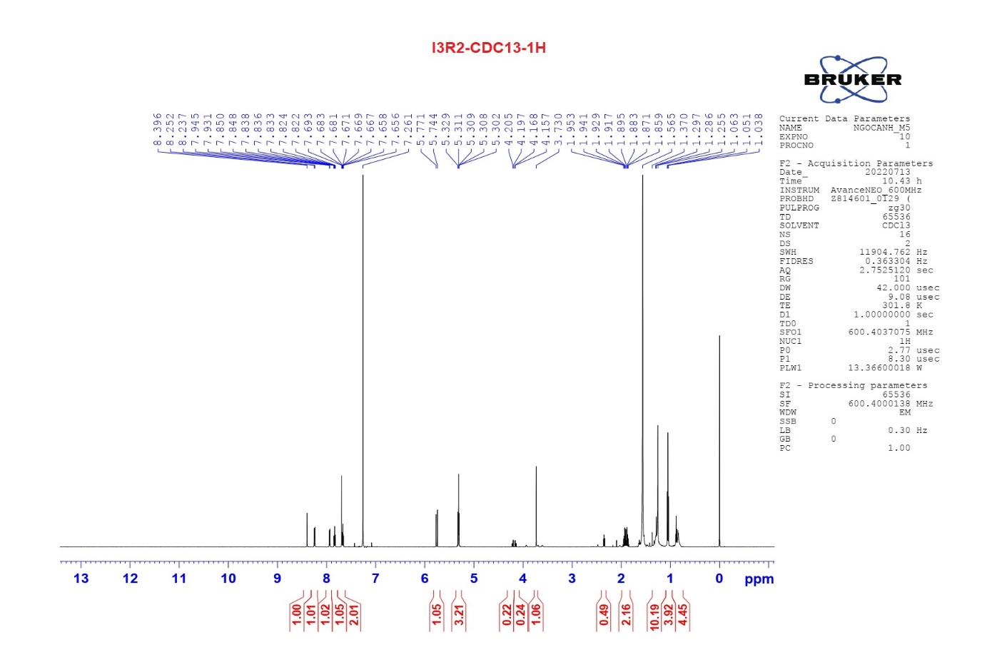
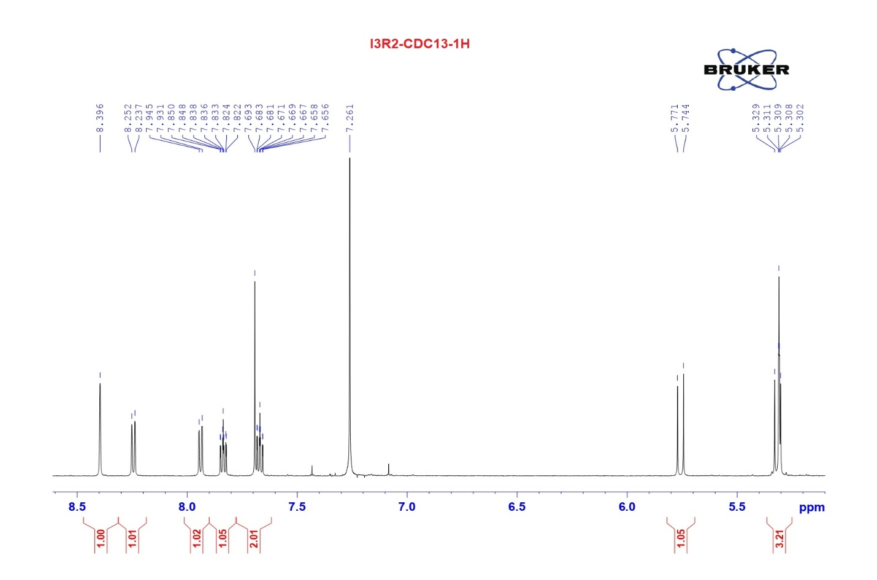
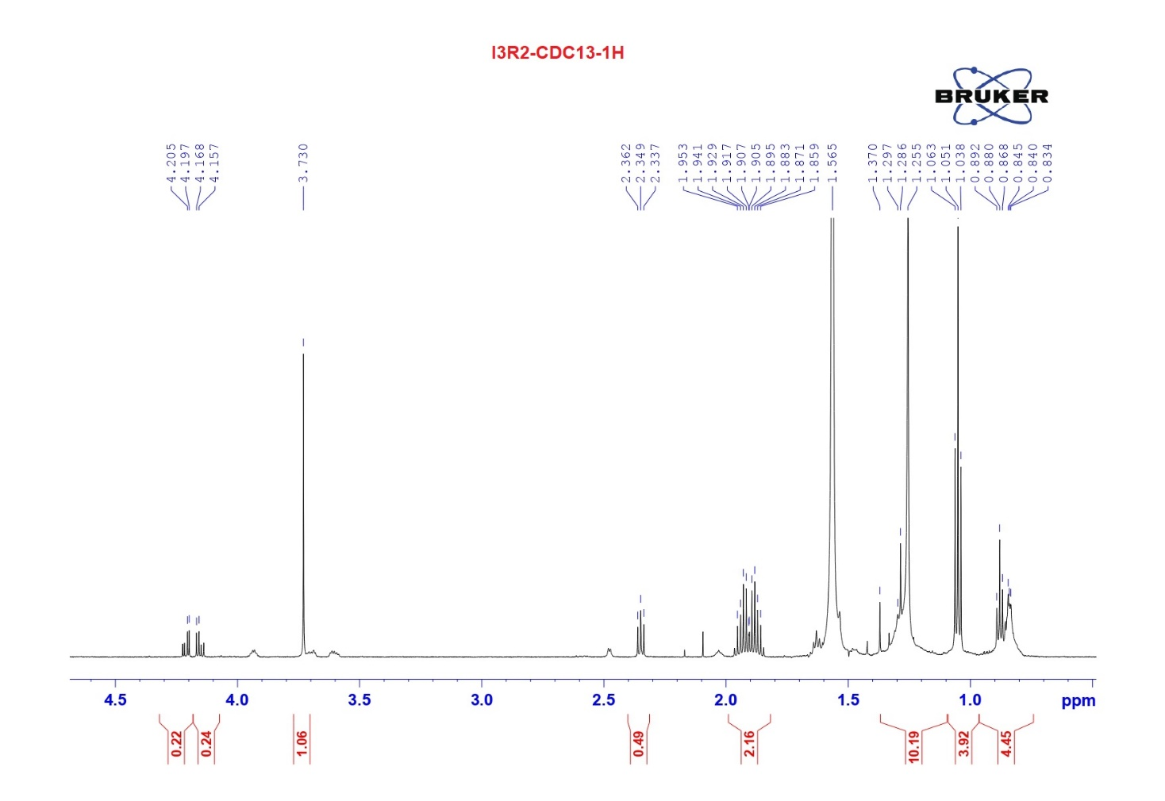
Figure S3. ¹H NMR spectrum of CPT extracted from Penicillium sp. I3R2 strain

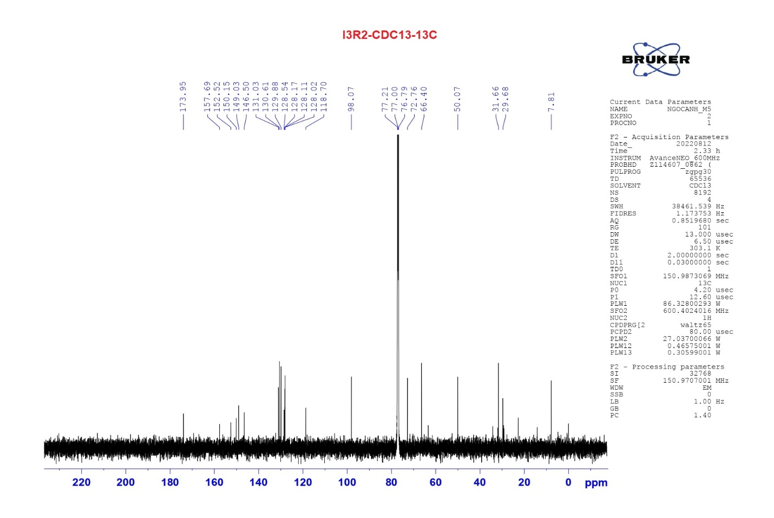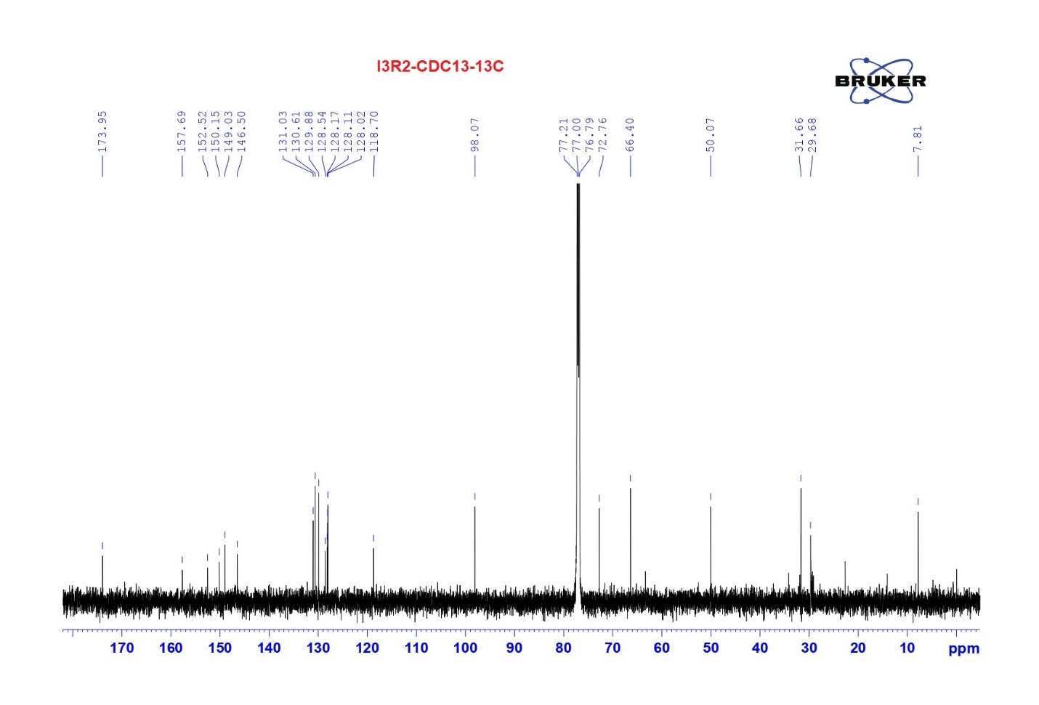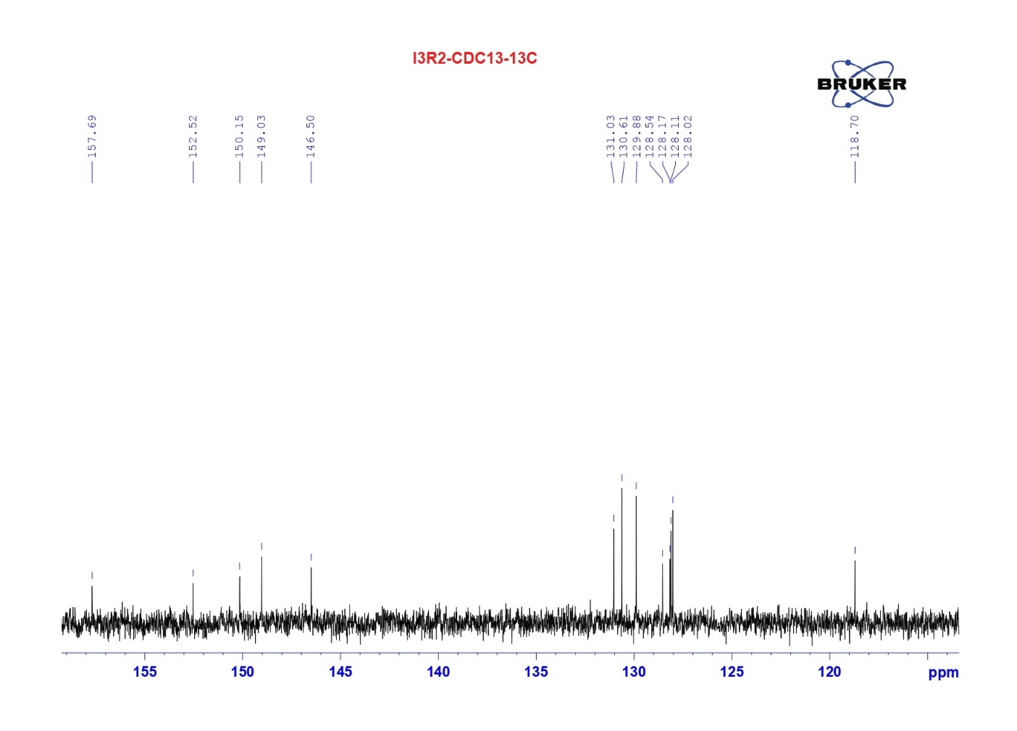
Figure S4. ¹³C NMR spectrum of CPT extracted from Penicillium sp. I3R2 strain.

