Supporting Information for

ORIGINAL ARTICLE
A novel synergistic enzyme-Antibiotic Therapy with Immobilization of Mycobacteriophage LysinB enzyme onto Rif@UiO-66 Nanocomposite for Enhanced Anti-TB Nanotherapeutic; Nanoenzybiotics approach

Zienab E. Eldin,^{a*} Tarek Dishisha,^{b} Ahmed Farghali,ª Hanaa.M.Salama, ^{c} Ossama M. Sayed^{d}
ª Department of Material Sciences and Nanotechnology, Faculty of Postgraduate Studies for Advanced Sciences, Beni-Suef University, Beni-Suef, Egypt
^{b} Department of Pharmaceutical Microbiology and Immunology, Faculty of Pharmacy, Beni-Suef University, 62511 Beni-Suef, Egypt
^{c} Department of Chemistry, Faculty of Science, Port Said University, Port Said, Egypt
^{d} Department of Pharmaceutics, Faculty of Pharmacy, Sinai University—Kantara Branch, Ismailia 41636, Egypt
*Corresponding author: Zienab E. Eldin
E-mail: t-zienabessam@zewailcity.edu.eg
Tel: +201065439009

Enzymatic Activity of Free and Immobilized LysB-D29 assays
For measuring the specific enzymatic activity and Enzymatic activity for the free LysB, the following equations were used:

$$Units/mg enzyme =\frac{Activity (U/ml}{ enzyme concentration (mg/ml }$$

[Eq. SB.1]

$$Activity (U/ml enzyme=\frac{(∆A410 test-∆A410 blank)×(total volume)}{ε×(Volume of enzyme )}$$
[Eq.SB.2]

where:

One unit (U) of enzyme activity corresponds to the amount of enzyme
liberating 1 µmol of p-nitrophenol per min under the assay conditions

ε
ε is the extinction coeﬃcient of p-nitropheno

Table.S1. Band (peak) assignments for UiO-66, Rif and Rif@UiO-66 infrared spectra.
Peaks (cm⁻¹) | Functional group assignment | Vibration type | Ref
UiO-66
3751,3413 | -O- H | Stretching | 1
1664 | C=O bond | Stretching | 3
1587 | C−O bond carboxyl group | symmetrical stretching | 1
1510 | C=C | asymmetric stretching | 2
1403 | C−O bond carboxyl group | stretching | 1
1261 | C=N amino groups to the benzene ring | Symmetrical, stretching | 2,4
808 | C-H In ligand | - | 4
743,662 | OH and C–H | stretching | 4
662 | µ3-o | vibrational bindings | 3
550 | Zr(O–C) | Stretching | 3
482 | µ₃-OH | asymmetric stretch | 3
Rifampicin
3748,3440 | -OH,N-H,O-H | Stretching | 6
2926 | -C=O, C-H | Stretching | 5
1631 | NH, C=C, N-H | Stretching | 5
1435 | C=C ar OH phenol | Asymmetric stretching | 5
1090 | C-N | Stretching | 5
863 | OH in crystal lattice CH, NH | Stretching | 5
RiF@UiO-66
3749,3411 | -O-H | Stretching
1669 | C=O bond | Stretching
1571 | C−O bond carboxyl group | symmetrical stretching
1422 | C−O bond carboxyl group | asymmetric stretching
1094 | C=N amino groups to the benzene ring | stretching
804 | C-H In ligand | - | This study
738,659 | OH and C–H | stretching
659 | µ3-O | vibrational bending
553 | Zr(O–C) | stretching
484 | µ3-OH | asymmetric stretch

Fig.1S. BJH pore size distribution (B) of samples (a) UiO-66 and (b) Rif@UiO-66.(c) LysB/Rif@UiO-66.

Table 2S. Release kinetics data of all Samples.
LysB/Rif@UiO-66 | LysB enzyme |  | Rif@UiO-66 | Rifampicin | Model
 |  | Zero order
0.8705 | 0.8705 | 0.999 |  | 0.9844 | R2
23.054x +17.5 | 23.054x+17.5 | 7.5282x- 0.4718 |  | 15.505x + 5.198 | Y
 |  | First order
0.0051 | 0.0051 | 0.9926 |  | 0.9917 | R2
-0.0239x +1.5236 | -0.0239x +1.5236 | -0.0406x+2.0075 |  | - 0.1299x + 2.0166 | Y
 |  | Higuch
0.9933 | 0.9933 | 0.9052 |  | 0.9679 | R2
49.806x+ 2.3836 | 49.806x+ 2.3836 | 17.049x - 5.9404 |  | 36.579x- 7.9666 | Y
 |  | Kors-peppas
0.7277 | 0.7277 | 0.8708 |  | 0.8681 | R2
121.75x+30 | 121.75x+30 | 35.766x+7.1126 |  | 74.094x+20.71 | Y
 |  | Hixson
0.0009 | 0.0009 | 0.9956 |  | 0.9991 | R2
0.0239x +1.3215 | 0.0239x +1.3215 | 0.1343x- 0.0193 |  | 0.3658x +0.0072 | Y

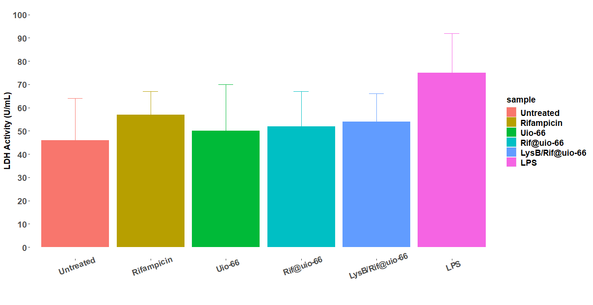
Fig.2S LDH activity in BALF of rats after pulmonary delivery of different samples into rats for 48 h (Data are expressed as mean±SD, n=6).

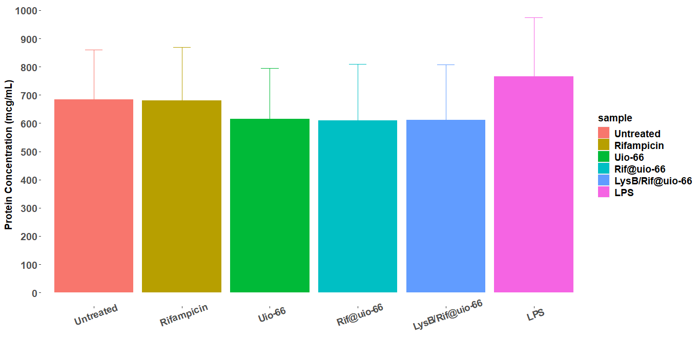
Fig.3S Protein concentration in BALF of rats after pulmonary delivery of different samples into rats for 48 h (Data are expressed as mean±SD, n=6).

Table 4S. Docking scores and energies of Rifampicin and UiO-66 with Crystal structure of lysin B from Mycobacteriophage D29 (3HC7) receptors.
Mol | rseq | mseq | S | rmsd_refine | E_conf | E_place | E_score1 | E_refine | E_score2
Rifampicin | 1 | 1 | -6.93606 | 2.474942 | 202.6967 | -58.1555 | -6.27604 | -37.7388 | -6.93606
Rifampicin | 1 | 1 | -6.23252 | 7.84041 | 88.08795 | -29.7279 | -5.8288 | -33.862 | -6.23252
Rifampicin | 1 | 1 | -5.80238 | 5.058779 | 170.4688 | -41.6344 | -7.87339 | -23.9621 | -5.80238
Rifampicin | 1 | 1 | -5.76019 | 1.846086 | 223.8887 | -57.1464 | -6.78137 | -31.2174 | -5.76019
Rifampicin | 1 | 1 | -5.63268 | 2.334917 | 360.9593 | -28.5327 | -6.97185 | -20.9185 | -5.63268
UiO-66 | 1 | 2 | -6.7957 | 2.465772 | -222.435 | -69.6953 | -2.38727 | -71.5728 | -8.7957
UiO-66 | 1 | 2 | -6.62816 | 3.205668 | -223.156 | -71.7509 | -2.41367 | -27.9343 | -6.62816
UiO-66 | 1 | 2 | -6.52124 | 2.576178 | -234.623 | -59.7493 | -4.29618 | -34.9507 | -6.52124
UiO-66 | 1 | 2 | -6.1647 | 3.104955 | -234.843 | -49.7634 | -3.35529 | -37.7493 | -6.1647
UiO-66 | 1 | 2 | -6.10791 | 4.696726 | -233.237 | -23.9915 | -2.33145 | -30.4653 | -6.10791

Table 5S. Interaction of Rifampicin and Uio-66 with Crystal structure of lysB from Mycobacteriophage D29 (3HC7) receptors.
Mol | Ligand | Receptor | Interaction | Distance | E (kcal/mol)
Rifampicin | O 109 | N TYR 168 (A) | H-acceptor | 3.32 | -1.9
UiO-66 | O 15 | N MET 167 (A) | H-acceptor | 3.19 | -1.3

References
[1] Xu W, Dong M, Di L, Zhang X. A Facile Method for Preparing UiO-66 Encapsulated Ru Catalyst and itsApplication in Plasma-Assisted CO2 Methanation. Nanomaterials.10(2019)1432.https://doi.org/10.3390/nano9101432.[2] Guangran L, Jianming L, Zhenhu X, Zhanhang Z, and Ziyang G. Selectivity Adsorptive Mechanism of Different Nitrophenols on UIO-66 and UIO-66-NH2 in
Aqueous Solution. Journal of Chemical & Engineering Data. 61 (2016)3868-3876 [3] Shangkum GY, Chammingkwan P, Trinh DX, Taniike T. Design of a Semi-Continuous Selective Layer Based on Deposition of UiO-66 Nanoparticles for Nanofiltration. Membranes. 8(2018)129.https://doi.org/10.3390/membranes8040129.
[4] Wang YL, Zhang S, Zhao YF, Bedia J, Rodriguez JJ, Belver C.44. UiO-66-based metal organic frameworks for the photodegradation of acetaminophen under simulated solar irradiation, 2021. Journal of Environmental Chemical Engineering, Volume. 9(2021)106087. https://doi.org/10.1016/j.jece.2021.106087.
[5] Pratiksha P, Trinette F, Pramila C, Sujata PS. Design, development and characterization of carrier mediated drug delivery system for effective management of Osteoarticular Tuberculosis.2021.https://doi.org/10.21203/rs.3.rs-383712/v1.
[6] U Farooq ,T Ahmad, A Khan, R Sarwar, J Shafiq,3 Y Raza,y Ahmed, S Ullah, N Ur Rehman, A Al-Harrasi , Rifampicin conjugated silver nanoparticles: a new arena for development of antibiofilm potential against methicillin resistant Staphylococcus aureus and Klebsiella pneumonia.14(2019)3983-3993. https://doi.org/10.2147/IJN.S198194.

