Supporting Information

New Halide Solid Electrolytes with High Sodium Ionic Conductivity for All-Solid-State Batteries
Chengyu Fu^{1#}, Yifan Li^{2#}, Wenjie Xu³, Xuyong Feng^{1*}, Weijian Gu¹, Jue Liu⁴, Wenwen Deng⁵, Wei Wang⁶, Lingyun Zhu⁷, Xiaojun Wu², Hongfa Xiang^{1*}
# These authors contributed equally
¹ School of Materials Science and Engineering, Anhui Provincial Key Laboratory of Advanced Functional Materials and Devices, Hefei University of Technology, Hefei 230009, Anhui, PR China
² Hefei National Laboratory for Physical Sciences at the Microscale, School of Chemistry and Material Sciences, CAS Key Laboratory of Materials for Energy Conversion, and CAS Center for Excellence in Nanoscience, University of Science and Technology of China, Hefei, Anhui 230026, China
³ National Synchrotron Radiation Laboratory, Chinese Academy of Sciences Center for Excellence in Nanoscience, University of Science and Technology of China, Hefei, Anhui 230029, People's Republic of China
⁴ Neutron Scattering Division, Oak Ridge National Laboratory, Oak Ridge, Tennessee 37831, United States
⁵ Materials Science and Devices Institute, Suzhou University of Science and Technology, Suzhou, Jiangsu 215009, China
⁶ CAS Key Laboratory of Design and Assembly of Functional Nanostructures, and Fujian Provincial Key Laboratory of Nanomaterials, Fuzhou, 360002, China
⁷ School of Chemistry and Chemical Engineering, School of Materials Science and Engineering, Institutes of Physical Science and Information Technology, Key Laboratory of Structure and Functional Regulation of Hybrid Materials of Ministry of Education, Anhui University, Hefei, 230601 P. R. China
*2021800026@hfut.edu.cn, *hfxiang@hfut.edu.cn

Methods
Material synthesis.
The raw materials of NaCl, ZrCl₄ and LaCl₃ were all purchased from Sinopharm without further purification. NaCl, ZrCl₄ and LaCl₃ were hand milled with a Na : Zr : La : Cl molar ratio of (1-x) : x : (1−x) : 4 for 30 min. The pre-mixed powders were then sintered at 450 ℃ for 10 h under an Ar environment. After that, the samples were ball-milled (QM-3SP2, Nanda Instruments) in a 50 ml ZrO₂ jar, with a speed of 550 rpm for 10 h under vacuum. All operations were performed in an Ar filled glovebox (Mikrouna, H₂O < 0.1 ppm, O₂ < 0.1 ppm).
Na_{2.9}PS_{3.9}Cl_{0.1} powders were prepared according to our previous reports^{[1]}. A stoichiometric mixture of Na₂S (Sigma Aldrich), P₂S₅ (99%, Sigma Aldrich) and NaCl (Sinopharm) was ball milled at 550rpm for 2 h and sintered at 300 ℃ for 2h under Ar. After ground again, the powders were sintered at 420 ℃ for another 12h under Ar.
The NaCrO₂ cathode was prepared via a solid-state reaction. Na₂CO₃ and Cr₂O₃ (Sinopharm) were mixed with a Na : Cr ratio of 1.05 : 1, 5% excess Na to compensate for the volatilization at high temperature. The mixture was first ball milled at 550 rpm for 10 h under vacuum and then sintered at 900 ℃ for 10h (OTF-1200X, HF-Kejing) under Ar. When cooling to 200 ℃, the sample was transferred to the glovebox quickly to reduce sample exposure to air.
Na₂Sn anode was prepared with ball milling Na and Sn metal. The stoichiometric mixture of Na and Sn metal (Sinopharm) was first rolled together and then transferred into a steel jar, sealed under Ar. The mixture was ball milled at 300 rpm for 10 h to obtain the homogenous product. If the product is not homogenous, another 10 h ball milling is needed.
Characterization—XRD.
Powder XRD experiments were performed using a Philips X’Pert powder diffractometer (D/MAX2500VL/PC, Rigaku) at 45 kV and 40 mA with Cu-K_{α} radiation (λ = 1.5406 Å). The samples were placed in a zero-background holder and sealed with a Kapton film to avoid air exposure. The data was collected at room temperature with 2θ from 10º to 80º.
Rietveld refinement of Na_{1-x}Zr_{x}La_{1-x}Cl₄ were carried out from XRD data with strong intensity. The following parameters were refined step wisely: 1) scale factor, 2) background using linear interpolate function with 10 coefficients, 3) peak shape using the pseudo-Voigt function, 4) unit cell parameters and fractional atomic coordinates, 5) fractional occupancy and thermal displacement parameters (Uiso).
Characterization—XAFS.
The X-ray absorption spectra (XAS) including X-ray absorption near-edge structure (XANES) and extended X-ray absorption fine structure (EXAFS) of the sample at Zr K-edge and La L3-edge was collected at the Beamline of TLS07A1 in National Synchrotron Radiation Research Center (NSRRC), Taiwan.
Characterization—electrochemical.
The ionic conductivity of Na_{1-x}Zr_{x}La_{1-x}Cl₄ was measured at 25 ℃ using Ac electrochemical impedance spectroscopy (EIS) in the frequency range from 1 MHz to 1 Hz with a potential perturbation of 50 mV (Biologic SP-200). The activation energy was calculated based on variable-temperature impedance from room temperature up to 100 ℃ in a microclimate chamber. The as-synthesized Na_{1-x}Zr_{x}La_{1-x}Cl₄ powders were pressed into pellets with a diameter of 12 mm, under a pressure of 260 MPa and then sandwiched by two steel rods for all measurements.
The electrochemical stability of Na_{1-x}La_{1-x}Zr_{x}Cl₄ was characterized with cyclic voltammetry. Na_{1-x}La_{1-x}Zr_{x}Cl₄ was mixed with 30% SP and used as the cathode, Na_{2.9}PS_{3.9}Cl_{0.1} was used as the solid-state electrolyte and Na₂Sn was used as the anode. These three parts were respectively pressed under 300 MPa in a cylinder cell with a diameter of 12 mm. The cyclic voltammetry was carried on Biologic SP-200 with a scan rate of 0.2 mV/s and voltage window of 1.3-4.9 V.
All-solid-state NaCrO₂|| NLZC0.3-HM ||Na_{2.9}PS_{3.9}Cl_{0.1}||Na₂Sn battery was fabricated using the following procedure. The composite cathode was made by ball milling the mixture of NaCrO₂, NLZC0.3-HM and SP (50 : 50 : 3 in weight ratio) at 300 rpm for 30 min. The ASSB was made by co-pressing Na₂Sn anode (50 mg), Na_{2.9}PS_{3.9}Cl_{0.1} (70 mg) anolyte, NLZC0.3-HM (70 mg) catholyte and NaCrO₂ composite cathode (12 mg) together in order, and under 300 MPa.
Characterization—SEM.
SEM image of the assembled ASSBs were conducted on a higher solution field emission scanning electron microscope (Hitachi). Before that, the ASSBs were polished using a cooling cross section polisher (JEOL) to obtain a smooth surface.
Density functional theory calculations
The first-principles calculations were conducted using the Vienna Ab initio Simulation 5.4.4 Package based on density functional theory (DFT).^{[2, 3]} The exchange correlation interaction was generalized gradient approximation (GGA) using the Perdew-Burke-Ernzerhof (PBE) exchange-correlation functional while the projector augmented-wave (PAW) pseudopotential was used to account electron-ion interactions^{[4-6]}. The cutoff energy for the plane-wave basis was set to 400 eV, and the total energy convergence was set to be lower than 1 × 10⁻⁵ eV, with the force convergence at 0.03 eV Å⁻¹, the integrations in the reduced Brillouin zone are performed on a Γ-centered 3×3×3 special k-points for all calculations.

Ab initio molecular dynamics simulations
In order to realize the fractional occupied structures, the structure of 2×2×3 supercell of NLZC0.3 and NLC was randomly generated using supercell software package, and the lowest electrostatic potential 500 structures were output, structural convergence was carried out respectively. The optimal structure was selected based on lattice difference and energy. Considering that La/Na mixing appears in the 2c site of the synthesized materials, the mixing structure is selected based on the criteria of energy and lattice difference, mixing structure were also screened in 2×2×3 supercell for reducing the time consuming.
The AIMD simulation of the supercell model was carried out to study ion diffusion, and the non-spin polarization model was used. The SCF convergence criterion of 10 ⁻⁴ eV in the NVT ensemble lasted above 40 ps with a time step of 2 fs until the diffusivity (D/ cm² s⁻¹) converges.^{[7]} D is calculated as the mean azimuth shift (MSD) over the time interval Δt:
$$D=\frac{1}{2NdΔt}\sum_{i=1}^{n}{⟨{|r_{Na}(t+Δt)-r_{Na}(t)|}^{2}⟩}$$
where N is the total number of diffusion ions, d is the dimension of the diffusion system, r_{Na}(t) is the displacement of the Na-th ion at time t and the bracket represents averaging over t. Ionic conductivity (σ/S cm⁻¹) was derived from the Nernst–Einstein relationship:
$$σ=\frac{n{z^{2}e}^{2}}{K_{B}T}D$$
Where n is the number of diffusion ions per unit volume (Å³), z is Ionic charge number, e is the Electron charge (C).

References
[1] X. Feng; P. Chien; Z. Zhu; I. Chu; P. Wang; M. Immediato-Scuotto; H. Arabzadeh; S. Ong; Y. Hu. Studies of Functional Defects for Fast Na-Ion Conduction in Na_{3−y}PS_{4−x}Cl_{x} with a Combined Experimental and Computational Approach Advanced Functional Materials 2019, 29, 1807951.
[2] G. Kresse; J. Hafner. Ab initio molecular dynamics for liquid metals Physical Review B 1993, 47, 558-561.
[3] G. Kresse; J. Furthmüller. Efficient iterative schemes for ab initio total-energy calculations using a plane-wave basis set Phys Rev B Condens Matter 1996, 54, 11169-11186.
[4] J.P. Perdew; K. Burke; M. Ernzerhof. Generalized Gradient Approximation Made Simple Phys. Rev. Lett. 1996, 77, 3865-3868.
[5] G. Kresse; D. Joubert. From ultrasoft pseudopotentials to the projector augmented-wave method Physical Review B 1999, 59, 1758-1775.
[6] P.E. Blöchl. Projector augmented-wave method Physical Review B 1994, 50, 17953-17979.
[7] X.F. He, Y.Z. Zhu, A. Epstein, Y.F. Mo. Statistical variances of diffusional properties from ab initio molecular dynamics simulations. npj Computational Materials 2018, 4, 18.

Supplementary Figure 1 XRD patterns of NLZCx-HT (a) with high temperature sintering and NLZCx-HM (b) after ball milling.
Supplementary Figure 2 Rietveld refinements of NaLaCl₄-HT (a), Na_{0.9}La_{0.9}Zr_{0.1}Cl₄-HT (b), Na_{0.8}La_{0.8}Zr_{0.2}Cl₄-HT (c), Na_{0.7}La_{0.7}Zr_{0.3}Cl₄-HT (d).

Supplementary Figure 3 Lattice parameters of Na_{1-x}La_{1-x}Zr_{x}Cl₄-HT obtained from XRD refinement

Supplementary Figure 4 Nyquist plots of NLZCx-HT with high temperature sintering. a) NLC-HT. b) NLZC0.1-HT. c) NLZC0.2-HT. d) NLZC0.3-HT. e) NLZC0.4-HT. f) NLZCx-HT at room temperature
Supplementary Figure 5 a) Ionic conductivity and activation energy and b) Arrhenius conductivity plots of NLZCx-HT (0≤x≤0.4) with high temperature sintering.
Supplementary Figure 6 Nyquist plots of NLZCx by high temperature. a) NLC-HM. b) NLZC0.1-HM. c) NLZC0.2-HM. d) NLZC0.3-HM. e) NLZC0.4-HM. f) NLZCx-HM at room temperature.

Supplementary Figure 7 Polyhedral style structure of (a) LaCl₃, (b) NLC and (c) NLZC. The [NaCl₆] tricapped trigonal prism is eliminated in the upper part to better display the tunnel of the structure.
Supplementary Figure 8 Na⁺ probability density, represented by green isosurfaces from AIMD simulations at 300 K of (a) NLZC-La/Na mixing and (b) NLC.

Supplementary Figure 9 Zr K-edge XANES spectra for the Na_{0.7}La_{0.7}Zr_{0.3}Cl₄
Supplementary Figure 10 R space of Zr K-edge XANES spectra for Na_{0.7}La_{0.7}Zr_{0.3}Cl₄
Supplementary Figure 11 R space of La L3-edge XANES spectra for Na_{0.7}La_{0.7}Zr_{0.3}Cl₄
Supplementary Figure 12 Cyclic voltammograms of NLZC0.3-HM at 0.1 mV s⁻¹ and 30℃
Supplementary Figure 13 XRD pattern of NaCrO₂
Supplementary Figure 14 Cross section SEM of the ASSB: these are NaCrO₂ composite (60 μm), NLZC0.3-HM (300 μm), Na_{2.9}PS_{3.9}Cl_{0.1} (450 μm), and Na2Sn (250 μm) from the top to the bottom.
Supplementary Figure 15 SEM and EDS of the NaCrO₂ composite cathode layer.

Supplementary Figure 16 SEM and EDS of the NLZC0.3-HM SSE layer.

Supplementary Figure 17 SEM and EDS of the Na_{2.9}PS_{3.9}Cl_{0.1} SSE layer.

Supplementary Figure 18 SEM and EDS of the Na₂Sn anode layer.

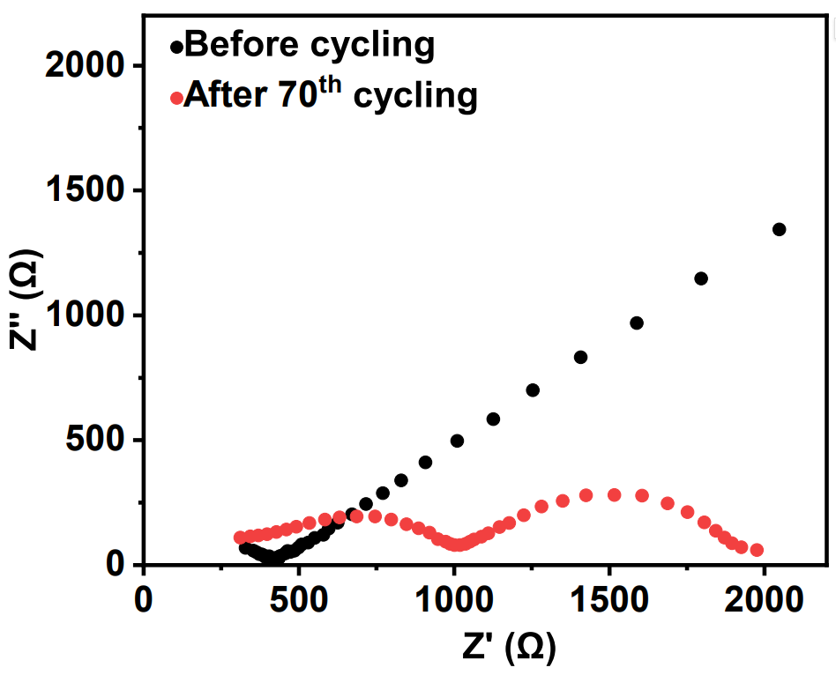
Supplementary Figure 19 Nyquist plots of NaCrO₂||NLZC0.3-HM||Na_{2.9}PS_{3.9}Cl_{0.1}||Na₂Sn before and after cycling.

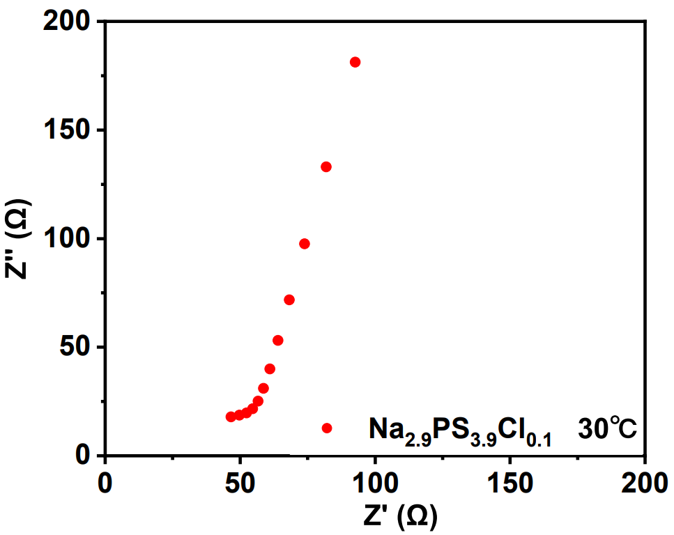
Supplementary Figure 20 Nyquist plots of Na_{2.9}PS_{3.9}Cl_{0.1}.

Supplementary Figure 21 Nyquist plots of NaCrO₂ composite cathode and NLZC0.3-HM (a), NLZC0.3-HM and Na_{2.9}PS_{3.9}Cl_{0.1} (b), Na_{2.9}PS_{3.9}Cl_{0.1} and Na₂Sn.

Supplementary Figure 22 Rate performance of NaCrO₂||NLZC0.3-HM||Na_{2.9}PS_{3.9}Cl_{0.1}||Na₂Sn ASSB.
Supplementary Figure 23 Cycle performance of ASSB using Na_{2.9}PS_{3.9}Cl_{0.1} SSE.
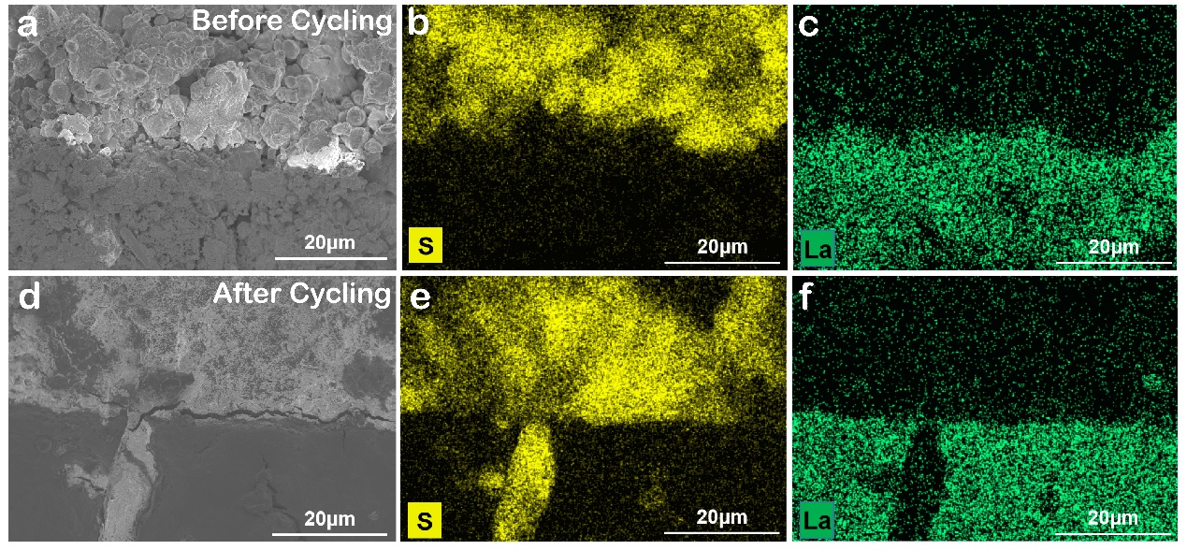
Supplementary Figure 24 SEM image of NLZC0.3-HM/Na_{2.9}PS_{3.9}Cl_{0.1} layer before (a) and after (d) cycling, S mapping before (b) and after (e) cycling, La mapping before (c) and after (f) cycling.

Supplementary Table 1 XRD refinement results of NaLaCl₄-HT
Component：NaLaCl₄-HT
Space group：P6₃/m
Lattice Parameters：a = b =7.5669(9) Å, c = 4.3458(5) Å, V = 215.50(2) Å³
α = β = 90°, γ = 120°
Atom | x | y | z | Wyckoff | Occupancy | Uiso
Na1 | 0 | 0 | 0 | 2b | 0.534 | 0.3419
Na2 | 0.33333 | 0.66667 | 0.25000 | 2c | 0.233 | 0.0035(3)
La1 | 0.33333 | 0.66667 | 0.25000 | 2c | 0.767 | 0.0035(3)
Cl1 | 0.38642 | 0.30207 | 0.25000 | 6h | 1.000 | 0.0529(14)
R_{wp} = 6.660 % GOF = 1.55 %

Supplementary Table 2 XRD refinement results of Na_{0.9}La_{0.9}Zr_{0.1}Cl₄-HT
Component：Na_{0.9}La_{0.9}Zr_{0.1}Cl₄-HT
Space group：P6₃/m
Lattice Parameters：a = b = 7.5729(8) Å, c = 4.3533 Å, V = 216.21(A) Å³
α = β = 90°, γ = 120°
Atom | x | y | z | Wyckoff | Occupancy | Uiso
Na1 | 0 | 0 | 0 | 2b | 0.331 | 0.3419
Na2 | 0.33333 | 0.66667 | 0.25000 | 2c | 0.359 | 0.0035(3)
La1 | 0.33333 | 0.66667 | 0.25000 | 2c | 0.559 | 0.0035(3)
La2 | 0.00000 | 0.00000 | 0.00000 | 2b | 0.131 | 0.3419
Zr1 | 0.33333 | 0.66667 | 0.25000 | 2c | 0.082 | 0.0035(3)
Cl1 | 0.38642 | 0.30207 | 0.25000 | 6h | 1.000 | 0.0529(14)
R_{wp} = 6.182 % GOF= 1.42 %

Supplementary Table 3 XRD refinement results of Na_{0.8}La_{0.8}Zr_{0.2}Cl₄-HT
Component：Na_{0.8}La_{0.8}Zr_{0.2}Cl₄-HT
Space group：P6₃/m
Lattice Parameters：a = b =7.5775(6) Å, c = 4.3566(7) Å, V = 216.64(3) Å³
α = β = 90°, γ = 120°
Atom | x | y | z | Wyckoff | Occupancy | Uiso
Na1 | 0 | 0 | 0 | 2b | 0.282 | 0.3419
Na2 | 0.33333 | 0.66667 | 0.25000 | 2c | 0.331 | 0.0035(3)
La1 | 0.33333 | 0.66667 | 0.25000 | 2c | 0.505 | 0.0035(3)
La2 | 0.00000 | 0.00000 | 0.00000 | 2b | 0.108 | 0.3419
Zr1 | 0.33333 | 0.66667 | 0.25000 | 2c | 0.164 | 0.0035(3)
Cl1 | 0.38642 | 0.30207 | 0.25000 | 6h | 1.000 | 0.0529(14)
R_{wp} = 6.264% GOF= 1.48 %

Supplementary Table 4 XRD refinement results of Na_{0.7}La_{0.7}Zr_{0.3}Cl₄-HT
Component：Na_{0.7}La_{0.7}Zr_{0.3}Cl₄-HT
Space group：P6₃/m
Lattice Parameters：a = b =7.5454(9) Å, c =4.3586(4) Å, V = 214.90(9) Å³
α = β = 90°, γ = 120°
Atom | x | y | z | Wyckoff | Occupancy | Uiso
Na1 | 0 | 0 | 0 | 2b | 0.266 | 0.3419
Na2 | 0.33333 | 0.66667 | 0.25000 | 2c | 0.259 | 0.0035(3)
La1 | 0.33333 | 0.66667 | 0.25000 | 2c | 0.516 | 0.0035(3)
La2 | 0.00000 | 0.00000 | 0.00000 | 2b | 0.009 | 0.3419
Zr1 | 0.33333 | 0.66667 | 0.25000 | 2c | 0.225 | 0.0035(3)
Cl1 | 0.38642 | 0.30207 | 0.25000 | 6h | 1.000 | 0.0529(14)
R_{wp} = 6.493% GOF= 1.59 %

Supplementary Table 5 XRD refinement results of NaLaCl₄-HM
Component：NaLaCl₄-HM
Space group：P6₃/m
Lattice Parameters：a = b = 7.5646(16) Å, c = 4.3717(5) Å, V = 216.65(6) Å³
α = β = 90°, γ = 120°
Atom | x | y | z | Wyckoff | Occupancy | Uiso
Na1 | 0 | 0 | 0 | 2b | 0.534 | 0.3419
Na2 | 0.33333 | 0.66667 | 0.25000 | 2c | 0.233 | 0.0035(3)
La1 | 0.33333 | 0.66667 | 0.25000 | 2c | 0.767 | 0.0035(3)
Cl1 | 0.38642 | 0.30207 | 0.25000 | 6h | 1.000 | 0.0529(14)
R_{wp} = 3.898 % GoF = 1.79 %

Supplementary Table 6 XRD refinement results of Na_{0.9}La_{0.9}Zr_{0.1}Cl₄-HM
Component：Na_{0.9}La_{0.9}Zr_{0.1}Cl₄-HM
Space group：P6₃/m
Lattice Parameters：a = b = 7.5699(17) Å, c = 4.3717(5) Å, V = 216.95(7) Å³
α = β = 90°, γ = 120°
Atom | x | y | z | Wyckoff | Occupancy | Uiso
Na1 | 0 | 0 | 0 | 2b | 0.391 | 0.3419
Na2 | 0.33333 | 0.66667 | 0.25000 | 2c | 0.399 | 0.0035(3)
La1 | 0.33333 | 0.66667 | 0.25000 | 2c | 0.619 | 0.0035(3)
La2 | 0.00000 | 0.00000 | 0.00000 | 2b | 0.071 | 0.3419
Zr1 | 0.33333 | 0.66667 | 0.25000 | 2c | 0.082 | 0.0035(3)
Cl1 | 0.38642 | 0.30207 | 0.25000 | 6h | 1.000 | 0.0529(14)
R_{wp} = 3.497% GOF = 1.63 %

Supplementary Table 7 XRD refinement results of Na_{0.8}La_{0.8}Zr_{0.2}Cl₄-HM
Component：Na_{0.8}La_{0.8}Zr_{0.2}Cl₄-HM
Space group：P6₃/m
Lattice Parameters：a = b = 7.5702(17) Å, c = 4.3718(5) Å, V = 216.97(7) Å³
α = β = 90°, γ = 120°
Atom | x | y | z | Wyckoff | Occupancy | Uiso
Na1 | 0 | 0 | 0 | 2b | 0.330 | 0.3419
Na2 | 0.33333 | 0.66667 | 0.25000 | 2c | 0.283 | 0.0035(3)
La1 | 0.33333 | 0.66667 | 0.25000 | 2c | 0.553 | 0.0035(3)
La2 | 0.00000 | 0.00000 | 0.00000 | 2b | 0.061 | 0.3419
Zr1 | 0.33333 | 0.66667 | 0.25000 | 2c | 0.164 | 0.0035(3)
Cl1 | 0.38642 | 0.30207 | 0.25000 | 6h | 1.000 | 0.0529(14)
R_{wp} = 3.522% GOF = 1.65 %

Supplementary Table 8 XRD refinement results of Na_{0.7}La_{0.7}Zr_{0.3}Cl₄-HM
Component：Na_{0.7}La_{0.7}Zr_{0.3}Cl₄-HM
Space group：P6₃/m
Lattice Parameters：a = b = 7.6048(21) Å, c = 4.3999(7) Å, V = 220.37(10) Å³
α = β = 90°, γ = 120°
Atom | x | y | z | Wyckoff | Occupancy | Uiso
Na1 | 0 | 0 | 0 | 2b | 0.281 | 0.3419
Na2 | 0.33333 | 0.66667 | 0.25000 | 2c | 0.244 | 0.0035(3)
La1 | 0.33333 | 0.66667 | 0.25000 | 2c | 0.511 | 0.0035(3)
La2 | 0.00000 | 0.00000 | 0.00000 | 2b | 0.061 | 0.3419
Zr1 | 0.33333 | 0.66667 | 0.25000 | 2c | 0.245 | 0.0035(3)
Cl1 | 0.38642 | 0.30207 | 0.25000 | 6h | 1.000 | 0.0529(14)
R_{wp} = 3.583% GOF = 1.63 %

