Supplementary File
Appendix A: Australian Red Cross 2020 Antenatal Audit Tool
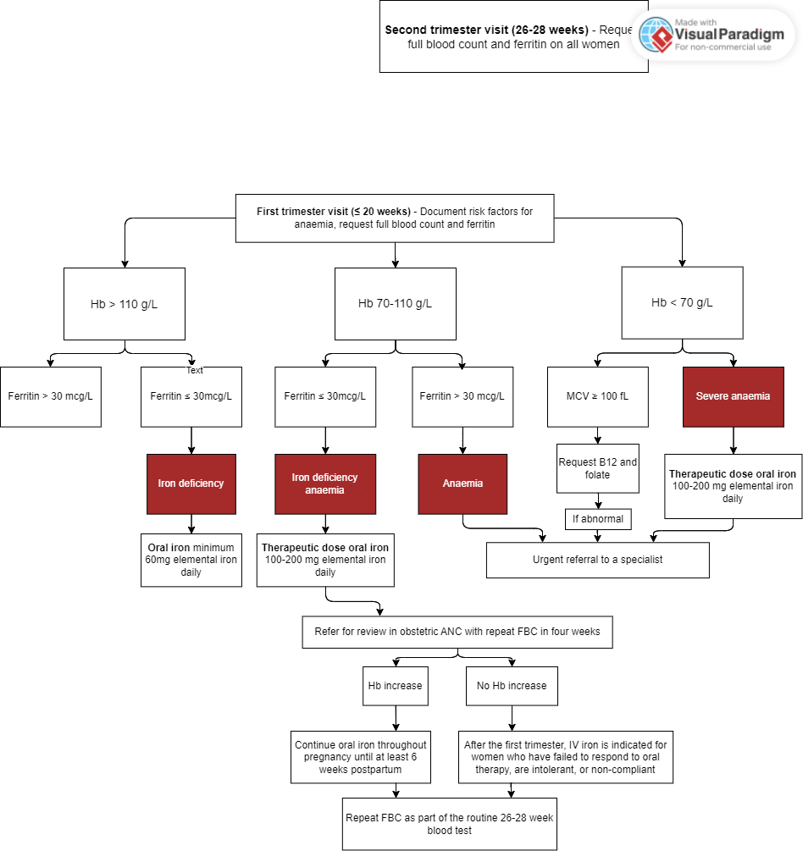
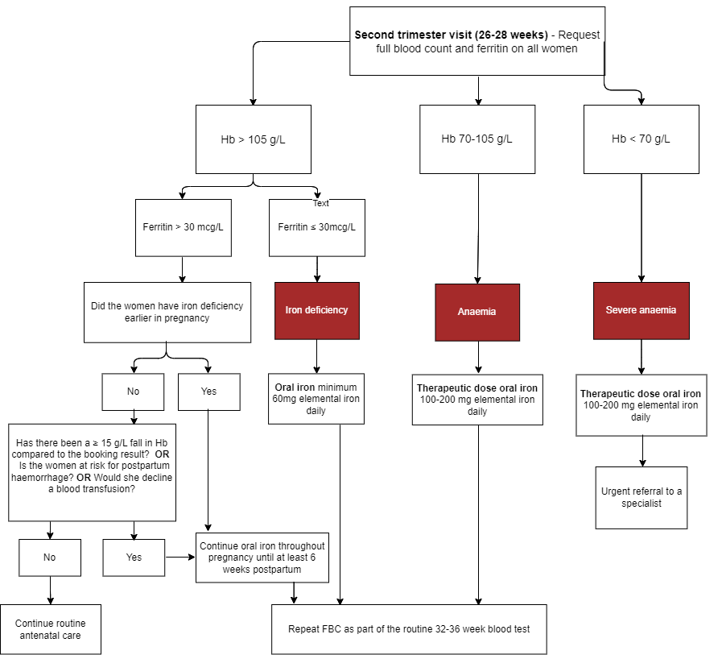

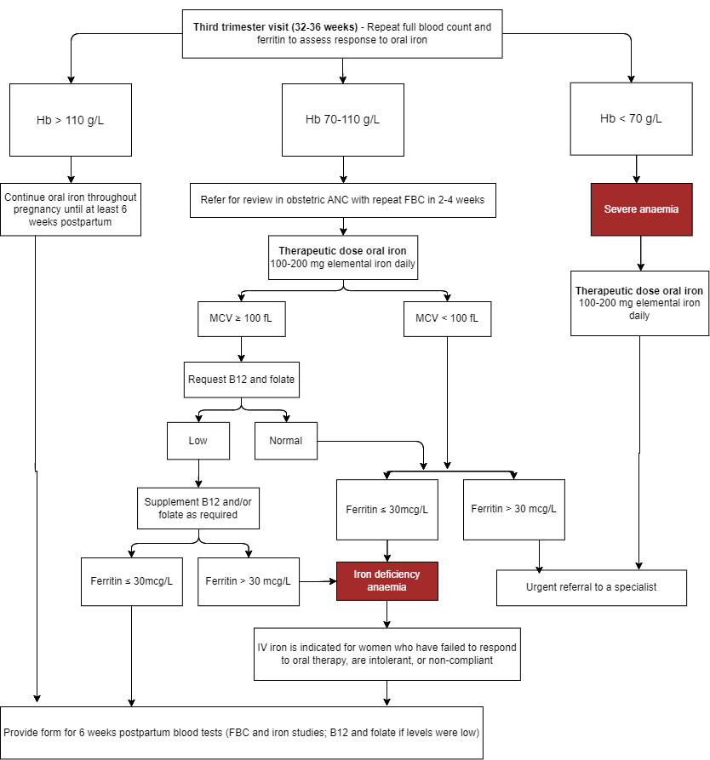

Appendix B: Data collected from participants
Sociodemographic Factors | Aboriginal or Torres Strait Islander  Age
Behavioural | Diet  BMI  Vegetarian or Vegan diet
General Medical History | Previous anaemia  History of bleeding
Obstetric History | Parity  Gravity  Interpregnancy interval  History of postpartum haemorrhage
Antenatal | Conception of pregnancy  Bloods – Haemoglobin, MCV, MCH, Ferritin  Location of antenatal care – Hospital clinic, GP, shared care (hospital and GP)  Prescription of oral iron  Compliance with oral iron  Prescription of IV iron  Side effects relating to IV iron infusions
Intrapartum | Bloods – Haemoglobin
Postnatal | Mode of Delivery  Delivery complications eg. Blood loss, PPH, potential blood transfusions  Follow up bloods, if required – Haemoglobin

