Ecological dynamics of moa extinctions reveal convergent refugia that today harbor flightless birds - Supplementary Materials

Sean Tomlinson¹, Mark V. Lomolino², Jamie R. Wood^{1,3}, Atholl Anderson⁴, Stuart C. Brown^{1,5}, Sean Haythorne⁶, George L. W. Perry⁷, Janet M. Wilmshurst³, Jeremy J. Austin¹, Damien A. Fordham^{1,10,11}
¹ School of Biological Sciences, University of Adelaide, Adelaide SA 5000 AUSTRALIA
² College of Environmental Science and Forestry, State University of New York, Syracuse NY 13210 USA
³ Ecosystems & Conservation, Manaaki Whenua Landcare Research, Lincoln 7640 NEW ZEALAND
⁴ School of Culture, History and Language, Australian National University, Canberra ACT 0200 AUSTRALIA
⁵ Globe Institute, University of Copenhagen, Øster Farimagsgade 5, 1353 København K, DENMARK
⁶ Centre of Excellence for Biosecurity Risk Analysis, University of Melbourne, Parkville VIC 3010 AUSTRALIA
⁷ School of Environment, University of Auckland, Auckland 1142 NEW ZEALAND
⁸ Center for Macroecology, Evolution, and Climate, GLOBE Institute, University of Copenhagen, Copenhagen, DENMARK.
⁹ Center for Global Mountain Biodiversity, GLOBE Institute, University of Copenhagen, Copenhagen, DENMARK.
¹³ Center for Macroecology, Evolution, and Climate, GLOBE Institute, University of Copenhagen, Copenhagen, Denmark.
¹⁴ Center for Global Mountain Biodiversity, GLOBE Institute, University of Copenhagen, Copenhagen, Denmark.

Email: sean.tomlinson@adelaide.edu.au; damien.fordham@adelaide.edu.au

This document contains:
Ecological niches of moa 3
Fossil data 3
Climate and environmental data 4
Multi-temporal ENM 5
Model projection and validation 6
Hypervolume sampling and realized niches 7
Human density 8
Process-explicit model of moa-climate-human interactions 8
Carrying capacity 9
Survival, fecundity and population growth 9
Dispersal 10
Human hunting 11
Latin hypercube sampling 12
Pattern oriented modelling 13
Fossil-based inferences 13
Comparing simulated and inferred data 14
Approximate Bayesian Computation 15
Analysis of SEPM outputs 15
Moa functional trait space 16
Drivers of extirpation 16
Associations with extant species 17
Survey data 17
Analysis of spatial pattern 17
Supplementary Results 17
Ecological niche models 17
Pattern oriented modelling 18
Population sizes prior to human arrival 18
Timing of extinction 18
Ecological correlates of extinction 18
Figures and Tables 19
References 44

This supplement provides detailed methods on how we used spatially-explicit population models (SEPMS¹) to reconstruct the extinction dynamics of six species of moa using a broad array of plausible ecological and demographic parameters. The simulations have been developed using the ‘poems’ package² in the R statistical environment³, and ‘poems’ v1.0.2 must be installed to run the accompanying examples. The scripts are designed to run in parallel across n sessions. Currently this is coded as 75% of the resources available - please set n accordingly.
There are two scripts contained in the repository, numbered in the order that they are required to develop the data reported here. The first script builds a spatiotemporal template for the simulations using the ‘hypervolume’ package⁴ to build multitemporal species distribution models⁵ from radiocarbon dated fossil records. The second script builds, runs, and saves the SEPM output (using the multi-simulation manager in ‘poems’²). The second script implements POM, using Approximate Bayesian Computation (ABC⁶) to identify the most accurate simulations. All outputs are saved in the demonstration directory. The data and computational code (written in Program R v4.2.3) are located here: 10.6084/m9.figshare.21946187.

Supplementary Methods
Process-driven statistical-simulation models of moa-climate-human interactions, which integrate extensive palaeoecological information, were developed to reconstruct critical interactions between intrinsic demographic processes and extrinsic environmental factors that caused the decline and extinction of six species of moa. Pattern-oriented modelling techniques⁷ and Approximate Bayesian Computation⁸ were used to identify vital processes, find accurate parameters, and validate models. Validated models were used to reconstruct and compare range and extinctions dynamics. The conceptual approach is summarized in Figure S8.

Ecological niches of moa
We used a multi-temporal ecological niche modelling (ENMs⁹) approach to define the initial spatial structure for moa in our process-driven simulations of moa-human interactions^{10,11}. Development of this ENM involved intersecting fossil and climate data.

Fossil data
Spatiotemporal occurrence data for moa were obtained from published studies with georeferenced and ¹⁴C dated fossils (662 specimens; Dataset S1). These radiocarbon dates were calibrated using the ‘BChron’ R package and the SHCal 13 calibration curve¹². All calibrated dates are reported as years prior to 1950 AD. We discarded 76 specimens for which there was no reliable taxonomic information. We discarded a further 114 specimens because they had low-quality dates based on established criteria¹³. This resulted in 526 georeferenced and ¹⁴C dated unique fossil occurrences of high taxonomic resolution from the late Pleistocene and Holocene, which we used to train ENMs (Dataset S1). This fossil database comprised fossils for Dinornis robustus (n = 112), D. novaezealandiae (n = 7), Pachyornis elephantopus (n = 103), P. australis (n = 36) and P. geranoides (n = 7), Emeus crassus (n = 67), Euryapteryx curtus (n = 74), Megalapteryx didinus (n = 44) and Anomalopteryx didiformis (n = 22).

Climate and environmental data
Annual paleoclimate data for New Zealand were extracted from PaleoView v1.5.1 for the period 21 kBP to the present using a 30-year sliding window. Paleoclimate simulations were generated by the Community Climate System Model Version 3 (CCSM3¹⁴⁻¹⁶). Climate reconstructions available in PaleoView accurately reproduce major climatic features associated with the most recent deglaciation event, and predict present-day patterns of climate conditions (including for New Zealand) with verified hindcast skill¹⁷.
The climatic parameters were total annual average rainfall (mm), annual average temperature, and average monthly maximum and minimum temperatures (°C) for the coolest (July) and warmest (January) months. The warmest and coldest temperatures represent the most extreme physiological constraints for moa, which can be significant even at sublethal levels¹⁸. July minima also correlate with the lowest elevation of snow cover, which likely constrained access to parts of the distribution for moa. January maxima is likely to have constrained incubation of eggs, given that moa were summer nesters¹⁹. Annual precipitation was retained because the habitat preferences of many moa species were associated with vegetation patterns dictated by rainfall²⁰.
To capture important orthographic elements in New Zealand’s climate, all climate layers were downscaled to ~ 0.25° (20 km²) grid cell resolution using a change factor (bias-correction) method²¹. This was done using climate data from the New Zealand National Institute of Water and Atmospheric Research (NIWA) and the University of East Anglia Climatic Research Unit (CRU)²². We could not downscale the PaleoView data directly to the higher resolution NIWA data because PaleoView provides 30-year average climate data up until 1975, while NIWA provide 30-year average data from 1985. We used CRU data to address this temporal mismatch, using the following steps:
- Bilinear interpolation was used to align NIWA and CRU climate data (native resolutions of ~ 0.12° and 0.5°, respectively) with the downscaled PaleoView projections (20 km² resolution).
- The NIWA climate data were adjusted for observed climatic changes in New Zealand between 1975 and 1985 using CRU data.
This harmonization process has been used elsewhere in a similar way²³.Likewise, the climate downscaling approach has been used to reconstruct climatic change in New Zealand since the last ice age.
Some species of moa are hypothesized to have been restricted to steep, upland habitats²⁰. We therefore calculated average ruggedness of each ~ 0.25° grid cell using a high-resolution (~ 1 arcsec, 25 m²) digital elevation model²⁴. We did this by computing the largest inter-cell difference between each pixel and its surrounding cells. Since different species of moa are likely to have used different vegetation types²⁵⁻²⁷, and vegetation patterns are strongly linked to edaphic conditions, we also extracted information on the content (g.kg⁻¹) of clay and silt in the topsoil layer (5-15cm deep), downscaled from a native 10 arcsec resolution²⁸.

Multi-temporal ENM
To maximize occurrence data in ENMs, and avoid niche truncation²⁹, full potential ecological niches were estimated for phylogenetic groups³⁰. We initially identified five functional phylogenetic groups according to relatedness³⁰ and ecological attributes and demographic traits²⁶. There were sufficient fossil data to model four of these phylogenetic groups. These phylogenetic groups comprised two Dinornis spp (119 fossils), two Pachyornis spp (74 fossils), Megalapteryx didinus (44 fossils), and two subspecies of Euryapteryx curtus (110 fossils).
We intersected climate projections for each georeferenced fossil for the period ± 2 SD around its estimated age, generating a time series of climate data for each fossil^{10,31}. Collectively, this represents the climate history over which moa were likely to have been present at the fossil sites. We ‘merged’ fossil records of the same phylogenetic group within each grid-cell where there were overlapping confidence intervals for calibrated radiocarbon ages (Calibrated Age ± 2 S.D.) of fossils. Where temporal overlap occurred, the confidence intervals were merged for all overlapping records resulting in a single record with an expanded age interval³².
We tested for collinearity between climate variables and removed variables that were strongly correlated (|r| > 0.7³³), opting for variables that have well established biological evidence for affecting the population dynamics of New Zealand avifauna^{34,35} , providing strong support for their inclusion in the niche hypervolume³⁶. The final climatic variables used in the ENMs were total annual average rainfall, maximum January temperature and minimum July temperature.
We initially modelled a three-dimensional climate-only ENM for each phylogenetic group separately using a Monte Carlo approach , using the ‘hypervolume’ R package⁴. The approach generates an approximation of the full potential niche — the climatic space where the species could have lived⁴. We created a Gaussian hypervolume of ecological suitability, a technique for niche estimation that does not require absence data⁴. We tuned the kernel density estimation bandwidth by optimizing the mean square error using cross-validation⁴. We selected the lower values for each parameter (bandwidth, hyper-ellipse standard deviations and inclusion quantiles) that maximized the minimum likelihood of occurrence across all fossil locations in the construction of the final hypervolumes (Figure S9).
Hypervolumes for each of the four phylogenetic groups were compared in n-dimensional space to assess overlap and to confirm that separate ENMs were in fact needed for each phylogenetic group. This was done using the “hypervolume_overlap_statistics” function of the ‘hypervolume’ package⁴. The Pachyornis spp. and Dinornis spp. had the highest degree of overlap, but all four phylogenetic groups maintained at least 50% unique 3-dimensional climate niche space (Table S5; Figure S9). The Jaccard overlap between Pachyornis spp and Euryapteryx curtus was 0.16, the Jaccard overlap between Pachyornis spp. and Dinornis spp. was 0.18 and the Jaccard overlap Pachyornis spp. and Megalapteryx didinus was 0.20. The Jaccard overlap between Euryapteryx curtus and Dinornis spp. was 0.32, and Jaccard overlap between Euryapteryx curtus and Megalapteryx didinus was 0.13. The Jaccard overlap between Dinornis spp. and Megalapteryx didinus was 0.15.
A second three-dimensional environment-only ENM was constructed using a Gaussian KDE to capture non-climate aspects of the ecological niches of moa. These variables could not be included in the multi-temporal climate-only ENM because the spatial data sources were not temporally variable, and replication of identical data sources biased the ENM if included in models with temporarily varying climate variables. The bandwidth of the Gaussian KDE was estimated via a cross-validation estimator using the ‘estimate_bandwidth’ function applied to the n-dimensional combinations of environmental variables used to define the niche. The resulting hypervolume captured broad environmental niches using the default settings of the hypervolume algorithm, and we did not optimize these further.

Model projection and validation
Projections of probability density of moa occupancy were generated at annual time steps from 11800 YBP to the present for the climatic ENM using 10-fold cross-validation to tune the ‘weight.exponent’, and ‘edges.zero.distance.factor’ parameters. These two parameters control the rate and distance at which habitat suitability reduces to 0 from its empirical maximum. Final parameters were chosen based on the combination of parameters that maximized the minimum habitat suitability at fossil locations through time, resulting in a ‘weight.exponent’ of -3 and ‘edges.zero.distance.factor’ of 10. Spatial projections of probability of occupancy were generated once for the edaphic ENM and used as a mask for the climate ENM, assuming that changing patterns in climatic suitability through time would be constrained by edaphic suitability³⁷.
The accuracy of the climate hypervolume for each phylogenetic group was assessed using 10-fold cross validation where a unique 10% of fossil records were excluded for use as test data in each fold. For each fold, habitat suitability was projected to the grid cells containing the 10% hold-out fossils, and pseudoabsences were generated by randomly sampling 50 times the number of cells containing fossils from the grid cells that fell outside the masked hypervolume projection. The AUC was calculated using the ‘gbm’ package³⁸ and functions provided by Elith, et al. ³⁹. The process is described graphically in Figure S10, and the results of these analyses are reported in the Supplementary Results.

Hypervolume sampling and realized niches
The full multi-temporal approximations of potential niches for each phylogenetic group were exhaustively subsampled to identify potential realized niches of each moa species using a process-driven approach described below. This approach has been used elsewhere^{10,11,31}.
To do this the full multi-temporal niche hypervolume was subsampled using ‘boxes’ with different widths (from 0.6 to 1.0, every 0.05), moving throughout the three-dimensional space. To obtain unique niche subsamples, the climate variables were rounded to 1 decimal place. Identical subsampled niches were removed, and the remainder converted to a Gaussian three-dimensional hypervolume with parameters identical to the full fundamental niche.
We calculated the marginality of each unique niche subsample using the ‘ade4’ R package⁴⁰ as a measure of climatic specialization. We calculated this as the distance between the climate conditions of the niche subsample and the mean conditions of the full (multi-temporal) potential niche³². Highly marginal niche subsamples have less common climatic conditions compared to the full potential niche, while low marginality niches represent climates that are typical of the full potential niche. We calculated niche volume as the volume of the Gaussian hypervolumes⁴.
Potential (unique) realized niches were identified using marginality and niche volume. This resulted in 930 unique plausible niches for the Dinornis spp., 1848 unique plausible niches for the Pachyornis spp., 1413 unique plausible niches for the combined Euryapteryx curtus and 1575 unique plausible niches for Megalapteryx didinus.

Human density
We modelled the peopling of New Zealand using a spatially explicit population model (SEPM) that integrates archaeological data with population growth and colonization dynamics to simulate human colonization of New Zealand at high spatiotemporal resolution⁴¹. The model has previously been shown to accurately reconstruct spatiotemporal occurrence based on the archaeological record of Māori presence in New Zealand, and Māori population size at the time of European arrival in New Zealand in 1769. While alternative models provide estimates of the arrival of people in the Pacific⁴²⁻⁴⁵, they are unable to provide a detailed pattern of likely expansion and abundance across the New Zealand archipelago.
The New Zealand landscape is represented in the Māori SEPM as 20 km (400 km²) square grid-cells of habitat suitability, affected by shifts in annual average rainfall (mm) and the average monthly temperature (°C) for the coldest and warmest three-month periods. Climate data are based on PaleoView v1.5.1¹⁷. Each simulation identifies the most suitable areas for initial colonization based on a founding population size, a foraging footprint and a population growth rate. Subsequently, any cell that is inhabited will grow annually, sending out migrants to uninhabited cells. The demographic parameters underlying this simulated reconstruction of Polynesian colonization were determined⁴⁶ using Approximate Bayesian Computation⁶ in a pattern-oriented framework⁴⁷. The simulation runs from 935 CE to 1970 CE at annual time steps.
To account for parameter uncertainty in spatiotemporal projections of Māori abundance we ran 10,000 different Māori SEPMs each using a unique combination of parameter settings (based on established upper and lower confidence bounds⁴⁶) using Latin hypercube sampling⁴⁸. Each reconstruction of Māori colonization was reprojected to the same 20km × 20km model template as our estimates of moa habitat suitability, providing estimates of Māori population size in each grid cell at annual time steps.

Process-explicit model of moa-climate-human interactions
We developed spatially explicit population models (SEPMs) that simulate landscape-level population processes (including dispersal and source-sink dynamics) and integrated these with the ecological niche model (ENM) projections of habitat suitability and the process-explicit simulations of Māori population growth and expansion⁴⁶. Since moa populations were relatively stable prior to Polynesian colonization⁴⁹, we limited the simulation time frame of the moa SEPMs to the last 2,500 years. The moa SEPM had a lattice spatial structure, with each grid cell being modelled with a female-only, post-breeding, age-based stochastic population model that simulated survival, fecundity and density-dependent population growth². Related approaches have been used to reconstruct the range and extinction dynamics of megafauna in the Northern Hemisphere^{10,11,31}, and the extinction of the Thylacine in Australia².
We used pattern-oriented modelling (POM) techniques to validate the models and to identify parameter values needed to predict demographic changes inferred from the extensive fossil chronology^{43,50}. We followed established protocols for applying a POM framework to SEPMs² (Figure S8). We developed this approach using the ‘poems’ R package ^{2,51}.

Carrying capacity
The carrying capacity of each cell varied through time in response to ENM suitability (see above⁵²). To convert ENM suitability to carrying capacity, we scaled values spatiotemporally between 0 and 1, using the 95th percentile of multi-temporal suitability as the upper scaling value. The carrying capacity of each population was then determined by multiplying scaled ENM suitability by an estimate of upper abundance¹¹. We used published ranges for upper abundances for each moa phylogenetic group²⁷: 1.51 (0.73 – 3.52) birds.km⁻² for Pachyornis spp., 0.80 (0.40 – 1.78) birds.km⁻² for Dinornis spp., 1.53 (0.74 – 3.58) birds.km⁻² for the combined Euryapteryx and Emeus spp. and 1.60 (0.78 – 3.77) birds.km⁻² for Megalapteryx didinus. The maximum number of individuals allowed in a population (density_max) was also scaled to the size of each grid cell from upper abundance estimates, multiplied by 0.75 because not all of a 20km x 20km grid cell will be highly suitable habitat⁵³.

Survival, fecundity and population growth
Survival and fecundity rates for moa were based on published, female-only, post-breeding Leslie matrices²⁵. We modified these so that they were specific to each phylogenetic group. We did this using ages at sexual maturity reported by Turvey, et al. ⁵⁴ for different phylogenetic group (Table S6).
We calculated the maximum rate of population increase using a method developed to calculate growth rates for rare birds with incomplete data⁵⁵ by solving equation 1:
λ_{max} = $\frac{\left(sα - s + α + 1\right)+ \sqrt{{(s - sα - α - 1)}^{2}+ {4sα}^{2}}}{2α}$ (1)
where s = adult survival rate and α = age at sexual maturity, we estimated maximum population increases at λ_{max} = 1.08.year⁻¹ (s = 0.95; α = 5 years) for the Pachyornis spp., λ_{max} = 1.11.year⁻¹ (s = 0.95; α = 3 years) for the Dinornis spp., λ_{max} = 1.06.year⁻¹ (s = 0.95; α = 7 years) for the combined Euryapteryx and Emeus spp., and at λ_{max} = 1.08.year⁻¹ (s = 0.95; α = 5 years) for Megalapteryx didinus. Based on estimates of λ_{max}, for each phylogenetic group, we allowed values of λ_{max} to vary between 1.00 - 1.20 in our SEPMs.
We used time-series data from population monitoring of several flightless bird species at or near carrying capacity in New Zealand⁵⁶⁻⁵⁸ to derive the standard deviation (SD) in population growth rate³¹. We set a variable standard deviation (SD) in population growth rate between 0.00 - 0.33 to model plausible population fluctuations driven by environmental stochasticity. Although flightless New Zealand birds are not true analogues of moa, they are likely to provide a more accurate representation of stochastic population change compared to evolutionarily more similar species, such as the Cassowary (Casuarius spp.), which come from bio-climatically different regions, such as tropical Australia or New Guinea⁵⁹.
Density-dependent population growth was modelled using a Ricker-type density-dependent response function, where increasing population abundance in a cell reduces the availability of resources to individuals, slowing population growth⁶⁰.
Evidence of Allee effects for moa species is equivocal⁶¹, possibly because the extinction event was so rapid and widespread. Regardless, negative density-dependence at < 0.5 total moa km⁻² has been hypothesized⁶²⁻⁶⁴. To test for this effect, we allowed a local Allee effect to vary log-normally between 0 and 50 birds per grid cell based on the real possibility of inbreeding^{65,66}. We also imposed a regional Allee effect in three bioregions⁶⁷, whereby moa populations could not persist below a population threshold. In the absence of published information specific to moa to guide this figure, we allowed this to vary across a large but plausible range of 50 to 3800 birds⁶⁸.

Dispersal
Based on daily movement patterns and home ranges of extant herbivorous ratites⁶⁹⁻⁷³, we assumed that moa were likely to be highly mobile. We used allometric scaling to estimate natal dispersal distance and assumed an average of 30 % of birds dispersed each year. Allometrically scaled estimates of mean⁷⁴ dispersal distance were 34, 48, 31 and 22 km for Pachyornis spp., Dinornis spp., the combined Emeus/Euryapteryx spp, and Megalapteryx didinus, respectively (Figure S11). For the purposes of the model, we fixed the mean dispersal distance at these specific values for each phylogenetic group. Maximum dispersal distance was included as a variable parameter in the model ranging from 50 to 100 km, while the proportion of the population dispersing ranged between 0 and 60%. Together these parameters influenced mean dispersal distance.
Dispersal rates between populations (m_{ij}) were modelled using a distance-based function:
$m_{ij}=\left\{\begin{aligned}p^{\left(\frac{{-D}_{ij}}{b}\right)}, D <D_{max} \\ 0, & D≥ D_{max}\end{aligned}\right.$ (2)
where p is the proportion of the population dispersing, b is the average dispersal distance and D_{max} is the maximum dispersal distance, and D represents the dispersal distance between cell i and j².
Dispersal was parameterized such that the dispersal rate to resource-depleted areas was reduced in direct proportion to declining carrying capacity. Dispersal rate was reduced proportionally once the carrying capacity of the target population fell below a target threshold (d_target_k; Table S7) of 50 birds^{65,66}. Similarly, the dispersal rate to overcrowded cells was also reduced when the abundance of the target population exceeded a target threshold of 600 birds (80% of the maximum density allowable in the model; d_target_n; Table S7).
Environmental correlation
We used spatial correlation of climatic conditions to account for similarity in environmental fluctuations for populations located close together versus those further apart. This approach has been used to simulate spatial correlation in demographic processes for vertebrates^{53,75}. To do this we analyzed monthly NIWA precipitation data for the period 1961 to 1985 from 52 meteorological stations across New Zealand (https://niwa.co.nz/education-and-training/schools/resources/climate) as a proxy for environmental correlation⁷⁶. We measured spatiotemporal environmental correlation separately for the North and South Islands using a non-centered (spline) spatial cross-correlogram implemented in the R package ‘ncf’ v1.8.1⁷⁷. We ran 500 bootstrap iterations to estimate 95% error bounds in the spatial correlation of temperature and precipitation. Using non-linear regression in the R package ‘nlstools’ v2.0.0⁷⁸ we parameterized a negative exponential correlation function⁷⁹ incorporating the patterns of correlation by distance across both islands. The resulting parameters were used to define spatial correlation in demographic processes in our SEPM.

Human hunting
We simulated human hunting of moa in our SEPM following an approach established elsewhere^{10,11}, whereby hunting was a function of the timing of the arrival and abundance of Polynesian settlers in a given grid cell⁴⁶, with no hunting preference for any specific phylogenetic group⁸⁰. Humans were able to harvest a maximum of 5-75% of eggs and 0-75% of birds ≥ 1-year old. These rates reflect inferences of intense egg and bird harvest rates by Māori⁸¹. While egg harvest was applied at a flat rate in the presence of humans, bird harvesting was modelled using the following functional response:
$Functional response=\frac{\left(F×P^{z}\right)}{\left(G+P^{z}\right)}$ (3)
Where P is the population density of prey (current population size, divided by maximum population size), F is the maximal predation rate (variable between 0.05 – 0.75), equivalent to approx. 450 birds annually, or a maximum of seven birds per person per year. These are near the maximum harvest rates previously estimated^{63,82}. G is a constant equal to the prey density at which predation is half-maximal (fixed at 0.4^{83,84}), and z is a measure of the departure from maximal predation. The functional response gives the number of prey killed per predator per year. The harvest rate (H, proportion of the prey population killed) was calculated by dividing eq. 3 by the current prey density.
$H=\frac{\left(\frac{F×P^{z}}{G + P^{z}}\right)}{P}$ (4)
The above parameterization considers all of the human population in a particular grid cell at maximal density as a single predator. Thus, to calculate the harvest rate at a particular time and grid cell, eq. 4 was multiplied by N, the human population density at that time and grid cell:
$H^{`}=\frac{\left(\frac{N×F×P^{z}}{G + P^{z}}\right)}{P}$ (5)
Previously Alroy ⁸⁴ modelled hunting success of megafauna by setting z = 1 in Eq. 5, resulting in a Type II functional response. We modelled z as a variable parameter ranging from 1 to 2¹¹. At z = 1 the function is monotonic, under which predation is modulated only by prey density and predator satiation, implying complete naivety of prey. At z >1.5 hunting success takes on an increasingly sigmoidal Type III functional response, under which prey become harder to hunt at low densities. This response might result from prey adaptation (evolved or learned behavior), prey switching by hunters, or prey being located in refugia^{83,85}. Since Māori used a range of food sources (plant and animal)^{86,87}, and showed substantial variation in wild food sources as well^{86,88,89}, we concluded them not to be obligate moa hunters, and we did not model a numerical predation response. All parameters (and their ranges) used in the SEPM are provided in Table S7.

Latin hypercube sampling
Parameters for all SEPMs were varied across wide but plausible ranges (Table S7) using Latin hypercube sampling⁹⁰. Latin hypercube sampling generates a stratified random subset of parameter input values for simulation by assigning a plausible range for each parameter and sampling all subsets of its distribution once, based on subdivisions of equal probability density⁹⁰. There were no best estimates, so we used uniform sampling distributions for all parameters. This procedure produced 25,000 conceivable SEPMs for each species, each model with different ecological affinities, demographic parameters and hunting offtake rates.
Phylogenetic groups generally comprised one distinct species on the North and South island respectively³⁰. On the North Island separate models were built and run for Pachyornis geranoides, Dinornis novaezealandiae and Euryapteryx curtus curtus. On the South Island separate models were built and run for Pachyornis elephantopus, Dinornis robustus, Euryapteryx curtus gravis and Megalapteryx didinus. Each simulation was run for a single replicate⁹¹. Simulations were run at an annual time step for 2000 years (from to 2050 YBP to 50 YBP), following a climatically stable burn-in period of 300 years (approximately 50 moa generations). This burn-in period allowed the initial population abundance and metapopulation structure to stabilize.

Pattern oriented modelling
We used pattern-orientated modelling (POM) to evaluate whether each moa SEPM was adequate in its structure and parameterization to simulate mechanistic responses to climate change and exploitation in a way that realistically matches the observed outcomes^{47,92}. Model simulations of moa abundance were assessed using a multivariate target based on inferences from the fossil record¹¹ (Figure S1). The fossil-based inferences used in POM were spatiotemporal occurrence, and timing and location of extinction. Spatiotemporal occurrence was estimated as the percentage of known fossil locations where moa were simulated to occur at the right time. Timing of extinction on the North and South Islands was estimated from the fossil record accounting for the Signor-Lipps effect⁹³, and the extinction location was based on the youngest known fossil locations on the North and South Islands respectively. These targets have been used to reconstruct the extinction dynamics of animals that went extinct long ago^{11,31}.

Fossil-based inferences
POM targets were calculated using reliably dated ¹⁴C fossils — those that obtained the highest possible dating quality score of 12¹³ (see above). This required them to have been radiocarbon dated after 2008, and have been collected from paleontological sources, rather than archaeological sources recovered from Māori middens and ovens. This screening was done for two reasons: first, Māori are likely to have moved moa carcasses substantial distances from the location of harvest to the final location of deposition^{62,94}. Secondly, butchering and processing by Māori has rendered the majority of moa fossils taxonomically indistinct.
The radiocarbon dates associated with each fossil were recalibrated using the SHCal20 calibration curve⁹⁵, which became available during the lifetime of the project. This was done using the ‘BChron’ R package⁹⁶. Ages based on the SHCal13 and SHCal20 calibration curve were similar (Dataset S1).
The SHCal20 calibrated fossil ages were used to estimate a window of occupancy of each grid cell containing a fossil, and the eight grid cells surrounding it³¹. The occupancy window was characterized by the sequence of years encapsulated by the radiocarbon age (±2 SD) of each fossil at each grid cell (Figure S12). Where temporal overlap occurred between fossils, the confidence intervals were merged to produce a single record with an expanded age interval¹⁰.
The timing of extinction was estimated for each species taking into account the Signor-Lipps effect⁹³. Following Bradshaw, et al. ⁹⁷ we calculated a likely year of extinction considering the temporal distribution of fossils for each species over the last 15,000 years. Conducting these analyses independently for each species, and separately on the North and South Islands for Euryapteryx curtus, resulted in estimated windows of probable extinction that are more recent than the calibrated radiocarbon ages of the fossils (Figure S13). This is consistent with theory that the most recent fossil of any species is unlikely to represent the last living individual, due to stochasticity in the deposition, identification and dating of fossil material^{93,97}.
We conducted a sensitivity analysis to determine whether the temporal distribution of fossils affected extinction estimates. To do this, 1000 drop-one replicates were taken of the SHCal20 calibrated fossil ages and used to calculate a likely year of extinction. Estimated times of extinction were largely insensitive to the distribution of the fossil record. Although confidence intervals were larger for species with the sparsest fossil material (Pachyornis geranoides and Euryapteryx curtus on the North Island). The youngest SHCal20 calibrated fossils were used to identify the last known location of occurrence for each species, and the eight grid cells surrounding it (Figure S12). This was used as an estimate of extinction location³¹.

Comparing simulated and inferred data
The capacity of moa SEPMs to correctly simulate spatiotemporal occurrence was assessed by calculating the proportion of fossil sites where SEPMs generated populations of moa during the occupancy window. The ability of the simulations to model the extinction year was assessed according to the number of years between the modelled extinction year and the median extinction year estimated from the fossil record. Simulations were assessed according to the distance between the modelled extinction location and the location of the last known record of occurrence. The minimum distance (km) between last known location and the final modelled population was calculated using the ‘fields’ R package⁹⁸. This was calculated as the distance between the centroid of the grid cell modeled to hold the last population of moa, and the centroid of the nearest grid cell to hold the last fossil record of the species.

Approximate Bayesian Computation
Approximate Bayesian Computation (ABC⁶) was used to determine species-specific SEPMs that did well at replicating inferences of occurrence and extinction from the fossil record. For each species we retained the 1.0% of simulations that best matched the multivariate target (described above), using the ‘rejection’ algorithm in the R package ‘abc’ v2.1⁹⁹. We used the rejection algorithm because it maintains the parameter estimates as a subsample of the priors, rather than correcting them to the summary statistics of the prior distribution⁹⁹.
To further refine the parameter distributions and to improve the ability of the models to hit the validation targets, we generated informed priors by resampling the parameter space according to the characteristics of the best simulations identified by the ABC. We did this by generating 10,000 new parameter combinations. For each demographic parameter, we generated values using parameter-specific distribution types constrained to the 90% CI of the posterior parameter distributions (i.e. the 90% CI from the selected simulations). The probability density function with the best fit to the posterior distribution was identified separately for each parameter using Akaike’s Information Criterion (AIC). Resampling was repeated to refine parameter distributions of SEPMs until Bayes Factors (calculated using a 90% region of practical equivalence¹⁰⁰) were less than 1, indicating convergence between the prior and posterior distributions. For each species this was achieved within two rounds of parameter refinement.
We evaluated model performance using the ‘gfit’ algorithm in the R package ‘abc’ v2.1⁹⁹. The algorithm compares the distance among the simulated summary metrics from the final round of POM simulations with the distance between the simulated summary metrics of the previous round. The model passes the goodness of fit check if there is high overlap (small difference in means) between the two sets of distances. The two distance data sets were statistically indistinguishable for all seven moa taxa (D. novaezealandiae: p = 0.90; D. robustus: p = 0.95; P. geranoides p = 0.40, P. elephantopus p = 0.95; E. curtus curtus, p = 0.4, E. curtus gravis, p = 0.4, M. didinus p = 0.30).

Analysis of SEPM outputs

The ecological and demographic parameters in the best simulations (Figure S6) were used to better understand how different species of moa were represented in functional trait space, and to understand the determinants of time of extirpation (extinction in grid cell).

Moa functional trait space
We used principal components analysis (PCA) to quantify the functional trait space of each moa species and compare it to that of all moa¹⁰¹. Ecological and demographic parameters were based on the best SEPMs selected using our POM method (see Table S1). They were species-specific estimates of mean carrying capacity, niche marginality (measured using outlying mean index; OMI¹⁰²), area of occupancy¹⁰³ immediately before human arrival, maximum population growth rate, the proportion of individuals that dispersed in each generation and mean dispersal distance.
The PCA of ecological and demographic traits was constructed using the ‘prcomp’ algorithm in R v 4.0.4³. The first three principal components accounted for significant proportions of the variance in the modelled trait data, each with eigenvalues greater than 1 (Table S2). Principal component 1 was driven by the population growth rate, proportion of dispersers and area of occupancy (Table S2), accounting for 26.4% of variation in moa trait space. Principal component 2 was driven by mean dispersal distance and dispersal proportion (Table S2), accounting for 25.5% of the variation moa trait space. Principal component 3 was driven by niche marginality and carrying capacity (Table S2), accounting for 21.9% of the variation moa trait space. We used convex hulls to estimate the area of trait space for different moa species, using the ‘Momocs’ package¹⁰⁴ and compared it to the generic (all species) moa trait space (Figure S2; Table S3).

Drivers of extirpation
To establish the determinants of the patterns of extirpation, the extinction timing of each species was standardized such that the year of extinction of each grid cell was transformed to a proportion relative to the oldest extinction date (i.e. the grid cells that went extinct first were equivalent to 1, and the grid cells that went extinct last were equivalent to zero). We compared relative timing of extirpation to ecological and anthropogenic correlates using a beta regression generalized additive model (GAM), which incorporated species identity as a random factor, and accounted for spatial autocorrelation by incorporating geolocation as a Gaussian process in the model¹⁰⁵.
Ecological correlates of timing of local extinction in each grid cell were species-specific habitat suitability (from ENMs) and distance from the abundance-weighted latitudinal center of each species’ pre-human distribution^{106,107} (Figure S4). Anthropological correlates were the timing of Māori arrival in each cell, and the maximum human abundance in each cell⁴⁶. We also calculated the minimum distance from the grid cells of the most likely first landfall.

Associations with extant species

Survey data
The modelled patterns of moa extirpation were compared with distributions of extant endemic flightless birds inferred from survey data collected between 1949 and 1981 for the Atlas of New Zealand birds¹⁰⁸. These data pre-date significant conservation efforts to recover threatened or endangered species, such as the establishment of fenced, predator-free reserves, insurance translocations, or population supplementations by reintroduction¹⁰⁹. To further ensure that the data did not include any populations resulting from direct conservation actions, such as introductions to predator-free islands, the data were restricted to records from the two main islands of New Zealand, removing all other island populations including Stewart Island. This left a total of 1542 occurrence records of populations of kākāpō (Strigops habroptilus; 13 records), takahē (Porphyrio hochstetteri; 20 records), weka (Gallirallus australis; 1057 records), tokoeka (Apteryx australis; 102 records), roroa (Apteryx maxima; 43 records), and the North Island brown kiwi (Apteryx mantelli; 307 records).

Analysis of spatial pattern
Occurrence records for each species were temporally collapsed (temporal duplicates removed) at the resolution of our moa simulations and intersected with the modelled year of final moa extinction (Figure S7). Each population was associated with the most recent projected year of moa extirpation (regardless of species) in the populated grid cell or the eight surrounding grid cells, consistent with the spatial buffering applied during the POM. For a ‘null’ comparison, we generated 150 random grid locations across the two main islands of New Zealand and intersected them with the most recent year of moa extirpation projected from our models. This provided a background pattern for comparison. The difference between the year of moa extirpation at each population of endemic flightless birds was compared to this background by analysis of variance, using a comparison contrasts design, where each species’ values was compared directly with the random background¹¹⁰.

Supplementary Results

Ecological niche models

The cross-validated AUC was 0.826 for the Pachyornis species, 0.824 for the Dinornis species, 0.920 for the combined Euryapteryx and Emeus species and 0.899 for Megalapteryx didinus (Figure S14). These AUC values show good cross validation skill¹¹¹. The projections suggest that all four moa groups were widespread at the approximate time of Māori settlement (c. 1230-1280^{46,112}), and that habitat suitability and area of occupancy was stable for all three groups over the entire projection period (Figure S3; Animations S1 – S6).

Pattern oriented modelling

Population sizes prior to human arrival
Our statistical-simulation modelling suggests stable populations of moa since the early Holocene, with standing populations of 33 602 Dinornis novezealandiae, 41 449 Dinornis robustus, 67 086 Euryapteryx curtus (North Island: 29 856, South Island: 37 230), 49 909 Megalapteryx didnus, 18 409 Pachyornis geranoides and 45 245 Pachyornis elephantopus, in the 1000 years prior to Māori settlement. These population estimates compare favorably with population sizes estimated by allometry for each of these groups²⁷, despite being calculated entirely independently (i.e. we did not use the published population estimates to refine or validate our simulations).

Timing of extinction
Following Polynesian colonization of New Zealand, consensus models (based on the 100 best SEPMs for each species) estimated extinction of P. geranoides, D. novaezealandiae and E. curtus curtus on the North Island to have occurred at 1354, 1459 and 1567 CE respectively. Extinctions on the South Island for D. robustus, P. elephantopus, E. curtus gravis and M. didinus were estimated to have occurred at 1450, 1453, 1497, 1535 CE, respectively. Species on the North Island all contracted to regions north of Wellington, and species on the South Island all contracted westwards (Figure S5; Animation S7).

Ecological correlates of extinction
The strongest correlate of the extinction patterns was the distance to the abundance-weighted latitudinal center of the distribution (Table S4), where the final populations of moa persisted in areas that were geographically close to the latitudinal center of their distribution. These regions were also of poor habitat suitability to moa, being at high elevations where temperatures were colder than the surrounding parts of New Zealand and were colonized later by humans (Table S4).

Figures and Tables

Table S1: Posterior distribution of parameter values resulting from reiterative Approximate Bayesian Computation (ABC). The yellow ridges show prior values, while blue ridges indicate demographic posteriors, red ridges indicate harvest posteriors and green ridges indicate ecological niche posteriors for each parameter in the moa SEPMs. Parameter ranges are presented as minimum-(mean)-maximum values in each set of simulations.
 | Parameter | Priors | Posteriors | BF
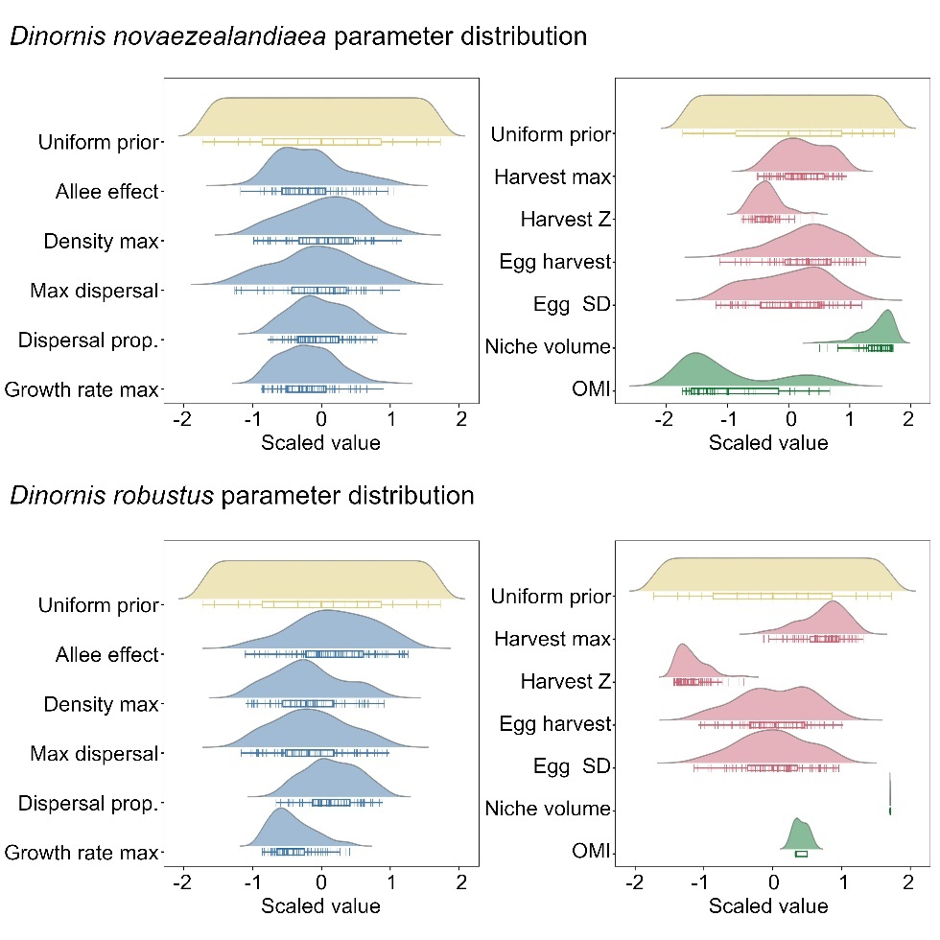 | Allee effect | 50-(1925)-3800 | 652-(1740)-3056 | 402.67
 | Maximum density | 240-(430)-620 | 322-(437)-558 | 0.00
 | Maximum dispersal | 50-(75)-100 | 57-(74)-91 | 0.00
 | Maximum growth rate | 1-(1.1)-1.2 | 1.05-(1.09)-1.15 | 0.00
 | Maximum harvest | 0.05-(0.40)-0.75 | 0.30-(0.45)-0.59 | 0.00
 | Harvest Z | 1-(1.5)-2 | 1.2-(1.4)-1.6 | 0.00
 | Maximum egg harvest | 0.05-(0.40)-0.75 | 0.17-(0.46)-0.65 | 0.18
 | Egg harvest S.D. | 0-(0.1)-0.2 | 0.03-(0.10)-0.17 | 0.98
 | Allee effect | 50-(1925)-3800 | 719-(2126)-3288 | 25807.38
 | Maximum density | 240-(430)-620 | 309-(408)-530 | 0.00
 | Maximum dispersal | 50-(75)-100 | 58-(73)-89 | 0.00
 | Maximum growth rate | 1-(1.1)-1.2 | 1.05-(1.07)-1.12 | 0.00
 | Maximum harvest | 0.05-(0.40)-0.75 | 0.37-(0.55)-0.67 | 0.02
 | Harvest Z | 1-(1.5)-2 | 1.1-(1.2)-1.4 | 0.49
 | Maximum egg harvest | 0.05-(0.40)-0.75 | 0.18-(0.41)-0.61 | 0.03
 | Egg harvest S.D. | 0-(0.1)-0.2 | 0.03-(0.10)-0.16 | 0.02
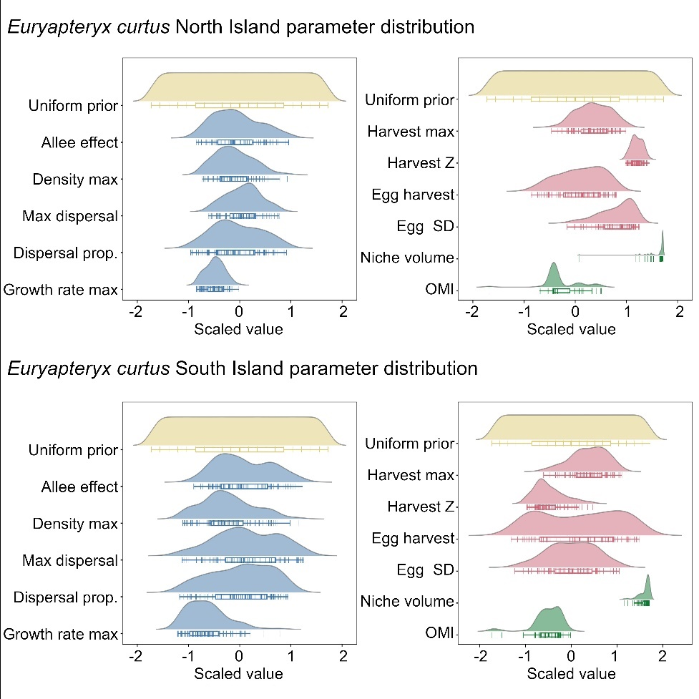 | Allee effect | 50-(1925)-3800 | 1003-(1851)-2962 | 101118100
 | Maximum density | 240-(430)-620 | 350-(417)-532 | 0.00
 | Maximum dispersal | 50-(75)-100 | 66-(76)-86 | 0.00
 | Maximum growth rate | 1-(1.1)-1.2 | 1.05-(1.07)-1.10 | 0.00
 | Maximum harvest | 0.05-(0.40)-0.75 | 0.31-(0.47)-0.60 | 0.00
 | Harvest Z | 1-(1.5)-2 | 1.8-(1.8)-1.9 | 0.00
 | Maximum egg harvest | 0.05-(0.40)-0.75 | 0.22-(0.42)-0.56 | 0.00
 | Egg harvest S.D. | 0-(0.1)-0.2 | 0.09-(0.15)-0.17 | 0.00
 | Allee effect | 50-(1925)-3800 | 952-(2009)-3259 | 1044903
 | Maximum density | 240-(430)-620 | 308-(404)-557 | 0.00
 | Maximum dispersal | 50-(75)-100 | 59-(77)-93 | 0.37
 | Maximum growth rate | 1-(1.1)-1.2 | 1.03-(1.06)-1.14 | 0.00
 | Maximum harvest | 0.05-(0.40)-0.75 | 0.28-(0.48)-0.62 | 0.01
 | Harvest Z | 1-(1.5)-2 | 1.2-(1.3)-1.6 | 0.00
 | Maximum egg harvest | 0.05-(0.40)-0.75 | 0.13-(0.43)-0.70 | 0.52
 | Egg harvest S.D. | 0-(0.1)-0.2 | 0.03-(0.10)-0.16 | 0.00
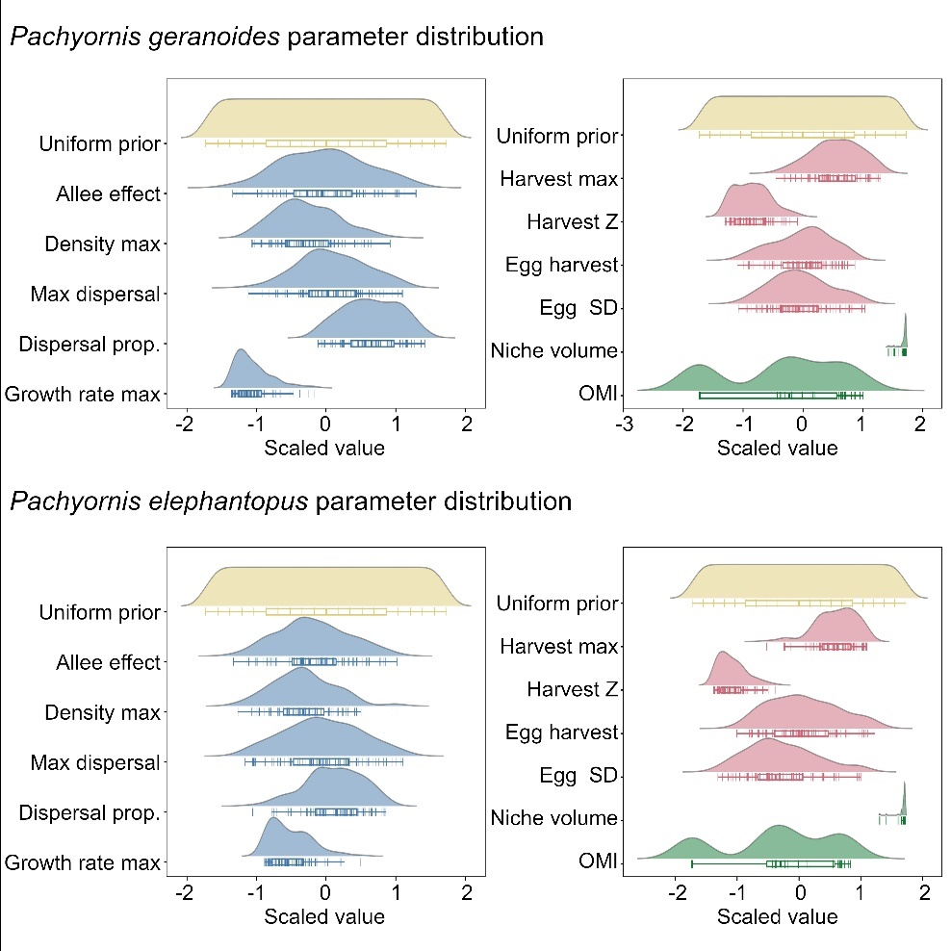 | Allee effect | 50-(1925)-3800 | 470-(1908)-3327 | 385.82
 | Maximum density | 240-(430)-620 | 313-(399)-531 | 0.00
 | Maximum dispersal | 50-(75)-100 | 59-(76)-91 | 0.02
 | Maximum growth rate | 1-(1.1)-1.2 | 1.02-(1.04)-1.09 | 0.00
 | Maximum harvest | 0.05-(0.40)-0.75 | 0.31-(0.51)-0.66 | 0.00
 | Harvest Z | 1-(1.5)-2 | 1.1-(1.2)-1.5 | 0.00
 | Maximum egg harvest | 0.05-(0.40)-0.75 | 0.18-(0.40)-0.58 | 0.00
 | Egg harvest S.D. | 0-(0.1)-0.2 | 0.04-(0.10)-0.16 | 0.00
 | Allee effect | 50-(1925)-3800 | 483-(1728)-3026 | 15024.04
 | Maximum density | 240-(430)-620 | 291-(395)-541 | 0.00
 | Maximum dispersal | 50-(75)-100 | 58-(74)-91 | 0.00
 | Maximum growth rate | 1-(1.1)-1.2 | 1.05-(1.07)-1.13 | 0.00
 | Maximum harvest | 0.05-(0.40)-0.75 | 0.29-(0.52)-0.62 | 0.00
 | Harvest Z | 1-(1.5)-2 | 1.1-(1.2)-1.4 | 0.00
 | Maximum egg harvest | 0.05-(0.40)-0.75 | 0.20-(0.41)-0.65 | 0.04
 | Egg harvest S.D. | 0-(0.1)-0.2 | 0.02-(0.08)-0.16 | 0.00
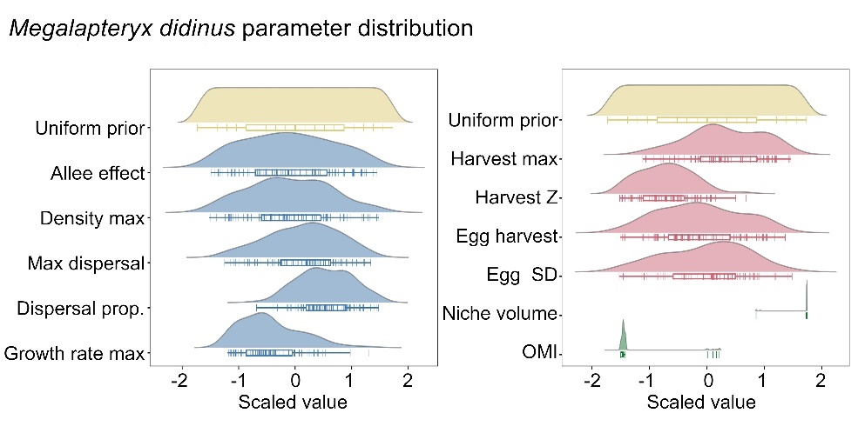
 | Allee Effect | 50-(1925)-3800 | 307-(1811)-3490 | 3810396.00
 | Maximum density | 240-(430)-620 | 263-(418)-592 | 0.00
 | Maximum dispersal | 50-(75)-100 | 57-(77)-94 | 0.00
 | Maximum growth rate | 1-(1.1)-1.2 | 1.03-(1.07)-1.17 | 0.00
 | Maximum harvest | 0.05-(0.40)-0.75 | 0.17-(0.46)-0.69 | 0.00
 | Harvest Z | 1-(1.5)-2 | 1.1-(1.3)-1.7 | 0.62
 | Maximum egg harvest | 0.05-(0.40)-0.75 | 0.09-(0.38)-0.67 | 0.00
 | Egg harvest S.D. | 0-(0.1)-0.2 | 0.01-(0.10)-0.18 | 0.00

Table S2. Trait contributions to Principal Component Analysis. “Correlation” shows the strength and direction of contribution of each trait to each Principal Component (PC1, PC2, PC3, PC4, PC5 and PC6). Principal Components in grey text contribute only weakly to the overall analysis (i.e. eigenvalues < 1). “Contribution” indicates the percentage of the variance explained in each Principal Component by each trait. This shows the overall percentage of variance accounted for by each Principal Component, where all four Principal Components combined account for > 85% of variance in the species traits.
 |  | PC1 | PC2 | PC3 | PC4 | PC5 | PC6
Niche marginality | contribution | 4.43 | 1.87 | 58.61 | 8.88 | 2.45 | 23.76
Niche marginality | correlation | 0.26 | 0.17 | -0.88 | -0.26 | 0.12 | -0.22
Mean carrying capacity | contribution | 15.98 | 0.09 | 23.76 | 47.92 | 11.78 | 0.46
Mean carrying capacity | correlation | -0.50 | 0.04 | -0.56 | 0.60 | -0.27 | 0.03
Area of occupancy | contribution | 24.03 | 10.39 | 2.26 | 38.78 | 21.82 | 2.72
Area of occupancy | correlation | -0.62 | -0.40 | -0.17 | -0.54 | -0.37 | 0.08
Growth rate (λ) | contribution | 29.08 | 11.14 | 0.45 | 0.14 | 59.19 | 0.00
Growth rate (λ) | correlation | -0.68 | -0.41 | -0.08 | 0.03 | 0.60 | 0.00
Dispersal proportion | contribution | 24.06 | 24.44 | 12.01 | 0.22 | 0.89 | 38.38
Dispersal proportion | correlation | 0.62 | -0.61 | -0.40 | 0.04 | 0.07 | 0.28
Mean dispersal distance | contribution | 2.41 | 52.08 | 2.90 | 4.06 | 3.86 | 34.68
Mean dispersal distance | correlation | 0.20 | -0.89 | 0.20 | 0.17 | -0.15 | -0.27
eigenvalue |  | 1.6 | 1.5 | 1.3 | 0.8 | 0.6 | 0.2
% variance accounted for |  | 26.4 | 25.5 | 21.9 | 12.5 | 10.2 | 3.5
Cumulative variance accounted for |  | 26.4 | 51.9 | 73.8 | 86.3 | 96.5 | 100.0

Table S3: Pairwise overlap in the probability distributions of traits. Columns (focal taxa) represent the species being compared to all other species. For each row, the values represent the proportion of the trait probability distributions of the focal species that is overlapped by the species represented in each row.

 | Focal taxa
 | Dinornis novaezealandiae | Dinornis  robustus | Euryapteryx curtus curtus | Euryapteryx curtus gravis | Megalapteryx didinus | Pachyornis gernaoides | Pachyornis elephantopus
Dinornis novaezealandiae |  | 0.97 | 0.42 | 0.28 | 0.02 | 0.04 | 0.52
Dinornisrobustus | 0.32 |  | 0.06 | 0.03 | 0.00 | 0.00 | 0.21
Euryapteryx curtus curtus | 0.21 | 0.09 |  | 0.48 | 0.00 | 0.12 | 0.23
Euryapteryx curtus gravis | 0.25 | 0.09 | 0.88 |  | 0.07 | 0.21 | 0.35
Megalapteryx didinus | 0.02 | 0.00 | 0.00 | 0.10 |  | 0.03 | 0.22
Pachyornis gernaoides | 0.04 | 0.01 | 0.23 | 0.23 | 0.02 |  | 0.04
Pachyornis elephantopus | 0.62 | 0.75 | 0.55 | 0.45 | 0.20 | 0.05

Table S4: Ecological correlates of moa extirpation. Strength of predominant effects in the Generalized Additive Model, showing that abundance-weighted latitudinal center of the distribution and elevation made the strongest contributions to the GAM, followed by the year in which Polynesian colonists arrived in each grid cell.
 | Degrees of freedom | Sum of squares | Mean square | F | p
distance to center | 1 | 25.605 | 25.6048 | 740.7 | << 0.001
elevation | 1 | 29.771 | 29.7708 | 861.3 | << 0.001
year of human arrival | 1 | 8.982 | 8.9825 | 259. 9 | << 0.001
habitat suitability | 1 | 0.368 | 0.3681 | 10.6 | 0.001
Species | 6 | 3.999 | 0.6664 | 19.3 | << 0.001

Table S5: Proportion climate niche space uniquely inhabited by different moa phylogenetic groups. The columns represent the focal phylogenetic group in each two-way comparison with the appropriate phylogenetic groups in each row.
 | Focal Phylogenetic Group
 | Dinornis spp. | Emeus/Euryapteryx spp. | Megalapteryx | Pachyornis spp
Dinornis spp. |  | 59% | 79% | 73%
Emeus/Euryapteryx spp. | 51% |  | 80% | 74%
Megalapteryx didinus | 66% | 72% |  | 65%
Pachyornis spp | 66% | 71% | 69%

Table S6: Fecundity (f) and survivorship (s) coefficients characterizing the age matrices of each phylogenetic group of moa. Fecundity and survivorship parameters were based on an earlier Leslie matrix model for moa²⁵, with ages at sexual maturity adjusted⁵⁴.
Age | Pachyornis spp. |  | Dinornis spp. |  | Emeus & Euryapteryx spp |  | Megalapteryx spp.
Age | f | s | f | s | f | s | f | s
0 | 0 | 0.25 | 0 | 0.25 | 0 | 0.25 | 0 | 0.25
1 | 0 | 0.74 | 0 | 0.74 | 0 | 0.74 | 0 | 0.74
2 | 0 | 0.75 | 0 | 0.75 | 0 | 0.75 | 0 | 0.75
3 | 0 | 0.83 | 0.05 | 0.83 | 0 | 0.83 | 0 | 0.83
4 | 0 | 0.93 | 0.1 | 0.93 | 0 | 0.93 | 0 | 0.93
5 | 0.05 | 0.95 | 0.15 | 0.95 | 0 | 0.95 | 0.05 | 0.95
6 | 0.1 | 0.95 | 0.2 | 0.95 | 0 | 0.95 | 0.1 | 0.95
7 | 0.15 | 0.95 | 0.25 | 0.95 | 0.05 | 0.95 | 0.15 | 0.95
8 | 0.2 | 0.95 | 0.2 | 0.95 | 0.1 | 0.95 | 0.2 | 0.95
9 | 0.25 | 0.95 | 0.85 | 0.95 | 0.15 | 0.95 | 0.25 | 0.95
10 | 0.5 | 0.95 | 0.95 | 0.95 | 0.2 | 0.95 | 0.5 | 0.95
11 | 0.8 | 0.95 | 0.95 | 0.95 | 0.25 | 0.95 | 0.8 | 0.95
12 | 0.95 | 0.95 | 0.95 | 0.95 | 0.5 | 0.95 | 0.95 | 0.95
13 | 0.95 | 0.95 | 0.95 | 0.95 | 0.8 | 0.95 | 0.95 | 0.95
14 | 0.95 | 0.95 | 0.95 | 0.95 | 0.95 | 0.95 | 0.95 | 0.95

Table S7: Parameter values used in the spatially explicit population model (SPEM) of moa extinction. Fixed values were consistent across all simulations, while non-fixed parameters were allowed to vary randomly across the entire parameter space (Type). Fixed and prior values for parameters are provided (Value/range). Unless specified, the range of prior values was applied to all moa phylogenetic groups and optimized to unique estimates for each species using pattern-oriented modelling (POM). Published sources for the prior estimates are cited.
Parameter |  | Description |  | Type | Value/range | Source
Spatiotemporal template
 | Time steps | Simulation years |  | fixed | 1101
 | Lattice | Number of 0.25° grid-cells |  | fixed | 533
Demographic parameters
 | Stage matrix | Leslie matrix  (base values) |  | fixed |  | ²⁵
 | standard_deviation | Standard deviation for applying environmental stochasticity to transition rates. |  | variable | 0.0 - 0.20 | ^{56-58,113}
 | survival max | Upper survival allowable in the transformed Leslie stage matrix |  | fixed | 0.97
 | Maximum growth R | λ for of the population, estimated following guidelines on the calculation of population dynamics of rare birds, using estimates of survivorship and age of sexual maturity. |  | variable | 1.0 – 1.20 | ^{25,54,55}
 | dispersal p | Fraction of each cell-based population dispersing at each time step. |  | variable | 0.0 - 0.6
 | dispersal max distance | Maximum dispersal distance per time step (km), estimated from allometric regressions of maximum natal dispersal distances of birds and mammals |  | variable | 50 - 100 | ⁷⁴
 | dispersal b | Average dispersal distance per time step (km), estimated from allometric regressions of mean natal dispersal distances of birds and mammals |  | fixed for each group | E1: 35  D1: 50  E2: 30  M1: 25 | ⁷⁴
 | D target K | Dispersal rate positively affected above K threshold |  | fixed | < 50 | ^{65,66}
 | D target N | Dispersal rate negatively affected by target population abundance (N), between min and max density |  | fixed | > 100 and < 600 | ^{27,63}
 | density max | Maximum number of individuals allowed in a population (grid cell), estimated from mean high density projections for each phylogenetic group, scaled by 0.75 on the assumption that not all suitable habitat will be occupied in any given grid cell. |  | variable | 240-620 | ^{27,53}
 | abundance threshold | Population level Allee effect, representing the minimum viable population size, inferred at < 0.5 total moa km⁻² |  | variable | 0-50 | ^{65,66}
 | regional allee | bioregional Allee effect |  | variable | 50 - 3800 | ^{66,68}
Human expansion models
 | human ref | Unique human expansion simulation randomly sampled and introduced as the template for expanding harvest pressure |  | variable | List
Harvest model parameters
 | harvest max | Maximum proportion that can be harvested per year, equivalent to approx. 450 bird per year, or a maximum of 7 birds per person per year |  | variable | 0.05 - 0.75 | ^{63,82}
 | harvest g | A constant equal to the prey density at which predation is half-maximal |  | fixed | 0.40 | ^{83,84}
 | harvest z | The Z parameter in the harvest function. |  | variable | 1 – 2
 | human threshold | normalization threshold for human density = 1, beyond which harvest is equivalent to harvest max |  | fixed | 50
 | egg harvest rate | proportion of eggs harvested each timestep |  | variable | 0.05 - 0.75 | ⁸¹

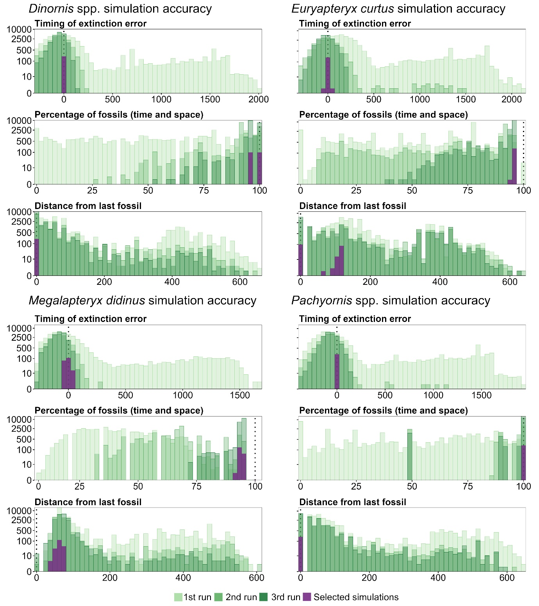
Figure S1: Accuracy of simulations assessed against a multivariate target, indicating the percentage of simulations that accurately modelled a) the year of extinction estimated accounting for the Signor-Lipps effect, b) the known fossil locations, and c) the distance between the modelled location of extinction and the last fossil record. The dashed vertical lines indicate the model targets.
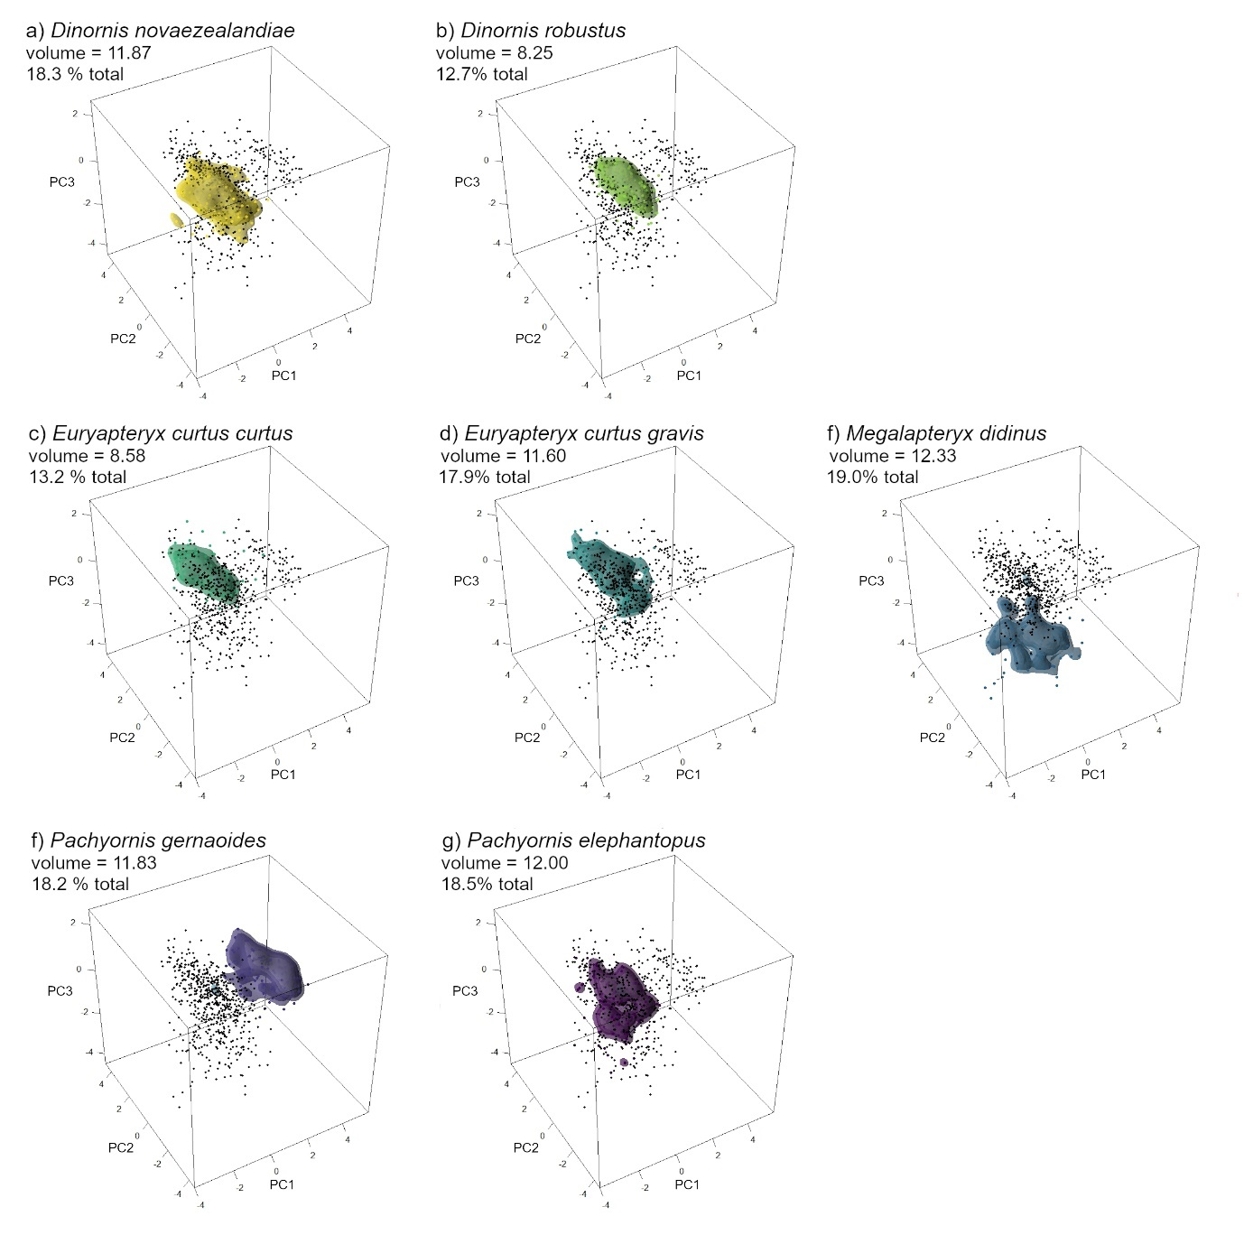
Figure S2. Summary of ecological and demographic trait space for moa. The black points represent functional trait space for all species based on parameters from the best spatially explicit population models (SEPMs) and a principal components (PC) analysis. Colored polygons represent the kernel density estimates (KDE) of the functional trait space for a given species (a-g). Increasingly intense shading represents escalating kernel density estimates. Volumes were estimated for each KDE, presented as approximations of the Lebesgue measure of the entire KDE¹¹⁴. Parameter contributions and correlates for each principal component are summarized in Table S2.
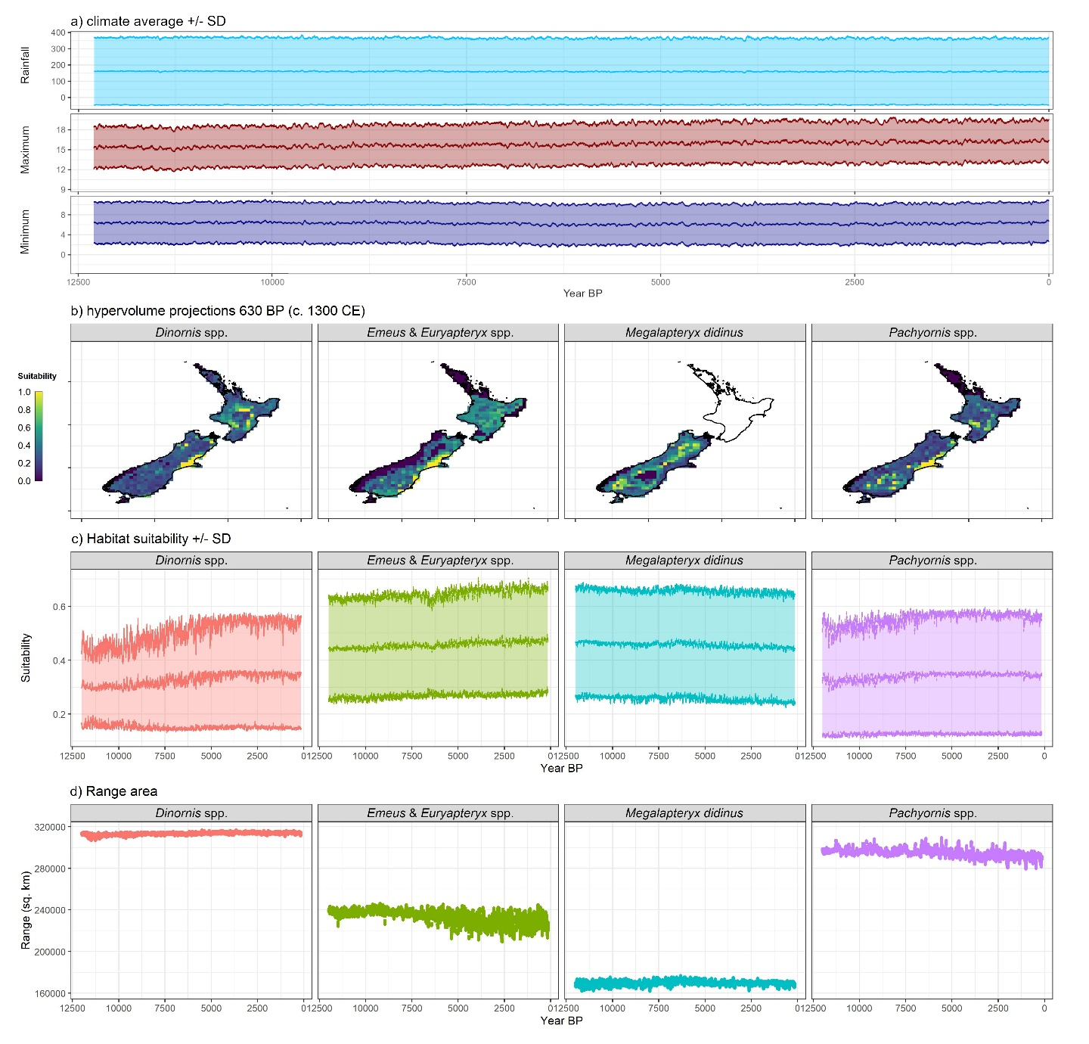
Figure S3: Climate suitability for moa. a) Change in minimum and maximum temperature and rainfall in New Zealand during the Holocene; b) hypervolume projections of habitat suitability for each phylogenetic group at approximate time of Māori settlement; c) mean habitat suitability throughout the Holocene for each phylogenetic group in the absence of people; d) estimated distributional range for each phylogenetic group in the Holocene in the absence of people

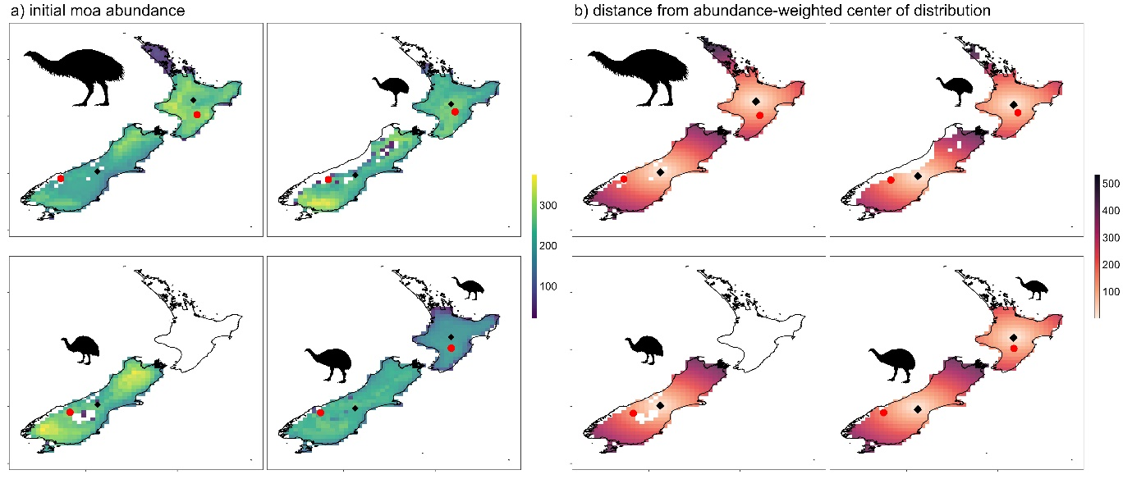
Figure S4: Maps of initial abundance for each phylogenetic group, prior to the arrival of Polynesian colonists. Black diamonds indicate the abundance-weighted center of the distributions for each species, while the red circles indicate the final location of extinction. Phylogenetic groups in clockwise direction are Dinornis spp., Euryapteryx curtus, Pachyornis spp. and Megalapteryx didinus.

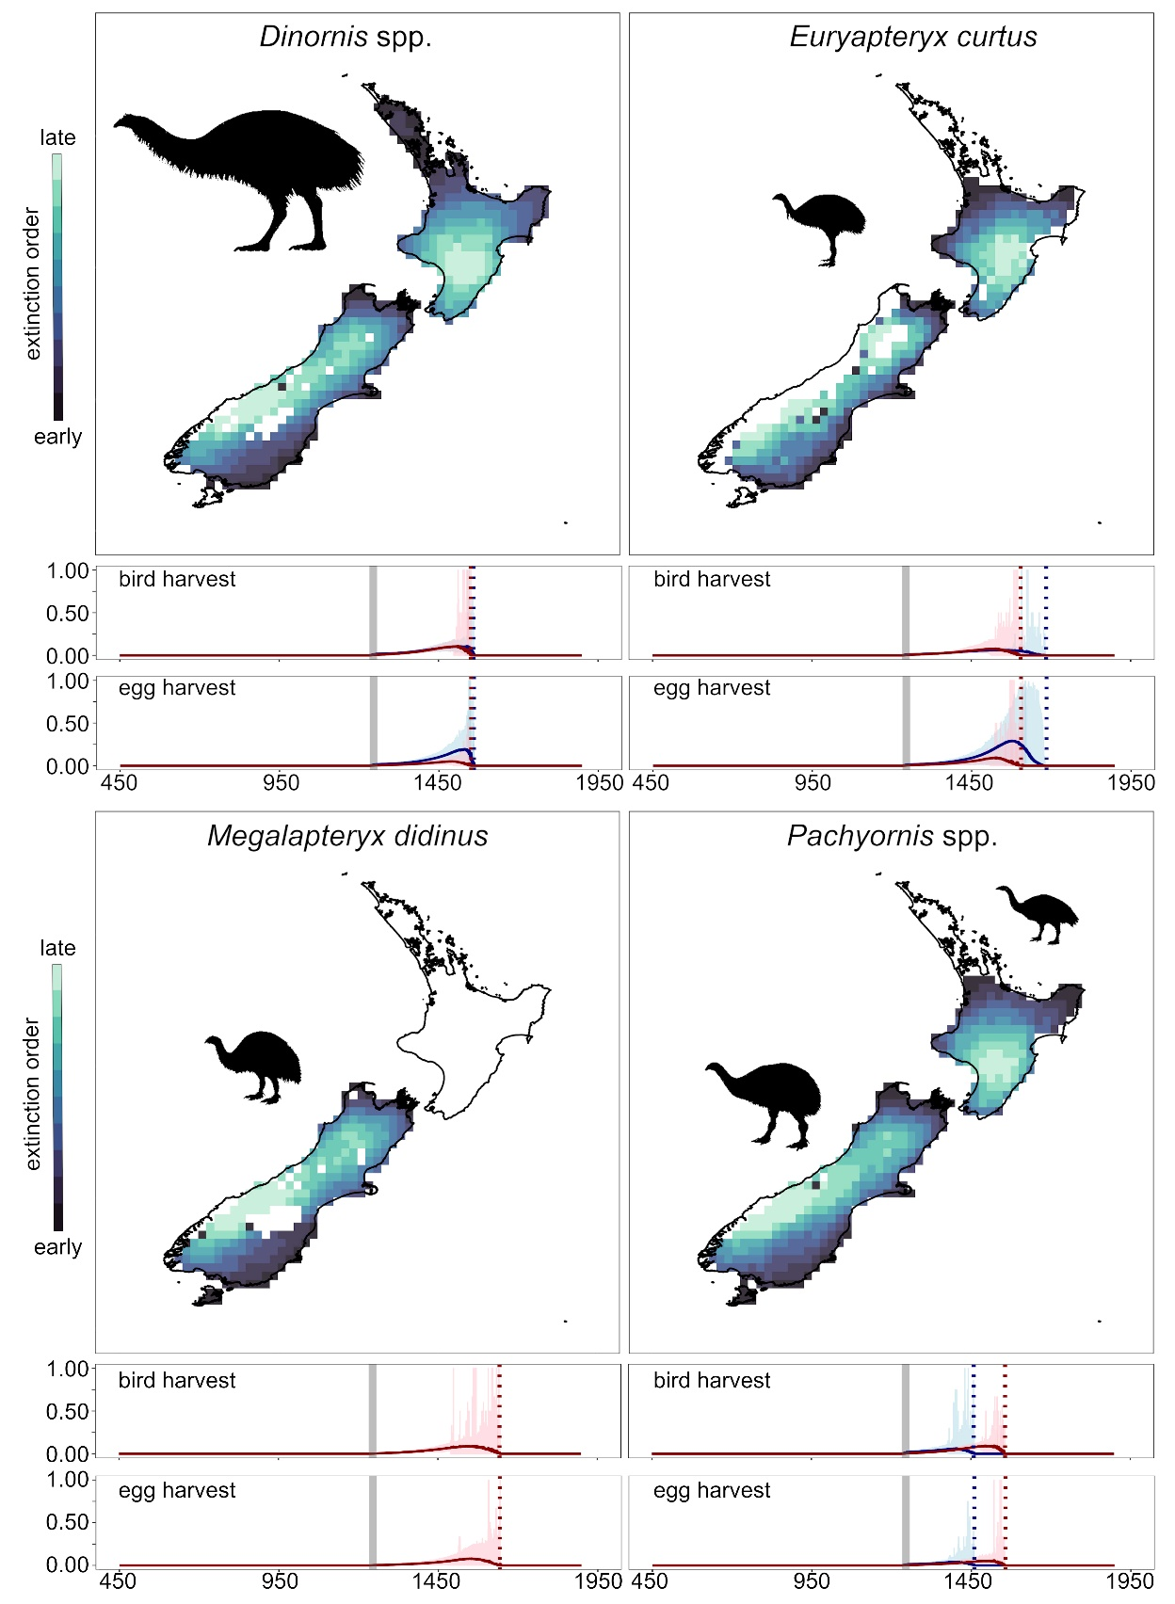
Figure S5: Order of extirpation for all seven moa taxa, simulated independently and validated against species-specific multivariate targets. Grid cells in the darkest blue indicate the first populations to go extinct following Polynesian colonization of New Zealand, and the palest grid cells indicate the last surviving populations. Projected harvests of birds and eggs since approximately 450 C.E. are shown in charts (under maps), where dynamics of species on the North Island are indicated in blue, and species on the South Island are indicated in red. The grey bar indicates the range of Polynesian colonization dates in our models and the vertical dashed lines indicate timing of extinction.
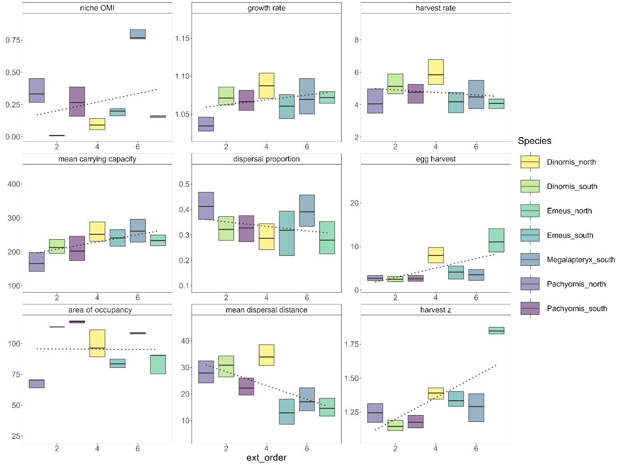
Figure S6: Relationship between ecological and demographic traits and timing of extinction. Patterns of order of extinction (1-7) indicate that later extinction was associated with higher carrying capacity and smaller dispersal distances and areas of occupancy. Dotted lines represent the linear relationship between the trait value, fitted between the numerical order of modelled extinction and the 700 trait values identified by our most accurate simulations using the lm function in the R base statistical package³. Parameter values are described in Dataset S2.
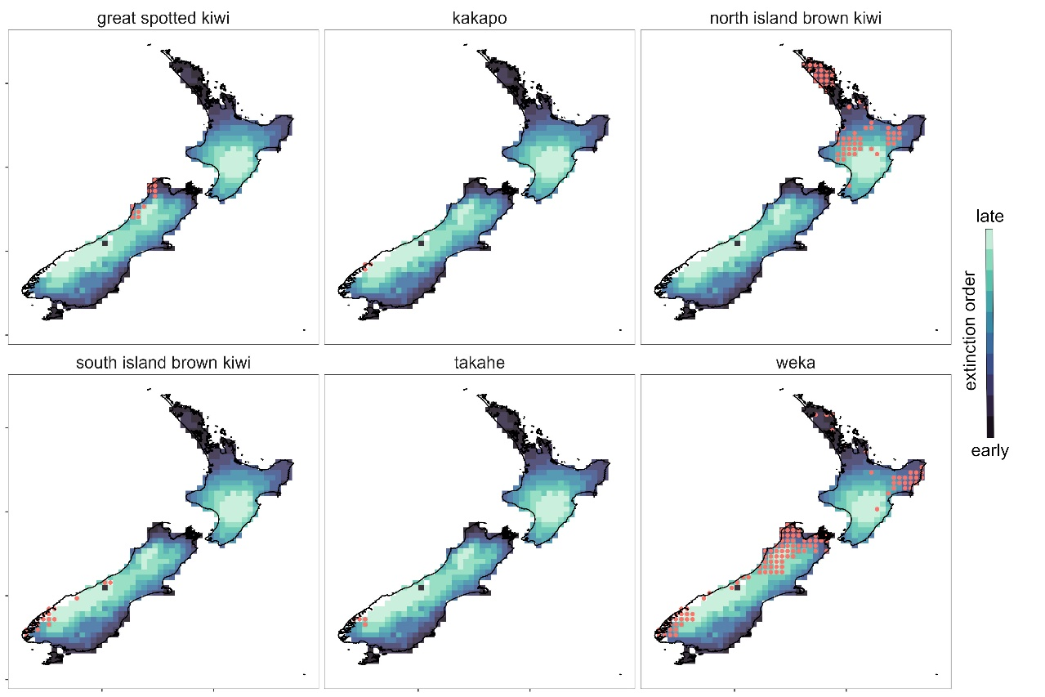
Figure S7: Occurrence locations of extant flightless bird species prior to 1980, plotted against the spatial order of extinction of all moa species pooled together.

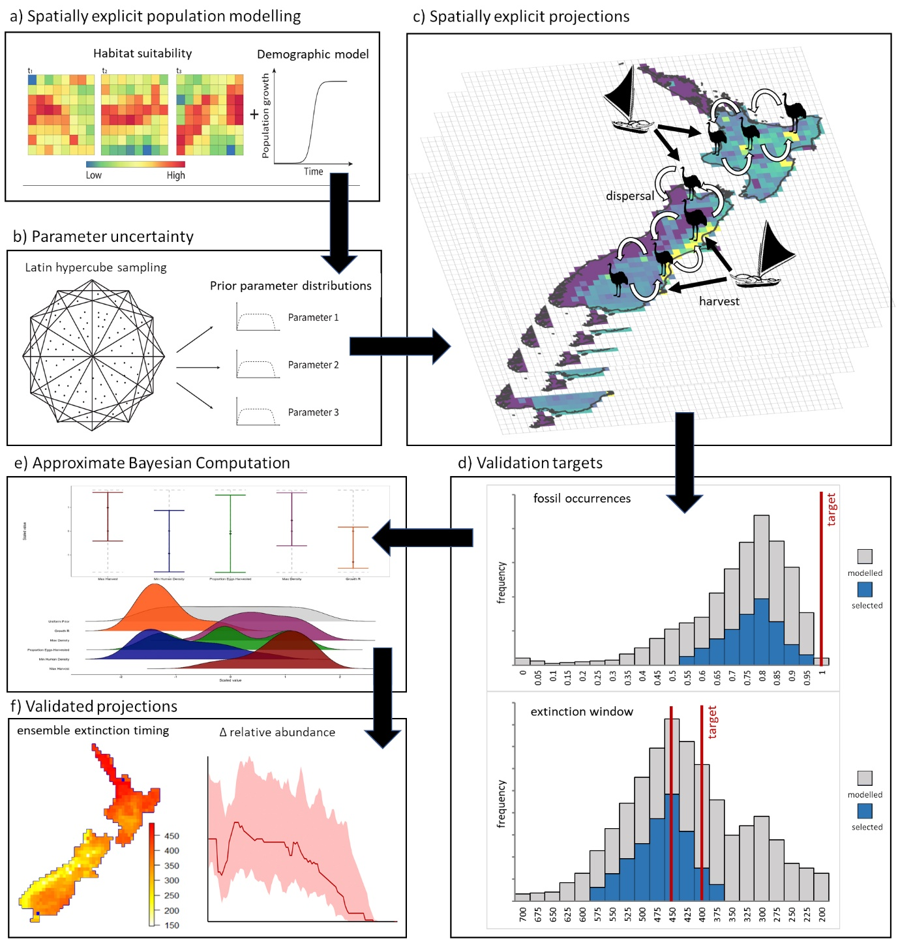
Figure S8: Workflow for the development and validation of SEPMs implemented by the ‘poems’ package⁵¹ begins with a) integrating spatial estimates of habitat suitability with demographic parameters to build SEPMs, which are then b) parameterized in a manner that captures the breadth of potential parameter uncertainty to produce c) spatiotemporal projections of occurrence, abundance, dispersal and harvest. These projected outcomes are d) validated against evidence of known spatiotemporal patters using e) Approximate Bayesian Computation (ABC⁶) to statistically compare and visually inspect the prior and posterior distributions of parameters. The subset of simulations that best approximate the known patterns of spatiotemporal dynamics are then be used to f) generate ensemble projections of range and extinction dynamics.

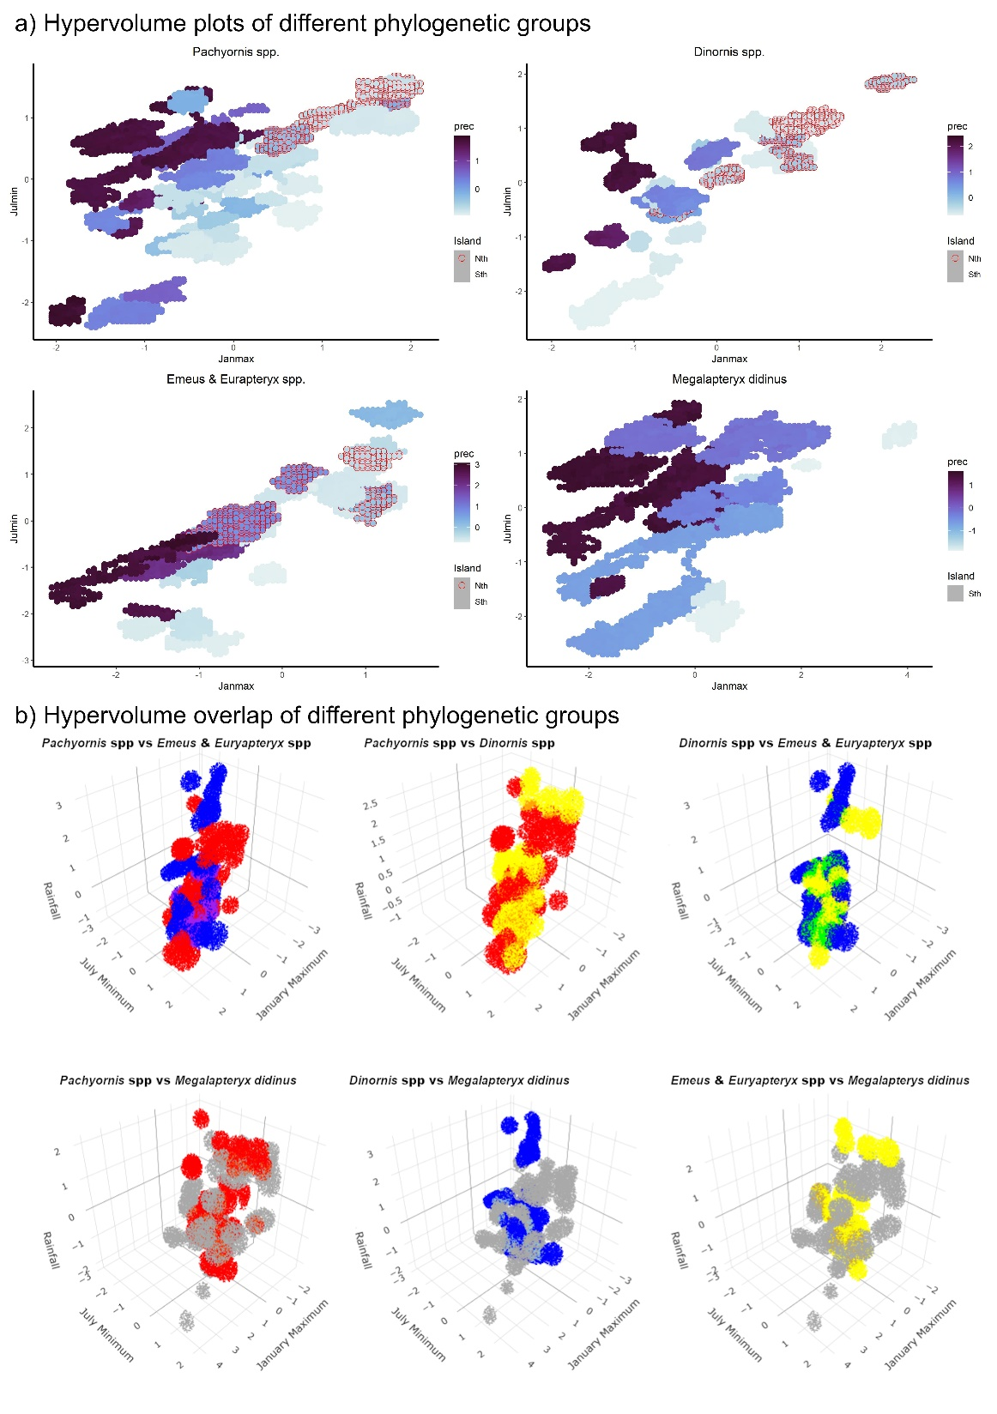
Figure S9: a) Three-dimensional climatic hypervolumes for each moa phylogentic group. Plots show how the data are distributed in relation to minimum July temperatures (JulMin), January maximum temperatures (JanMax) and annual precipitation (prec; shaded in blue). Points outlined in red indicate fossils from the North Island; all others originate on the South Island. b) comparisons of overlap between pairs of climatic hypervolumes. In all cases, blue points represent volume uniquely inhabited by Pachyornis spp, yellow points represent volume uniquely inhabited by Dinornis spp. red points represent volume uniquely inhabited by Euryapteryx and Emeus spp, and grey points represent volume uniquely inhabited by Megalapteryx didinus. Other colors represent volume of overlap shared by each pair of phylogenetic groups respectively.

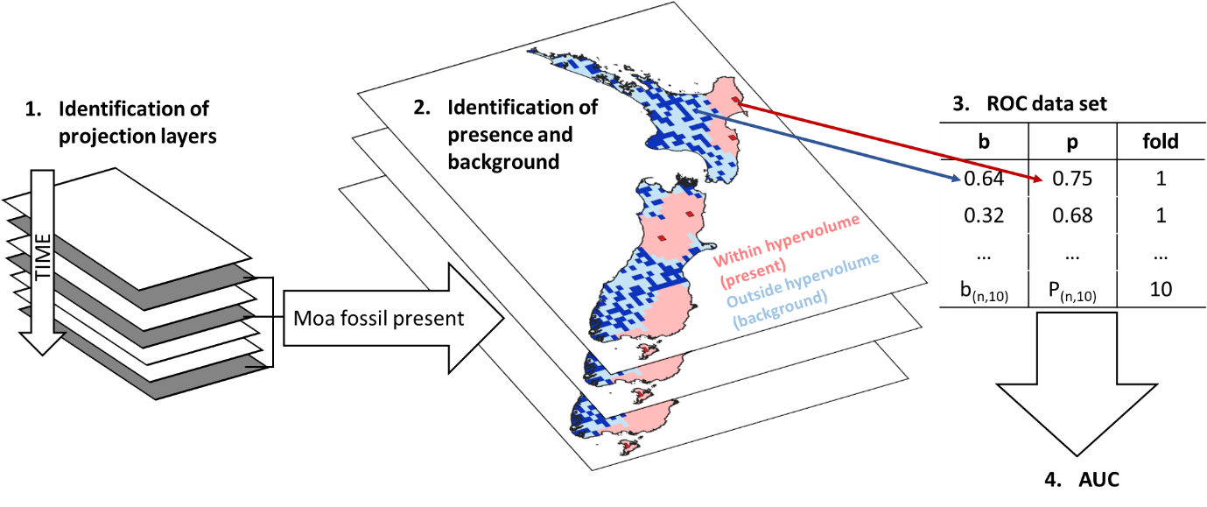
Figure S10: Flow chart of the process for deriving the ROC data set to validate the model projections. 1) for each of ten folds of the data, projection times containing moa fossils were identified. 2) within each of these projections a background area was identified using the ‘hypervolume’ package⁴ in the R statistical environment. 3) presence data at known fossil locations, and random background data were collated into a single data set encompassing all data folds. 4) the area under the receiver operator curve (AUC) was calculated.

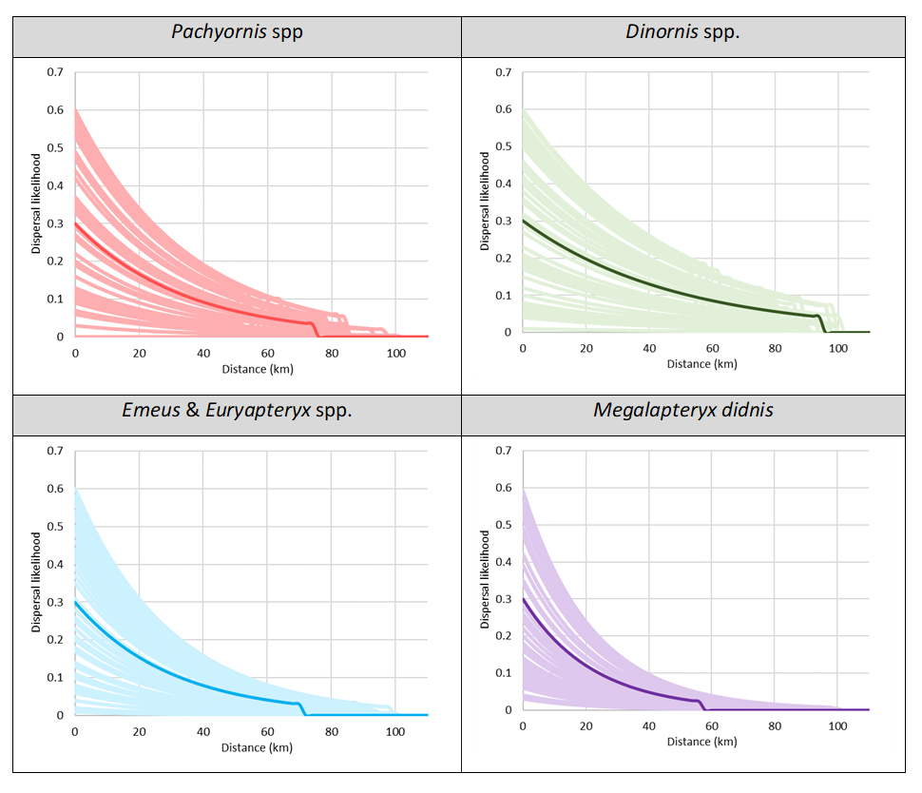
Figure S11: Potential dispersal for each phylogenetic group. Dispersal is defined by proportion of the population dispersing annually (variable between 0.0 - 0.6) and upper dispersal distance (variable between 50 – 100 km), and mean annual dispersal distance. The first two parameters were variable and the latter fixed. The heavier line represents the median dispersal function for each phylogenetic group, while the paler lines represent 50 random samples of the dispersal parameter space for each phylogenetic group.

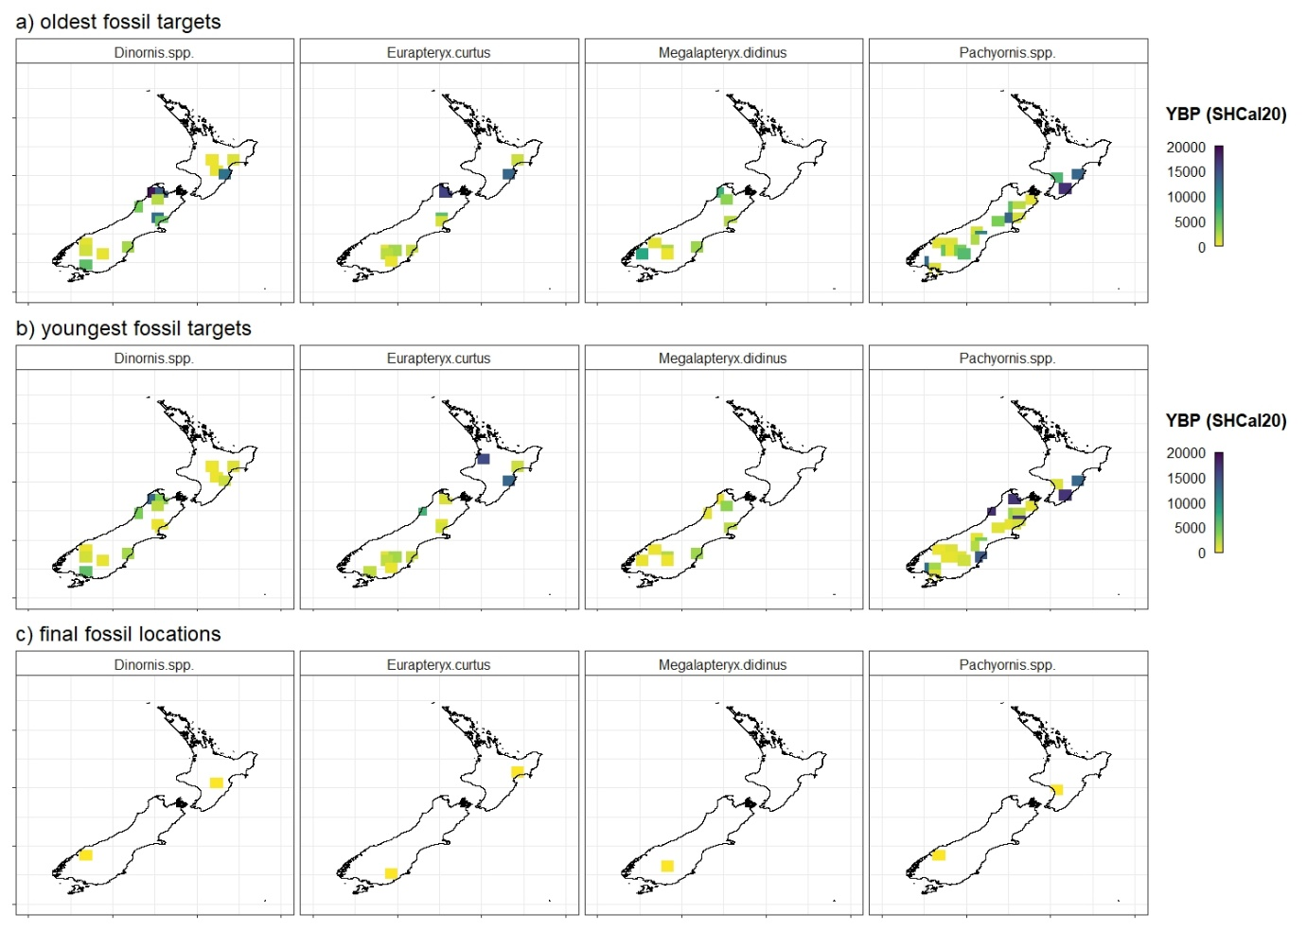
Figure S12: Validation targets estimated from the radiocarbon dated fossil record used to validate each species-specific simulation, showing grid locations encompassing a) the oldest site-based estimated age of fossil occurrence, b) the youngest site-based estimate of fossil occurrence, and c) the grid cell with the last (most recent) natural fossil record for each species. Age estimates account for the Signor-Lipps effect¹¹⁵.

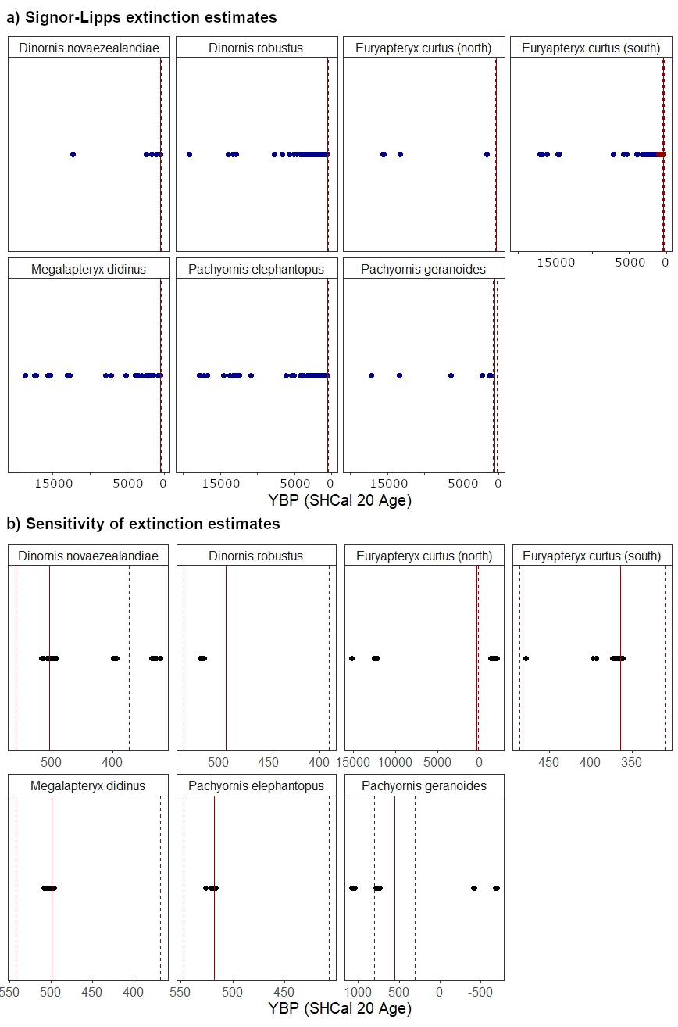
Figure S13: Estimation of likely times of extinction assuming a Signor-Lipps effect¹¹⁵ for each species (a). The points represent radiocarbon fossil dates in the last 20,000 years, quality filtered according to¹³. The black bars represent the standard deviation of the radiocarbon age of the fossil calibrated to SHCal20⁹⁵. The vertical lines represent the median estimated timing of extinction (solid line) and the minimum and maximum likely extinction times (dashed lines). Sensitivity analysis of extinction estimates (b) conducted using 1000 replicate drop-one analyses. The points represent the 1000 replicate estimates of extinction timing, and the vertical bars represent the consensus (mean) timing of extinction (solid line) and the minimum and maximum likely extinction times (dashed lines).

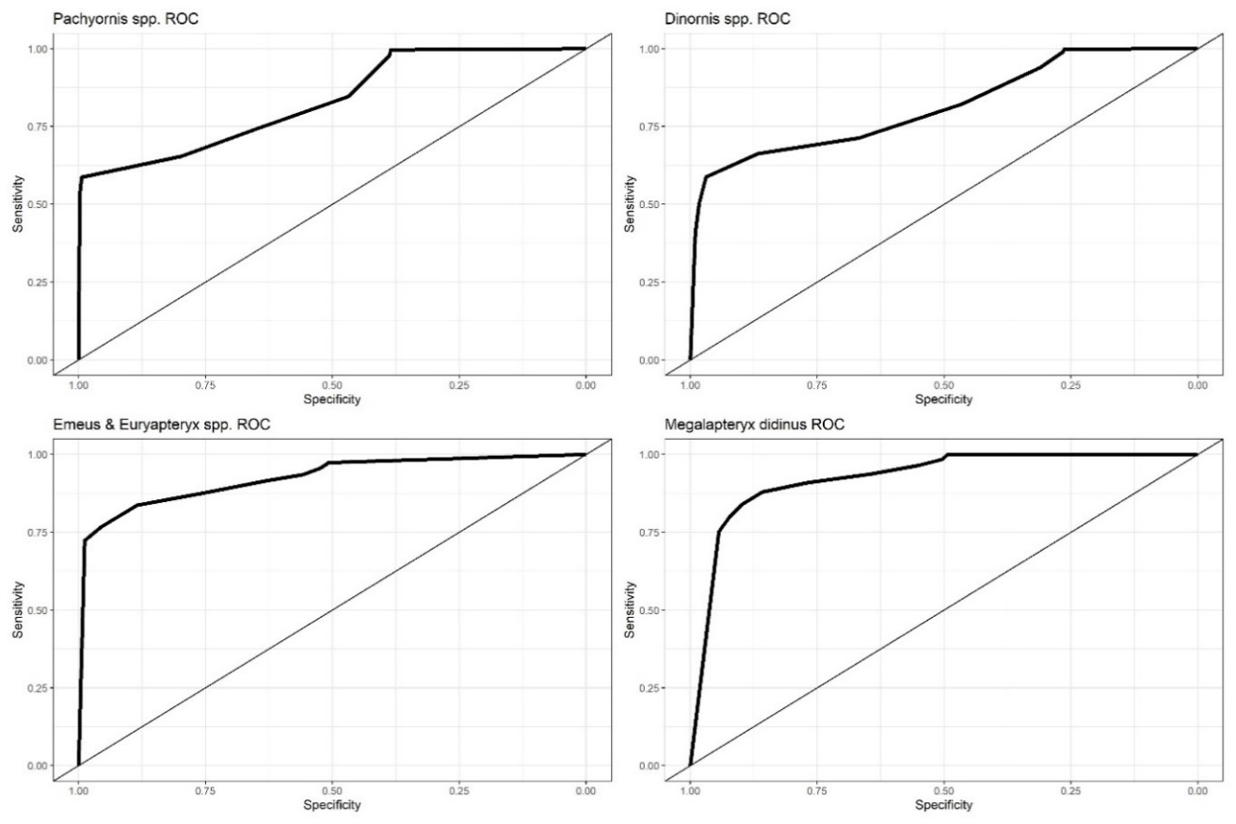
Figure S14: Receiver operator curves (ROC) for the climatic hypervolumes of each moa phylogenetic group. The AUC for Pachyornis spp. was 0.826, the AUC for Dinornis spp. was 0.824, the AUC for the combined Euryapteryx and Emeus spp. was 0.920, and the AUC for Megalapteryx didinus was 0.899. The straight line is the line below which the area under the curve (AUC) is 0.5.

References
1 Wiegand, T., Moloney, K. A., Naves, J. & Knauer, F. Finding the missing link between landscape structure and population dynamics: A spatially explicit perspective. The American Naturalist 154, 605-627 (1999).
2 Fordham, D. A., Haythorne, S., Brown, S. C., Buettel, J. C. & Brook, B. W. poems: R package for simulating species’ range dynamics using pattern-oriented validation. Methods in Ecology and Evolution 12, 2364-2371 (2021).
3 R: A language and environment for statistical computing. (R Foundation for Statistical Computing, Vienna, Austria, 2023).
4 Blonder, B. et al. New approaches for delineating n‐dimensional hypervolumes. Methods in Ecology and Evolution 9, 305-319 (2018).
5 Nogués‐Bravo, D. Predicting the past distribution of species climatic niches. Global Ecology and Biogeography 5, 521-531 (2009).
6 Csilléry, K., Blum, M. G. B., Gaggiotti, O. E. & François, O. Approximate Bayesian Computation (ABC) in practice. Trends in Ecology and Evolution 25, 410-418 (2010).
7 Grimm, V. et al. Pattern-oriented modeling of agent-based complex systems: lessons from ecology. Science 310, 987-991, doi:10.1126/science.1116681 (2005).
8 Csillery, K., Blum, M. G., Gaggiotti, O. E. & Francois, O. Approximate Bayesian Computation (ABC) in practice. Trends Ecol Evol 25, 410-418, doi:10.1016/j.tree.2010.04.001 (2010).
9 Elith, J. & Leathwick, J. R. Species distribution models: ecological explanation and prediction across space and time. . Annual Review of Ecology, Evolution, and Systematics 40, 677-697 (2009).
10 Canteri, E. et al. Spatiotemporal influences of climate and humans on muskox range dynamics over multiple millennia. . Global Change Biology doi.org/10.1111/gcb.16375 (2022).
11 Fordham, D. A. et al. Process‐explicit models reveal pathway to extinction for woolly mammoth using pattern‐oriented validation. Ecology Letters 25, 125-137 (2022).
12 Hogg, A. SHCal13 Southern Hemisphere calibration, 0-50,000 Years cal BP. Radiocarbon 55, 1889-1903 (2013).
13 Barnosky, A. D. & Lindsey, E. L. Timing of Quaternary megafaunal extinction in South America in relation to human arrival and climate change. Quaternary International 217, 10-29 (2010).
14 Collins, W. D. et al. The Community Climate System Model version 3 (CCSM3). Journal of Climate 19, 2122-2143 (2006).
15 Yeager, S. G., Shields, C. A., Large, W. G. & Hack, J. J. The low-resolution CCSM3. Journal of Climate 19, 2545-2566 (2006).
16 Otto-Bliesner, B. L. et al. Climate sensitivity of moderate-and low-resolution versions of CCSM3 to preindustrial forcings. Journal of Climate 19, 2567-2583 (2006).
17 Fordham, D. A. et al. PaleoView: a tool for generating continuous climate projections spanning the last 21 000 years at regional and global scales. Ecography 40, 1348-1358 (2017).
18 Bozinovic, F. & Pörtner, H. O. Physiological ecology meets climate change. Ecology and Evolution 5, 1025-1030 (2015).
19 Wood, J. R. Moa (Aves: Dinornithiformes) nesting material from rockshelters in the semi-arid interior of South Island, New Zealand. Journal of the Royal Society of New Zealand 38, 115-129 (2008).
20 Worthy, T. H. An analysis of the distribution and relative abundance of moa species (Aves: Dinornithiformes). . New Zealand Journal of Zoology 17, 213-241 (1990).
21 Fordham, D. A., Wigley, T. M. & Brook, B. W. Multi‐model climate projections for biodiversity risk assessments. Ecological Applications 21, 3317-3331 (2011).
22 Harris, I., Osborn, T. J., Jones, P. & Lister, D. Version 4 of the CRU TS monthly high-resolution gridded multivariate climate dataset. Scientific Data 7, 1-18 (2020).
23 Fordham, D. A. et al. Humans hastened the range collapse and extinction of woolly mammoth. . Ecology Letters Accepted (2021).
24 Barringer, J. R. F., Pairman, D. & McNeill, S. J. (ed Landcare Research) (Lincoln, New Zealand, 2002).
25 Holdaway, R. N. & Jacomb, C. Rapid extinction of the moas (Aves: Dinornithiformes): model, test, and implications. Science 287, 2250-2254 (2000).
26 Wood, J. R., Richardson, S. J., McGlone, M. & Wilmshurst, J. M. The diets of moa (Aves: Dinornithiformes). New Zealand Journal of Ecology 44, 3397 (2020).
27 Latham, A. D. M. et al. A refined model of body mass and population density in flightless birds reconciles extreme bimodal population estimates for extinct moa. Ecography 43, 353-364 (2020).
28 Leathwick, J. et al. (ed Ministry for the Environment (New Zealand)) (Government of Nez Zealand, 2002).
29 Faurby, S. & Araújo, M. B. Anthropogenic range contractions bias species climate change forecasts. Nature Climate Change 8, 252-256 (2018).
30 Bunce, M. et al. The evolutionary history of the extinct ratite moa and New Zealand Neogene paleogeography. Proceedings of the National Academy of Sciences 106, 20646-20651 (2009).
31 Pilowsky, J. A. et al. Range and extinction dynamics of the steppe bison in Siberia: A pattern‐oriented modelling approach. Global Ecology and Biogeography https://doi.org/10.1111/geb.13601 (2022).
32 Canteri, E. et al. Spatiotemporal influences of climate and humans on muskox range dynamics over multiple millennia. Global Change Biology, doi:10.1111/gcb.16375 (2022).
33 Dormann, C. F. et al. Collinearity: a review of methods to deal with it and a simulation study evaluating their performance. Ecography 36, 27-46 (2013).
34 Lomolino, M. V., Tomlinson, S., Wood, J., Wilmshurst, J. & Fordham, D. A. Geographic and ecological segregation in an extinct guild of flightless birds: New Zealand’s moa. Frontiers of Biogeography 13, e53416 (2021).
35 Rawlence, N. J. et al. The effect of climate and environmental change on the megafaunal moa of New Zealand in the absence of humans. Quaternary Science Reviews 50, 141-153 (2012).
36 Hutchinson, G. E. Population studies: Animal ecology and demography - concluding remarks. Cold Spring Harb Symp Quant Biol 22, 415-427 (1957).
37 Fordham, D. A. et al. Plant extinction risk under climate change: are forecast range shifts alone a good indicator of species vulnerability to global warming? Global Change Biology 18, 1357-1371 (2012).
38 gbm: Generalized Boosted Regression Models version 2.1.5. (The Comprehensive R Archive Network, https://CRAN.R-project.org/package=gbm, 2019).
39 Elith, J., Leathwick, J. R. & Hastie, T. A working guide to boosted regression trees. Journal of Animal Ecology 77, 802-813 (2008).
40 Dray, S. & Dufour, A. B. The ade4 package: Implementing the duality diagram for ecologists. Journal of Statistical Software 22, 1-20, doi:10.18637/jss.v022.i04 (2007).
41 Tomlinson, S. et al. Reconstructing colonization dynamics to establish how human activities transformed island biodiversity. bioRxiv 2023.02.09.526923, doi: https://doi.org/10.1101/2023.1102.1109.526923 (2023).
42 Timmermann, A. & Friedrich, T. Late Pleistocene climate drivers of early human migration. Nature 538, 92-95 (2016).
43 Eriksson, A. et al. Late Pleistocene climate change and the global expansion of anatomically modern humans. Proceedings of the National Academy of Sciences 109, 16089 (2012).
44 Beyer, R. M., Krapp, M., Eriksson, A. & Manica, A. Climatic windows for human migration out of Africa in the past 300,000 years. Nature Communications 12, 1-10 (2021).
45 Zhu, D., Galbraith, E. D., Reyes-García, V. & Ciais, P. Global hunter-gatherer population densities constrained by influence of seasonality on diet composition. Nature Ecology & Evolution 5, 1536-1545 (2021).
46 Tomlinson, S. et al. Reconstructing colonization dynamics to establish how human activities transformed island biodiversity. Global Ecology and Biogeography At Review (2023).
47 Grimm, V. et al. Pattern-oriented modeling of agent-based complex systems: lessons from ecology. Science 310, 987-991 (2005).
48 McKay, M. D., Beckman, R. J. & Conover, W. J. A Comparison of Three Methods for Selecting Values of Input Variables in the Analysis of Output from a Computer Code. Technometrics 21, 239-245, doi:10.2307/1268522 (1979).
49 Allentoft, M. E. et al. Extinct New Zealand megafauna were not in decline before human colonization. Proceedings of the National Academy of Sciences 111, 4922-4927 (2014).
50 van der Vaart, E., Beaumont, M. A., Johnston, A. S. A. & Sibly, R. M. Calibration and evaluation of individual-based models using Approximate Bayesian Computation. . Ecological Modelling 312, 182-190 (2015).
51 poems: pattern-oriented ensemble modeling system. (The Comprehensive R Archive Network, 2021).
52 Van der Wal, J., Shoo, L. P., Johnson, C. N. & Williams, S. E. Abundance and the environmental niche: Environmental suitability estimated from niche models predicts the upper limit of local abundance. The American Naturalist 174, 282-291 (2009).
53 Fordham, D. A. et al. Adapted conservation measures are required to save the Iberian lynx in a changing climate. Nature Climate Change 3, 899-903 (2013).
54 Turvey, S. T., Green, O. R. & Holdaway, R. N. Cortical growth marks reveal extended juvenile development in New Zealand moa. Nature 435, 940-943 (2005).
55 Niel, C. & Lebreton, J.-D. Using demographic invariants to detect overharvested bird populations from incomplete data. Conservation Biology 19, 826-835 (2005).
56 Pierce, R. J., Gardiner, C., Moodie, H., Robertson, H. A. & Sporle, W. Sustainable management of brown kiwi and other threatened birds in Northland., (Wildland Consultants, Whangarei, New Zealand, 2006).
57 Beauchamp, A. J. & Chambers, R. Population density changes of adult North Island weka (Gallirallus australis greyi) in the Mansion House Historic Reserve, Kawau Island, in 1992-1999. Notornis 47, 82-89 (2000).
58 Crouchley, D. Takahe Recovery Plan (Porphyrio [Notornis] mantelli). (Department of Conservation (New Zealand), Wellington, New Zealand, 1994).
59 Ullah, H., Nagelkerken, I., Goldenberg, S. U. & Fordham, D. A. Climate change could drive marine food web collapse through altered trophic flows and cyanobacterial proliferation. PLoS Biol 16, e2003446 (2018).
60 Ricker, W. E. Stock and recruitment. Journal of the Fisheries Research Board of Canada 11, 559-623 (1954).
61 Allee, W. C. Animal Aggregations: A Study in General Sociology. . (University of Chicago Press, 1931).
62 Anderson, A. Prodigious birds: moas and moa hunting in prehistoric New Zealand., (Cambridge University Press, 1989).
63 Perry, G. L., Wheeler, A. B., Wood, J. R. & Wilmshurst, J. M. A high-precision chronology for the rapid extinction of New Zealand moa (Aves, Dinornithiformes). Quaternary Science Reviews 105, 126-135 (2014).
64 Forsyth, D. M., Wilmshurst, J. M., Allen, R. B. & Coomes, D. A. Impacts of introduced deer and extinct moa on New Zealand ecosystems. New Zealand Journal of Ecology 34, 48-65 (2010).
65 Shaffer, M. L. Minimum population sizes for species conservation. BioScience 31, 131-134 (1981).
66 Frankham, R., Bradshaw, C. J. & Brook, B. W. Genetics in conservation management: revised recommendations for the 50/500 rules, Red List criteria and population viability analyses. Biological Conservation 170, 56-63 (2014).
67 Harding, J. S. & Winterbourne, M. J. New Zealand ecoregions : a classification for use in stream conservation and management., (Department of Conservation, 1997).
68 Traill, L. W., Bradshaw, C. J. & Brook, B. W. Minimum viable population size: a meta-analysis of 30 years of published estimates. Biological Conservation 139, 159-166 (2007).
69 Davies, S. J. J. F., Beck, W. R. M. & Kruiskamp, J. P. The results of banding 154 Emus in Western Australia. Wildlife Research 16, 77-79 (1971).
70 Westcott, D. A., Bentrupperbäumer, J., Bradford, M. & McKeown, A. Incorporating patterns of disperser behaviour into models of seed dispersal and its effects on estimated dispersal curves. Oecologia 146, 57-67 (2005).
71 Bellis, L. M., Martella, M. B., Navarro, J. L. & Vignolo, P. E. Home range of greater and lesser rhea in Argentina: relevance to conservation. Biodiversity and Conservation 13, 2589-2598 (2004).
72 Nield, A. P., Enright, N. J. & Ladd, P. G. Study of seed dispersal by Emu (Dromaius novaehollandiae) in the Jarrah (Eucalyptus marginata) forests of south-western Australia through satellite telemetry. Emu 115, 29-34 (2015).
73 Mack, A. L. & Druliner, G. A non-intrusive method for measuring movements and seed dispersal in cassowaries. Journal of Field Ornithology 74, 193-196 (2003).
74 Sutherland, G. D., Harestad, A. S., Price, K. & Lertzman, K. P. Scaling of natal dispersal distances in terrestrial birds and mammals. Conservation Ecology 4, 16 (2000).
75 Fordham, D. A. et al. How complex should models be? Comparing correlative and mechanistic range dynamics models. Global Change Biology 24, 1357-1370 (2018).
76 Fordham, D. A. et al. Plant extinction risk under climate change: are forecast range shifts alone a good indicator of species vulnerability to global warming? Global Change Biology 18, 1357-1371 (2012).
77 Bjornstad, O. N. & Falck, W. Nonparametric spatial covariance functions: estimation and testing. Environmental and Ecological Statistics 8, 53-70 (2001).
78 Baty, F. et al. A toolbox for nonlinear regression in R: The package nlstools. Journal of Statistical Software 66, 1-21 (2015).
79 Akçakaya, H. R. RAMAS GIS: Linking Landscape Data with Population Viability Analysis (version 3.0). (Applied Biomathematics, 1998).
80 Kooyman, B. P. Moa and Moa Hunting: An Archaeological Analysis of Big Game Hunting in New Zealand Doctor of Philosophy thesis, University of Otago, (1985).
81 Oskam, C. L. et al. Ancient DNA analyses of early archaeological sites in New Zealand reveal extreme exploitation of moa (Aves: Dinornithiformes) at all life stages. Quaternary Science Reviews 52, 41-48 (2012).
82 Holdaway, R. N. et al. An extremely low-density human population exterminated New Zealand moa. Nature Communications 5, 5436 (2014).
83 Brook, B. W. & Johnson, C. N. Selective hunting of juveniles as a cause of the imperceptible overkill of the Australian Pleistocene megafauna. Alcheringa: An Australasian Journal of Palaeontology 30, 39-48 (2006).
84 Alroy, J. A multispecies overkill simulation of the end-Pleistocene megafaunal mass extinction. Science 292, 1893-1896 (2001).
85 Brook, B. W. & Bowman, D. M. J. S. The uncertain blitzkrieg of Pleistocene megafauna. Journal of Biogeography 31, 517-523 (2004).
86 Furey, L. Maori Gardening: An Archaeological Perspective., (Department of Conservation, 2006).
87 Seersholm, F. V. et al. Subsistence practices, past biodiversity, and anthropogenic impacts revealed by New Zealand-wide ancient DNA survey. Proceedings of the National Academy of Sciences 115, 7771-7776 (2018).
88 Allen, M. W. in The Archaeology of Food and Warfare - Food Insecurity in Prehistory (eds A.M. VanDerwarker & G.D. Wilson) 41-59 (Springer, 2016).
89 Walter, R., Buckley, H., Jacomb, C. & Matisoo-Smith, E. Mass migration and the Polynesian settlement of New Zealand. Journal of World Prehistory 30, 351-376 (2017).
90 Norton, J. An introduction to sensitivity assessment of simulation models. Environmental Modelling & Software 69, 166-174 (2015).
91 Prowse, T. A. et al. An efficient protocol for the global sensitivity analysis of stochastic ecological models. Ecosphere 7, p.e01238 (2016).
92 Grimm, V. & Railsback, S. F. Pattern-oriented modelling: a ‘multi-scope’ for predictive systems ecology. Philosophical Transactions of the Royal Society B 367, 298-310 (2012).
93 Solow, A. R., Roberts, D. L. & Robbirt, K. M. On the Pleistocene extinctions of Alaskan mammoths and horses. Proceedings of the National Academy of Sciences 103, 7351-7353 (2006).
94 Worthy, T. H. Fossil avifaunas from Old Neck and Native Island, Stewart Island - Polynesian middens or natural sites? Records of the Canterbury Museum 12, 49-82 (1998).
95 Hogg, A. G. et al. SHCal20 Southern Hemisphere calibration, 0–55,000 years cal BP. Radiocarbon 62, 759-778 (2020).
96 Haslett, J. & Parnell, A. C. A simple monotone process with application to radiocarbon-dated depth chronologies. Journal of the Royal Statistical Society: Series C (Applied Statistics) 57, 399–418 (2008).
97 Bradshaw, C. J. A., Cooper, A., Turney, C. S. M. & Brook, B. W. Robust estimates of extinction time in the geological record. Quaternary Science Reviews 33, 14-19 (2012).
98 fields: Tools for spatial data. v. version 13.3 (The Comprehensive R Archive Network, 2021).
99 Csilléry, K., François, O. & Blum, M. G. B. abc: an R package for approximate Bayesian computation (ABC). Methods in Ecology and Evolution 3, 475-479 (2012).
100 Makowski, D., Ben-Shachar, M. S. & Lüdecke, D. bayestestR: Describing effects and their uncertainty, existence and significance within the Bayesian framework. Journal of Open Source Software 4, 1541 (2019).
101 Ringnér, M. What is principal component analysis? Nature Biotechnology 26, 303-304 (2008).
102 Dolédec, S., Chessel, D. & Gimaret-Carpentier, C. Niche separation in community analysis: A new method. Ecology 81, 2914-2927 (2000).
103 Gaston, K. J. & Fuller, R. A. The sizes of species’ geographic ranges. Journal of Applied Ecology 46, 1-9 (2009).
104 Bonhomme, V., Picq, S., Gaucherel, C. & Claude, J. Momocs: Outline analysis using R. Journal of Statistical Software 56, 1-24 (2014).
105 Wood, S. N. Generalized Additive Models: An Introduction with R., (Chapman and Hall, 2017).
106 Anderson, B. J. et al. Dynamics of range margins for metapopulations under climate change. Proceedings of the Royal Society B: Biological Sciences 276, 1415-1420 (2009).
107 Watts, M. J., Fordham, D. A., Akçakaya, H. R., Aiello-Lammens, M. E. & Brook, B. W. Tracking shifting range margins using geographical centroids of metapopulations weighted by population density. Ecological Modelling 269, 61-69 (2013).
108 Walker, S., Monks, A. & Innes, J. (ed Landcare Research Manaaki Whenua) (Dunedin, New Zealand., 2017).
109 Craig, J. et al. Conservation issues in New Zealand. Annual Review Ecology, Evolution and Systematics 31, 61-78 (2000).
110 Schad, D. J., Vasishth, S., Hohenstein, S. & Kliegl, R. How to capitalize on a priori contrasts in linear (mixed) models: A tutorial. Journal of Memory and Language 110, 104038 (2020).
111 Swets, J. Measuring the accuracy of diagnostic systems. Science 240, 1285-1293 (1988).
112 Wilmshurst, J. M., Anderson, A. J., Higham, T. F. & Worthy, T. H. Dating the late prehistoric dispersal of Polynesians to New Zealand using the commensal Pacific rat. Proceedings of the National Academy of Sciences 105, 7676-7680 (2008).
113 Jolly, J. N. A field study of the breeding biology of the little spotted kiwi (Apteryx owenii) with emphasis on the causes of nest failures. Journal of the Royal Society of New Zealand 19, 433-448 (1989).
114 Duong, T. ks: Kernel density estimation and kernel discriminant analysis for multivariate data in R. Journal of Statistical Software 21, 1-16 (2007).
115 Signor, P. W., Lipps, J. H., Silver, L. T. & Schultz, P. H. in Geological Implications of Impacts of Large Asteroids and Comets on the Earth (eds L.T. Silver & P.H. Schultz) 291-296 (Geological Society of America, 1982).

