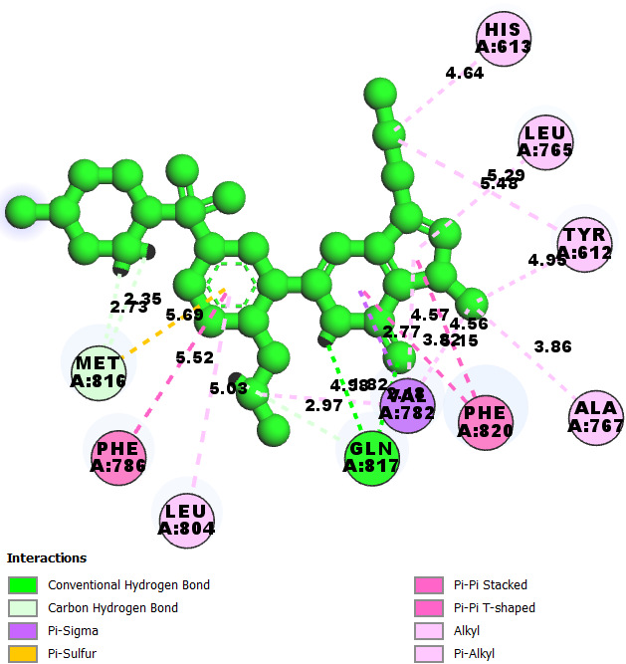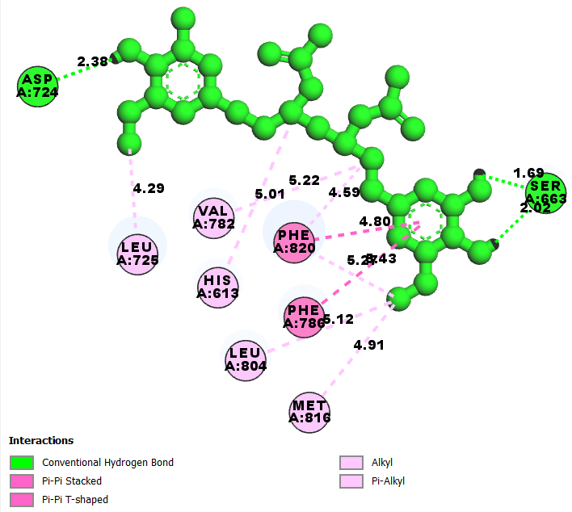
CO-LIGAND CMPD 1

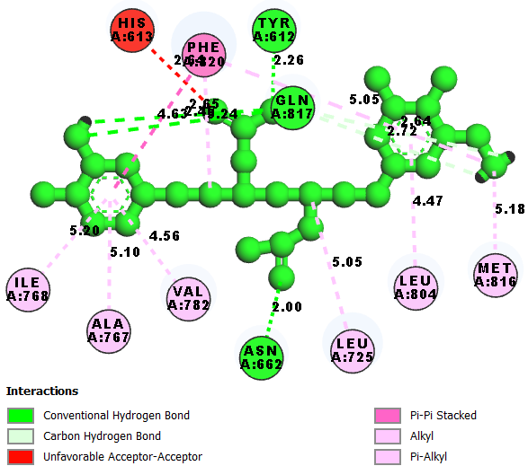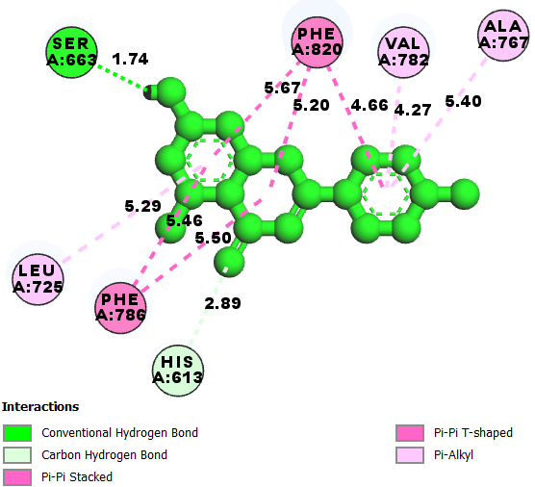
CMPD 2 CMPD 3

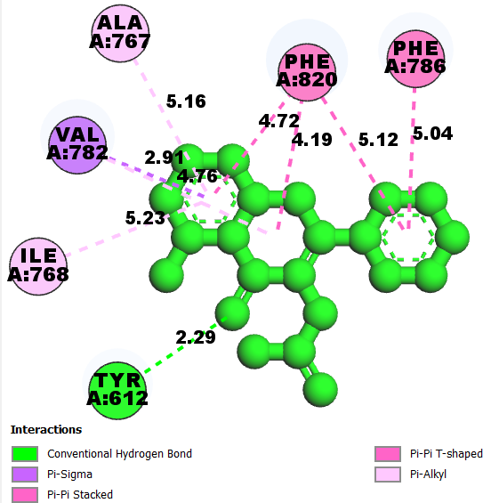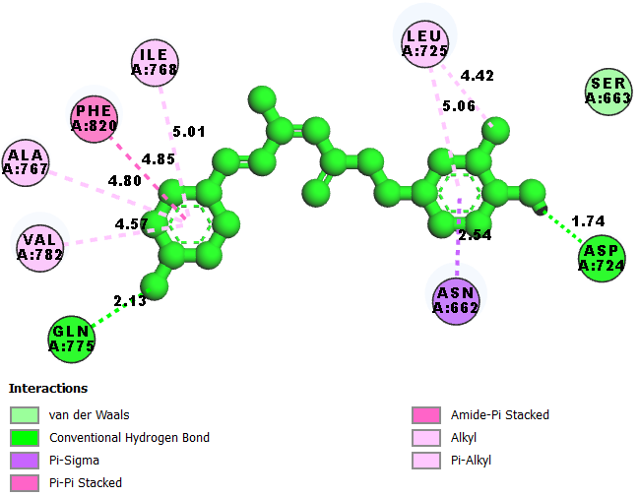
CMPD 4 CMPD 5
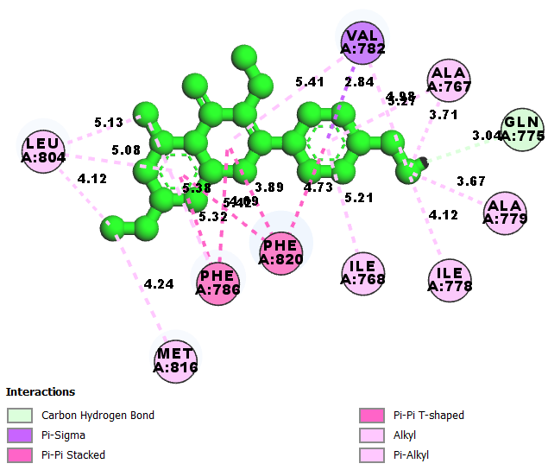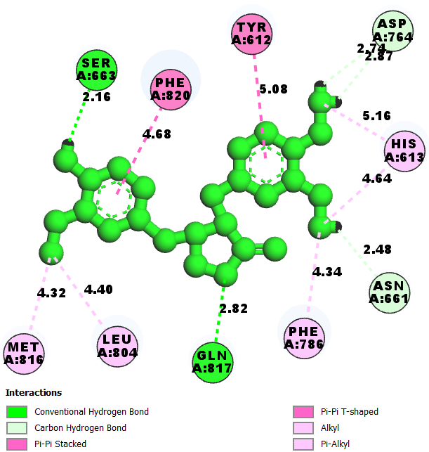
CMPD 6 CMPD 7

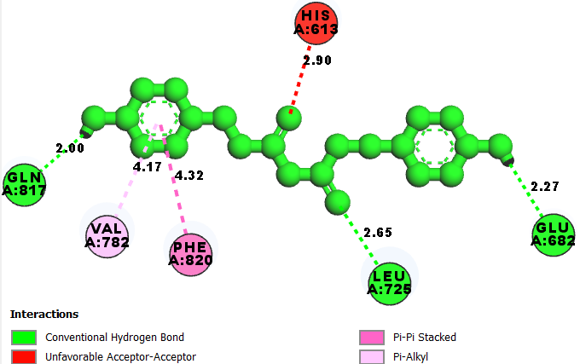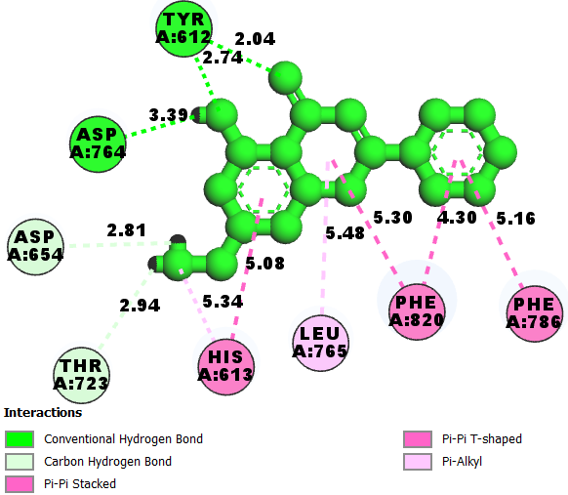
CMPD 8 CMPD 9

Table S1: Details of predicted Auto-QSAR model
ID Set Y(Obs) Y(Pred) Error
1 train 8.5300 8.4753 -0.0547
2 test 8.1900 8.4767 0.2867
3 train 7.5700 8.3732 0.8032
4 train 9.0200 9.2233 0.2033
5 train 8.5000 8.4961 -0.0039
6 test 5.2100 6.1207 0.9107
7 train 7.5700 8.3827 0.8127
8 train 9.2700 8.4574 -0.8126
9 train 5.9000 5.2155 -0.6845
10 test 5.0000 5.5831 0.5831
11 train 5.4800 6.3939 0.9139
12 train 9.5500 9.9020 0.3520
13 train 8.1500 8.0947 -0.0553
14 test 6.8000 5.7571 -1.0429
15 train 8.3000 7.9174 -0.3826
16 train 5.3100 5.7771 0.4671
17 train 5.7000 6.0591 0.3591
18 train 5.4700 4.9466 -0.5234
19 train 5.5000 6.0271 0.5271
20 test 5.4900 5.0524 -0.4376
21 train 6.1900 6.5247 0.3347
22 test 5.8900 6.3899 0.4999
23 train 5.0700 5.3060 0.2360
24 train 5.1200 4.9535 -0.1665
25 train 5.8000 5.7985 -0.0015
26 train 5.4600 5.4522 -0.0078
27 train 7.4000 6.5420 -0.8580
28 train 8.7000 9.7296 1.0296
29 train 10.3000 8.8323 -1.4677
30 train 6.8900 7.0350 0.1450
31 train 6.2800 5.8683 -0.4117
32 train 5.0600 5.8030 0.7430
33 train 9.0500 8.2079 -0.8421
34 test 5.4000 6.9565 1.5565
35 test 9.7000 8.7231 -0.9769
36 train 9.4200 9.3998 -0.0202
37 train 8.3000 7.7536 -0.5464
38 test 7.8500 7.8210 -0.0290
39 train 7.5700 7.0534 -0.5166
40 test 8.9000 8.1678 -0.7322
41 test 8.9200 8.4014 -0.5186
42 train 9.1000 8.8691 -0.2309
43 train 8.3000 8.3732 0.0732
44 train 7.8200 8.2075 0.3875
45 train 8.8400 9.2816 0.4416
46 test 7.7700 6.9886 -0.7814
47 train 8.5800 7.9182 -0.6618
48 train 10.5500 9.9905 -0.5595
49 train 5.1200 5.4315 0.3115
50 test 7.2200 7.1095 -0.1105
51 train 6.7000 7.3133 0.6133
52 train 5.2400 5.0857 -0.1543
53 test 5.1600 5.2295 0.0695
54 train 6.0700 6.6377 0.5677
55 train 7.1300 7.1129 -0.0171
56 test 8.5200 7.7294 -0.7906
57 train 6.0000 5.8908 -0.1092
58 train 5.1900 5.0763 -0.1137
59 train 7.8900 8.4709 0.5809
60 train 8.5200 7.8197 -0.7003

