Supporting Information

Investigating the adsorption of humic acid from water using CTS/PAM and CTS/PAM/EDTA adsorbents

Mahdi Alizadeh ª, Sajjad Abdi ª, Seyed Majid Abdoli ^{a,*,}, Hossein Hazrati ^{a,*,}, Mehdi Salami Kalajahi ^{b},

ª Faculty of Chemical Engineering, Sahand University of Technology, P.O. Box 51335-1996, Sahand New Town, Tabriz, Iran.
^{b} Faculty of Polymer Engineering, Sahand University of Technology, P.O. Box 51335-1996, Sahand New Town, Tabriz, Iran.

- Molecular structure of materials
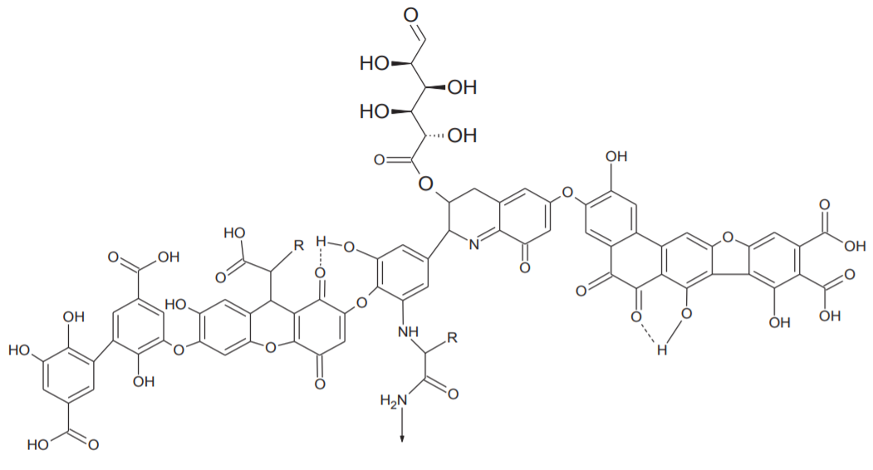
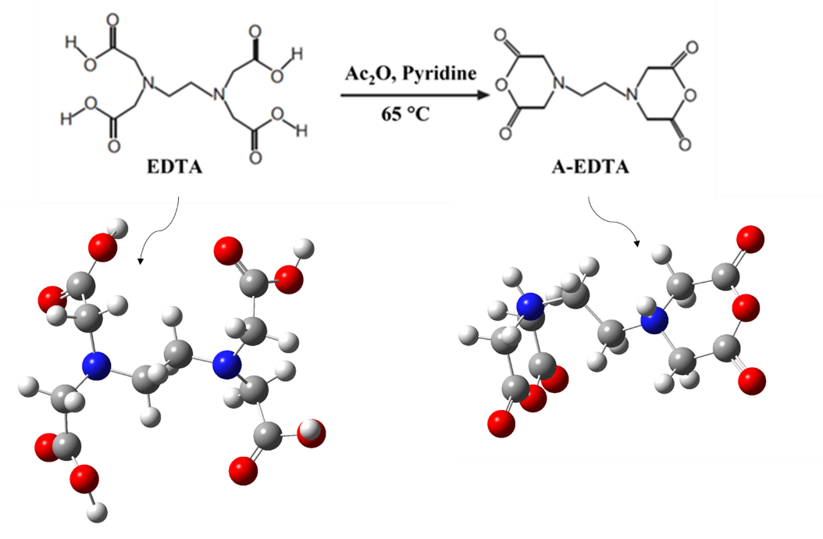
Fig. S1. Molecular structure of HA ¹
Fig. S2. Chemical reactions related to the synthesis of EDTA dianhydride ² which nitrogen, carbon, oxygen and hydrogen are illustrated with blue, gray, red and white particles

- The methodology for preparing the solution
The pH of the solution was brought up to 10 using NaOH, and the mixture was agitated for 24 to prepare the HA solution in various concentrations. Finally, HCl was used to decrease the pH to 7. At 4°C, the produced solution was stored in the dark ³. After each test, HA is analyzed using a spectrophotometer. It was made for this purpose from HA in the existing introductions, and a quartz cell with a 254 nm length was used to create its calibration curve. The final firsts were calculated following the intended trials using the device's specified absorption number and in accordance with the calibration curve. After each test, the transfer solution is sufficiently run through the paper for the final determination. The filtered solution is then poured into the quartz cell, and after adjusting the apparatus, the desired absorbance is read at a wavelength of 254 nm. It was possible to convert the absorbance value displayed by the combined calibration curve of the solution (C) in each experiment. HA's calibration diagram is depicted in Fig. S3.
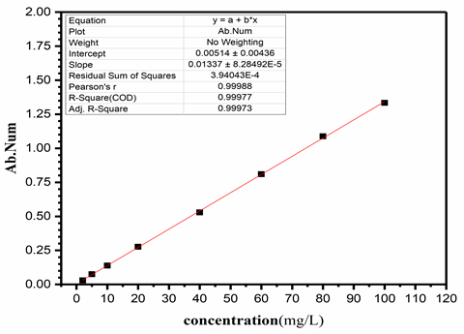
Fig. S3. Humic acid calibration diagram

3. Adsorption kinetics
Adsorption kinetics shows the evolution of the adsorption process with time and is the second important parameter that should be considered. In addition, in the purification of aqueous solutions, the adsorption process is strongly dependent on other experimental parameters such as pH, ionic strength, temperature, the concentration of the adsorbed substance, amount of adsorbent, the structure of the adsorbent, etc., which affects the kinetics of adsorption of the substance. The adsorbent acts on any adsorbent; Therefore, the contact time in which the adsorption process approaches a real equilibrium must be determined based on these parameters ⁴.
In batch systems, several models have been presented to describe how the adsorbed substance diffuses on the adsorbent surface, which can be used in adsorption kinetics. Nevertheless, pseudo-first-order and pseudo-second-order models are widely used ⁴. Therefore, these two models are obtained using the general relationship E. S1:
(E. S1)
Where, q_{e} and q_{t} are respectively the amount of adsorbed material per unit mass of the adsorbent at the equilibrium time and each instant of time in minutes (min). K_{n} in terms of (1/min) defines the pseudo-order constant of the kinetic model.

3.1. Pseudo-first-order kinetic model
When n=1, in relation E. S1, we will reach the Pseudo-first-order kinetic model ⁴:
(E. S2)
where, q_{e} and q_{t} are respectively the amount of substance adsorbed per unit mass of the adsorbent at the equilibrium time and every instant of time in minutes, (1/min) K₁ is the rate constant of the pseudo-first-order kinetic equation.

3.2. Pseudo-second-order kinetic models
By putting n=2 in equation E. S1, we will reach the pseudo-second-order kinetic models ⁴:
(E. S3)

where, q_{e} and q_{t} are respectively the amount of substance adsorbed per unit mass of the adsorbent at the equilibrium time and every moment of time in minutes, (g/mg.min) K₂ is the rate constant of the pseudo-second-order kinetic equation.

3.3. Kinetic model of intraparticle penetration
Weber and Morris found that in most cases, adsorption kinetics is approximately proportional to the second root (t^{1/2}) ⁵. The linear shape of this model is E. S4:
(E. S4)

K_{i} (mg/g.min ^{0.5}) intraparticle penetration rate constant is obtained by determining the slope of the line in the q_{t} diagram in terms of t^{1/2 5}. The c (mg. g⁻¹) parameter is an important parameter representing an adsorbent layer's boundary layer thickness. This thickness is important for adsorption, as it influences the mass transfer rate. The adsorbent layer is thicker and the mass transfer rate is larger as parameter C's value increases. This means that a higher value of parameter C indicates that the boundary layer thickness is larger, thus providing a greater rate of adsorption ⁶.

4. Adsorption isotherms
4.1. Langmuir isotherm
The theory of Langmuir isotherm assumes that adsorption occurs with a single layer thickness on the adsorbent surface. This means that the adsorbed layer is only as thick as one molecule, so when one point of the adsorber reaches equilibrium, no more adsorption takes place at that point of the adsorber. Also, a basic assumption in this theory is that the adsorption process occurs only in homogeneous and special places inside the adsorber ^{7,8}. Based on this, Langmuir's relationship is given as E. S5⁹.
(E. S5)
where:
q_{e}: amount of adsorbed material per unit mass of adsorbent (mg HA or BSA / mg Hydrogel)
C_{e}: equilibrium concentration of adsorbed substance in solution (mg HA or BSA/L)
K_{L}: Langmuir constant (L/mg)
q_{m}: the maximum amount of adsorbent capacity on the desired adsorbent material in terms of (mg HA or BSA / g Hydrogel).

4.2. Freundlich isotherm
The Freundlich relation is an exponential equation that assumes that with the increase in the concentration of the adsorbed material, the amount of adsorbed material on the adsorbent increases; in other words, this model is based on the assumption of multi-layer adsorption ^{7,8}. The Freundlich relation is expressed as E. S6 ¹⁰:
(E. S6)

K_{f} and n are experimental constants of the Freundlich model. This relationship is known based on the heterogeneous constant n, so the Freundlich isotherm can be used to describe heterogeneous systems. Theoretically, based on the Freundlich relation, an infinite amount of adsorption can occur. The Freundlich relation is consistent with the Langmuir equation in the range of medium concentrations, but among the weaknesses of both equations, it can be mentioned that in the range of wide concentrations, equilibrium data with a set of constants are not consistent ^{7,8}.

4.3. Temkin isotherm
Temkin and Pijou considered some interactions between the adsorbent and the adsorbed material in the isotherm. They suggested that due to these interactions, the heat of adsorption of all molecules adsorbed on the surface of the adsorbent decreases linearly ^{7,8}. This relationship is expressed as E. S7 ¹¹:
(E. S7)

where:
A: bond equilibrium constant (L/g)
b: Compliant equilibrium constant
R: equilibrium constant of gases (J/mol. K)
T: temperature in Kelvin
q_{e}: amount of adsorbed material per unit mass of adsorbent (mg HA or BSA / mg Hydrogel)
C_{e}: equilibrium concentration of adsorbed substance in solution (mg HA or BSA/L)

References
1 Shabani, A., Sepaskhah, A. & Kamgar-Haghighi, A. Growth and physiologic response of rapeseed (Brassica napus L.) to deficit irrigation, water salinity and planting method. International Journal of Plant Production 7, 569-596 (2013).
2 Tuelue, M. & Geckeler, K. E. Synthesis and properties of hydrophilic polymers. Part 7. Preparation, characterization and metal complexation of carboxy‐functional polyesters based on poly (ethylene glycol). Polymer international 48, 909-914 (1999).
3 Wu, J., Jiang, R., Liu, Q. & Ouyang, G. Impact of different modes of adsorption of natural organic matter on the environmental fate of nanoplastics. Chemosphere 263, 127967 (2021).
4 Moussout, H., Ahlafi, H., Aazza, M. & Maghat, H. Critical of linear and nonlinear equations of pseudo-first order and pseudo-second order kinetic models. Karbala International Journal of Modern Science 4, 244-254 (2018).
5 Weber, W. & Morris, J. Sanitary Eng. Div., Am. Civil Eng 89, 31-39 (1963).
6 Abdoli, S. M., Bastani, D. & Bargozin, H. Adsorption of phenol compounds by nanoporous silica aerogel. Scientia Iranica 22, 992-1000 (2015).
7 Mozaffari Majd, M., Kordzadeh-Kermani, V., Ghalandari, V., Askari, A. & Sillanpää, M. Adsorption isotherm models: A comprehensive and systematic review (2010−2020). Science of The Total Environment 812, 151334, doi:https://doi.org/10.1016/j.scitotenv.2021.151334 (2022).
8 Allen, S., Mckay, G. & Porter, J. F. Adsorption isotherm models for basic dye adsorption by peat in single and binary component systems. Journal of colloid and interface science 280, 322-333 (2004).
9 Langmuir, I. The constitution and fundamental properties of solids and liquids. Part I. Solids. Journal of the American chemical society 38, 2221-2295 (1916).
10 Fritz, W. & Schluender, E.-U. Simultaneous adsorption equilibria of organic solutes in dilute aqueous solutions on activated carbon. Chemical Engineering Science 29, 1279-1282 (1974).
11 Temkin, M. Kinetics of ammonia synthesis on promoted iron catalysts. Acta physiochim. URSS 12, 327-356 (1940).

Corresponding Author: abdoli@sut.ac.ir
Corresponding Author: h.hazrati@sut.ac.ir

