Feature | Training set patients  N=3819 | Validation set patients  N=674 | p-value
G5 CKD progression during study period (%) | 1210 (31.68%) | 227 (33.68%) | 0.327
RRT initiation during study period (%) | 758 (19.84%) | 124 (18.40%) | 0.411
eGFR on recruitment (ml/min/1.73m2) | 24.42 (24.29 - 24.54) | 24.57 (24.26 - 24.88) | 0.368
Demographic data
Age (years) (95% CI) | 70.50 (70.10 - 70.91) | 70.76 (69.79 - 71.73) | 0.634
Female gender (%) | 1668 (43.68%) | 303 (44.96%) | 0.565
Medical History
Hypertension | 2204 (57.71%) | 381 (56.53%) | 0.596
Type 2 diabetes mellitus | 1272 (33.31%) | 207 (30.71%) | 0.201
Heart failure | 883 (23.12%) | 152 (22.55%) | 0.327
Glomerular disorders | 857 (22.44%) | 139 (20.62%) | 0.754
Biochemical Data
Creatinine (µmol/L) | 194.79 (193.16 - 196.42) | 192.66 (188.68 - 196.64) | 0.323
Urea (mmol/L) | 13.09 (12.94 - 13.24) | 12.97 (12.59 - 13.35) | 0.532
ALT (U/L) | 18.97 (18.5 - 19.44) | 19.88 (18.18 - 21.59) | 0.181
AST (U/L) | 35.13 (29.37 - 40.89) | 29.49 (24.62 - 34.37) | 0.395
ALP (U/L) | 87.39 (85.83 - 88.96) | 87.43 (84.62 - 90.24) | 0.987
Albumin (g/L) | 39.20 (39.05 - 39.34) | 38.97 (38.61 - 39.34) | 0.266
Urate (mmol/L) | 0.47 (0.47 - 0.48) | 0.46 (0.44 - 0.47) | 0.045
Calcium (mmol/L) | 2.32 (2.32 - 2.33) | 2.33 (2.31 - 2.34) | 0.505
Phosphate(mmol/L) | 1.17 (1.16 - 1.18) | 1.17 (1.16 - 1.19) | 0.907
Ca X PO4 (mg2/dL2) | 33.73 (33.5 - 33.95) | 33.83 (33.30 - 34.36) | 0.718
Haemoglobin (g/L) | 11.44 (11.37 - 11.52) | 11.35 (11.17 - 11.54) | 0.350
Haemoglobin a1c (%) | 7.83 (7.75 - 7.9) | 7.65 (7.48 - 7.82) | 0.065
Spot urine protein: creatinine (mg/mg Cr) | 2.26 (2.04, 2.49) | 1.86 (1.4, 2.32) | 0.166
Table ST1. Comparison of baseline characteristics of patients in training set and validation set
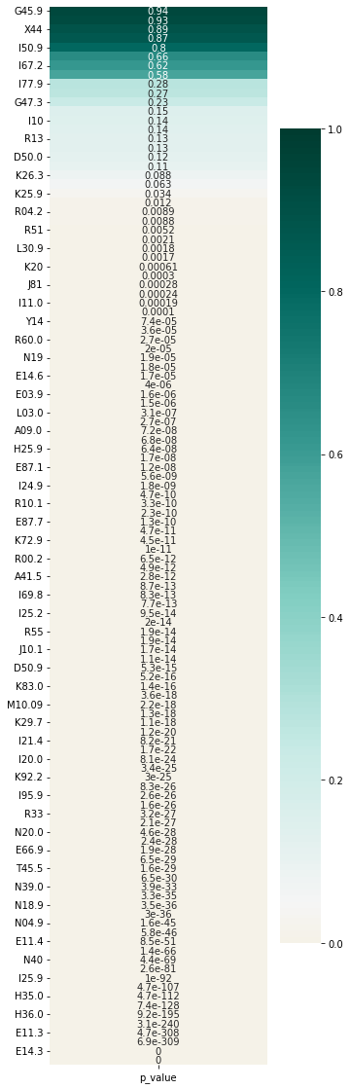
Figure SF1. p-value of Chi-square test on ICD-10 codes 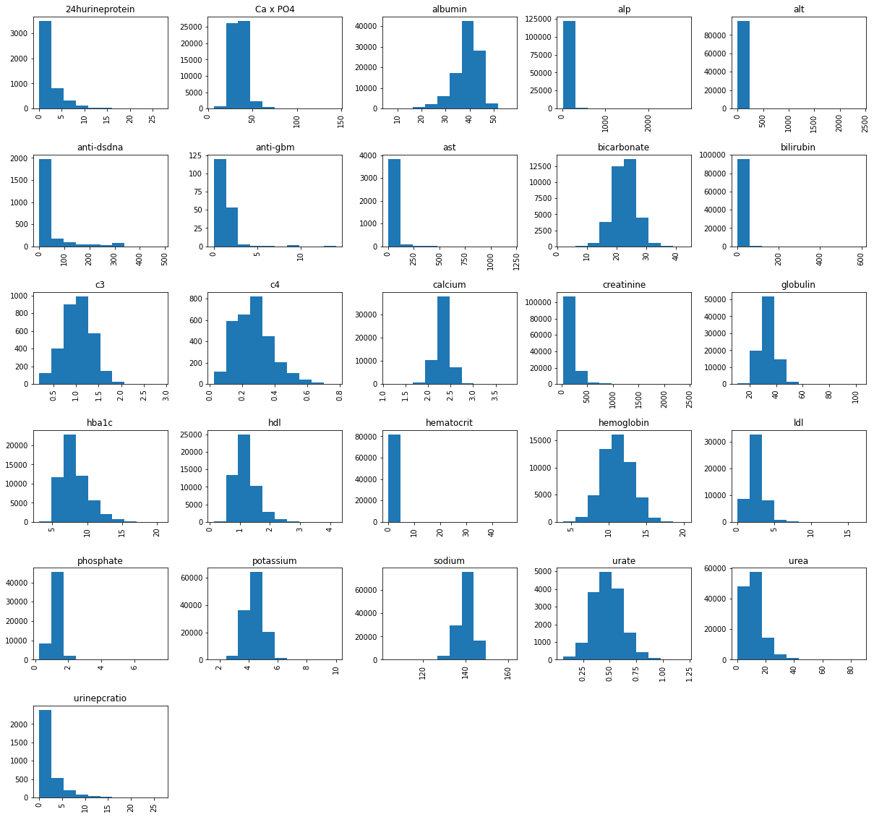
Figure SF2. Histogram of continuous biochemical investigations
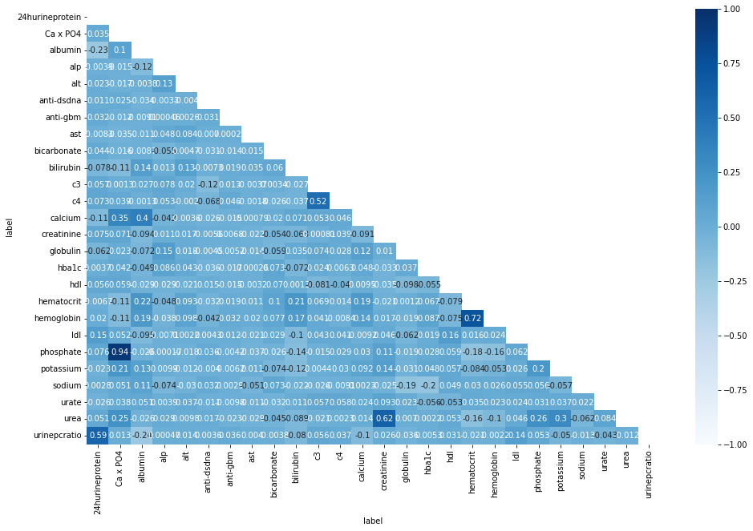
Figure SF3. Pearson correlation of continuous biochemical data
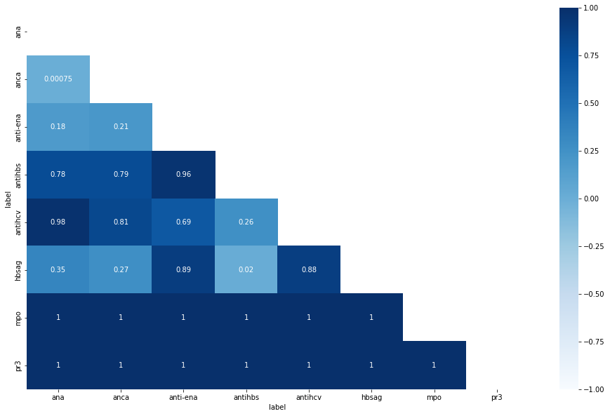
Figure SF4. P-value of Chi-square test for categorical biochemical data

 | Drug name | t_test | p_value |  | Drug name | t_test | p_value
0 | acarbose | -4.22 | 0.000 | 84 | isosorbide mononitrate | -0.87 | 0.387
1 | acetazolamide | -0.22 | 0.825 | 85 | labetalol | 2.36 | 0.020
2 | acyclovir | 0.96 | 0.346 | 86 | lamivudine | -11.67 | 0.000
3 | alendronate | -2.23 | 0.030 | 87 | lansoprazole | -1.95 | 0.053
4 | alfacalcidol | 2.66 | 0.008 | 88 | levofloxacin | -0.88 | 0.384
5 | alfuzosin | 0.91 | 0.369 | 89 | linagliptin
6 | allopurinol | -4.40 | 0.000 | 90 | lisinopril | 10.14 | 0.000
7 | aluminium hydroxide | 0.51 | 0.612 | 91 | loperamide | 1.13 | 0.271
8 | amiloride |  |  | 92 | loratadine
9 | amiodarone |  |  | 93 | losartan | 2.80 | 0.005
10 | amlodipine | 7.78 | 0.000 | 94 | lysozyme | 3.27 | 0.001
11 | aspirin | -9.52 | 0.000 | 95 | mecobalamin | -5.75 | 0.000
12 | atenolol | 0.73 | 0.467 | 96 | mefenamic acid | 0.04 | 0.966
13 | atorvastatin | 10.05 | 0.000 | 97 | mesalazine | 1.72 | 0.090
14 | azathioprine | -3.94 | 0.000 | 98 | metformin | -6.38 | 0.000
15 | baclofen | -2.89 | 0.005 | 99 | methotrexate | -10.35 | 0.000
16 | benserazide | 1.03 | 0.307 | 100 | methyclothiazide
17 | bisoprolol | -1.87 | 0.063 | 101 | methyldopa | -0.81 | 0.420
18 | bumetanide |  |  | 102 | metolazone | -0.68 | 0.501
19 | caco3 | 4.58 | 0.000 | 103 | metoprolol | -14.27 | 0.000
20 | caco3 + vitamin d | 0.40 | 0.690 | 104 | metronidazole | 1.86 | 0.071
21 | captopril | -1.25 | 0.214 | 105 | mircera | 2.17 | 0.037
22 | carbamazepine | 3.59 | 0.001 | 106 | mmf | -6.41 | 0.000
23 | carbimazole | -0.06 | 0.950 | 107 | montelukast
24 | carvedilol | -7.25 | 0.000 | 108 | naproxen | -0.40 | 0.689
25 | cefuroxime | -0.68 | 0.497 | 109 | nifedipine | 28.85 | 0.000
26 | chlorpheniramine | -7.19 | 0.000 | 110 | nitrofurantoin | -5.08 | 0.000
27 | cilostazol | -1.11 | 0.273 | 111 | oxpentifylline | -1.16 | 0.249
28 | cinacalcet |  |  | 112 | oxybutynin | -1.37 | 0.176
29 | citalopram | -1.53 | 0.132 | 113 | pantoprazole | 5.95 | 0.000
30 | citrate | -2.73 | 0.008 | 114 | perindopril | 1.86 | 0.063
31 | clopidogrel | -0.88 | 0.377 | 115 | phenazopyridine | 1.31 | 0.193
32 | cloxacillin | -0.29 | 0.769 | 116 | phenobarbitone
33 | colchicine | -9.55 | 0.000 | 117 | phenytoin | 0.63 | 0.530
34 | cotrimoxazole | 1.35 | 0.180 | 118 | pioglitazone | -0.66 | 0.508
35 | cyclophosphamide | 1.38 | 0.170 | 119 | piroxicam
36 | cyclosporin | -3.01 | 0.003 | 120 | potassium chloride | -0.70 | 0.485
37 | dabigatran | -1.51 | 0.176 | 121 | prazosin | 7.78 | 0.000
38 | darbepoetin alfa | 4.11 | 0.000 | 122 | prednisolone | -4.42 | 0.000
39 | dexamethasone | -0.22 | 0.829 | 123 | pregabalin | -1.41 | 0.164
40 | diclofenac | -0.36 | 0.719 | 124 | probenecid
41 | digoxin | -5.09 | 0.000 | 125 | propranolol | 1.45 | 0.149
42 | diltiazem | -1.98 | 0.048 | 126 | pyridostigmine | 9.41 | 0.000
43 | dimethylpolysiloxane | -0.59 | 0.553 | 127 | quinine
44 | dipyridamole | 4.41 | 0.000 | 128 | rabeprazole | 0.92 | 0.356
45 | domperidone |  |  | 129 | ramipril
46 | donepezil |  |  | 130 | rosiglitazone
47 | doxazosin | 3.67 | 0.000 | 131 | rosuvastatin | 0.60 | 0.551
48 | empagliflozin |  |  | 132 | sevelamer
49 | enalapril | 1.65 | 0.100 | 133 | simvastatin | 5.55 | 0.000
50 | entecavir | -6.17 | 0.000 | 134 | sirolimus
51 | esomeprazole | 5.08 | 0.000 | 135 | sitagliptin | -4.30 | 0.000
52 | ezetimibe |  |  | 136 | sodium bicarbonate | 7.47 | 0.000
53 | famotidine | -11.42 | 0.000 | 137 | sodium chloride | -2.11 | 0.043
54 | febuxostat | -1.07 | 0.284 | 138 | sotalol
55 | felodipine | 1.83 | 0.068 | 139 | spironolactone | -1.66 | 0.098
56 | fenofibrate | -6.95 | 0.000 | 140 | sulphasalazine | 7.98 | 0.000
57 | ferrous sulphate | -0.83 | 0.407 | 141 | tacrolimus | -4.36 | 0.000
58 | ferrum hausmann |  |  | 142 | tamoxifen
59 | finasteride |  |  | 143 | tamsulosin | -6.40 | 0.000
60 | fludrocortisone | -7.73 | 0.000 | 144 | telmisartan | 0.47 | 0.637
61 | fluvastatin | -1.00 | 0.318 | 145 | terazosin | -0.52 | 0.606
62 | folic acid | -1.65 | 0.100 | 146 | terbutaline | 3.74 | 0.000
63 | frusemide | 11.73 | 0.000 | 147 | thalidomide | 0.00 | 1.000
64 | gabapentin | -9.31 | 0.000 | 148 | theophylline | -1.93 | 0.054
65 | gemfibrozil | 4.17 | 0.000 | 149 | thyroxine | -0.46 | 0.647
66 | glibenclamide | 0.57 | 0.566 | 150 | ticagrelor
67 | gliclazide | -17.03 | 0.000 | 151 | tolbutamide
68 | glimepiride | -2.50 | 0.013 | 152 | tramadol | -8.35 | 0.000
69 | glipizide | -9.98 | 0.000 | 153 | tranexamic acid | -0.75 | 0.454
70 | glucosamine |  |  | 154 | trimetazidine | 1.65 | 0.099
71 | glyceryl trinitrate |  |  | 155 | ursodeoxycholic acid | -0.27 | 0.791
72 | haloperidol | -10.87 | 0.000 | 156 | valproate | -1.13 | 0.259
73 | hydralazine | -0.95 | 0.344 | 157 | valsartan | 5.15 | 0.000
74 | hydrochlorothiazide | -3.93 | 0.000 | 158 | verapamil | 1.42 | 0.179
75 | hydrocortisone | 1.67 | 0.096 | 159 | vitamin b1 | 2.59 | 0.010
76 | hydroxychloroquine | 0.15 | 0.883 | 160 | vitamin b12 | -1.50 | 0.135
77 | hydroxyzine | -0.36 | 0.723 | 161 | vitamin b6 | -2.84 | 0.005
78 | Ibuprofen | -1.03 | 0.306 | 162 | vitamin c | -1.20 | 0.233
79 | Imatinib | -7.00 | 0.000 | 163 | vitamin d2
80 | indapamide | -9.37 | 0.000 | 164 | vitamin d3 | -5.00 | 0.000
81 | indomethacin | -0.95 | 0.343 | 165 | vitamin k
82 | Insulin | -7.77 | 0.000 | 166 | warfarin | -2.67 | 0.008
83 | isosorbide dinitrate | -2.26 | 0.024
Table ST2. Student’s T-test of daily doses of drugs between those who achieved primary outcome and those who don’t
Demographics | ICD-10 Codes | Laboratory investigations | Drugs
Age, gender | A09.0, A09.9, A41.5, A41.9, B02.9, B18.1, D50.9, D56.0, D64.9, E03.9, E11.2, E11.3, E11.4, E11.6, E11.7, E11.9, E14.3, E14.6, E14.9, E16.0, E16.2, E66.9, E78.0, E86, E87.1, E87.5, E87.6, E87.7, H25.9, H35.0, H35.2, H36.0, I11.0, I12.9, I20.0, I21.4, I24.9, I25.1, I25.2, I25.9, I44.2, I48, I50.0, I64, I69.8, I73.9, I77.9, I95.9, J10.1, J18.9, J81, J90, K25.3, K25.9, K29.7, K30, K63.5, K72.9, K74.6, K83.0, K92.2, L03.0, L03.1, L30.9, L97, M10.09, M10.99, M54.59, N02.8, N04.9, N08.8, N17.9, N18.9, N19, N20.0, N39.0, N40, R00.2, R10.1, R11, R13, R31, R33, R40.2, R51, R55, R60.0, R60.9, R73.9, R80, T45.5, T83.0, Y44.2, Z22.5, Z85.0 | sodium, potassium, urea, creatinine, calcium, phosphate, urate, albumin, globulin, bicarbonate, ALT, AST, ALP, bilirubin, hemoglobin, hba1c, HDL, LDL, anti-dsDNA, c3, c4, anti-GBM Antibody, urine protein:creatinine, ANA, anti-ENA, anti-HBs, anti-HCV, HbsAg | acarbose, alendronate, alfacalcidol, allopurinol, amiloride, amiodarone, amlodipine, aspirin, atorvastatin, azathioprine, baclofen, bumetanide, CaCO3, carbamazepine, carvedilol, chlorpheniramine, cinacalcet, citrate, colchicine, cyclosporin, darbepoetin alfa, digoxin, diltiazem, dipyridamole, domperidone, donepezil, doxazosin, empagliflozin, entecavir, esomeprazole, ezetimibe, famotidine, fenofibrate, ferrum hausmann, finasteride, fludrocortisone, frusemide, gabapentin, gemfibrozil, gliclazide, glimepiride, glipizide, glucosamine, glyceryl trinitrate, haloperidol, hydrochlorothiazide, imatinib, indapamide, insulin, isosorbide dinitrate, labetalol, lamivudine, linagliptin, lisinopril, loratadine, losartan, lysozyme, mecobalamin, metformin, methotrexate, methyclothiazide, metoprolol, mircera, mmf, montelukast, nifedipine, nitrofurantoin, pantoprazole, phenobarbitone, piroxicam, prazosin, prednisolone, probenecid, pyridostigmine, quinine, ramipril, rosiglitazone, sevelamer, simvastatin, sirolimus, sitagliptin, sodium bicarbonate, sodium chloride, sotalol, sulphasalazine, tacrolimus, tamoxifen, tamsulosin, terbutaline, ticagrelor, tolbutamide, tramadol, valsartan, vitamin b1, vitamin b6, vitamin d2, vitamin d3, vitamin k, warfarin
Table ST3. Features recruited for model training.

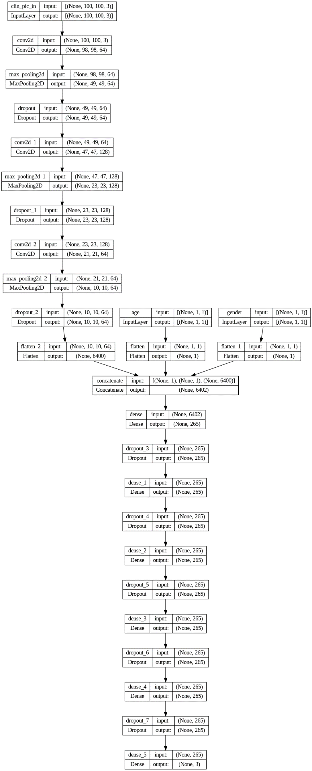
Figure SF5. Structure of optimized convolutional neural network (CNN)

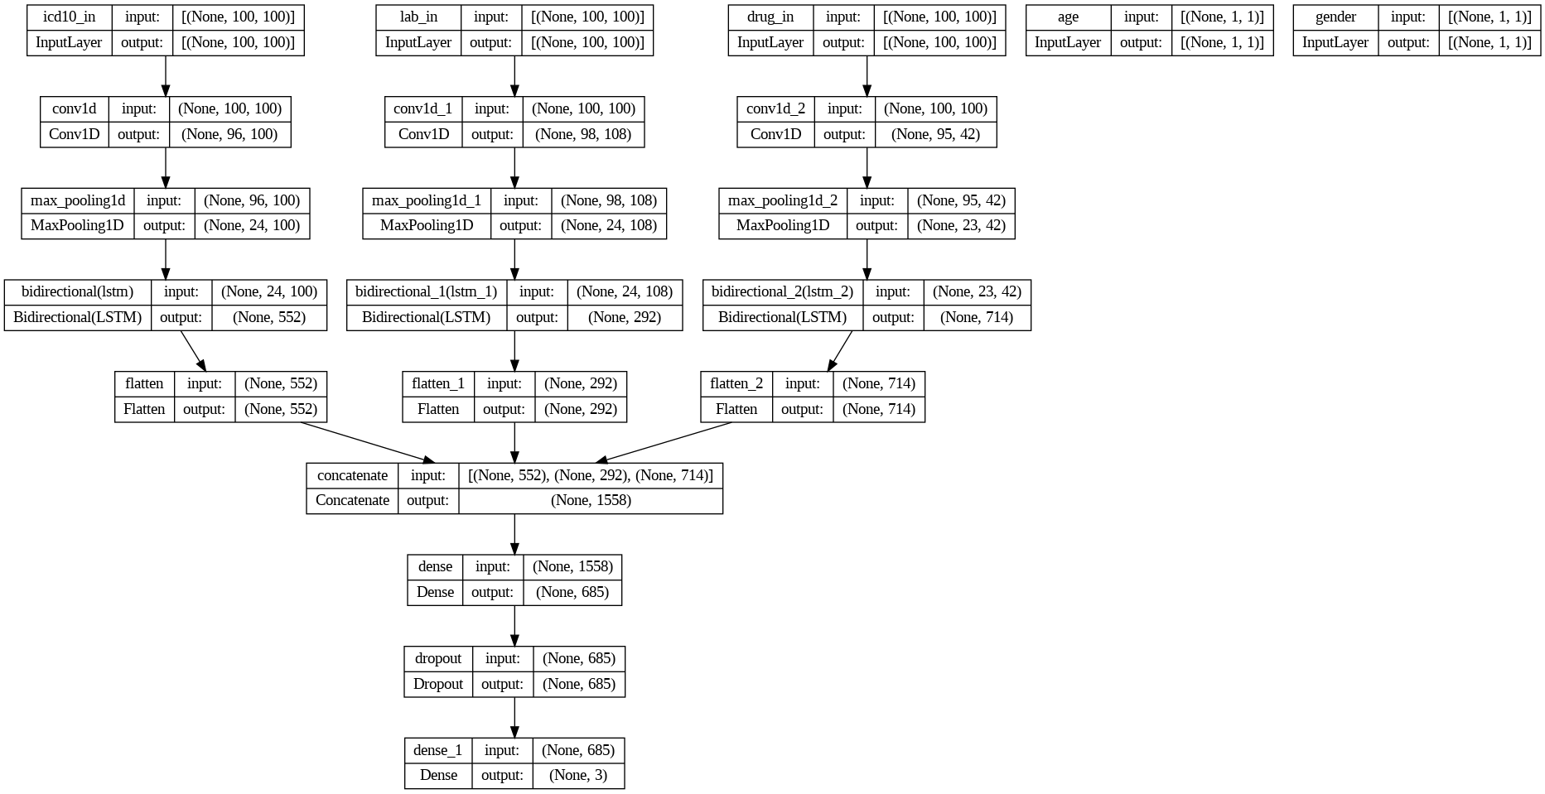
Figure SF6. Structure of optimized combination neural network of CNN, artificial neural network (ANN) and long short-term memory (LSTM)
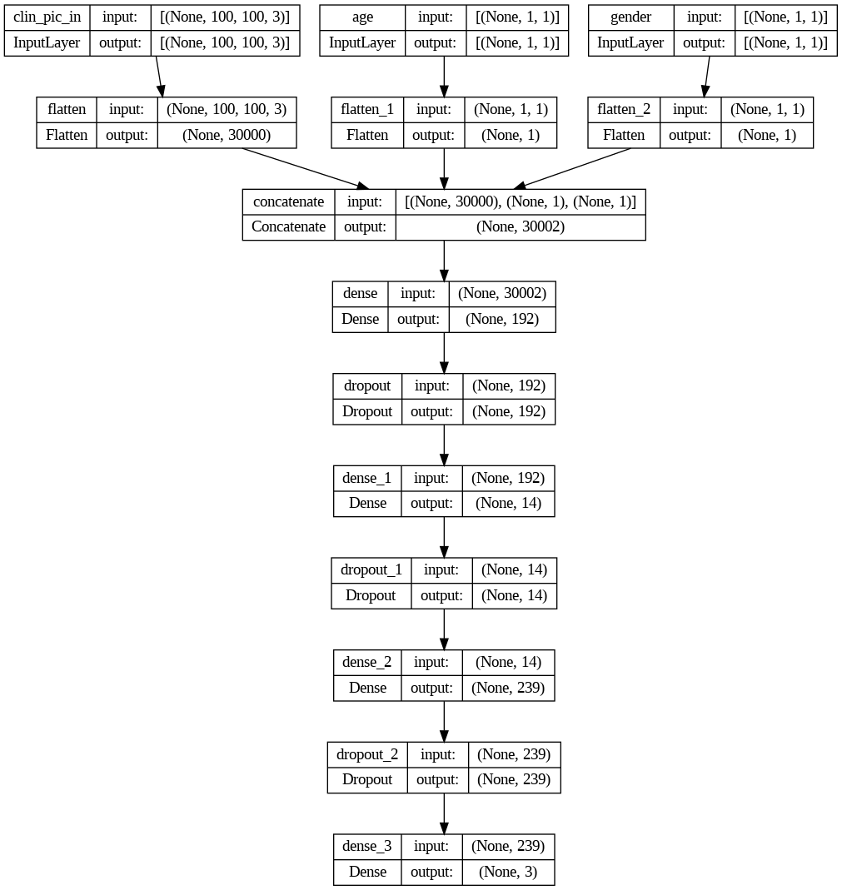
Figure SF7. Structure of optimized ANN
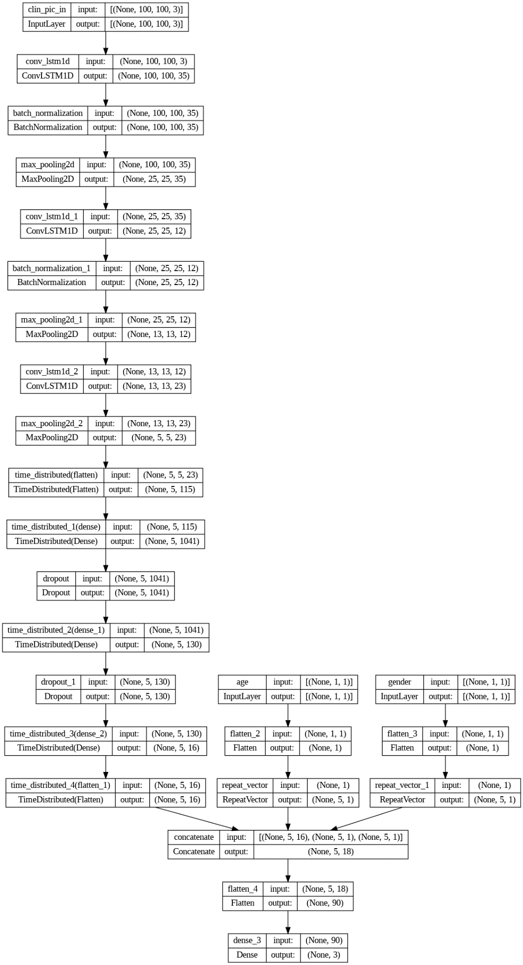
Figure SF8. Structure of optimized combination convolutional LSTM (convLSTM) and ANN neural network.
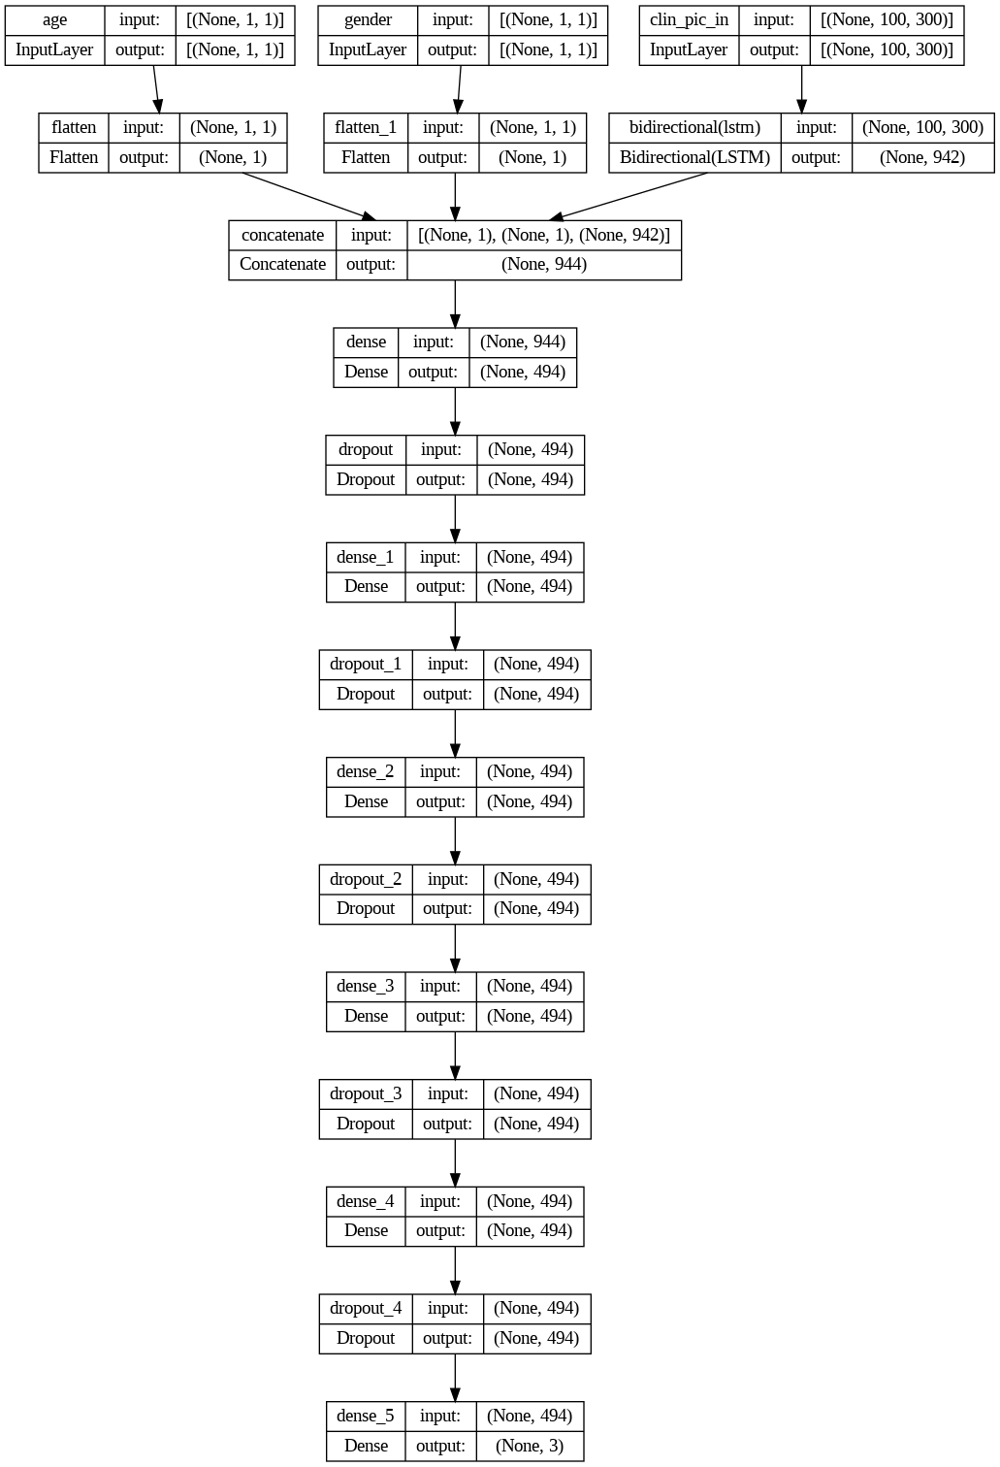
Figure SF9. Structure of optimized LSTM

 | CNN | CNN + LSTM + ANN
False positive
Number of clinical entries (n=11276) | 258 (2.29%) | 1564 (13.87%)
Number of patients (n=499) (%) | 27 (5.41%) | 218 (43.69%)
Number of patients need dialysis after 5 years | 4 (0.80%) | 18 (5.81%)
Number of patients received unrecorded renal transplant ª | 0 (0.00%) | 11 (2.20%)
False negative
Number of clinical entries | 1715 (15.21%) | 1294 (11.48%)
Number of patients | 85 (17.03%) | 80 (16.03%)
Number of patients predicted with risk of RRT | 32 (6.41%) | 47 (9.42%)
Number of patients with forecast labelling ^{b} | 21 (4.21%) | 22 (4.41%)
Number of patients with delayed labelling ^{c} | 11 (2.20%) | 25 (5.01%)
Number of patients with completely miss ^{d} | 53 (10.62%) | 33 (6.61%)
Number of completely miss patients with peritoneal dialysis | 46 (9.22%) | 25 (5.01%)
Number of completely miss patients with hemodialysis | 5 (1.00%) | 4 (0.80%)
Number of completely miss patients with renal transplant | 2 (0.40%) | 4 (0.80%)
Table ST4. Mislabeling analysis of the 2 most robust models
a. unrecorded renal transplant: patient received renal transplantation in other countries during study period, not recorded in the ICD code
b. forecast labelling: patient actually have initiated RRT in 5 years, but labelled with risk of RRT in 2 years
c. delayed labelling: patient actually have initiated RRT in 2 years, but labelled with risk of RRT in 5 years
d. completely miss: patient actually have initiated RRT in 5 years or 2 years, but labelled with no risk of RRT in 5 years

