Electronic Supplementary Material
Organic enrichment negatively impacts meiobenthic copepods on Argentinean coasts
MICHEL SCIBERRAS^{1,2,*}, AGUSTIN G. MENECHELLA^{2,3}, NÉSTOR PÉREZ-MÉNDEZ⁴, NÉSTOR J. CAZZANIGA^{2,5}, HUGO J. MARRERO^{6,7}
¹ Consejo Nacional de Investigaciones Científicas y Técnicas (CONICET).
² Departamento de Biología, Bioquímica y Farmacia, Universidad Nacional del Sur (UNS). San Juan 670, Bahía Blanca 8000, Buenos Aires, Argentina.
³ Instituto Argentino de Oceanografía (IADO), UNS-CONICET. Camino La Carrindanga Km 7.5, Bahía Blanca 8000, Buenos Aires, Argentina.
⁴ Inst. de Recerca i Tecnologia Agroalimentaries (IRTA), Estació Experimental de l'Ebre, Amposta, Tarragona, España.
⁵ Comisión de Investigaciones Científicas de la Provincia de Buenos Aires (CIC).
⁶ Centro de Recursos Naturales Renovables de la Zona Semiárida – CERZOS (CONICET/UNS), Camino de la Carrindanga km 7, 8000, Bahía Blanca, Argentina.
⁷ Laboratorio de Interacciones Bióticas en Agroecosistemas, (LIBA), Bahía Blanca, Argentina.
*Corresponding author. Email: sciberras.michele@gmail.com. Telephone number: +54-0291-4522287 / 4595129 ext. 2422

Submission date: August 17, 2023

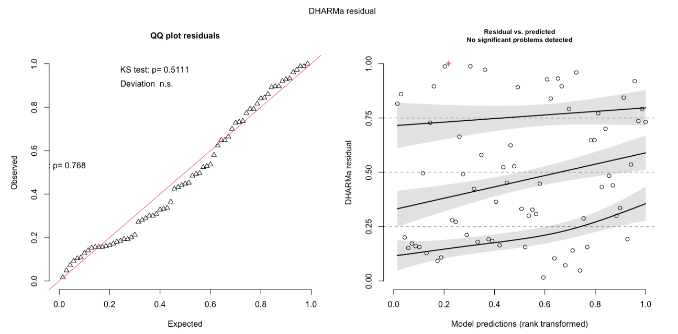
Fig. S1: Fit of model for copepod richness. Goodness of the models fit performed in DHARMa package (function: plotQQunif and plotResiduals). The package uses a simulation-based approach to create readily interpretable scaled (quantile) residuals for fitted (generalized) linear mixed models. The qq-plot detects overall deviations from the expected distribution, by default with added tests for correct distribution (Kolmogorov-Smirnov test), dispersion and outlier test. The residuals plot produces a plot of the residuals against the predicted value.

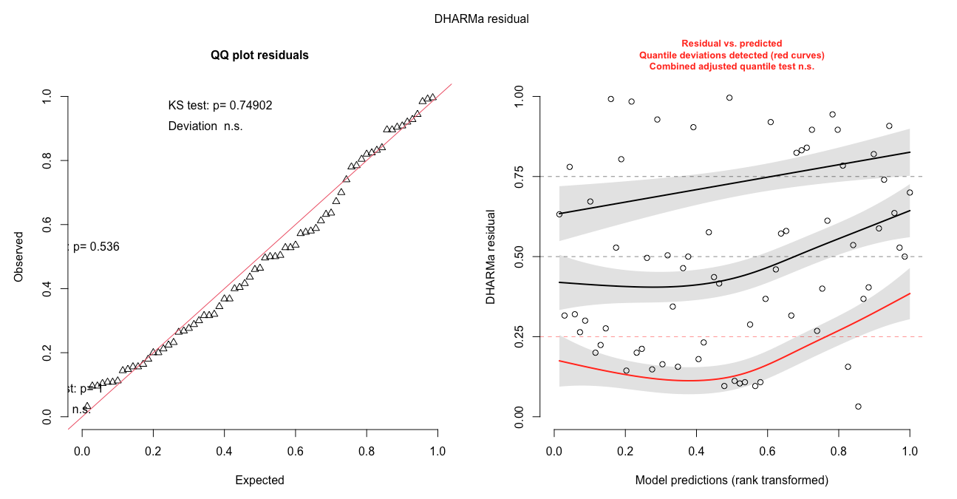
Fig. S2: Fit of model for copepod diversity. Goodness of the models fit performed in DHARMa package (function: plotQQunif and plotResiduals). The package uses a simulation-based approach to create readily interpretable scaled (quantile) residuals for fitted (generalized) linear mixed models. The qq-plot detects overall deviations from the expected distribution, by default with added tests for correct distribution (Kolmogorov-Smirnov test), dispersion and outlier test. The residuals plot produces a plot of the residuals against the predicted value.

