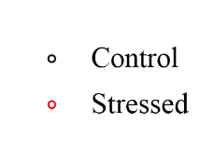
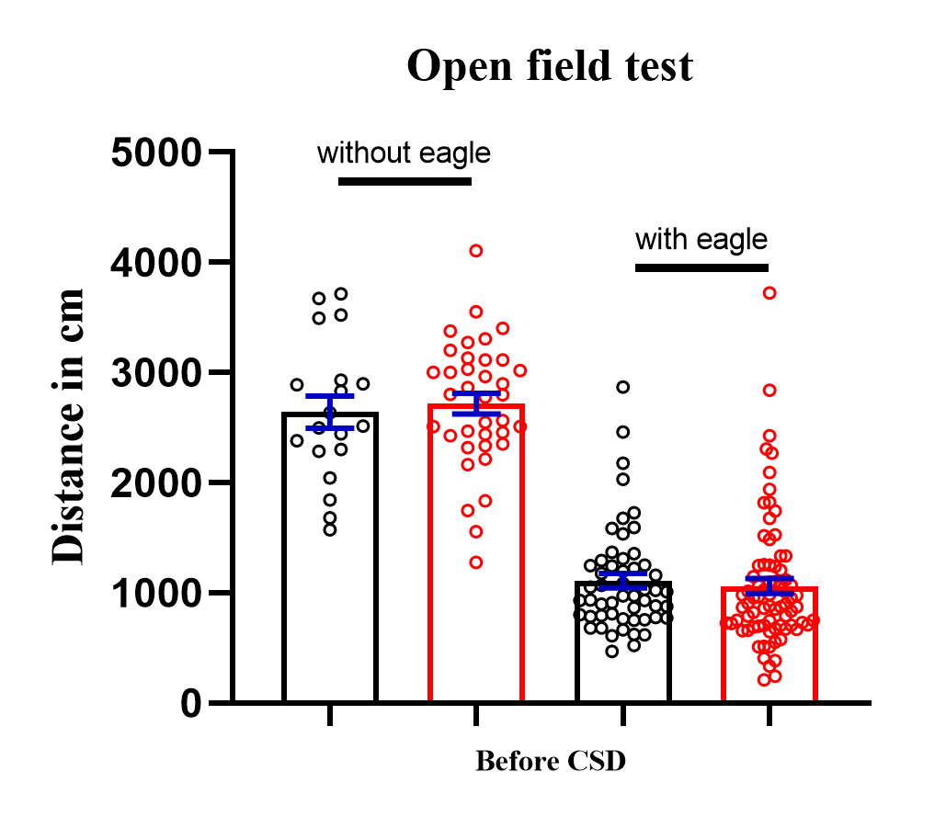
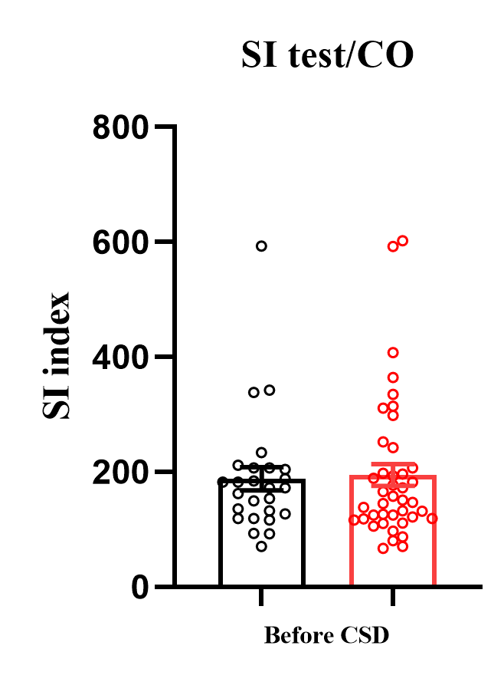
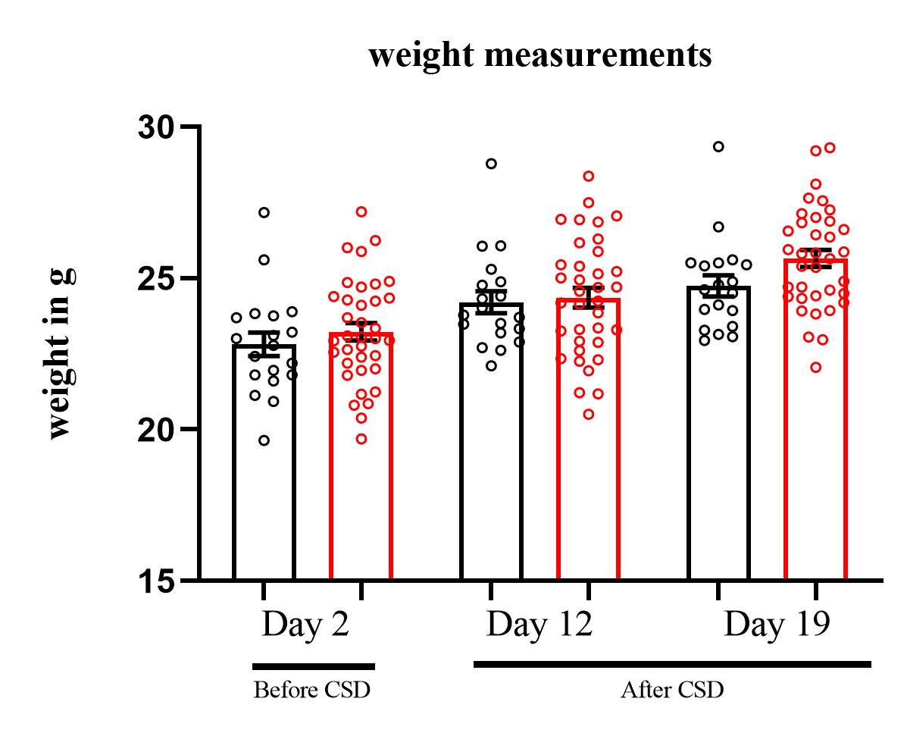
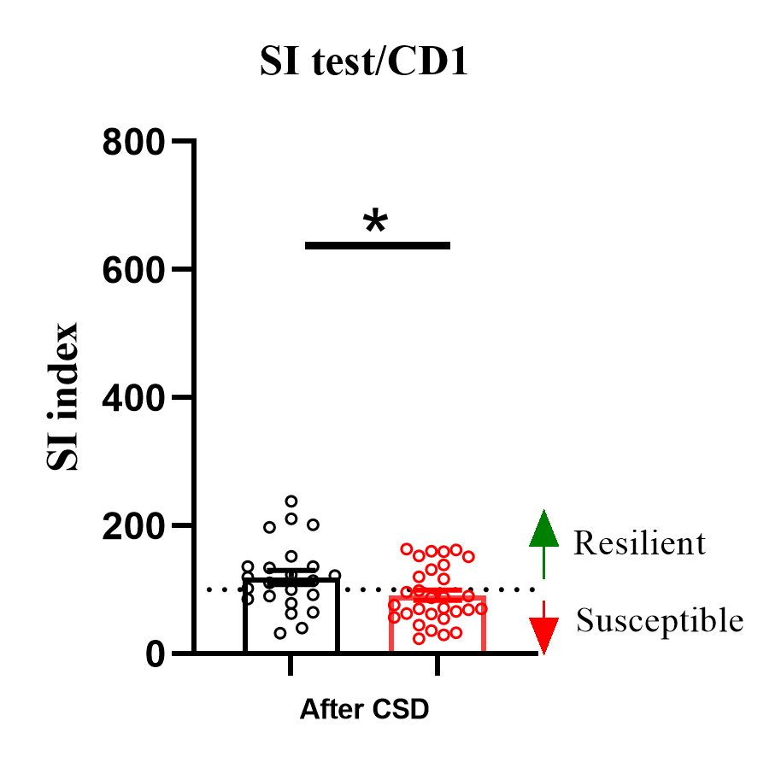
E
D
C
B
A

Supplementary Figure 1. Experimental outline for CSDS and results from the WT-GFP. A. Principle of CSD. Open field/eagle (OF/E) tests and social interaction test with conspecifics (SI/CO) were performed for a non-biased segregation of test animals to control or stressed groups. CSD was performed for 10 days with 15S attacks repeated 3 times per day. After 7 days of rest, TAM (150 mg/kg) was injected 5 hours before the social interaction test with CD1 to segregate into susceptible and resilient groups. 72 hours after the TAM injection, representative populations of SI-determined resilient, susceptible and control mice were sacrificed. Tissue regions of PFC and vHipp were then isolated from individual mouse. Weights were also measured periodically to assess stress-related modifications as shown in the scheme. B-E. Behaviour assessments of WT-GFP mice: Segregation of the test animals into control (black) and stressed (red) groups, based on their baseline behaviours of open field/eagle exploration (B) or social interactions (C) with conspecifics before CSD, indicating a non-biased segregation of test animals to control or stressed groups. D. Stressed group revealed a significant decrease in social interaction compared to control after CSD (t-test, p<0.05). E. Stressed group revealed an observable though non-significant increased weight compared to control following CSD (t-test, n.s.). All error bars indicate +/- S.E.M. Black circles represent individual non-stressed control mouse, while red circles represent individual stressed mouse.

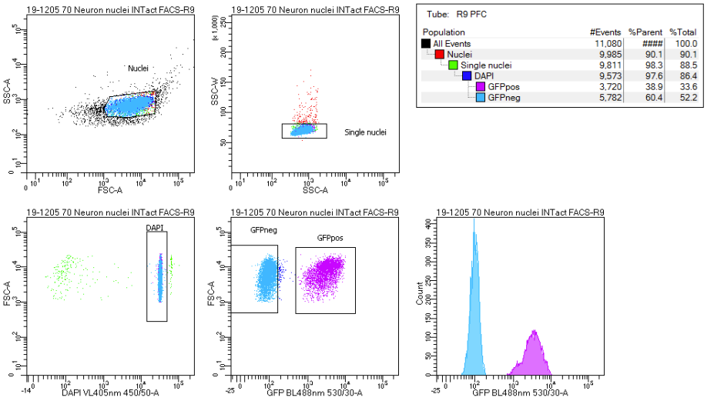

Supplementary Figure 2. Fluorescence activated nuclei sorting and characterization of GFP+ and GFP- nuclei populations. A. Following nuclei isolation, nuclei were gated according to their forward-and side-scatter properties (FSC-A/SSC-A) (top right), followed by doublet exclusion using SSC-A and SSC-W (top right). Nuclei were then gated according to their DAPI expression (DAPI VL405nm 450/50-A, bottom left) and GFP expression was used as a sorting gate (GFP BL488nm 530/30-A, bottom right). Sorted nuclei were collected in 1.5 mL Eppendorf tubes, containing the buffers for downstream analyses. B. % GFP expression of resilient, susceptible, and control mice in the PFC and vHIP. Data represents the average of 9-13 biological replicates. (PFC samples n=13,13,9; vHIP data: n=11,12,9; resilience, susceptible and control, respectively). Error bars represent ±SD.G (Statistical test). C. Gene expression of glial (Olig2, Mog, Sox10) and interneurons (Pvalb, Vip and Sst) across GFP+ and GFP- samples in the vHIP and PFC. D-E. Single cell level expression of selected markers along with Arc as annotated in “Allen Brain Map” database (Yao et al. 2021). The heatmap represents the trimmed mean expression of single cell clusters labeled according to their cell-type in two independent sequencing platforms: 10X Genomics (D) and SMART-seq (E). Clustered cell-types belonging to L5,L4, L5/6 NP CTX and oligodendrocytes are highlighted in yellow and red, respectively. For additional information, see “Allen Brain Map” database (Yao et al. 2021).

Supplementary Figure 3. Transcriptional analysis across the distinct comparison groups in vHIP. A-C. Principal component clustering analysis (PCA) of Res vs Ctrl (A), Sus vs Ctrl (B) and Sus vs Res (C). Resilience, Ctrl and Susceptible are represented as blue, black and red dots, respectively. D-F. Volcano plots representing the upregulated (red) and downregulated (blue) DEGs in Res vs Ctrl (D), Sus vs Ctrl (E) and Sus vs Res (F) in vHIP. G-I. Heatmaps of selected DEGs classified according to their gene family in Res vs Ctrl (J), Sus vs Ctrl (K) and Sus vs Res (L). Gene expression in G-I are represented by expression z-scores computed for selected DEGs.

Supplementary Figure 4. Identification of shared DEGs associated with susceptible and resilient activated nuclei in the vHIP. A-B. Upset plot displaying the overlapping DEGs across the distinct behavioral conditions. DEGs were classified as total upregulated in susceptible compared to resilient (red and purple) and total upregulated resilient compared to susceptible (green and blue).

Supplementary Figure 5. Overlap of classified gene families across the distinct behavioral groups in the vHIP. Gene family classification was obtained using ToppGene database and gene families were overlapped across distinct behavioral comparison groups. Each behavioral comparison comprised of DEGs classified according to their gene families (Supplementary Table 4). Gene families were overlapped revealing 6 groups of shared genes families. Genes in purple represent shared DEGs among different comparison groups.
Supplementary Figure 6. Transcriptional analysis across the distinct comparison groups in PFC. A-C. PCA clustering analysis of Res vs Ctrl (A), Sus vs Ctrl (B) and Sus vs Res (C). D-F. Volcano plots representing the upregulated (red) and downregulated (blue) DEGs in Res vs Ctrl (D), Sus vs Ctrl (E) and Sus vs Res (F) in PFC (P-value <0.01, FDR <0.01) G. Overlap of classified gene families across the distinct behavioral groups in PFC. Each behavioral comparison comprised of DEGs classified according to their gene families (Supplementary file). Gene families were overlapped revealing 3 groups of shared genes families. Genes in purple represent shared DEGs within different comparison groups.

Supplementary Figure 7. Visual representation of DEGs and their corresponding Gene Ontology (GO) terms, as classified by SynGO, within a hypothetical synapse located in the vHIP. Upregulated genes in susceptible are highlighted in red while upregulated in resilient are highlighted in blue. Synapse illustration was taken from SwissBioPics database (SIB). The figure provides annotations of DEGs based on the classified SynGO Gene Ontology (GO) terms. Therefore, the annotations were systematically arranged accordingly, yet it is plausible for actual gene functions to manifest in diverse regions within the synapse.

Supplementary Figure 8. Visual representation of DEGs and their corresponding Gene Ontology (GO) terms, as classified by SynGO, within a hypothetical synapse located in the PFC. Upregulated genes in susceptible are highlighted in red while upregulated in resilient are highlighted in blue. Synapse illustration was taken from SwissBioPics database (SIB). The figure provides annotations of DEGs based on the classified SynGO Gene Ontology (GO) terms. Therefore, the annotations were systematically arranged accordingly, yet it is plausible for actual gene functions to manifest in diverse regions within the synapse.

Supplementary Figure 9. Summary of the transcriptional changes observed in activated nuclei associated with susceptible and resilient within vHIP and PFC. In the ventral hippocampus (vHIP), transcriptional changes associated with susceptibility are characterized by alterations in synaptic cytoskeleton organization and non-clustered protocadherins. On the other hand, transcriptional changes associated with resilience involve an increased expression of various glutamate ionotropic and metabotropic receptors, as well as clustered protocadherins, while the expression of RNA binding and serine/arginine splicing factors is decreased. In the prefrontal cortex (PFC), susceptibility-associated genes display an overall increase in expression, primarily observed in synaptic signaling and immediate early genes. (NB: The most common trends of a family are depicted here, some individual genes of a family might show an opposing trend, see more details in the data).

