Drug | Route | Dose | Days | DL -6 | DL -5 | DL -4 | DL -3 | DL -2 | DL -1 | DL 1 | DL 2 | DL 3
Nivolumab | IV | mg | 1 | 360 | 360 | 360 | 360 | 360 | 360 | 360 | 360 | 360
Etoposide | CIV | mg/m2/d | 1-4 | 50 | 50 | 50 | 50 | 50 | 50 | 50 | 60 | 72
Doxorubicin | CIV | mg/m2/d | 1-4 | 10 | 10 | 10 | 10 | 10 | 10 | 10 | 12 | 14.4
Vincristine | CIV | mg/m2/d | 1-4 | 0.4 | 0.4 | 0.4 | 0.4 | 0.4 | 0.4 | 0.4 | 0.4 | 0.4
Cyclophosphamide | IV | mg/m2 | 5 | 196 | 245 | 307 | 384 | 480 | 600 | 750 | 900 | 1080
Prednisone | PO | mg/m2/d | 1-5 | 60 | 60 | 60 | 60 | 60 | 60 | 60 | 60 | 60
Supplementary Table 1:
IV = intravenous; CIV = continuous intravenous infusion; PO = oral; DL = dose level; mg = milligram; m2 = meters squared; d = day

Supplementary Table 2: Any non-hematologic adverse event of grade 1–2 that occurred in at least 10% of patients and all grade 3–5 adverse events
Adverse Event | Grade 1 | Grade 2 | Grade 3 | Grade 4 | Grade 5
Abdominal pain | 0 (0%) | 4 (22.2%) | 0 (0%) | 0 (0%) | 0 (0%)
Acute kidney injury | 1 (5.6%) | 1 (5.6%) | 0 (0%) | 0 (0%) | 0 (0%)
Agitation | 0 (0%) | 0 (0%) | 1 (5.6%) | 0 (0%) | 0 (0%)
Alanine aminotransferase increased | 0 (0%) | 0 (0%) | 1 (5.6%) | 0 (0%) | 0 (0%)
Anorexia | 0 (0%) | 2 (11.1%) | 0 (0%) | 0 (0%) | 0 (0%)
Back pain | 1 (5.6%) | 1 (5.6%) | 0 (0%) | 0 (0%) | 0 (0%)
Cardiac disorders | 2 (11.1%) | 2 (11.1%) | 2 (11.1%) | 0 (0%) | 0 (0%)
Chills | 4 (22.2%) | 3 (16.7%) | 0 (0%) | 0 (0%) | 0 (0%)
Concentration impairment | 1 (5.6%) | 1 (5.6%) | 0 (0%) | 0 (0%) | 0 (0%)
Confusion | 2 (11.1%) | 2 (11.1%) | 1 (5.6%) | 0 (0%) | 0 (0%)
Constipation | 4 (22.2%) | 5 (27.8%) | 0 (0%) | 0 (0%) | 0 (0%)
Cough | 1 (5.6%) | 2 (11.1%) | 0 (0%) | 0 (0%) | 0 (0%)
Dehydration | 0 (0%) | 0 (0%) | 1 (5.6%) | 0 (0%) | 0 (0%)
Diarrhea | 7 (38.9%) | 3 (16.7%) | 1 (5.6%) | 0 (0%) | 0 (0%)
Dizziness | 1 (5.6%) | 1 (5.6%) | 1 (5.6%) | 0 (0%) | 0 (0%)
Dry eye | 1 (5.6%) | 2 (11.1%) | 0 (0%) | 0 (0%) | 0 (0%)
Dyspepsia | 0 (0%) | 2 (11.1%) | 0 (0%) | 0 (0%) | 0 (0%)
Dyspnea | 3 (16.7%) | 1 (5.6%) | 0 (0%) | 0 (0%) | 0 (0%)
Edema Limbs | 2 (11.1%) | 2 (11.1%) | 0 (0%) | 0 (0%) | 0 (0%)
Encephalopathy | 0 (0%) | 0 (0%) | 0 (0%) | 1 (5.6%) | 0 (0%)
Epistaxis | 1 (5.6%) | 1 (5.6%) | 0 (0%) | 0 (0%) | 0 (0%)
Fall | 1 (5.6%) | 2 (11.1%) | 1 (5.6%) | 0 (0%) | 0 (0%)
Fatigue | 4 (22.2%) | 6 (33.3%) | 0 (0%) | 0 (0%) | 0 (0%)
Febrile neutropenia | 0 (0%) | 1 (5.6%) | 4 (22.2%) | 0 (0%) | 0 (0%)
Fever | 6 (33.3%) | 2 (11.1%) | 1 (5.6%) | 0 (0%) | 0 (0%)
Flank pain | 0 (0%) | 0 (0%) | 1 (5.6%) | 0 (0%) | 0 (0%)
Gait disturbance | 0 (0%) | 2 (11.1%) | 1 (5.6%) | 0 (0%) | 0 (0%)
Gastritis | 0 (0%) | 0 (0%) | 1 (5.6%) | 0 (0%) | 0 (0%)
Gastroesophageal reflux disease | 0 (0%) | 3 (16.7%) | 0 (0%) | 0 (0%) | 0 (0%)
Gastrointestinal disorders - other | 3 (16.7%) | 3 (16.7%) | 1 (5.6%) | 0 (0%) | 0 (0%)
Generalized edema | 3 (16.7%) | 0 (0%) | 0 (0%) | 0 (0%) | 0 (0%)
Generalized muscle weakness | 0 (0%) | 0 (0%) | 1 (5.6%) | 0 (0%) | 0 (0%)
Hallucinations | 1 (5.6%) | 1 (5.6%) | 0 (0%) | 0 (0%) | 0 (0%)
Headache | 4 (22.2%) | 2 (11.1%) | 1 (5.6%) | 0 (0%) | 0 (0%)
Hematuria | 2 (11.1%) | 0 (0%) | 0 (0%) | 0 (0%) | 0 (0%)
Hepatobiliary disorders – other | 0 (0%) | 0 (0%) | 1 (5.6%) | 0 (0%) | 0 (0%)
Hot flashes | 2 (11.1%) | 0 (0%) | 0 (0%) | 0 (0%) | 0 (0%)
Hyperglycemia | 1 (5.6%) | 1 (5.6%) | 1 (5.6%) | 0 (0%) | 0 (0%)
Hypertension | 2 (11.1%) | 3 (16.7%) | 1 (5.6%) | 0 (0%) | 0 (0%)
Hyperuricemia | 2 (11.1%) | 0 (0%) | 0 (0%) | 0 (0%) | 0 (0%)
Hypocalcemia | 2 (11.1%) | 0 (0%) | 0 (0%) | 0 (0%) | 0 (0%)
Hypokalemia | 5 (27.8%) | 4 (22.2%) | 2 (11.1%) | 0 (0%) | 0 (0%)
Hypomagnesemia | 2 (11.1%) | 1 (5.6%) | 0 (0%) | 0 (0%) | 0 (0%)
Hyponatremia | 3 (16.7%) | 1 (5.6%) | 0 (0%) | 0 (0%) | 0 (0%)
Hypophosphatemia | 1 (5.6%) | 2 (11.1%) | 1 (5.6%) | 0 (0%) | 0 (0%)
Hypotension | 1 (5.6%) | 2 (11.1%) | 0 (0%) | 0 (0%) | 0 (0%)
Hypoxia | 0 (0%) | 3 (16.7%) | 4 (22.2%) | 0 (0%) | 0 (0%)
Infections | 6 (33.3%) | 3 (16.7%) | 4 (22.2%) | 1 (5.6%) | 0 (0%)
Insomnia | 2 (11.1%) | 3 (16.7%) | 0 (0%) | 0 (0%) | 0 (0%)
INR increased | 0 (0%) | 0 (0%) | 1 (5.6%) | 0 (0%) | 0 (0%)
Mucositis oral | 2 (11.1%) | 2 (11.1%) | 1 (5.6%) | 0 (0%) | 0 (0%)
Nasal congestion | 2 (11.1%) | 1 (5.6%) | 0 (0%) | 0 (0%) | 0 (0%)
Nausea | 5 (27.8%) | 5 (27.8%) | 0 (0%) | 0 (0%) | 0 (0%)
Nervous system disorders - other | 7 (38.9%) | 5 (27.8%) | 3 (16.7%) | 0 (0%) | 0 (0%)
Pain | 2 (11.1%) | 0 (0%) | 0 (0%) | 0 (0%) | 0 (0%)
Peripheral sensory neuropathy | 2 (11.1%) | 1 (5.6%) | 0 (0%) | 0 (0%) | 0 (0%)
Pleural effusion | 2 (11.1%) | 0 (0%) | 0 (0%) | 0 (0%) | 0 (0%)
Pneumonitis | 0 (0%) | 0 (0%) | 1 (5.6%) | 0 (0%) | 0 (0%)
Psychiatric disorders | 0 (0%) | 0 (0%) | 1 (5.6%) | 0 (0%) | 0 (0%)
Respiratory failure | 0 (0%) | 0 (0%) | 0 (0%) | 2 (11.1%) | 0 (0%)
Rhinorrhea | 1 (5.6%) | 2 (11.1%) | 0 (0%) | 0 (0%) | 0 (0%)
Sepsis | 0 (0%) | 2 (11.1%) | 1 (5.6%) | 1 (5.6%) | 0 (0%)
Sinus tachycardia | 4 (22.2%) | 1 (5.6%) | 0 (0%) | 0 (0%) | 0 (0%)
Sore throat | 3 (16.7%) | 0 (0%) | 0 (0%) | 0 (0%) | 0 (0%)
Syncope | 0 (0%) | 0 (0%) | 1 (5.6%) | 0 (0%) | 0 (0%)
Urinary retention | 0 (0%) | 0 (0%) | 1 (5.6%) | 0 (0%) | 0 (0%)
Urinary tract infection | 0 (0%) | 2 (11.1%) | 0 (0%) | 0 (0%) | 0 (0%)
Vomiting | 2 (11.1%) | 1 (5.6%) | 0 (0%) | 0 (0%) | 0 (0%)
Weight loss | 0 (0%) | 2 (11.1%) | 1 (5.6%) | 0 (0%) | 0 (0%)
Percentage indicates proportion of patients according to highest grade of event. Only highest grade event recorded for each event. People could have had more than one event.
Supplementary Methods:
EPOCH Dose Level Adjustments:
Dose adjustment was based on twice weekly complete blood counts (CBC) to achieve a limited duration of ANC below 500/microliter with the administration of growth factor. Patients received growth factor in form of one of the following: pegylated filgrastim, daily administration of filgrastim until ANC reached over 5000 per microliter after the nadir, or 10 days of filgrastim. Per protocol, if nadir ANC was greater or equal to 500, the dose level of EPOCH was increased. If nadir ANC was less than 500 on 1 or 2 measurements, then patients were continued at the same dose level. If nadir ANC was less than 500 on at least 3 measurements (3-4 days apart), then the dose level was decreased. If nadir platelet count was less than 25,000 on one measurement, then the dose level was decreased. An ANC greater than 1000 and platelets greater than 100,000 were required before starting next cycle. If blood count recovery was delayed due to marrow infiltration by disease, no dose reduction was required but could be reduced per investigator discretion.

Next-Generation Sequencing:
The panel evaluated DNA variants by screening the coding regions and adjacent intronic bases of 133 genes for DNA variants that have been associated with lymphoid neoplasms. Panel included the following genes: ABL1, ABL2, ALK, ARID1A, ARID2, ASXL1, ATM, B2M, BCL11B, BCL2, BCL6, BCOR, BRAF, CARD11, CCND1, CCND2, CCND3, CCR4, CCR7, CD58, CD79A, CD79B, CDK4, CDK6, CDKN1B, CDKN2A, CDKN2B, CHEK2, CIITA, CREBBP, CRLF2, CSF1R, CTNNB1, CXCL12, CXCR4, DDX3X, DNM2, DNMT3A, EBF1, EED, EP300, EPHA7, ETV6, EZH2, FAS, FASLG, FBXW7, FGFR1, FGFR3, FLT3, FOXO1, FOXP1, GATA3, GNA13, HRAS, ID3, IDH1, IDH2, IKZF1, IKZF3, IL7R, INO80, JAK1, JAK2, JAK3, JUNB, KDM6A, KIR3DL2, KLF2, KMT2A, KMT2C, KMT2D, KRAS, MAP2K1, MAPK1, MDM2, MEF2B, MTOR, MYC, MYCN, MYD88, NF1, NOTCH1, NOTCH2, NRAS, NT5C2, NTRK3, PAX5, PDGFRA, PDGFRB, PHF6, PIK3CA, PIK3R1, PIM1, PPM1D, PRDM1, PRPS1, PSMB5, PTEN, PTPN1, PTPN11, PTPRD, RB1, REL, RELN, RHOA, RUNX1, SETD2, SF3B1, SGK1, SH2B3, SMARCA4, SOCS1, STAT3, STAT5B, STAT6, TCF3, TENT5c (FAM46C), TERT, TET2, TET3, TLX1, TNFAIP3, TNFRSF10A, TNFRSF14, TP53, TP63, USP7, WHSC1, WT1, XPO1, ZEB1, ZMYM3. Nucleic acid was isolated from the patient’s FFPE specimen using standardized methodology and was quantified. Target enrichment of the regions of interest was carried out by a hybridization-based methodology using long biotinylated olionucleotide probes followed by polymerase chain reaction (PCR) and sequencing on Illumina instruments generating 150bp paired reads. Patient specific barcode were used to separate reads approximately and unique molecular indices were used to distinguish duplicated reads. Approximately 4 Gb of data was for each patient and quality control metrics were monitored to ensure 95% CI in the accuracy and specificity of the calls that include but are not limited to, percent on target, and duplication rate. Genomic regions with decreased complexity were subject to additional empirically derived quality control metrics to maintain the high confidence of the calls and subject to additional confirmation. An in-house bioinformactics pipeline, including read alignments to GRCh37/hg19 genome assembly, variant calling and annotation, and comprehensive variant filtering was applied. Stringent quality criteria and filtering steps have been established to reduce erroneous calls. Single nucleotide variants, small indels and flanking intronic regions up to 2bp are annotated in the DNA assay. When a paired normal specimen was received, the variant status of somatic versus germline was assigned. DNA variants are reported in the format of gene name, transcript, chromosome, genomic position, cDNA change and protein change. Chromosomal coordinates are generated by the analysis pipeline. For missense variants, the reported coordinates represent the affected genomic base. For insertion, duplications, and deletions, coordinates represent the base immediately 5-prime to the first base of the genomic events. For known single nucleotide polymorphisms (SNPs) present at greater than 1% in the general population (potentially including known risk alleles), synonymous variants with no known clinical significance, variants in non-coding regions beyond intron/exon boundaries, and sequencing artifacts were not reported.

Supplementary Figure 1: Comparison of OS by IPI—Low or Low-Int vs High or High-Int:
p = 0.0471
IPI = Low or Low-Int: Median OS = Not Reached, 95% CI = (333 days, Not Reached)
IPI = High or High-Int: Median OS = 316 days, 95% CI = (151 days, Not Reached)

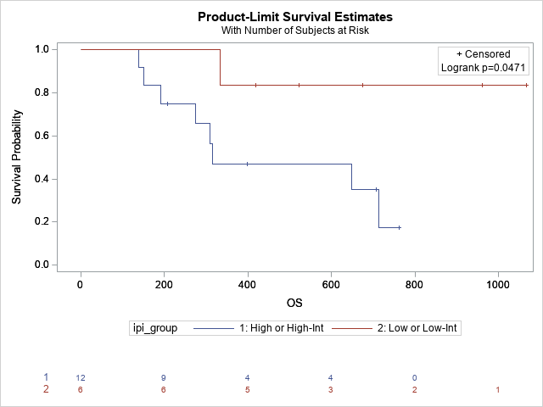

Supplementary Figure 2: Comparison of PFS by IPI—Low or Low-Int vs High or High-Int:
p = 0.1101
IPI = Low or Low-Int: Median PFS = 666 days, 95% CI = (333 days, Not Reached)
IPI = High or High-Int: Median PFS = 269 days, 95% CI = (97 days, 616 days)

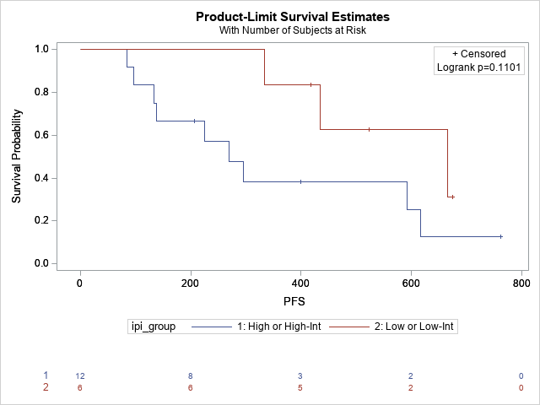

Supplementary Figure 3: Comparison of EFS by IPI—Low or Low-Int vs High or High-Int:
p = 0.1938
IPI = Low or Low-Int: Median EFS = 550 days, 95% CI = (214 days, Not Reached)
IPI = High or High-Int: Median EFS = 282 days, 95% CI = (97 days, 499 days)
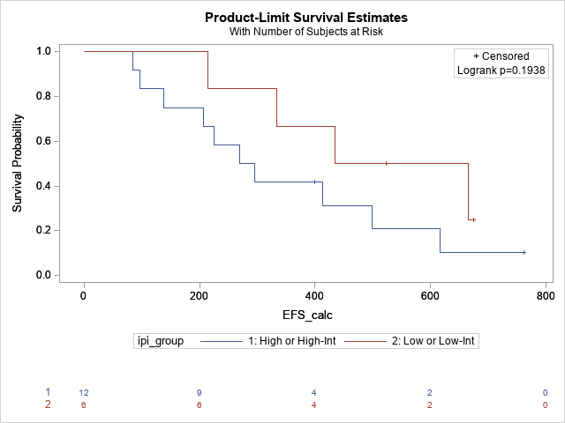

Supplementary Figure 4: Comparison of OS by IPI—Low, Low-Int, High-int vs High:
p = 0.0648
OS = 714 days, 95% CI = (333 days, Not Reached)
IPI = High: Median OS = 309 days, 95% CI = (138 days, 309 days)

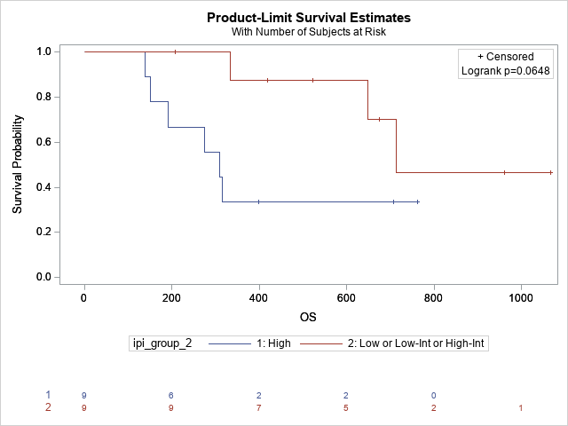

Supplementary Figure 5: Comparison of PFS by IPI—Low, Low-Int, High-int vs High:
p = 0.0515
IPI = Low, Low-Int, High-Int: Median PFS = 616 days, 95% CI = (333 days, Not Reached)
IPI = High: Median PFS = 225 days, 95% CI = (84 days, Not Reached)

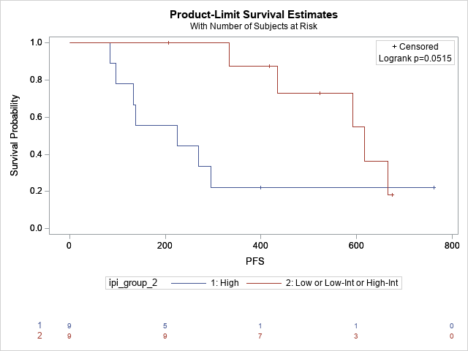

Supplementary Figure 6: Comparison of EFS by IPI—Low, Low-Int, High-int vs High:
p = 0.3217
IPI = Low, Low-Int, High-Int: Median EFS = 434 days, 95% CI = (207 days, 666 days)
IPI = High: Median EFS = 269 days, 95% CI = (84 days, 499 days)

