Online Resource 1: Remote sensing figures of rainfall and deciduousness.

Rainfall Variability and Deciduous-Evergreen Coexistence in Tropical Forests
Authors: Andrew J. Muehleisen^{1,2}, Naomi B. Schwartz³, Simon M. Stump^{1,4}, A. Carla Staver^{1,4}
Affiliations:
¹ Yale School of Forestry and Environmental Studies, New Haven, CT 06511 USA
² Institute of Ecology and Evolution, University of Oregon, Eugene, OR 97403, USA
³ Department of Geography, University of British Columbia, Vancouver, BC V6T 1Z4 Canada
⁴ Department of Ecology and Evolutionary Biology, Yale University, New Haven, CT 06511 USA

Corresponding author: Andrew J. Muehleisen; 272 Onyx Bridge, 5289 University of Oregon, Eugene, OR 97403; amuehlei@uoregon.edu

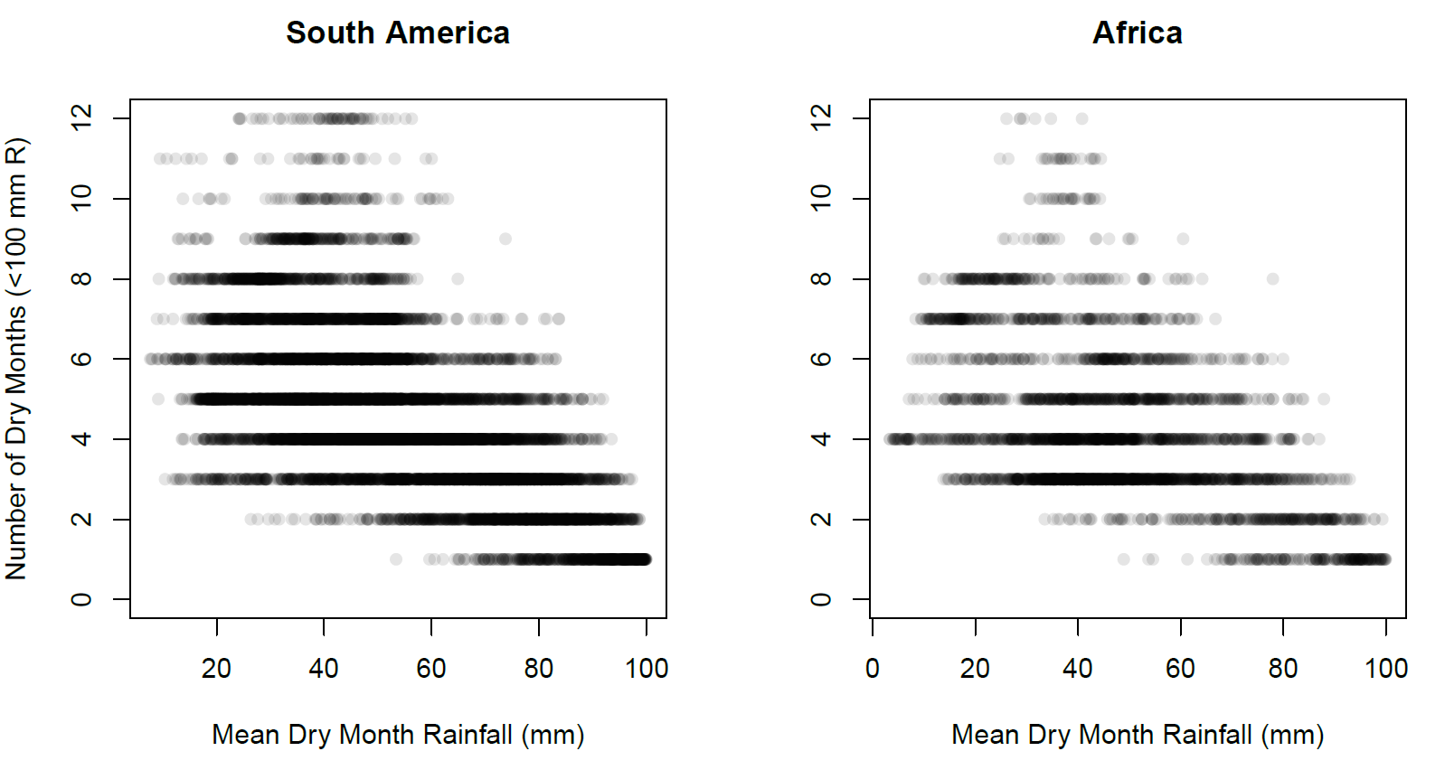
Fig. S1. Number of observed dry months (months with <100 mm rainfall) as a function of average dry month rainfall across our study range in South America and Africa

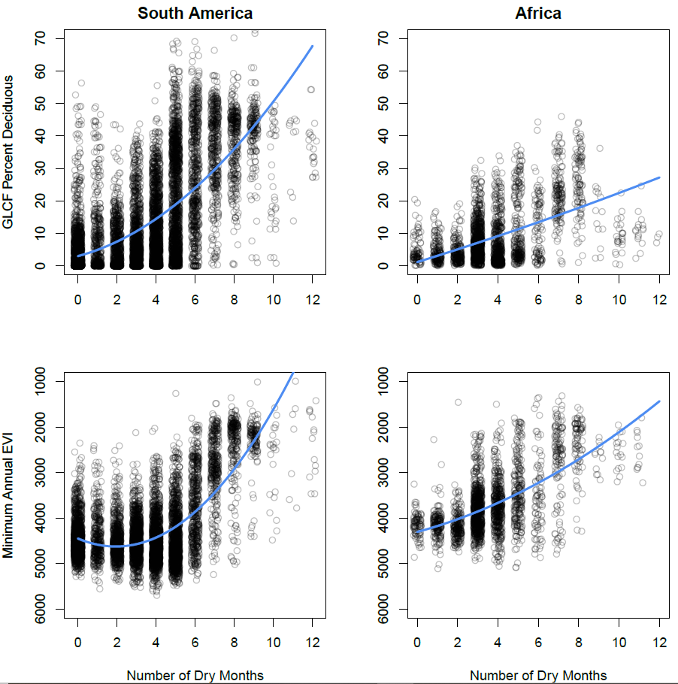
Fig. S2. Relationship between both GLCF-derived deciduousness and minimum annual EVI and the number of observed dry months (months with <100 mm rainfall), across our study range in both South America and Africa. R² values can be found in Tables S1 and S2

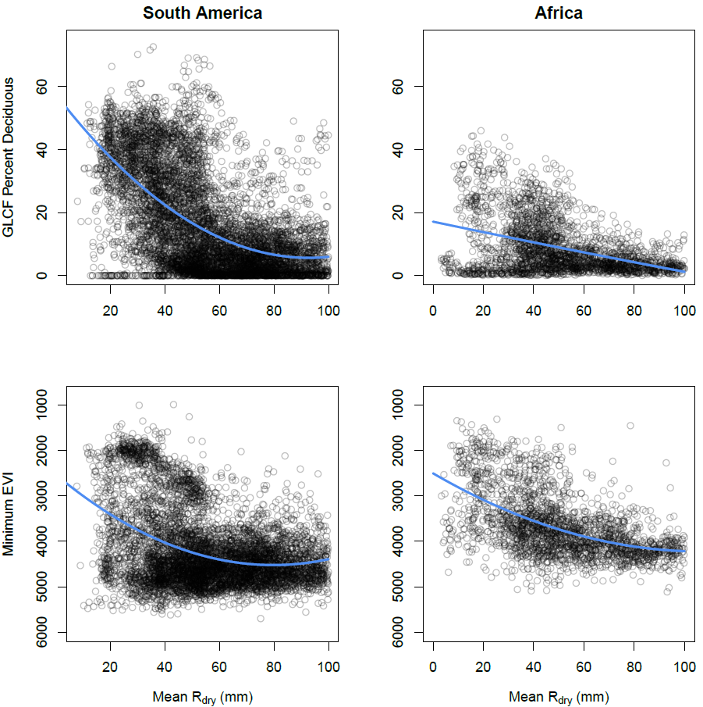
Fig. S3. Relationship between both GLCF-derived deciduousness and minimum annual EVI and the mean dry-month rainfall (mm) across our study range in both South America and Africa. R² values can be found in Tables S1 and S2
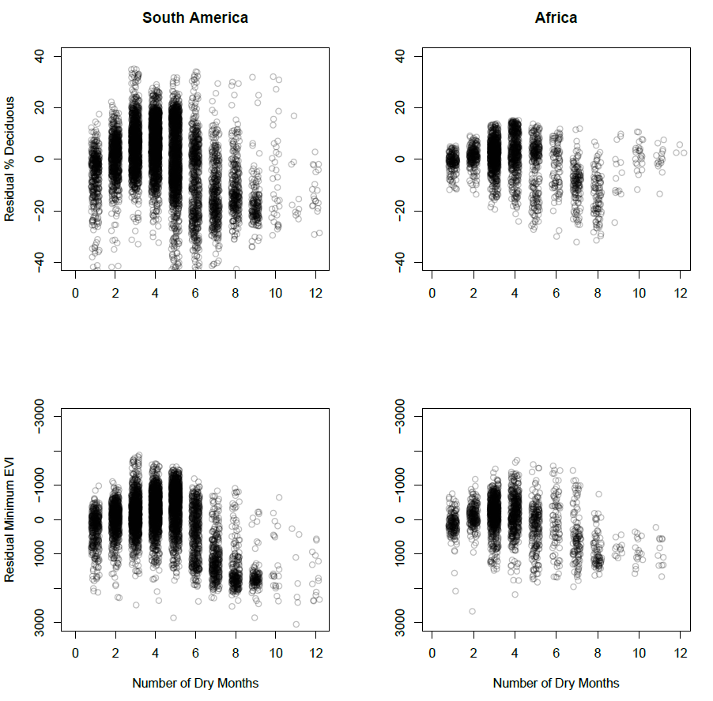
Fig. S4. Relationship between the residuals of the model ‘deciduousness ~ dry month R’ and the number of dry months, representing the interaction between the number of dry months and the average dry-season intensity. A negative relationship indicates that the model is underpredicting deciduousness during longer dry seasons

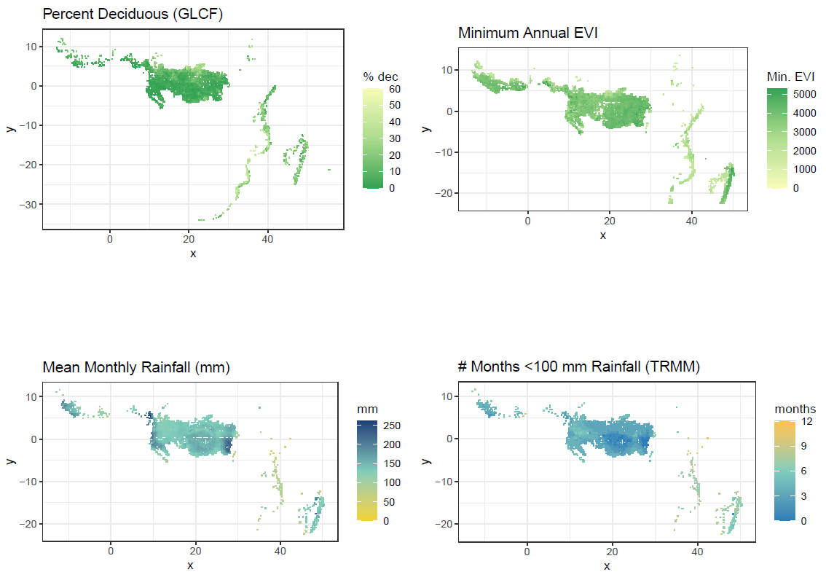
Fig. S5. Map of percent deciduousness (GLCF; Defries et al. 2000), minimum annual EVI (Huete et al. 1999), average monthly rainfall in mm (TRMM; Huffman et al. 2007), and average number of months < 100 mm rainfall (TRMM) across Africa, masked for only tropical dry and broadleaf forest (Olsen et al. 2001), elevation < 1000m (Bamber et al. 1997), and minimal anthropogenic disturbance (Global Land Cover 2003)

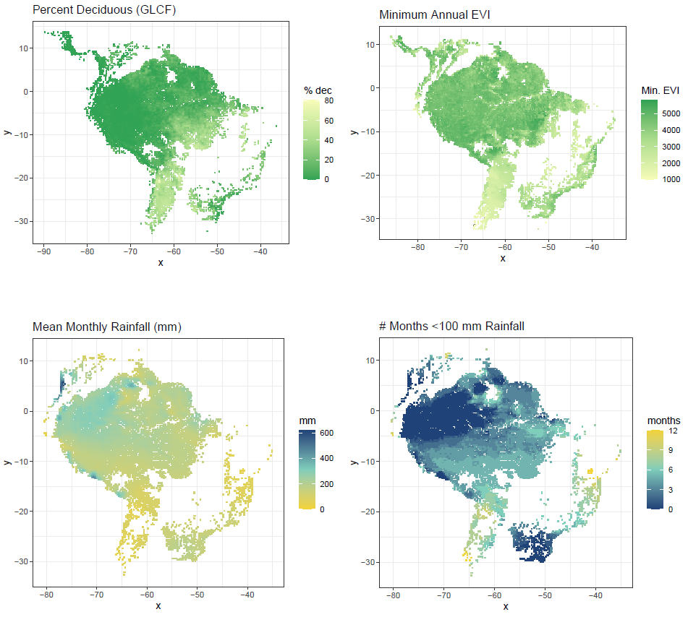
Fig. S6. Map of percent deciduousness (GLCF; Defries et al. 2000), minimum annual EVI (Huete et al. 1999), average monthly rainfall in mm (TRMM; Huffman et al. 2007), and average number of months < 100 mm rainfall (TRMM) across South America, masked for only tropical dry and broadleaf forest (Olsen et al. 2001), elevation < 1000m (Bamber et al. 1997), and minimal anthropogenic disturbance (Global Land Cover 2003)

