Supplementary Information: Novel climates are already widespread below undisturbed tropical moist forest canopies.

Authors: Brittany T. Trew*, David P. Edwards, Alexander C. Lees, David H. Klinges, Regan Early, Martin Svátek, Roman Plichta, Radim Matula, Joseph Okello, Armin Niessner, Matti Barthel, Johan Six, Ilya M.D. Maclean

Supplementary Tables

Table S1.1 | Mean and standard deviation values of novelty across Africa for BIO1 (mean annual temperature), BIO2 (mean diurnal temperature range), BIO3 (isothermality), BIO4 (temperature seasonality), BIO5 (maximum temperature of the warmest month), BIO6 (minimum temperature of the coldest month), and BIO7 (annual temperature range) for different forest classifications: Undisturbed tropical forest where wilderness areas are excluded (n = 59,001), undisturbed tropical forest in wilderness areas only (n = 8,798) and degraded tropical forest only (n = 12,800).

 | Undisturbed - Wilderness |  | Undisturbed |  | Degraded
Variable | Mean | S.D. | Mean | S.D. | Mean | S.D.
BIO1 | 0.61 | 0.09 | 0.60 | 0.12 | 0.57 | 0.14
BIO2 | 0.51 | 0.16 | 0.51 | 0.17 | 0.48 | 0.17
BIO3 | 0.27 | 0.10 | 0.28 | 0.12 | 0.25 | 0.17
BIO4 | 0.38 | 0.19 | 0.40 | 0.18 | 0.38 | 0.16
BIO5 | 0.37 | 0.12 | 0.38 | 0.13 | 0.38 | 0.14
BIO6 | 0.32 | 0.11 | 0.28 | 0.10 | 0.29 | 0.11
BIO7 | 0.28 | 0.10 | 0.30 | 0.12 | 0.31 | 0.12

Table S1.2 | Mean and standard deviation values of novelty across Central and South America for BIO1 (mean annual temperature), BIO2 (mean diurnal temperature range), BIO3 (isothermality), BIO4 (temperature seasonality), BIO5 (maximum temperature of the warmest month), BIO6 (minimum temperature of the coldest month), and BIO7 (annual temperature range) for different forest classifications: Undisturbed tropical forest where wilderness areas are excluded (n = 98,612), undisturbed tropical forest in wilderness areas only (n = 87,271) and degraded tropical forest only (n = 22,119).

 | Undisturbed - Wilderness |  | Undisturbed |  | Degraded
Variable | Mean | S.D. | Mean | S.D. | Mean | S.D.
BIO1 | 0.51 | 0.14 | 0.52 | 0.16 | 0.50 | 0.19
BIO2 | 0.54 | 0.19 | 0.50 | 0.19 | 0.42 | 0.18
BIO3 | 0.27 | 0.12 | 0.26 | 0.10 | 0.26 | 0.10
BIO4 | 0.44 | 0.17 | 0.40 | 0.16 | 0.35 | 0.16
BIO5 | 0.37 | 0.12 | 0.38 | 0.13 | 0.38 | 0.14
BIO6 | 0.32 | 0.11 | 0.28 | 0.10 | 0.29 | 0.11
BIO7 | 0.28 | 0.10 | 0.30 | 0.12 | 0.31 | 0.12

Table S1.3 | Mean and standard deviation values of novelty across Asia & Australia for BIO1 (mean annual temperature), BIO2 (mean diurnal temperature range), BIO3 (isothermality), BIO4 (temperature seasonality), BIO5 (maximum temperature of the warmest month), BIO6 (minimum temperature of the coldest month), and BIO7 (annual temperature range) for different forest classifications: Undisturbed tropical forest where wilderness areas are excluded (n = 50,127), undisturbed tropical forest in wilderness areas only (n = 14,000) and degraded tropical forest only (n = 21,469).

 | Undisturbed - Wilderness |  | Undisturbed |  | Degraded
Variable | Mean | S.D. | Mean | S.D. | Mean | S.D.
BIO1 | 0.56 | 0.13 | 0.48 | 0.14 | 0.47 | 0.13
BIO2 | 0.30 | 0.12 | 0.33 | 0.14 | 0.32 | 0.15
BIO3 | 0.24 | 0.10 | 0.27 | 0.11 | 0.28 | 0.10
BIO4 | 0.32 | 0.12 | 0.33 | 0.13 | 0.31 | 0.14
BIO5 | 0.39 | 0.15 | 0.33 | 0.12 | 0.31 | 0.12
BIO6 | 0.36 | 0.13 | 0.33 | 0.13 | 0.32 | 0.13
BIO7 | 0.26 | 0.10 | 0.28 | 0.11 | 0.27 | 0.11

Table S2.1 | Results of piecewise generalised linear models (GLMs) with a binomial logit between the below-canopy novelty of each temperature variable and the mean change in undisturbed tropical forests in Central and South America. Each point represents one grid cell (n = 185,883).

Variable | Direction of mean change | estimate | std.error | p.value | 2.5% CI | 97.5% CI | deviance
BIO1 | negative | -2.33 | 0.52 | < 0.001 | -3.34 | -1.31 | 40.71
BIO1 | positive | 3.51 | 0.03 | < 0.001 | 3.45 | 3.58 | 5145.83
BIO2 | negative | -2.51 | 0.09 | < 0.001 | -2.68 | -2.35 | 915.14
BIO2 | positive | 2.77 | 0.02 | < 0.001 | 2.73 | 2.82 | 8544.23
BIO3 | negative | -38.21 | 0.88 | < 0.001 | -39.94 | -36.49 | 3017.49
BIO3 | positive | 32.96 | 0.66 | < 0.001 | 31.67 | 34.26 | 2769.82
BIO4 | negative | -0.94 | 0.03 | < 0.001 | -1.00 | -0.88 | 2029.66
BIO4 | positive | 1.80 | 0.02 | < 0.001 | 1.76 | 1.83 | 6544.07
BIO5 | negative | -0.72 | 0.06 | < 0.001 | -0.83 | -0.61 | 431.46
BIO5 | positive | 1.04 | 0.01 | < 0.001 | 1.02 | 1.06 | 8489.92
BIO6 | negative | -0.91 | 0.05 | < 0.001 | -1.02 | -0.81 | 1147.87
BIO6 | positive | 0.60 | 0.02 | < 0.001 | 0.56 | 0.64 | 7852.20
BIO7 | negative | -0.61 | 0.04 | < 0.001 | -0.69 | -0.53 | 758.40
BIO7 | positive | 0.69 | 0.01 | < 0.001 | 0.67 | 0.71 | 7050.58

Table S2.2 | Results of piecewise generalised linear models (GLMs) with a binomial logit between the below-canopy novelty of each temperature variable and the mean change in undisturbed tropical forests in Africa. Each point represents one grid cell (n = 67,799).

Variable | Direction of mean change | estimate | std.error | p.value | 2.5% CI | 97.5% CI | deviance
BIO1 | negative | -1.48 | 0.73 | < 0.05 | -2.93 | -0.05 | 18.89
BIO1 | positive | 2.72 | 0.06 | < 0.001 | 2.61 | 2.84 | 1535.22
BIO2 | negative | -1.50 | 0.12 | < 0.001 | -1.74 | -1.27 | 362.12
BIO2 | positive | 2.72 | 0.05 | < 0.001 | 2.62 | 2.83 | 2874.88
BIO3 | negative | -34.35 | 1.61 | < 0.001 | -37.52 | -31.21 | 839.89
BIO3 | positive | 39.40 | 1.06 | < 0.001 | 37.33 | 41.47 | 1415.03
BIO4 | negative | -1.19 | 0.05 | < 0.001 | -1.29 | -1.09 | 545.71
BIO4 | positive | 2.74 | 0.04 | < 0.001 | 2.66 | 2.82 | 2582.87
BIO5 | negative | -0.56 | 0.06 | < 0.001 | -0.69 | -0.44 | 169.84
BIO5 | positive | 0.92 | 0.02 | < 0.001 | 0.88 | 0.97 | 2355.72
BIO6 | negative | -0.70 | 0.07 | < 0.001 | -0.84 | -0.56 | 1061.80
BIO6 | positive | 0.74 | 0.02 | < 0.001 | 0.70 | 0.78 | 1732.37
BIO7 | negative | -0.61 | 0.03 | < 0.001 | -0.67 | -0.55 | 335.59
BIO7 | positive | 0.84 | 0.02 | < 0.001 | 0.79 | 0.88 | 2090.32

Table S2.3 | Results of piecewise generalised linear models (GLMs) with a binomial logit between the below-canopy novelty of each temperature variable and the mean change in undisturbed tropical forests in Southeast Asia and Australia. Each point represents one grid cell (n = 64,127).

Variable | Direction of mean change | estimate | std.error | p.value | 2.5% CI | 97.5% CI | deviance
BIO1 | negative | -1.77 | 0.33 | < 0.001 | -2.43 | -1.13 | 56.27
BIO1 | positive | 2.70 | 0.06 | < 0.001 | 2.59 | 2.81 | 2274.81
BIO2 | negative | -1.75 | 0.06 | < 0.001 | -1.86 | -1.64 | 1668.68
BIO2 | positive | 2.13 | 0.06 | < 0.001 | 2.01 | 2.26 | 1003.71
BIO3 | negative | -35.91 | 1.75 | < 0.001 | -39.33 | -32.48 | 795.98
BIO3 | positive | 31.66 | 1.18 | < 0.001 | 29.35 | 33.97 | 1166.13
BIO4 | negative | 0.00 | 0.00 | 0.27 | 0.00 | 0.00 | 3275.63
BIO4 | positive | 0.00 | 0.00 | < 0.05 | 0.00 | 0.00 | 618.53
BIO5 | negative | -0.31 | 0.02 | < 0.001 | -0.35 | -0.26 | 665.50
BIO5 | positive | 0.53 | 0.03 | < 0.001 | 0.48 | 0.58 | 3005.13
BIO6 | negative | -0.52 | 0.11 | < 0.001 | -0.73 | -0.30 | 170.61
BIO6 | positive | 0.90 | 0.03 | < 0.001 | 0.85 | 0.96 | 2556.01
BIO7 | negative | -0.40 | 0.02 | < 0.001 | -0.43 | -0.37 | 1494.07
BIO7 | positive | 0.30 | 0.03 | < 0.001 | 0.24 | 0.36 | 831.55

Table S3 | Percentage of tropical forest grid cells with low (0 to 0.2) to high (0.81 to 1) recent fractional novelty across all modeled climate variables; classified by continental group: CSA (Central & South America), AFR (Africa), SEAA (Southeast Asia & Australia).

0-0.2 | 0.21-0.4 | 0.41-0.6 | 0.61-0.8 | 0.81-1.0 | Group | Variable
3 | 21 | 49 | 24 | 3 | CSA | BIO1
1 | 8 | 35 | 56 | 0 | AFR | BIO1
2 | 26 | 48 | 24 | 0 | SEAA | BIO1
7 | 28 | 33 | 27 | 4 | CSA | BIO2
4 | 28 | 40 | 28 | 0 | AFR | BIO2
23 | 58 | 16 | 3 | 0 | SEAA | BIO2
42 | 50 | 8 | 0 | 0 | CSA | BIO3
40 | 51 | 9 | 1 | 0 | AFR | BIO3
41 | 52 | 6 | 0 | 0 | SEAA | BIO3
13 | 45 | 30 | 12 | 1 | CSA | BIO4
17 | 38 | 30 | 15 | 0 | AFR | BIO4
22 | 59 | 18 | 1 | 0 | SEAA | BIO4
8 | 35 | 33 | 21 | 2 | CSA | BIO5
8 | 49 | 40 | 3 | 0 | AFR | BIO5
17 | 57 | 24 | 2 | 0 | SEAA | BIO5
34 | 56 | 10 | 0 | 0 | CSA | BIO6
32 | 57 | 11 | 1 | 0 | AFR | BIO6
18 | 59 | 22 | 1 | 0 | SEAA | BIO6
28 | 56 | 15 | 1 | 0 | CSA | BIO7
22 | 60 | 17 | 1 | 0 | AFR | BIO7
36 | 57 | 7 | 1 | 0 | SEAA | BIO7

Table S4 | Results of validation of modeled microclimate temperatures against 47 temperature logger observations at 0.1m whereby both the hourly modeled microclimate temperatures and the ERA5 hourly temperatures were tested against the temperature logger observations using RMSE (root mean square error) and RMSD (root mean square deviation) to quantify similarity. For both RMSE and RMSD, the closer the value to zero, the more similar the two datasets are. Logger latitude and longitude are rounded to the nearest three decimals and therefore are overlapping.

 |  |  | RMSE |  | RMSD
Latitude | Longitude | Year | Microclimate Model | ERA5 | Microclimate Model | ERA5
0.374 | 29.932 | 2018 | 2.30 | 9.15 | 3.99 | 15.85
0.374 | 29.932 | 2018 | 2.43 | 10.73 | 4.20 | 18.58
0.462 | 30.374 | 2018 | 3.35 | 3.45 | 5.80 | 5.97
0.462 | 30.374 | 2018 | 3.34 | 3.51 | 5.78 | 6.08
0.451 | 30.387 | 2018 | 3.81 | 4.04 | 6.60 | 6.99
0.451 | 30.387 | 2018 | 3.18 | 4.45 | 5.51 | 7.70
0.450 | 30.388 | 2018 | 4.31 | 4.88 | 7.47 | 8.44
-2.313 | 28.755 | 2017 | 3.22 | 5.81 | 5.58 | 10.06
0.811 | 24.490 | 2016 | 5.48 | 8.04 | 9.50 | 13.92
0.293 | 25.301 | 2017 | 2.19 | 4.58 | 3.79 | 7.93
-4.103 | -79.183 | 2006 | 7.50 | 9.50 | 12.98 | 16.46
-4.103 | -79.183 | 2006 | 7.25 | 9.47 | 12.55 | 16.41
-4.103 | -79.183 | 2006 | 7.26 | 9.52 | 12.58 | 16.48
4.695 | 117.582 | 2019 | 1.25 | 2.86 | 2.17 | 4.96
4.736 | 117.618 | 2019 | 1.29 | 3.09 | 2.24 | 5.35
4.729 | 117.621 | 2019 | 2.68 | 2.07 | 4.65 | 3.58
4.730 | 117.620 | 2019 | 1.92 | 3.28 | 3.32 | 5.67
4.689 | 117.584 | 2019 | 1.72 | 3.09 | 2.98 | 5.35
4.730 | 117.618 | 2019 | 1.58 | 3.08 | 2.74 | 5.33
4.733 | 117.619 | 2019 | 2.10 | 3.32 | 3.64 | 5.76
4.728 | 117.625 | 2019 | 2.05 | 3.32 | 3.56 | 5.76
4.664 | 117.540 | 2019 | 2.13 | 3.30 | 3.69 | 5.72
4.693 | 117.580 | 2019 | 2.19 | 3.33 | 3.79 | 5.76
4.684 | 117.540 | 2019 | 2.59 | 3.75 | 4.48 | 6.50
4.680 | 117.540 | 2019 | 2.07 | 3.46 | 3.58 | 6.00
4.728 | 117.623 | 2019 | 2.30 | 3.39 | 3.98 | 5.88
4.742 | 117.589 | 2019 | 2.28 | 3.63 | 3.94 | 6.29
4.698 | 117.582 | 2019 | 2.43 | 3.50 | 4.21 | 6.07
4.685 | 117.540 | 2019 | 2.06 | 3.49 | 3.57 | 6.05
4.737 | 117.618 | 2019 | 2.00 | 3.59 | 3.47 | 6.23
4.682 | 117.540 | 2019 | 2.40 | 3.66 | 4.16 | 6.35
4.692 | 117.578 | 2019 | 2.42 | 3.36 | 4.20 | 5.81
4.694 | 117.581 | 2019 | 1.06 | 2.92 | 1.84 | 5.05
4.724 | 117.597 | 2019 | 2.82 | 3.75 | 4.88 | 6.50
4.743 | 117.588 | 2019 | 2.17 | 3.64 | 3.76 | 6.31
4.727 | 117.613 | 2019 | 2.34 | 3.37 | 4.05 | 5.84
4.729 | 117.617 | 2019 | 2.48 | 3.52 | 4.29 | 6.09
4.691 | 117.582 | 2019 | 2.52 | 3.46 | 4.36 | 5.99
4.728 | 117.614 | 2019 | 2.13 | 3.30 | 3.69 | 5.72
4.699 | 117.583 | 2019 | 2.11 | 3.46 | 3.65 | 5.99
4.692 | 117.581 | 2019 | 1.61 | 2.92 | 2.79 | 5.05
4.732 | 117.619 | 2019 | 2.22 | 3.45 | 3.85 | 5.97
4.728 | 117.596 | 2019 | 2.17 | 3.55 | 3.75 | 6.15
4.691 | 117.576 | 2019 | 2.25 | 3.42 | 3.90 | 5.92
4.726 | 117.597 | 2019 | 2.61 | 3.69 | 4.53 | 6.38
-9.425 | -74.734 | 2014 | 4.79 | 9.24 | 8.30 | 16.00
-9.470 | -74.773 | 2015 | 3.28 | 4.69 | 5.68 | 8.13

Table S5 | Number of years in the recent period (2005 to 2019) where temperature variables were greater than the maximum value of all years in the historic baseline period (1990 to 2004).

Temperature Variable | Number of years | Greatest increase (ºC) | Continental Group
BIO1 | 6 | 0.4 | Africa
BIO1 | 4 | 0.25 | Central & South America
BIO1 | 0 | 0.00 | Southeast Asia & Australia
BIO2 | 11 | 0.30 | Africa
BIO2 | 15 | 0.32 | Central & South America
BIO2 | 0 | 0.00 | Southeast Asia & Australia
BIO4 | 2 | 0.10 | Africa
BIO4 | 8 | 0.32 | Central & South America
BIO4 | 2 | 1.00 | Southeast Asia & Australia

Supplementary Figures

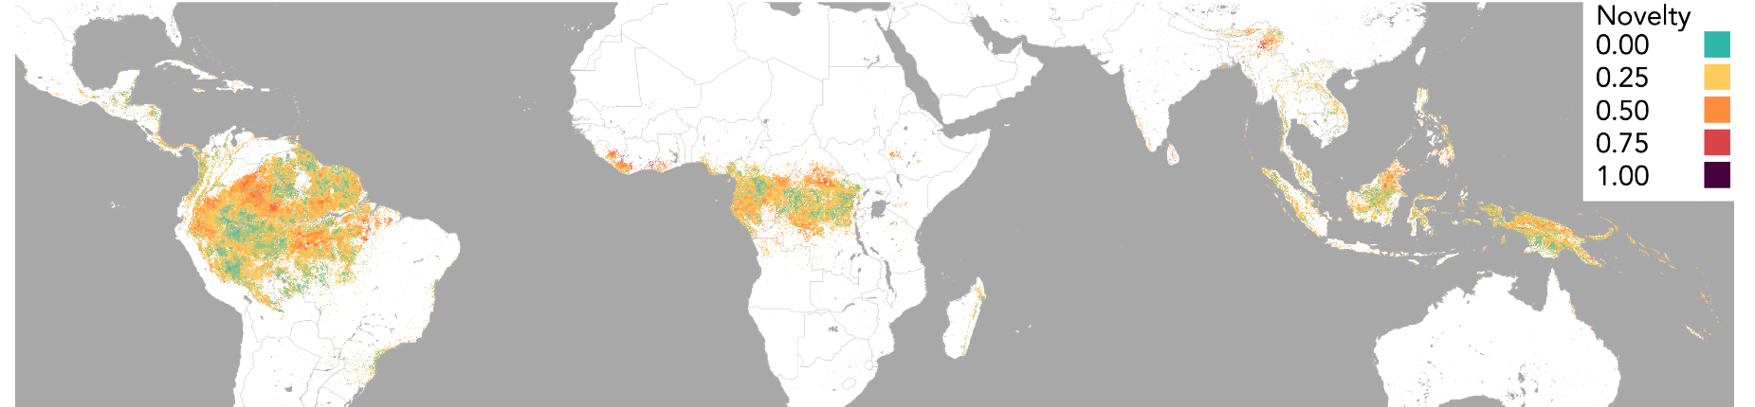Figure S1.1 | Below-canopy climate novelty across global undisturbed tropical forests for isothermality.

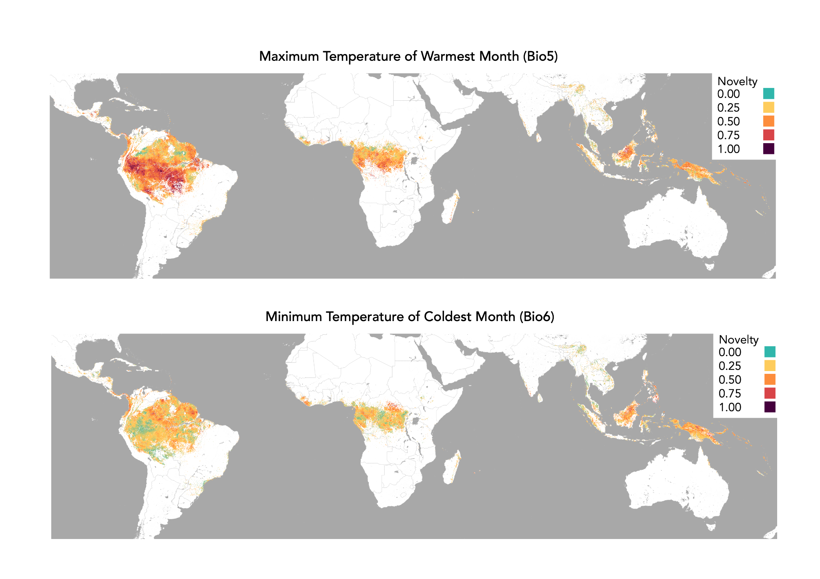Figure S1.2 | Below-canopy climate novelty across global undisturbed tropical forests for maximum temperature of the warmest month.
Figure S1.3 | Below-canopy climate novelty across global undisturbed tropical forests for minimum temperature of the coldest month.

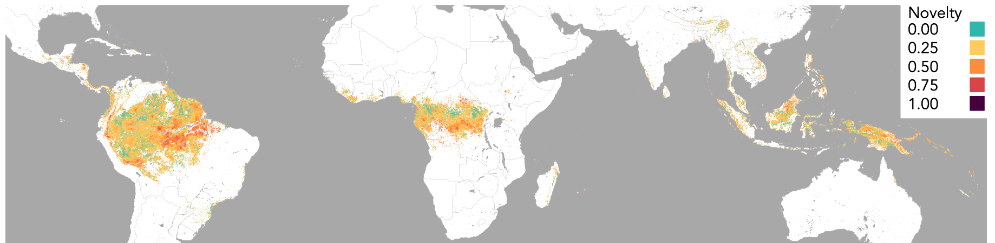
Figure S1.4 | Below-canopy climate novelty across global undisturbed tropical forests for temperature annual range.

A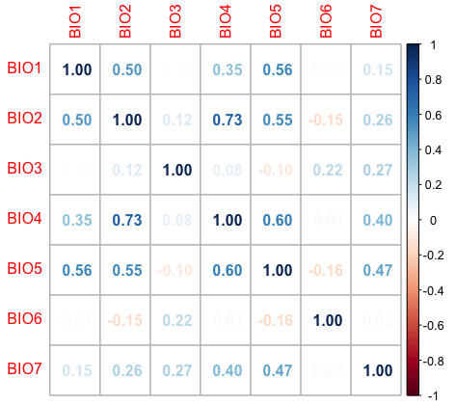 B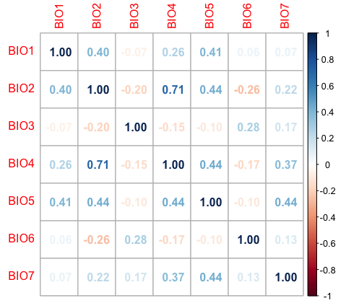 C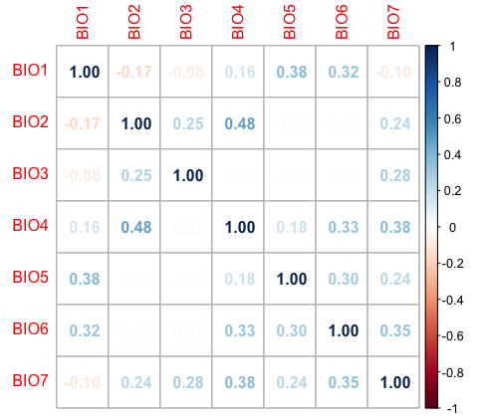

Figure S2.1 | Spearman’s correlation coefficient for novelty scores of all temperature variables (full list in methods) for continental groups: (a) South and Central America, (b) Africa, (c) SE Asia and Australia.

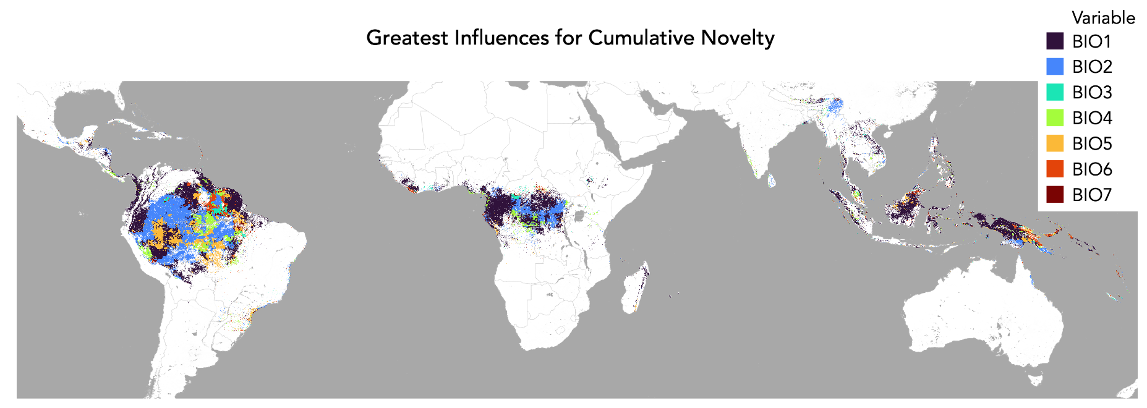
Figure S3.1 | Undisturbed tropical forest locations showing which temperature variable (n = 7) had the greatest influence on the index of cumulative novelty in temperature. Temperature variables include: BIO1 – mean annual temperature, BIO2 – mean diurnal temperature range, BIO3 – isothermality, BIO4 – temperature seasonality, BIO5 – maximum temperature of the warmest month, BIO6 – minimum temperature of the coldest month, BIO7 – annual temperature range.

A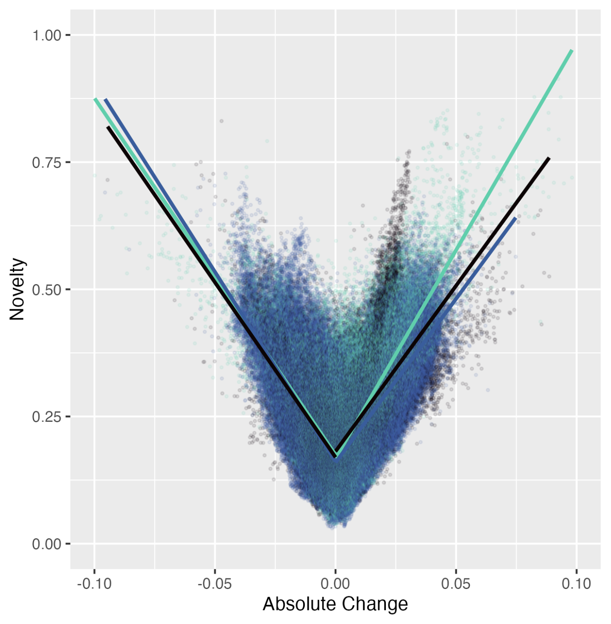 B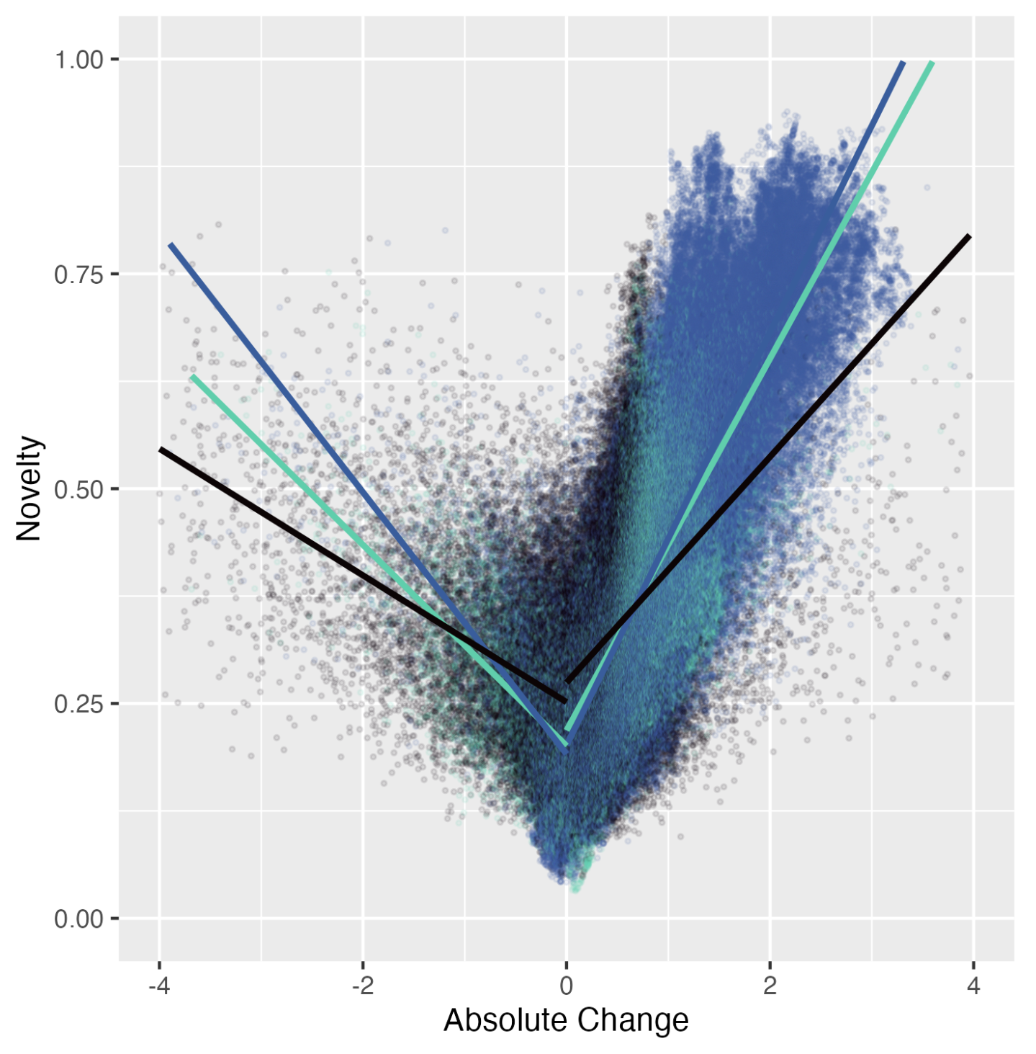
C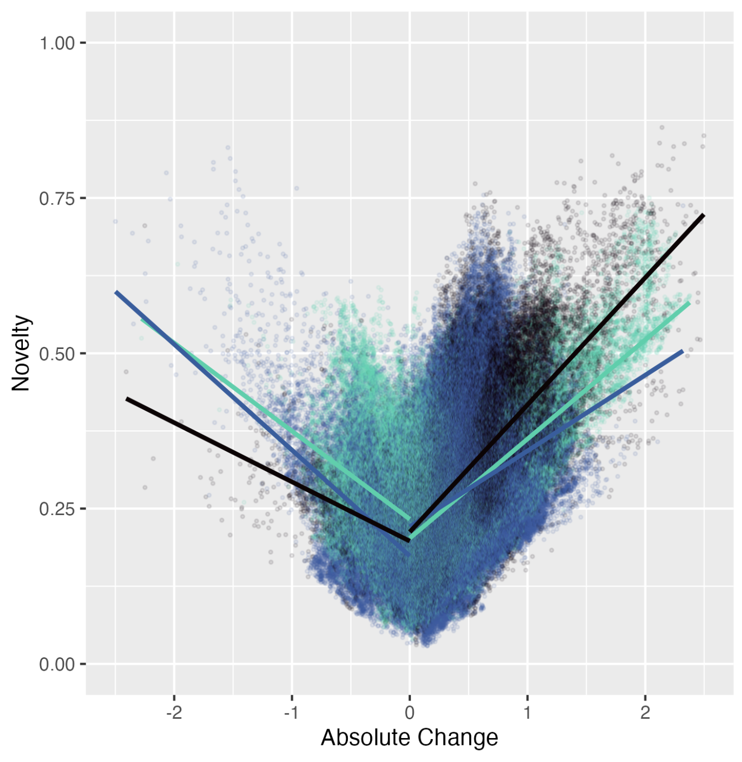 D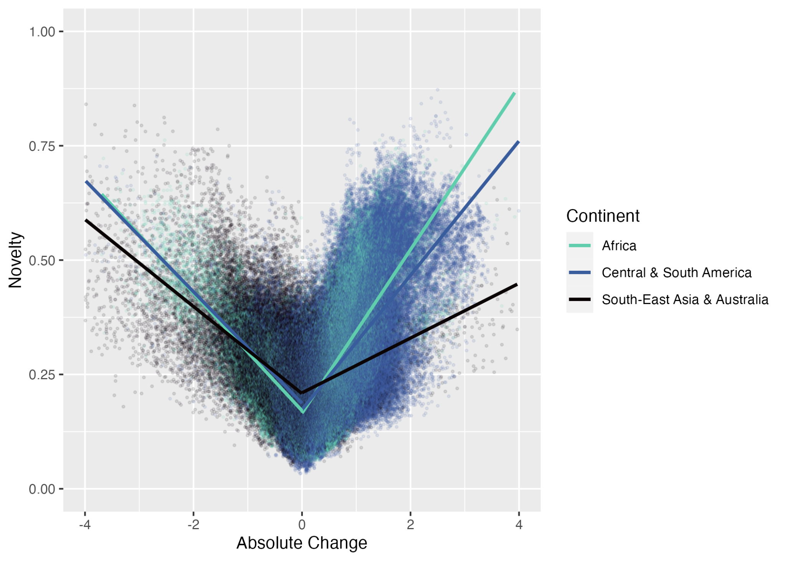

Figure S4.1 | Scatterplots showing the correlation (as investigated using piecewise generalised linear models with a binomial logit; GLMs) between the below-canopy novelty of each temperature variable and the mean change in undisturbed tropical forests (n = 317,809) for (A) isothermality, (B) maximum temperature of the warmest month, (C) minimum temperature of the coldest month, and (D) annual range of temperature. Each point represents one grid cell for Africa (n = 67,799), Central and South America (n = 185,883), and Asia and Australia (n = 64,127). Please see Supplementary Table S2 for model results for each group.

A 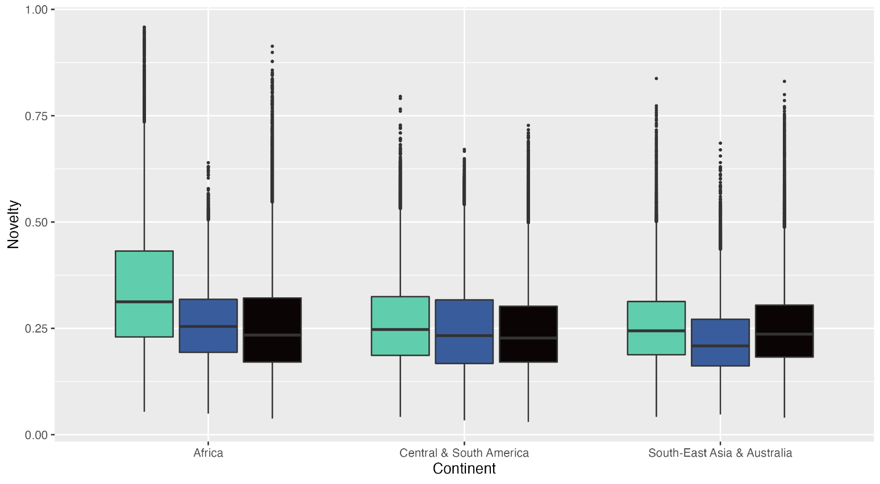 B 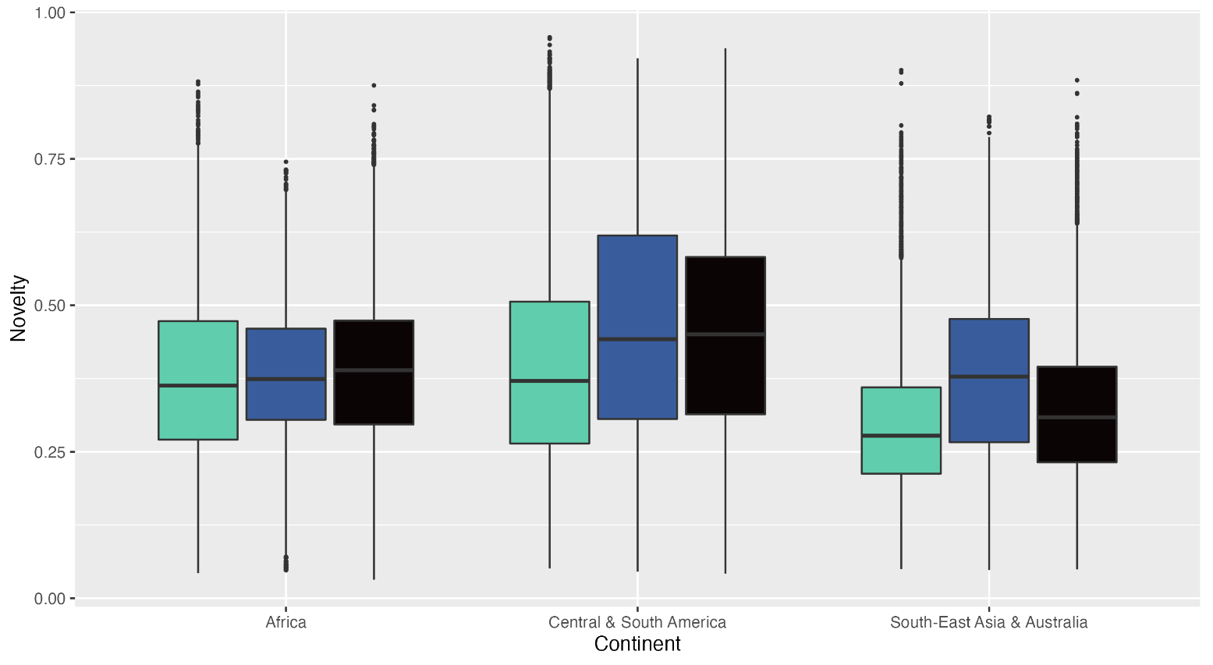
C 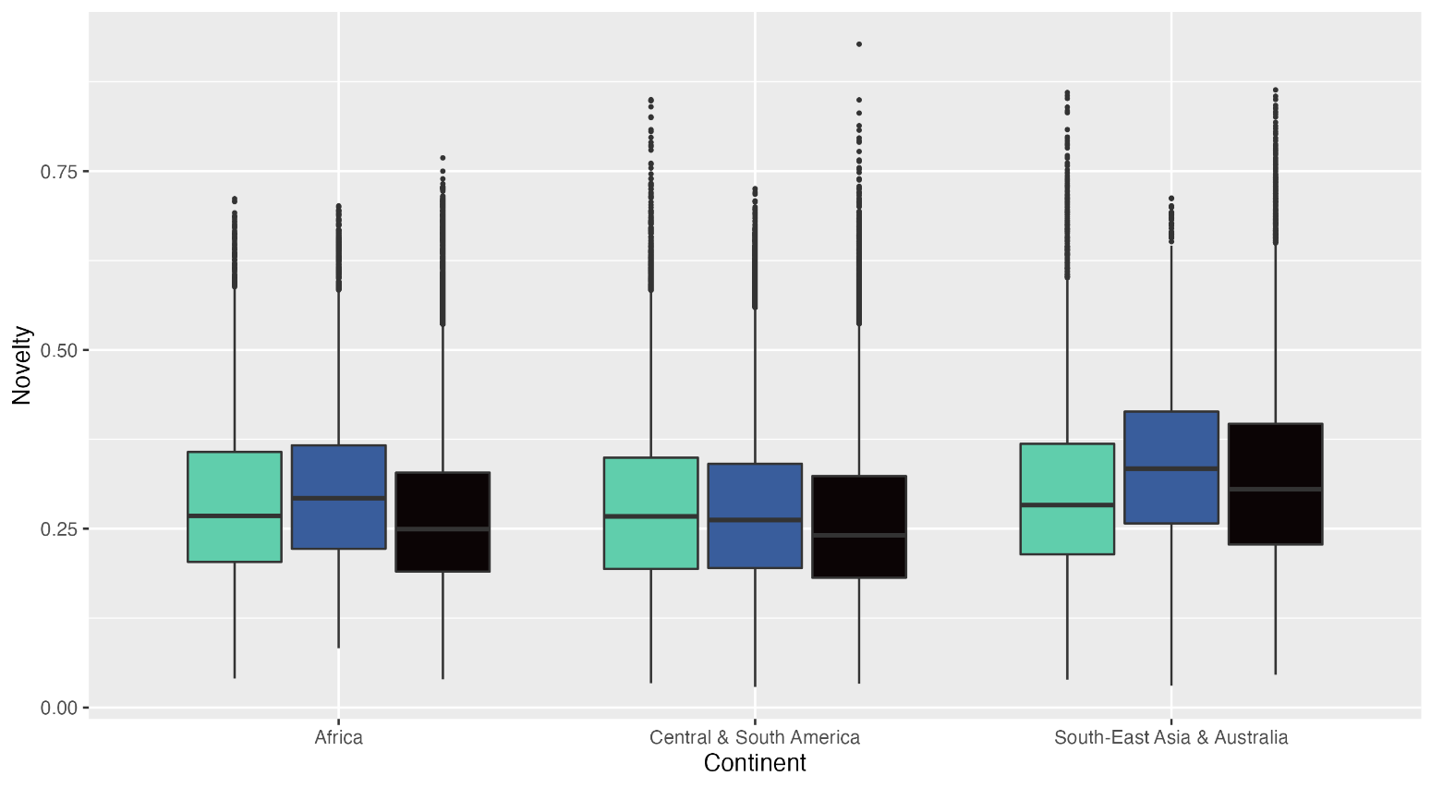 D 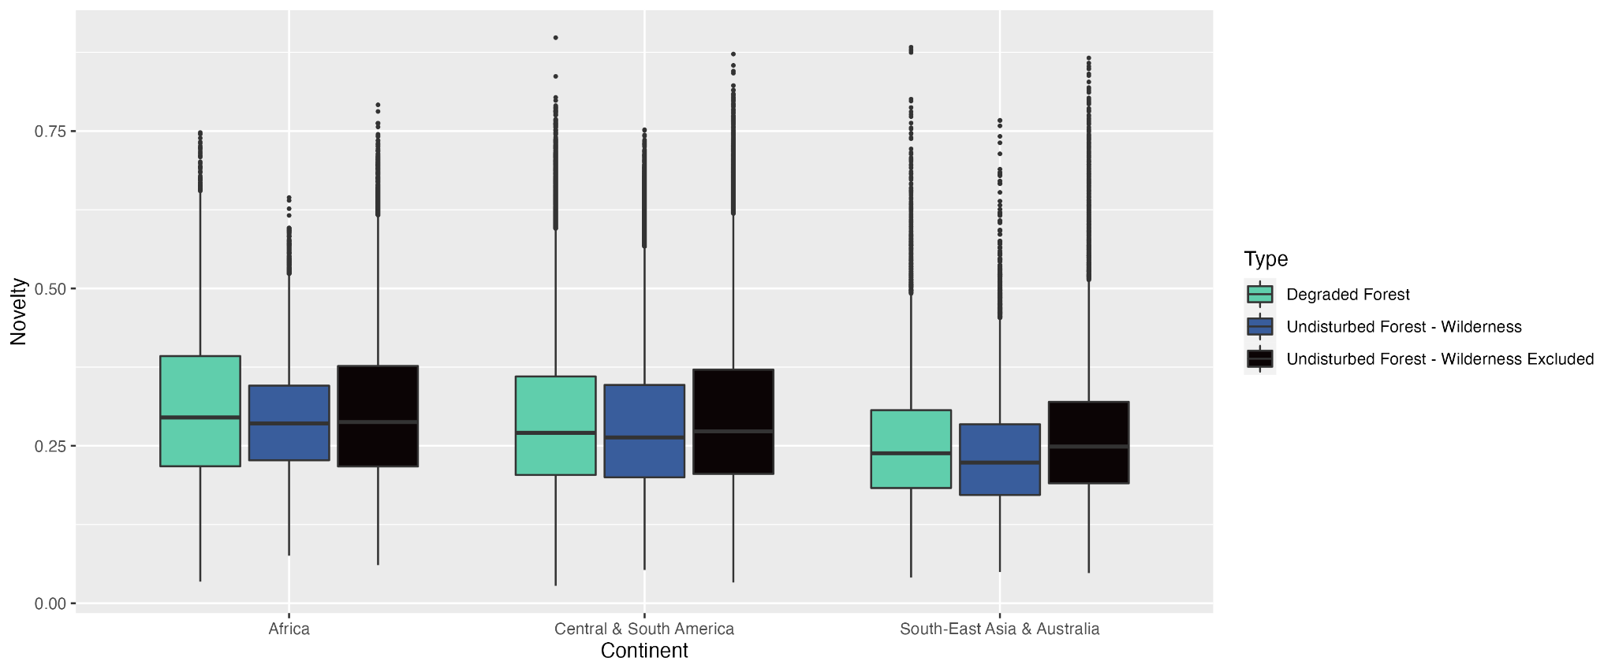

Figure S5 | Box plot of the distribution of climate novelty scores in tropical forest across Africa (AFR), Central and South America (CSA), and Southeast Asia and Australia (SEAA) for: (A) isothermality, (B) maximum temperature of the warmest month, (C) minimum temperature of the coldest month, and (D) annual range of temperature. Climate novelty values are separated into three distinct forest classifications: undisturbed tropical forest outside ecologically unfragmented areas (defined by wilderness areas, sensu Watson et al. 2016), undisturbed tropical forest within ecologically unfragmented areas, and degraded tropical forest only. Please see Supplementary Table S1 for group sample sizes and statistical parameters.
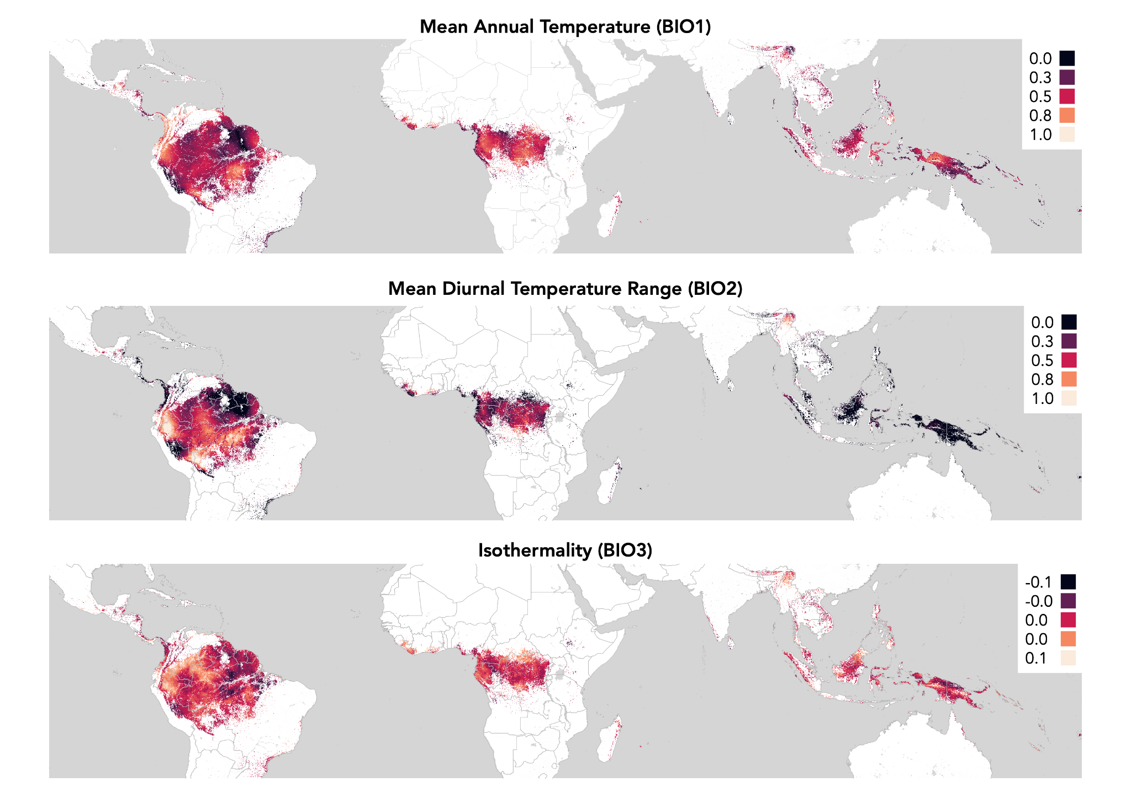Figure S6.1 | Mean overall change in mean annual temperature across global undisturbed tropical forests. Change is defined as the difference between the mean of the temperature variable for 1990-2004 and the mean for 2005-2019.

Figure S6.2 | Mean overall change in mean diurnal temperature range across global undisturbed tropical forests. Change is defined as the difference between the mean of the temperature variable for 1990-2004 and the mean for 2005-2019.

Figure S6.3 | Mean overall change in isothermality across global undisturbed tropical forests. Change is defined as the difference between the mean of the temperature variable for 1990-2004 and the mean for 2005-2019.

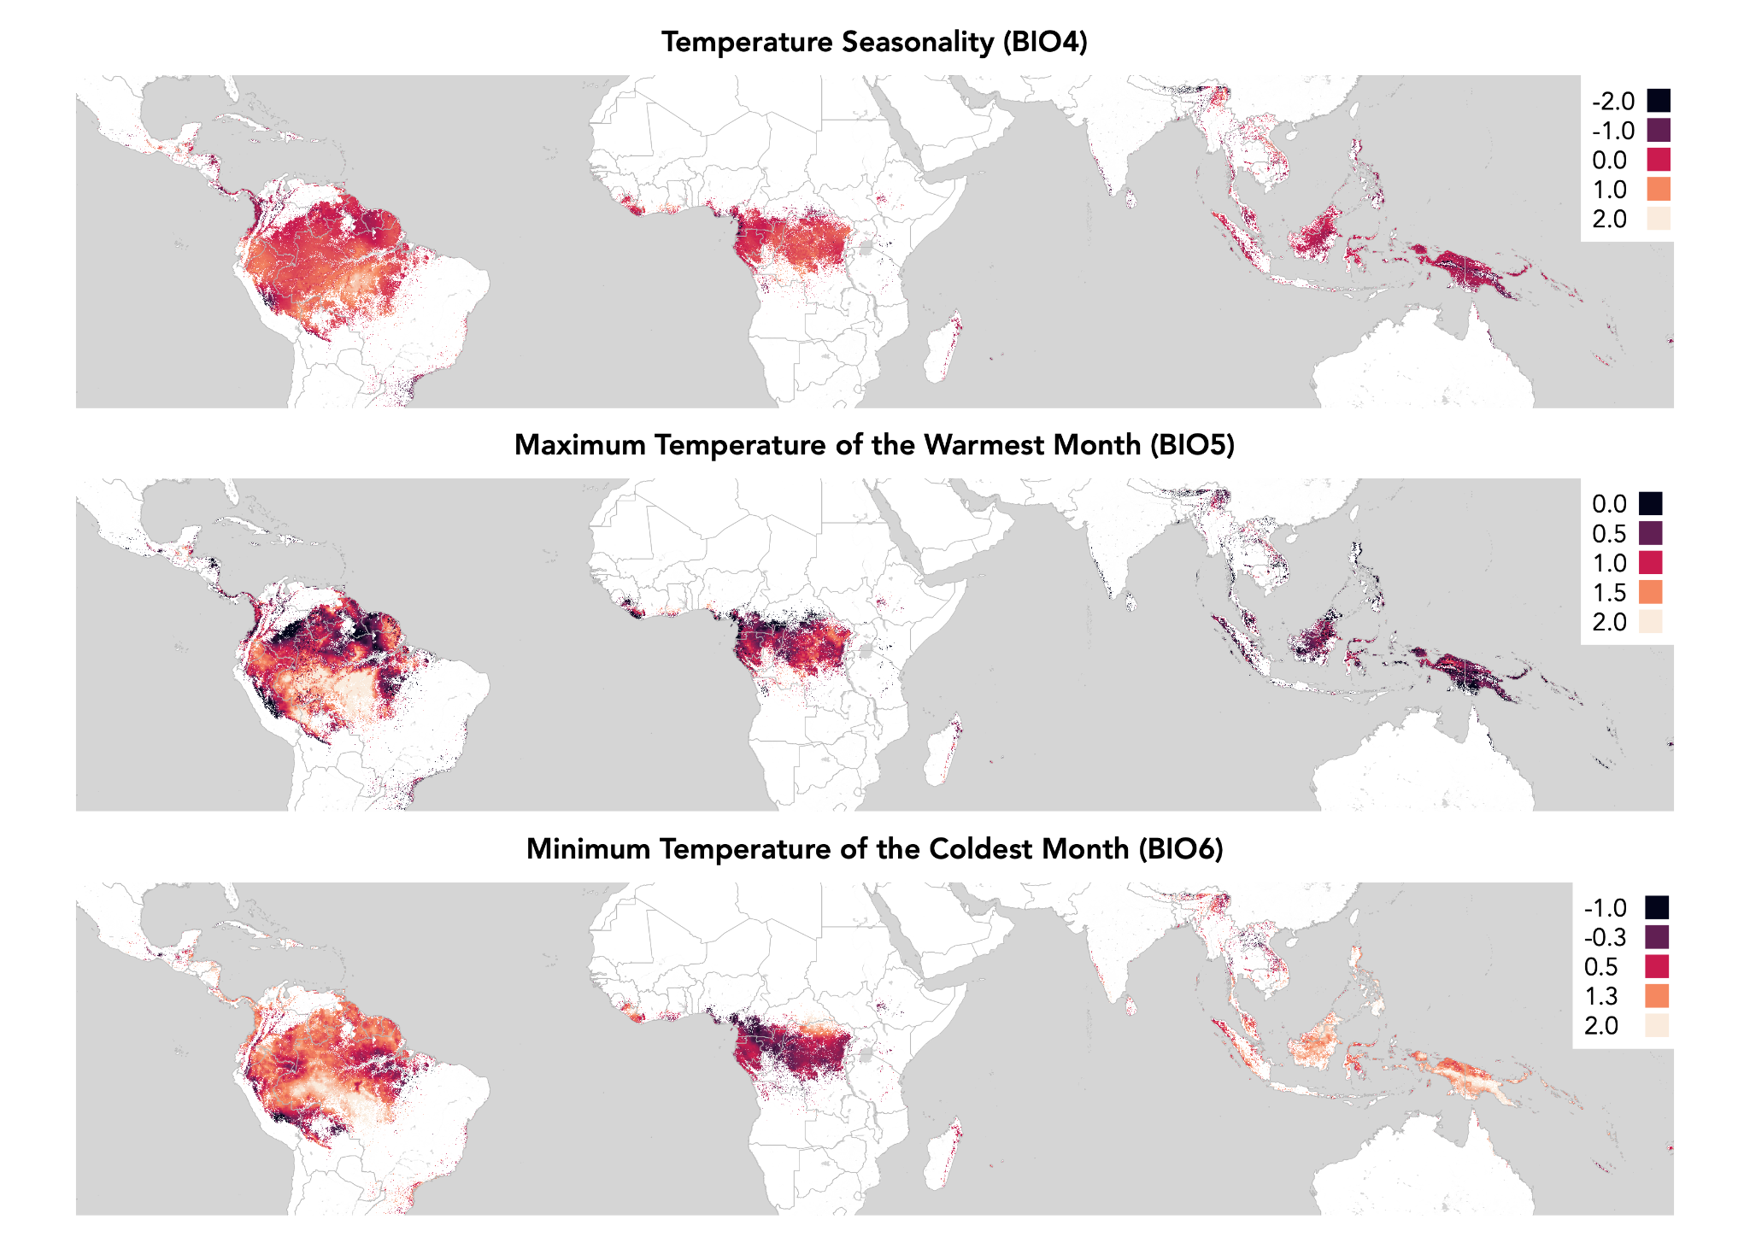
Figure S6.4 | Mean overall change in temperature seasonality across global undisturbed tropical forests. Change is defined as the difference between the mean of the temperature variable for 1990-2004 and the mean for 2005-2019.

Figure S6.5 | Mean overall change in maximum temperature of the warmest month across global undisturbed tropical forests. Change is defined as the difference between the mean of the temperature variable for 1990-2004 and the mean for 2005-2019.

Figure S6.6 | Mean overall change in minimum temperature of the coldest month across global undisturbed tropical forests. Change is defined as the difference between the mean of the temperature variable for 1990-2004 and the mean for 2005-2019.

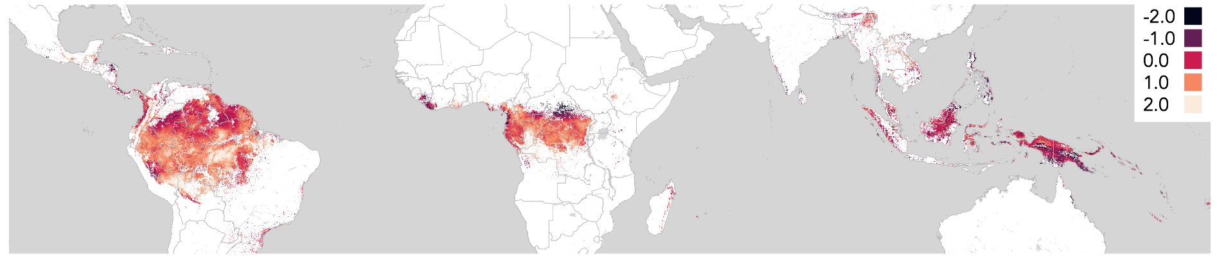
Figure S6.5 | Mean overall change in the annual range of temperature across global undisturbed tropical forests. Change is defined as the difference between the mean of the temperature variable for 1990-2004 and the mean for 2005-2019.

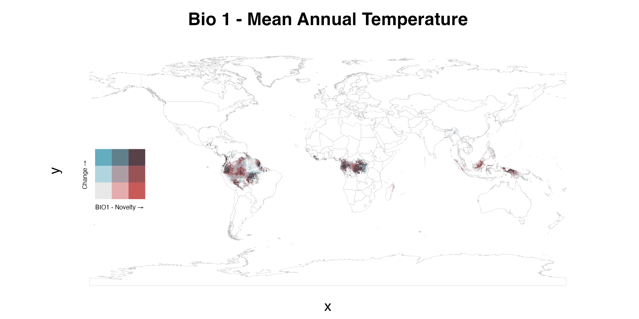

Figure S7.1 | Bivariate maps across undisturbed tropical forests of the spatial relationship between mean overall change in mean annual temperature and the recent novelty of mean annual temperature. Change is defined as the difference between the mean of the temperature variable for 1990-2004 and the mean for 2005-2019.

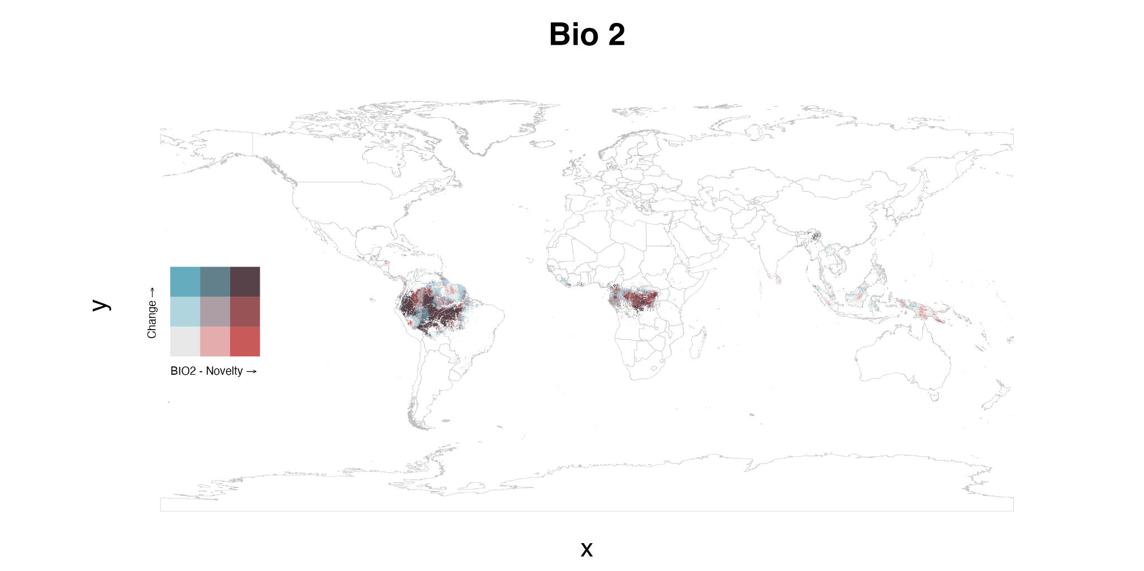

Figure S7.2 | Bivariate maps across undisturbed tropical forests of the spatial relationship between mean overall change in mean diurnal temperature range and the recent novelty of mean diurnal temperature range. Change is defined as the difference between the mean of the temperature variable for 1990-2004 and the mean for 2005-2019.

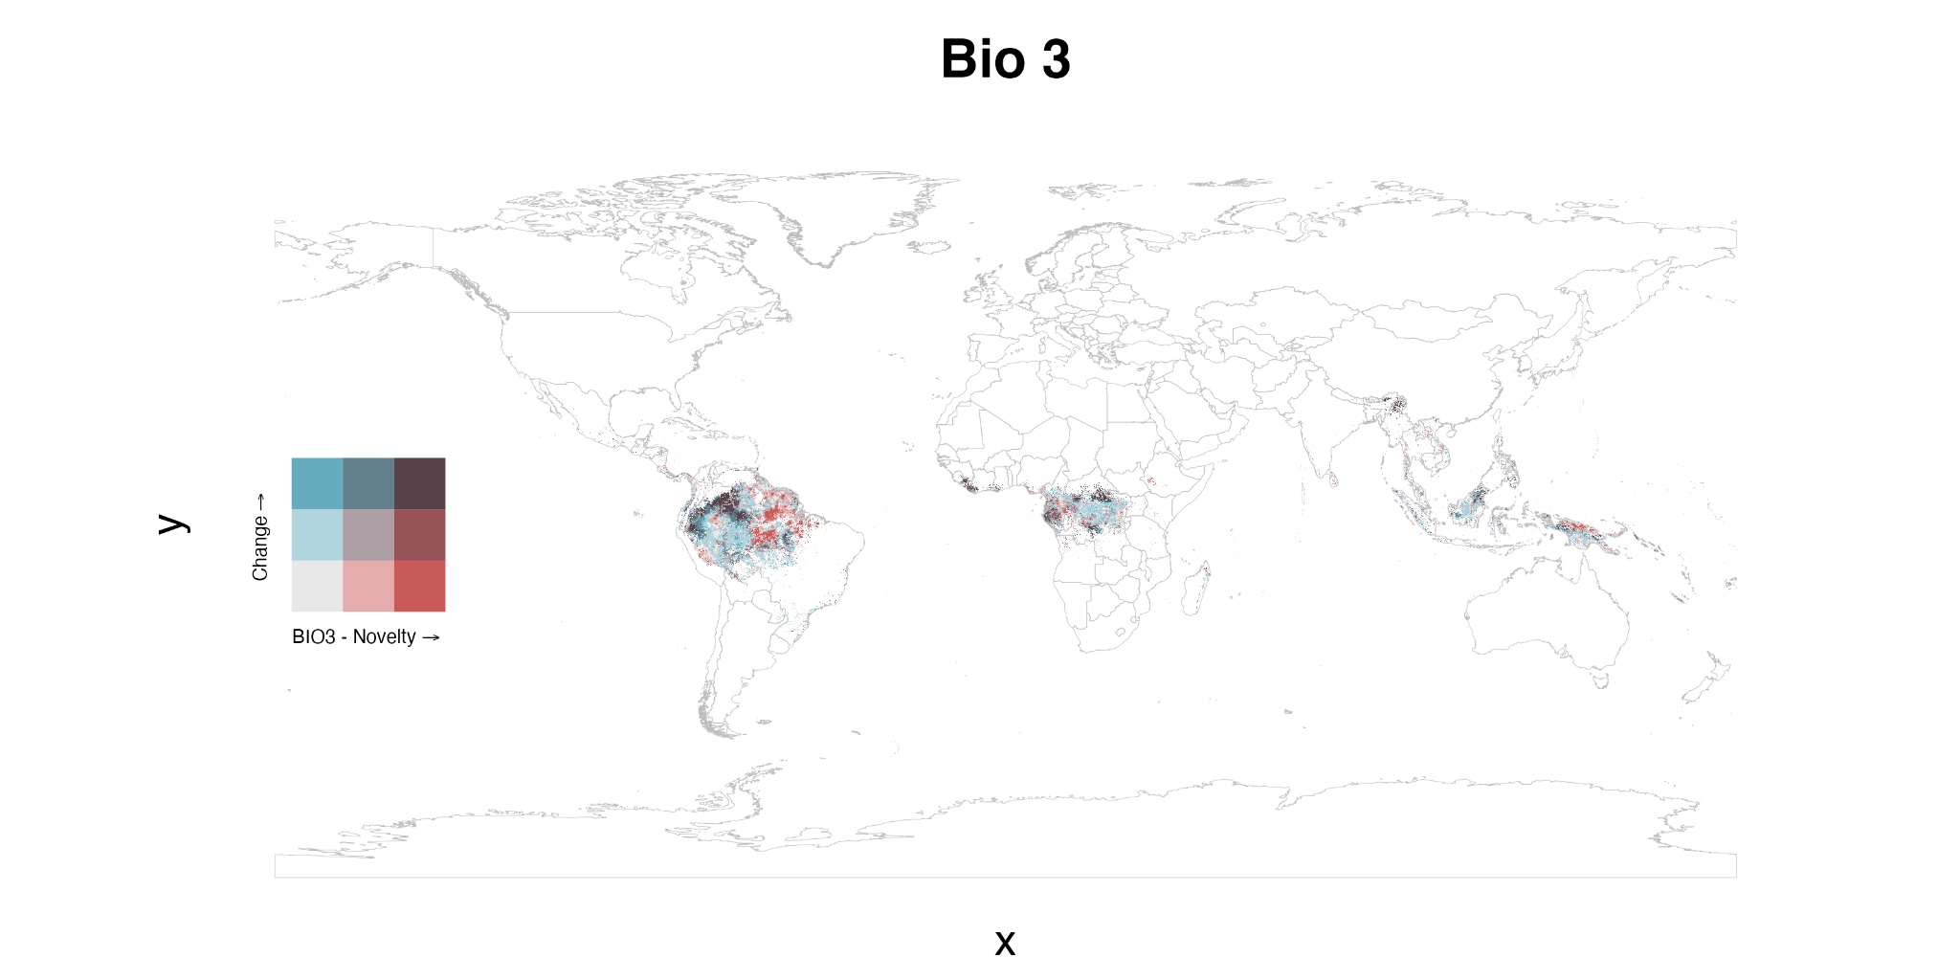

Figure S7.3 | Bivariate maps across undisturbed tropical forests of the spatial relationship between mean overall change in isothermality and the recent novelty of isothermality. Change is defined as the difference between the mean of the temperature variable for 1990-2004 and the mean for 2005-2019.

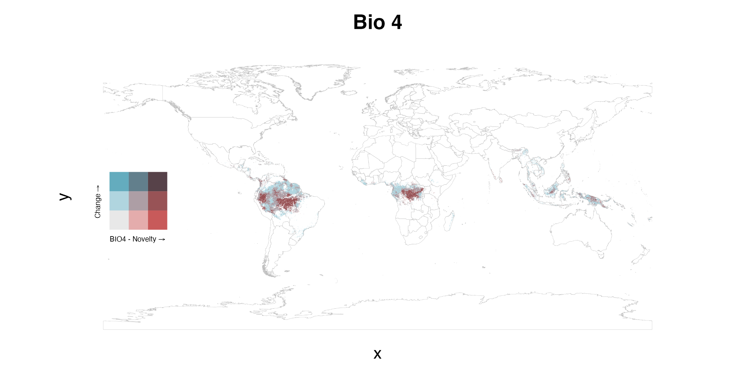

Figure S7.4 | Bivariate maps across undisturbed tropical forests of the spatial relationship between mean overall change in temperature seasonality and the recent novelty of temperature seasonality. Change is defined as the difference between the mean of the temperature variable for 1990-2004 and the mean for 2005-2019.

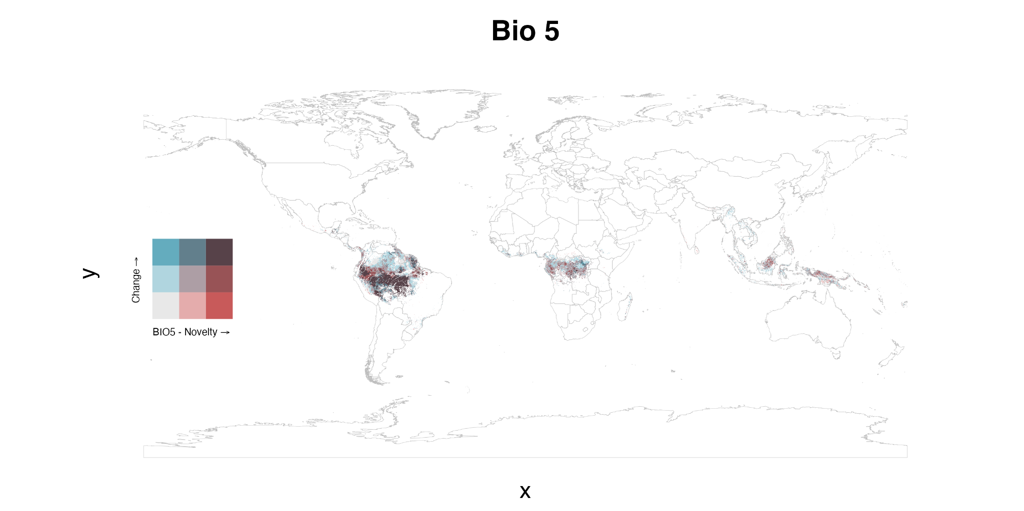

Figure S7.5 | Bivariate maps across undisturbed tropical forests of the spatial relationship between mean overall change in maximum temperature of the warmest month and the recent novelty of the maximum temperature of the warmest month. Change is defined as the difference between the mean of the temperature variable for 1990-2004 and the mean for 2005-2019.

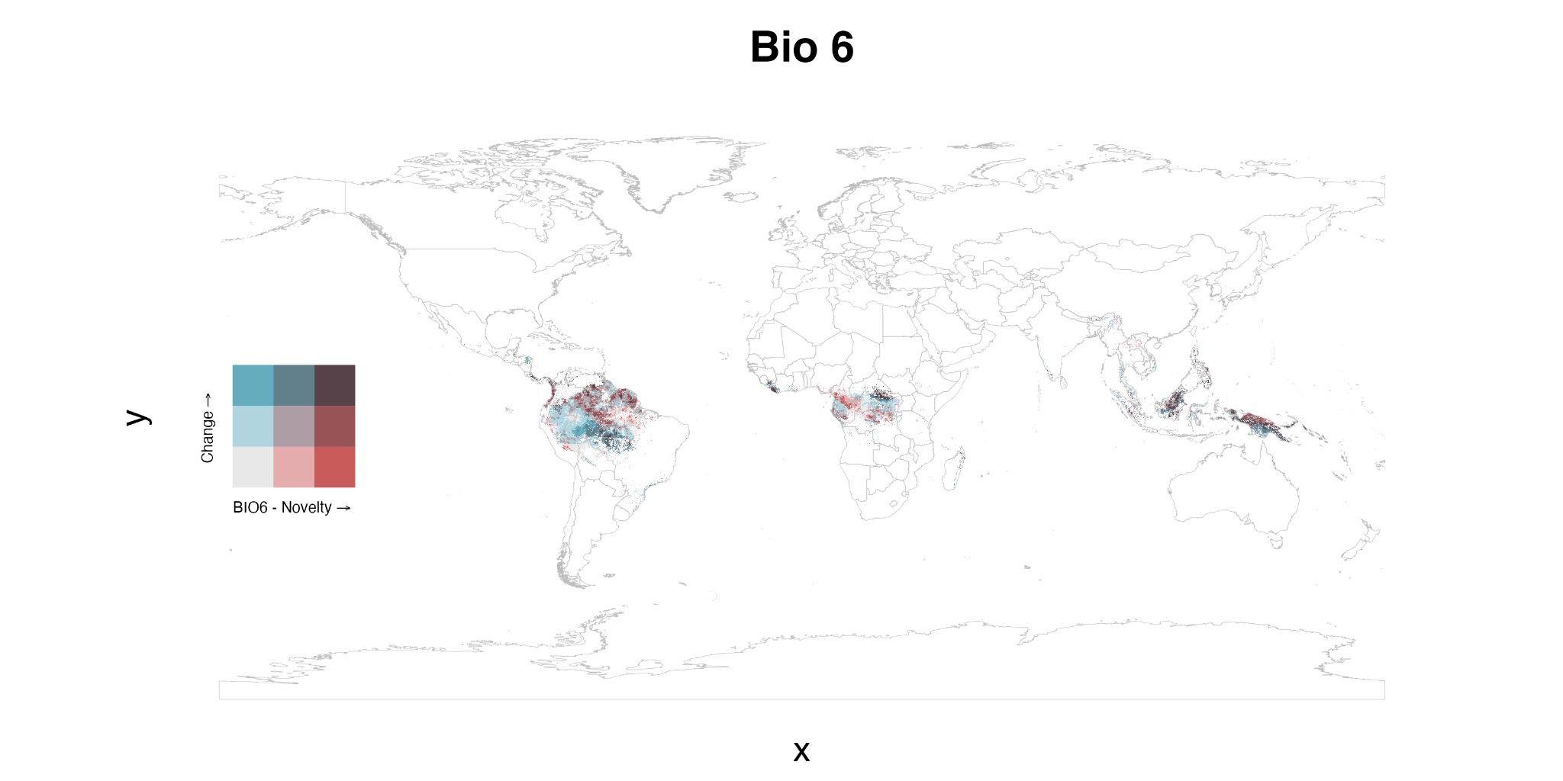

Figure S7.6 | Bivariate maps across undisturbed tropical forests of the spatial relationship between mean overall change in minimum temperature of the coldest month and the recent novelty of the minimum temperature of the coldest month. Change is defined as the difference between the mean of the temperature variable for 1990-2004 and the mean for 2005-2019.

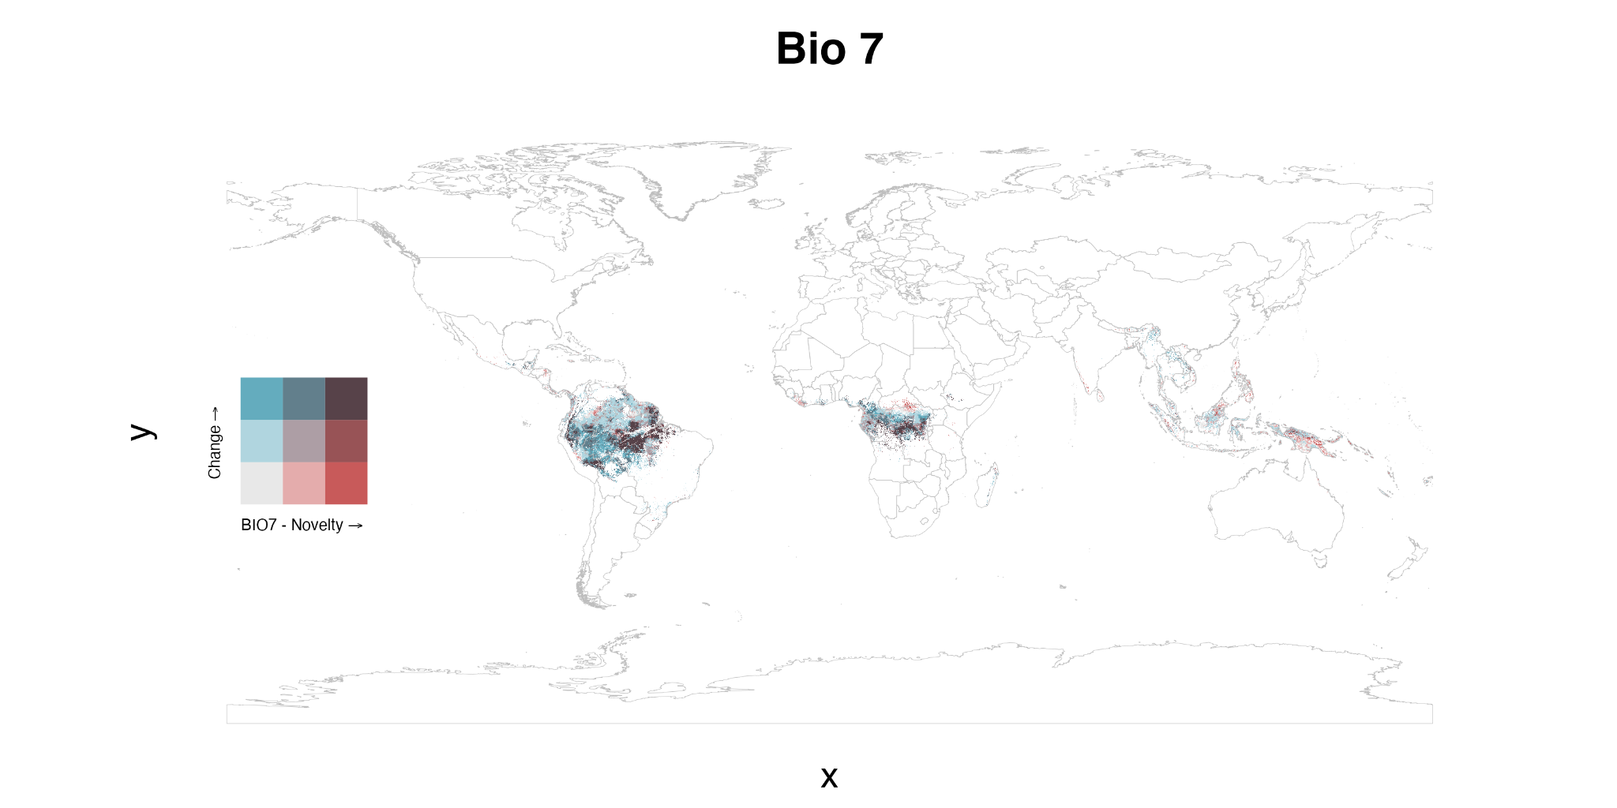
Figure S7.7 | Bivariate maps across undisturbed tropical forests of the spatial relationship between mean overall change in the annual temperature range and the recent novelty of the annual temperature range. Change is defined as the difference between the mean of the temperature variable for 1990-2004 and the mean for 2005-2019.

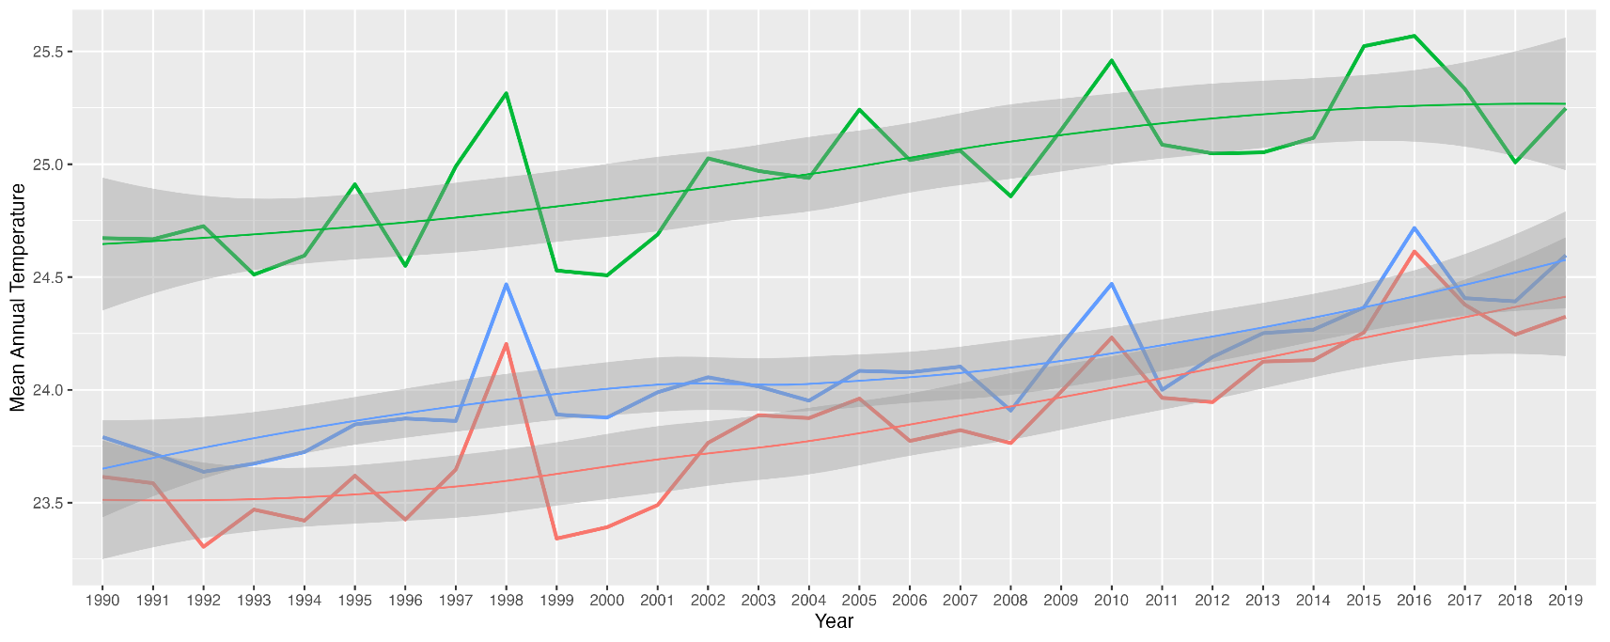
Figure S8.1 | Time series plots of mean annual temperature from 1990 to 2019, averaged across all grid cells in each continental group. Overall long-term change for Central & South America (green), Africa (red), and South-East Asia & Australia (blue) respectively: 0.41, 0.50, 0.37.

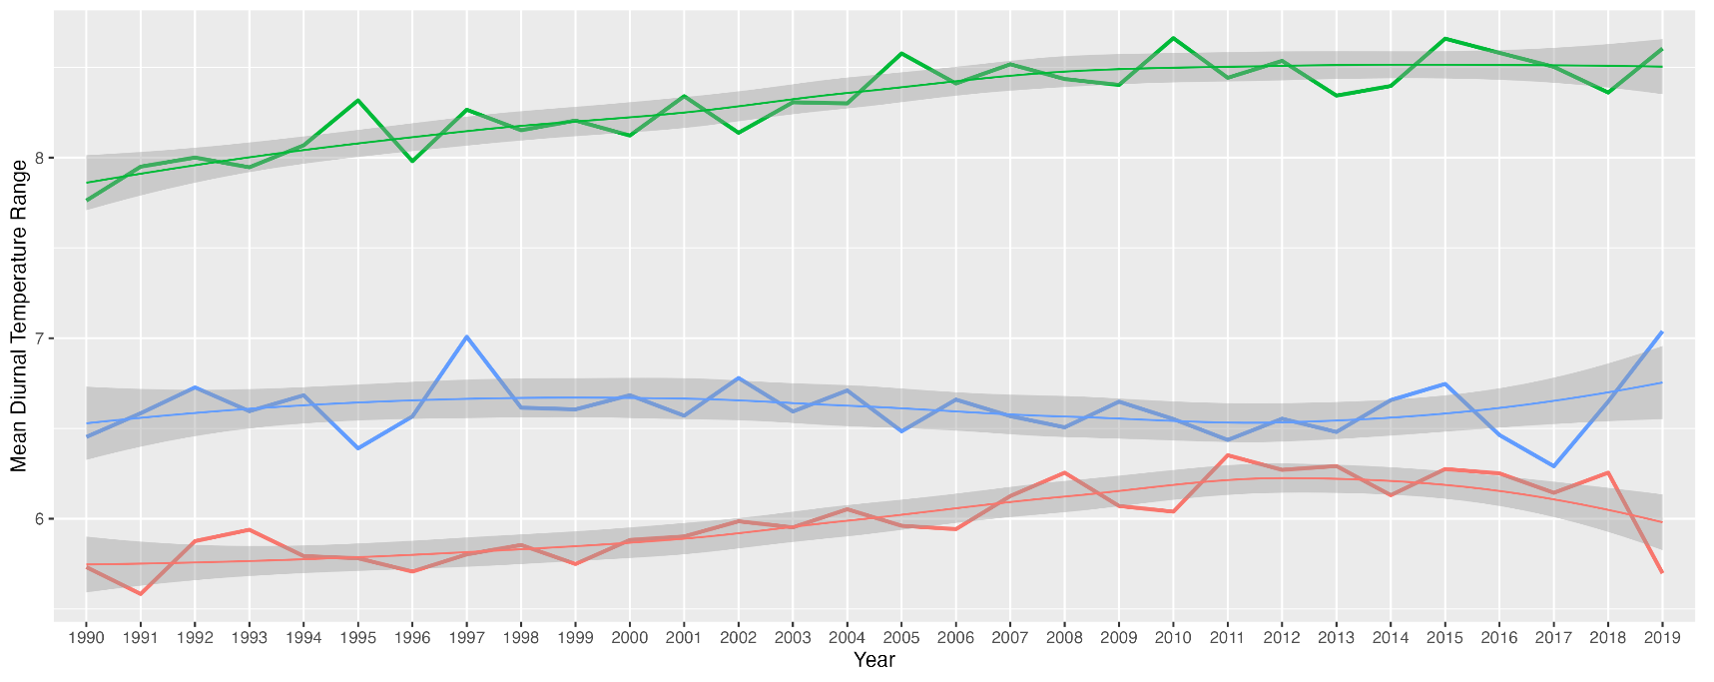
Figure S8.2 | Time series plots of mean diurnal temperature range from 1990 to 2019, averaged across all grid cells in each continental group. Overall long-term change for Central & South America (green), Africa (red), and South-East Asia & Australia (blue) respectively: 0.37, 0.30, -0.06.

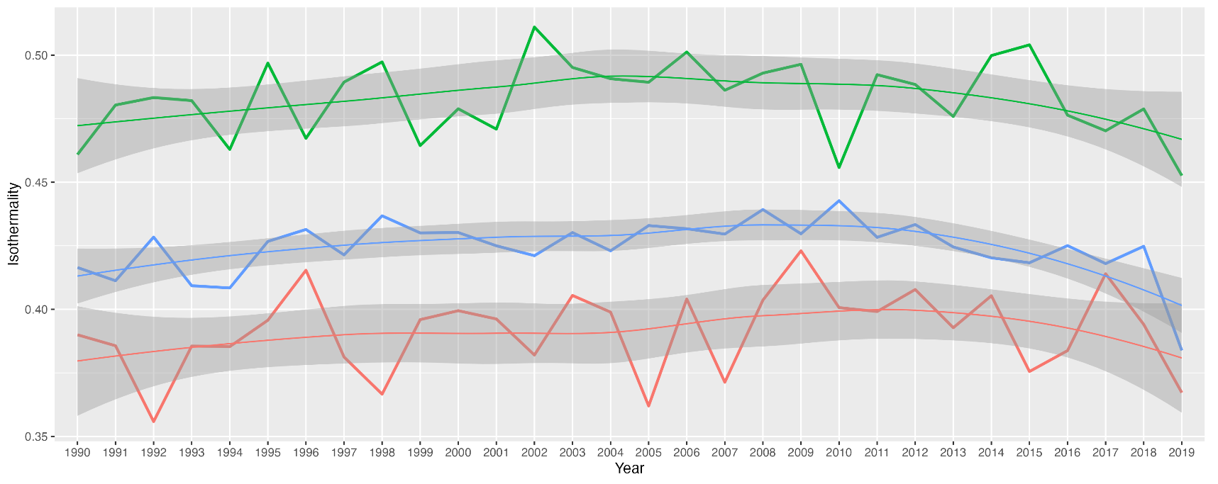
Figure S8.3 | Time series plots of temperature isothermality from 1990 to 2019, averaged across all grid cells in each continental group. Overall long-term change for Central & South America (green), Africa (red), and South-East Asia & Australia (blue) respectively: 0.002, 0.004, 0.002.

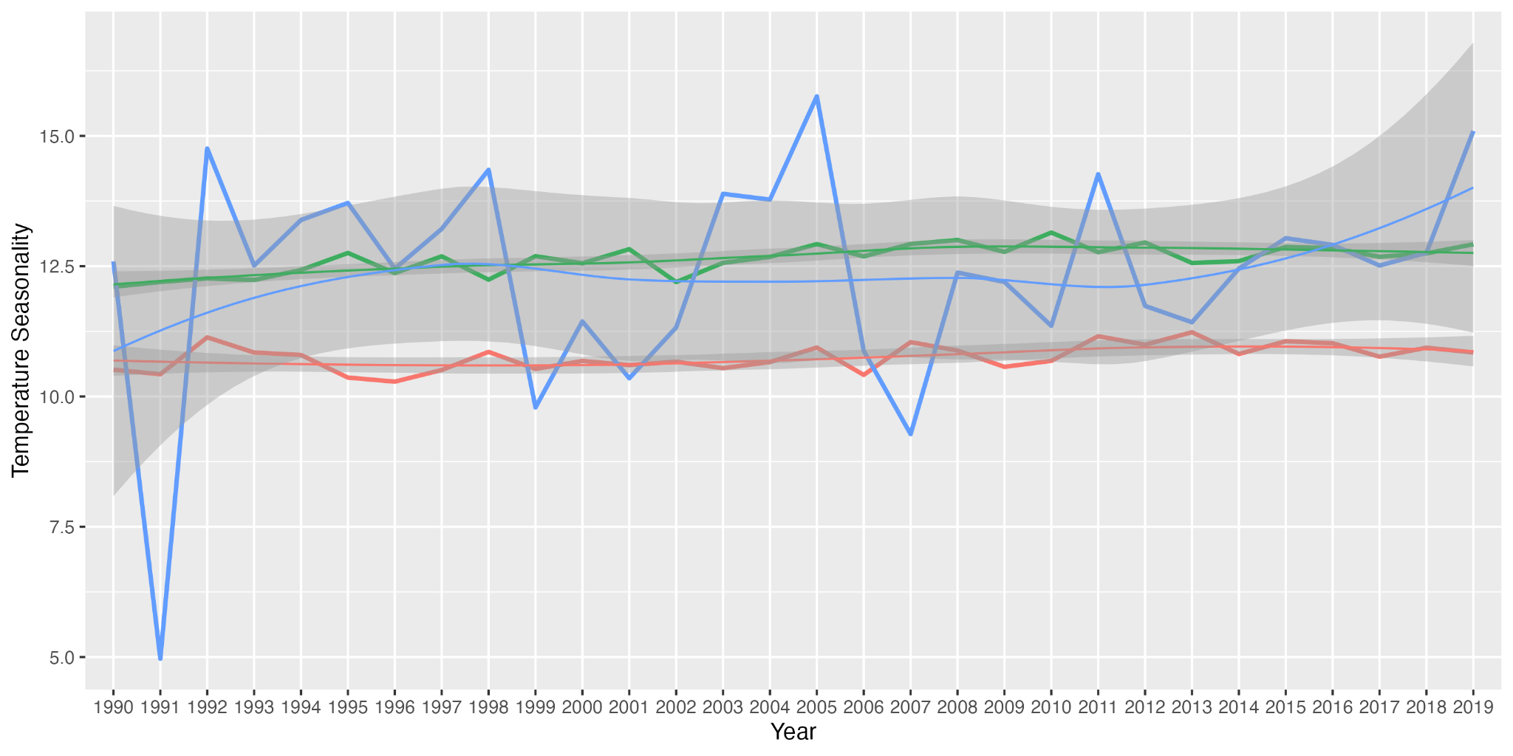
Figure S8.4 | Time series plots of temperature seasonality from 1990 to 2019, averaged across all grid cells in each continental group. Overall long-term change for Central & South America (green), Africa (red), and South-East Asia & Australia (blue) respectively: 0.37, 0.26, 0.37.

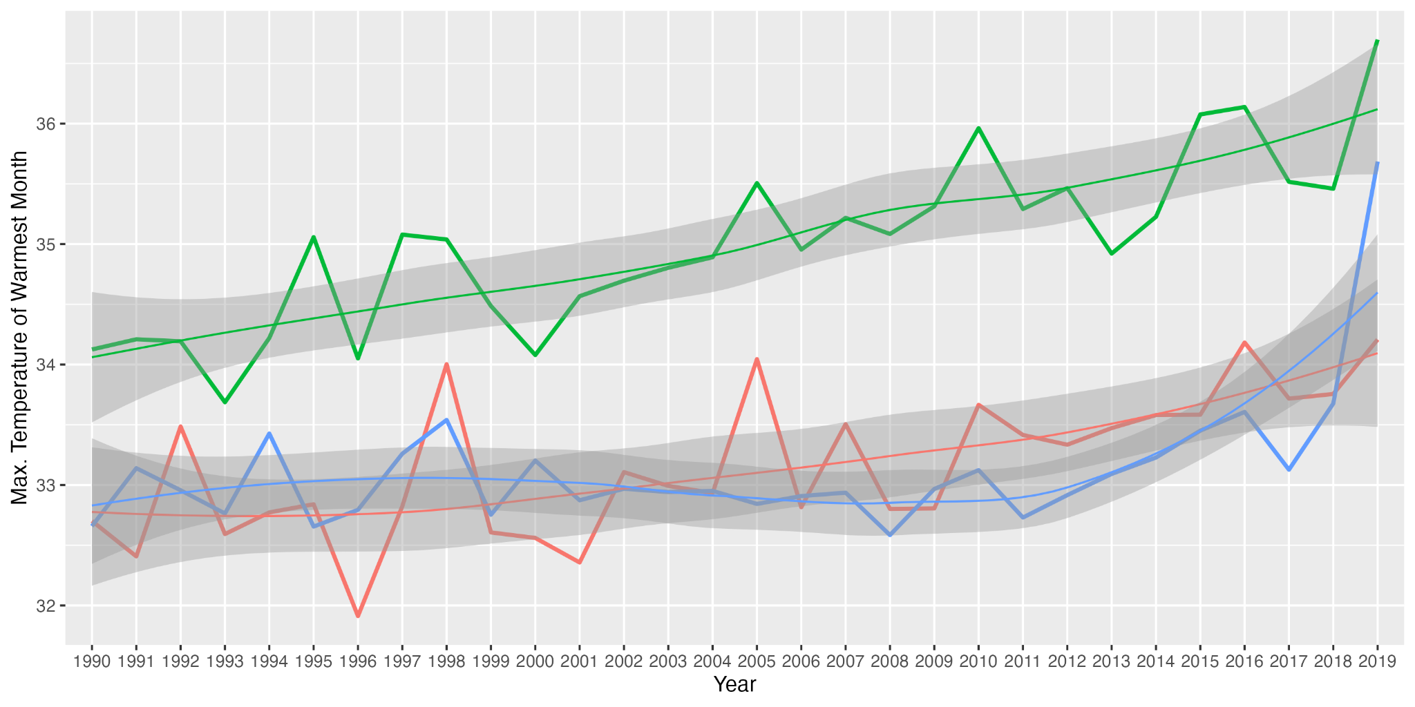
Figure S8.5 | Time series plots of maximum temperature of the warmest month from 1990 to 2019, averaged across all grid cells in each continental group. Overall long-term change for Central & South America (green), Africa (red), and South-East Asia & Australia (blue) respectively: 1.04, 0.72, 0.27.

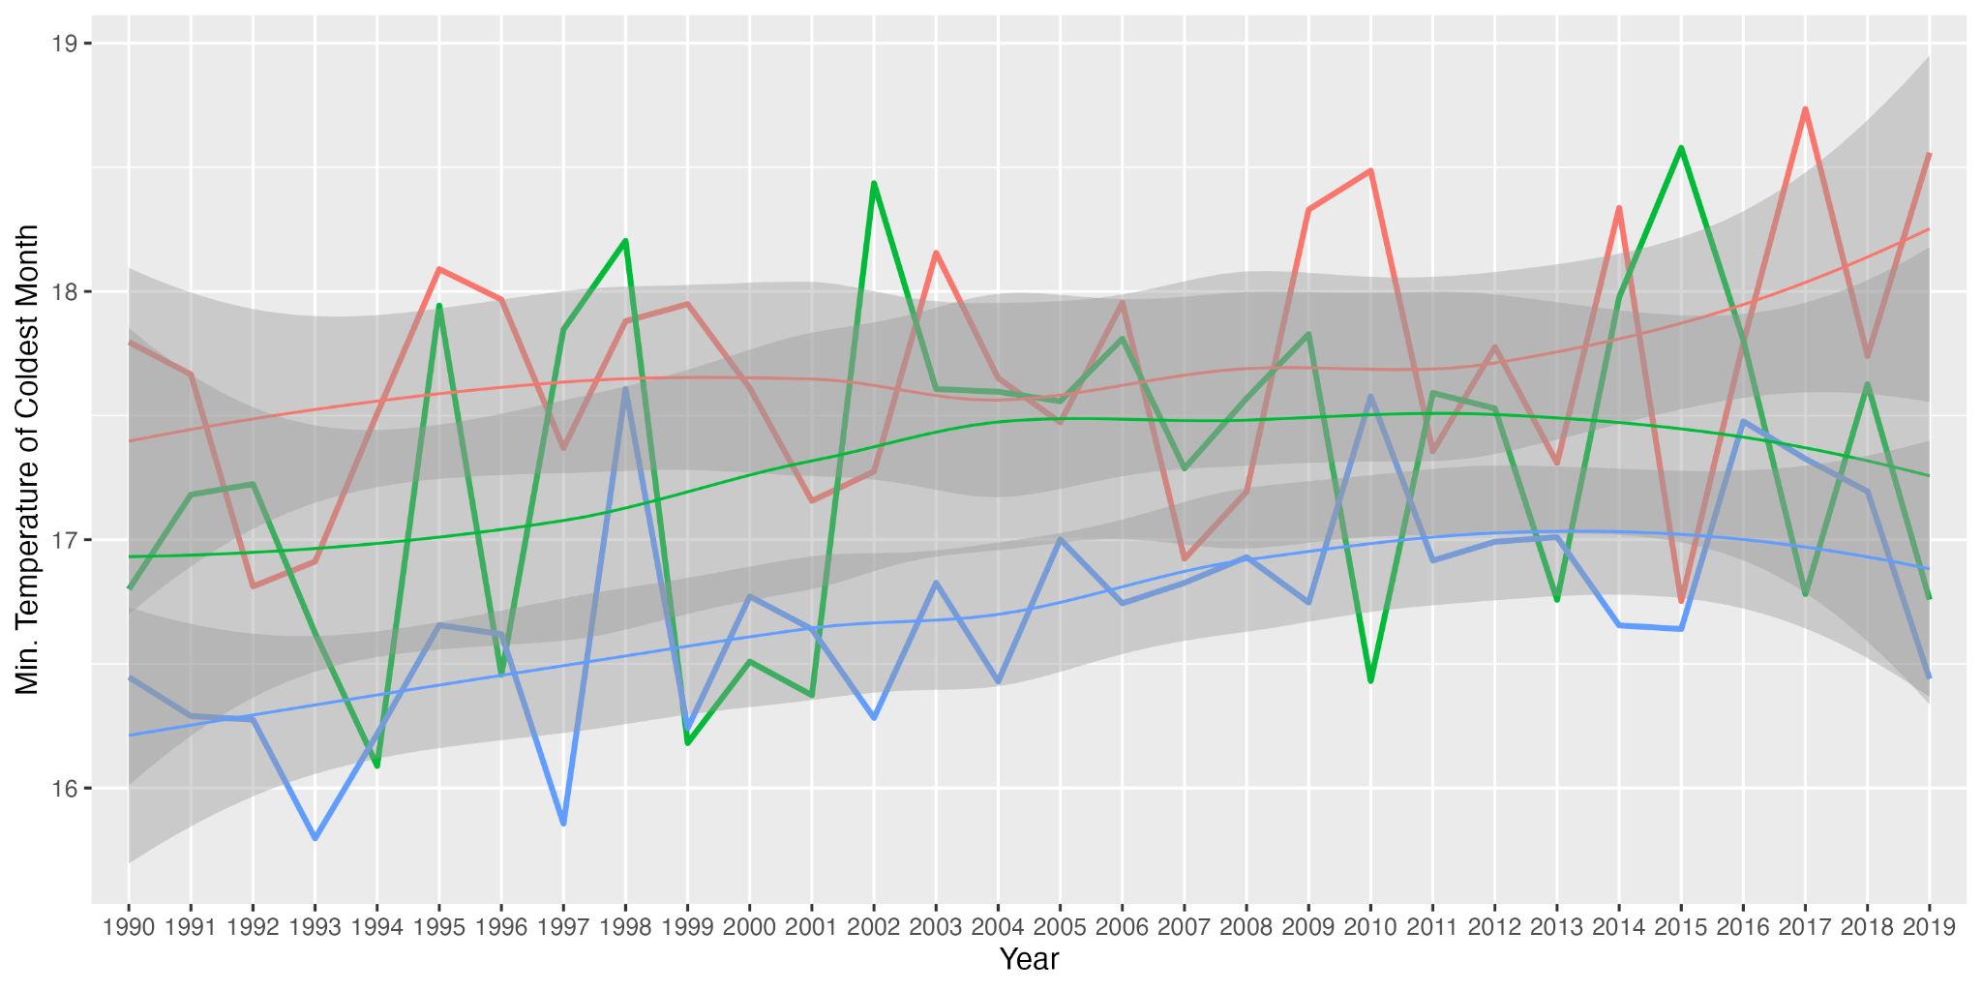
Figure S8.6 | Time series plots of minimum temperature of the coldest month from 1990 to 2019, averaged across all grid cells in each continental group. Overall long-term change for Central & South America (green), Africa (red), and South-East Asia & Australia (blue) respectively: 0.32, 0.19, 0.50.

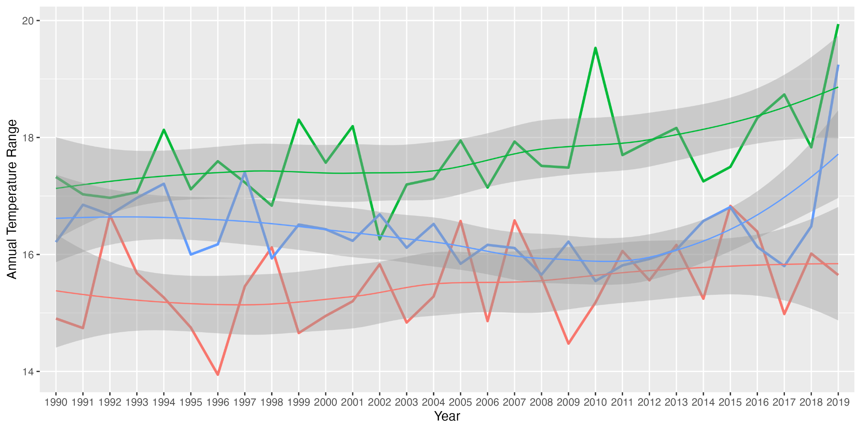Figure S8.6 | Time series plots of annual temperature range from 1990 to 2019, averaged across all grid cells in each continental group. Overall long-term change for Central & South America (green), Africa (red), and South-East Asia & Australia (blue) respectively: 0.72, 0.52, -0.24.

