Index Abstract

XRD Line Profile Analysis for Calcite Produced by Precipitation Method at Different Pre-Cursor Concentration

N.H.Sulimai, M.J.Salifairus, N.E.A Azhar, M.F.Malek, Z.Khusaimi, S.Abdullah , Salman Alrokayan, Haseeb Khan, and M.Rusop

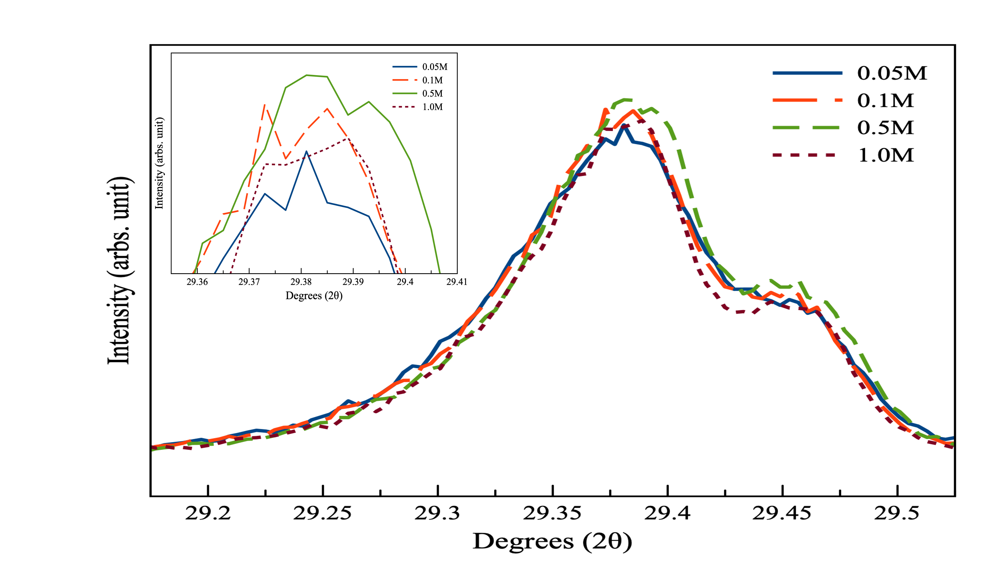

Molar concentration of pre-cursors causes distortion in the CaCO₃ lattice occurs, nucleation and growth and changes to lattice parameters indicating concentration limit 0.5M of viable precipitation of single phase calcite nanocrystal (85.71nm).

