Supplementary Information
for
High-Modulus Homochiral Torsional Oxide Ceramic Artificial Muscles

Supplementary Methods
Fabrication of homochiral coiled ceramic artificial muscles
The Al₂O₃ filament yarns were fabricated with a centrifugal spinning technique by using raw Al₂O₃ powders as the precursors. The filament yarns were led out of the winding drum and then passed through the as-prepared dopamine/polyethyleneimine (PEI) solution. The solution was formed by dissolving 2 mg/ml of dopamine and 2 mg/ml of PEI in Tris-HCl solution. The Tris-HCl solution was formulated by dissolving 10 mM/L of Tris(hydroxymethyl)-aminomethane in deionized water and adjusting pH to 8.5 with hydrochloric acid. The Al₂O₃ filament yarns were soaked into the solution for 6 h. When the filament yarns changed from white to light yellow, they were washed with deionized water to remove the poly-dopamine that were physically adsorbed on the filament yarns. Then, the dopamine coated Al₂O₃ filament yarns were passed through the Pd²⁺ solution for 2 h, the solution consisted of 0.005 mM/ml ammonium tetrachloropalladate. The filament yarns were then washed with deionized water to remove the un-adsorbed catalyst ions on the yarns. Finally, the dopamine coated Al₂O₃ filament yarns with catalytic sites passed through the chemical plating solution of Cu, which consisted of 12 g/L NaOH, 13g/L CuSO₄·5H₂O, 29g/L NaKC₄H₄O₆·5H₂O, and 9.5 ml/L CH₂O. During the chemical plating process, many bubbles might be formed on the surface of the filament yarns. At this time, the solution was stirred to remove the bubbles. After 20 min, the Cu@Al₂O₃ filament yarns were obtained. Next, the yarns were sintered to densify the Cu particles and to enhance the mechanical properties of the composite yarns.
Firstly, the Cu@Al₂O₃ filament yarns were sintered at 300 °C for 1 h to stabilize the composite yarn structures and to convert dopamine into carbides. The heating rate was set as 5 °C/min. Then, the filament yarns were sintered at 900 °C in argon atmosphere for 0.5 h to densify the Cu-layer, and the heating rate was set as 10 °C/min. Of note, argon should be continuously provided to protect the filament yarns during the sintering. Last, freezing air was provided to rapid annealing the filament yarns, and the hot temperature of 900 ºC should be reduced to room temperature quickly to form a dense Cu layer.
The conductive Cu@Al₂O₃ filament yarns were then twisted to form the homochiral Archimede structure. A single yarn could be twisted into S-type or Z-type structure, and a hierarchical structure was obtained when twisting two or more ply yarns. For example, a homochiral hierarchical structure could be obtained by twisting two S-twisted yarns into S-type, otherwise a heterochiral hierarchical structure was obtained by twisting two S-twisted yarns into Z-type. In this study, the single filament yarn was S-twisted 200 turns/m, and then 8 ply yarns with 200 turns/m were S-twisted to obtain the 8-ply yarn with a homochiral Archimede structure. After that, the 8-ply yarn was soaked in a paraffin solution at 80 °C to infiltrate the paraffin. After fixing both ends of the 8-ply yarn containing paraffin and hanging the weight, the yarn could be overtwisted in a temperature range from 30 to 50 °C. As increasing the twist number, the 8-ply yarn shrank to an appropriate length and then could form a homochiral coiled ceramic artificial muscle (HCCAM) with a solenoid structure once the paraffin cooled into solid.
Materials characterization
Here, Field Emission SEM (SU8010) was used to observe the morphology of materials. The interface of Cu-Al₂O₃ was observed by TEM (JEM-2100). The thicknesses of dopamine and dopamine/PEI coatings were analyzed with atomic force microscopy measurement using Innova (NanoScope IV) under the tapping mode. The sintering temperature of filament yarns was determined by TG Analysis (TG209F1 Libra) and Differential Scanning Calorimetry (DS8500) under a nitrogen atmosphere. The self-polymerization reaction of dopamine was detected by Ultraviolet (UV3600). The Raman spectrum was obtained by Raman spectrometers (inVia-Reflex) with 514 and 785 nm excitation laser. FTIR measurements were performed with a FTIR spectrometer (NEXUS-670). XRD measurements were conducted by Brucker Escalab 250Xi using a beam with Cu Kα wavelength. Optical photographs were obtained through the stereomicroscope (NIKON SMZ745T). The dynamic polarization test and EIS were obtained by using an Electrochemical workstation (Chi660e). For the stress–strain curves, the samples were equilibrated at 30 °C under a preload of 0.1 N, and the force was increased at a rate of 0.2 N min^{–1}. All the values of the mechanical properties, including tensile strength, strain, toughness, and modulus, were averaged from more than ten measurements. All the electrical measurements were conducted using a semiconductor parameter analyzer (Keithley DMM7510 and Keithley 2400). During the operations, a voltage was applied at the top electrode, whereas the bottom electrode was kept grounded. The actuation performance was acquired by analyzing the frames from a high-speed camera as the time to reach the length shrinkage/relaxation of a certain constant.

Calculation of the grain sizes and micro-strains by Williamson-Hall method:
The finite size and surface effects of the crystal cause the deviation from the perfect crystallinity. This deviation results the broadening of the XRD diffraction peaks, affecting on the crystallite size of NPs, lattice strain and dislocation density. To determine the crystal nature, the Williamson-Hall method was applied, and the formulas are as follows:
$$β_{T}=β_{D}+β_{ε}$$
$$β_{D}=\frac{Kλ}{Dcosθ}$$
$$β_{ε}=4εtanθ$$
where $β_{T}$ is the total broadening of the crystal, $β_{D}$ is the full width at half maximum (FWHM), $β_{ε}$ is the broadening due to micro-strain, K is the shape factor, $λ$ is the wavelength of X-ray sour, D is the crystallites size, $θ$ is the peak position in radians, and $ε$ is the micro-strain. plot ($4sinθ$) on x-axis and $β_{T}cosθ$ on y-axis, and linearly fitting. The value of the straight-line slope is micro-strain $ε$, and the value of the y-intercept is $\frac{Kλ}{D}$.

Bending test for filament yarns:
There were two methods for evaluating the bending properties of the filament yarns. The first one is using the Hanging method to evaluate the bending stiffness B. Specifically, bending the filament yarn into a loop and securing it, and then measure the radius (r) of the loop. After that, hanging objects with different weights on the loop, and measuring the vertical drop (d) of the loop. The bending stiffness B could be obtained by the following formula:
$$B=0.0047mg\left(2πr\right)2cosθ/tanθ$$
Where, m is the mass of the heavy object, r is the radius of the circular yarn, and θ is the bending angle.
The second method is to evaluate the equivalent flexural modulus, Eb. Specifically, selecting a straight filament yarn, and measuring its length (L) and radius (y). Then, fixing one end of the straight filament yarn, and a constant force (Pcr) was applied to the other end. The yarn would be bend and then measuring its height (X) and the bending curvature ($\ddot{y}$). The flexural modulus Eb could be obtained by the following formula:
$$M=E_{b}I\ddot{y}，M=P_{cr}y-R(L-x)$$
Where, M is the coupling moment of the yarn, I is the mass moment of inertia of the yarn, y is the distance from the surface of the yarn to the axis of the yarn, x is the length corresponding to the bending fiber, L is the total length of the fiber, P_{cr} is the force received, and R is the horizontal component of the receiving force.

Tests for the torsional properties of the filament yarns:
Specifically, selecting a single Al₂O₃ filament yarn, a single Cu@Al₂O₃ filament yarn, 2-ply homochiral hierarchical yarn, 4-ply homochiral hierarchical yarn, and 8-ply homochiral hierarchical yarn. Of note, the single Al₂O₃ filament yarn was untwisted, and the others were S-twisted with 10 turns.
Then, hanging a filament yarn as sample. One end of the filament yarn was fixed and the other was hanging a suspended mass. Continuing to S-twisted (5 turns) the filament yarn and then releasing it. Using a high-speed camera to record the torsion angle of the filament yarns over time. The torsional stiffness k could be obtained by the following formula:
$$k=\left[\frac{{\left(\ln{\frac{θ(t_{m})}{θ(t_{n})}}\right)}^{2}}{4π^{2}{(n-m)}^{2}}+1\right]\frac{jf^{2}}{4π^{2}}$$
Where, k is the torsional stiffness of the yarn, n and m are the number of torsion cycles, t is time, θ is the torsion angle, j is the mass moment of inertia, and j is the torsion frequency.

Supplementary Figures

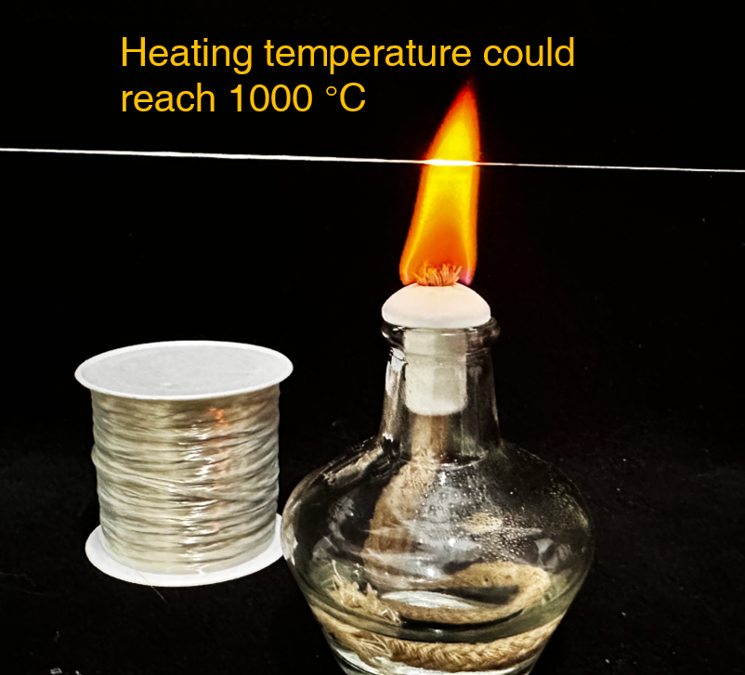
Supplementary Fig. S1. Fire resistance test of the bare Al₂O₃ filament yarn. The bare Al₂O₃ filament yarns could withstand the alcohol lamp flame for a long time, as the yarn was α-Al₂O₃ crystal structure. The α-Al₂O₃ crystal structure was tightly packed in six directions, so that its crystal phase was stable and had a high melting point of 2054 °C.

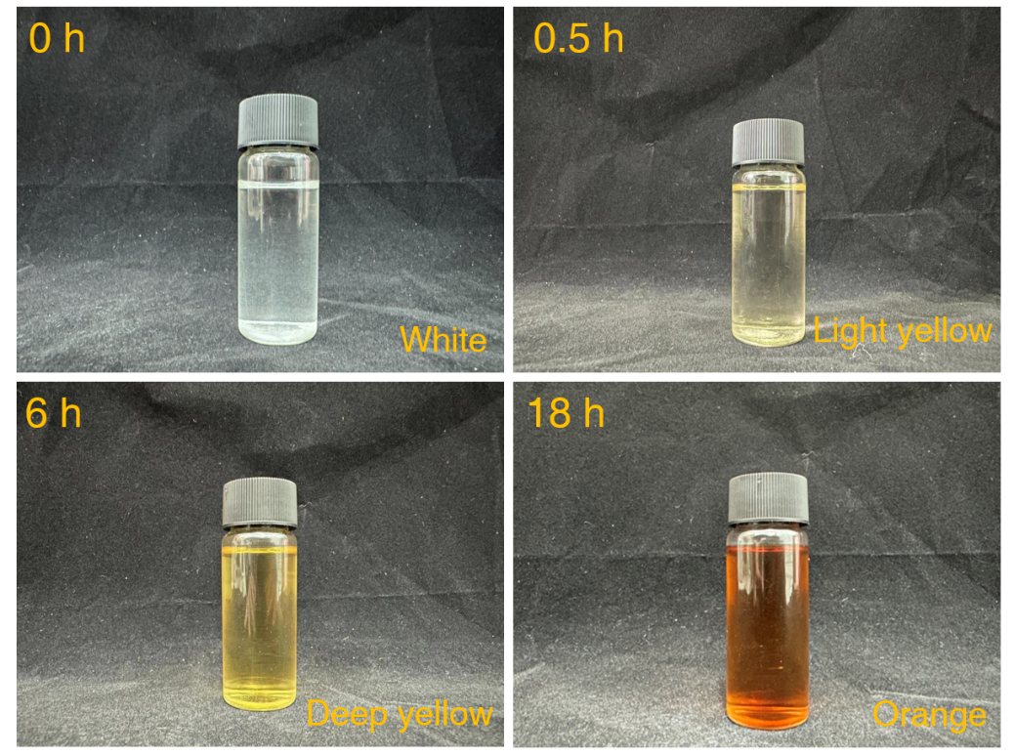
Supplementary Fig. S2. The color changes of the dopamine/PEI solution along with time. Dopamine and PEI were mixed to form a white solution. After standing the solution for a period, the color of the solution changed to yellow, and finally to orange. During the self-polymerization of dopamine, the color of the dopamine solution changed from white to black directly. Therefore, it was difficult to effectively regulate the self-polymerization reaction of dopamine. With the help of PEI, the solution had more color variations, and the self-polymerization reaction of dopamine could be intuitively judged from the color change of solution.

a
b
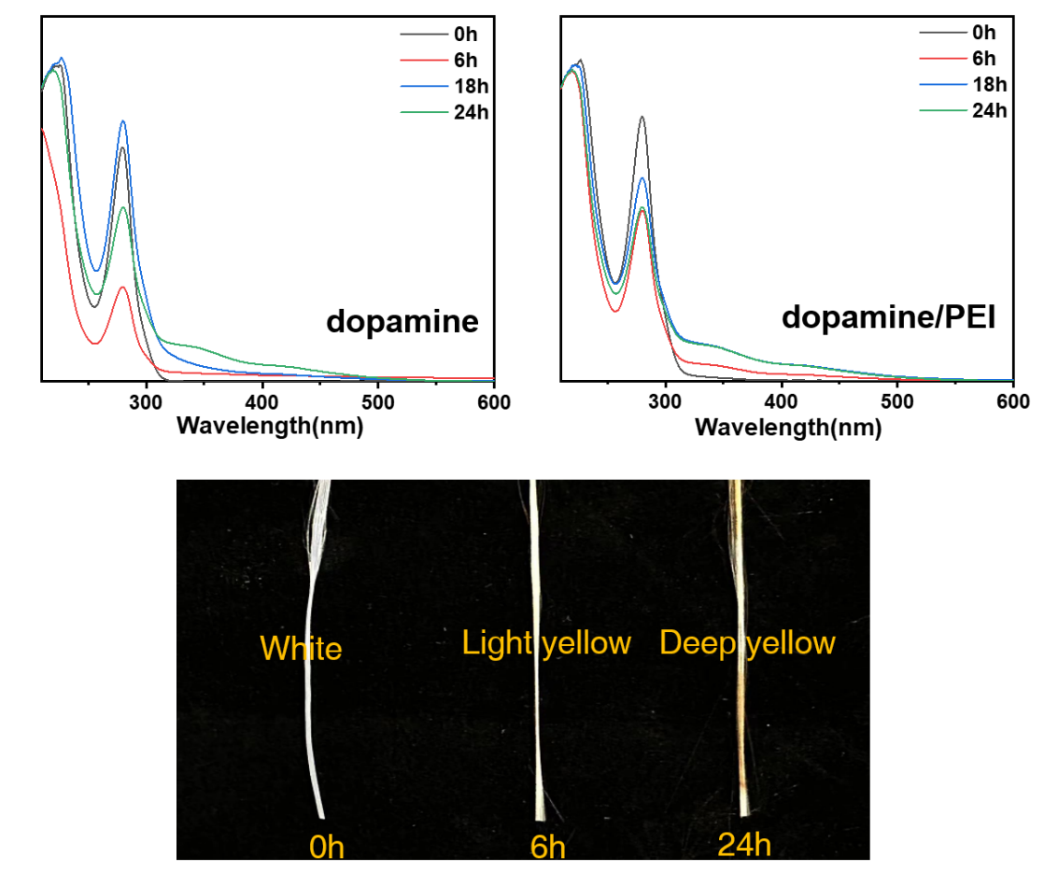
c
Supplementary Fig. S3. Ultraviolet diagram of (a) the dopamine solution and (b) the dopamine/PEI solution at different self-polymerization time. In general, the peaks at 204 nm, 280 nm and 350 nm were caused by carboxyl, catechol hydroxyl and o-quinone group. When the self-polymerization took for 6 h, the peaks centered at 204 nm and 280 nm decreased, indicating the dopamine was undergoing Michael addition and open-chain addition reactions. After the end of the reactions, the peaks at 204 nm and 280 nm were increased to the original height. Therefore, by comparing the peaks at 350 nm for the dopamine and dopamine/PEI solutions, we can conclude that the dopamine produced adhesion with the help of PEI after 6 h. (c) Changes in surface color of the Al₂O₃ filament yarns under different time of soaking in the dopamine/PEI solution.

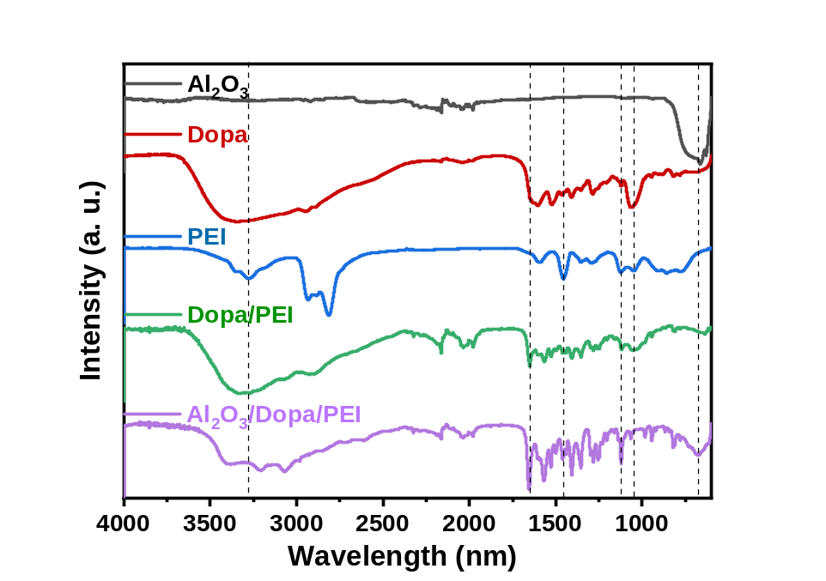
Supplementary Fig. S4. FTIR characterization of the Al₂O₃ filament yarn, dopamine, PEI, dopamine/PEI, and the dopamine coated Al₂O₃ filament yarn. Compared with the peak of Al₂O₃ located at 420 nm, the peak of Al₂O₃/Dopa/PEI was decreased due to the dopamine coating. In the self-polymerization of dopamine and PEI, the changes in functional groups were extremely complex. Therefore, several specific peaks were selected for comparative analysis. In general, PEI was analyzed by nitrogen groups. The peaks at 1054 nm and 1125 nm were generated by C-N group, and the peak at 1463 nm were generated by N-H group. Dopamine could be analyzed by hydroxyl group which located at 3300 nm. The dopamine-coated Al₂O₃ filament yarn exhibited all the as-mentioned functional groups, thus proving the presence of dopamine/PEI copolymers on the yarn surface.

b
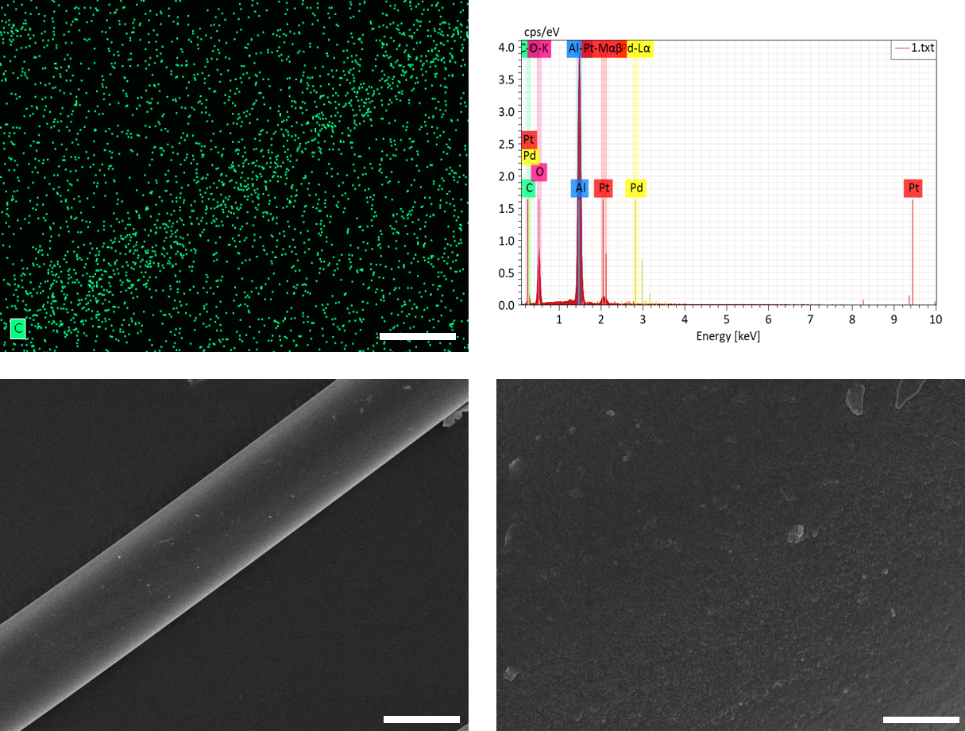
d
c
a
Supplementary Fig. S5. SEM images and EDS mapping characterization of the dopamine coated Al₂O₃ filament. (a) EDS mapping and (b) carbon contents in the dopamine coated Al₂O₃ filament. There was a small amount of carbon on the Al₂O₃ filament surface, indicating the adhesion of dopamine and PEI on the yarns. (c) After being modified by dopamine/PEI, the Al₂O₃ filament surface was smooth. The scale bar is 10 um. (d) Continue to enlarge surface microtopography of the Al₂O₃ filament surface, which was still smooth. The scale bar is 1 um.

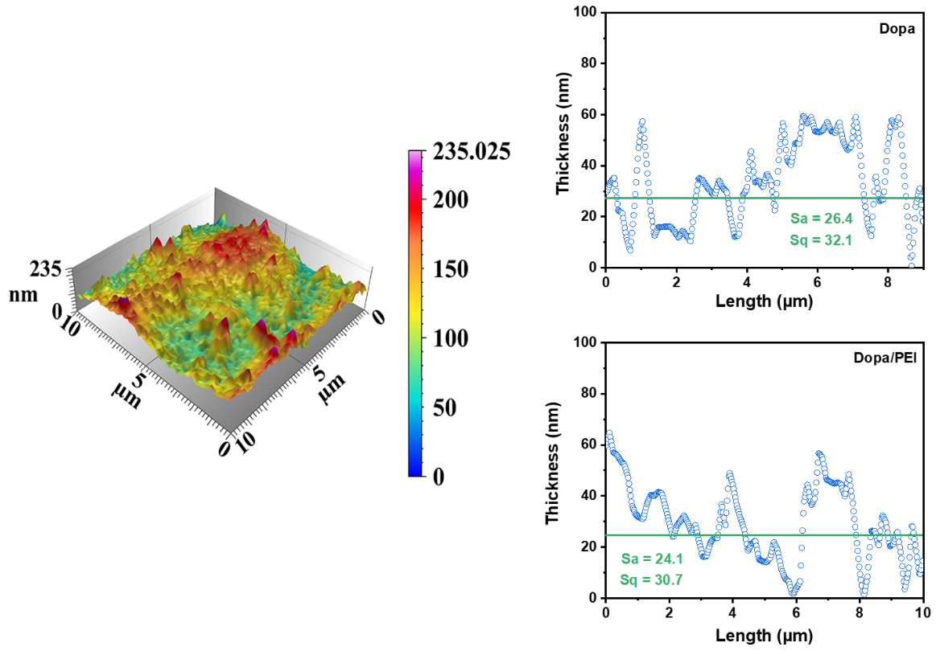
a
c
b
Supplementary Fig. S6. Atomic force microscope characterization of the dopamine coated Al₂O₃ filament. (a) Gradient plot of the surface roughness of dopamine/PEI. Surface roughness of (b) dopamine and (c) dopamine/PEI on the filament yarns. The Arithmetic mean height (Sa) indicated that the average thickness of the dopamine coating on the filament yarn, and Root mean square height (Sq) indicated that the standard deviation between thickness of the dopamine layer and the average thickness Sa. Both the values of Sa and Sq of dopamine /PEI were lower than dopamine, showing that surface roughness of dopamine was more evenly distributed on the filament yarns with the help of PEI.

b
a
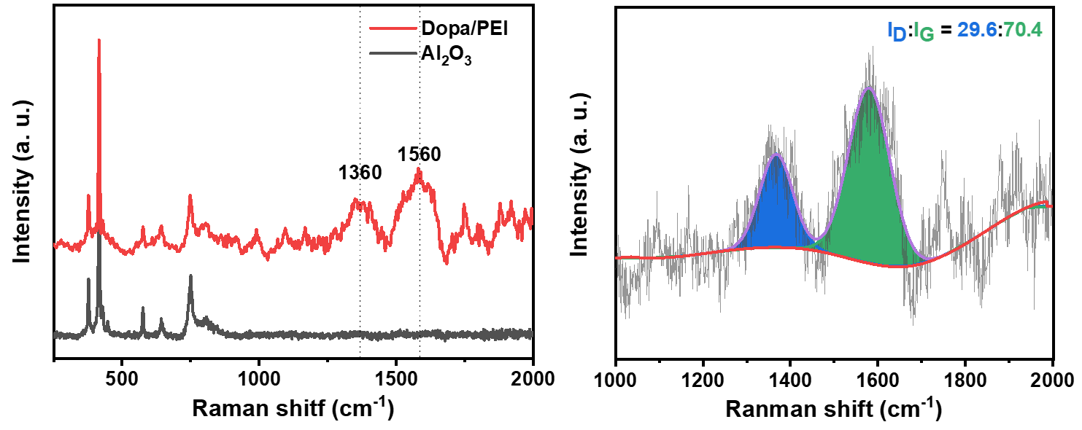
Supplementary Fig. S7. (a) Raman characterization of the Al₂O₃ filament yarn and the dopamine/PEI modified Al₂O₃ filament yarn. (b) D peak and G peak of carbon peaks of the yarn. There were new peaks at 1360 nm and 1560 nm generated on the red curve, confirming that the Al₂O₃ filament yarn was coated with dopamine. Moreover, the ratio of peak area between 1360 nm and 1560 nm indicated the existence of carbon materials. Especially, the D-peak was at 1360 nm, which represented the defect in the carbon material, and the defect was benefit for dopamine to capture the Pd²⁺ catalyst ions in the following plating process.

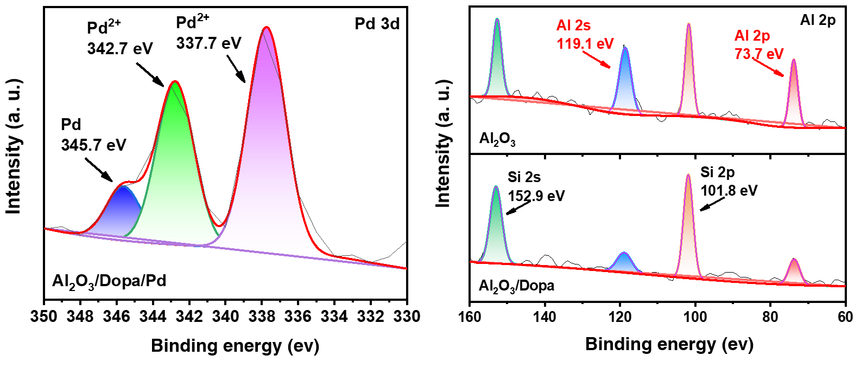
b
a
Supplementary Fig. S8. XPS spectra of the dopamine coated Al₂O₃ filament yarns after soaking in Pd²⁺ solution. (a) Local enlargement of the Pd 3d spectrum. It is believed that the hydrogen atom of catechol hydroxyl group was negatively charged, which could attract Pd²⁺ metal ions with positive charges. Furthermore, four catechol hydroxyl groups could form a cage to trap catalyst ions. However, the dopamine showed a weak reduction, thus a small amount of Pd²⁺ ions were reduced to metallic Pd. (b) Local amplification of the Al 2p spectrum. The photoelectron beam of XPS could only detect a depth of 10 nm of the filament yarn surface, thus with the increase of the dopamine-coating thickness, the strength of the Al peak of the dopamine coated Al₂O₃ filament yarn decreased.

c
a
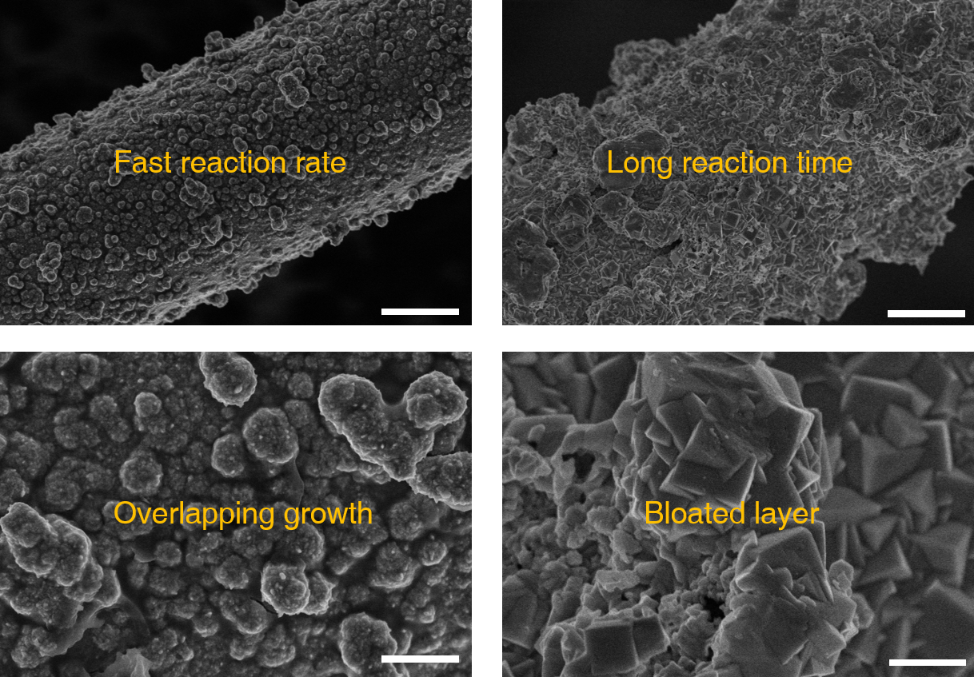
d
b
Supplementary Fig. S9. SEM images of the Cu@Al₂O₃ filament yarns before the heat treatment. (a) An ultra-fast Cu plating rate caused an uneven distribution of Cu on the surface of Al₂O₃ filament yarn. The scale bar is 10 um. (b) An enlarged view of the local Cu layer of showed that Cu particles were overlapping grew on the yarn. The scale bar is 1 um. (c) Under a long plating time, the Cu layer on the surface of Al₂O₃ filament yarn was also uneven. The scale bar is 10 um. (d) An enlarged view of the local Cu layer showed that Cu particles were too bloated. The scale bar is 1um.

b
a
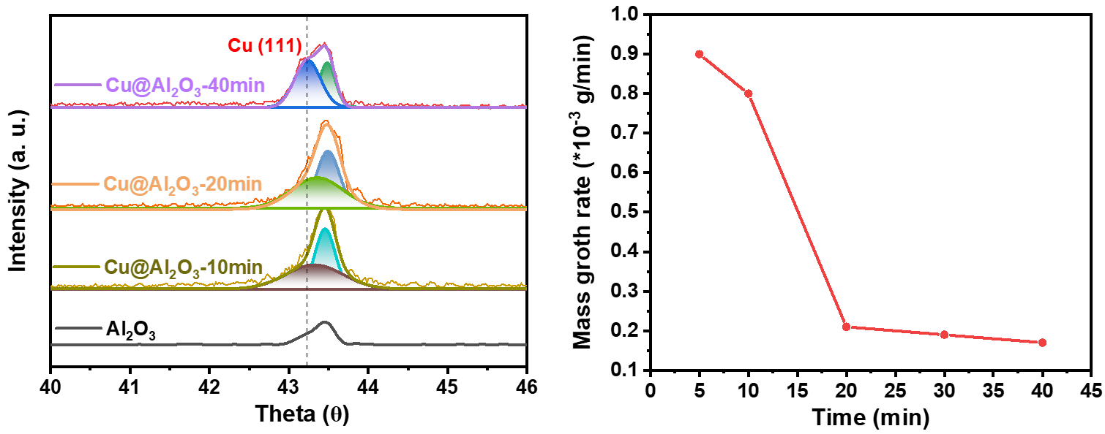
Supplementary Fig. S10. XRD and Cu growth rate characterizations. (a) XRD pattern of the Cu@Al₂O₃ filament yarn at different Cu plating time. When the plating time was 40 min, the intensity of Cu (111) peak was the same as that of Al₂O₃, indicating that Cu layer was too bloated. (b) The relationship between the Cu growth rate along with the plating time. Along with the plating time, the growth rate decreased quickly. Therefore, we chose 15 min as the plating time in this study.

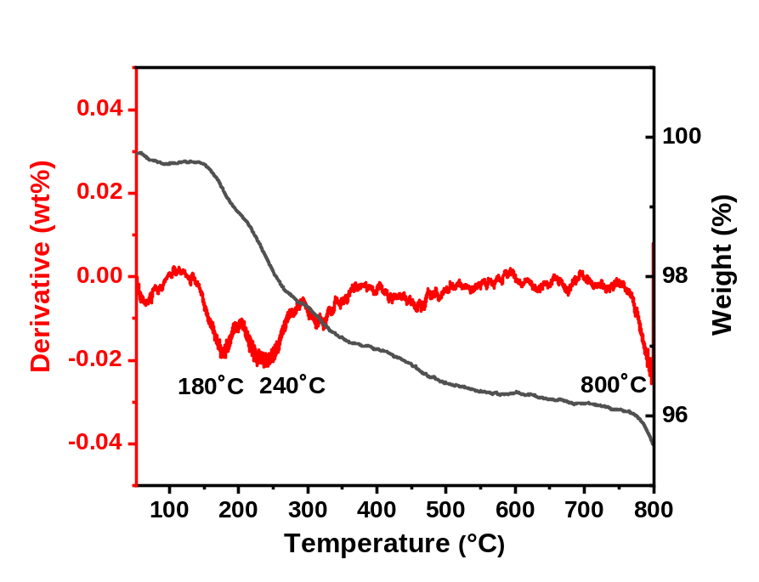
Supplementary Fig.S11. Thermogravimetry and decomposition rate of the dopamine coated Al₂O₃ filament yarns. The red curve could obviously show the structural transformation of dopamine under high-temperature sintering. There were three critical temperature points (180 °C, 240 °C and 800 °C) at which the mass of the yarns decreased rapidly. The former two temperature points corresponded to the transformation of dopamine to carbide, and the latter indicated that carbide was decomposed at 800 °C.

a
b
Supplementary Fig. S12. Cross-sectional SEM images of the Cu@Al₂O₃ filament yarns after being sintered at 900 °C. (a) The Al₂O₃ filament yarn was smooth, and the thin Cu layer was tightly bonded on the surface. (b) We used a tweezer to peel off the outer copper layer and analyzed its thickness. The thickness of the Cu layer was about 1 µm.

c
a
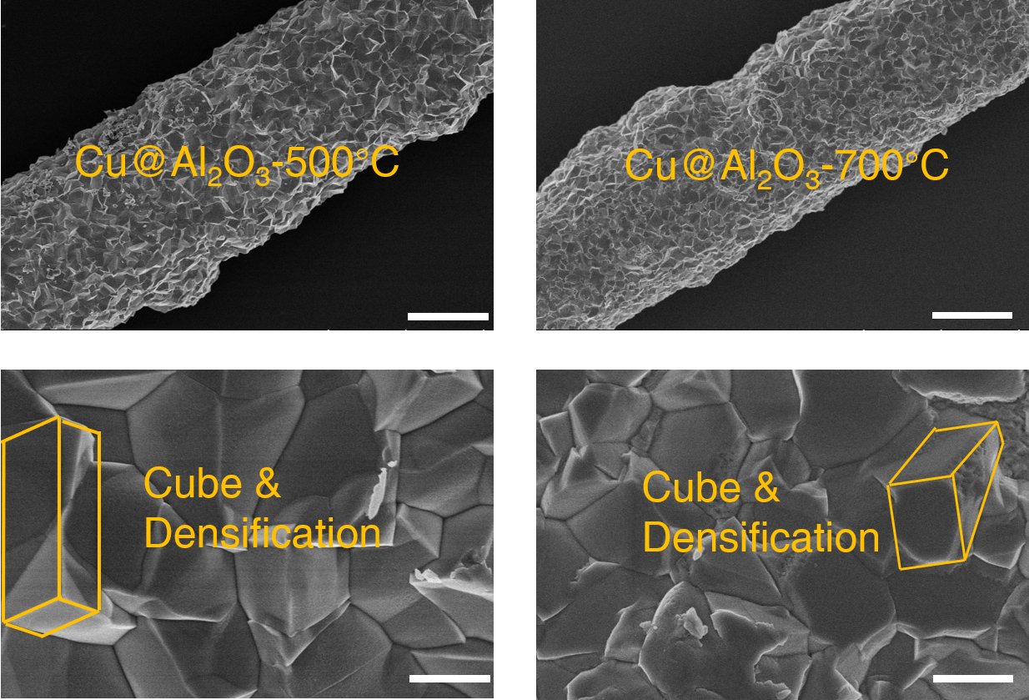
b
d
Supplementary Fig. S13. SEM images of the Cu@Al₂O₃ filament yarns after being sintered at 500 °C and 700 °C. (a) The surface microtopography of Cu@Al₂O₃ filament yarn sintered at 500 °C became densified; the scale bar is 10 um. (b) An enlarged view of the local microtopography of the Cu@Al₂O₃-500 °C filament yarn showed the Cu particles became cube structure. The scale bar is 1 um. (c) The surface topography of Cu@Al₂O₃ filament yarn sintered at 700 °C became densified, scar bar:10 um. (d) An enlarged view of the local micro-topography of the Cu@Al₂O₃-700 °C filament yarn showed the Cu particles became cube structure. The scale bar is 1 um.

b
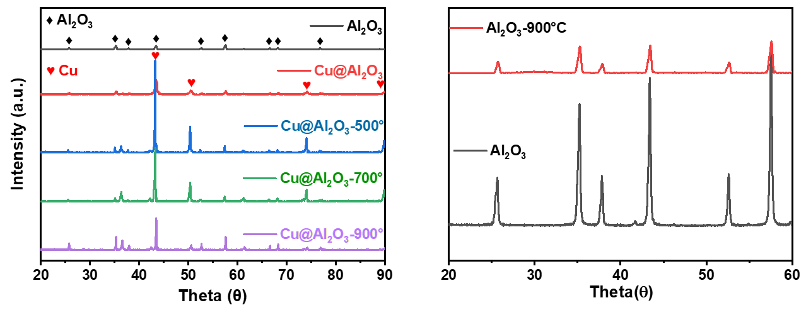
a
Supplementary Fig. S14. XRD patterns of different filament yarns. (a) XRD patterns of the yarns of Al₂O₃, Cu@Al₂O₃, Cu@Al₂O₃-500°C, Cu@Al₂O₃-700°C, and Cu@Al₂O₃-900°C showed that no new peaks appeared, but a high angular offset occurred for the peaks in Cu@Al₂O₃-900°C. (b) Compared with the peaks of the bare Al₂O₃, there was no high angular shift in the Al₂O₃-900°C after being sintered at 900 °C.

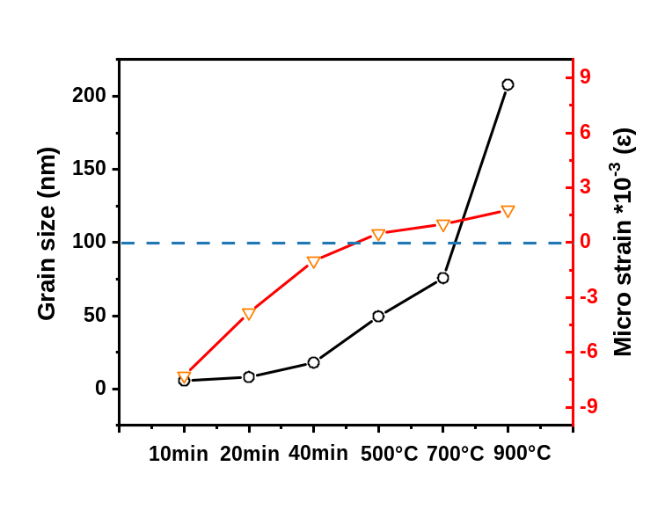
Supplementary Fig. S15. The grain size and microscopic stress of Cu crystals in different yarns calculated with the Williamson-Hall method. The internal stress of the Cu crystals before and after sintering were opposite, since the growth of Cu during the chemical plating produced outward internal stress, while the hot temperature sintering forced Cu to densify inwardly.

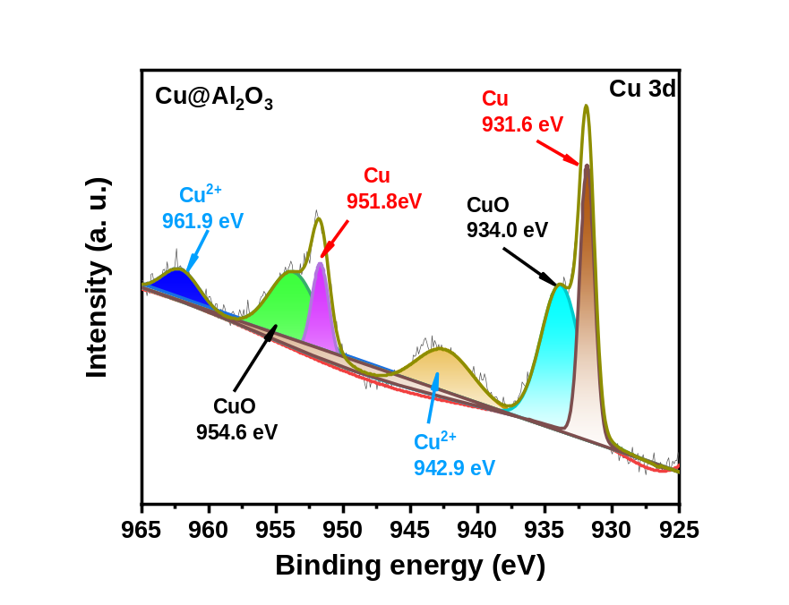
Supplementary Fig. S16. XPS spectra of the Cu@Al₂O₃ filament yarn. There was a small amount of CuO and Cu²⁺ in the initial Cu@Al₂O₃ filament yar. The photoelectron beam of XPS could only detect a depth of 10 nm of the yarn surface, and the Cu particles were dispersed spheres. Therefore, the CuO generated at the early stage of chemical plating could be detected. After sintering the Cu@Al₂O₃ filament yarn, the Cu layer became densified, so only a small amount of CuO oxidized on the Cu layer could be detected, and the intensity of the CuO peak decreased.

b
a
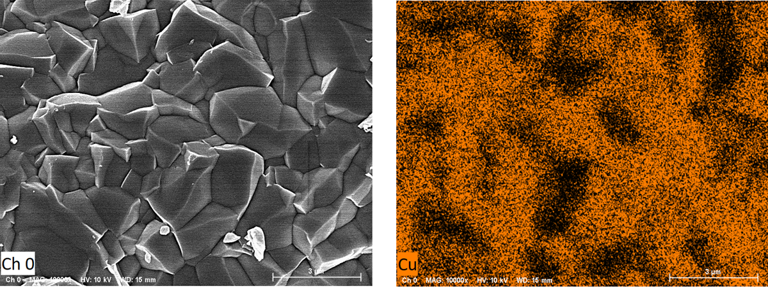
Supplementary Fig. S17. SEM morphology and the corresponding EDS mapping of the Cu@Al₂O₃ filament yarn sintered at 900 °C. From the mapping image, we can conclude that the surface of the Cu layer was densified, which could decrease the corrosion resistance and enhance the corrosion current density.

a
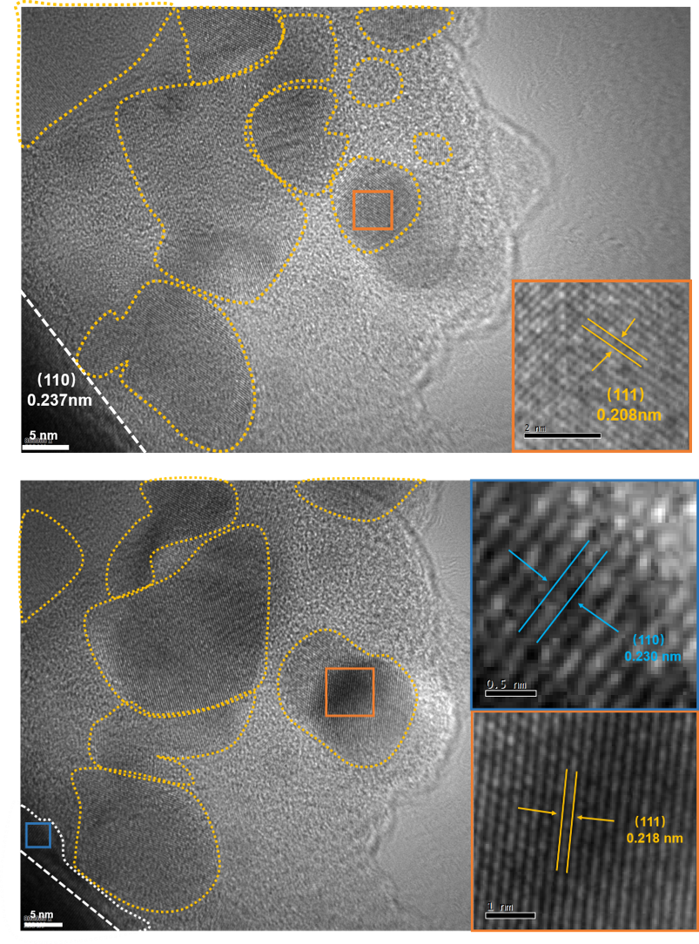
b
Supplementary Fig. S18. TEM images of the Cu@Al₂O₃ filament yarn and the Cu@Al₂O₃-900°C filament yarn without keeping the sintering time at 900 ºC. (a) The TEM image of Cu@Al₂O₃ filament yarn showed that the Cu layer contained a large amount of amorphous Cu. (b) The TEM image of Cu@Al₂O₃-900°C filament yarn without keeping warm at 900 ºC indicated that the lattice distortion started to occur due to the interaction of Cu and Al₂O₃.

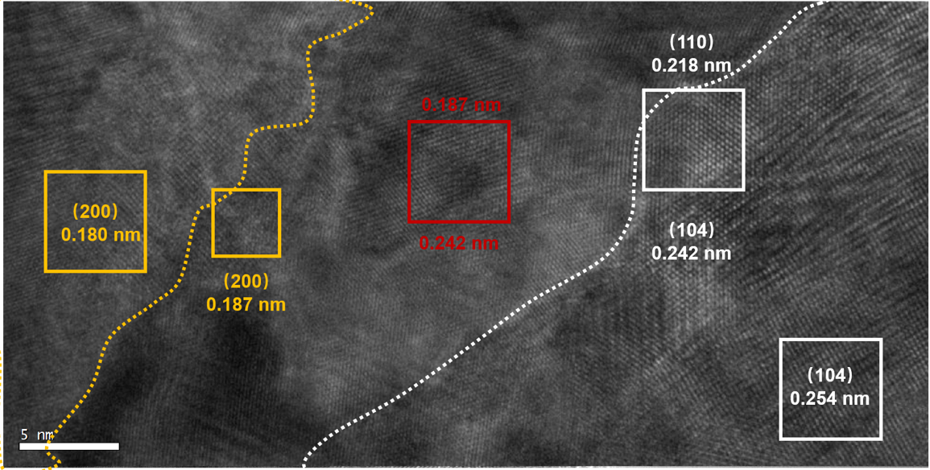
Supplementary Fig. S19. A TEM image of the Cu@Al₂O₃ filament yarn sintered at 900 ºC for 0.5 h. The lattice spacing of the (104) facet in Al₂O₃ was 0.254 nm, and the lattice spacing of the (200) facet in Cu was 0.180 nm. Between the yellow line and the white line, the interface of Cu-Al₂O₃ could be clearly observed. After being sintered at 900°C, the lattice spacing of the (104) facet in Al₂O₃ decreased to 0.242 nm, and the lattice spacing of the (200) facet in Cu increased to 0.187 nm. This lattice distortion was caused by the interaction of Cu and Al₂O. In the red box, the presence of the interplanar crystal spacing of both Cu and Al₂O₃ proved this strong interaction.

b
a
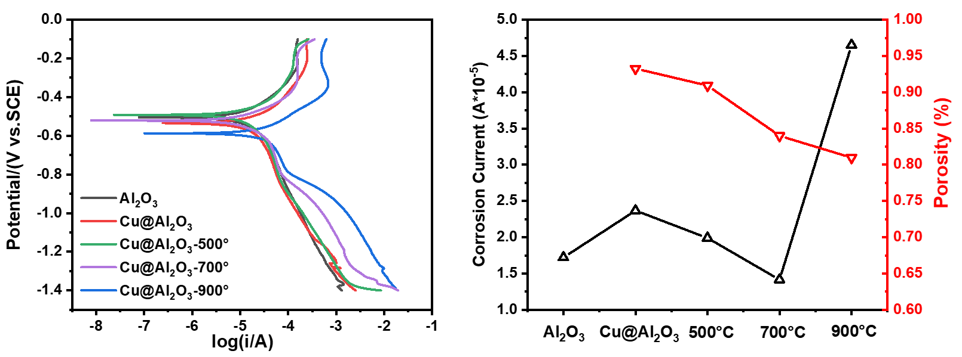
Supplementary Fig. S20. Dynamic polarization tests for different filament yarns. (a) Dynamic polarization curves of the Al₂O₃, Cu@Al₂O₃, Cu@Al₂O₃-500 °C, Cu@Al₂O₃-700 °C, and Cu@Al₂O₃-900 °C filament yarns. (b) The corrosion current and porosity of the Al₂O₃, Cu@Al₂O₃, Cu@Al₂O₃-500 °C, Cu@Al₂O₃-700 °C, and Cu@Al₂O₃-900 °C filament yarns.

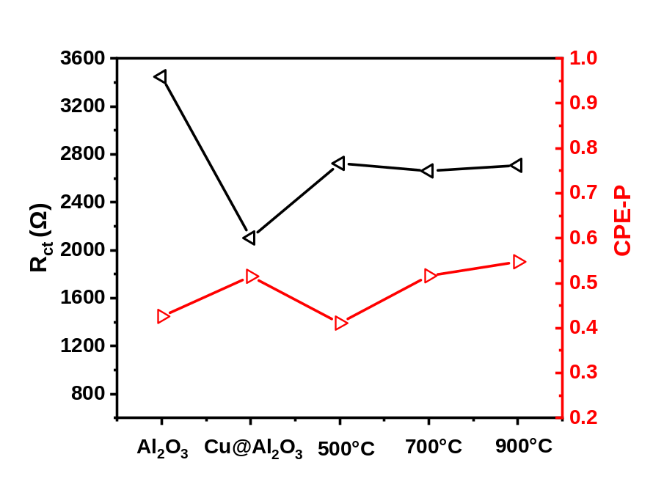
Supplementary Fig. S21. Impedance tests of different filament yarns. In the fitted circuit there were the internal resistance and CPE-P value of the Al₂O₃, Cu@Al₂O₃, Cu@Al₂O₃-500°C, Cu@Al₂O₃-700°C, and Cu@Al₂O₃-900°C filament yarns. The value of CPE-P presents the similarity to pure capacitors. When the value of CPE-P equal to 0.5, it means that the electrode interface (filament yarn surface) appears as a Warburg impedance. At the same time, the value of CPE-P presents the electrode roughness. When n=0.5, it means the fractal dimension (D) of the surface is 3. The filament yarn surface is a rough and fractal surface, and the surface branching every-which-way through space and resembling a porous cube.

b
a
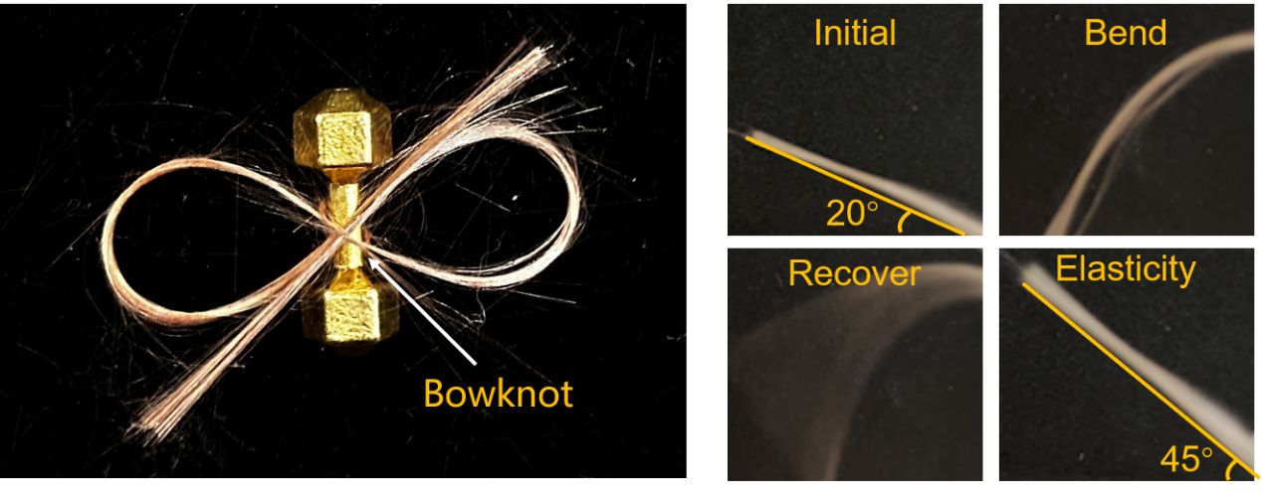
Supplementary Fig. S22. Optical graphs of the Cu@Al₂O₃ filament yarns sintered at 900 ºC. (a) The Cu@Al₂O₃ filament yarns exhibited great flexibility and could be knotted on a barbell without breaking. As a comparison, the Al₂O₃ filament yarn was brittle, and it could not be bow knotted. (b) The Cu@Al₂O₃ filament yarns had excellent bending recovery elasticity. The initial angle of the filament yarn was 20°. When a force was applied at one end of the filament yarn, it bent into a semi-circle. After the applied force was removed, the filament yarn rebounded quickly. Due to its excellent elasticity, it showed a large bending angle of more than 45°.

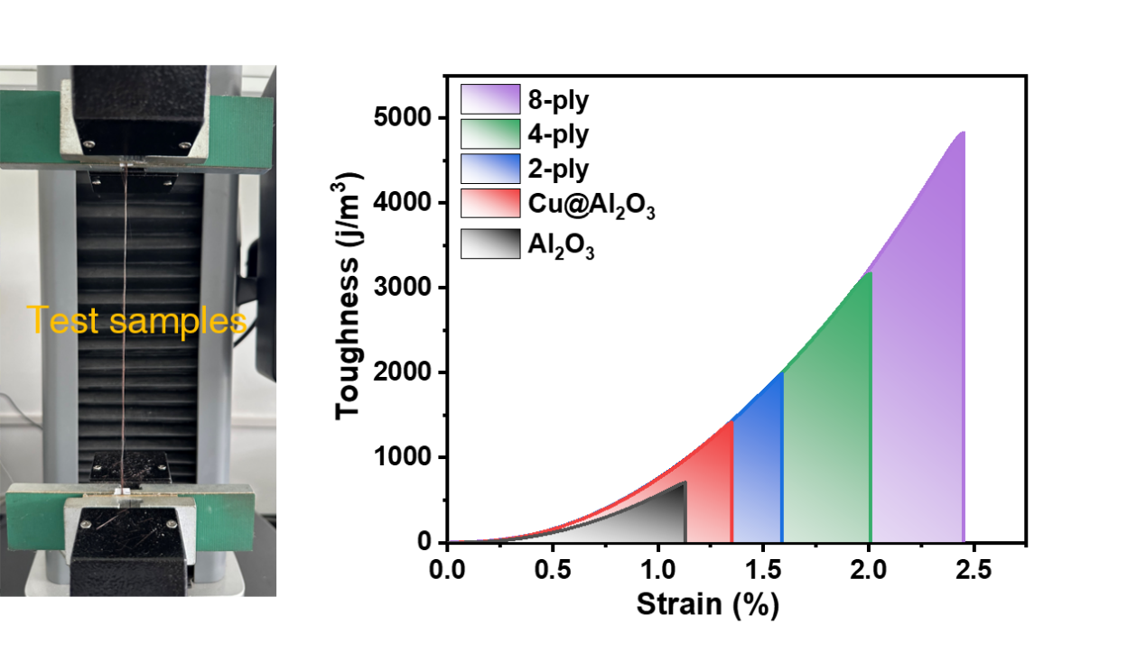
a
b
Supplementary Fig. S23. The tensile fracture test of a single Al₂O₃ filament yarn, a single Cu@Al₂O₃ filament yarn, a 2-ply homochiral hierarchical yarn, a 4-ply homochiral hierarchical yarn, and an 8-ply homochiral hierarchical yarn. (a) Optical graph of the machine for the tensile fracture testing. (b) The toughness of filament yarns under different treatments. Toughness refers to the resistance of a material to breaking when subjected to external forces, and brittle materials have poor toughness. The Al₂O₃ filament yarn was obvious a brittle material, which had a toughness lower than 1000 j/m³ and <1% strain. As a comparison, both the toughness and strain were increased for the Cu@Al₂O₃ filament yarn. Furthermore, the homochiral structure could improve the toughness of the filament yarn as well.

a
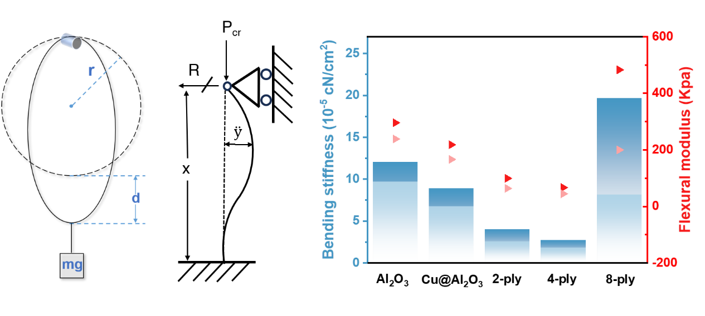
b
Supplementary Fig. S24. The bending tests of a single Al₂O₃ filament yarn, a single Cu@Al₂O₃ filament yarn, a 2-ply homochiral hierarchical yarn, a 4-ply homochiral hierarchical yarn, and an 8-ply homochiral hierarchical yarn. (a) The schematic of the test to obtain the bending stiffness B (left), and the schematic of the test to obtain the equivalent flexural modulus Eb (right). (b) A summary of the bending stiffness and flexural modulus of these yarns.

a
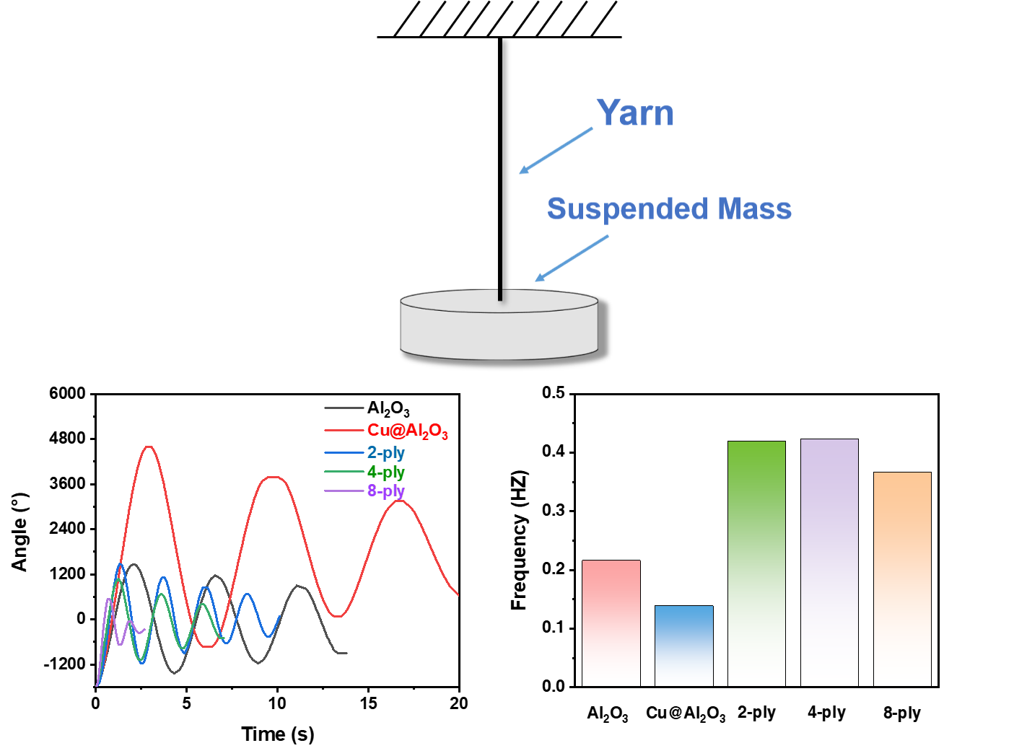
c
b
Supplementary Fig. S25. The tortional property tests of a single Al₂O₃ filament yarn, a single Cu@Al₂O₃ filament yarn, a 2-ply homochiral hierarchical yarn, a 4-ply homochiral hierarchical yarn, and an 8-ply homochiral hierarchical yarn. (a) Schematic of the torsional pendulum tests. (b) Diagram of the torsional angle of yarns over time, and (c) eigenfrequencies of yarns’ torsion obtained by Fast Fourier transforming.

b
a
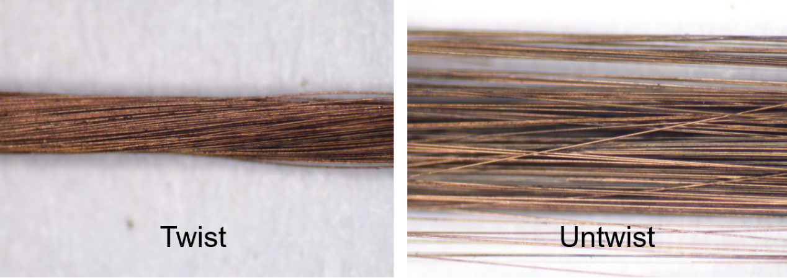
Supplementary Fig. S26. Optical photographs of the twisted and untwisted Cu@Al₂O₃ yarns. Without being sintered, the quality of the Cu layer on the filament yarn was poor, and the Cu particles were easily to fall off during torsion and bending. The inferior quality of the Cu layer was due to that the Cu particles were not connected to each other. Previous studies improved the durability of Cu layers by controlling the chemical plating time. However, a long chemical plating time would cause the bloated coating. Therefore, a lot of research tried to find a balance point to obtain an excellent quality of Cu layer. In this study, the superior quality of Cu layer could be obtained by sintering the Cu@Al₂O₃ filament yarn at 900 ºC in argon. After twisting and untwisting the filament yarn, the Cu layer was still smooth, and the conductivity of the filament yarn had not changed.

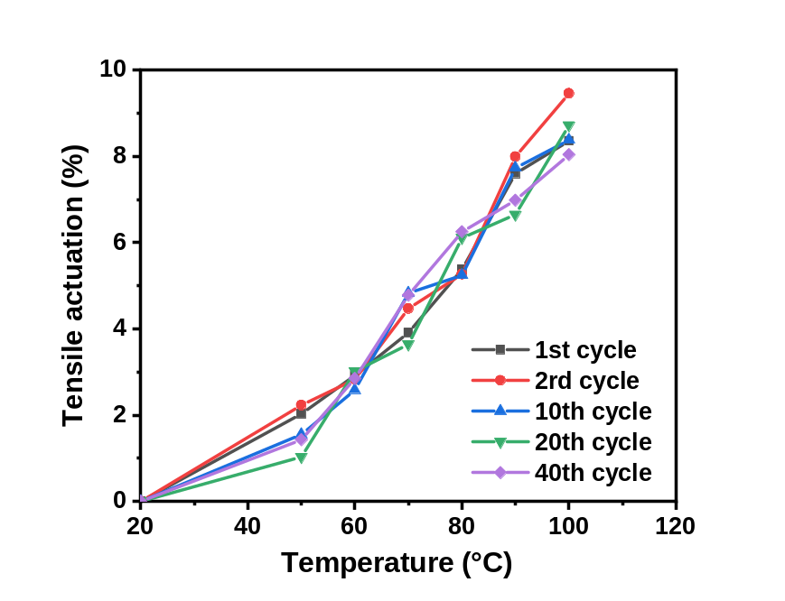
Supplementary Fig. S27. Actuation performance diagram of the homochiral coiled ceramic artificial muscles (HCCAMs) after 40 cycles’ actuation training processes. After fixing both ends of the filament yarn containing paraffin and hanging the weight to obtain the HCCAM, the HCCAM should be trained several times to remove the excessive paraffin on the surface and formed a stable actuation performance.

c
b
a
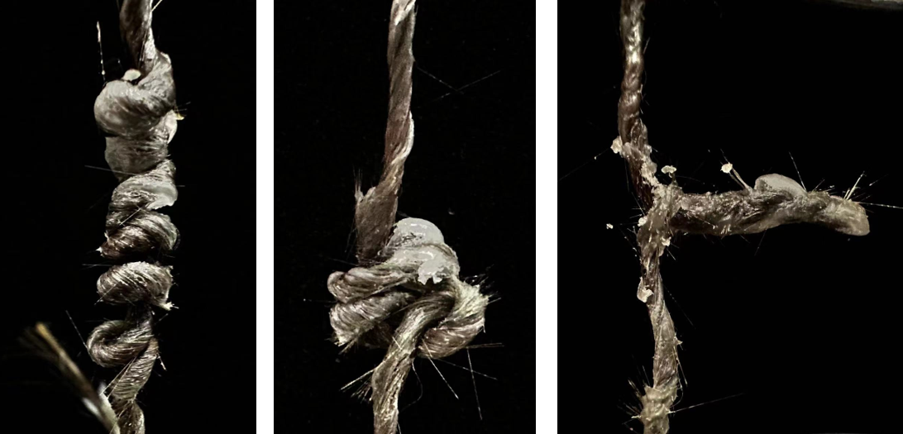
Supplementary Fig. S28. Optical photographs of the topological transformation process of HCCAM containing paraffin with a decrease in the viscosity of paraffin. (a) The HCCAM could be obtained by twisting the 8-ply filament yarn in the high viscosity field. (b) After that, heating the paraffin to decrease the viscous force of viscosity field, the topological structure of HCCAM changed into chaotic. (c) If continued to heat the paraffin, the HCCAM finally became the DNA supercoiled structure.

b
a
Supplementary Fig. S29. Cycling stability tests of the HCCAM under different actuation stresses. (a) Under an actuation stress of 241.8 MPa, the tensile actuation of HCCAM changed by heating and cooling. The red color represents the heating, and the white color represents the cooling. Driven by heating, the HCCAM produced a ~6% actuated stroke in 12 seconds, and with the help of the cool gun, the HCCAM could be restored to original solenoid structure. Furthermore, the actuation performance of HCCAM remained stable after 5 cycles. (b) Comparison of the actuation performance of HCCAM through thermal drive under the actuation stresses of 96.7 MPa and 483.5 MPa. The HCCAM could produce a larger actuated stroke under an actuation stress of 96.7 MPa than that with an actuation stress of 483.5 MPa. While the HCCAM had a faster speed to restore the solenoid structure under the actuation stress of 96.7 MPa.

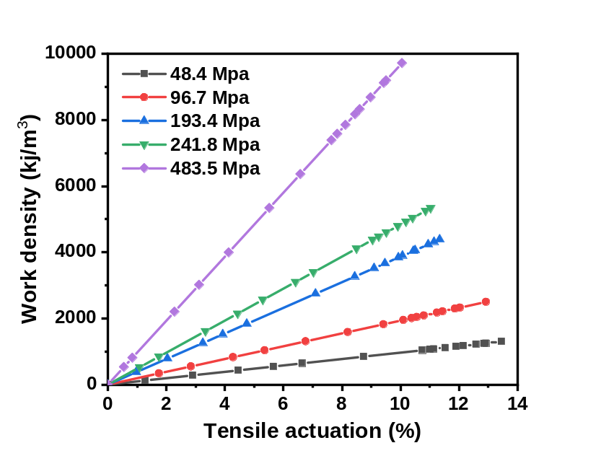
Supplementary Fig. S30. The energy density of HCCAMs under volume normalized conditions. Under the larger actuation stress, the HCCAM generated the less tensile actuation while it could provide a huger work density. The huge work density of the HCCAM stemmed from a shift in topology structure. When the viscous force of the viscous flow field decreased, the topology of the HCCAM changed from the solenoid structure to the DNA supercoiled structure. This topology transformation was spontaneous, thus leading to the huge work density.

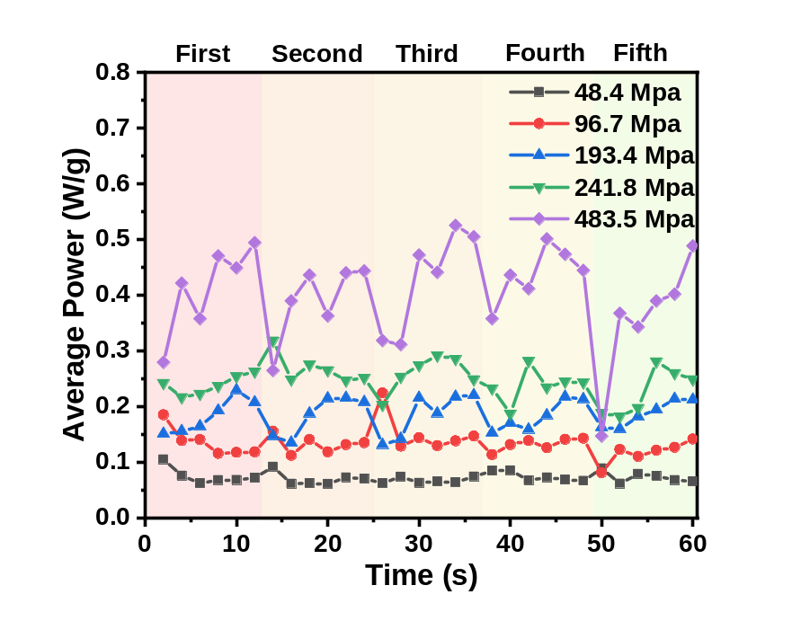
Supplementary Fig. S31. Calculations of the average power of HCCAMs under different actuating stresses in 5 cycles. Under the actuation stresses of 48.4 MPa and 96.7 MPa, the average power of HCCAM was steady, while under the actuation stresses of 193.4 MPa, 241.8 MPa, and 483.5 MPa, the average power of HCCAM became unsteady. The large actuation stress (usually above 193.4 MPa) of HCCAM produced by the topology transformation. This topology transformation was uncontrollable, spontaneous, thus there were some abnormally increased power points under the actuation stress of 976.7 MPa.

b
a
Supplementary Fig. S32. Electrothermal performance tests of the HCCAM. (a) Diagram of the maximum temperature and consumption time that a single Cu@Al₂O₃ filament yarn could achieve at different voltages. Under the voltage of 5 V, the maximum temperature of the Cu@Al₂O₃ filament yarn could reach up to 900 °C. However, the elevated temperature would lead to the generation of a large amount of CuO on the surface of Cu layer, thus the resistance of the filament yarn sharply increased. The time it took for yarn to reach the maximum temperature increased exponentially, because as the filament yarn temperature increased the heat dissipation power also increased. (b) Schematic diagram of the electric drive of HCCAM.

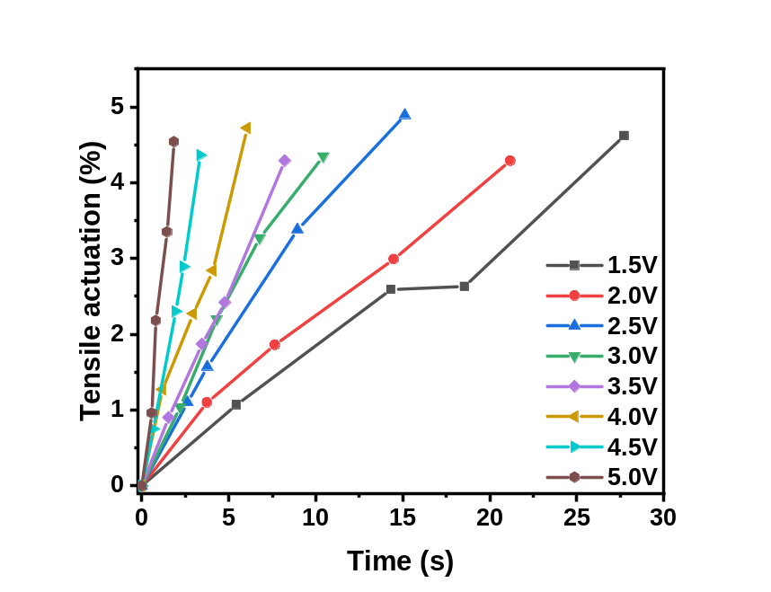
Supplementary Fig. S33. Tensile actuated of HCCAM driven by different voltages. The greater the voltage applied on the HCCAMs, the less time it took for HCCAMs to generate the same actuated stroke. The impressive performance of the HCCAMs generated by the resistance as low as 1 Ω. The low resistance produced a large power up to 25 W for the HCCAM under the voltage of 5 V, while the HCCAM could only produce 2.25 W power under 1.5 V.

b
a
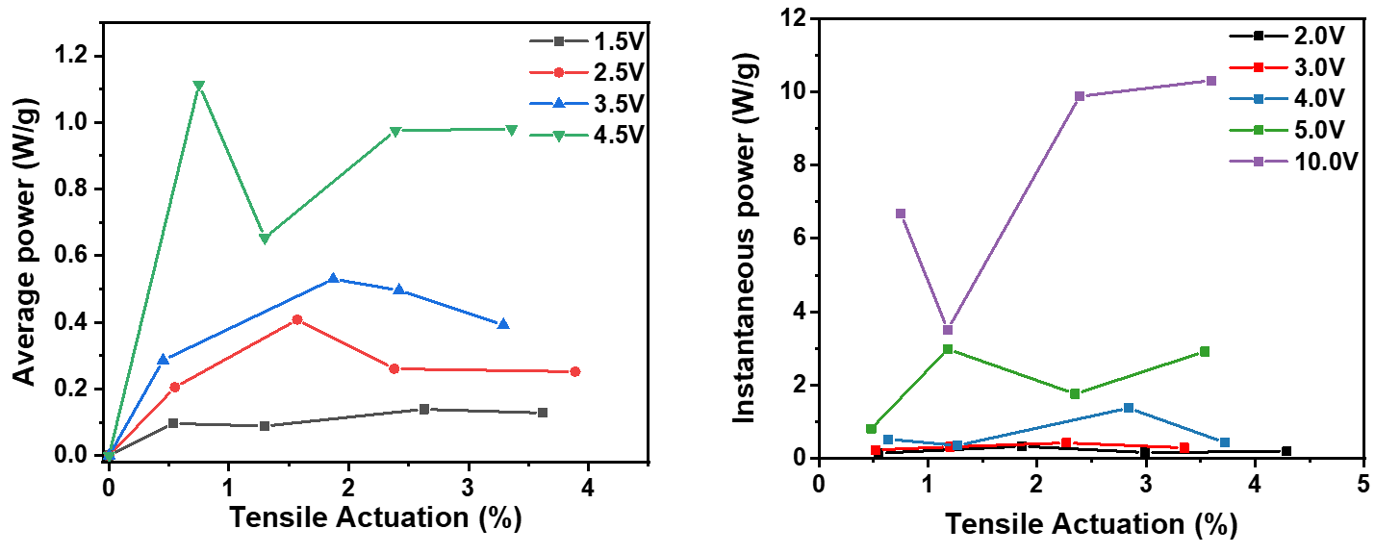
Supplementary Fig. S34. Tensile actuation of HCCAMs under different voltages. (a) The average powers of HCCAMs when tensile actuated under the voltages of 1.5 V, 2.5 V, 3.5 V, and 4.5 V. (b) The instantaneous powers of HCCAMs for every ~1% tensile actuation generated under the voltages of 2.0 V, 3.0 V, 4.0 V, and 5.0 V. When the voltage applied on the HCCAM increased, more power was produced for the HCCAM. Moreover, when the HCCAM generated a too much larger power, the output power of the HCCAM became unstable. Under the larger voltage, the HCCAM would be more easily to transform the topology structure, thus the uncontrollable topology transformation led to the unstable output power.

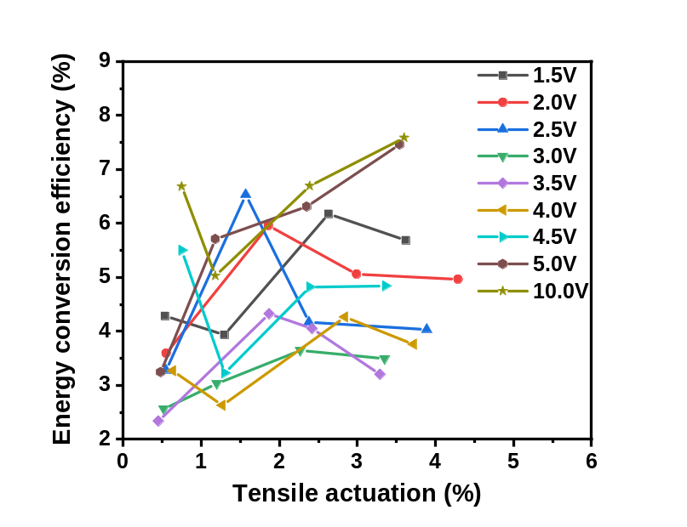
Supplementary Fig. S35. The instantaneous energy conversion efficiency of HCCAMs generated per 1% tensile actuation under the voltages of 1.5 V, 2.0 V, 2.5 V, 3.0 V, 3.5 V, 4.0 V, 4.5 V, 5.0 V, and 10.0 V. The energy conversion efficiency of the HCCAMs were chaotic, while they were all above 2%. For other artificial muscles, the maximum energy conversion efficiency usually less than 1%. Such high energy conversion efficiency came from the topology transformation, and the topology transformations were easily affected by the internal friction of the filament yarns. Therefore, the energy conversion efficiency of the HCCAMs could not always maintain 7%.

a
b
Supplementary Fig. S36. Characterizations of Cu in the early stage of chemical plating. (a) Optical photograph of Cu in the early stage of chemical plating. (b) XPS spectra of the Cu@Al₂O₃ filament yarns in the early stage of chemical plating. In the early stage of chemical plating, the grain size of the Cu particles was ~10 nm, which had a strong chemically activation. The Cu particles could react with the dissolved oxygen in the deionized water to generate CuO. On the other hand, the reducing properties of dopamine were too weak to protect Cu from oxidation.

Supplementary Videos

Video S1.
Topological transformation process of the homochiral coiled ceramic artificial muscle from a solenoid structure to a DNA supercoiled structure.

Video S2.
Electric actuation of the homochiral coiled ceramic artificial muscle under a stress of 483.5 MPa with a voltage of 10 V.

