Table of Contents

Supplementary Table 1: Support Vector Machine Classification 2
Supplementary Figure 1: Data Split. 2
Supplementary Table 2: Confusion Matrix. 2
Supplementary Table 3: Class Proportions. 2
Supplementary Table 4: Evaluation Metrics 3
Supplementary Figure 2: ROC Curves Plot. 4
Supplementary Figure 3: Andrews Curves Plot. 5
Supplementary Figure 4: Decision Boundary Matrix. 6

Support material

A linear support vector classification approach was used to classify addiction or not by betaMB, craving, BASBIS_inhibition, BASBIS_reward.

Supplementary Table 1: Support Vector Machine Classification
Support Vectors | n(Train) | n(Test) | Test Accuracy
51 | 97 | 24 | 0.833

Note. The trained model is not saved until 'Save trained model' is checked.

Supplementary Figure 1: Data Split

Supplementary Table 2: Confusion Matrix
 |  | Predicted
 |  | HC | IA
Observed | HC | 0.33 | 0.12
Observed | IA | 0.04 | 0.5

Supplementary Table 3: Class Proportions

 | Data Set | Training Set | Test Set
HC | 0.504 | 0.515 | 0.458
IA | 0.496 | 0.485 | 0.542

Supplementary Table 4: Evaluation Metrics
 | HC | IA | Average / Total
Support | 11 | 13 | 24
Accuracy | 0.833 | 0.833 | 0.833
Precision (Positive Predictive Value) | 0.889 | 0.800 | 0.841
Recall (True Positive Rate) | 0.727 | 0.923 | 0.833
False Positive Rate | 0.077 | 0.273 | 0.175
False Discovery Rate | 0.111 | 0.200 | 0.156
F1 Score | 0.800 | 0.857 | 0.831
Area Under Curve (AUC) | 0.825 | 0.825 | 0.825
Negative Predictive Value | 0.800 | 0.889 | 0.844
True Negative Rate | 0.923 | 0.727 | 0.825
False Negative Rate | 0.273 | 0.077 | 0.175
False Omission Rate | 0.200 | 0.111 | 0.156
Threat Score | 1.600 | 1.714 | 1.657
Statistical Parity | 0.375 | 0.625 | 1.000

Note. All metrics are calculated for every class against all other classes.

Supplementary Figure 2: ROC Curves Plot

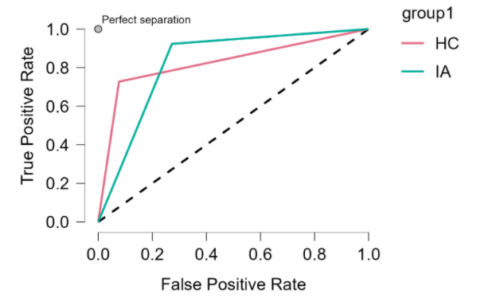
Legend: ROC，Receiver Operating Characteristic. ROC is the probability curve and it is used to measure the performance of machine learning models for classification problems at different thresholds.

Supplementary Figure 3: Andrews Curves Plot

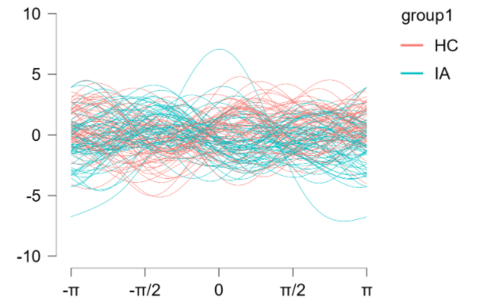
Legend: Andrews Curves is a method for visualizing multidimensional data by mapping each observation to a function. Andrews Curves greatly facilitates the visualization of homogeneity and it helps to detect anomalies. The blue line represents IA, and the red line represents HC. It can be seen that the fluctuation within the group has a certain pattern, and there is a difference between the two groups.

Supplementary Figure 4: Decision Boundary Matrix

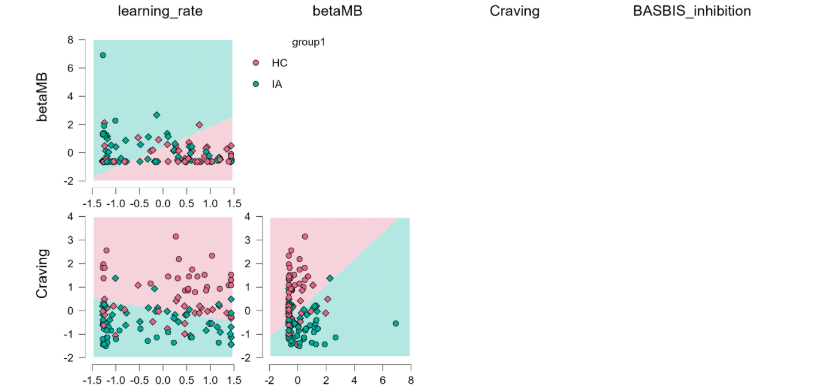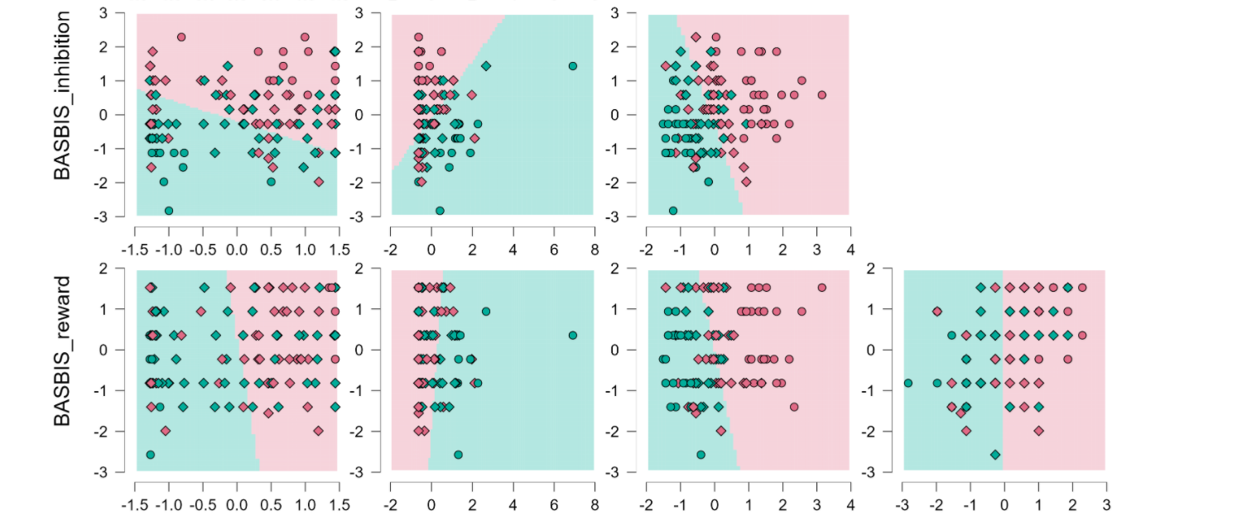

Legend: The samples are classified according to different features and decision boundaries are fitted. With decision boundaries, the classification results are better visualized. The boundary on the graph is a decision boundary composed of two variables, the blue-green area represents IA, and the pink area is HC. The rhombus is IA and the circle is HC.

