Graphical abstract:

Development of glucose/pH responsive smart hydrogel of carbopol and application in microneedles

Mingli Pi¹, Weijun Liu¹∗ , Beibei Huang¹, Tingxuan Wu¹, Tao Zhang¹, Wei Wang²

A hydrogel made from a new carbopol polymer derivative, which has good sensitivity to glucose concentration changes in addition to the solution pH. These features were heightened by the introducing ammoniated ZnO nanoparticles and related to the hydrogel morphology from initial regular lamellar into irregular sheet along with porous structure. Two types of microneedles gained from the resulting materials displayed sufficient stiffness for piercing pigskin. The releases in vitro and pulsatile tests of insulin-loaded microneedles verified that the loaded drug could control to be released, implying that the developed smart materials exist potential application in the field of biomedicine.

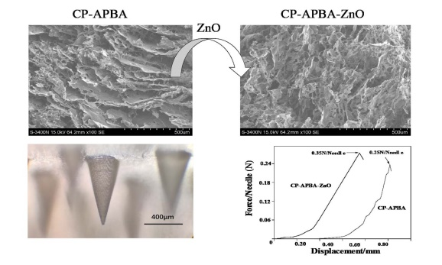

∗ Corresponding author, E-mail: liuwj@sit.edu.cn, Tel: 021-60877214

