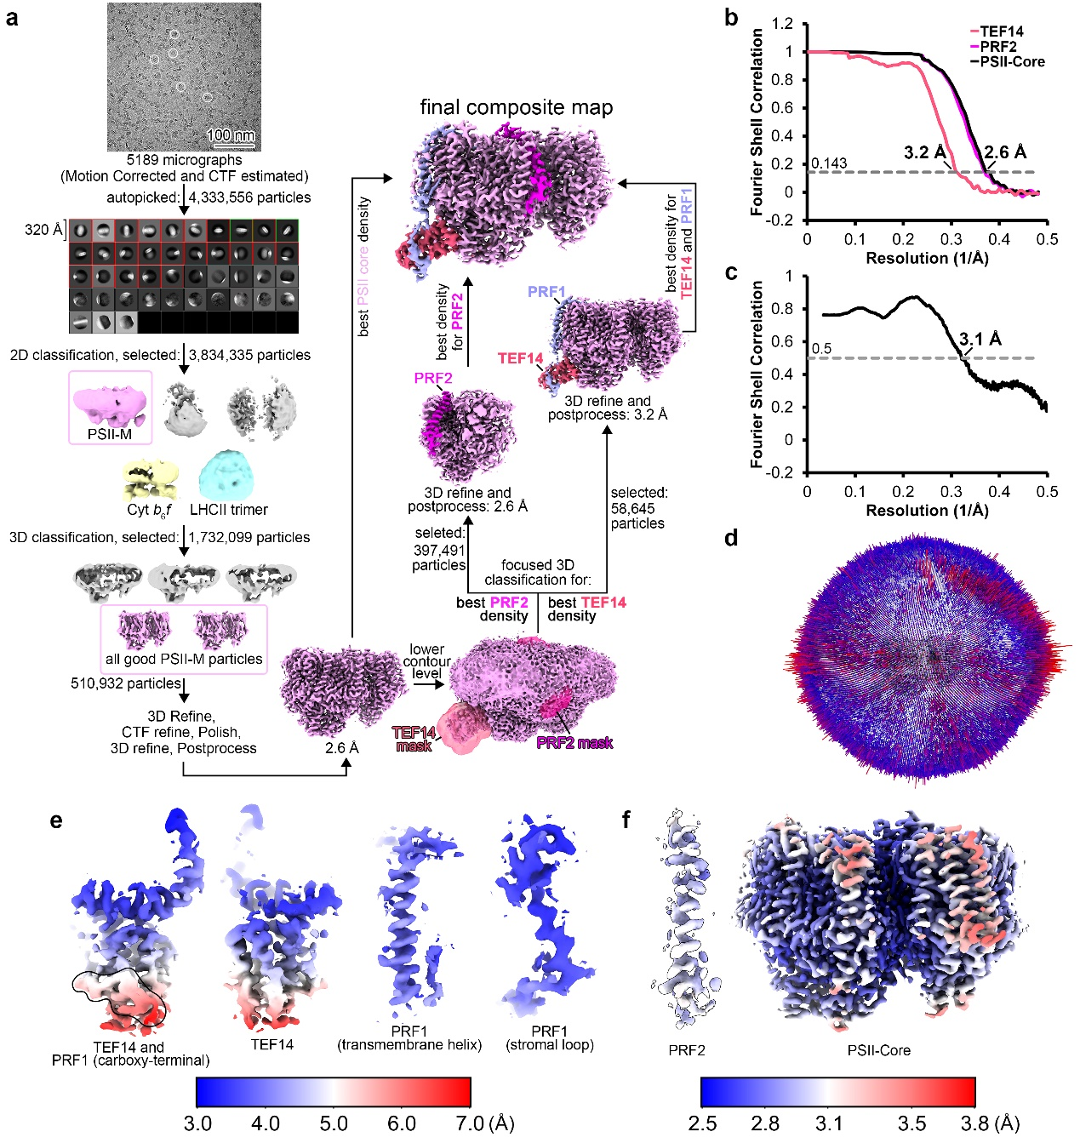
Extended Data Fig. 1: Single particle cryo-EM analysis work flow and evaluation for the PSII-TPP complex from the C. reinhardtii pph1;pbcp mutant strain. a, The overall scheme for the single particle cryo-EM data processing procedure. Representative PSII-M particles are highlighted by white circles in the micrograph. All selected classes potentially containing PSII-M particles are framed by rectangles, while the representative PSII-M 2D averaged classes are highlighted by green squares. b, The gold standard Fourier shell correlation (GSFSC) curves of local refined density maps with a resolution-cutoff threshold at 0.143. c, The Fourier shell correlation (FSC) curves between the structural model and the composite cryo-EM density map of the PSII-TPP complex. d, Representative orientational distribution plot of 58,645 3D-refined particles of the PSII-TPP complex with the best TEF14 and PRF1 density at an overall resolution of 3.2 Å. The map with the best densities of the PSII core, TEF14/PRF1 and PRF2 region yielded an E_{od} value of 0.8, 0.8 and 0.79, respectively. The high E_{od} values indicate that the orientational distributions of the three datasets are all in a reasonable range. e and f, Local resolution estimations of the TEF14, PRF1, PRF2 and PSII core part of the final composite map. The carboxy-terminal region of PRF1 is circled by the black line in (e).

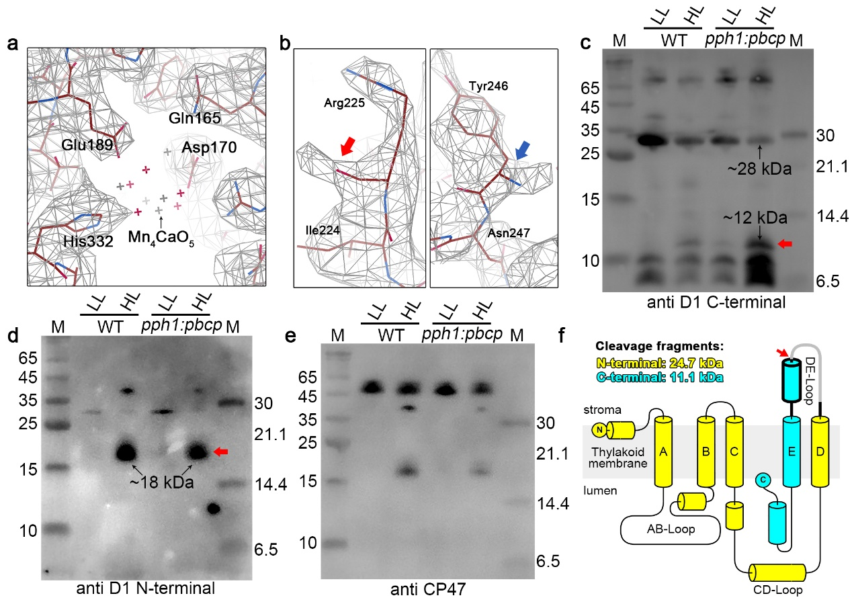Extended Data Fig. 2: The structural and biochemical evidences suggesting the D1 subunit in the PSII-TPP complex is at a damaged state. a, The cryo-EM density of the local region around the empty Mn-cluster binding site in the PSII-TPP complex. The atomic model of the Mn-cluster (gray and red crosses) is docked into its binding site by fitting the model of a PSII-LHCII supercomplex (PDB ID: 6KAC) into the PSII-TPP density map. b, The cryo-EM densities at the local regions around Arg255 and Tyr246 residues of the D1 subunit in the PSII-TPP complex. The α-carboxyl group of Arg225 and the α-amino group of Tyr246 were indicated respectively as red and blue arrows. Evidently, the cryo-EM density for the loop connecting the two residues is either very weak or absent. c and d, The western blot analysis of the PSII-M or PSII-TPP samples prepared from the WT and pph1;pbcp strains acclimated under low light (LL) and high light (HL) conditions. The antibodies against the carboxy-terminal (c) and amino-terminal fragment (d) of D1 were used to detect potential degradation products of the D1 proteins. The bands corresponding to the D1 amino/carboxy-terminal fragments were indicated by red arrows. Note that the apparent molecular weight detected for the amino-terminal fragment of D1 in d appears lower than expected (~25 kDa as estimated in f). The highly hydrophobic nature of the amino-terminal fragment of the D1 apoprotein might make the protein resistant to the denaturing effect of SDS so that it could migrate on the gel in a partially unfolded state and faster than expected during SDS-PAGE. It is also the case for the full length D1 apoprotein which also migrates faster than expected on SDS-PAGE gel. e, The western blot of the SDS-PAGE gel probed with the antibody against CP47 as the loading control for the different PSII-M or PSII-TPP complex samples. LL and HL refer to the conditions with light intensities of 20 and 330 μmol·photons m²·s⁻¹, respectively. f, A topological diagram of the D1 apoprotein. The putative proteolytic degradation site at the DE loop is marked by a red arrow. After proteolytic cleavage at the site, the large fragment in yellow corresponds to a 24.7-kDa amino-terminal fragment and the smaller one in cyan is a 11.1-kDa carboxy-terminal fragment. The local region of the DE loop with unobserved cryo-EM density is shown as gray.

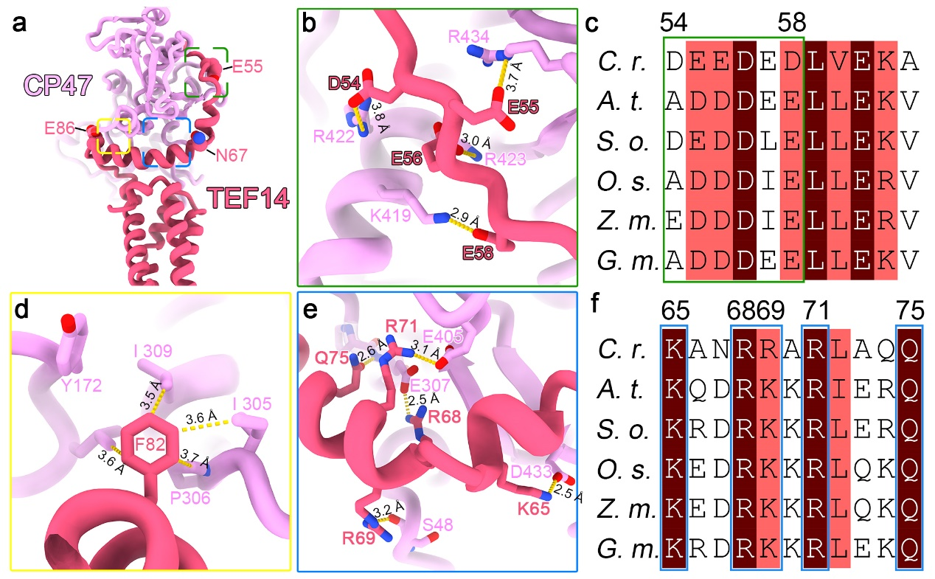
Extended Data Fig. 3: Interactions between TEF14 and CP47. a, The binding site of TEF14 at the lumenal surface of CP47. E55, N67 and E86 from the amino-terminal region of TEF14 are shown as spheres. b, d and e, The detailed interactions between three local regions at the amino-terminal helix of TEF14 and their nearby amino acid residues from CP47. c and f, Sequence alignment of CrTEF14 with various MPH2 homologs from higher plants showing the conserved CP47-binding residues (framed by green and blue rectangles corresponding to those shown in d and g respectively). A. t., S. o., O. s., Z. m. and G. m. stand for Arabidopsis thaliana, Spinacia oleracea, Oryza sativa, Zea mays and Glycine max, respectively.

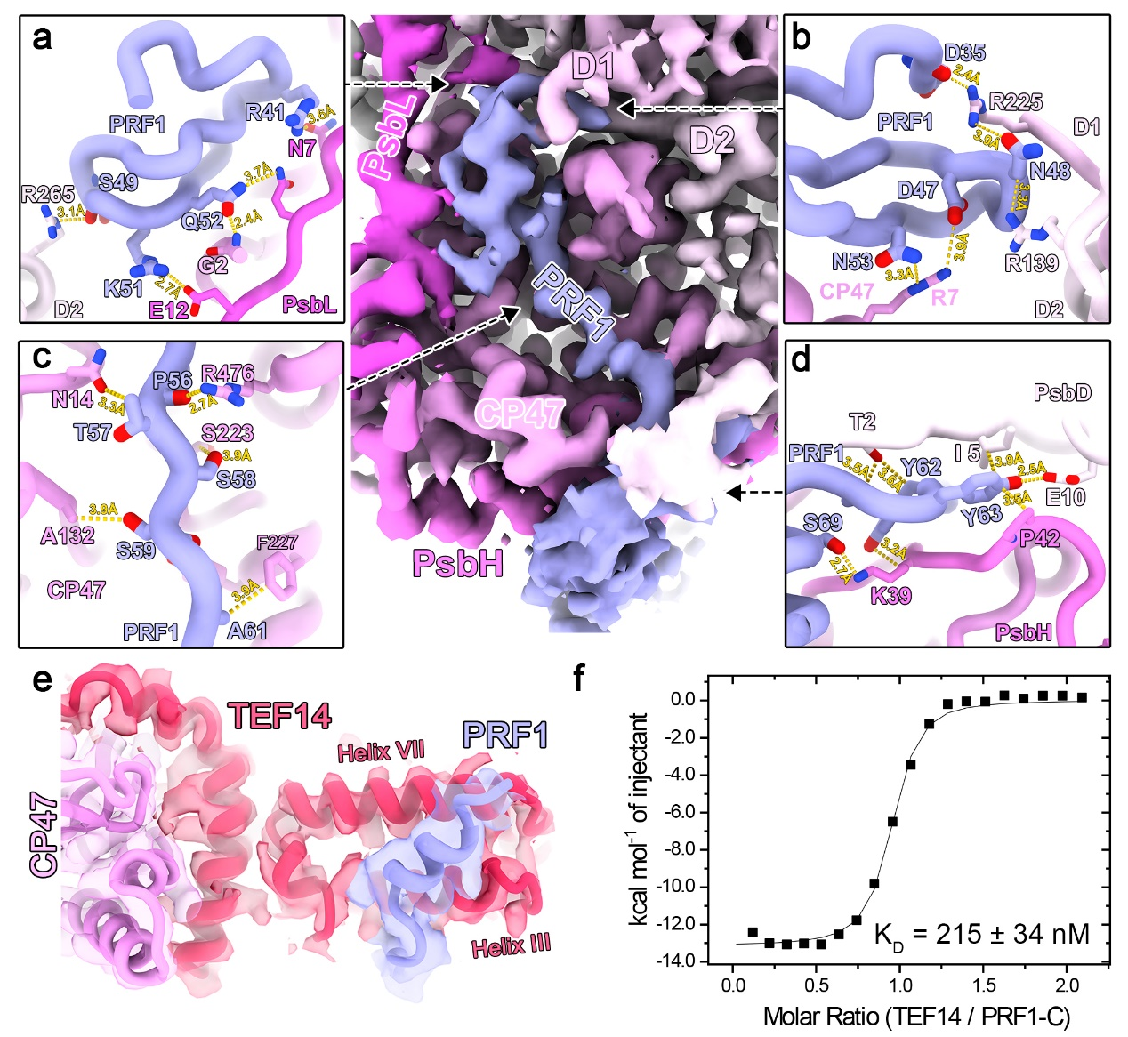
Extended Data Fig. 4: Interactions between PRF1 and PSII-M/TEF14. a and b, The amino-terminal hairpin structure of PRF1 forms extensive interactions with amino acid residues from D1, D2, CP47 and PsbL. c, The loop connecting the hairpin motif and the transmembrane helix of PRF1 at the amino-terminal region is embedded in a stromal surface groove of CP47. d, Two consecutive tyrosine residues from PRF1 are sandwiched between D2 and PsbH. e, The interactions between the carboxy-terminal helix of PRF1 and the five-helical-bundle domain of TEF14. The cartoon model is superposed on the Cryo-EM density map (transparent). f, The isothermal titration calorimetry (ITC) analysis on the kinetics of interactions between TEF14 and the carboxy-terminal region of PRF1. The result is fit with the single-site-binding isotherm model with ΔH = -13.1 ± 0.2 kcal/mol and K_{D} = 215.0 ± 34.2 μM.

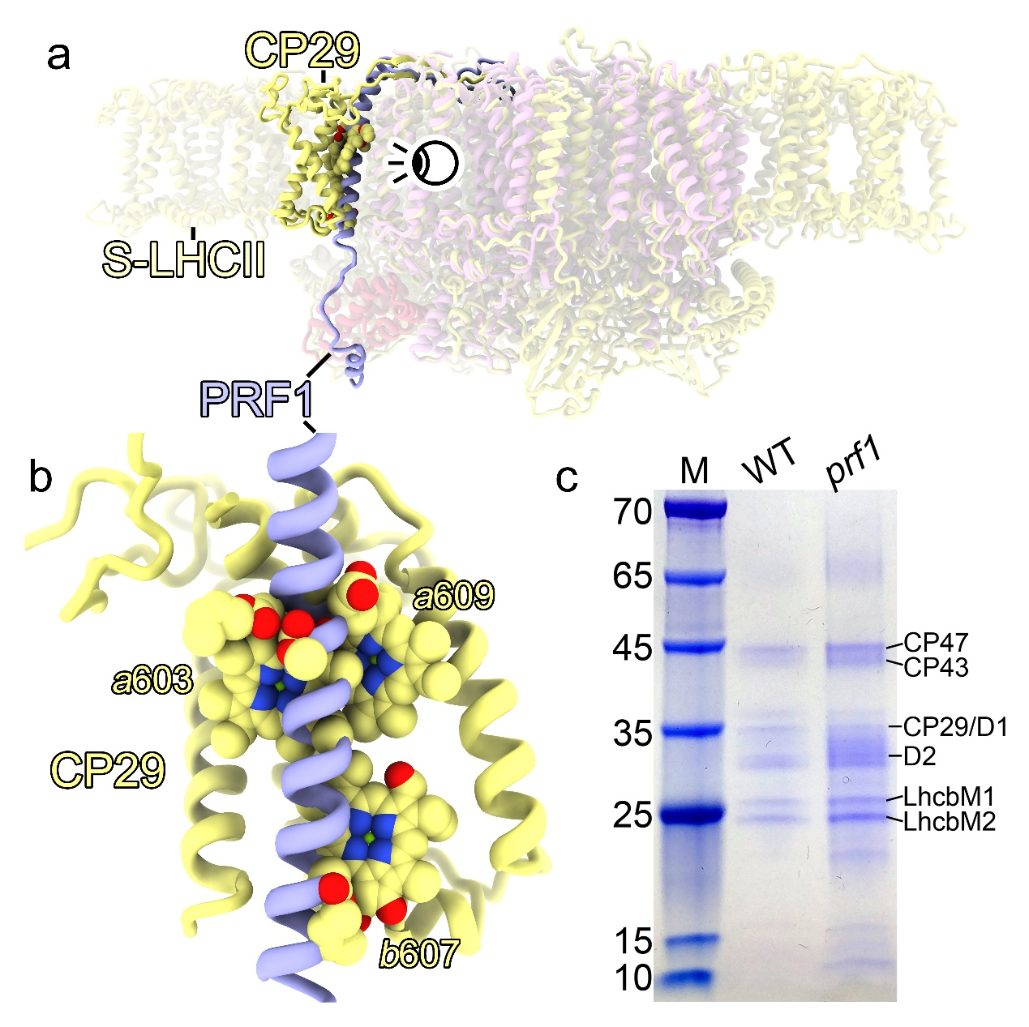
Extended Data Fig. 5: The binding site of PRF1 in the PSII-TPP complex overlaps largely with that of CP29 in the PSII-SC complex. a, Superposition of the PSII-TPP complex (blue, red and magenta) with the low light adapted PSII-SC complex (yellow). The chlorophyll molecules from CP29 which overlap with PRF1 are shown as spheres. The eye symbol represents the viewing angle of (b). b, A zoom-in view of the local membrane-embedded region showing the overlapping parts of PRF1 and CP29. c, SDS-PAGE analysis confirms that the enriched SDG band marked by the light purple arrow in Fig. 4c prepared from the prf1 mutant cells is composed of PSII-SC complex, whose components are highly similar to those from the corresponding fraction prepared from the WT cells.

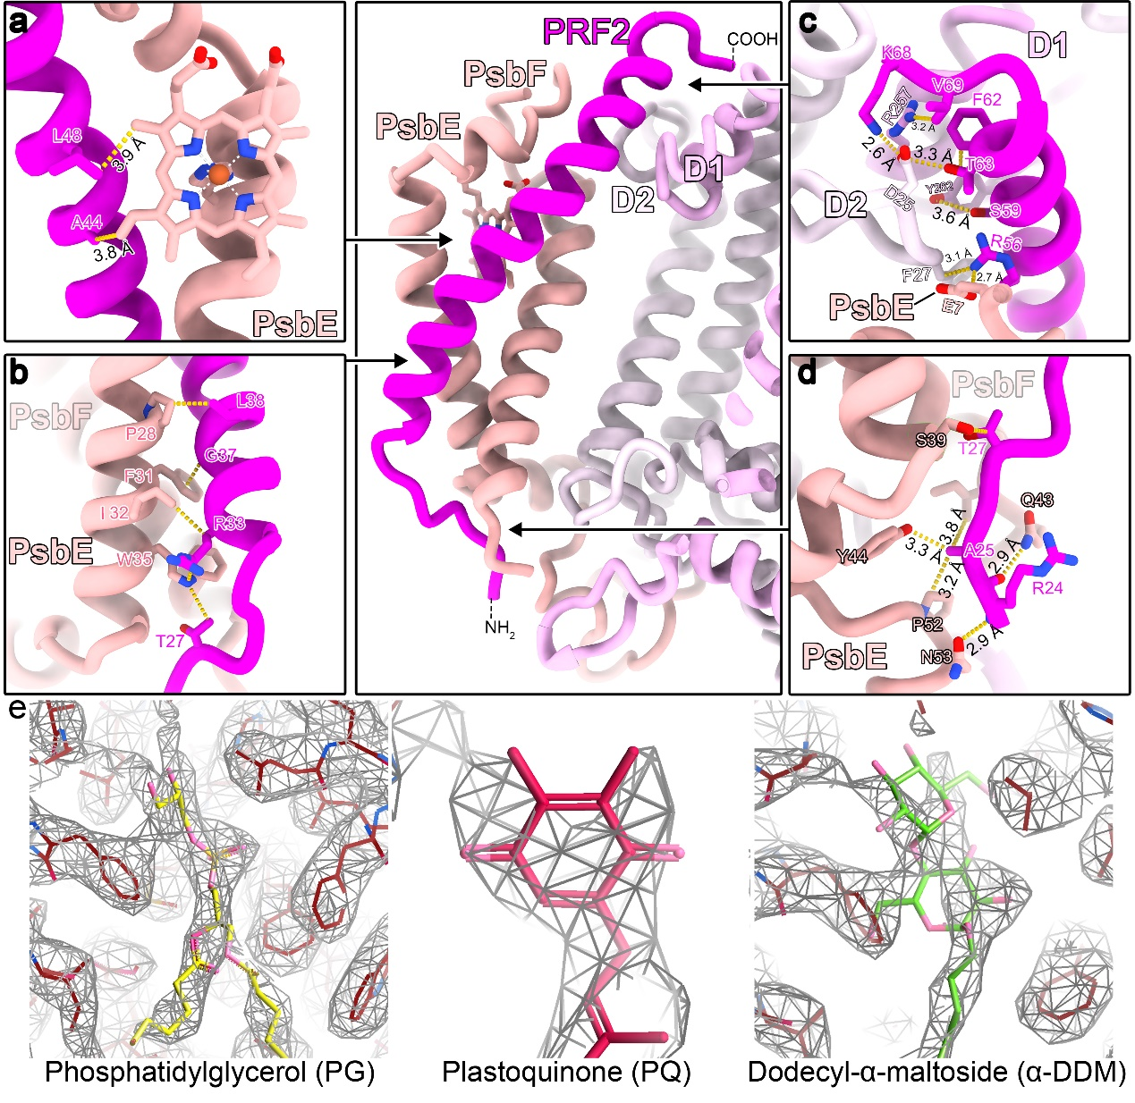
Extended Data Fig. 6: Interactions between PRF2 and PSII-M. a and b, The transmembrane helix of PRF2 forms multiple van der Waals interactions with PsbE/F. c, The carboxy-terminal region of PRF2 extends to the stromal side and is clamped between PsbE-PsbF and D1-D2. d, The amino-terminal region of PRF2 interacts with PsbE/F at the lumenal side. e, The local cryo-EM density around the Q_{B} site with a putative lipid (PG) molecule. The density is overlaid with the structural models of PG (left), PQ (middle) or α-DDM (right). It is evident that the PG model fits well with the density, whereas those of PQ and α-DDM do not match with the density.

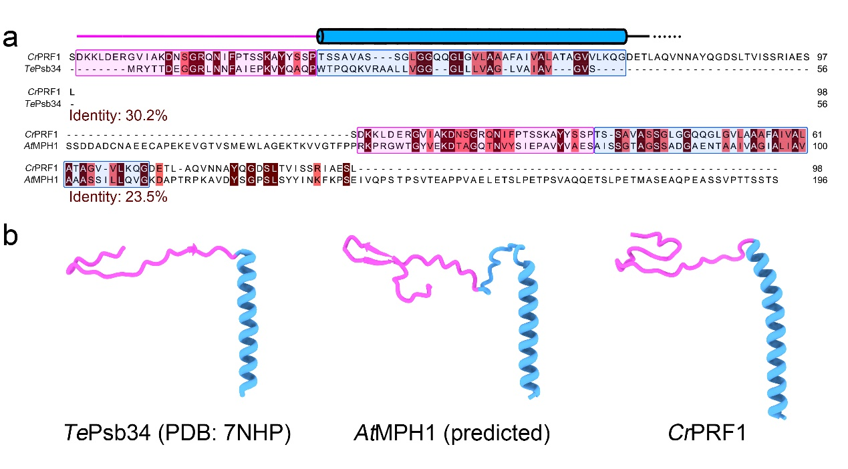
Extended Data Fig. 7: Sequence alignment and structural comparison among CrPRF1, TePsb34 and AtMPH1. a, sequence alignment between CrPRF1 and TePsb34, and between CrPRF1 and AtMPH1. A scheme drawing of the secondary structure of CrPRF1 is labeled above the sequence. The amino-terminal regions and the transmembrane helix regions are framed by magenta and blue rectangles, respectively. The identities of the sequence pairs were listed below the alignment results. b, The structural models of TePsb34 (PDB: 7NHP) and AtMPH1 (predicted by AlphaFold2⁸³) in comparison with the cryo-EM structure of CrPRF1 (reported in this work). The carboxy-terminal regions and the disordered amino-terminal region of AtMPH1 and CrPRF1 are omitted for clarity.

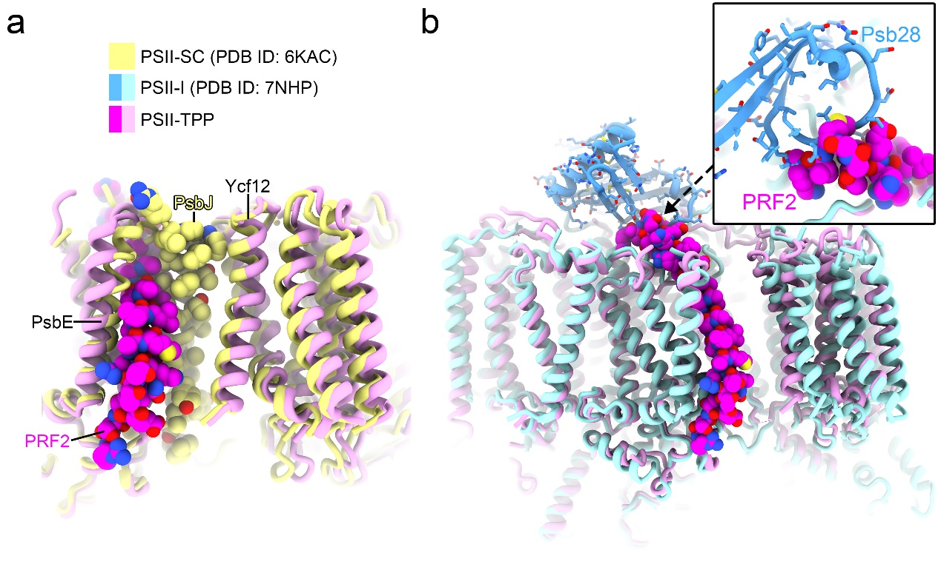
Extended Data Fig. 8: PRF2 partially overlaps with the binding sites of PsbJ and Psb28. a, The structural model of PSII-TPP is superposed with that of the low-light adapted PSII-SC complex (PDB ID: 6KAC). b, Superposition of PSII-TPP with the PSII assembly intermediate complex (PSII-I, PDB ID: 7NHP). PsbJ and PRF2 are shown as spheres, Psb28 in PSII-I is shown as cartoon and stick models.

