SUPPLEMENTAL TABLES

Supplemental Table 1. Additional details of patient subgroups.
Infection group (n=51)
 | n |  | ESR, mm/h |  | CRP, mg/dl | WBCs /µl | sCAL, ng/ml
All samples | 51 |  | 65  (5-109) |  | 8.0  (1.2-44.1) | 11,375  (3,400-38,000) | 5,350  (250-18,500)
Proven bacterial infections | 19 |  | 70 (18-109) |  | 9.3 (1.7-44.1) | 12,500  (4,300-38,000) | 7,110  (550-14,600)
Proven viral infections | 7 |  | 63 (32-86) |  | 8.8 (1.2-20.4) | 7,000  (3,790-16,410) | 5,360  (2,550-18,500)
Clinically diagnosed infections | 25 |  | 60 (5-100) |  | 7.3 (1.2-41.0) | 10,400  (3,400-38,000) | 3,540  (250-17,270)
SID group (n=126)
 | n |  | ESR, mm/h |  | CRP, mg/dl | WBCs /µl | sCAL, ng/ml
All samples | 126 |  | 27  (1-140) |  | 4.3  (1.0-32.8) | 9,520  (1,100-25,000) | 2,770  (270-19,290)
Connective tissue diseases | 5 |  | 18 (7-90) |  | 3.7 (1.1-14.0) | 6,950  (3,960-13,000) | 13,370  (1,210-19,290)
Lymphoproliferative Disorder | 3 |  | 70 (8-132) |  | 2.8 (2.1-32.0) | 11,900  (8,000-19,560) | 12,270  (2,660-14,640)
Osteitis | 4 |  | 50 (6-53) |  | 5.3 (1.0-8.0) | 5,450  (2,300-8,200) | 3,565  (640-4,050)
Periodic fever syndromes | 47 |  | 25 (5-110) |  | 2.1 (1.1-19.1) | 10,400  (1,560-24,200) | 2,450  (410-12,640)
PFAPA | 27 |  | 29 (2-105) |  | 9.1 (1.0-32.8) | 12,600  (5,000-25,000) | 3,530  (280-10,640)
Unclear inflammation | 30 |  | 29 (1-132) |  | 3.0 (1.0-22.8) | 9,700  (3,700-21,510) | 2,640  (560-10,170)
Undifferentiated autoinflammation | 5 |  | 111 (82-140) |  | 13.7 (3.2-20.1) | 6,800  (1,100-17,800) | 12,890  (2,690-16,510)
Vasculitis | 5 |  | 14 (5-25) |  | 1.5 (1.0-5.1) | 6,600 (1,400-10,000) | 2,240 (270-3,820)
ALL group (n=147)
Parameter | Arthralgia,  n (%) |  | Fever,  n (%) |  | LDH, U/l | Hb, g/dl | Platelets /µl
 | 27 (18) |  | 76 (52) |  | 494  (126-5,000) | 8.0  (5.1-15.0) | 47,000  (2,000-376,000)
nsJIA group (n=169)
Category | Oligoarticular JIA |  | Polyarticular  JIA |  | Psoriatic  JIA | Enthesitis-related JIA | Undifferentiated JIA
Subcategory | Pers. | Ext. | RF+ | RF-
n | 87 | 7 | 4 | 34 | 3 | 12 | 21
All data expressed as median (range) except otherwise stated.
n = number; ESR = erythrocyte sedimentation rate; CRP = C-reactive protein; WBC = white blood cells; sCAL = serum calprotectin; LDH = lactate dehydrogenase; Hb = hemoglobin; PFAPA = periodic fever with aphthous stomatitis, pharyngitis, and adenitis, ALL = acute lymphoblastic leukemia; SID = systemic inflammatory diseases; nsJIA = non-systemic juvenile idiopathic arthritis; Pers. = persistent; Ext. = extended; RF+ = rheumatic factor positive; RF- = rheumatic factor negative

Supplemental Table 2. Descriptive statistics of sCAL in different disease groups.
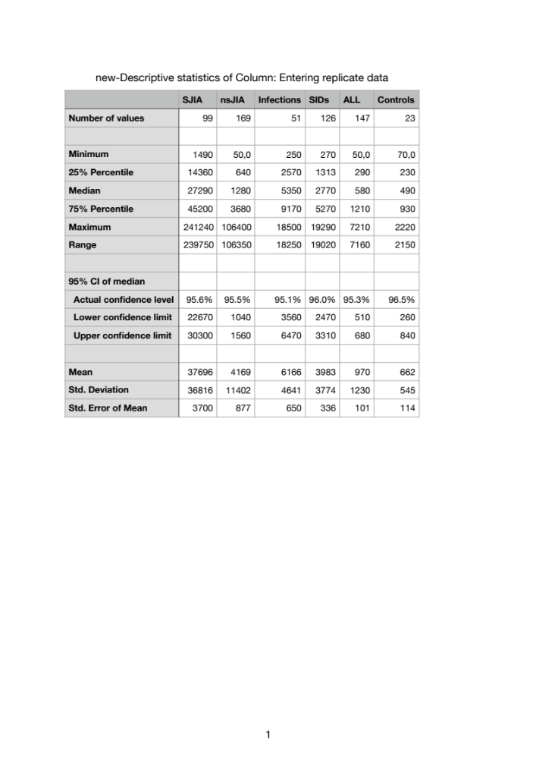
sCAL = serum calprotectin; SJIA = systemic juvenile idiopathic arthritis: nsJIA = non-systemic juvenile idiopathic arthritis; SIDs = systemic inflammatory diseases; ALL = acute lymphoblastic leukemia; CI = confidence interval; Std. = standard.

Supplemental Table 3. Accuracy of sCAL turbo measurements in differentiating groups at higher cut-off levels
 | SJIA vs all groups | SJIA vs infections | SJIA vs ALL
AUC (95%CI) | 0.960 (0.941-0.978) | 0.908 (0.862-0.953) | 0.992 (0.985-0.999)
Cut-Off (ng/ml) | 15,000 | 15,000 | 15,000
Sensitivity (%) | 75 | 75 | 75
Specificity (%) | 98 | 94 | 100
Positive likelihood ratio (LR+) | 37.5 | 12.5 | $$∞$$
Negative likelihood ratio (LR-) | 0.26 | 0.27 | 0.25

sCAL = serum calprotectin; SJIA = systemic juvenile idiopathic arthritis: nALL = acute lymphoblastic leukemia; AUC = Area under the curve; CI = confidence interval.

