Supplement

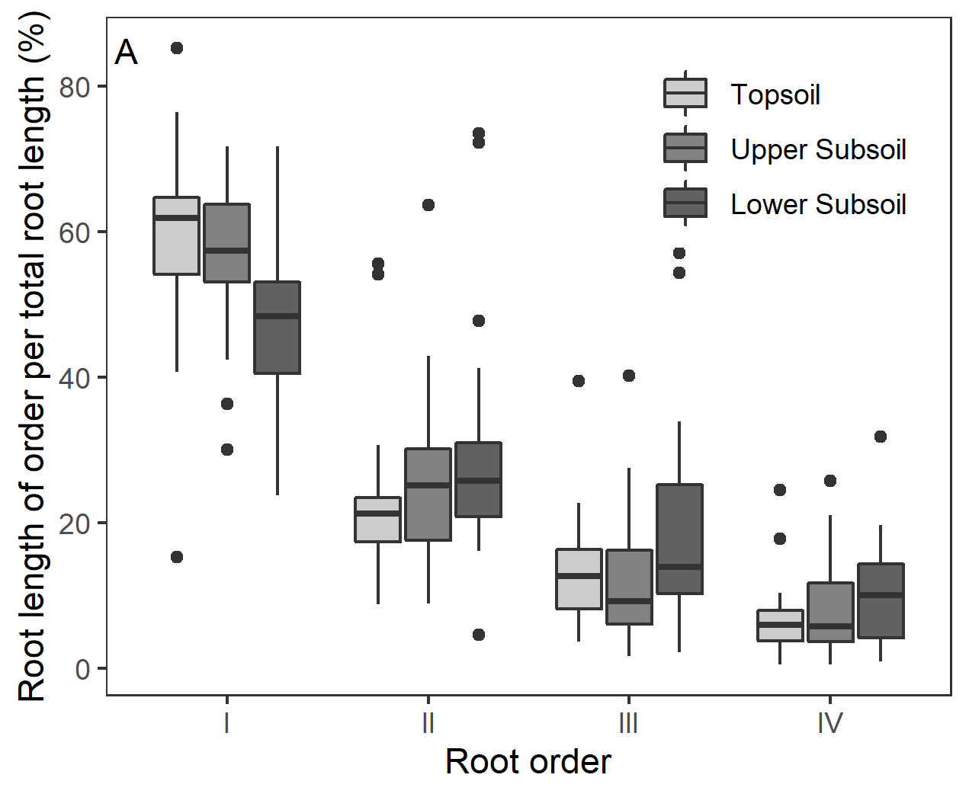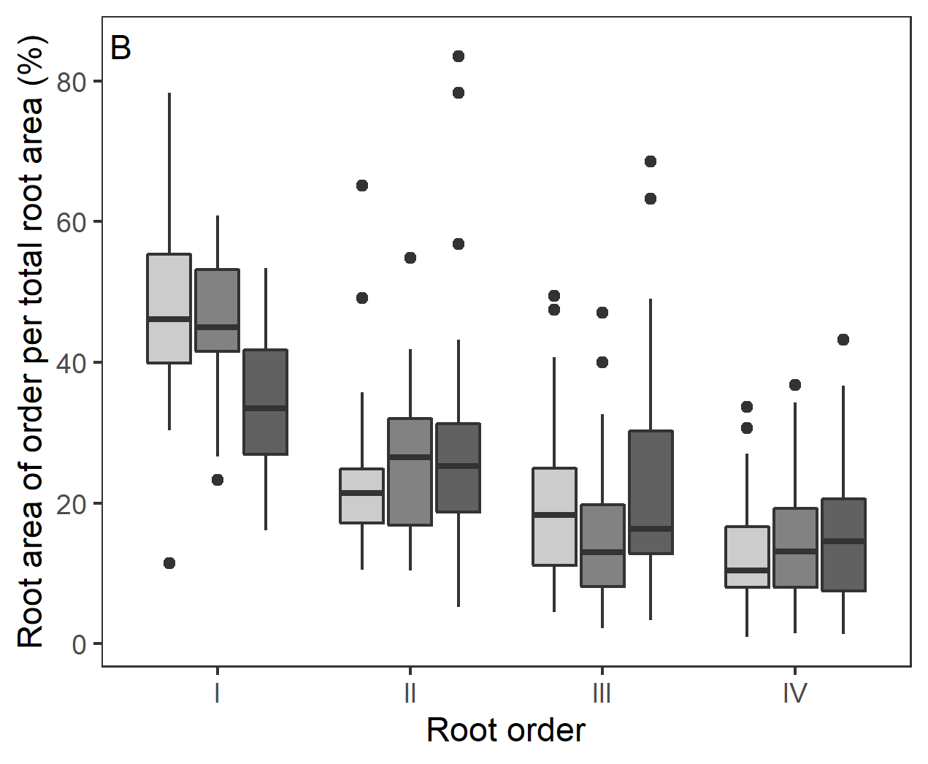
Figure S1. Contribution of the 1st to 4th root order to total root length (A) and total root area (B) in percent (box-whisker plots with median, 25- and 75-percentiles (box), and highest/lowest value not exceeding 1.5 inter-quartile ranges (whisker)).

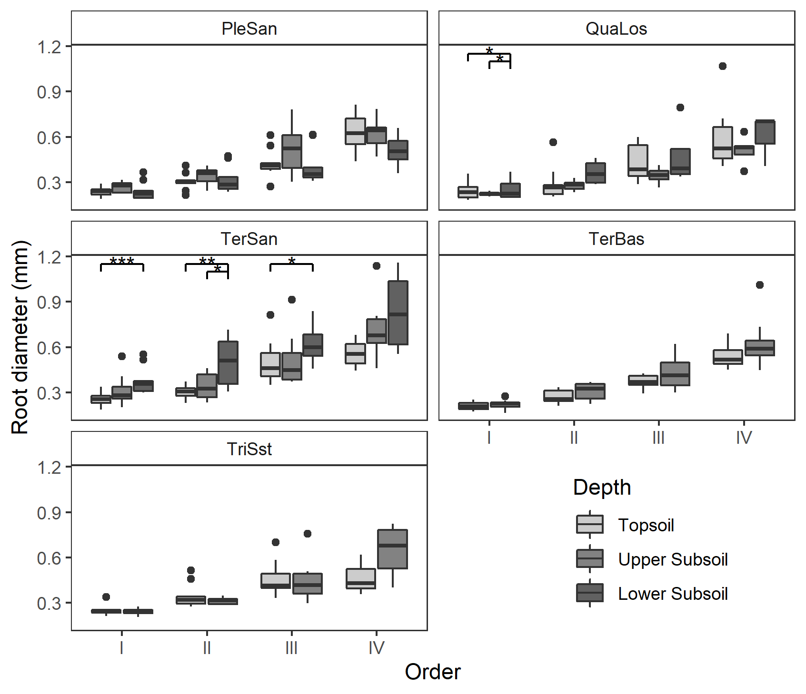
Figure S2. Root diameter distribution in the first four root orders (I to IV) at the five sites in the three different soil depths (box-whisker plots with median, 25- and 75-percentiles (box), and highest/lowest value not exceeding 1.5 inter-quartile ranges (whisker)). Topsoil (0-20cm), upper subsoil (20-110cm) and lower subsoil (110-200cm). PleSan: Pleistocene sand, QuaLos: Quaternary loess, TerBas: Tertiary basalt, TerSan: Tertiary sand, TriSst: Triassic sandstone. Significant differences between the soil depths at a site in a root order class are indicated by horizontal lines and asterisks at the figure top (* p<0.05, ** p<0.01, *** p<0.001).

Table S1. Results of PCAs with inclusion of all root morphological and chemical traits and root order and soil depth, conducted separately for the five sites. Values give loadings of displayed traits on the PCA axes.
PleSan | Axis 1 | Axis 2 | QuaLos | Axis 1 | Axis 2
Eigenvalues | 3.39 | 1.249 | Eigenvalues | 3.519 | 1.195
Depth | 0.151 | 0.774 | Depth | 0.050 | 0.950
Root order | 0.881 | -0.308 | Root order | 0.920 | -0.045
Root diameter | 0.738 | -0.529 | Root diameter | 0.767 | -0.131
SRA | -0.926 | -0.028 | SRA | -0.951 | -0.088
RTD | 0.638 | 0.456 | RTD | 0.708 | 0.397
Root CN | 0.885 | 0.258 | Root CN | 0.822 | -0.330
TerSan | Axis 1 | Axis 2 | TerBas | Axis 1 | Axis 2
Eigenvalues | 3.221 | 1.205 | Eigenvalues | 3.989 | 1.01
Depth | 0.413 | 0.765 | Depth | 0.121 | 0.991
Root order | 0.751 | -0.329 | Root order | 0.936 | -0.139
Root diameter | 0.862 | 0.145 | Root diameter | 0.843 | 0.049
SRA | -0.906 | 0.147 | SRA | -0.962 | 0.026
RTD | 0.333 | -0.662 | RTD | 0.800 | -0.054
Root CN | 0.901 | 0.177 | Root CN | 0.908 | 0.041
TriSst | Axis 1 | Axis 2
Eigenvalues | 3.458 | 1.091
Depth | 0.150 | 0.873
Root order | 0.884 | -0.180
Root diameter | 0.773 | -0.255
SRA | -0.928 | -0.132
RTD | 0.684 | 0.413
Root CN | 0.853 | -0.210

