Supplemental Information

Supplemental S1
Variation characteristics of gut microbiota in AD-cohousing mice. Heatmap of gut microbiota at the Phylum, Order, Class, Family level.

Supplemental S2
A PCoA plot use to compare how close the overall composition of the control1, control2, S1N and S2N.
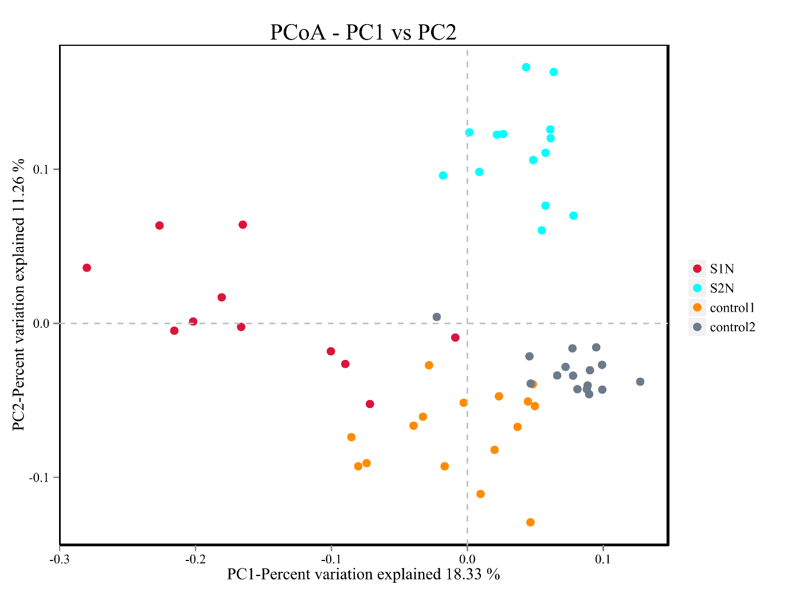

Supplemental S3
Differences species of gut microbiota in AD patients and control group.(control group, n=28; AD patients, n=48)
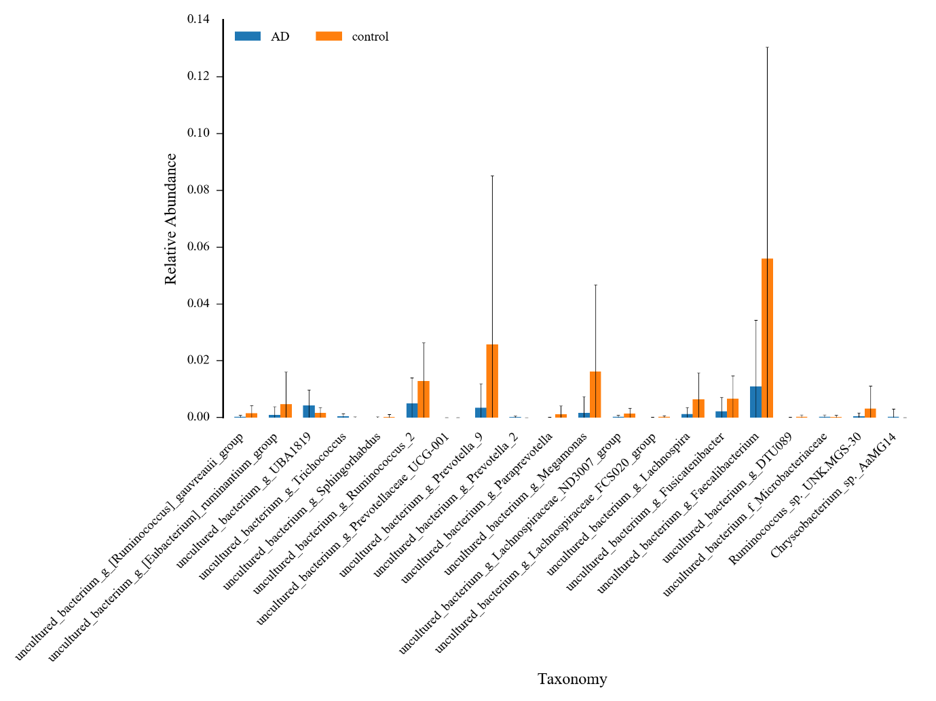

Supplemental S4
Differences species of gut microbiota in S1N and control1 group.( S1N group, n=11; control1 group, n=16)
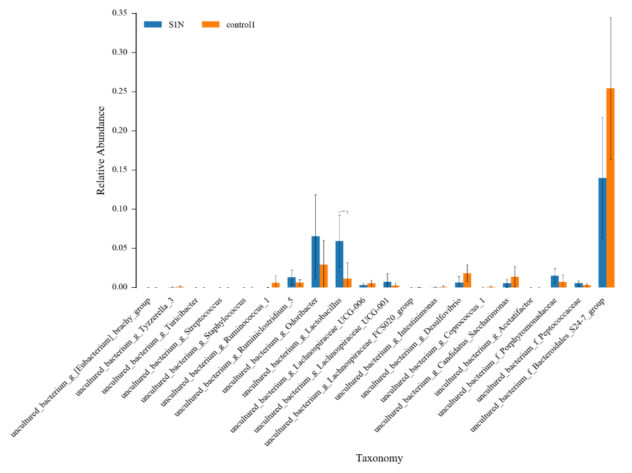

Supplemental S5
Differences species of gut microbiota in S1N and control1 group.( S2N group, n=14; control2 group, n=16)

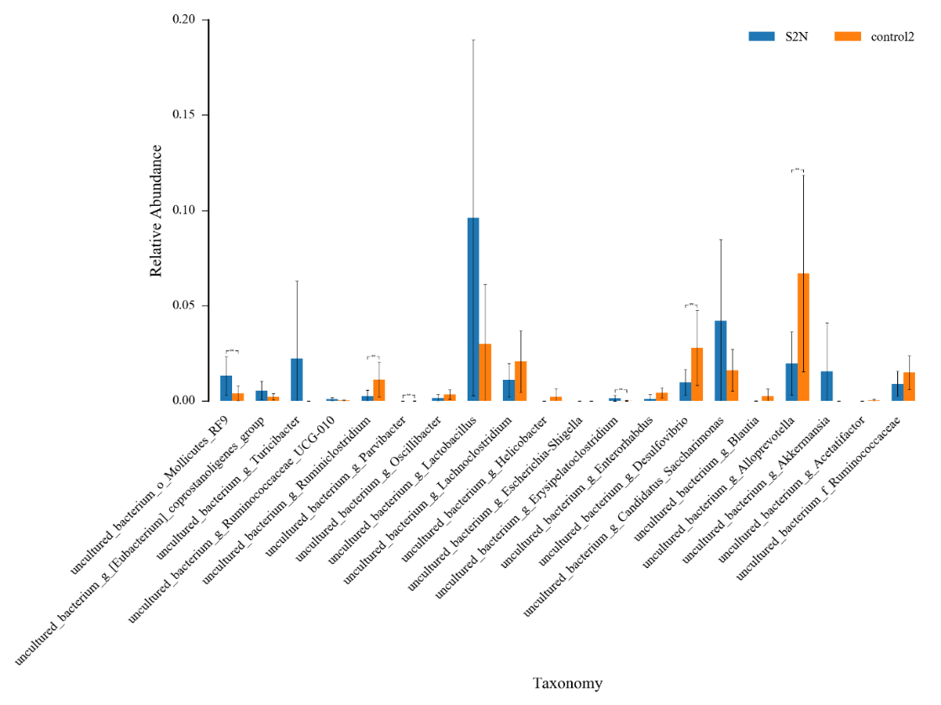

Supplemental table

Supplemental table 1
Different genus between control 1 and S1N
Genus | P value | Modify
Lactobacillus | 0.000136 | up
Ruminiclostridium_5 | 0.026467 | up
Odoribacter | 0.043054 | up
uncultured_bacterium_f_Porphyromonadaceae | 0.043873 | up
uncultured_bacterium_f_Bacteroidales_S24-7_group | 0.00194 | down
Desulfovibrio | 0.004872 | down
Turicibacter | 0.02367 | down
Candidatus_Saccharimonas | 0.04472 | down

Supplemental table 2
Different genus between control 2 and S2N
Genus | P value | Modify
uncultured_bacterium_o_Mollicutes_RF9 | 0.002543 | up
Lactobacillus | 0.01304 | up
Candidatus_Saccharimonas | 0.02634 | up
Turicibacter | 0.035717 | up
Ruminococcaceae_UCG-014 | 0.038901 | up
Enterorhabdus | 0.001578 | down
Ruminiclostridium | 0.002004 | down
Desulfovibrio | 0.002864 | down
Alloprevotella | 0.002919 | down
uncultured_bacterium_f_Ruminococcaceae | 0.042476 | down

Supplemental table 3 Metabolites pathway analysis of serum differences metabolites between AD-cohousing mice and control
Use online software MetaboAnalyst (version 4.0) (http://www.metaboanalyst.ca/) for differences metabolites pathway analysis
Pathway | Total | Expected | Hits | Raw p | -LOG(p) | Holm adjust | FDR | Impact
Linoleic acid metabolism | 6 | 0.080452 | 1 | 0.077936 | 2.5519 | 1 | 1 | 1
Phenylalanine, tyrosine and tryptophan biosynthesis | 4 | 0.053634 | 1 | 0.05262 | 2.9447 | 1 | 1 | 0.5
Phenylalanine metabolism | 11 | 0.14749 | 1 | 0.13845 | 1.9772 | 1 | 1 | 0.40741
Valine, leucine and isoleucine biosynthesis | 11 | 0.14749 | 1 | 0.13845 | 1.9772 | 1 | 1 | 0.33333
Glycerophospholipid metabolism | 30 | 0.40226 | 1 | 0.33583 | 1.0912 | 1 | 1 | 0.04444
Arginine and proline metabolism | 44 | 0.58998 | 1 | 0.45296 | 0.79195 | 1 | 1 | 0.03042
Citrate cycle (TCA cycle) | 20 | 0.26817 | 1 | 0.23801 | 1.4354 | 1 | 1 | 0.02566
Purine metabolism | 68 | 0.91179 | 1 | 0.60958 | 0.49499 | 1 | 1 | 0.02077
Pantothenate and CoA biosynthesis | 15 | 0.20113 | 2 | 0.016126 | 4.1273 | 1 | 1 | 0.02041
Starch and sucrose metabolism | 19 | 0.25476 | 1 | 0.22751 | 1.4805 | 1 | 1 | 0.00233
Butanoate metabolism | 22 | 0.29499 | 2 | 0.03355 | 3.3947 | 1 | 1 | 0
Synthesis and degradation of ketone bodies | 5 | 0.067043 | 1 | 0.065359 | 2.7279 | 1 | 1 | 0
Biosynthesis of unsaturated fatty acids | 42 | 0.56316 | 2 | 0.10674 | 2.2373 | 1 | 1 | 0
Aminoacyl-tRNA biosynthesis | 69 | 0.92519 | 2 | 0.23565 | 1.4454 | 1 | 1 | 0
Propanoate metabolism | 20 | 0.26817 | 1 | 0.23801 | 1.4354 | 1 | 1 | 0
Alanine, aspartate and glutamate metabolism | 24 | 0.32181 | 1 | 0.27867 | 1.2777 | 1 | 1 | 0
Arachidonic acid metabolism | 36 | 0.48271 | 1 | 0.38867 | 0.94502 | 1 | 1 | 0
Amino sugar and nucleotide sugar metabolism | 37 | 0.49612 | 1 | 0.39708 | 0.92361 | 1 | 1 | 0
Valine, leucine and isoleucine degradation | 38 | 0.50953 | 1 | 0.40538 | 0.90292 | 1 | 1 | 0
P represents the possibility that pathway compounds (metabolites) in pathway enrichment analysis are not related to classification. The higher the p value is, the less likely the pathway metabolites are related to classification, and the lower the p value is, the greater the possibility that the pathway metabolites are related to classification (e.g., two groups). The Impact value indicated the magnitude (significance) of the contribution of this metabolic pathway to the difference between the two groups.

Supplemental table 4 Metabolites pathway analysis of feces differences metabolites between AD-cohousing mice and control
Use online software MetaboAnalyst (version 4.0) (http://www.metaboanalyst.ca/) for differences metabolites pathway analysis
Pathway | Total | Expected | Hits | Raw p | -LOG(p) | Holm adjust | FDR | Impact
Valine, leucine and isoleucine biosynthesis | 11 | 0.14749 | 3 | 0.000316 | 8.061 | 0.025565 | 0.01294 | 0.99999
Glycine, serine and threonine metabolism | 31 | 0.41567 | 2 | 0.062878 | 2.7666 | 1 | 0.42966 | 0.50732
Phenylalanine, tyrosine and tryptophan biosynthesis | 4 | 0.053634 | 1 | 0.05262 | 2.9447 | 1 | 0.39226 | 0.5
Methane metabolism | 9 | 0.12068 | 2 | 0.005801 | 5.1498 | 0.45826 | 0.11892 | 0.4
Alanine, aspartate and glutamate metabolism | 24 | 0.32181 | 1 | 0.27867 | 1.2777 | 1 | 0.90144 | 0.19304
Tyrosine metabolism | 44 | 0.58998 | 1 | 0.45296 | 0.79195 | 1 | 1 | 0.14045
Aminoacyl-tRNA biosynthesis | 69 | 0.92519 | 8 | 1.04E-06 | 13.778 | 8.51E-05 | 8.51E-05 | 0.12903
Starch and sucrose metabolism | 19 | 0.25476 | 2 | 0.025436 | 3.6716 | 1 | 0.26072 | 0.11409
Pyruvate metabolism | 23 | 0.3084 | 1 | 0.2687 | 1.3141 | 1 | 0.90144 | 0.10625
Arginine and proline metabolism | 44 | 0.58998 | 2 | 0.11545 | 2.1589 | 1 | 0.67622 | 0.064
Galactose metabolism | 26 | 0.34862 | 2 | 0.045724 | 3.0851 | 1 | 0.37494 | 0.03644
Fructose and mannose metabolism | 21 | 0.28158 | 1 | 0.24838 | 1.3928 | 1 | 0.90144 | 0.03142
Primary bile acid biosynthesis | 46 | 0.6168 | 1 | 0.468 | 0.75928 | 1 | 1 | 0.02976
Cysteine and methionine metabolism | 27 | 0.36203 | 1 | 0.30781 | 1.1783 | 1 | 0.90144 | 0.02533
Glutathione metabolism | 26 | 0.34862 | 1 | 0.29822 | 1.2099 | 1 | 0.90144 | 0.00573
Purine metabolism | 68 | 0.91179 | 1 | 0.60958 | 0.49499 | 1 | 1 | 0.0026
Cyanoamino acid metabolism | 6 | 0.080452 | 2 | 0.002476 | 6.0012 | 0.19807 | 0.067673 | 0
Valine, leucine and isoleucine degradation | 38 | 0.50953 | 3 | 0.012821 | 4.3566 | 1 | 0.21027 | 0
Biosynthesis of unsaturated fatty acids | 42 | 0.56316 | 3 | 0.016864 | 4.0826 | 1 | 0.21057 | 0
Fatty acid biosynthesis | 43 | 0.57657 | 3 | 0.017975 | 4.0188 | 1 | 0.21057 | 0
Ubiquinone and other terpenoid-quinone biosynthesis | 3 | 0.040226 | 1 | 0.039717 | 3.226 | 1 | 0.36186 | 0
Nitrogen metabolism | 9 | 0.12068 | 1 | 0.11471 | 2.1653 | 1 | 0.67622 | 0
Phenylalanine metabolism | 11 | 0.14749 | 1 | 0.13845 | 1.9772 | 1 | 0.75686 | 0
Histidine metabolism | 15 | 0.20113 | 1 | 0.18413 | 1.6921 | 1 | 0.88817 | 0
Pantothenate and CoA biosynthesis | 15 | 0.20113 | 1 | 0.18413 | 1.6921 | 1 | 0.88817 | 0
beta-Alanine metabolism | 17 | 0.22795 | 1 | 0.2061 | 1.5794 | 1 | 0.90144 | 0
Pentose phosphate pathway | 19 | 0.25476 | 1 | 0.22751 | 1.4805 | 1 | 0.90144 | 0
Propanoate metabolism | 20 | 0.26817 | 1 | 0.23801 | 1.4354 | 1 | 0.90144 | 0
Sphingolipid metabolism | 21 | 0.28158 | 1 | 0.24838 | 1.3928 | 1 | 0.90144 | 0
Fatty acid elongation in mitochondria | 27 | 0.36203 | 1 | 0.30781 | 1.1783 | 1 | 0.90144 | 0
Porphyrin and chlorophyll metabolism | 27 | 0.36203 | 1 | 0.30781 | 1.1783 | 1 | 0.90144 | 0
Fatty acid metabolism | 39 | 0.52294 | 1 | 0.41358 | 0.88291 | 1 | 1 | 0

