The role of DNA methylation in chondrogenesis of human iPSCs as a stable marker of cartilage quality
Ghazaleh Hajmousa^{†1}, Rodrigo Coutinho de Almeida^{†1}, Niek Bloks¹, Alejandro Rodríguez Ruiz¹, Marga Bouma², Roderick Slieker³, Thomas B Kuipers², Rob GHH Nelissen⁴, Keita Ito⁵, Christian Freund², Yolande FM Ramos^{§1}, Ingrid Meulenbelt^{§*1}
Supplementary Figures
Figure S1. Characterization of hiPSC cell-lines. (A and B) representative pictures of hiPSCs confirming adequate pluripotency and spontaneous differentiation capacity of human skin fibroblast-derived iPSCs (2 cell-lines from healthy donors: LUMC0004iCTRL12-LUMC0030iCTRL12) and human cartilage-derived iPSCs (3 Clones from preserved cartilage of a patient who underwent joint replacement surgery due to OA: LUMC0131iCTRL02- LUMC0131iCTRL04- LUMC0131iCTRL05), respectively. (C) Presence of pluripotency and differentiation markers in all hiPSCs sources used in the study. (D) Confirming the normal karyotypes in all hiPSCs sources after reprogramming.
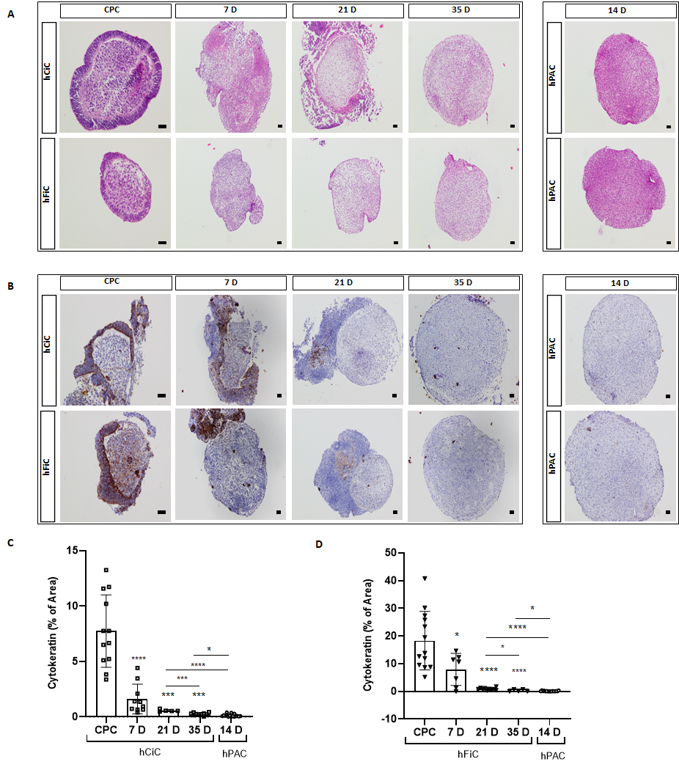
Figure S2. Histology and immunohistochemistry of hiPSC derived chondroprogenitor cells towards neo-cartilage. (A) Histological evaluation of neo-cartilage from human chondrocyte-derived iPSCs (hCiC) and from human fibroblast-derived iPSCs (hFiC) by Haematoxylin-eosin (H&E) staining, compared to primary articular chondrocytes (hPACs; day 7, 14, 21, and 35 of chondrogenic differentiation). (B) Immunohistochemical staining (Anti-Cytokeratin 7 Antibody (CK)) showing the presence of keratinocytes distributed in a mesh-like form amongst the undifferentiated/undefined population around the 3D neo-cartilage during the first 21 days of chondrogenic differentiation. (C) Quantification of cytokeratin presence presented by percentage of area in hCiC compared to hPAC. (D) Quantification of cytokeratin immunohistochemistry presented by percentage of area in hFiC compared to hPAC. Scale bars in CPC: 50 μm, other scale bars: 100 μm. All data are presented as mean ± STD. Two-tailed Student’s t tests were used to compare 1) each group relative to CPC (stars on top of the bars) and 2) each group relative to hPAC (indicated by lines). *p < 0.05, **p < 0.01, ***p < 0.001, ****p < 0.0001.
Figure S3. mRNA expression levels of chondrogenic genes. (A) mRNA expression of chondrogenic genes (COL2A, SOX9 and ACAN), fibrotic (COL1A1), and hypertrophic (COL10A1) cartilage markers at day 35 of differentiation (N=6). Representative of three independent experiments. (B) The ratio of the expression of COL2A1 to COL1A1 compared between hCiC, hFiC, and hPAC. The graph represents the chondrogenic potential of the neo-cartilages. Two-tailed Student’s t tests were used to compare means between groups. All data are presented as mean ± STD. *p < 0.05, **p < 0.01, ***p < 0.001, ****p < 0.0001.

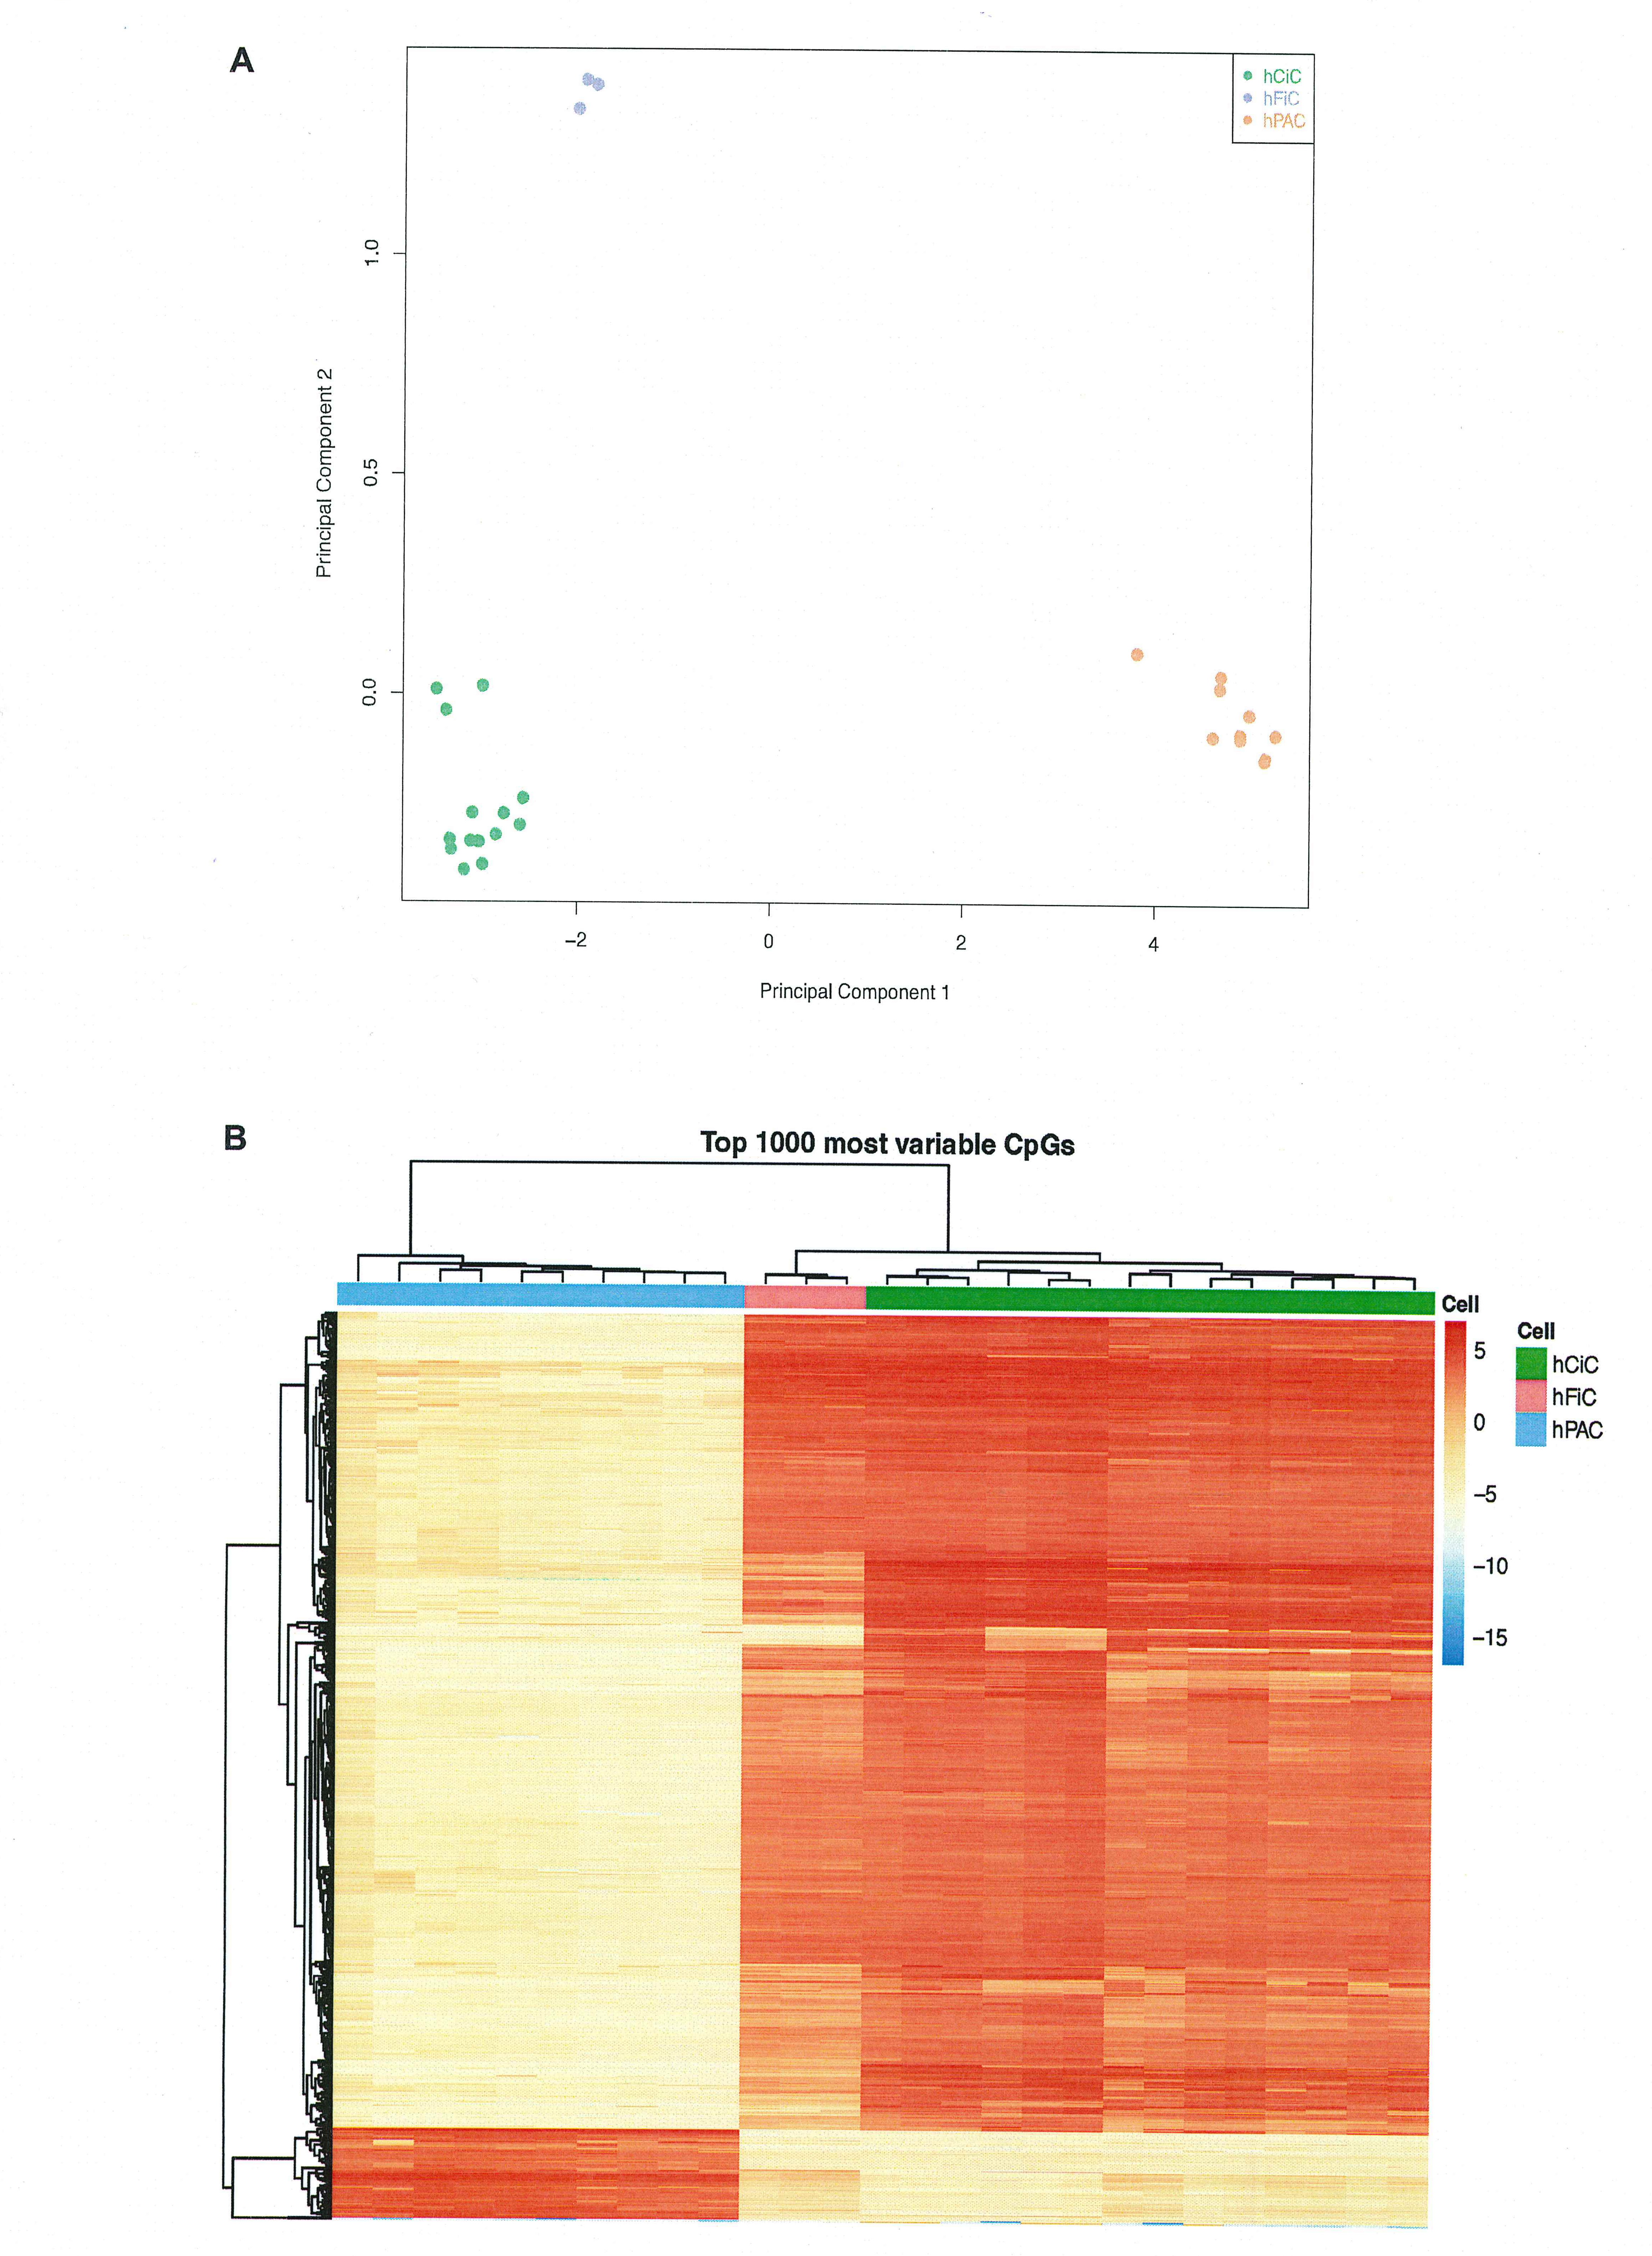
Figure S4. (A) Principal component Analysis (PCA) of genome-wide methylation sites in human iPSCs and hPAC. The green dots are displaying hCiC, blue dots hFiC and orange dots hPAC. Component 1 (x-axis) and component 2 (y-axis). (B) Heatmap constructed from the 1000 most variable CpGs (y-axis) that showed the largest variation (Standard Deviation) over the samples (x-axis). Samples are hierarchically clustered (dendrogram on the top), showing three distinct clusters: hCiC(green), hFiC (red), and hPAC (blue) together.
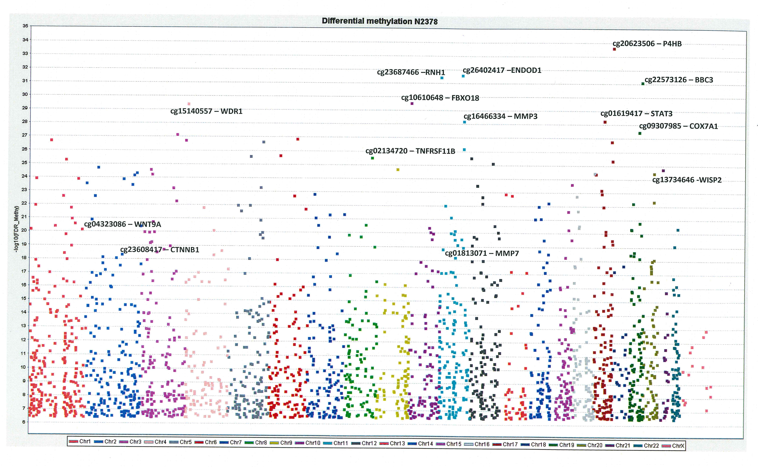
Figure S5. Manhattan plot of FDR significant differential methylated CpG sites between hCiC and hPACs. Plotted are N=2379 prioritized CpG-gene pairs as determined by singular mapping, highest correlation between methylation and expression. See also Fig. 3 box 2. Y-axes indicates the log(FDR) value of the differential methylated CpGs.

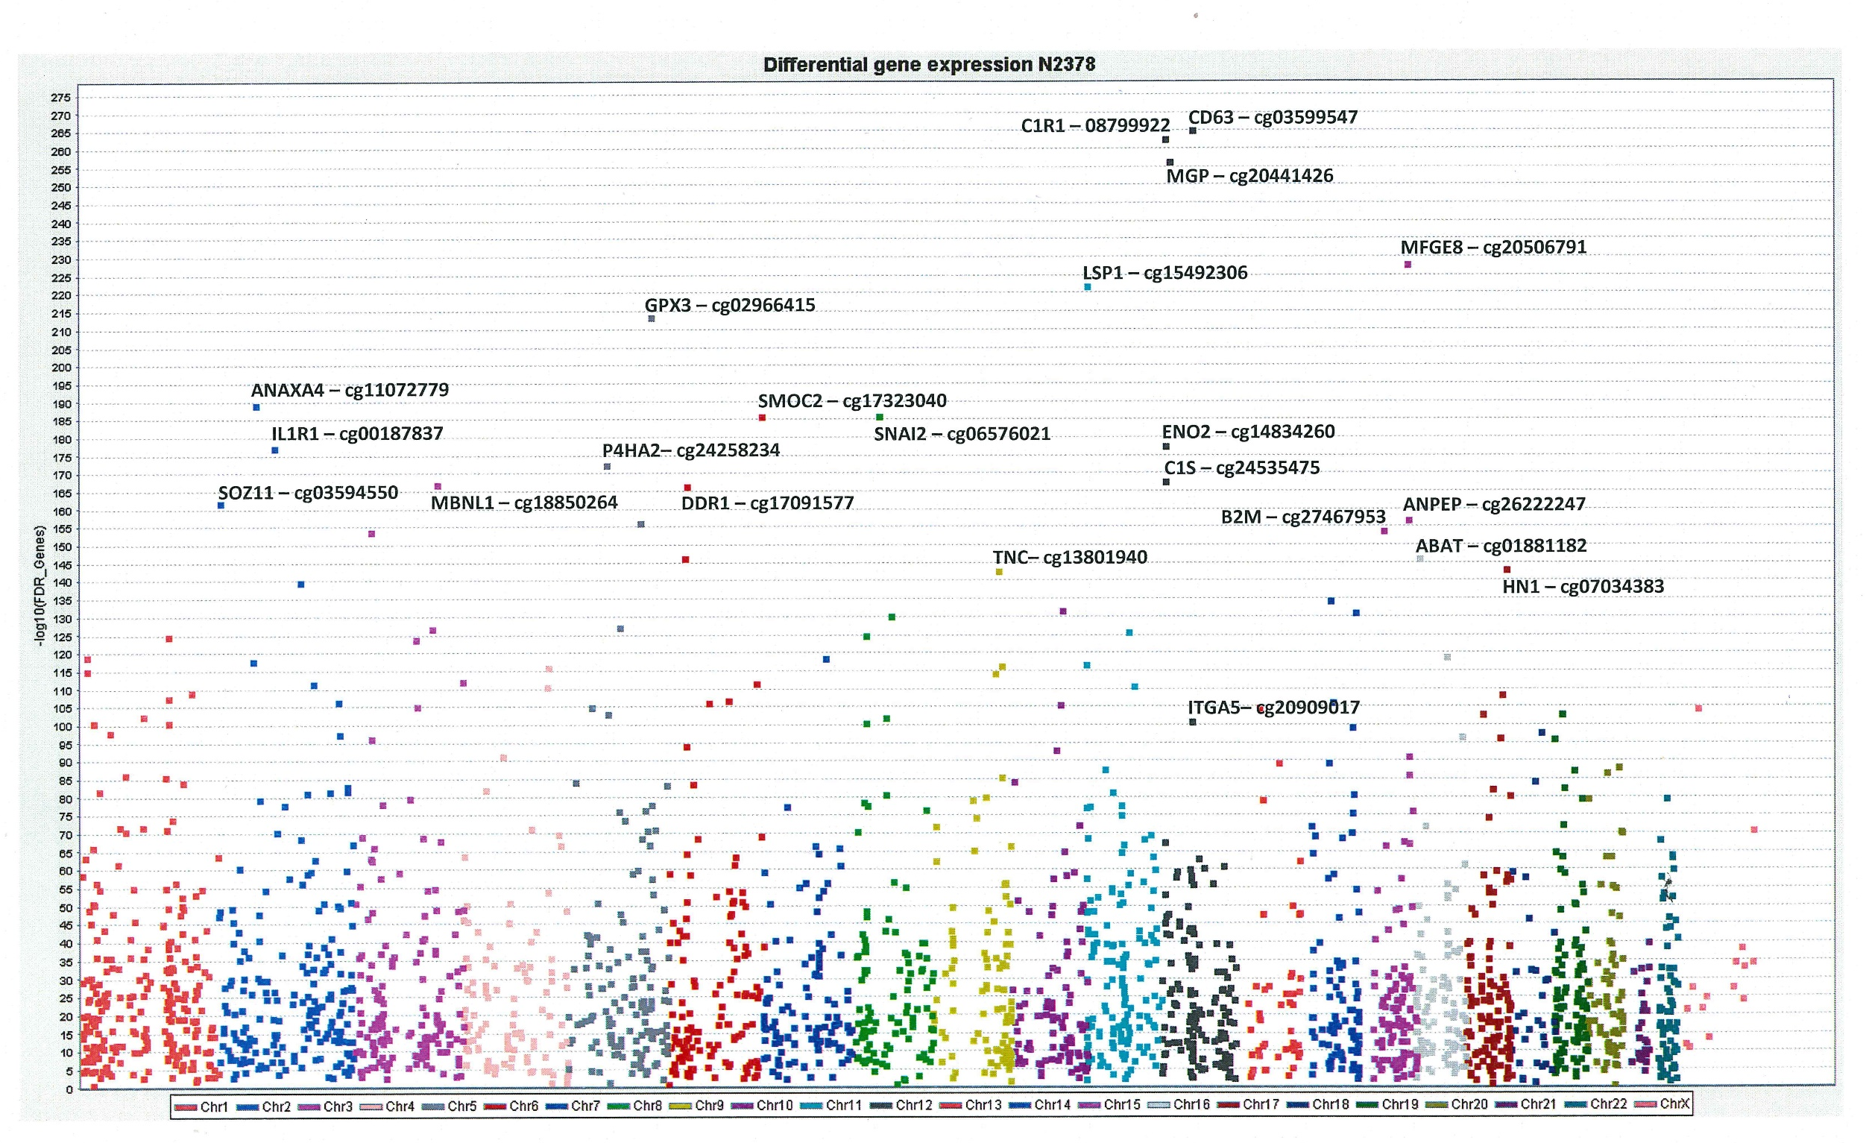
Figure S6. Manhattan plot of FDR significant differential expressed genes between hCiC and hPACs. Plotted are the N=2379 prioritized CpG-gene pairs as determined by singular mapping, highest correlation between methylation and expression. See also Fig. 3 box 2. Y-axes indicates the log(FDR) value of the differential expressed genes.

