Supplementary Material

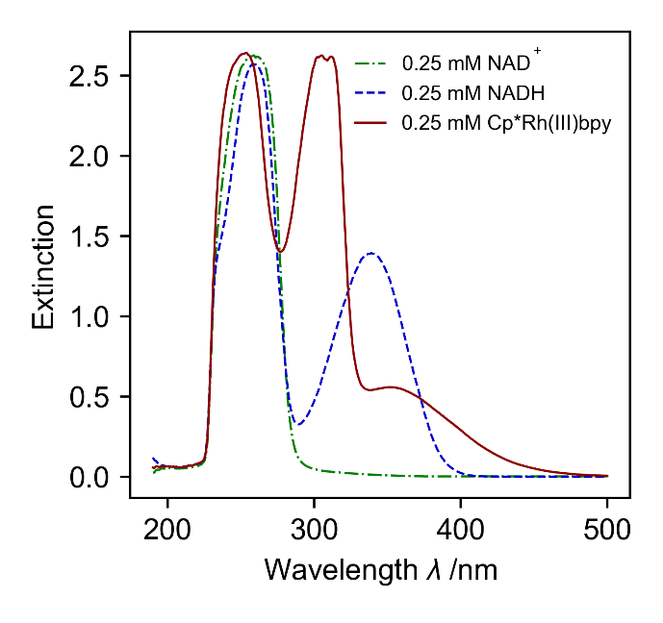
Figure 1: Extinction over the wavelength of each species in 0.1 M Hepes buffer at pH 8, without errorbars because they are to low to be shown.

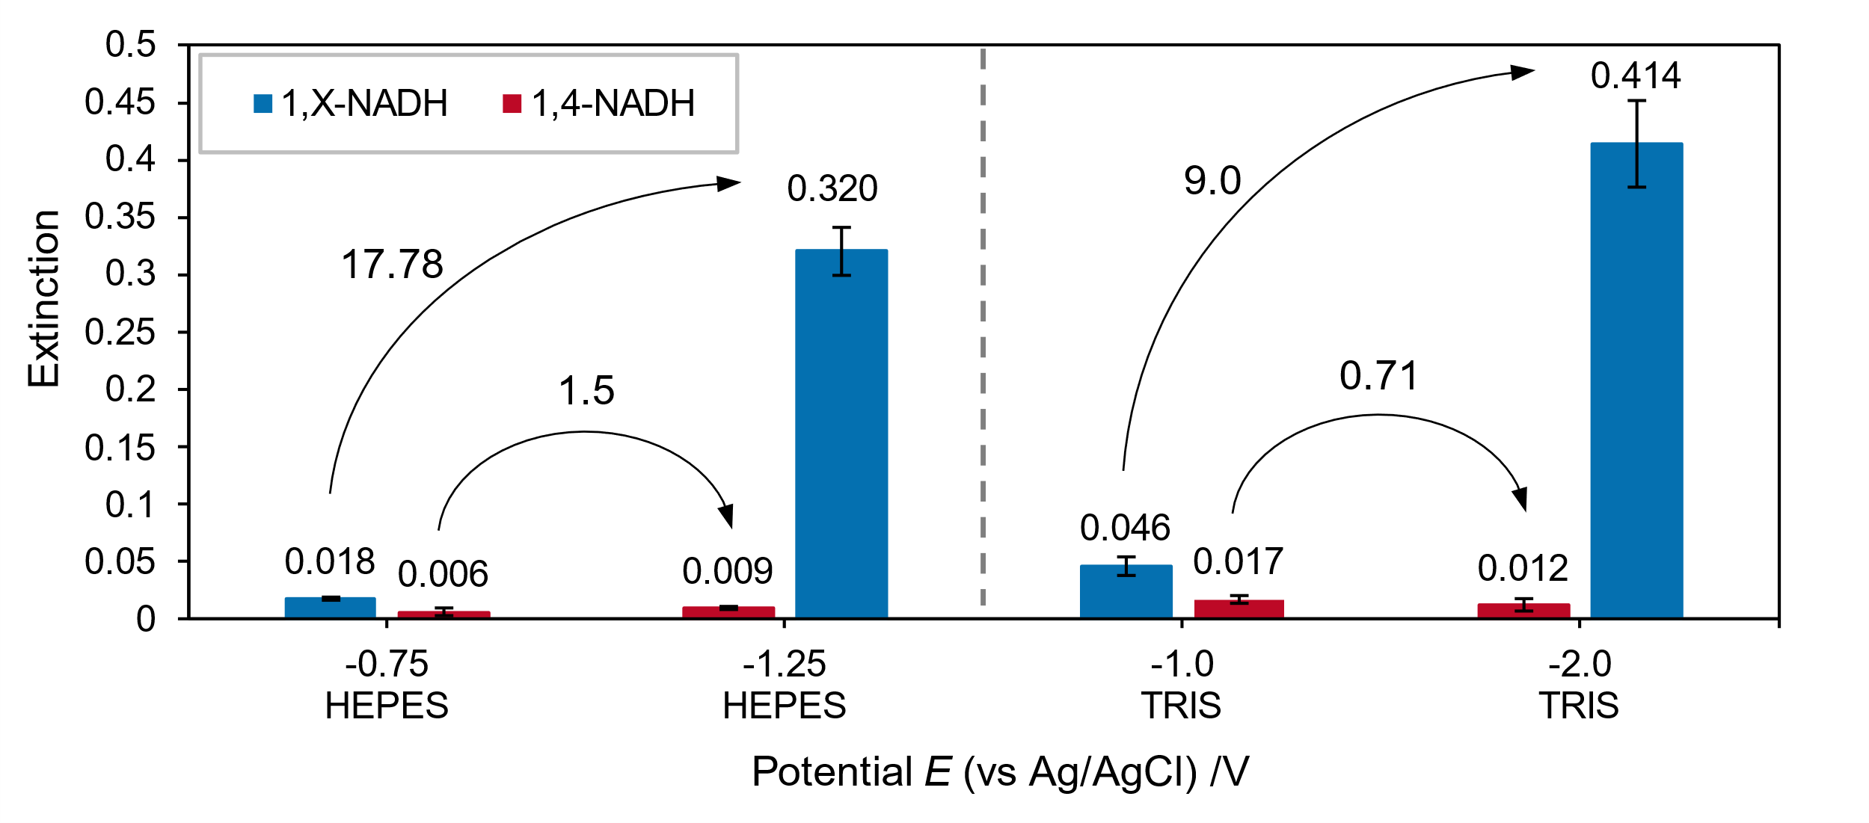
Figure 2: Direct NADH regeneration on glassy carbon in absence of rhodium based mediator in HEPES and TRIS buffer. Extinction of all NADH species and NAD₂ declared as 1,X-NADH.

