Supplemental Figure. Data Collection: Overview of Forms Completed at Each Participant Touchpoint

During pregnancy:
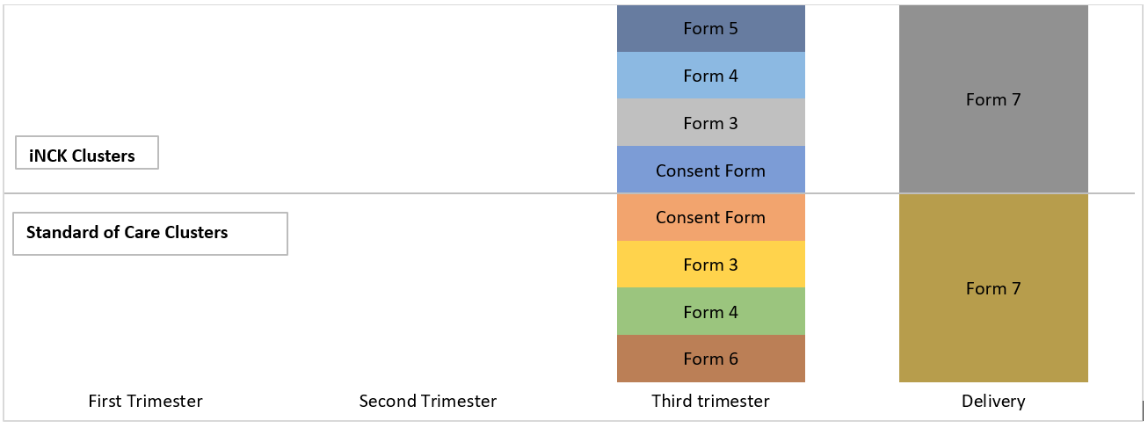

Form Number | Form Name
Form 3 | Participant eligibility screening form
Form 4 | Demographic and household data
Form 5 | LHW iNCK teaching checklist
Form 6 | LHW local standard of care teaching checklist
Form 7 | Birth notification form

Post-natal Days:
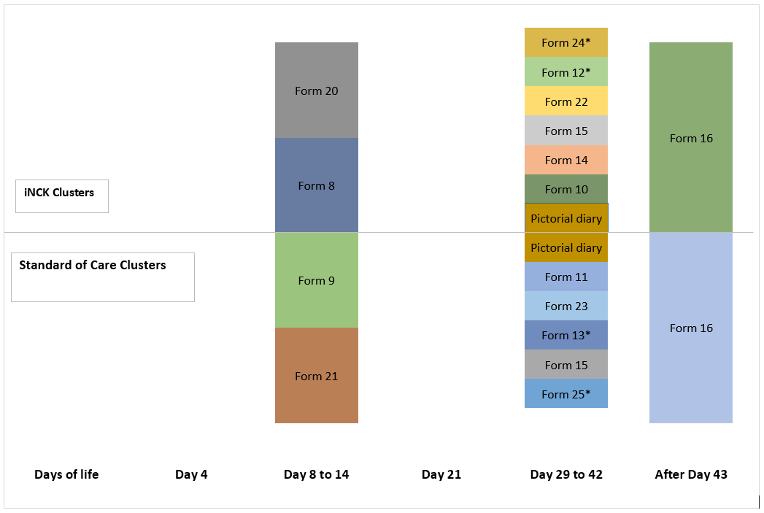
Form Number | Form Name
Form 8 | Day 8 phone call questionnaire
Form 9 | Day 8 phone call questionnaire
Form 20 | Day 8 phone call questionnaire for multiple births
Form 21 | Day 8 phone call questionnaire for multiple births
Form 10 | Day 29 outcomes questionnaire
Form 11 | Day 29 outcomes questionnaire
Form 12 | Day 29 outcomes questionnaire (* if the day 8 call was not completed)
Form 13 | Day 29 outcomes questionnaire (* if the day 8 call was not completed)
Form 22 | Day 29 outcomes questionnaire for multiple births
Form 23 | Day 29 outcomes questionnaire for multiple births
Form 24 | Day 29 outcomes questionnaire for multiple births (* if the day 8 call was not completed)
Form 25 | Day 29 outcomes questionnaire for multiple births (* if the day 8 call was not completed)
Form 14 | Acceptance and willingness to pay for iNCK
Form 15 | Verbal Autopsy form
Form 16 | Vital outcomes questionnaire

