SUPPLEMENTAL MATERIAL

Table of contents

- Supplemental Tables 3
- Supplemental Figures 5

1. Supplemental Tables

Supplemental Table I. TaqMan probes used in the qRT-PCR.
Gene | Probe
BANP | Hs0099999904_m1
PDCD6IP | Hs00994345_m1
CAMK2G | Hs00968809_mH
E2F4 | Hs00608098_m1
PPIA | Hs0099999904_m1

Supplemental Table II. Proportion of negative Z-score regarding the five neuropsychological domains adjusted by age and educational level. The neuropsychological tests were performed in five CADASIL patients from the validation cohort.

 | Percentage of negative Z-score
Executive Function | 80% (4/5)
Attention and Information Processing Speed | 60% (3/5)
Motor Speed | 60% (3/5)
Visuoconstructional Skills | 20% (1/5)
Verbal Memory | 60% (3/5)
Working Memory | 60% (3/5)

2. Supplemental Figures

Supplemental Figures I: Z-score regarding the five neuropsychological domains adjusted by age and educational level, evaluated in the five patients with available cognitive information.
EF: executive function; IPS: information processing speed; VCF: visuoconstructional function.
Supplemental Figure II. E2F4 gene expression profile in decreasing order (GTEx Portal, https://gtexportal.org/home/gene/E2F4.
Supplemental Figure III. Single-Nuclei Brain RNA-seq expression of E2F4.

Supplemental Figures I

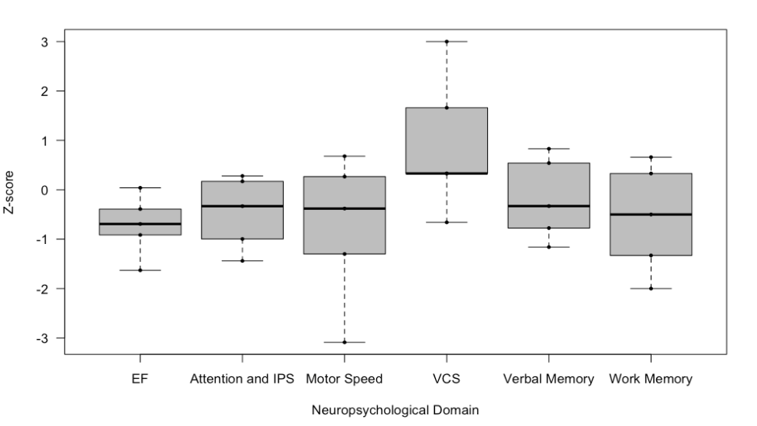

Supplemental Figure II
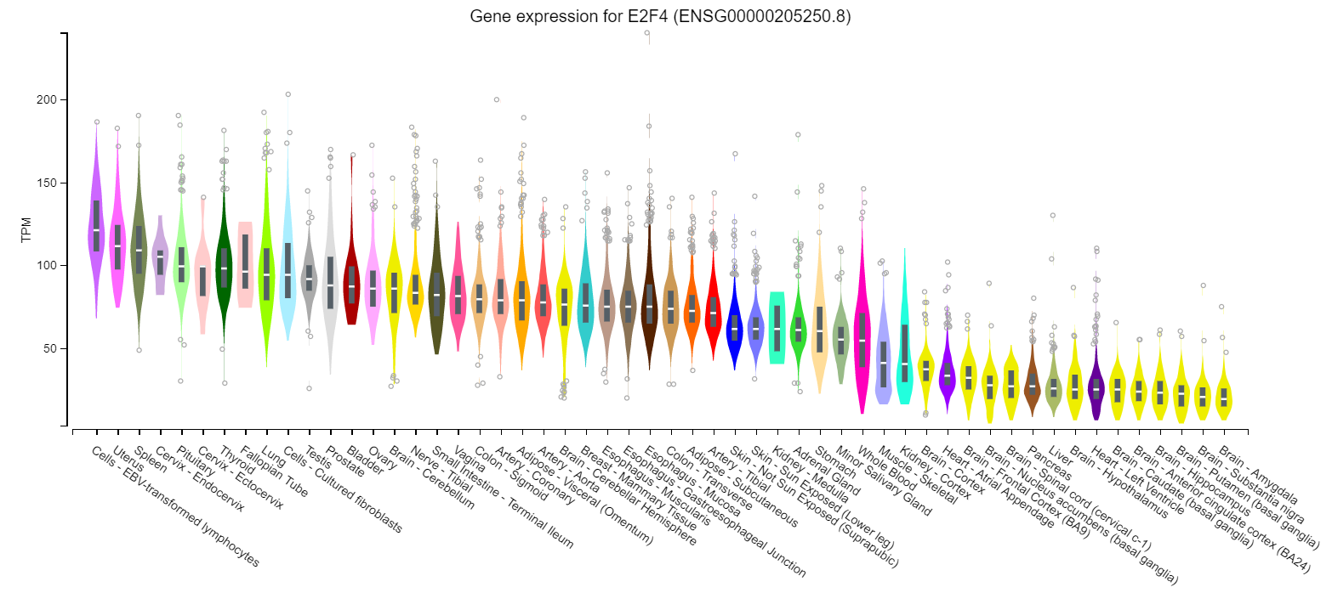
Supplemental Figure III

