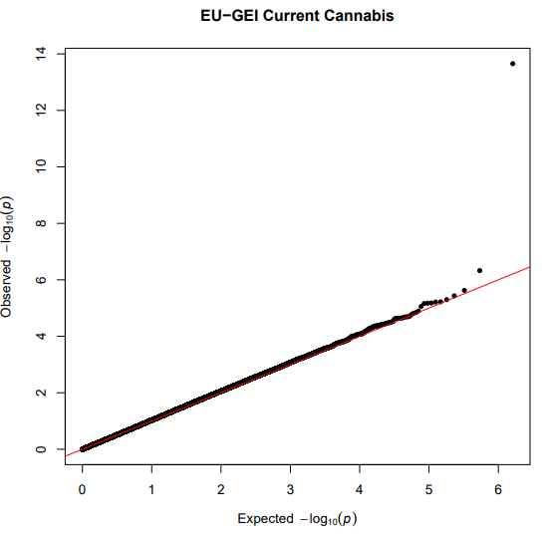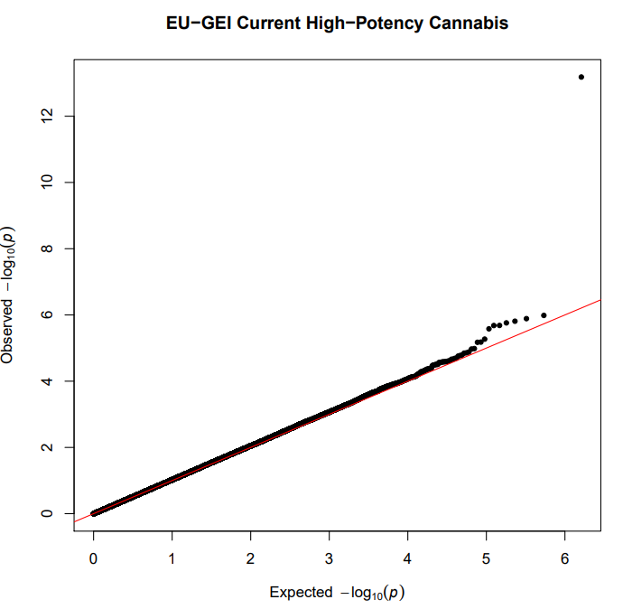
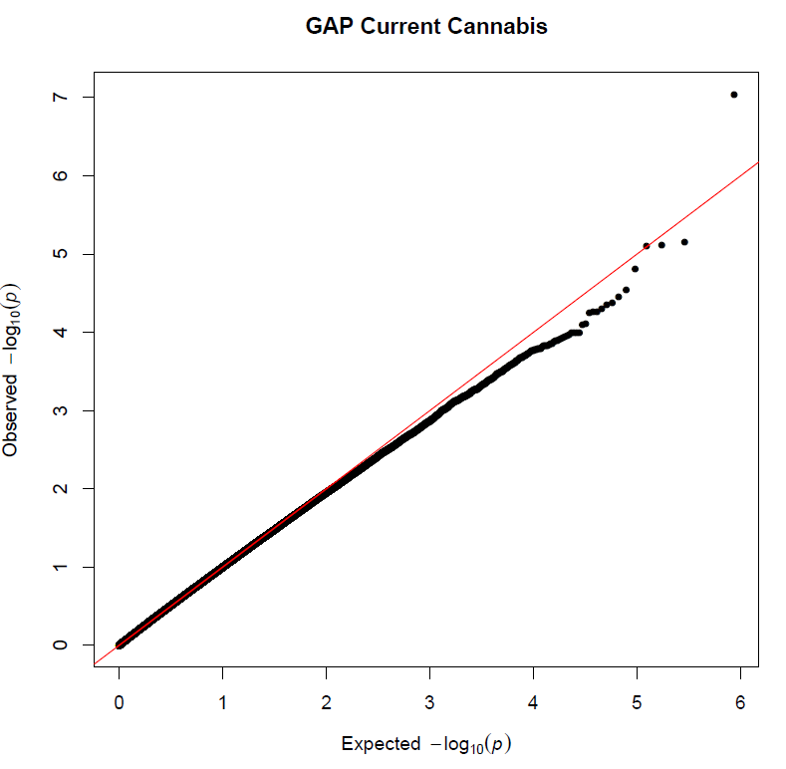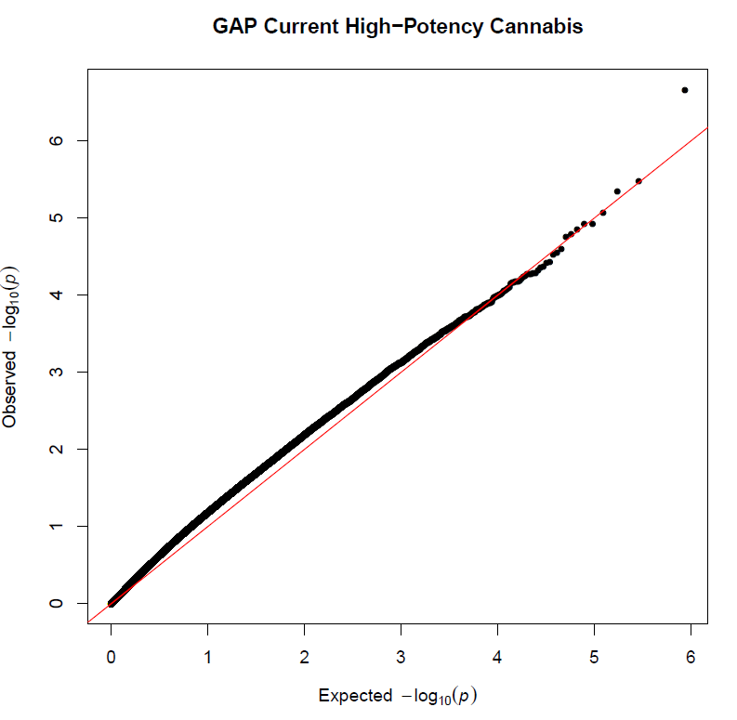
Figure S1. QQ-plots for each analysis in the two different cohorts: No evidence of p-value inflation was observed.

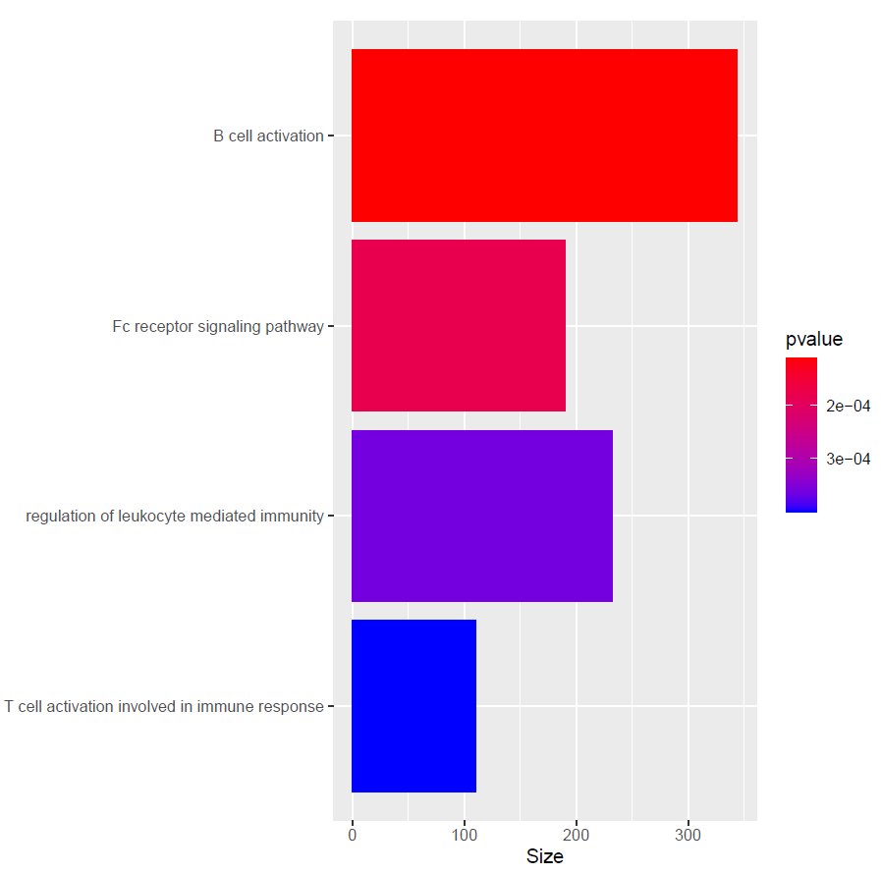
Figure S2: Pathway analyses of current high potency cannabis users compared to never users failed to identify any pathways that survived multiple testing (padj >0.05); however, the same pathways were identified at nominal significance as the main analysis

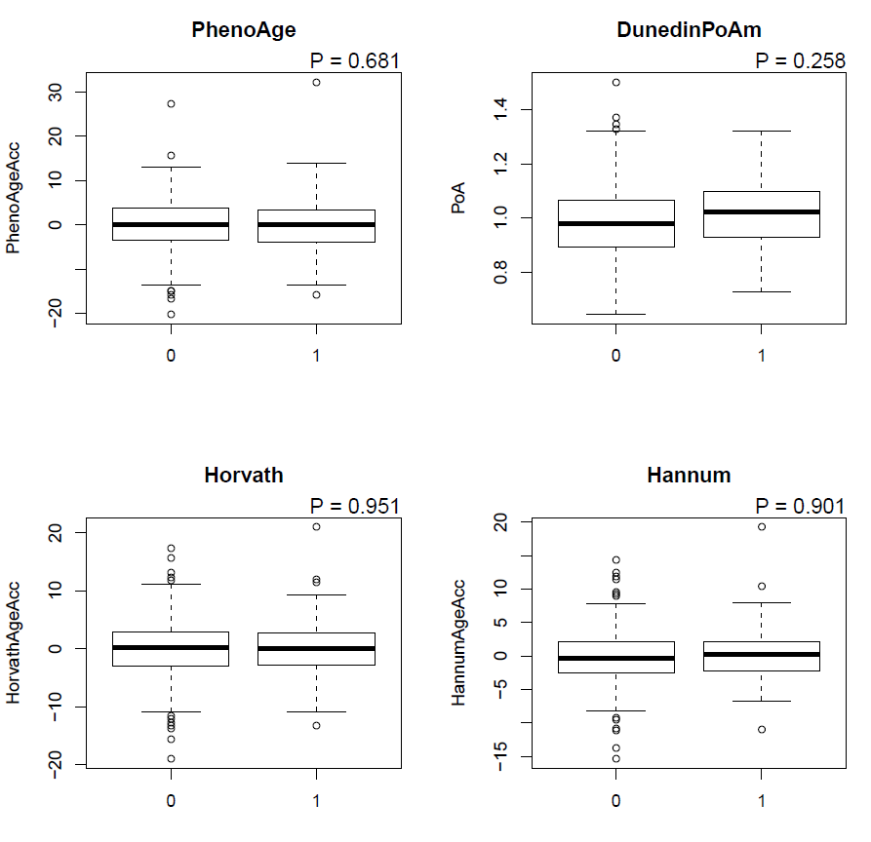

Figure S3: DNAm Age acceleration calculated using four different epigenetic clocks in the EU-GEI cohort: There was no evidence of age acceleration between cannabis current users and controls. (0= controls; 1=cannabis current user)

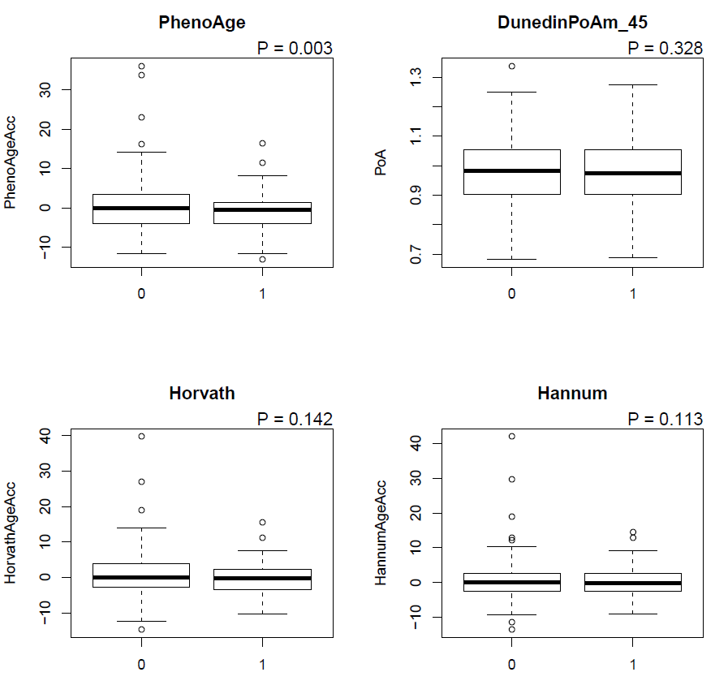

Figure S4: DNAm Age acceleration calculated using four different epigenetic clocks in the GAP cohort: There was no evidence of age acceleration between cannabis current users and controls . ( 0= controls 1=cannabis current user). PhenoAge showed a significant age deacceleration ( p= 0.00369)

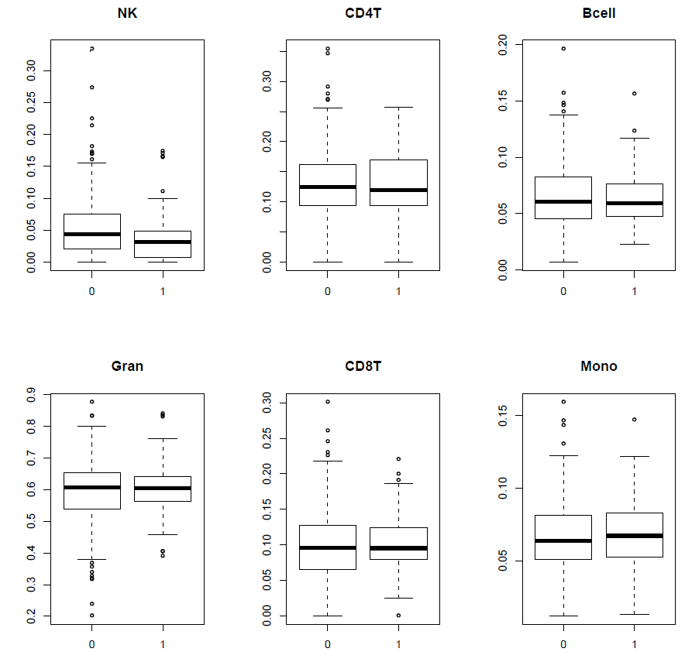
Figure S5: Investigation of the association between DNA methylation estimated cell composition and current cannabis use in the EU-GEI cohort. (0= controls 1=cannabis current user)

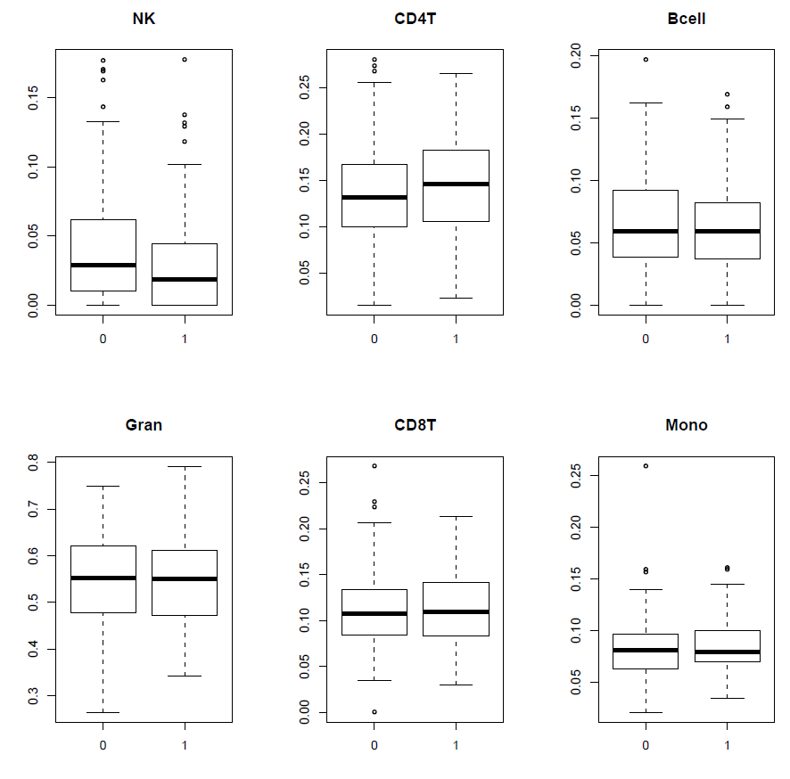
Figure S5: Investigation of the association between DNA methylation estimated cell composition and current cannabis use in the GAP cohort. (0= controls 1=cannabis current user)

