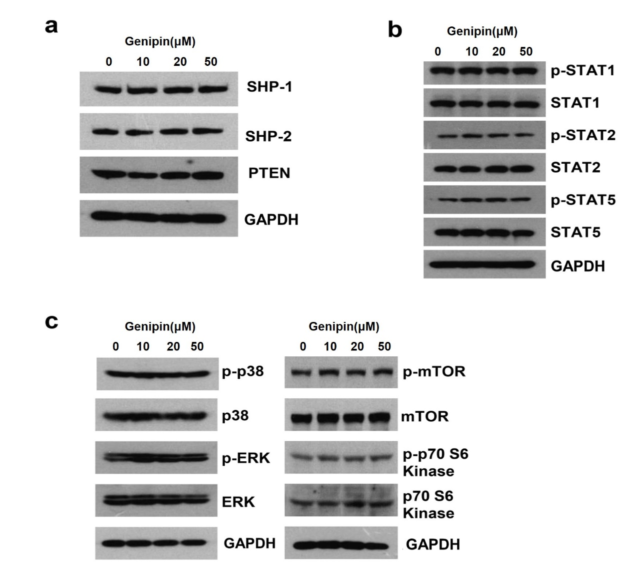
Supplementary Figure 1. Genipin failed to affect the expression of PTPases or activation of STAT-1, STAT-2, STAT-5, mTOR and MAPK signal pathways. (a) For validating the effects of genipin on the expression of PTPases , western blot assay was applied after genipin treatment.(b) For validating the effects of genipin on the activation of STAT-5, STAT-2, STAT-1, western blot assay was applied after genipin treatment. (c) For validating the effects of genipin on the activation of MAPK and mTOR signaling pathways, western blot assay was applied after genipin treatment.
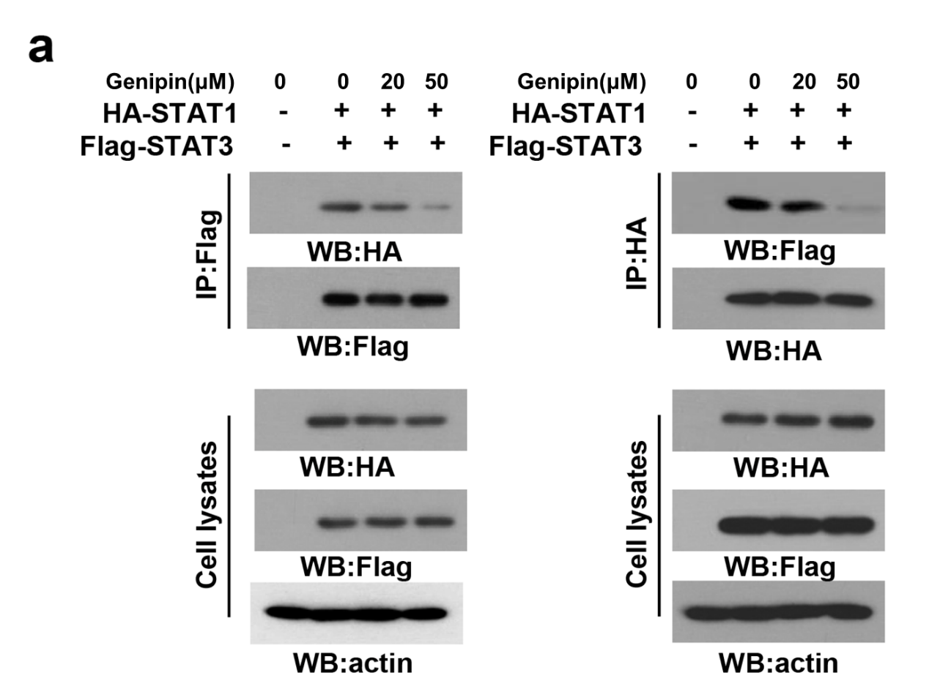

Supplementary Figure 2. Genipin inhibits the formation of STAT3-STAT1 heterodimer. (a) MHCC97L cells were transfected with HA-tagged STAT1 and FLAG-tagged STAT3 and pretreated with genipin, the binding ability of STAT3-STAT1 was validated by western blotting and immunoprecipitation assays.

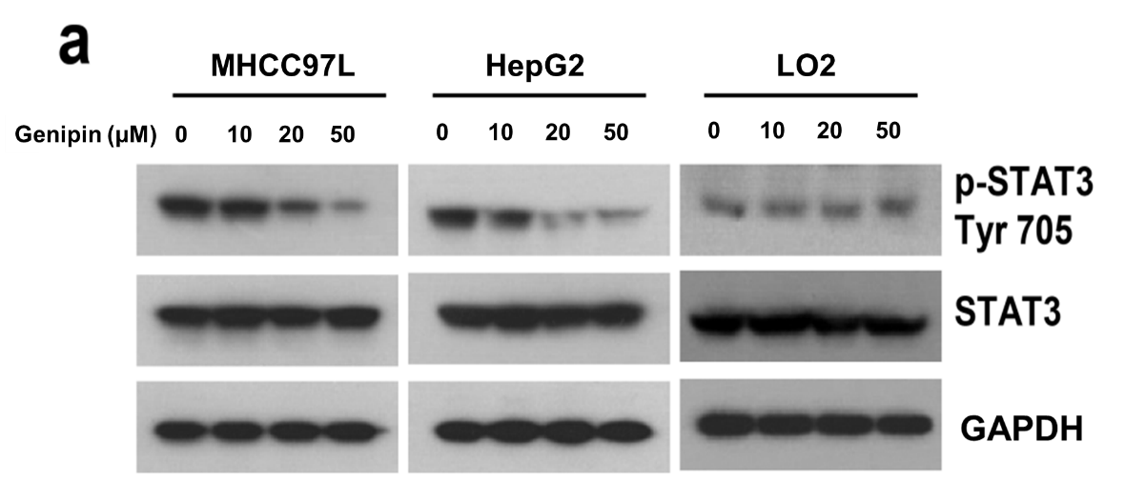
Supplementary Figure 3. Genipin suppresses the protein expression of p-STAT3 (Y705) in HCC cells. (a) HCC and normal liver cells were treated with genipin for 12 h, cells extracts were prepared and protein expressions were examined by western blot assay.

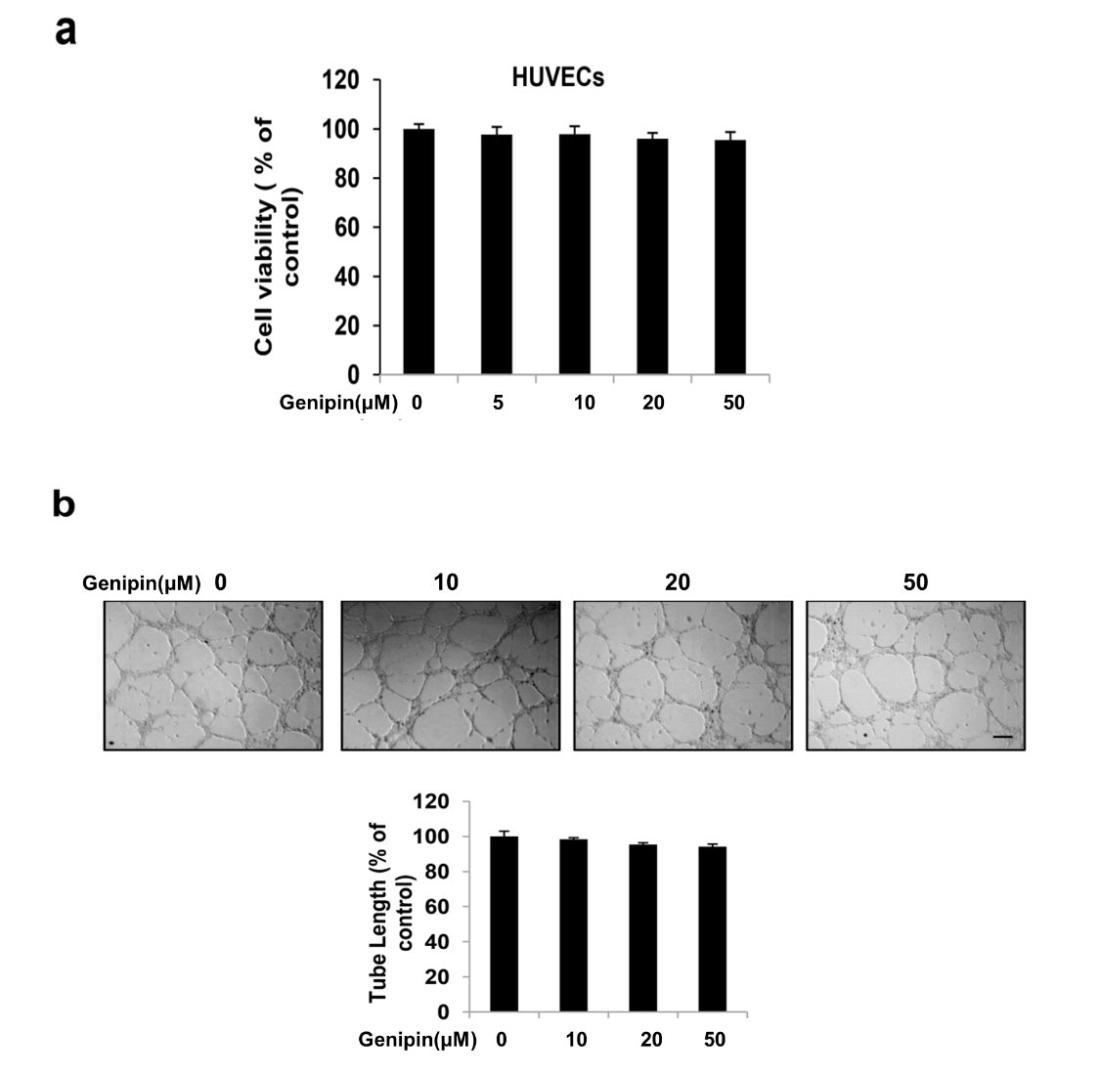
Supplementary Figure 4. Genipin failed to affect the proliferation of HUVECs and capillary structure formation. (a) HUVECs were treated with genipin (5,10, 20, 50 μM ) for 24 h and examined by MTS assay. (b) 5×10³ HUVECs were cultured in 24-well plates, then, genipin (10, 20, 50 μM ) were exposed to cells.. After 12 h incubation, Tubular structures were observed by inverted microscope(Carl Zeiss Vision, Germeny) and analyzed by Pro-Image ( Media Cybernetics, USA) software. The data represents mean ± SD. Scale bar = 20 μm.
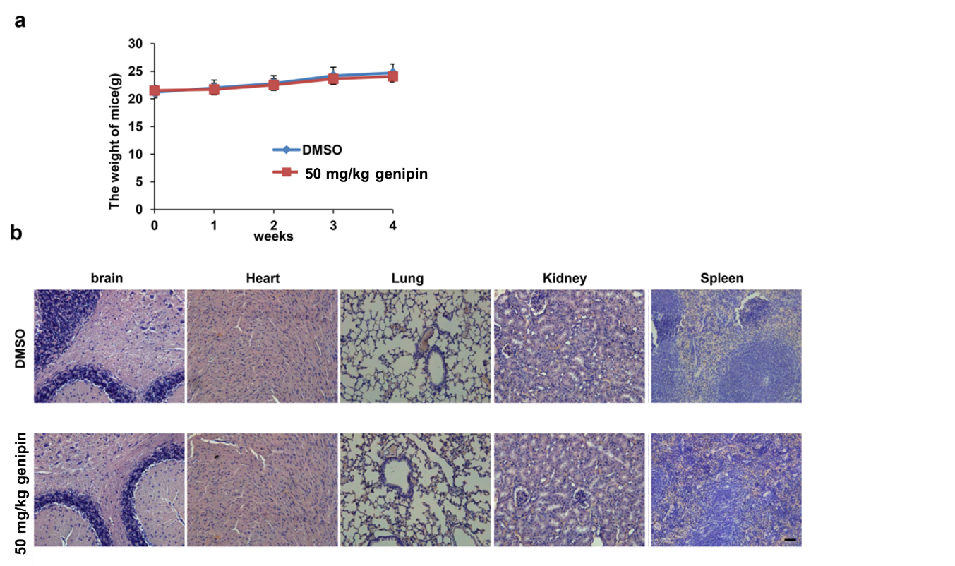
Supplementary Figure 5. The potential cytotoxicity of genipin in vivo. (a) Nude mice were administrated with genipin (50 mg/kg/day) or DMSO by i.p. injection for 4 weeks (n = 6). The body weight was detected each week. (b) H&E staining results of brain, heart, lung, kidney and spleen organs from DMSO group and genipin group. Scale bar=20 μm.

Supplementary Table 1. The information of HCC patients with tumor resection operation
Patient ID | Age | Sex | Tumor location
1# | 43 | male | left lobe of liver
2# | 71 | male | right lobe of liver
3# | 65 | female | right lobe of liver
4# | 67 | female | left lobe of liver
5# | 58 | male | left lobe of liver
6# | 62 | female | right lobe of liver
7# | 53 | male | left lobe of liver

Supplementary Table 2. The effects of genipin on kidney and liver functions in nude mice
Serum Chemistry | Control | Genipin | p-Value
Blood urea nitrogen (mg/dL) | 51.7 ± 4.97 | 49.8 ± 2.57 | 0.231
Serum creatinine (µmol/L) | 115.42 ± 8.52 | 110.60 ± 7.48 | 0.617
Alanine transaminase (U/L) | 69.78 ± 9.29 | 65.88 ± 11.81 | 0.569
Aspartate transaminase (U/L) | 373.96 ± 75.4 | 381.15 ± 86.3 | 0.309

Supplementary Table 3. The primer sequences used in RT-PCR assay
