Shear wave splitting and seismic velocity structure in the focal area of the earthquake swarm and their relation with earthquake swarm activity in the Noto Peninsula, central Japan

Tomomi Okada¹, Martha K. Savage², Shin'ichi Sakai³, Keisuke Yoshida¹, Naoki Uchida⁴, Ryota Takagi¹, Shuutoku Kimura¹, Satoshi Hirahara¹, Ayaka Tagami¹, Ryotaro Fujimura¹, Toru Matsuzawa¹, Eiji Kurashimo⁴, Yoshihiro Hiramatsu⁵

1 Research Center for Prediction of Earthquakes and Volcanic Eruptions, Graduate School of Science, Tohoku University, Aramaki-Aza-Aoba, Aoba-ku, Sendai, 980-8578, Japan
2 School of Geography, Environment and Earth Sciences, Victoria University of Wellington, Wellington 6140, New Zealand
3 Interfaculty Initiative in Information Studies and Graduate School of Interdisciplinary Information Studies, The University of Tokyo, 7-3-1 Hongo, Bunkyo-ku, Tokyo 113-0033 Japan
4 Earthquake Research Institute, The University of Tokyo, 1-1-1 Yayoi, Bunkyo-ku, Tokyo 113-0033 Japan
5 Division of Geosciences and Civil Engineering, Graduate School of Natural Science and Technology, Kanazawa University, Kakuma, Kanazawa, Ishikawa 920-1192, Japan

Supplementary materials

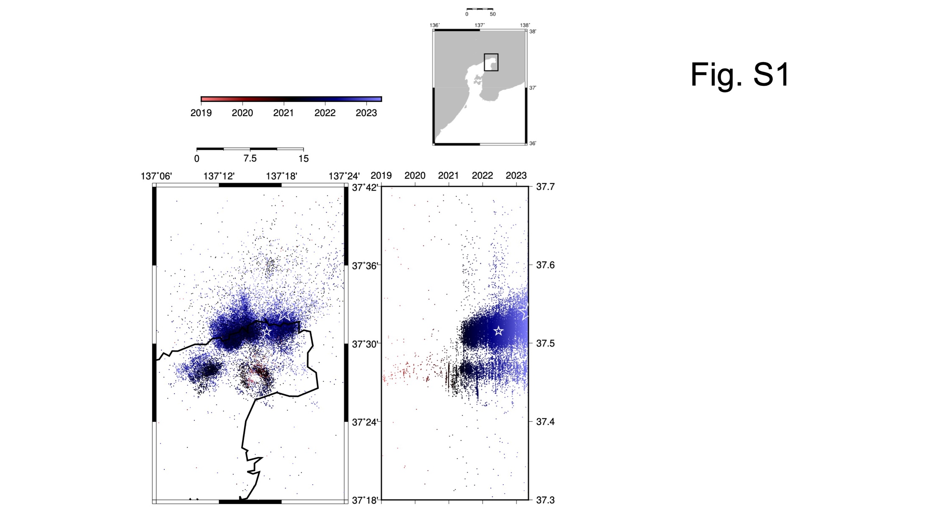
Fig. S1. Spacio-temporal distribution of the earthquake swarm. We used the Japan Meteorological Agency (JMA) catalog. The color denotes the occurrence time. (a) Map view. (b) Time-latitude plot.
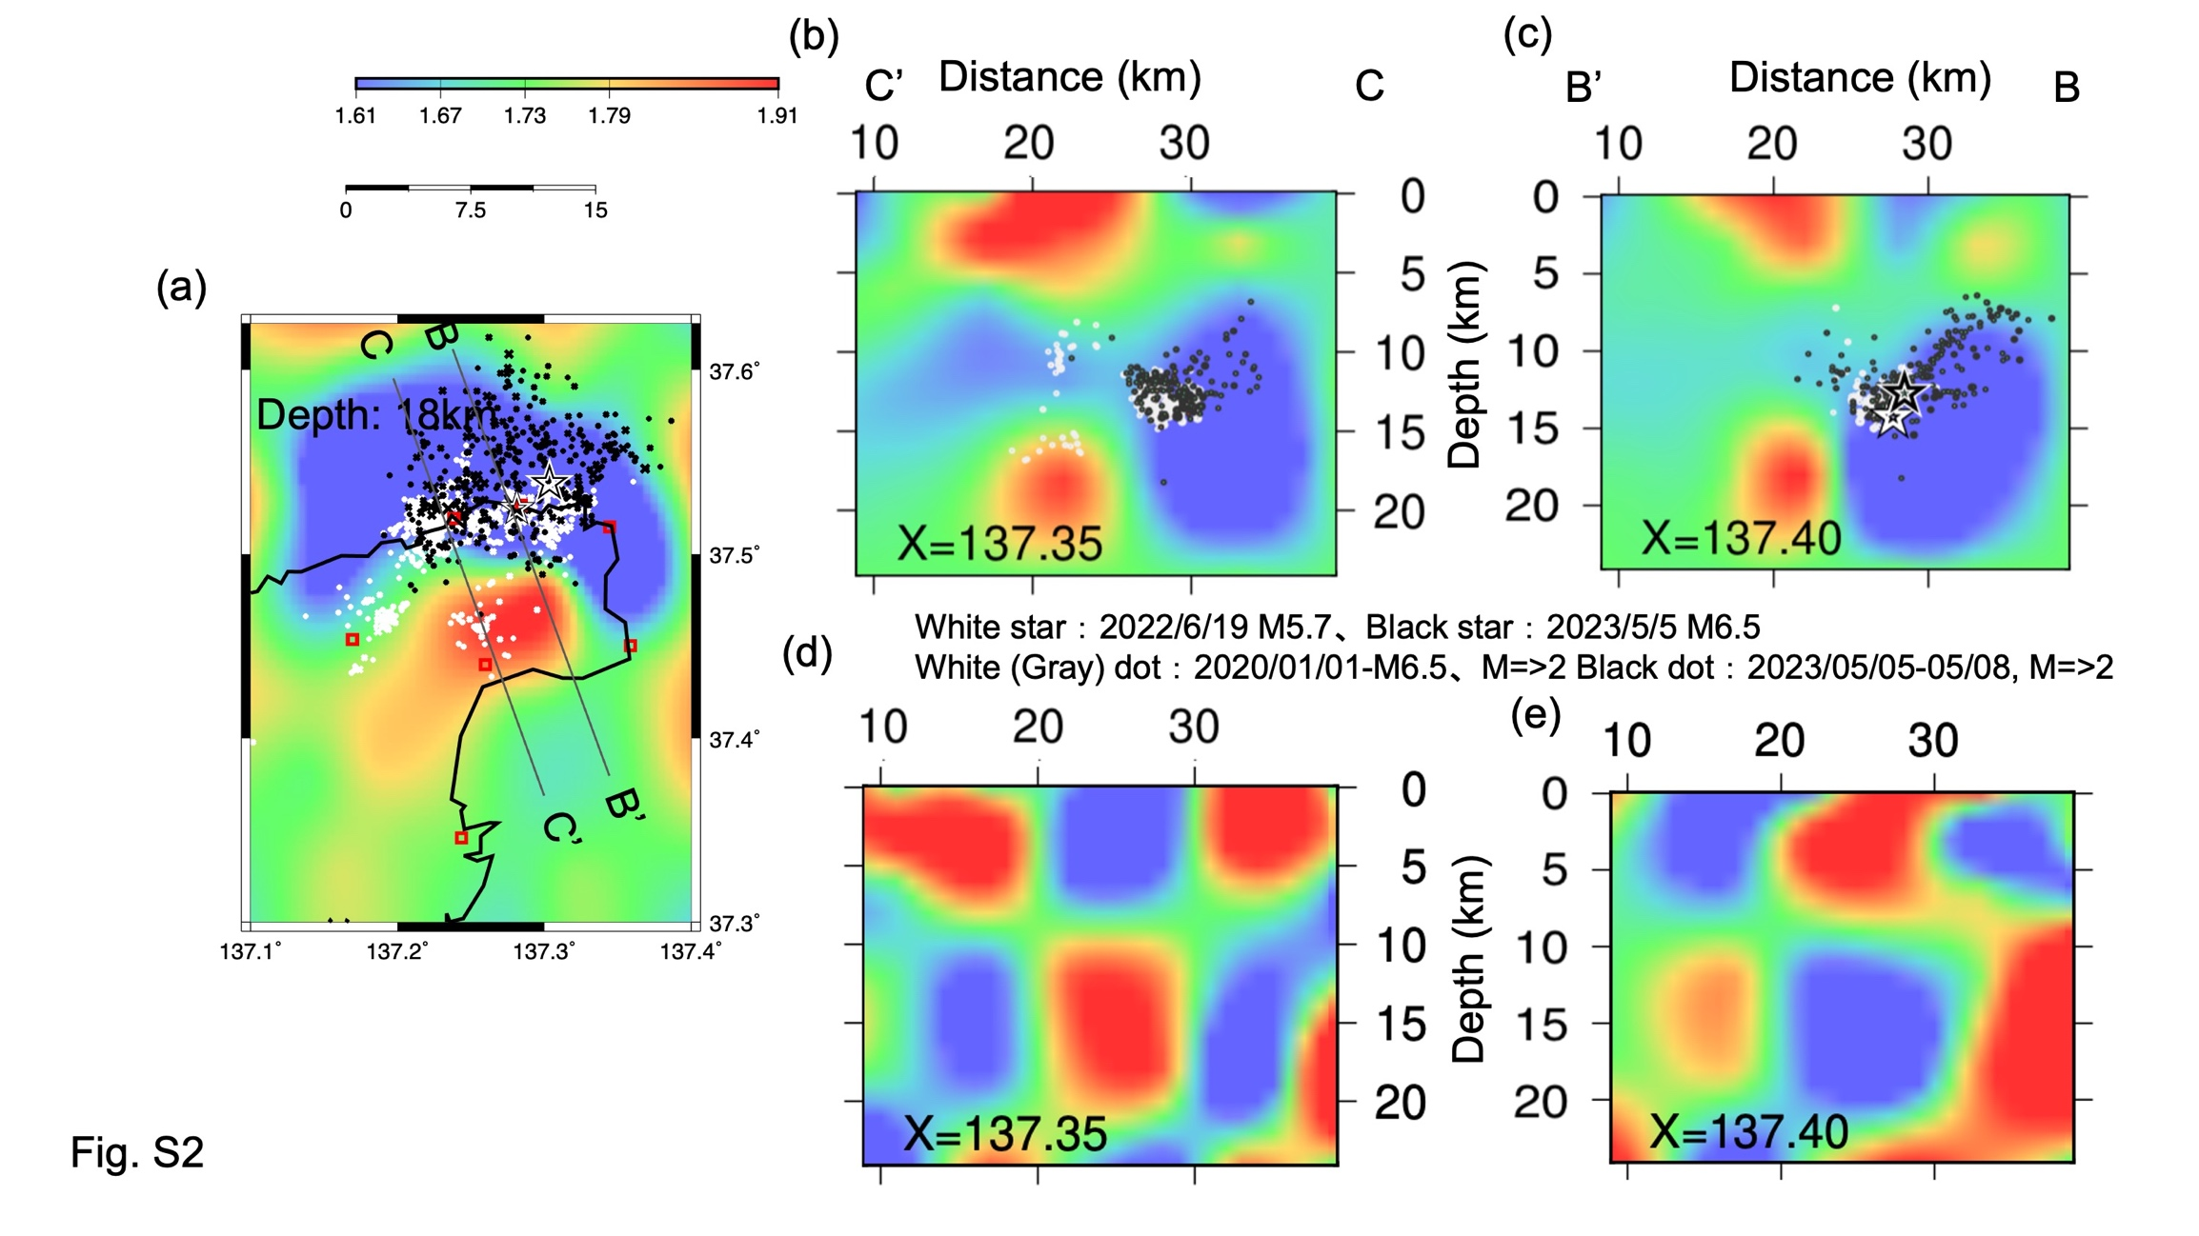
Fig. S2.
Result of the checkerboard resolution test. Same as Fig. 2, but the result of the checkerboard resolution is shown instead of the actual Vp image in (d) and (e).
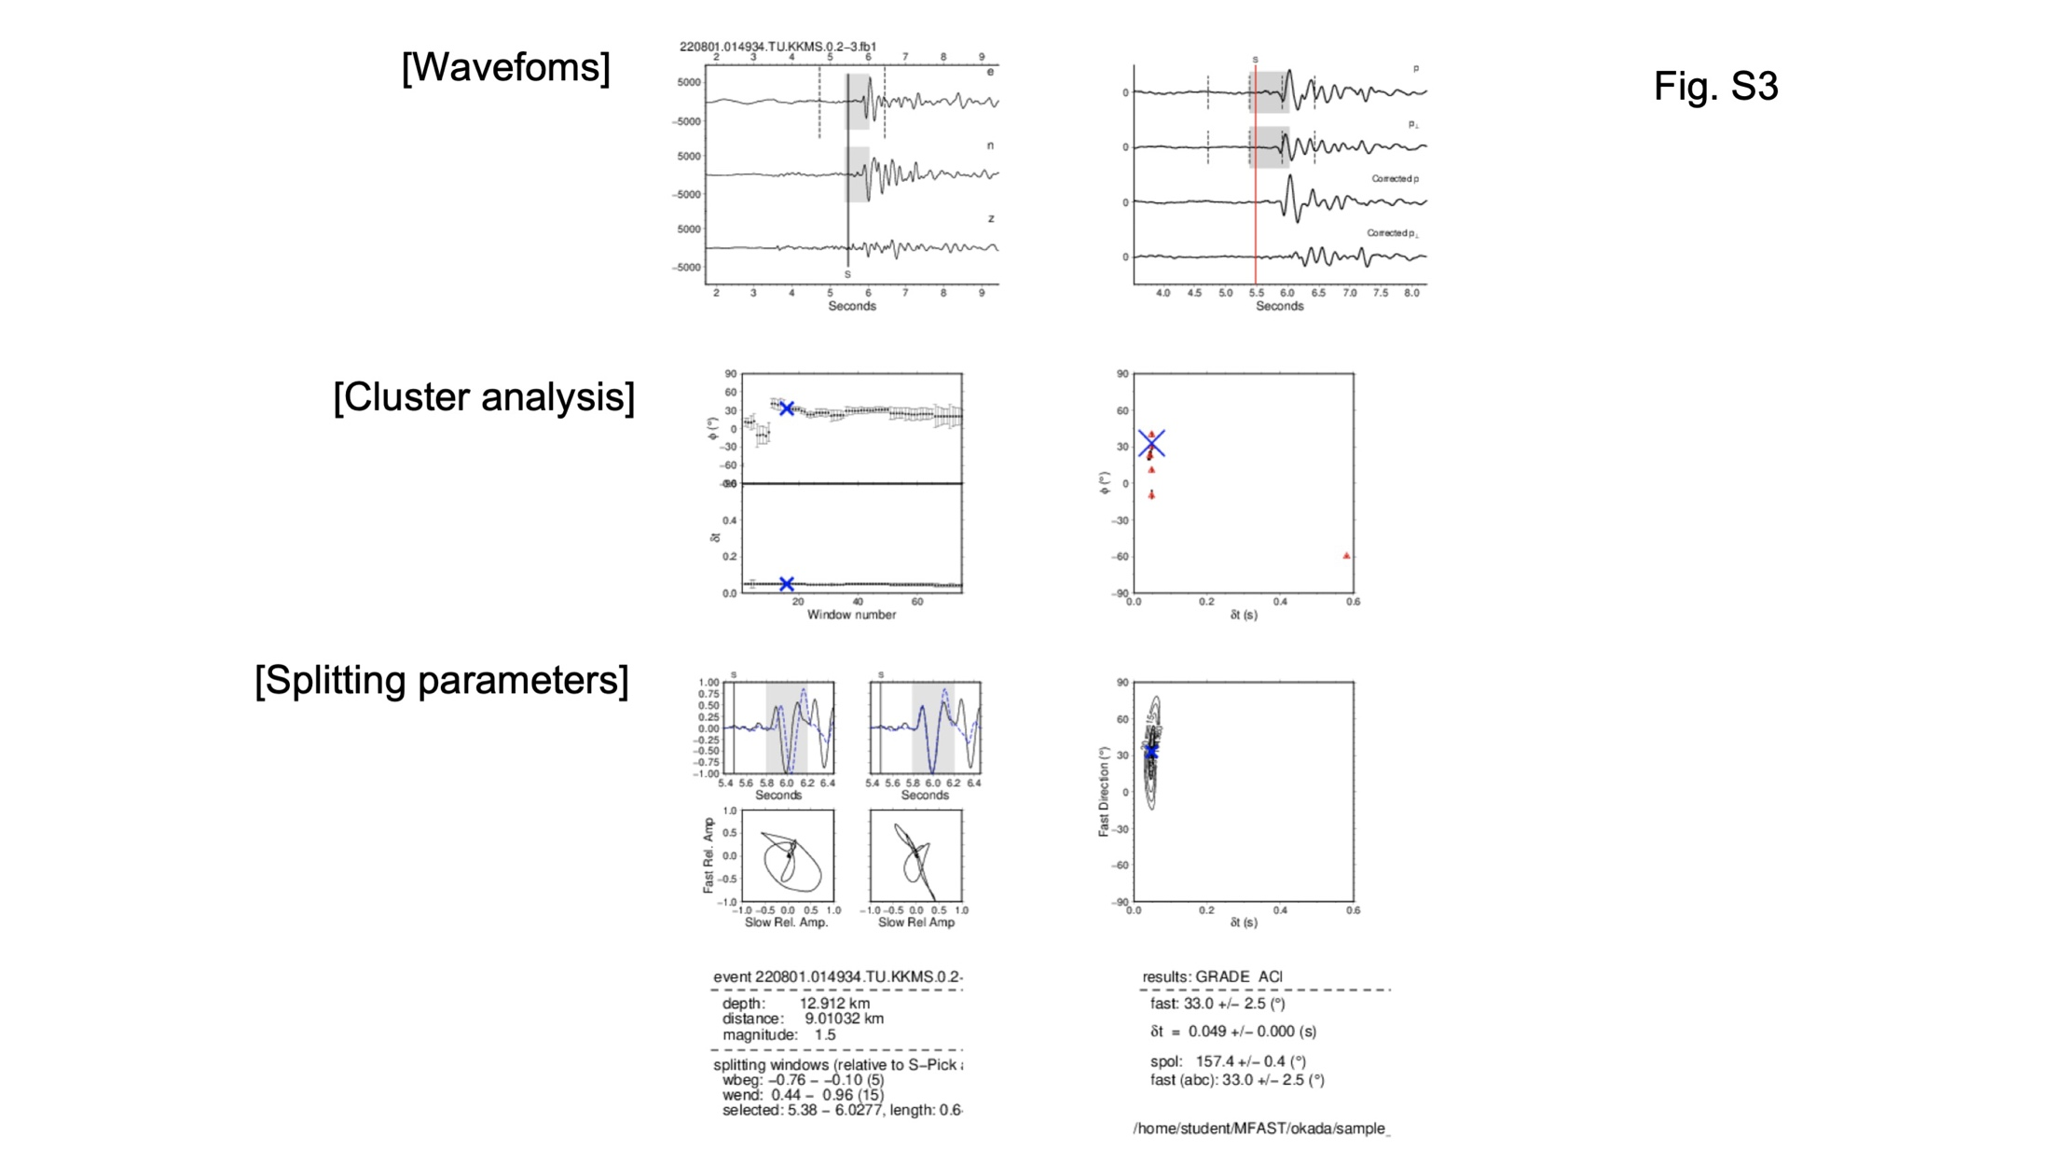
Fig. S3.
Examples of high-quality A-grade measurements of regional events recorded at station TU.KKMS. (a) Filtered waveforms of the eastern (E), northern (N), and vertical (Z) components. The vertical solid line is the S arrival time. The dashed lines are the minimum start time (1) and maximum end time (4) of the window used for processing. (b) For the window shown in gray, the original filtered waveform (top two curves) and the waveform corrected with dt determined by SC91 (bottom two curves) are shown rotated in the early S wave polarization direction (p), and its vertical direction (p⊥) determined by SC91. The vertical solid line is the S arrival time. The two dashed lines on either side of the vertical line indicate the range of start windows (1 and 2) and end windows (3 and 4) allowed in the SC91 measurements. (c) Values of φ and dt determined for each measurement window as a function of the window number shown on the abscissa. (d) For all clusters of five or more measurements, the large cross is the cluster finally chosen as the optimal value. (e) The (top) waveform and (bottom) particle motion of the (left) original and (right) corrected waveforms obtained by the finally selected window. (f) Contours of the smallest eigenvalue of the covariance matrix of the finally selected measurement with SC91. Gray boxes in a, b, and e represent the time window for the final measurement.
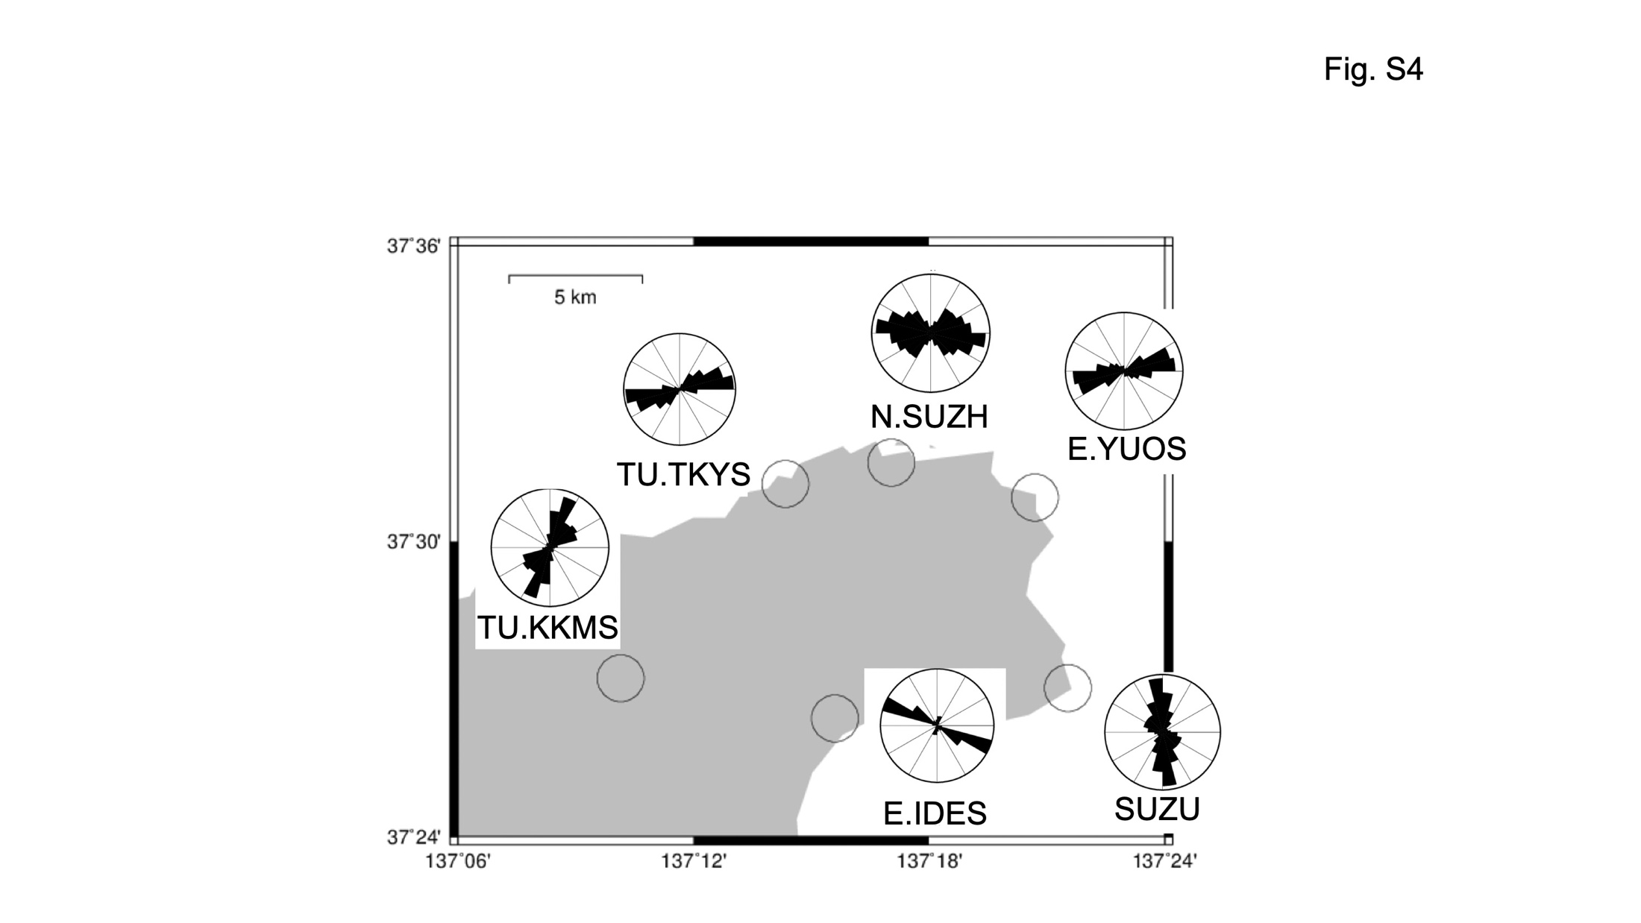
Fig. S4. Rose diagrams of the FSOD at six stations.

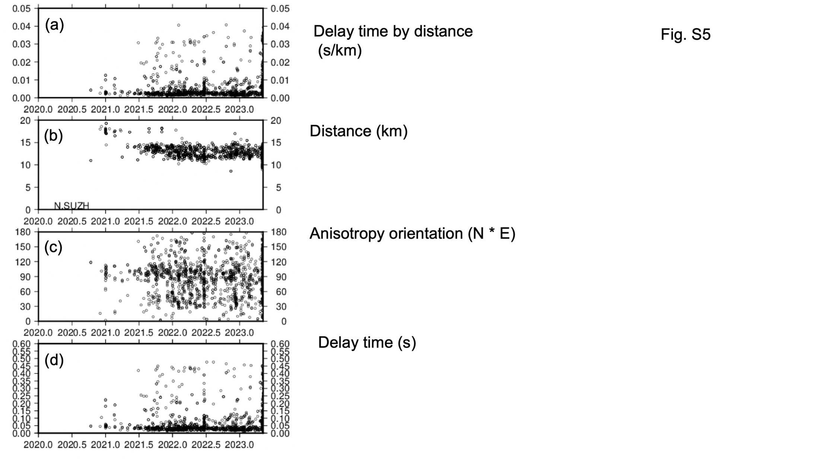
Fig. S5. Shear wave splitting: temporal change at station N.SUZH. Delay time between two split shear waves divided by the distance (b) Distance between the hypocenter of the earthquake and the observed station, (c) the direction of anisotropy, (d) delay time, with time on the horizontal axis.

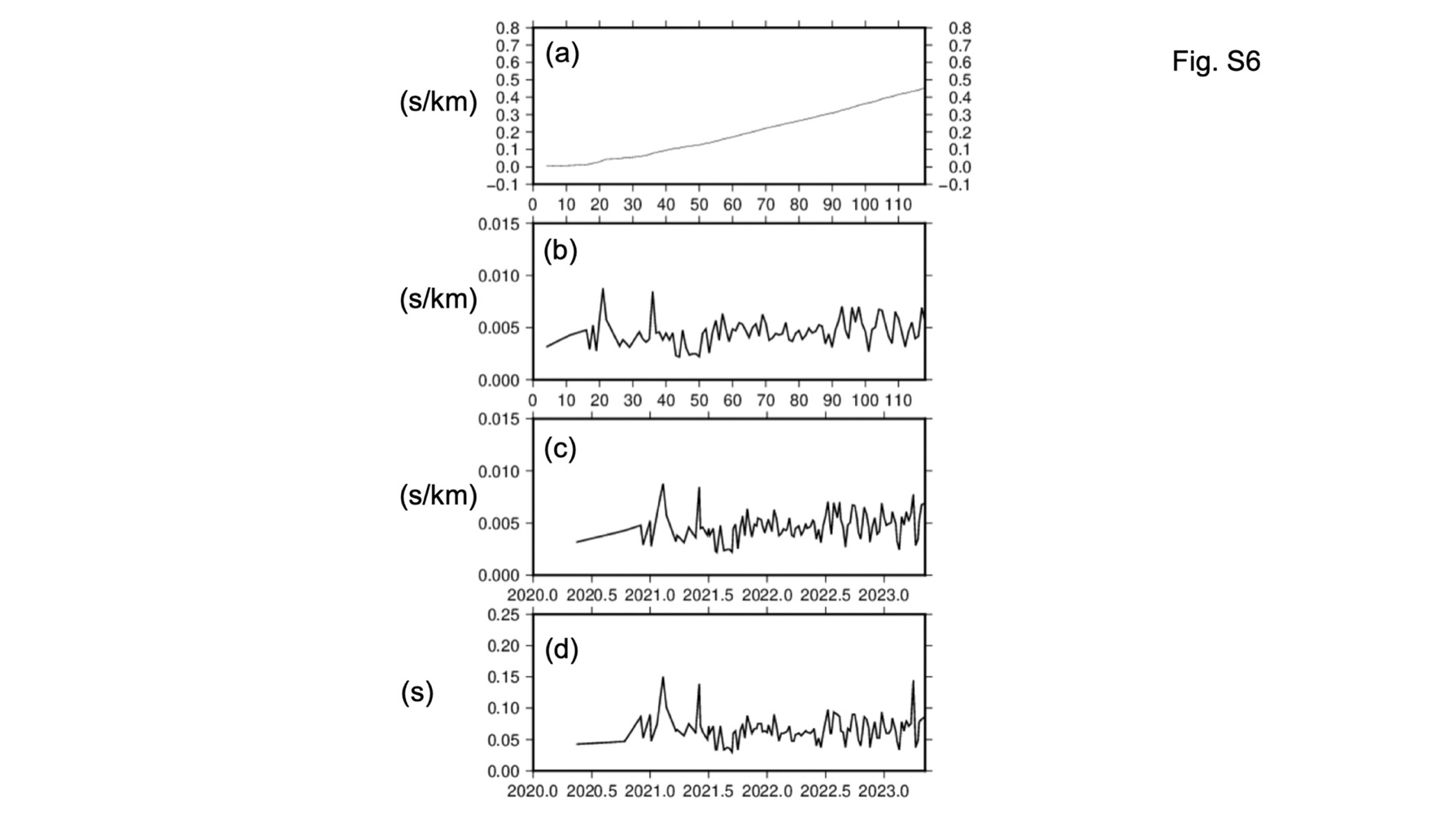
Fig. S6. Median values of the delay time in 7-day moving windows at station N.SUZH. (a) Cumulative value of median of delay time normalized by the path length. The horizontal axis is the number of the window. (b) The median of delay time is normalized by the length of the path. The horizontal axis is the number of windows. (c) The median of delay time is normalized by the length of the path. The horizontal axis is the year. (d) The delay time, which is not normalized by the length of the path. The horizontal axis is the year.
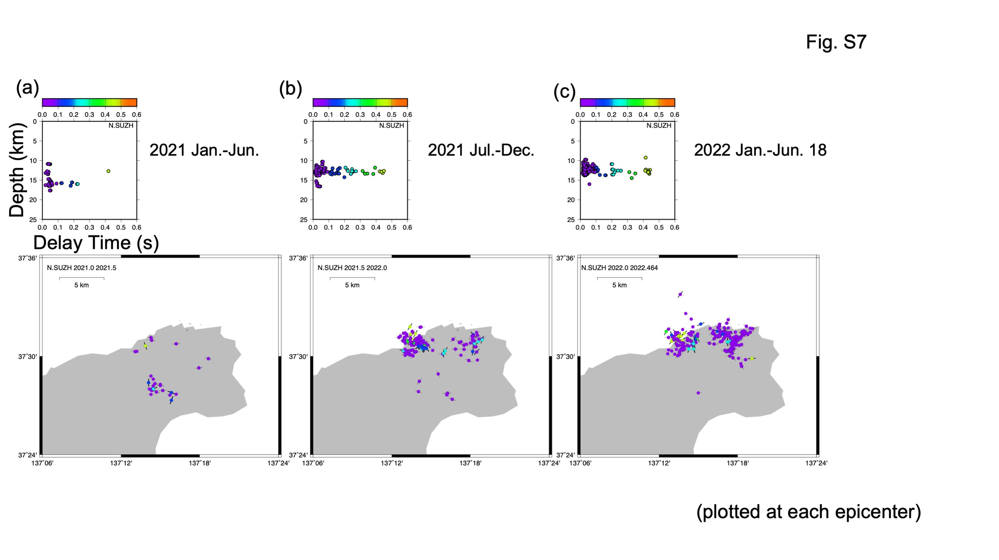
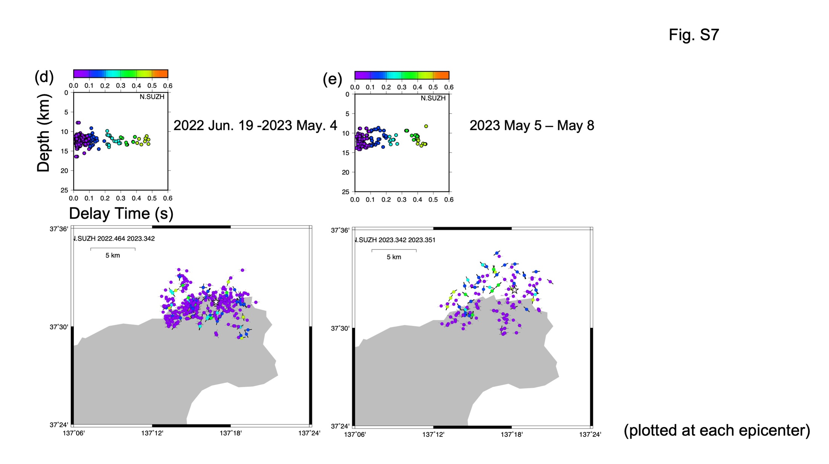
Fig. S7. Shear wave splitting: temporal change: map plots for five time windows. The observation at station N.SUZH is shown. The direction of anisotropy is the direction of the bar. The delay time is shown as the color of a small circle at the center of the bar. They are plotted at the epicenter location. Delay time versus hypocenter depth is also shown. The white star in (d) denotes the M5.4 earthquake on June 19, 2022. The white star in (e) denotes the M6.5 earthquake on May 5, 2023.
Explanation of Fig. S7:
The leftmost figure 7a is for January-June 2021. Most earthquakes that we are able to use for anisotropy analysis are located in the southern part of the epicentral region, and the direction of anisotropy is mainly in the NW-SE direction. Figure 7b is for July-December 2021. The earthquakes during this period are located in the northern part of the epicentral region and are especially active in its western part. Large delay times are identified from the earthquakes in this active western region. Figure S7c is from January 2022 to June 18, 2022. The earthquake swarms during this period are located in the northern part of the epicenter region and are active in the western and eastern parts with a blank area in between. Large delay times continue to be identified from earthquakes in the active region, mainly in the western part. The Figure S7d is from June 19, 2022, to May 4, 2023. A M5.4 earthquake (star) occurred on June 19 in the previously blank area, in the north-central part, and seismic activity, including aftershocks of the M5.4 earthquake, is seen in the vicinity of the M5.4 earthquake. Since seismic activity in the northwest part is relatively inconspicuous in this period, there are a few observations of large delay times. Figure S7e is from May 5, 2023, to May 8, 2023. A M6.5 earthquake (star) occurred on May 5, 2023, in the northern part, and seismic activity, including aftershocks of the M6.5 earthquake, extended to further north. Larger delay times are identified in the northerly extended epicentral area. Based on the above spatiotemporal changes, we considered that small regions of high anisotropy exist on the northern side of the epicenter area.

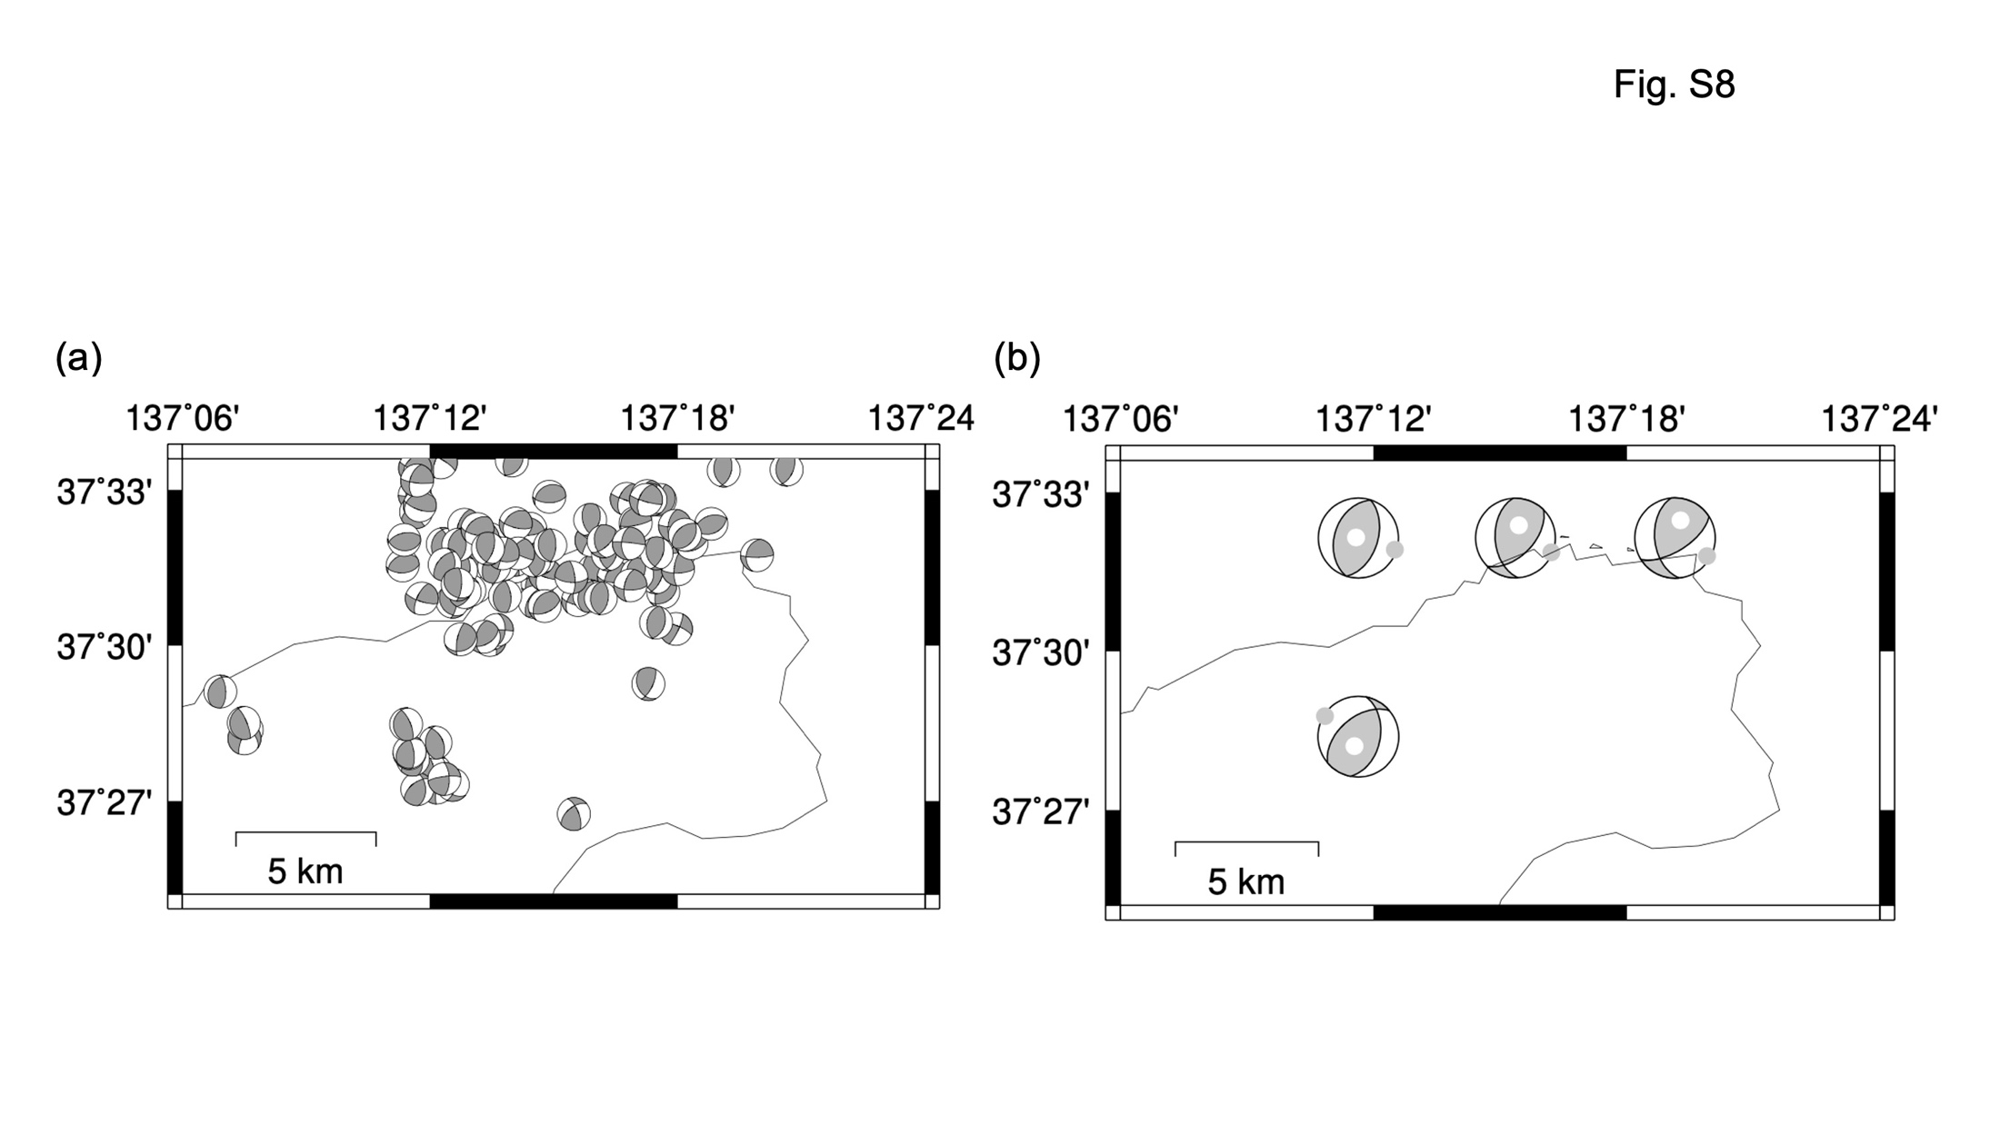
Fig. S8. Focal mechanisms and stress tensors. They are shown in the lower hemisphere projection. The left figure (a) shows the focal mechanism at each epicenter. We obtained 93 mechanisms from May 2021 to May 8, 2023. The right figure (b) shows the stress tensors in sub-areas with a 0.0625 x 0.0625 degrees size. Grey and white dots denote the P- and T-axis, respectively.

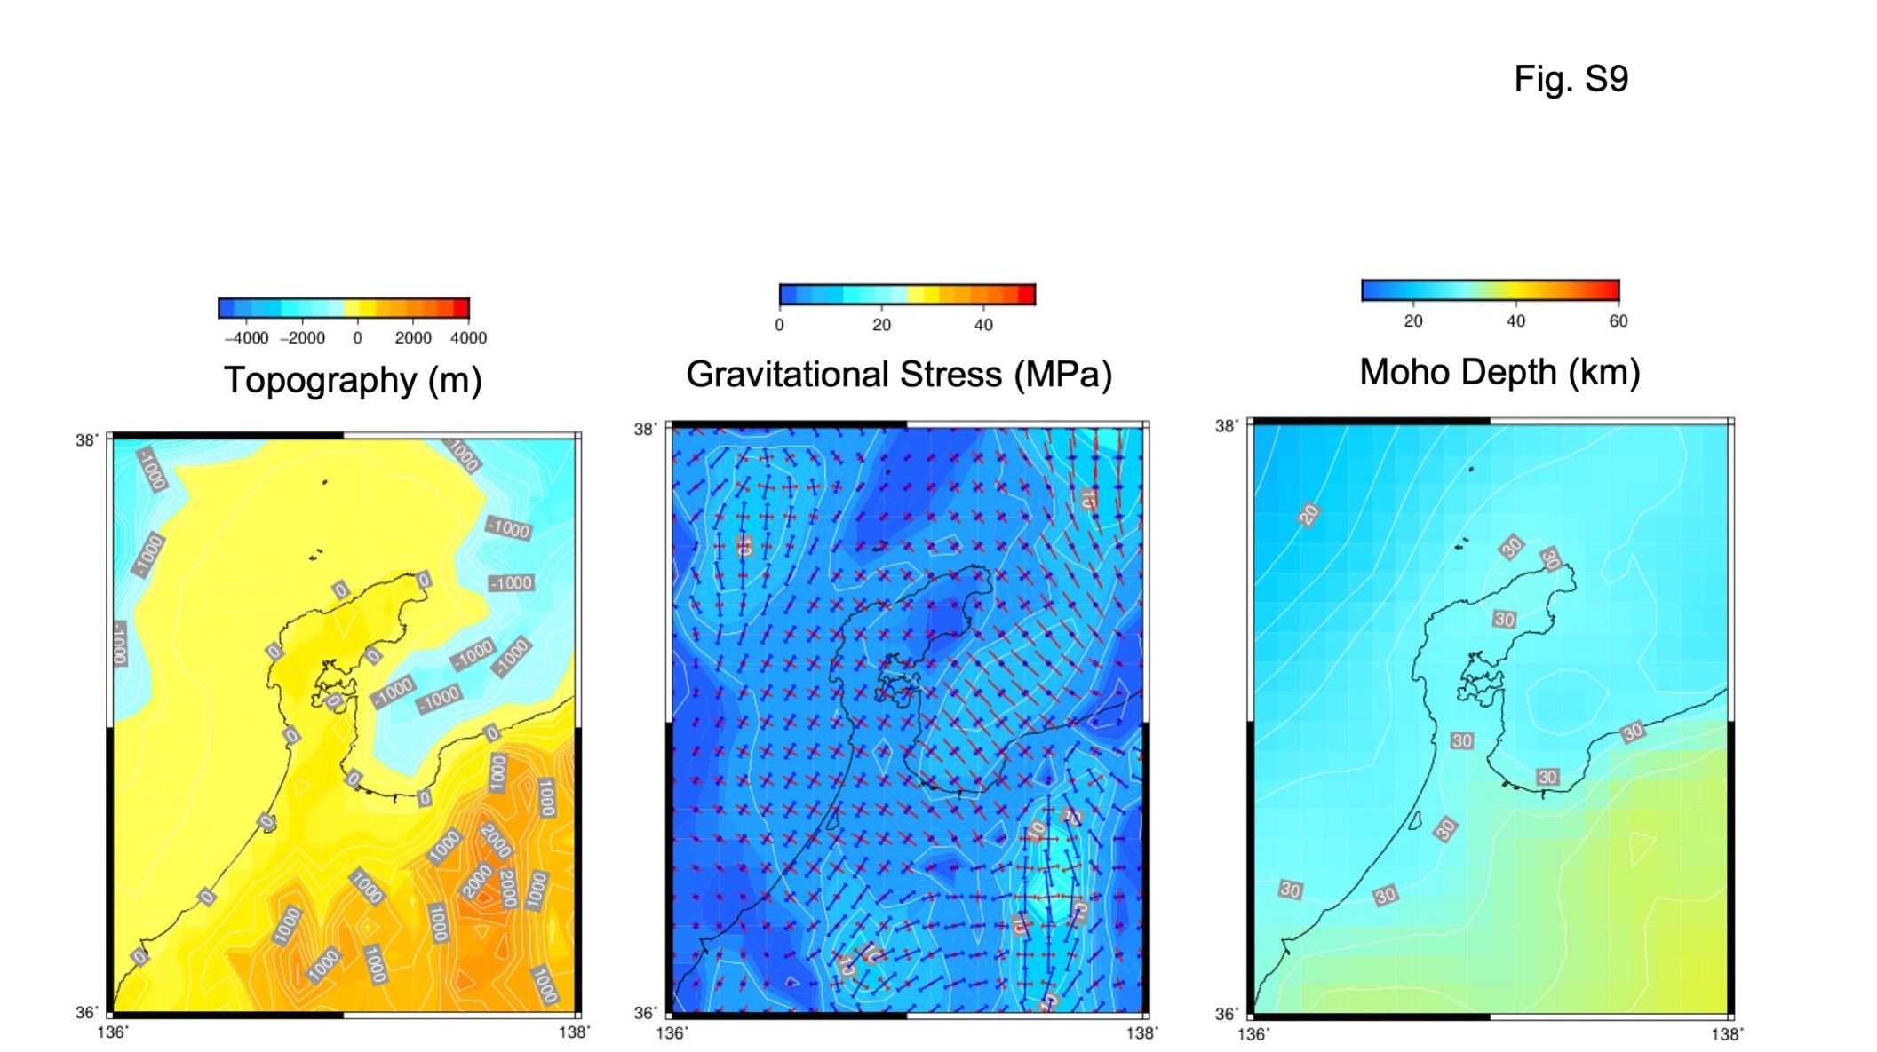
Fig. S9.
Gravitational-induced stress. This figure shows, from left to right, the topography, the gravity-induced stress field averaged from the surface to a depth of 25 km, and the depth of the Moho surface. In the gravitational stress map, red and blue arrows denote the maximum and minimum compressional stress axis, respectively.

