Supplemental methods

Imaging acquisition and preprocessing
A 1.5-tesla GE MRI scanner (GE Medical Systems, Milwaukee, WI) and standard quadrature head coil were used to obtain MRI images. A T1-weighted spoiled gradient echo sequence was used to generate 124 contiguous 1.5-mm-thick axial slices (repetition time = 6.1 msec; flip angle = 20°; field of view = 240 mm; matrix size = 256 x 256 x 124). MRI data were analysied with FSL-VBM.
A GE Advance three-dimensional PET scanner was used to acquire FDG-PET images (4.25-mm slice separation, 35 slices, axial field of view 15.3 cm, transverse field of view 55.0 cm). Subjects were made to fast from midnight before the scan and had no caffeine, alcohol, or nicotine for 24 h before the scan. The subject was given an intravenous injection of 5 millicuries of FDG. Starting with the time of injection and continuing through the cerebral uptake period and subsequent scan, 25 arterial blood specimens were taken at fixed intervals for assay of plasma radioactivity and glucose content. FDG-PET data were brain extracted, registered to the same subject’s T1 MRI, then to the study grey matter template obtained from FSL-VBM. Images were intensity normalised using a cerebellum mask.
For all analyses VBM and PET unilinear analyses, we accepted a threshold of p<0.05 Threshold-Free Cluster Enhancement (TFCE) correction 25.

Multimodal decomposition technique
This method assumes that the trajectory of a given voxel's values, as a function of the variable of interest, is mainly governed by one component, out of a possible L. The aim is to estimate the spatial maps and trajectories/subject weights associated with these L components. The voxel’s values represent membership/loading values, rather than p-values. The number of trajectories to extract for each behavioural component was determined though a dendrogram, which is obtained as part of the hierarchical clustering step in the method. Outliers were excluded from the analysis.

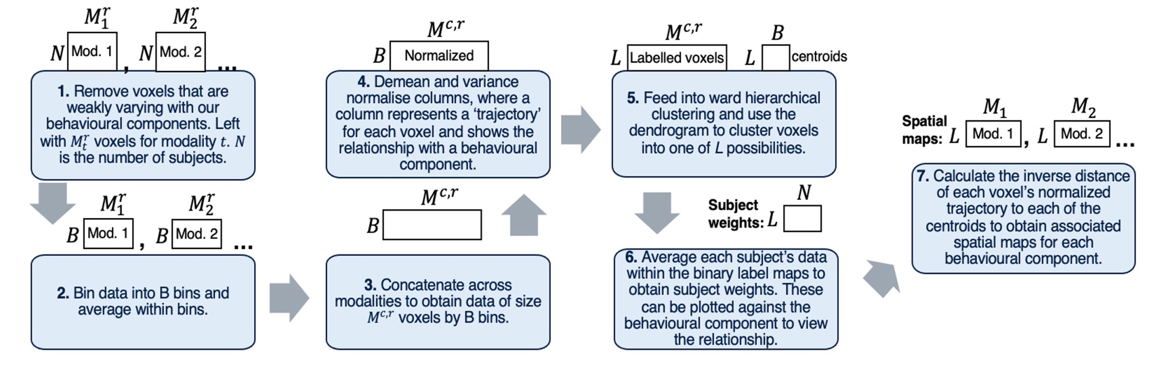
Overview of the method for multimodal analysis.
Above each blue box is a graphical depiction of the data representation at that stage.

Supplemental discussion
This study has limitations. First, patients were diagnosed at one point in time during a one-week stay at the NIH. Thus, we do not have longitudinal clinical data that could be included in the model. However, the present work was not aimed at studying the natural history of the disease, i.e., in which stages different behavioural symptoms present. It was aimed, instead, at identifying a framework of behavioural symptoms that can be used at any given moment along disease progression. Second, we only used observational questionnaires rather than experimental measures. But this was in line with our aim to identify a framework that could be easily clinically interpreted.

Supplementary Figure 1

Supplementary Figure 2
A) Dendrogram obtained with hierarchical clustering for Component 1, Apathy
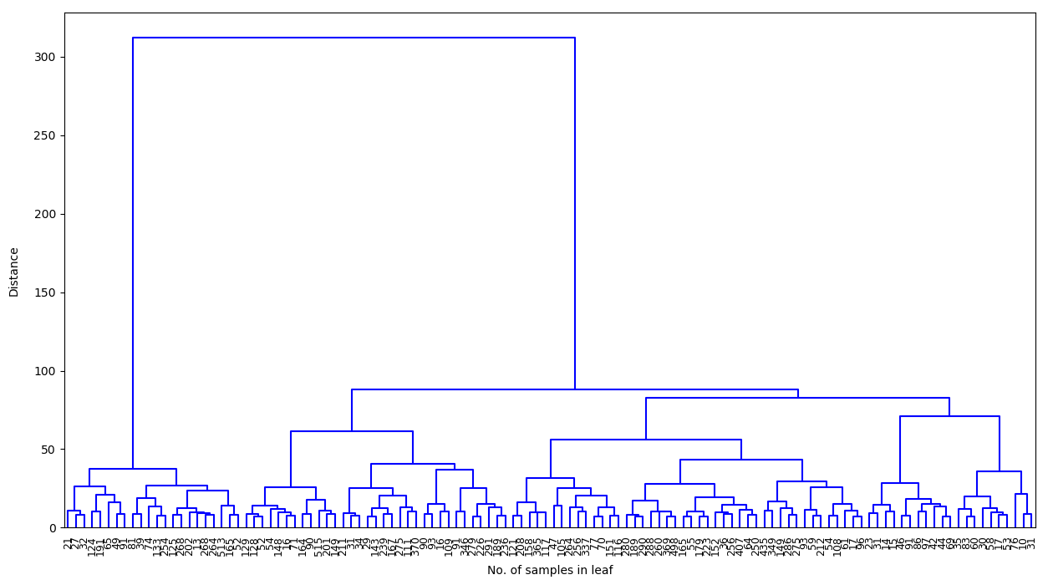

B) Dendrogram obtained with hierarchical clustering for Component 2, Disinhibition versus mutism/depression

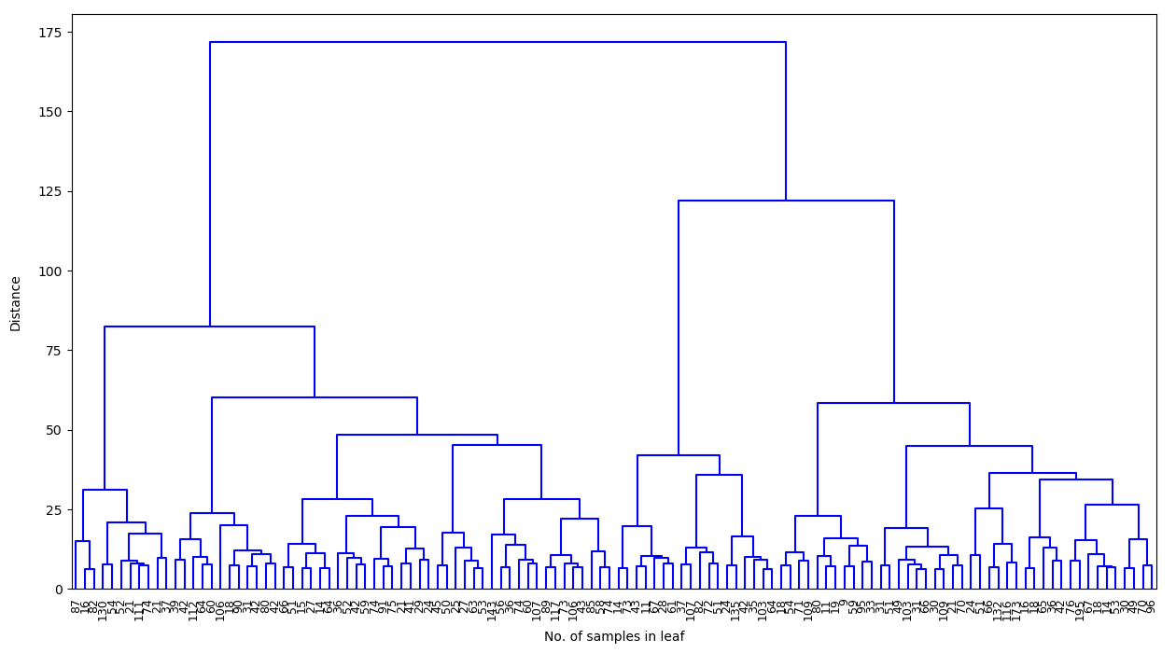

C) Dendrogram obtained with hierarchical clustering for Component 3, Psychosis

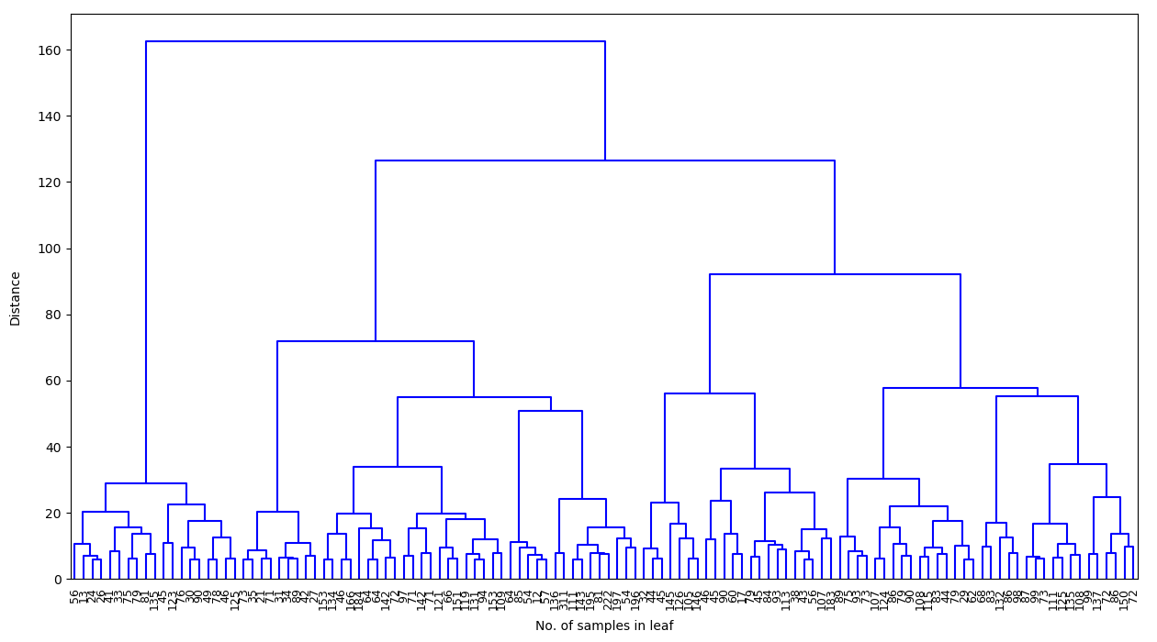

Supplementary Table 1 Rotated component matrix extracted from principal components analysis
Input variable | Components
 | Apathy | Disinhibition versus mutism | Psychosis
Eigenvalue | 7.644 | 3.961 | 3.445
FrSBe (Caregiver) Apathy | .695 | -.007 | -.032
FrSBe (Caregiver) Disinhibition | .369 | -.585 | -.057
FrSBe (Caregiver) Executive Dysfunction | .666 | -.211 | -.108
NBRS Inattention/Reduced Alertness | .762 | .101 | -.048
NBRS Somatic Concern | -.042 | -.021 | .232
NBRS Disorientation | .326 | .042 | -.253
NBRS Anxiety | .012 | .012 | .513
NBRS Expressive Deficit | .067 | .611 | .018
NBRS Emotional Withdrawal | .741 | .222 | .160
NBRS Conceptual Disorganization | .636 | .112 | -.116
NBRS Disinhibition | .316 | -.461 | .028
NBRS Guilt Feelings | -.027 | .134 | -.001
NBRS Memory Deficit | .623 | .080 | -.072
NBRS NBRS Agitation | .536 | -.327 | .058
NBRS Inaccurate Insight and Self Appraisal | .492 | -.362 | .160
NBRS Depressive Mood | .173 | .684 | -.146
NBRS Hostility/Uncooperativeness | .314 | -.010 | .126
NBRS Decreased Initiative, Motivation | .779 | .174 | -.117
NBRS Suspiciousness | .017 | .014 | .669
NBRS Fatigability | .356 | .172 | .231
NBRS Hallucinatory Behavior | .009 | .070 | .856
NBRS Motor Retardation | .193 | .493 | -.154
NBRS Unusual Thought Content | .051 | -.098 | .715
NBRS Blunted Affect | .562 | .222 | .302
NBRS Excitement | -.178 | -.447 | -.018
NBRS Poor Planning | .561 | .011 | .276
NBRS Lability of Mood | .056 | -.013 | .031
NBRS Tension | .203 | .105 | .631
NBRS Comprehension Deficit | .557 | .258 | -.010
NBRS Speech Articulation Defect | .124 | .577 | -.126
NPI Delusions | -.059 | -.222 | .561
NPI Hallucinations | .031 | .008 | .700
NPI Agitation | .425 | -.346 | .064
NPI Depression/Dysphoria | .146 | .394 | -.029
NPI Anxiety | .408 | -.275 | .199
NPI Euphoria/Elation | .137 | -.446 | -.192
NPI Apathy/Indifference | .710 | -.203 | -.008
NPI Disinihibition | .415 | -.568 | -.114
NPI Irritability/Lability | .299 | -.450 | .003
NPI Aberrant Motor Behavior | .437 | -.250 | -.179
Supplementary Table 2 Summary of the multimodal imaging results

 |  | VBM | PET
Comp 1  Apathy | T1 | right and left parahippocampal gyrus, left hescl gyrus and superior temporal gyrus, left occipiral pole, left pre and post centarl gyri, left precuneous | left inferior, middle and superior (anterior division) temporal gyrus, left supramarginal gyrus, left parietal operculum and left parietal lobule, temporal-occipital fusiform cortex, left lingual gyrus, lateral occipital cortex, left post central e precentral
Comp 1  Apathy | T2 | right frontal orbital, bilateral subcallosal cortex, right and left frontal pole, right and left insular cortex, left frontal operculum, left middle frontal gyrus, right and left superior frontal gyrus, right paracingulate cortex, right angular gyrus, right hippocampus and amygdala, right thalamus | right and left frontal pole, right and left caudate and putamen, right talamus, right hippocampus
Comp 1  Apathy | T3 | right frontal medial cortex/paracingulate gyrus and cingulate, right putamen, right and left angular gyrus, right inferior frontal gyrus, right and left middle frontal gyrus, right superior frontal gyrus, right and left subcallosal cortex, right middle temporal gyrus, right precuneous | right orbitofrontal, right frontal pole, bilateral insular cortices, left inferior frontal gyrus, right and left cingulate gyrus, right and left superior frontal gyrus, left middle frontal gyrus
Comp 2  Disinhibiition versus depression/mutism | T1 | left thalamus (pulvinar), left calcarine cortex, left frontal pole, left middle and inferior frontal gyrus, left and right superior frontal gyrus, left precentral gyrus, right cingulate gyrus (posterior division) | bilateral putamen, right thalamus, right caudate, bilateral precentral gyrus, right supramarginal gyrus, bilateral cyngulate posterior division, right and left superior and inferior frontal gyrus
Comp 2  Disinhibiition versus depression/mutism | T2 | left and right inferior temporal gyrus, left middle temporal gyrus, left lateral occipital cortex, left angular gyrus, left and right cingulate gyrus | left temporal pole, left and right lingual gyrus, left precuneus, left cingulate gyrus
Comp 2  Disinhibiition versus depression/mutism | T3 | right temporal fusiform cortex, right parahippocampal, left temporal pole, bilateral insular cortex, right superior temporal, right middle temporal gyrus, right lateral occipital cortex, left and right paracingulate gyrus, left frontal pole, left and right paracingulate gyrus | right temporal pole, left and right subcallosal cortex, right hippocampus and amygdala, right and left cingulate gyrus, right thalamus
Comp 3  Psychosis | T1 | left superior frontal gyrus, left cingulate gyrus (anterior division), left lingual gyrus | right occipital fusiform gyrus, left lateral occipital cortex, bilateral occipital pole, right lingual gyrus, left cuneal cortex, right putamen, bilateral precentral gyrus
Comp 3  Psychosis | T2 | right frontal pole, bilateral orbitofrontal cortex, bilateral amygdala, putamen, left and right thalamus, left and right frontal operculum, right paracingulate gyrus, right superior parietal lobule, right middle frontal gyrus, right supplementary motor cortex, left lingual gyrus, right occipital pole | left orbitofrontal cortex, left and right frontal pole, left superior frontal gyrus, left and right middle frontal gyrus, right precuneous
Comp 3  Psychosis | T3 | right inferior temporal gyrus, right temporal fusiform cortex, left temporal pole, left and right parahippocampal gyrus, left and right amygdala, bilateral insular cortices, right middle temporal gyrus, right supramarginal gyrus, right cingulate gyrus, right middle frontal gyrus, righr superior frontal gyrus, bilateral lateral occipital cortex, right precuneous | left and right temporal fusiform cortex, right inferior, middle and superior temporal gyrus, right heschl's and supramarginal gyri, right angular gyrus, left lingual gyrus, right lateral occipital cortex, right postcentral gyrus, right parietal lobule, left middle frontal gyrus, bilateral superior frontal gyri

