Comparative Omics Analysis for Novel Target Discovery in Plant Pathogens: A Case Study for Magnaporthe oryzae

Muhammad Luthfi ^{1,2}, Jittra Piapukiew^{3,4}, R.B. Pandey⁵, Pornthep Sompornpisut ^{*2}
¹Program in Bioinformatics and Computational Biology, Graduate School, Chulalongkorn University, Bangkok 10330, Thailand
²Center of Excellence in Computational Chemistry, Department of Chemistry, Faculty of Science, Chulalongkorn University, Bangkok 10330, Thailand
³Department of Botany, Faculty of Science, Chulalongkorn University, Patumwan, Bangkok, 10330, Thailand
⁴Center of Excellence in Biocatalyst and Sustainable Biotechnology, Faculty of Science, Chulalongkorn University, Pathumwan, Bangkok, 10330, Thailand
⁵School of Mathematics and Natural Sciences, University of Southern Mississippi, Hattiesburg, MS 39406, USA

∗ Corresponding author email address: Pornthep.S@chula.ac.th

Supplementary Figure

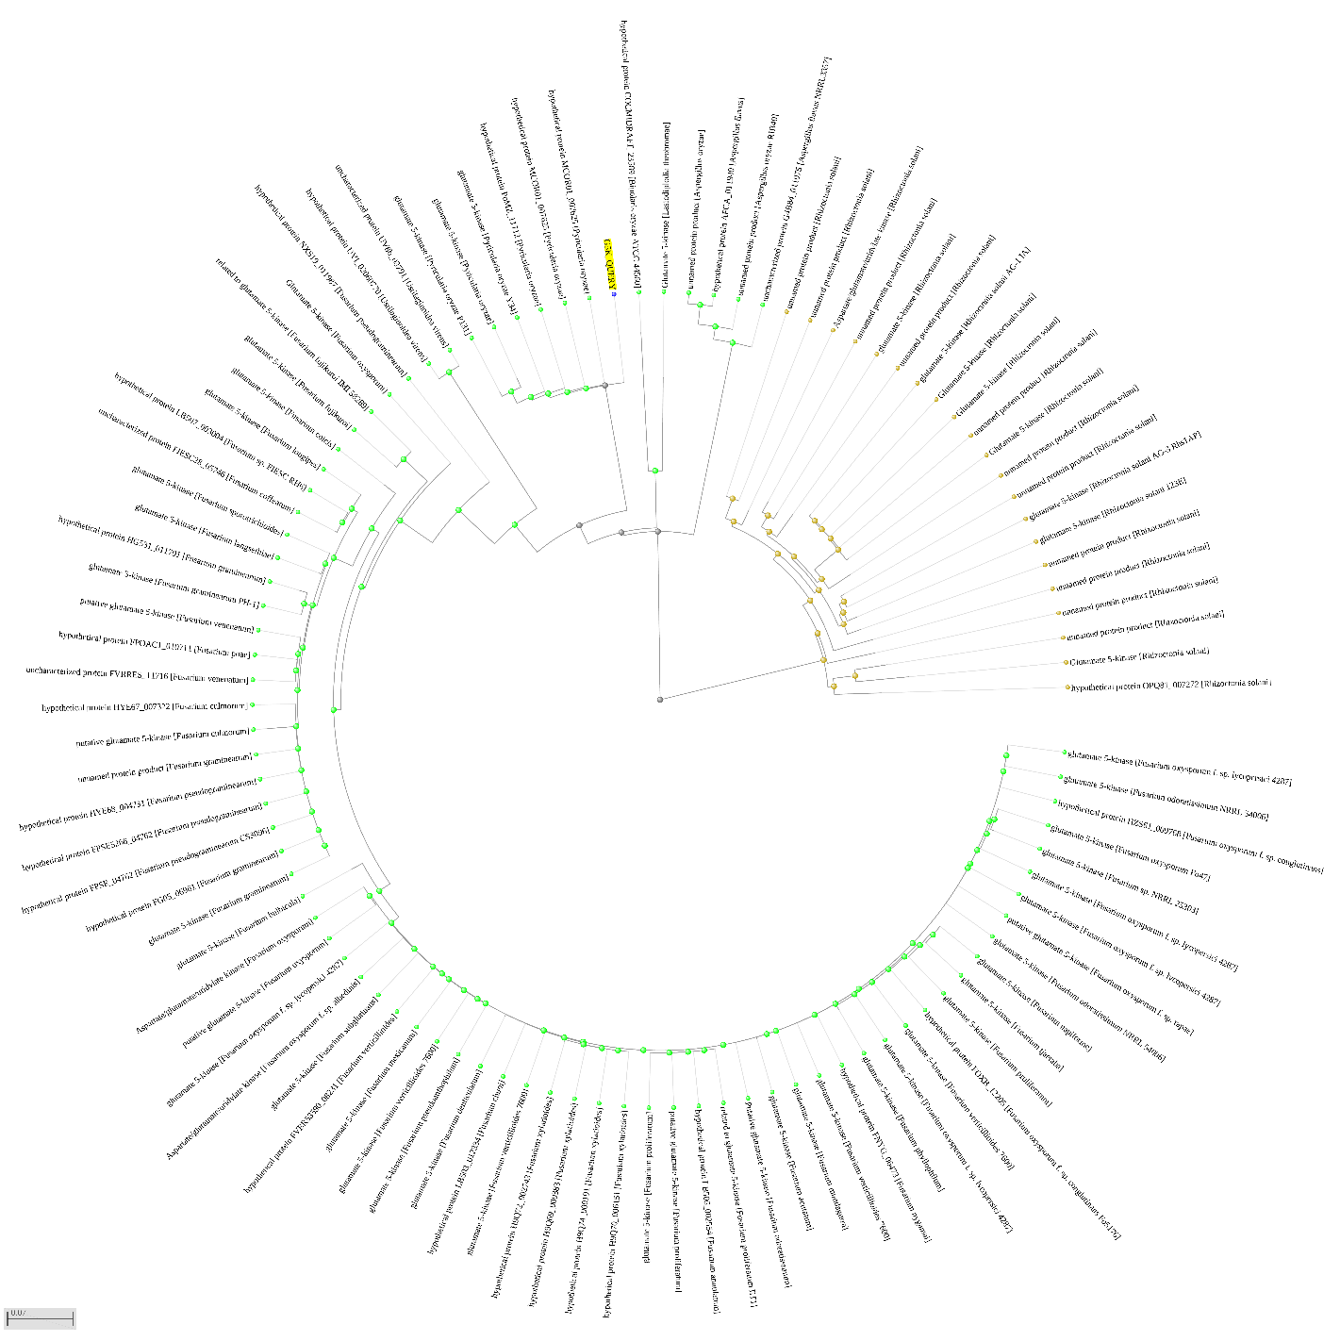

Fig. S1 Circular tree of 240 proteins from 85 different pathogens that shared high similarity with G5K. The query protein is highlighted in a yellow background.

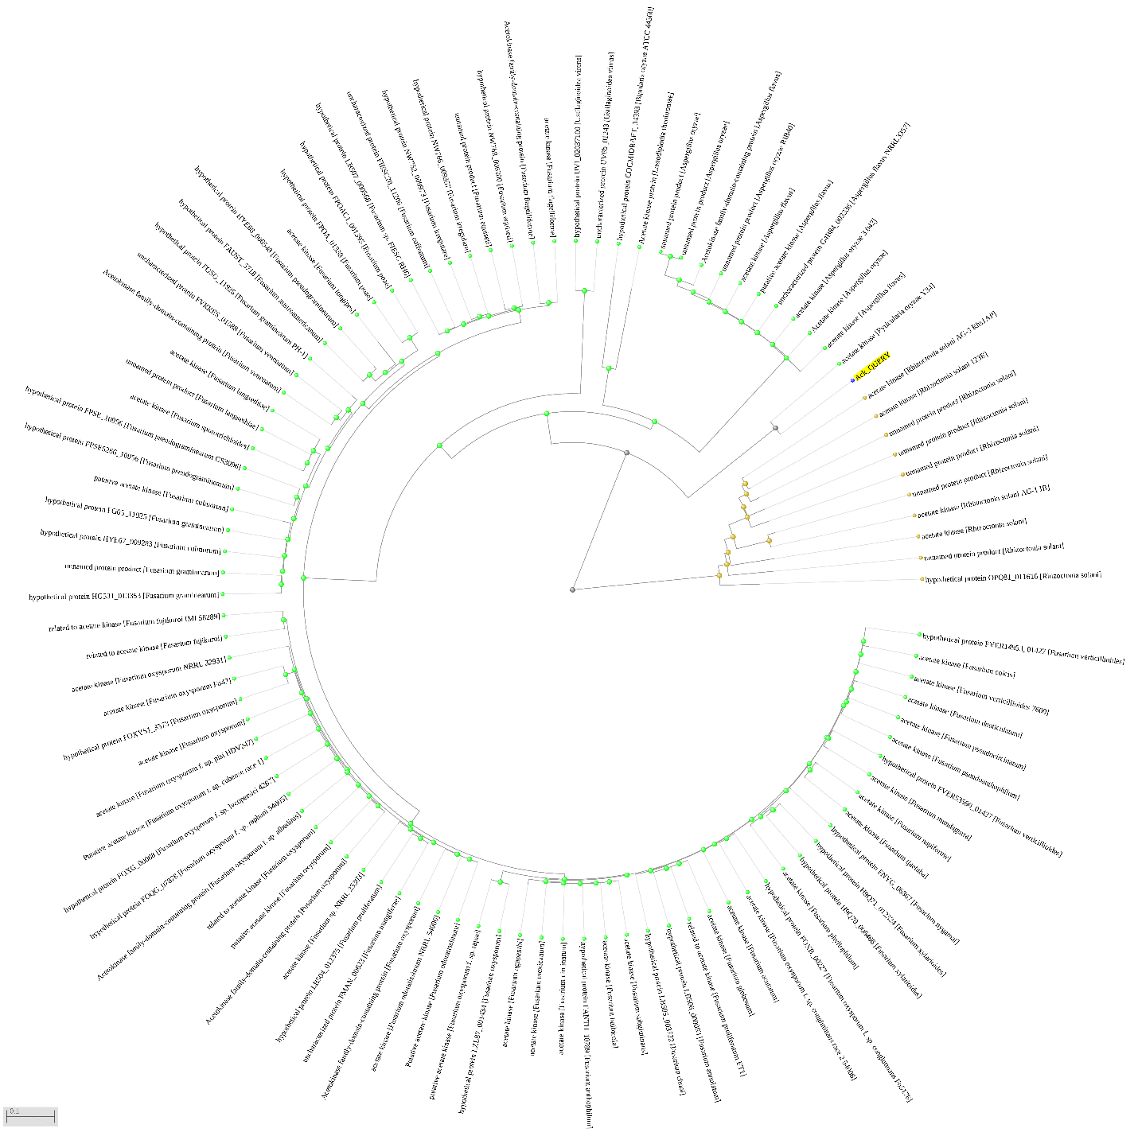

Fig. S2 Circular tree of 171 proteins from 86 different pathogens that shared high similarity with Ack. The query protein is highlighted in a yellow background.

Supplementary Table

Table S1. Comprehensive metabolic pathways covered by the utilized databases in the study

No | H.sapiens pathways | M. oryzae pathways | O. sativa pathways
1 | Glycolysis / Gluconeogenesis | Glycolysis / Gluconeogenesis | Glycolysis / Gluconeogenesis
2 | Citrate cycle (TCA cycle) | Citrate cycle (TCA cycle) | Citrate cycle (TCA cycle)
3 | Pentose phosphate pathway | Pentose phosphate pathway | Pentose phosphate pathway
4 | Pentose and glucuronate interconversions | Pentose and glucuronate interconversions | Pentose and glucuronate interconversions
5 | Fructose and mannose metabolism | Fructose and mannose metabolism | Fructose and mannose metabolism
6 | Galactose metabolism | Galactose metabolism | Galactose metabolism
7 | Ascorbate and aldarate metabolism | Ascorbate and aldarate metabolism | Ascorbate and aldarate metabolism
8 | Fatty acid biosynthesis | Fatty acid biosynthesis | Fatty acid biosynthesis
9 | Fatty acid elongation | Fatty acid elongation | Fatty acid elongation
10 | Fatty acid degradation | Fatty acid degradation | Fatty acid degradation
11 | Steroid biosynthesis | Cutin, suberine and wax biosynthesis | Cutin, suberine and wax biosynthesis
12 | Primary bile acid biosynthesis | Steroid biosynthesis | Steroid biosynthesis
13 | Ubiquinone and other terpenoid-quinone biosynthesis | Ubiquinone and other terpenoid-quinone biosynthesis | Ubiquinone and other terpenoid-quinone biosynthesis
14 | Steroid hormone biosynthesis | Oxidative phosphorylation | Oxidative phosphorylation
15 | Oxidative phosphorylation | Arginine biosynthesis | Photosynthesis
16 | Arginine biosynthesis | Purine metabolism | Photosynthesis - antenna proteins
17 | Purine metabolism | Caffeine metabolism | Arginine biosynthesis
18 | Caffeine metabolism | Pyrimidine metabolism | Purine metabolism
19 | Pyrimidine metabolism | Alanine, aspartate, and glutamate metabolism | Caffeine metabolism
20 | Alanine, aspartate, and glutamate metabolism | Glycine, serine, and threonine metabolism | Pyrimidine metabolism
21 | Glycine, serine, and threonine metabolism | Monobactam biosynthesis | Alanine, aspartate, and glutamate metabolism
22 | Cysteine and methionine metabolism | Cysteine and methionine metabolism | Glycine, serine, and threonine metabolism
23 | Valine, leucine, and isoleucine degradation | Valine, leucine, and isoleucine degradation | Monobactam biosynthesis
24 | Valine, leucine, and isoleucine biosynthesis | Valine, leucine, and isoleucine biosynthesis | Cysteine and methionine metabolism
25 | Lysine degradation | Lysine biosynthesis | Valine, leucine, and isoleucine degradation
26 | Arginine and proline metabolism | Lysine degradation | Valine, leucine, and isoleucine biosynthesis
27 | Histidine metabolism | Arginine and proline metabolism | Lysine biosynthesis
28 | Tyrosine metabolism | Carbapenem biosynthesis | Lysine degradation
29 | Phenylalanine metabolism | Histidine metabolism | Arginine and proline metabolism
30 | Tryptophan metabolism | Tyrosine metabolism | Histidine metabolism
31 | Phenylalanine, tyrosine, and tryptophan biosynthesis | Phenylalanine metabolism | Tyrosine metabolism
32 | beta-Alanine metabolism | Tryptophan metabolism | Phenylalanine metabolism
33 | Taurine and hypotaurine metabolism | Phenylalanine, tyrosine, and tryptophan biosynthesis | Tryptophan metabolism
34 | Phosphonate and phosphinate metabolism | Staurosporine biosynthesis | Phenylalanine, tyrosine, and tryptophan biosynthesis
35 | Selenocompound metabolism | beta-Alanine metabolism | Benzoxazinoid biosynthesis
36 | D-Amino acid metabolism | Taurine and hypotaurine metabolism | beta-Alanine metabolism
37 | Glutathione metabolism | Phosphonate and phosphinate metabolism | Taurine and hypotaurine metabolism
38 | Starch and sucrose metabolism | Selenocompound metabolism | Phosphonate and phosphinate metabolism
39 | N-Glycan biosynthesis | Cyanoamino acid metabolism | Selenocompound metabolism
40 | Other glycan degradation | D-Amino acid metabolism | Cyanoamino acid metabolism
41 | Mucin type O-glycan biosynthesis | Glutathione metabolism | D-Amino acid metabolism
42 | Various types of N-glycan biosynthesis | Starch and sucrose metabolism | Glutathione metabolism
43 | Other types of O-glycan biosynthesis | N-Glycan biosynthesis | Starch and sucrose metabolism
44 | Mannose type O-glycan biosynthesis | Other glycan degradation | N-Glycan biosynthesis
45 | Amino sugar and nucleotide sugar metabolism | Various types of N-glycan biosynthesis | Other glycan degradation
46 | Neomycin, kanamycin, and gentamicin biosynthesis | Other types of O-glycan biosynthesis | Various types of N-glycan biosynthesis
47 | Glycosaminoglycan degradation | Mannose type O-glycan biosynthesis | Other types of O
48 | Glycosaminoglycan biosynthesis - chondroitin sulfate / dermatan sulfate | Amino sugar and nucleotide sugar metabolism | Amino sugar and nucleotide sugar metabolism
49 | Glycosaminoglycan biosynthesis - keratan sulfate | Glycosaminoglycan degradation | Glycosaminoglycan degradation
50 | Glycosaminoglycan biosynthesis - heparan sulfate / heparin | Glycerolipid metabolism | Exopolysaccharide biosynthesis
51 | Glycerolipid metabolism | Inositol phosphate metabolism | Glycerolipid metabolism
52 | Inositol phosphate metabolism | Glycosylphosphatidylinositol (GPI)-anchor biosynthesis | Inositol phosphate metabolism
53 | Glycosylphosphatidylinositol (GPI)-anchor biosynthesis | Glycerophospholipid metabolism | Glycosylphosphatidylinositol (GPI)-anchor biosynthesis
54 | Glycerophospholipid metabolism | Ether lipid metabolism | Glycerophospholipid metabolism
55 | Ether lipid metabolism | Arachidonic acid metabolism | Ether lipid metabolism
56 | Arachidonic acid metabolism | Linoleic acid metabolism | Arachidonic acid metabolism
57 | Linoleic acid metabolism | alpha-Linolenic acid metabolism | Linoleic acid metabolism
58 | alpha-Linolenic acid metabolism | Sphingolipid metabolism | alpha-Linolenic acid metabolism
59 | Sphingolipid metabolism | Glycosphingolipid biosynthesis - globo and isoglobo series | Sphingolipid metabolism
60 | Glycosphingolipid biosynthesis - lacto and neolacto series | Glycosphingolipid biosynthesis - ganglio series | Glycosphingolipid biosynthesis - lacto and neolacto series
61 | Glycosphingolipid biosynthesis - globo and isoglobo series | Pyruvate metabolism | Glycosphingolipid biosynthesis - globo and isoglobo series
62 | Glycosphingolipid biosynthesis - ganglio series | Glyoxylate and dicarboxylate metabolism | Glycosphingolipid biosynthesis - ganglio series
63 | Pyruvate metabolism | Propanoate metabolism | Pyruvate metabolism
64 | Glyoxylate and dicarboxylate metabolism | Butanoate metabolism | Glyoxylate and dicarboxylate metabolism
65 | Propanoate metabolism | C5-Branched dibasic acid metabolism | Propanoate metabolism
66 | Butanoate metabolism | One carbon pool by folate | Butanoate metabolism
67 | One carbon pool by folate | Methane metabolism | C5-Branched dibasic acid metabolism
68 | Thiamine metabolism | Thiamine metabolism | One carbon pool by folate
69 | Riboflavin metabolism | Riboflavin metabolism | Carbon fixation in photosynthetic organisms
70 | Vitamin B6 metabolism | Vitamin B6 metabolism | Thiamine metabolism
71 | Nicotinate and nicotinamide metabolism | Nicotinate and nicotinamide metabolism | Riboflavin metabolism
72 | Pantothenate and CoA biosynthesis | Pantothenate and CoA biosynthesis | Vitamin B6 metabolism
73 | Biotin metabolism | Biotin metabolism | Nicotinate and nicotinamide metabolism
74 | Lipoic acid metabolism | Lipoic acid metabolism | Pantothenate and CoA biosynthesis
75 | Folate biosynthesis | Folate biosynthesis | Biotin metabolism
76 | Retinol metabolism | Porphyrin metabolism | Lipoic acid metabolism
77 | Porphyrin metabolism | Terpenoid backbone biosynthesis | Folate biosynthesis
78 | Terpenoid backbone biosynthesis | Diterpenoid biosynthesis | Porphyrin metabolism
79 | Nitrogen metabolism | Carotenoid biosynthesis | Terpenoid backbone biosynthesis
80 | Sulfur metabolism | Sesquiterpenoid and triterpenoid biosynthesis | Monoterpenoid biosynthesis
81 | Aminoacyl-tRNA biosynthesis | Nitrogen metabolism | Limonene and pinene degradation
82 | Metabolism of xenobiotics by cytochrome P450 | Sulfur metabolism | Diterpenoid biosynthesis
83 | Drug metabolism - cytochrome P450 | Aminoacyl-tRNA biosynthesis | Brassinosteroid biosynthesis
84 | Drug metabolism - other enzymes | Biosynthesis of various plant secondary metabolites | Carotenoid biosynthesis
85 | Biosynthesis of unsaturated fatty acids | Biosynthesis of unsaturated fatty acids | Zeatin biosynthesis
86 | Metabolic pathways | Metabolic pathways | Sesquiterpenoid and triterpenoid biosynthesis
87 | Carbon metabolism | Biosynthesis of secondary metabolites | Nitrogen metabolism
88 | 2-Oxocarboxylic acid metabolism | Carbon metabolism | Sulfur metabolism
89 | Fatty acid metabolism | 2-Oxocarboxylic acid metabolism | Phenylpropanoid biosynthesis
90 | Biosynthesis of amino acids | Fatty acid metabolism | Flavonoid biosynthesis
91 | Nucleotide metabolism | Biosynthesis of amino acids | Anthocyanin biosynthesis
92 | Biosynthesis of cofactors | Nucleotide metabolism | Flavone and flavonol biosynthesis
93 | Biosynthesis of nucleotide sugars | Biosynthesis of cofactors | Stilbenoid, diarylheptanoid and gingerol biosynthesis
94 | EGFR tyrosine kinase inhibitor resistance | Biosynthesis of nucleotide sugars | Isoquinoline alkaloid biosynthesis
95 | Endocrine resistance | beta-Lactam resistance | Tropane, piperidine and pyridine alkaloid biosynthesis
96 | Antifolate resistance | ABC transporters | Betalain biosynthesis
97 | Platinum drug resistance | Ribosome biogenesis in eukaryotes | Glucosinolate biosynthesis
98 | ABC transporters | Ribosome | Aminoacyl-tRNA biosynthesis
99 | Ribosome biogenesis in eukaryotes | Nucleocytoplasmic transport | Biosynthesis of various plant secondary metabolites
100 | Ribosome | mRNA surveillance pathway | Biosynthesis of unsaturated fatty acids
101 | Nucleocytoplasmic transport | RNA degradation | Metabolic pathways
102 | mRNA surveillance pathway | RNA polymerase | Biosynthesis of secondary metabolites
103 | RNA degradation | Basal transcription factors | Carbon metabolism
104 | RNA polymerase | DNA replication | 2-Oxocarboxylic acid metabolism
105 | Basal transcription factors | Spliceosome | Fatty acid metabolism
106 | DNA replication | Proteasome | Biosynthesis of amino acids
107 | Spliceosome | Protein export | Nucleotide metabolism
108 | Proteasome | Viral life cycle - HIV-1 | Biosynthesis of cofactors
109 | Protein export | Base excision repair | Biosynthesis of nucleotide sugars
110 | Viral life cycle - HIV-1 | Nucleotide excision repair | ABC transporters
111 | Virion - Human immunodeficiency virus | Mismatch repair | Ribosome biogenesis in eukaryotes
112 | Virion - Flavivirus | Homologous recombination | Ribosome
113 | Virion - Lyssavirus | Non-homologous end-joining | Nucleocytoplasmic transport
114 | Virion - Herpesvirus | MAPK signaling pathway | mRNA surveillance pathway
115 | Virion - Adenovirus | Phosphatidylinositol signaling system | RNA degradation
116 | PPAR signaling pathway | Cell cycle - yeast | RNA polymerase
117 | Base excision repair | Meiosis - yeast | Basal transcription factors
118 | Nucleotide excision repair | Ubiquitin mediated proteolysis | DNA replication
119 | Mismatch repair | Sulfur relay system | Spliceosome
120 | Homologous recombination | SNARE interactions in vesicular transport | Proteasome
121 | Non-homologous end-joining | Autophagy - other | Protein export
122 | Fanconi anemia pathway | Autophagy - yeast | Viral life cycle - HIV-1
123 | MAPK signaling pathway | Mitophagy - yeast | Base excision repair
124 | ErbB signaling pathway | Protein processing in endoplasmic reticulum | Nucleotide excision repair
125 | Ras signaling pathway | Endocytosis | Mismatch repair
126 | Rap1 signaling pathway | Phagosome | Homologous recombination
127 | Calcium signaling pathway | Peroxisome | Non-homologous end-joining
128 | cGMP-PKG signaling pathway |  | MAPK signaling pathway - plant
129 | cAMP signaling pathway |  | Phosphatidylinositol signaling system
130 | Cytokine-cytokine receptor interaction |  | Plant hormone signal transduction
131 | Viral protein interaction with cytokine and cytokine receptor |  | Ubiquitin mediated proteolysis
132 | Chemokine signaling pathway |  | Sulfur relay system
133 | NF-kappa B signaling pathway |  | SNARE interactions in vesicular transport
134 | HIF-1 signaling pathway |  | Autophagy - other
135 | FoxO signaling pathway |  | Protein processing in endoplasmic reticulum
136 | Phosphatidylinositol signaling system |  | Endocytosis
137 | Sphingolipid signaling pathway |  | Phagosome
138 | Phospholipase D signaling pathway |  | Peroxisome
139 | Neuroactive ligand-receptor interaction |  | Plant-pathogen interaction
140 | Cell cycle |  | Circadian rhythm -plant
141 | Oocyte meiosis
142 | p53 signaling pathway
143 | Ubiquitin mediated proteolysis
144 | Sulfur relay system
145 | SNARE interactions in vesicular transport
146 | Autophagy - other
147 | Mitophagy - animal
148 | Autophagy - animal
149 | Protein processing in endoplasmic reticulum
150 | Lysosome
151 | Endocytosis
152 | Phagosome
153 | Peroxisome
154 | mTOR signaling pathway
155 | PI3K-Akt signaling pathway
156 | AMPK signaling pathway
157 | Apoptosis
158 | Longevity regulating pathway
159 | Longevity regulating pathway - multiple species
160 | Apoptosis - multiple species
161 | Ferroptosis
162 | Necroptosis
163 | Cellular senescence
164 | Cardiac muscle contraction
165 | Adrenergic signaling in cardiomyocytes
166 | Vascular smooth muscle contraction
167 | Wnt signaling pathway
168 | Notch signaling pathway
169 | Hedgehog signaling pathway
170 | TGF-beta signaling pathway
171 | Axon guidance
172 | VEGF signaling pathway
173 | Apelin signaling pathway
174 | Osteoclast differentiation
175 | Hippo signaling pathway
176 | Hippo signaling pathway - multiple species
177 | Focal adhesion
178 | ECM-receptor interaction
179 | Cell adhesion molecules
180 | Adherens junction
181 | Tight junction
182 | Gap junction
183 | Signaling pathways regulating pluripotency of stem cells
184 | Complement and coagulation cascades
185 | Platelet activation
186 | Antigen processing and presentation
187 | Neutrophil extracellular trap formation
188 | Renin-angiotensin system
189 | Toll-like receptor signaling pathway
190 | NOD-like receptor signaling pathway
191 | RIG-I-like receptor signaling pathway
192 | Cytosolic DNA-sensing pathway
193 | C-type lectin receptor signaling pathway
194 | JAK-STAT signaling pathway
195 | Hematopoietic cell lineage
196 | Natural killer cell mediated cytotoxicity
197 | IL-17 signaling pathway
198 | Th1 and Th2 cell differentiation
199 | Th17 cell differentiation
200 | T cell receptor signaling pathway
201 | B cell receptor signaling pathway
202 | Fc epsilon RI signaling pathway
203 | Fc gamma R-mediated phagocytosis
204 | TNF signaling pathway
205 | Leukocyte transendothelial migration
206 | Intestinal immune network for IgA production
207 | Circadian rhythm
208 | Circadian entrainment
209 | Thermogenesis
210 | Long-term potentiation
211 | Synaptic vesicle cycle
212 | Neurotrophin signaling pathway
213 | Retrograde endocannabinoid signaling
214 | Glutamatergic synapse
215 | Cholinergic synapse
216 | Serotonergic synapse
217 | GABAergic synapse
218 | Dopaminergic synapse
219 | Long-term depression
220 | Olfactory transduction
221 | Taste transduction
222 | Phototransduction
223 | Inflammatory mediator regulation of TRP channels
224 | Regulation of actin cytoskeleton
225 | Insulin signaling pathway
226 | Insulin secretion
227 | GnRH signaling pathway
228 | Ovarian steroidogenesis
229 | Progesterone-mediated oocyte maturation
230 | Estrogen signaling pathway
231 | Melanogenesis
232 | Prolactin signaling pathway
233 | Thyroid hormone synthesis
234 | Thyroid hormone signaling pathway
235 | Adipocytokine signaling pathway
236 | Oxytocin signaling pathway
237 | Glucagon signaling pathway
238 | Regulation of lipolysis in adipocytes
239 | Renin secretion
240 | Aldosterone synthesis and secretion
241 | Relaxin signaling pathway
242 | Cortisol synthesis and secretion
243 | Parathyroid hormone synthesis, secretion and action
244 | GnRH secretion
245 | Type II diabetes mellitus
246 | Insulin resistance
247 | Non-alcoholic fatty liver disease
248 | AGE-RAGE signaling pathway in diabetic complications
249 | Cushing syndrome
250 | Growth hormone synthesis, secretion and action
251 | Alcoholic liver disease
252 | Type I diabetes mellitus
253 | Maturity onset diabetes of the young
254 | Aldosterone-regulated sodium reabsorption
255 | Endocrine and other factor
256 | Vasopressin-regulated water reabsorption
257 | Proximal tubule bicarbonate reclamation
258 | Collecting duct acid secretion
259 | Salivary secretion
260 | Gastric acid secretion
261 | Pancreatic secretion
262 | Carbohydrate digestion and absorption
263 | Protein digestion and absorption
264 | Fat digestion and absorption
265 | Bile secretion
266 | Vitamin digestion and absorption
267 | Mineral absorption
268 | Cholesterol metabolism
269 | Alzheimer disease
270 | Parkinson disease
271 | Amyotrophic lateral sclerosis
272 | Huntington disease
273 | Spinocerebellar ataxia
274 | Prion disease
275 | Pathways of neurodegeneration - multiple diseases
276 | Cocaine addiction
277 | Amphetamine addiction
278 | Morphine addiction
279 | Nicotine addiction
280 | Alcoholism
281 | Bacterial invasion of epithelial cells
282 | Vibrio cholerae infection
283 | Epithelial cell signaling in Helicobacter pylori infection
284 | Pathogenic Escherichia coli infection
285 | Shigellosis
286 | Salmonella infection
287 | Pertussis
288 | Legionellosis
289 | Yersinia infection
290 | Leishmaniasis
291 | Chagas disease
292 | African trypanosomiasis
293 | Malaria
294 | Toxoplasmosis
295 | Amoebiasis
296 | Staphylococcus aureus infection
297 | Tuberculosis
298 | Hepatitis C
299 | Hepatitis B
300 | Measles
301 | Human cytomegalovirus infection
302 | Influenza A
303 | Human papillomavirus infection
304 | Human T-cell leukemia virus 1 infection
305 | Kaposi sarcoma-associated herpesvirus infection
306 | Herpes simplex virus 1 infection
307 | Epstein-Barr virus infection
308 | Human immunodeficiency virus 1 infection
309 | Coronavirus disease - COVID-19
310 | Pathways in cancer
311 | Transcriptional misregulation in cancer
312 | Viral carcinogenesis
313 | Chemical carcinogenesis - DNA adducts
314 | Proteoglycans in cancer
315 | MicroRNAs in cancer
316 | Chemical carcinogenesis - receptor activation
317 | Chemical carcinogenesis - reactive oxygen species
318 | Colorectal cancer
319 | Renal cell carcinoma
320 | Pancreatic cancer
321 | Endometrial cancer
322 | Glioma
323 | Prostate cancer
324 | Thyroid cancer
325 | Basal cell carcinoma
326 | Melanoma
327 | Bladder cancer
328 | Chronic myeloid leukemia
329 | Acute myeloid leukemia
330 | Small cell lung cancer
331 | Non-small cell lung cancer
332 | Breast cancer
333 | Hepatocellular carcinoma
334 | Gastric cancer
335 | Central carbon metabolism in cancer
336 | Choline metabolism in cancer
337 | PD-L1 expression and PD-1 checkpoint pathway in cancer
338 | Asthma
339 | Autoimmune thyroid disease
340 | Inflammatory bowel disease
341 | Systemic lupus erythematosus
342 | Rheumatoid arthritis
343 | Allograft rejection
344 | Graft-versus-host disease
345 | Primary immunodeficiency
346 | Hypertrophic cardiomyopathy
347 | Arrhythmogenic right ventricular cardiomyopathy
348 | Dilated cardiomyopathy
349 | Diabetic cardiomyopathy
350 | Viral myocarditis
351 | Lipid and atherosclerosis
352 | Fluid shear stress and atherosclerosis

Table S2. Percent identity matrix of alcohol oxidase
Entry name | MGG_09072 | MGG_02127
MGG_09072 | 100.00 | 38.65
MGG_02127 | 38.65 | 100.00

Table S3. Percent identity matrix of serine hydroxymethyltransferase
Entry name | MGG_13781 | MGG_00923
MGG_13781 | 100.00 | 63.1
MGG_00923 | 63.1 | 100.00

Table S4. Percent identity matrix of dihydroxyacetone kinase
Entry name | MGG_03095 | MGG_04014
MGG_03095 | 100.00 | 41.93
MGG_04014 | 41.93 | 100.00

Table S5. Percent identity matrix of fructose-bisphosphate aldolase/fructose-bisphosphate aldolase 1
Entry name | MGG_00223 | MGG_03096 | MGG_13895
MGG_00223 | 100.00 | 28.67 | 25.44
MGG_03096 | 28.67 | 100.00 | 53.15
MGG_13895 | 25.44 | 53.15 | 100.00

Table S6. Percent identity matrix of acetyl-CoA synthetase
Entry name | MGG_03201 | MGG_04590
MGG_03201 | 100.00 | 69.07
MGG_04590 | 69.07 | 100.00

Table S7 Pathogen proteins homologous to human proteins in DrugBank database
No | Entry name | Enzyme name | Homolog human protein | E-Value** | Bit score**
1 | MGG_00481 | G5K | - | - | -
3 | MGG_16917 | gliotoxin/aspirochlorine/mycotoxins biosynthesis | - | - | -
4 | MGG_09072 | alcohol oxidase | Choline dehydrogenase, mitochondrial | 5.92812e-37 | 145.206
11 | MGG_02525 | alanine-glyoxylate transaminase / serine-glyoxylate transaminase / serine-pyruvate transaminase | Aspartate aminotransferase  Serine--pyruvate aminotransferase  Hepatic peroxysomal alanine:glyoxylate aminotransferase | 8.67371e-32  1.74137e-29  3.80701e-29 | 122.865  117.472  115.931
14 | MGG_03095 | triose/dihydroxyacetone kinase / FAD-AMP lyase (cyclizing) | Dihydroxyacetone kinase | 2.44075e-35 | 138.658
16 | MGG_00223 | fructose-bisphosphate aldolase, class 2 | Fructose-bisphosphate aldolase class 2 | 1.67508e-124 | 361.303
21 | MGG_13157 | Ack | - | - | -
28 | MGG_03661 | phosphoserine phosphatase | - | - | -
** Only human proteins with E-value ≤ 0.005 and bit score > 100 that were listed in this table

