Supplementary Information for:

Exposure to low levels of antidiabetic glibenclamide had no evident adverse effects on intestinal microbial composition and metabolic profiles in amphibian larvae

Jia-Hui Liuª, Qin-Yuan Mengª, Yu Chen^{b}, Jia-Meng Yangª, Jian-Fang Gaoª, Hong-Liang Lu^{a,⁎}

ª Herpetological Research Center, School of Life and Environmental Sciences, Hangzhou Normal University, Hangzhou 311121, Zhejiang, China
^{b} Zhejiang Dapanshan National Nature Reserve, Jinhua 322300, Zhejiang, China

Fig. S1. Rarefaction curves based on the Chao, Shannon and Simpson indexes for all samples.
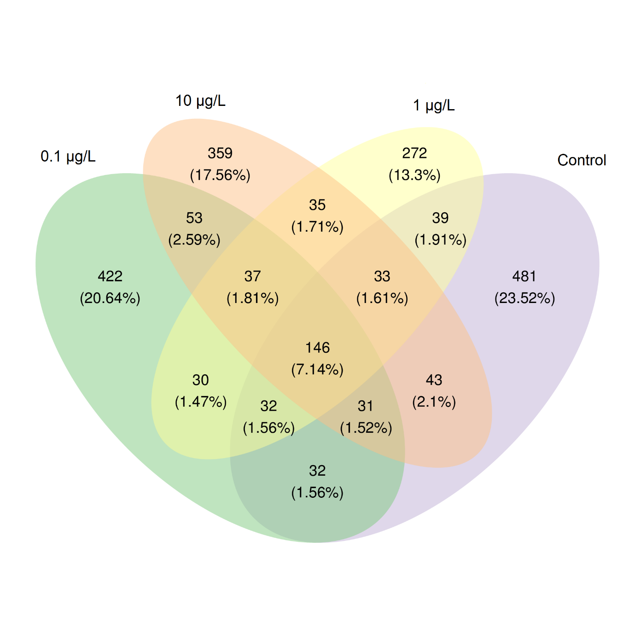
Fig. S2. Clustering of sequences into 2045 OTUs at the 97% similarity level. Control, 0.1, 1 and 10 μg/L glibenclamide-exposed groups had 837, 783, 624 and 737 OTUs, respectively. Among them, 146 OTUs were shared among these groups, 481, 422, 272 and 359 OTUs were exclusive in control, 0.1, 1 and 10 μg/L glibenclamide-exposed groups, respectively.

Table S1. Raw and pre-processed sequencing data for tadpole intestinal microbiota.
 | Input | Filtered | Denoised | Merged | Non-chimeric | Non-singleton
Control | 135173 ± 1049 | 123386 ± 254 | 122308 ± 366 | 121029 ± 650 | 107269 ± 4018 | 107167 ± 4042
0.1 µg/L | 133141 ± 6291 | 121443 ± 5884 | 120397 ± 5775 | 119556 ± 5709 | 113084 ± 5723 | 113001 ± 5716
1 µg/L | 131672 ± 8513 | 119806 ± 8237 | 118905 ± 8114 | 118178 ± 7951 | 114700 ± 6613 | 114635 ± 6601
10 µg/L | 134820 ± 2527 | 125996 ± 2374 | 125105 ± 3192 | 124368 ± 3026 | 120061 ± 1455 | 119993 ± 2491

