Supplementary Information

A window into the forest: post-release behaviour of rehabilitated Bornean Sun bears (Helarctos malayanus euryspilus) in Sabah, Malaysia
Elizabeth A. Brunton ¹ *, Alexis L. Levengood ¹, Thye Lim Tee³, Lin-May Chiew³, Pradeep A. Gunasegaran³, Yen Wah Seng², Boon Nie Yeoh², Augustine Tuuga⁴, Siew Te Wong ²
*Corresponding author – ebrunton@usc.edu.au

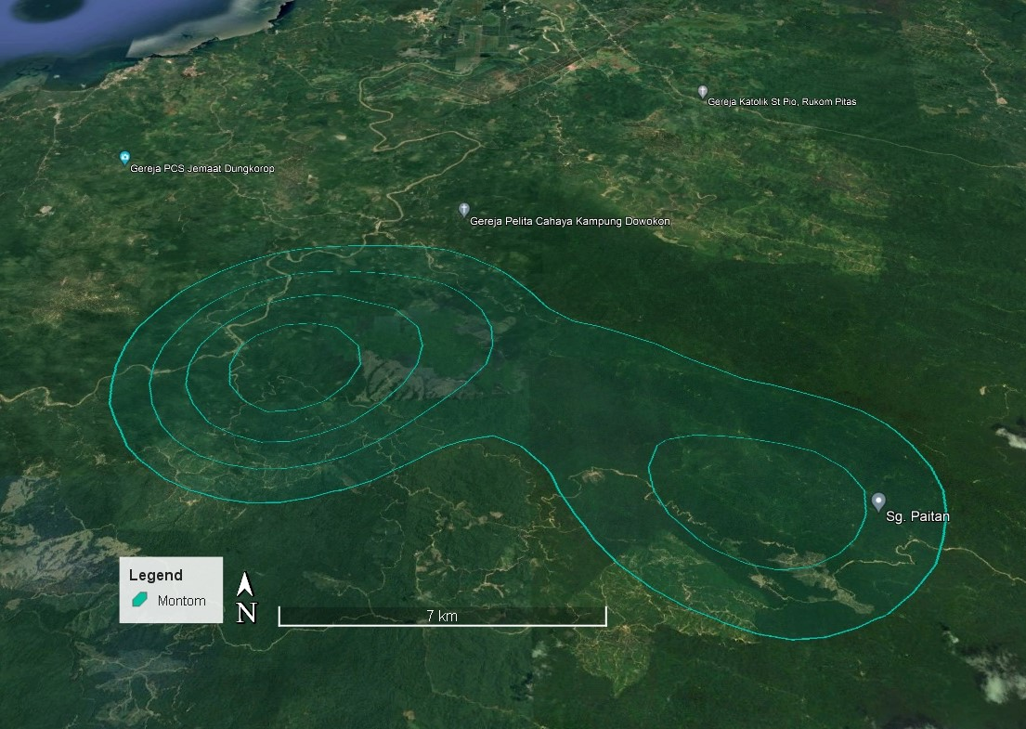
Figure S1. Kernel density estimates of home range for one rehabilitated Sun bear, Montom, released in Mandamai forest, Sabah.
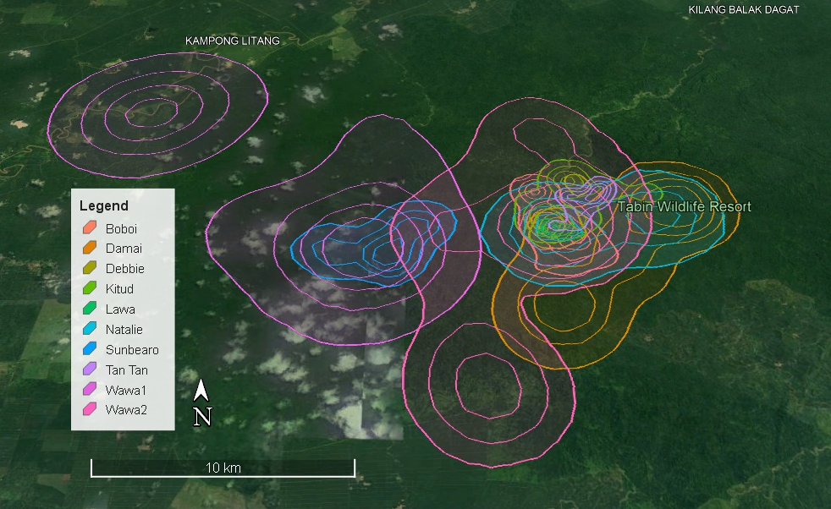
Figure S2. Home ranges (95%KDE) of nine rehabilitated Sun bears released in Tabin Wildlife Reserve, Sabah, over a period of eight years.
Figure. S3. Minimum distance travelled by six Sun bears (between hourly GPS fixes) in Tabin Wildlife Reserve, Sabah.
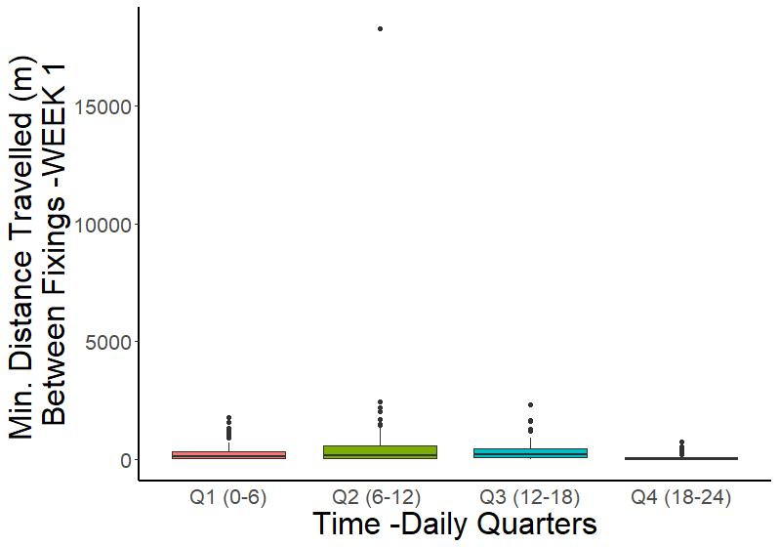
Figure S4. Minimum distance travelled by ten Sun bears between two consecutive GPS fixes at different times of the day (24-hour time), during the first week following release.

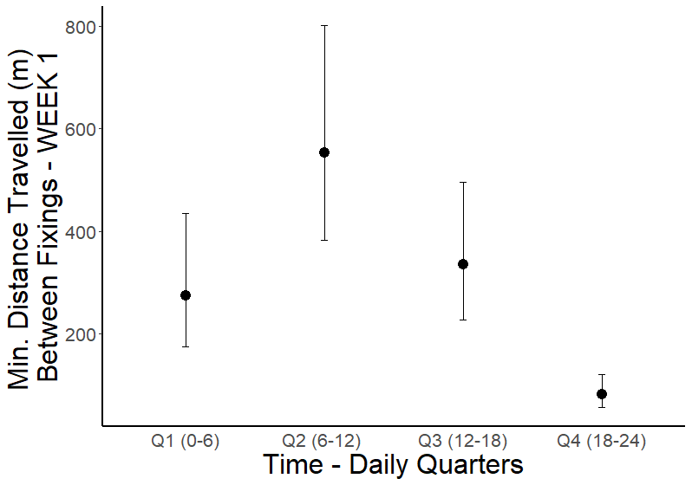
Figure S5. Mean ± 95% confidence intervals for minimum distance travelled by ten Sun bears between two consecutive GPS fixes at different times of the day (24-hour time), during the first week following release.
Figure S6. GPS tracks of rehabilitated Sun bears Debbie (mustard) and Damai (orange) released together in Tabin Valley showing no overlap in tracks after initial release.

Figure S7. GPS tracks of Sun bears Boboi (pink) and Kitud (green) and Tan Tan (purple) released together in Tabin Wildlife reserve, Sabah, showing tracks overlapping at multiple times during the first four weeks after release.

Table S1. IT gamma generalised linear modelling comparison showing quarterly time comparisons as the best predictor (lowest AIC) of variation in distance travelled between GPS fixes
Model | AIC
Day/Night (12-12) | 19768
AM/PM (6-6) | 19871
Quarters (0-6, 6-12, 12-18, 18-24) | 19496

Table S2. Gamma generalised linear model outputs showing a significant difference between distance travelled per quarter. Sun bear ID included to account for repeated observations and potentially individual specific trends.
Parameter | Estimate | SE | t-value | p
Intercept | 5.380 | 0.175 | 30.727 | < 0.001
Q2 | 0.405 | 0.120 | 3.379 | < 0.001
Q3 | 0.483 | 0.128 | 3.785 | < 0.001
Q4 | -1.158 | 0.122 | -9.565 | < 0.001
Damai | -0.167 | 0.205 | -0.814 | 0.416
Debbie | 0.192 | 0.194 | 0.990 | 0.322
Kitud | 0.008 | 0.213 | 0.037 | 0.970
Lawa | -0.265 | 0.633 | -0.419 | 0.676
Montom | 0.627 | 0.230 | 2.733 | < 0.001
Natalie | 0.887 | 0.276 | 3.218 | < 0.001
Sunbearo | 0.221 | 0.221 | 1.000 | 0.318
Tan Tan | -0.350 | 0.221 | -1.588 | 0.113
Wawa 1 | 0.018 | 0.171 | 0.107 | 0.915
Wawa 2 | -0.008 | 0.191 | -0.040 | 0.968

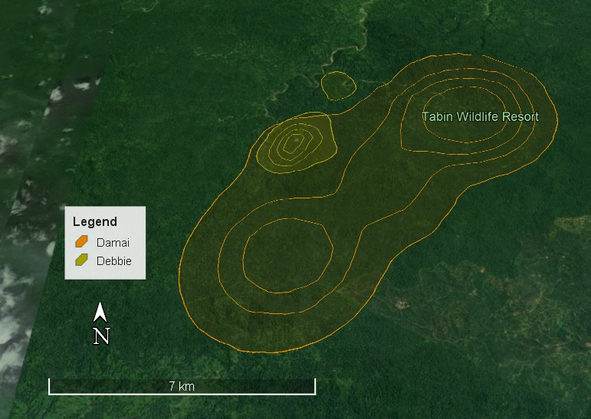

Figure S8. Home range (95% KDE) overlap between two Sun bears, Debbie (gold, & Damai (orange), released together in Tabin Wildlife reserve, Sabah.

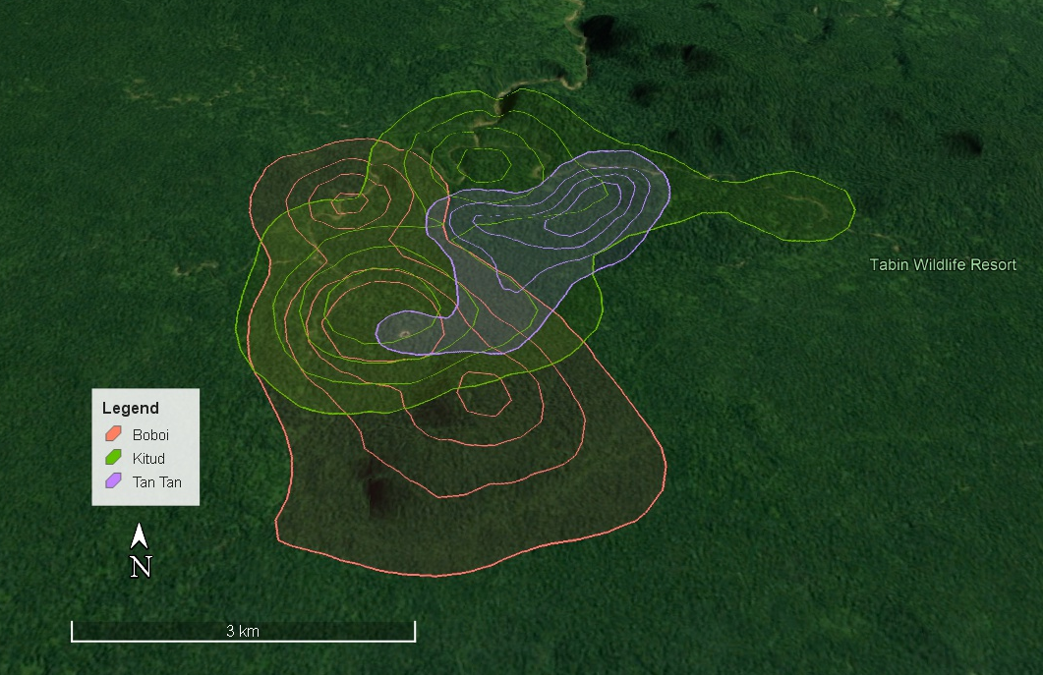
Figure S9. Home range (95% KDE) overlap between three Sun bears, Boboi (orange), Tan Tan (purple) & Kitud (green), released in Tabin Wildlife reserve, Sabah.

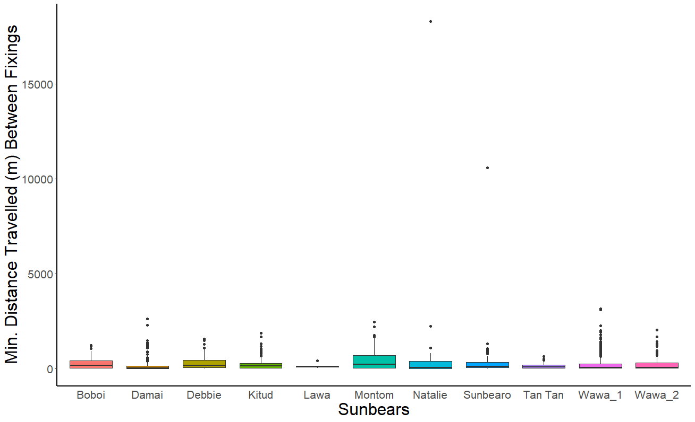
Figure S10. Minimum distance travelled between consecutive GPS fixes (6 hours or less between fixings) by ten Sun bears in Sabah, Malaysia (with outlier included).

