Supporting Information

Unraveling the adverse Impacts of Nano-scale Carbon Exposure on Nitrogen Metabolism during Early Seedling Establishment in Zea mays L. Roots
Di Zhang^{,2*}, Qi Sun^{1,3}, Ruixue Zhang¹, Lei Lu ¹, Junwei Wang¹, Xiaojie Fang¹
1 Department of Resources and Environmental Science, Northeast Agricultural University, Harbin, Heilongjiang 150030, China
2 Key Laboratory of Black Soil Protection and Restoration, Harbin, Heilongjiang 150030, China
3 Heilongjiang Academy of Black Soil Conservation & Utilization, Harbin 150086, China

* Corresponding Author:
Contact: Di Zhang
Author E-mail: zhangdi6283@neau.edu.cn
Telephone: 86+45155191170
Correspondence Address: Department of Resources and Environmental Science, Northeast Agricultural University, Harbin, Heilongjiang 150030, China

THREE FIGURES AND THREE TABLES

List of contents
Tables:
Tab S1.Effects of graphite nanoplatelets (GN) and humic acid (HU) conditions on growth, morphological and biochemical parameters of maize plants, and the results of one-way ANOVA...........................................................................................3
Tab S2.Effects of graphite nanoplatelets (GN) and humic acid (HU) conditions on maize root physiological activity indicators and the results of one-way ANOVA......................................................................................................................4
Tab S3.Some of the critical metabolites differentially accumulated between Graphite Nanoplatelets and Humic acid...10-13
Figures:
Fig. S1 Humic acid treated maize phenotype map..................................................................................................................5
Fig. S2 Graphite nanoplatelets treated maize phenotype map................................................................................................5
Fig. S3 The scanning electron micrograph (SEM) of graphite nanoplatelets.........................................................................7
Fig. S4 Root Electron Microscopy of Medium Graphite Nanoplatelets Added.....................................................................8
Fig. S5 GC-TOF-MS total ion flow map of all the tested samples.........................................................................................9

Table S1 Effects of graphite nanoplatelets (GN) and humic acid (HU) conditions on growth, morphological and biochemical parameters of maize plants, and the results of one-way ANOVA.
 | Parameters | Graphite nanoplatelets (GN) group |  |  |  | Humic acid (HU) group |  |  |  | Summary of ANOVA (p-values)
 | Parameters | CK | GNL | GNM | GNH | CK | HUL | HUM | HUH | GNL-HUL | GNM-HUM | GNH-HUH
Root | RL (cm) | 3046.98±146.66b | 3880.18±151.81a** | 3911.43±44.23a* | 3966.051±282.22a | 3046.98±146.66a | 3086.46±66.93a** | 3308.14±254.16a* | 3256.12±3256.12a | < 0.01 | < 0.05 | 0.09
Root | RAS (cm2) | 543.66±62.49b | 758.96±13.18a | 768.99±60.94a | 716.53±17.32a* | 543.66±62.49a | 704.07±46.24a | 664.76±10.41a | 484.46±15.35a* | 0.127 | 0.269 | < 0.05
Root | RV  (cm3) | 18.54±2.91b | 31.10±2.95a | 24.15±1.97b | 23.33±2.37b | 18.54±2.91c | 25.35±0.71a | 23.32±0.65ab | 20.88±0.79bc | 0.082 | 0.629 | 0.173
Root | RD  (mm) | 0.57±0.50a | 0.63±0.04a | 0.62±0.05a | 0.65±0.05a | 0.57±0.50a | 0.66±0.04a | 0.67±0.10a | 0.57±0.026a | 0.400 | 0.474 | 0.084
Root | RTN | 8965±923.47a | 10754.67±1317.77a** | 10107.33±1050.99a* | 9583±375.51a | 8965±923.47a | 5233.67±462.17c** | 7287.33±916.35b* | 8538.33±801.06ab | < 0.01 | < 0.05 | 0.110
Root | RDW  (g plant-1) | 0.54±0.04c | 0.88±0.03a | 0.76±0.06b | 0.75±0.034b* | 0.54±0.04d | 0.85±0.02a | 0.733±0.029b | 0.64±0.05c* | 0.256 | 0.624 | < 0.05
Root | R/T | 0.83±0.04c | 1.19±0.15b | 1.43±0.22ab | 1.39±0.20a | 0.83±0.04c | 0.99±0.10bc | 1.16±0.10b | 1.72±0.19a | 0.129 | 0.132 | 0.104
Note： Values are reported as means ±SD (n = 3). CK; GNL and HUL, 0.4 mol C kg−1; GNM and HUM, 2 mol C kg−1; GNH and HUH, 4 mol C kg−1. RL, total root length; RAS, total root surface area; RV, total root volume; RD, average root diameter; RTN, total root tip number; RDW, root dry weight; R/T, root/top ratio; Different letters indicate significant differences (p<0.05) compared with the control (CK). * indicates significant differences in graphite nanoplatelets and humic acid with equal carbon addition by using one-way ANOVA for equal amounts of carbon treatment at the P level.

Table S2 Effects of graphite nanoplatelets (GN) and humic acid (HU) conditions on maize root physiological activity indicators and the results of one-way ANOVA.
 | Parameters | Graphite nanoplatelets group |  |  |  | Humic acid (HU) group |  |  |  | Summary of ANOVA (p-values)
 | Parameters | CK | GN_{L} | GN_{M} | GN_{H} | CK | HU_{L} | HU_{M} | HU_{H} | GN_{L}-HU_{L} | GN_{M}-HU_{M} | GN_{H}-HU_{H}
Root | Root activity (μg·g⁻¹·h⁻¹) | 28.07±2.00d | 33.18±1.54c** | 43.84±1.67a | 40.17±0.69b | 28.07±2.00d | 70.96±9.05c** | 109.62±3.36b | 196.73±8.19a | < 0.01 | 7.00 | 5.04
Root | Total absorption area (m²) | 2.85±0.18d | 5.08±0.07b** | 6.55±0.35a** | 4.33±0.50c* | 2.85±0.18b | 4.38±0.21a** | 3.40±0.55b** | 3.19±0.12b* | < 0.01 | < 0.01 | < 0.05
Root | Active absorption area (m²) | 1.40±0.15c | 2.51±0.36b | 2.915±0.12a** | 2.12±0.06b* | 1.40±0.15a | 1.70±0.11a | 1.67±0.27a** | 1.55±0.35a* | 0.060 | < 0.01 | < 0.05
Root | NO₃⁻-N (mg/g) | 796.12±38.37b | 858.40±59.99b | 1682.95±35.84a*** | 990.74±0.05b | 796.12±38.37a | 453.75±32.90c | 478.81±19.71c*** | 591.65±6.93b | 8.850 | < 0.001 | 4.77
Root | NH₄⁺-N (mg/g) | 242.09±49.27b | 248.52±6.19b | 891.24±50.82a*** | 287.98±18.57b*** | 242.09±49.27b | 245.49±31.32b | 262.33±27.05b*** | 621.00±38.15a*** | 0.88 | < 0.001 | < 0.001
Root | Total nitrogen content (%) | 1.38±0.06a | 1.53±0.10a | 1.78±0.10a | 1.59±0.04a** | 1.38±0.06c | 1.51±0.07b | 1.57±0.09b | 1.85±0.03a** | 0.83 | <0.05 | < 0.01
Note： Values are reported as means ±SD (n = 3). CK; GN_{L} and HU_{L}, 0.4 mol C kg⁻¹; GN_{M} and HU_{M}, 2 mol C kg⁻¹; GN_{H} and HU_{H}, 4 mol C kg⁻¹. Root activity; Total absorption area; Active absorption area; NO₃⁻-N, nitrate-nitrogen accumulation; NH₄⁺-N, ammonium nitrogen accumulation; Total nitrogen accumulation; Different letters indicate significant differences (p<0.05) compared with the control (CK). * indicates significant differences in graphite nanoplatelets and humic acid with equal carbon addition by using one-way ANOVA for equal amounts of carbon treatment at the P level.

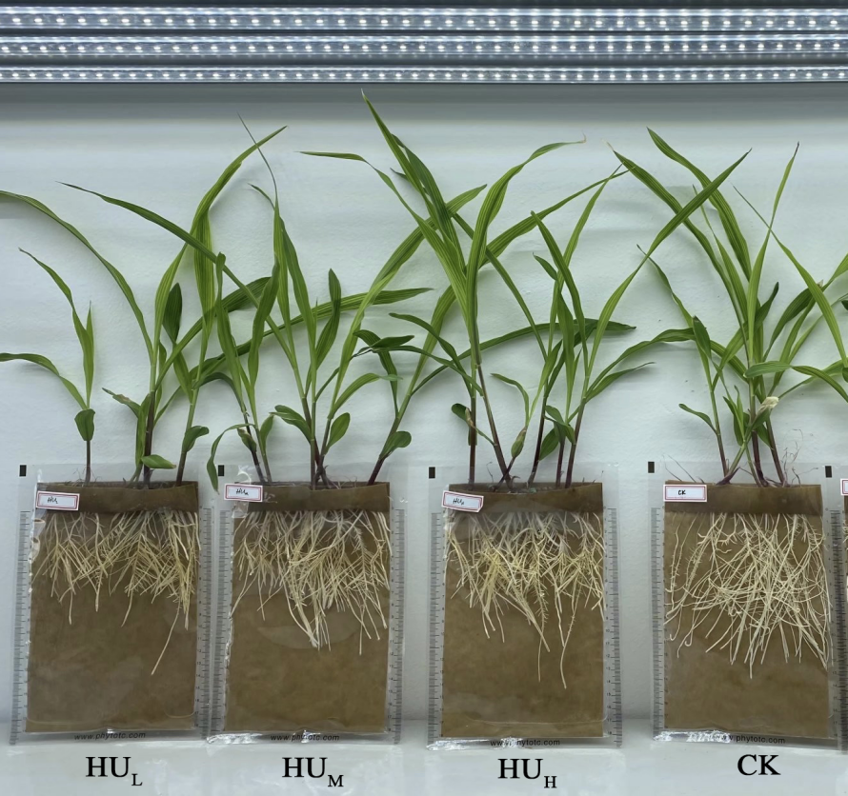
Fig.S1 Humic acid-treated maize phenotype map

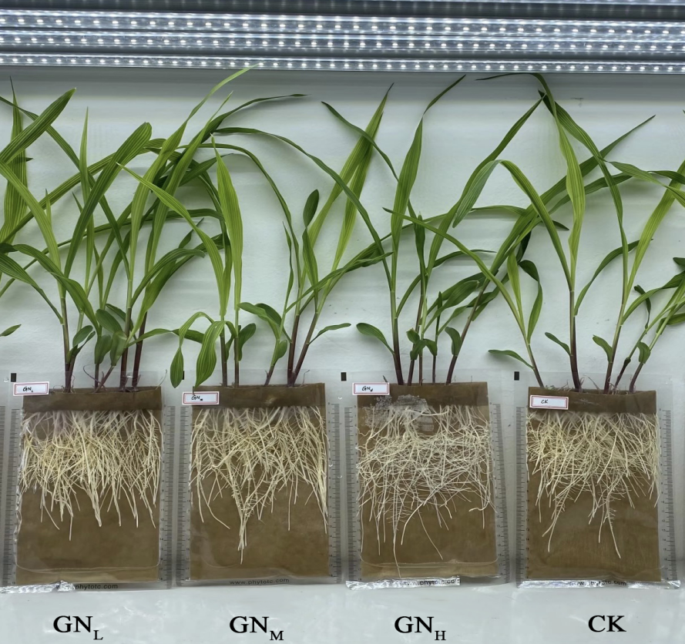
Fig.S2 Graphite nanoplatelets treated maize phenotype map

Method S1：Under the conditions of adding graphene and humic acid, the characteristics of the corn root system are quite different. Therefore, the two treatments and the CK-treated corn seedling roots were selected for further exploratory research for root metabolomics-related determinations. Material selection: Select 5 corn seedlings from each treatment, take representative primary and secondary roots, take the roots 2-3 cm from the root tip at a distance of more than 0.5 cm, and freeze-dry them with liquid nitrogen. After lyophilization, sample 10±1 mg of this book into a 2 mL EP tube, add 450 μL of pre-cooled extract (methanol to water volume ratio = 3:1), then add 10 μL of ribitol, vortex for 30 s, add ceramic beads, Treat the sample with a 45 Hz grinder for 4 min, ultrasonic for 5 min (ice-water bath), centrifuge the sample at 4 °C and centrifuge at 12000 rpm for 15 min, carefully pipette 200 μL of supernatant into a 1.5 mL EP tube, and mix 50 μL of each sample to form QC sample, dry the extract in a vacuum concentrator, add 50 μL of methoxamine salt reagent (methoxamine hydrochloride, dissolved in pyridine 20 mg/mL) to the dried metabolites, mix gently, and place Incubate in an oven at 80°C for 30 min, add 70 μL BSTFA (containing 1% TMCS, v/v) to each sample, incubate the mixture at 70°C for 1.5 h, cool to room temperature, add 5 μL FAMEs to the mixed sample (Dissolved in chloroform), random order on the machine, using Agilent 7890 gas chromatography-time-of-flight mass spectrometer with Agilent DB-5MS capillary column (30 m×250 μm×0.25 μm, J&W Scientific, Folsom, C, USA) detection, Tested by Shanghai Baiqu Biological Company.
GC-TOF-MS Analysis
GC-TOF-MS analysis was performed using an Agilent 7890 gas chromatograph coupled with a time-of-flight mass spectrometer. The system utilized a DB-5MS capillary column. 1 μL aliquot of sample was injected in splitless mode. Helium was used as the carrier gas, the front inlet purge flow was 3 mL min−1, and the gas flow rate through the column was 1 mL min−1. The initial temperature was kept at 50 °C for 1 min, then raised to 310 °C at a rate of 10 °C min−1, then kept for 8 min at 310 °C. The injection, transfer line, and ion source temperatures were 280, 280, and 250 °C, respectively. The energy was -70 eV in electron impact mode. The mass spectrometry data were acquired in full-scan mode with the m/z range of 50-500 at a rate of 12.5 spectra per second after a solvent delay of 6.25 min.

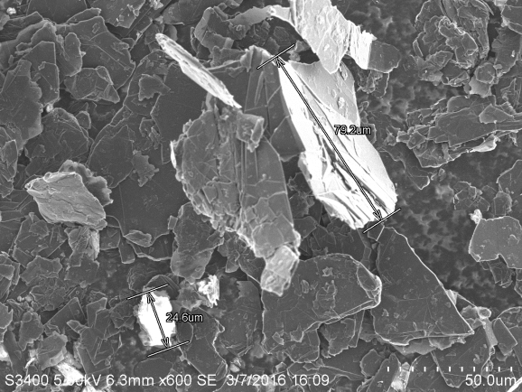
Fig.S3 The scanning electron micrograph (SEM) of graphite nanoplatelets

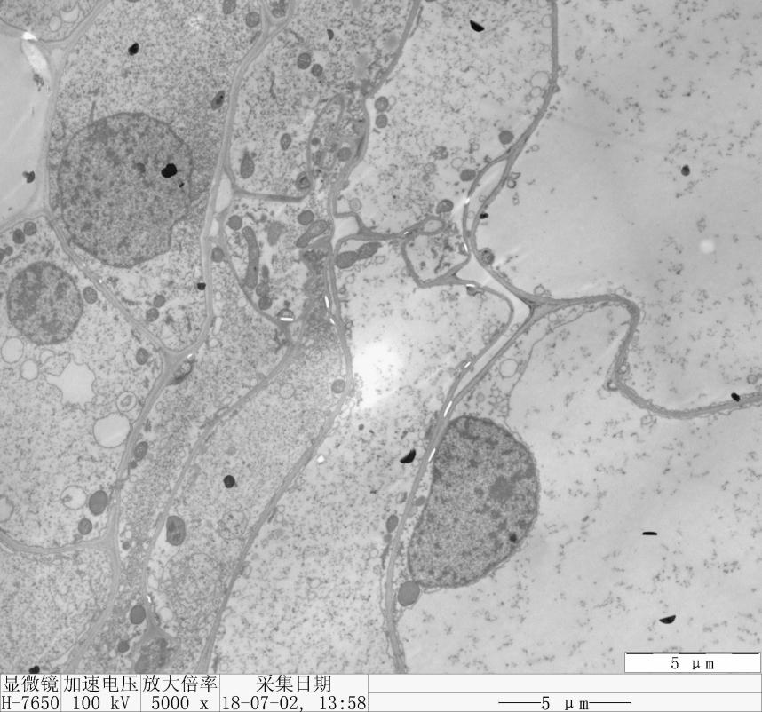

Fig.S4 Root Electron Microscopy of Medium Graphite Nanoplatelets Added

A total of 761 peaks were detected in this experiment, and please see the data for details.
Fig.S5 GC-TOF-MS total ion flow map of all the tested samples

Table.S3. Some of the critical metabolites differentially accumulated between Graphite Nanoplatelets and Humic acid
Class | Graphite Nanoplatelets | Humic acid | Formula | Molecular  weight | log2 Control/  Graphite/  Humic | P-value
Sugars | N-Acetyl-D-galactosamine 1↑ | N-Acetyl-D-galactosamine 1↑ | C₈H₁₅NO₆ | 221.21 | 1.703 | 0.019
Sugars | N-Acetyl-beta-D-mannosamine 1↑ | N-Acetyl-beta-D-mannosamine 1↑ | C₈H₁₅NO₆ | 221.21 | 1.295 | 0.006
Sugars | N-Acetyl-5-hydroxytryptamine 1↑ | N-Acetyl-5-hydroxytryptamine 1↑ | C₁₂H₁₄N₂O₂ | 218.25 | 4.140 | 0.010
Sugars | Lactose 1↓ | Lactose 1↓ | C₁₂H₂₂O₁₁ | 342.30 | -17.458 | 0.044
Sugars | Galactinol 3↓ | Galactinol 3↓ | C₁₂H₂₂O₁₁ | 342.30 | -2.562 | 0.026
Sugars |  | Xylitol↓ | C₅H₁₂O₅ | 152.15 | -0.899 | 0.003
Sugars |  | 2-Deoxy-D-galactose↑ | C₆H₁₂O₅ | 164.16 | 0.931 | 0.013
Sugars | Maltose↓ |  | C₁₂H₂₂O₁₁ | 342.30 | -0.575 | 0.008
Phosphorylated  metabolites | Beta-Mannosylglycerate 1↑ | Beta-Mannosylglycerate 1↑ | C₃H₈O₁₀P₂ | 266.04 | 3.370 | 0.004
Phosphorylated  metabolites | Methyl Phosphate↓ | Methyl Phosphate↓ | CH₅O₄P | 112.02 | -1.219 | 0.001
Phosphorylated  metabolites |  | Erythrose 4-phosphate 1↓ | C₄H₉O₇P | 200.0821 | -2.710 | 0.005
 |  | 4-nitrophenyl phosphate↓ | C₆H₆NO₆P | 219.09 | 0.801 | 0.033
Organic acids | Toluenesulfonic acid↓ |  | C₆H₆O₃S | 158.18 | 0.047 | -1.470
Organic acids | Pyruvic acid↑ | Pyruvic acid↓ | C₃H₄O₃ | 88.02 | 0.420 | 0.003
Organic acids | Mucic acid↓ | Mucic acid↓ | C₆H₁₀O₈ | 210.14 | -0.793 | 0.004
Organic acids | Lactic acid↑ |  | C₃H₆O₃ | 90.08 | 0.002 | 1.128
Organic acids |  | Citraconic acid degr1↓ | C₅H₆O₄ | 130.10 | -0.589 | 0.002
Organic acids | Caffeic acid↓ |  | C₉H₈O₄ | 180.16 | -6.824 | 0.033
Organic acids |  | Aminomalonic acid↓ | C₃H₅NO₄ | 119.08 | -1.784 | 0.008
Organic acids | Alpha-ketoisocaproic acid 1↓ | Alpha-ketoisocaproic acid 1↓ | C₆H₁₀O₃ | 130.14 | 0.002 | -0.959
Organic acids |  | Allantoic acid 3↓ | C₄H₈N₄O₄ | 176.13 | -2.740 | 0.008
Organic acids | 6-phosphoglucose acid↓ | 6-phosphoglucose acid↓ | C₆H₁₄NaO₁₀P | 300.13 | -15.491 | 0.019
Nucleosides |  | Adenine↓ | C₅H₅N₅ | 135.13 | -0.717 | 0.013
Nucleosides |  | 5'-methylthioadenosine 1↑ | C₁₁H₁₅N₅O₃S | 297.33 | 1.013 | 0.009
Nucleosides |  | 2-deoxyguanosine 1↓ | C₁₀H₁₃N₅O₄ | 267.25 | -2.441 | 0.001
Nucleosides |  | Purine riboside↑ | C₁₀H₁₂N₄O₄ | 252.23 | 0.707 | 0.009
Nucleosides | 6-Methylmercaptopurine 1↑ |  | C₆H₆N₄S | 166.20 | 1.650 | 0.017
Amino acid |  | Oxoproline↓ | C₅H₇NO₃ | 129.11 | -1.061 | 0.001
Amino acid |  | Glutamic acid↑ | C₅H₉NO₄ | 147.13 | 2.022 | 0.001
Amino acid |  | Glucosaminic acid↑ | C₆H₁₃NO₆ | 195.17 | 2.183 | 0.001
Amino acid |  | Aspartic acid 1↓ | C₄H₇NO₄ | 133.10 | -2.591 | 0.003
Amino acid |  | Nicotinamide↓ | C₆H₆N₂O | 122.12 | -3.408 | 0.000
Amino acid |  | Glycine 2↑ | C₂H₅NO₂ | 75.07 | 1.667 | 0.002
Amino acid |  | Glutamine 5↓ | C₅H₁₀N₂O₃ | 146.14 | -1.238 | 0.003
Amino acid |  | Cycloleucine 1↑ | C₆H₁₁NO₂ | 129.16 | 0.937 | 0.027
Amino acid |  | Beta-Alanine 2↑ | C₃H₇NO₂ | 89.09 | 1.718 | 0.018
Amino acid | Tyramine↓ |  | C₈H₁₁NO | 137.18 | -21.057 | 0.024
Amino acid |  | Maleimide↓ | C₄H₃NO₂ | 97.07 | -1.293 | 0.012
Alcohols |  | Glycerol↓ | C₃H₈O₃ | 92.09 | 0.929 | 0.004
Alcohols | Phthalic acid↑ |  | C₈H₆O₄ | 116.13 | 15.383 | 0.046
Alcohols |  | D-Glyceric acid↓ | C₃H₆O₄ | 106.08 | 0.770 | 0.003
Alcohols |  | Sorbitol↓ | C₆H₁₄O₆ | 182.17 | -1.840 | 0.011
Terpenes |  | Ribonic acid, gamma-lactone↓ | C₅H₈O₅ | 148.11 | -0.366 | 0.032
Terpenes |  | Glutaraldehyde 2↓ | C₅H₈O₂ | 100.12 | -3.184 | 0.000
Terpenes |  | Arbutin↓ | C₁₂H₁₆O₇ | 272.25 | -0.514 | 0.014
Esters | D-erythronolactone 2↓ |  | C₄H₆O₄ | 118.09 | -2.605 | 0.005
Esters |  | 1-Monopalmitin↓ | C₁₉H₃₈O₄ | 330.50 | 0.798 | 0.022
Phenol |  | 4-Hydroxy-6-methyl-2-pyrone↑ | C₆H₆O₃ | 126.11 | -1.570 | 0.031
Alkanes |  | 1,3-diaminopropane↓ | C₃H₁₀N₂ | 74.12 | 1.303 | 0.008
Base | 5,6-dihydrouracil 2↓ | 5,6-dihydrouracil 2↓ | C₄H₆N₂O₂ | 114.10 | -1.922 | 0.005
Arachidic acid |  | Arachidic acid↓ | C₂₀H₄₀O₂ | 312.53 | -0.478 | 0.001
Fatty acid | Myristic acid↑ |  | C₁₄H₂₈O₂ | 228.37 | -0.476 | 0.036

Corresponding Author: Di Zhang, Dr., Associate Professor, Tel:86+45155191170, Fox: 86+45155191170 E-mail: zhangdi6283@neau.edu.cn

